Deep Learning 3008ICT
Assignment 1
Kieran Ward, s5330019

Introduction
This report presents the implementation and evaluation of neural network architectures for image classification using the CIFAR-10 dataset. CIFAR-10 consists of 60,000 32×32 colour images across 10 object classes.
Two models are implemented and compared. A Softmax Regression model acts as a linear baseline, while a Convolutional Neural Network (CNN) is the primary model under investigation. Three experiments are conducted — analysing the effect of network depth, learning rate, and mini-batch size on model performance.
All models are implemented in PyTorch using a fixed random seed of 0 to ensure reproducible results.

Software Design
Data Preparation
The CIFAR-10 dataset is loaded using torchvision.datasets.CIFAR10 and split into three subsets using a fixed random seed of 0 for reproducibility. The training set contains 45,000 images, the validation set contains 5,000 images, and the test set contains 10,000 images. Each image is normalised using the mean and standard deviation values of the CIFAR-10 dataset across all three colour channels. Data loaders are created for each subset using PyTorch's DataLoader class, which handles batching and shuffling of the data during training.
Softmax Regression
The Softmax Regression model is implemented as a single fully connected layer using PyTorch's nn.Linear class, mapping the flattened input of 3,072 features (32×32×3) to 10 output classes. Each input image is flattened from its original shape of (3, 32, 32) to a one-dimensional vector before being passed through the layer. The model uses CrossEntropyLoss as the loss function, which applies softmax internally, and is optimised using Stochastic Gradient Descent (SGD) with a learning rate of 0.01.
Convolutional Neural Network
The CNN is implemented as a flexible class that accepts three parameters — the number of convolutional layers, whether to use residual connections, and the dropout rate. This allows a single class definition to cover all experimental configurations without code duplication.
The architecture consists of three main components. A first convolutional layer takes the 3-channel input and maps it to 64 feature maps. A series of middle convolutional layers maintain 64 feature maps throughout, each followed by Batch Normalisation and ReLU activation. A final convolutional layer feeds into a single Max Pooling layer which halves the spatial dimensions from 32×32 to 16×16. The output is then flattened and passed through a fully connected linear layer producing 10 class scores.
When residual connections are enabled, the output of each middle layer is added back to its input using the expression x = x + layer(x). This provides a shortcut path for gradients during backpropagation, helping to prevent the vanishing gradient problem in deeper networks. Dropout and weight decay are applied to deeper networks as additional regularisation.
Training Function
A shared training function handles both the training and validation phases for all models. During training, gradients are zeroed, a forward pass is performed, the loss is computed and backpropagated, and the optimiser updates the model weights. During validation, the model is switched to evaluation mode using model.eval() and gradients are disabled using torch.no_grad() to reduce memory usage. Training loss, validation loss, and validation accuracy are recorded after each epoch and returned as a history dictionary for plotting.
Plotting
A reusable plot_history function generates two graphs for each experiment — a loss curve showing training and validation loss over epochs, and a validation accuracy curve. Plots are automatically saved as PNG files for inclusion in this report.

Results & Diagrams
Softmax Regression
The Softmax Regression model was trained for 20 epochs using SGD with a learning rate of 0.01. As shown in Figure 1, the training loss decreased steadily throughout training, dropping from approximately 1.89 to 1.70. However, the validation loss remained unstable and noisy throughout, showing no clear downward trend. Validation accuracy fluctuated between approximately 28% and 36%, with no consistent improvement over time.
These results are consistent with the known limitations of linear models on image classification tasks. Softmax Regression has no ability to learn spatial features or hierarchical representations from images — it can only learn simple linear relationships between raw pixel values and class labels. The instability in validation performance suggests the model lacks the capacity to generalise effectively to unseen data, motivating the use of a CNN for the remaining experiments.
Figure 1.
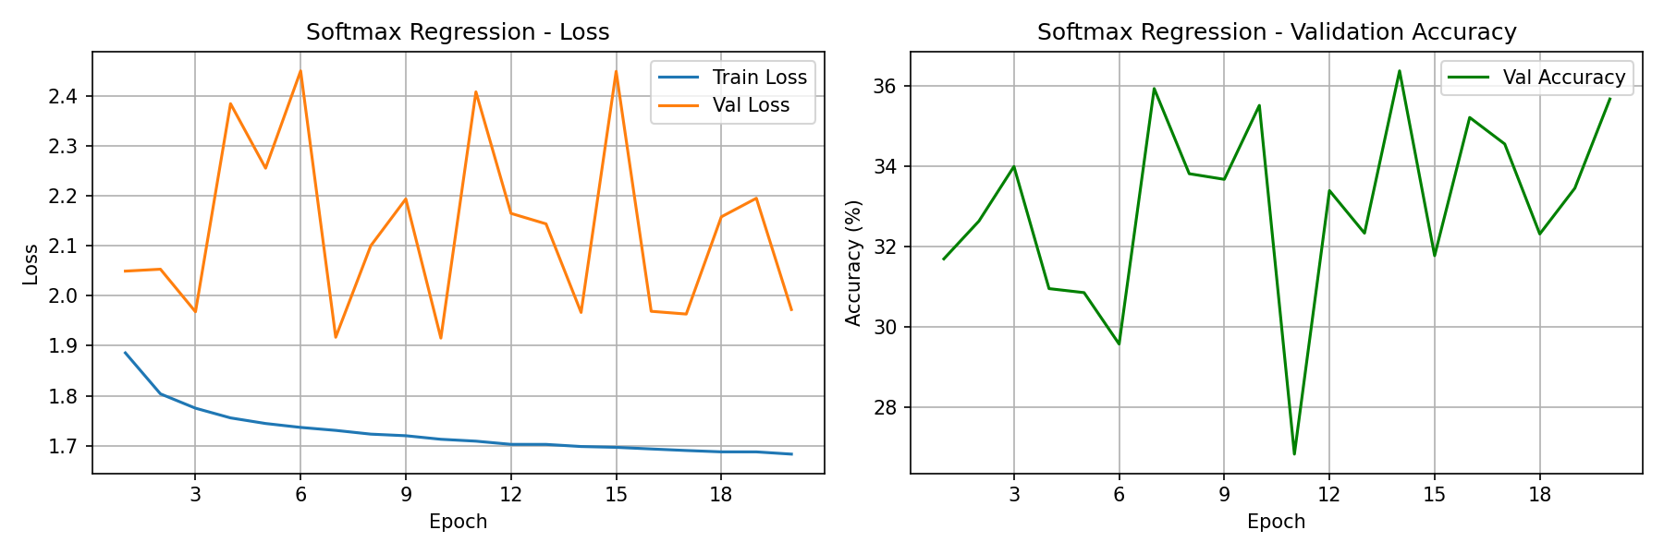

Experiment (a) — CNN Depth Analysis
The CNN was trained with four different depths — 2, 8, 16, and 32 convolutional layers — for 20 epochs using the Adam optimiser with a learning rate of 0.001. Results are summarised in Table 1.
Table 1 — CNN Depth Analysis Results (No Regularisation)
Model | Final Train Loss | Final Val Loss | Final Val Accuracy
CNN Depth 2 | ~0.10 | ~1.75 | ~69%
CNN Depth 8 | ~0.13 | ~1.35 | ~76%
CNN Depth 16 | ~0.25 | ~0.85 | ~80%
CNN Depth 32 | ~0.57 | ~0.75 | ~75%
As shown in Figures 2–5, increasing network depth generally improved validation accuracy up to 16 layers, with the 16 layer model achieving the highest accuracy of approximately 80%. However, performance did not continue to improve at 32 layers, with accuracy dropping back to approximately 75%.
The 2 layer model shows the most severe overfitting — despite achieving a very low training loss of ~0.10, the validation loss climbed steeply to ~1.75 by epoch 20. This large gap between training and validation loss indicates the model memorised the training data without learning generalisable features.
The 8 layer model improved on this with a validation accuracy of ~76%, however overfitting is still clearly visible from around epoch 10 where the validation loss begins diverging from the training loss.
The 16 layer model produced the best overall result, benefiting from BatchNorm acting as a natural regulariser across the deeper architecture. The 32 layer model without residual connections showed a slower start, taking more epochs to begin improving but ultimately converged to a reasonable accuracy, suggesting some gradient flow issues in the early epochs without regularisation support.

Figure 2.
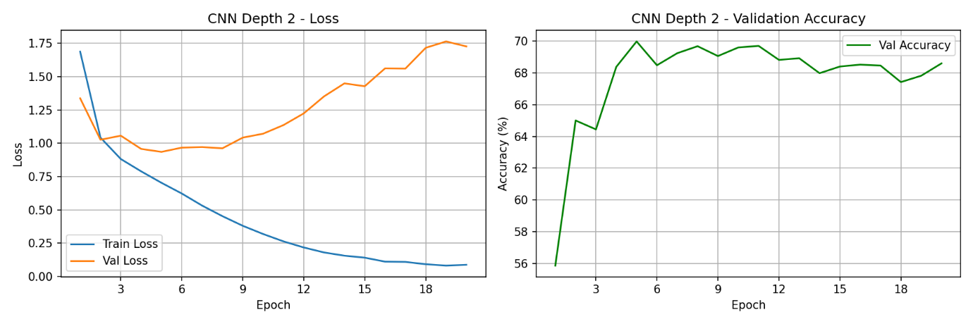

Figure 3.
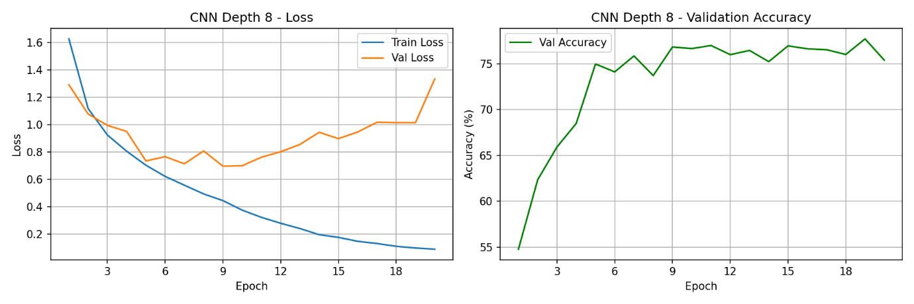

Figure 4.
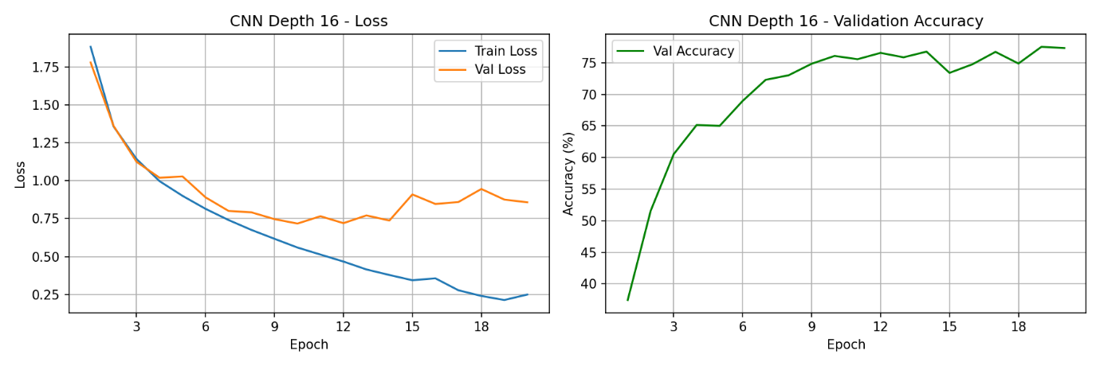

Figure 5.
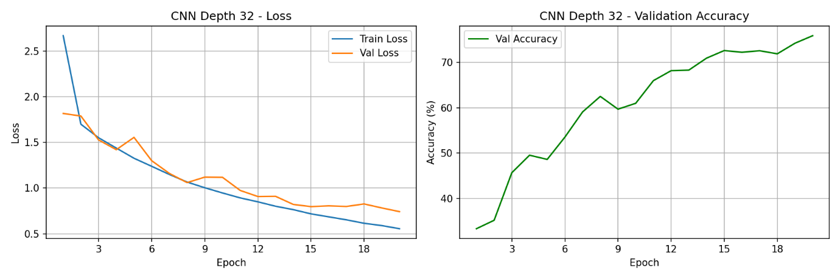

Regularised Deep Networks
The 16 and 32 layer models were retrained with residual connections, dropout of 0.3, and weight decay of 1e-4. Results are summarised in Table 2.
Table 2 — CNN Depth Analysis Results (With Regularisation)
Model | Final Train Loss | Final Val Loss | Final Val Accuracy
CNN Depth 16 Regularised | ~0.35 | ~0.80 | ~76%
CNN Depth 32 Regularised | ~0.35 | ~0.72 | ~77%
As shown in Figures 6–7, the regularised models display a noticeably tighter gap between training and validation loss compared to their unregularised counterparts. The validation curves are smoother and more stable throughout training, demonstrating the combined effect of dropout, weight decay, and residual connections in reducing overfitting.
The regularised 16 layer model achieved ~76% validation accuracy compared to ~80% for the unregularised version. This slight reduction is expected, regularisation intentionally constrains the model during training, which can marginally reduce peak accuracy while improving generalisation. The regularised 32 layer model improved on its unregularised counterpart, rising from ~75% to ~77%, suggesting that residual connections were particularly beneficial for the deeper architecture.

Figure 6.
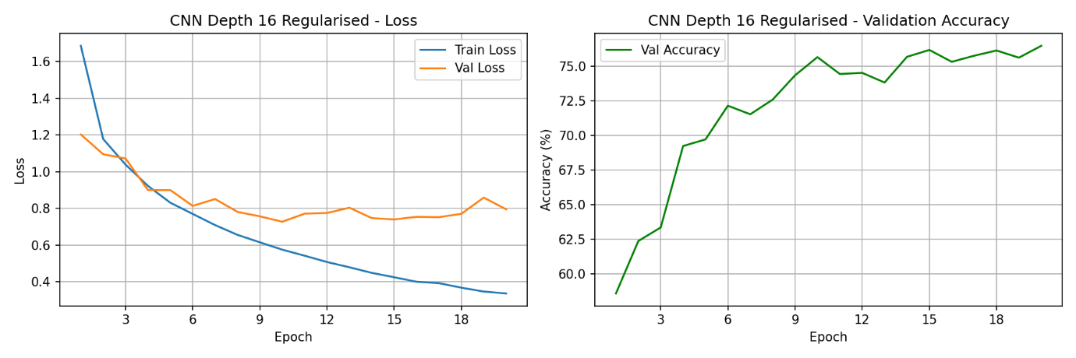
Figure 7.
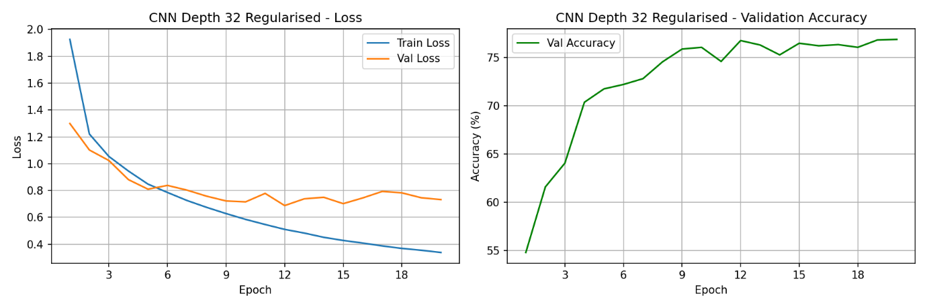

Experiment (b) — Learning Rate Analysis
The regularised 16 layer CNN was trained for 20 epochs using five different learning rates with the Adam optimiser. Results are summarised in Table 3.
Table 3 — Learning Rate Analysis Results
Learning Rate | Final Train Loss | Final Val Loss | Final Val Accuracy
0.000001 | ~1.61 | ~1.61 | ~42%
0.0001 | ~0.53 | ~0.74 | ~75%
0.001 | ~0.35 | ~0.79 | ~76%
0.01 | ~0.98 | ~0.98 | ~68%
1.0 | ~0.00 | ~500,000 | ~10%
As shown in Figures 8–12, the choice of learning rate had a dramatic effect on both model performance and training stability.
0.000001 — The model trained extremely slowly, with the accuracy curve still rising steeply at epoch 20 and showing no signs of plateauing. A final validation accuracy of only ~42% was achieved, well below all other learning rates. The very small gradient updates meant the model was unable to converge within 20 epochs, demonstrating that an excessively small learning rate makes training computationally impractical.
0.0001 — A clear improvement over 0.000001, with smooth and stable loss curves and a final validation accuracy of ~75%. The model converged well, though slightly slower than 0.001 in the early epochs.
0.001 — The best performing learning rate, achieving ~76% validation accuracy with smooth and stable training and validation curves throughout. The loss decreased consistently and the train/val gap remained controlled, indicating good generalisation.
0.01 — While the model learned quickly in the early epochs, the loss plateaued around epoch 5–6 and accuracy became noisy and unstable at approximately 68%. The larger gradient steps caused the optimiser to overshoot the optimal solution, preventing the model from settling into a well-generalised minimum.
1.0 — Complete training failure. The validation loss spiked dramatically to approximately 500,000 at epoch 15, indicating numerical instability caused by excessively large weight updates. The validation accuracy of ~10% is equivalent to random guessing across 10 classes, meaning the model learned nothing meaningful. This demonstrates that an excessively large learning rate destroys the model's learned weights rather than refining them.
Overall these results confirm that 0.001 is the optimal learning rate for this architecture, striking the best balance between convergence speed and training stability.

Figure 8.
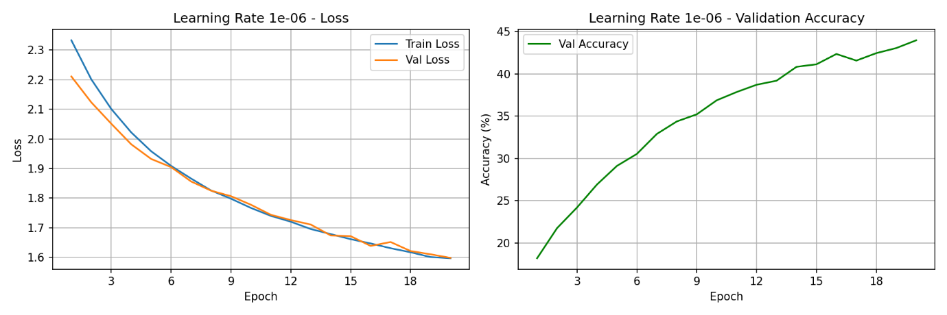

Figure 9.
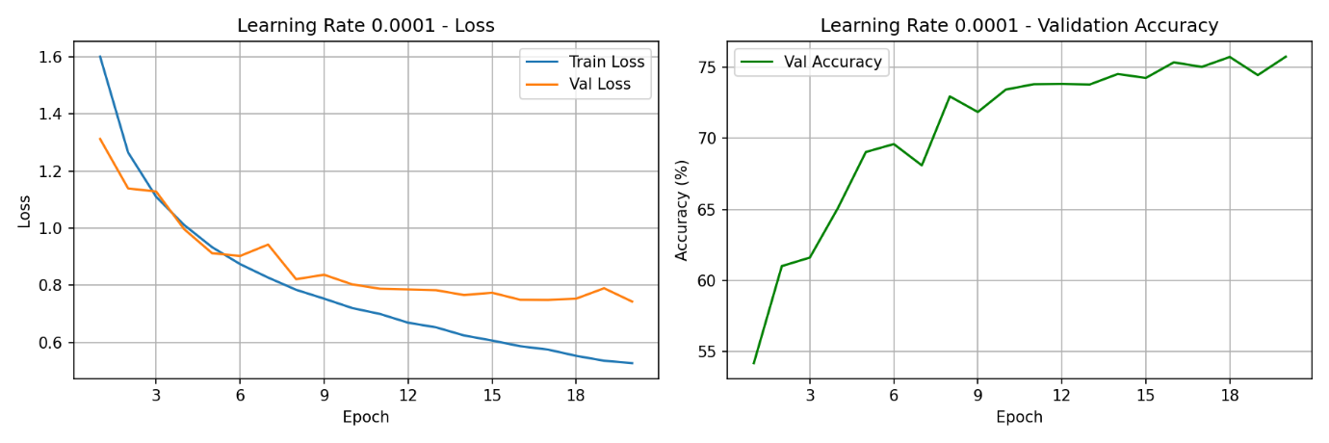

Figure 10.
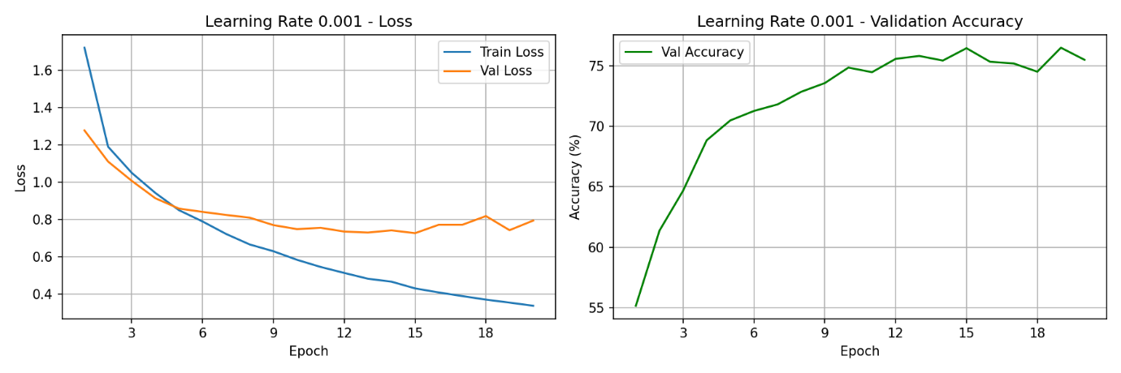

Figure 11.
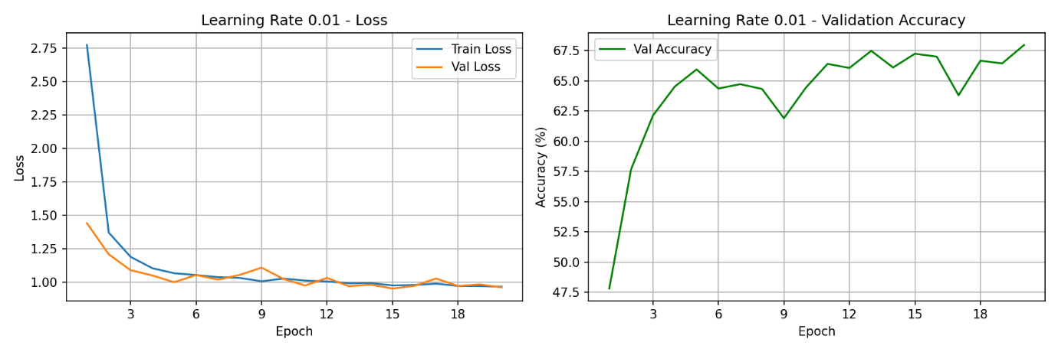
Figure 12.
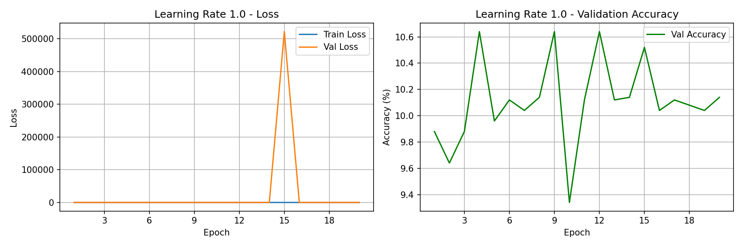
Experiment (c) — Mini-batch Size Study
The regularised 16 layer CNN was trained using five different mini-batch sizes with the Adam optimiser at a learning rate of 0.001. Batch size 1 was trained for 10 epochs due to computational constraints, while all other batch sizes were trained for 20 epochs. Results are summarised in Table 4.
Table 4 — Mini-batch Size Study Results
Batch Size | Epochs | Final Val Accuracy
1 | 10 | ~59%
8 | 20 | ~73%
16 | 20 | ~75%
64 | 20 | ~76%
256 | 20 | ~77%
As shown in Figures 13–17, mini-batch size had a significant effect on both training stability and final validation accuracy.
Batch size 1, produced the noisiest training curves with a validation loss that fluctuated considerably throughout all 10 epochs. Despite only being trained for 10 epochs due to its significant computational cost, processing 45,000 individual weight updates per epoch compared to approximately 176 updates for batch size 256, it still reached ~59% accuracy, showing it was learning but at a much slower and less stable rate.
Batch sizes 8 and 16 showed progressively smoother curves and improved accuracy, reaching ~73% and ~75% respectively. Both showed a slight gap between training and validation loss but remained reasonably stable throughout training.
Batch sizes 64 and 256 produced the smoothest and most stable training curves of all configurations. Batch size 256 achieved the highest validation accuracy of ~77%, with training and validation loss tracking closely together throughout. The larger batch sizes benefit from more accurate gradient estimates per update since each step averages over more samples, leading to smoother and more reliable weight updates.

Figure 13.
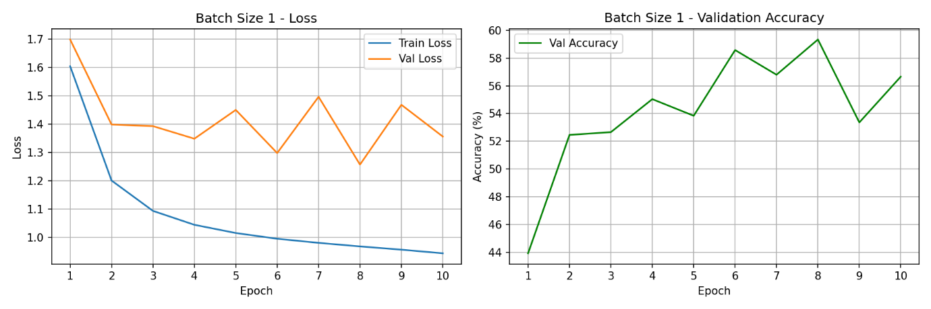

Figure 14.
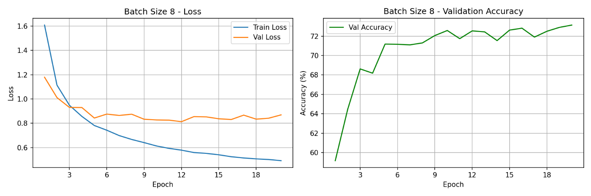

Figure 15.
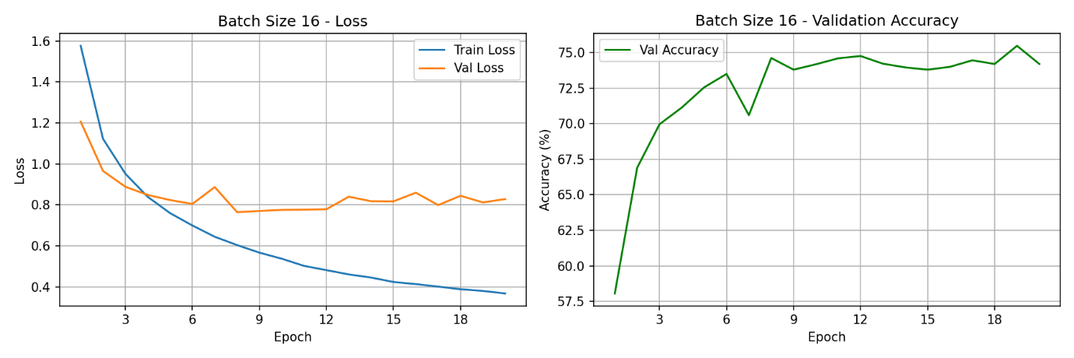
Figure 16.
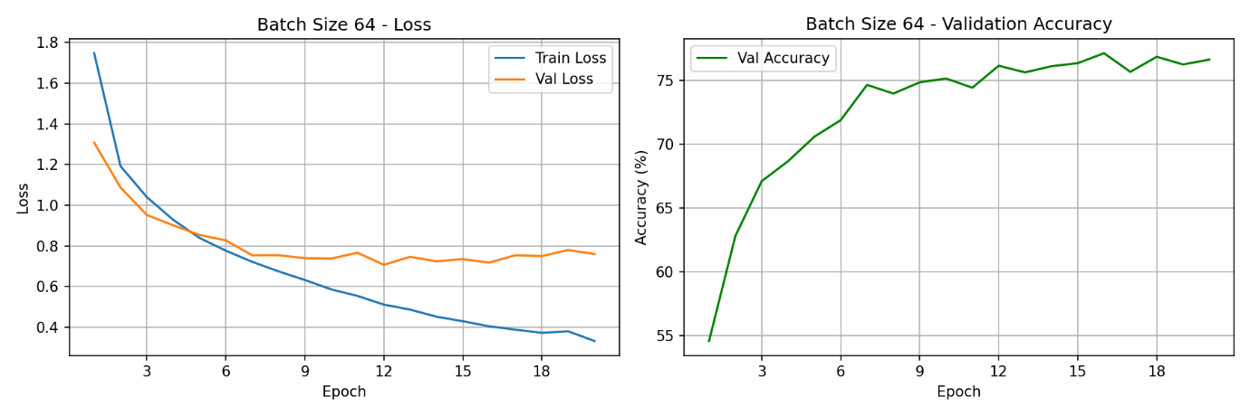
Figure 17.
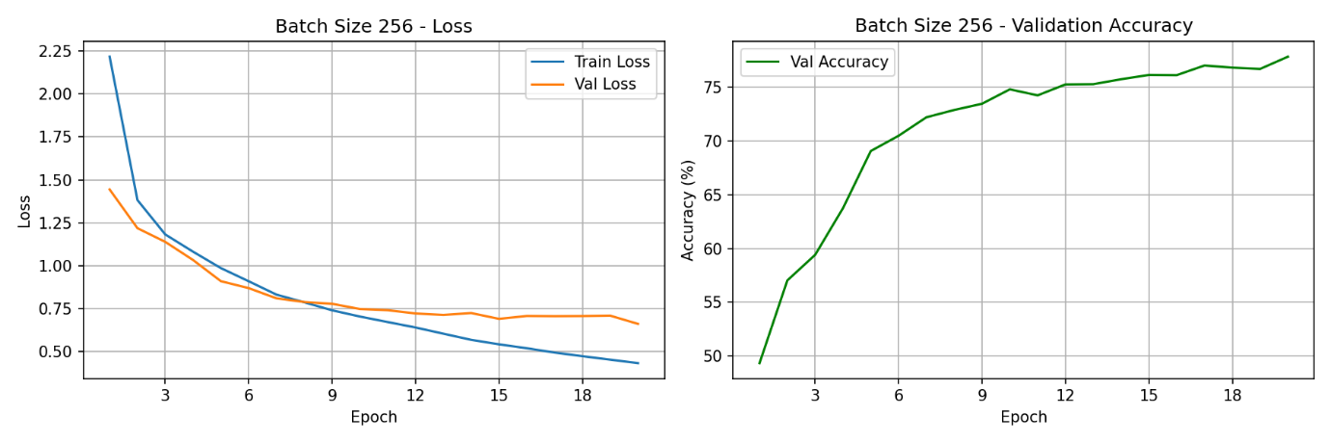

Final Model Performance
Figure 18. Final Model Training Curves
Training and validation loss, and validation accuracy for the final regularised 16-layer CNN with a learning rate of 0.001 and batch size of 256.
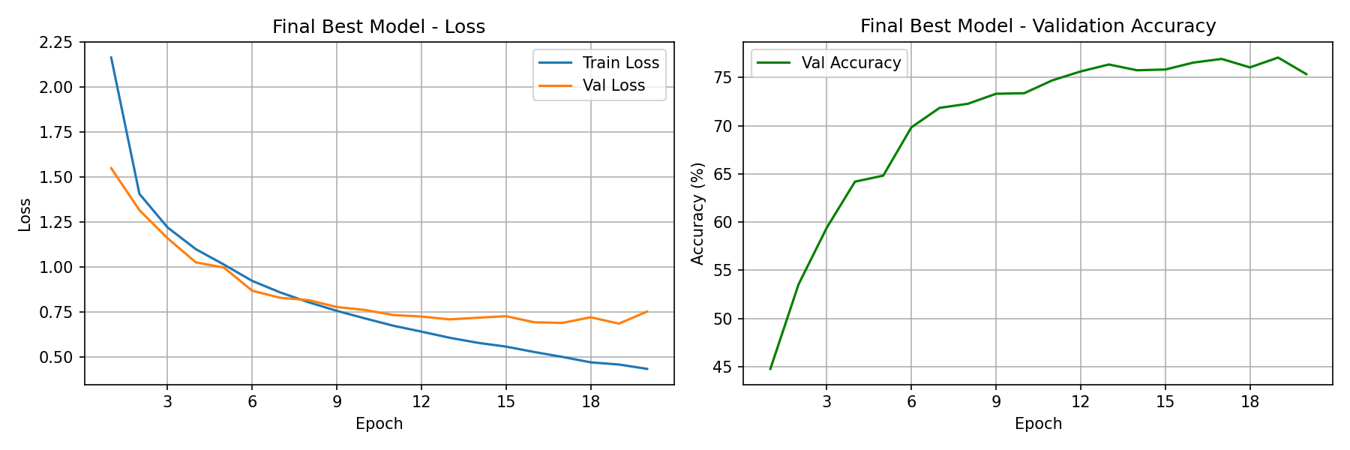
The final model shows smooth and stable convergence, with both training and validation loss decreasing consistently over epochs. The validation accuracy steadily increases before plateauing at approximately 77%, indicating that the model has effectively learned meaningful features from the data. The relatively small gap between training and validation loss suggests that overfitting is well controlled due to the use of regularisation techniques.

Discussion
Effect of Network Depth
The depth analysis revealed that increasing convolutional layers generally improved performance up to a point, with the 16 layer model achieving the highest unregularised validation accuracy of ~80%. However, simply adding more layers did not guarantee better results, the 2 layer model suffered from severe overfitting despite being the simplest architecture, while the 32 layer model without regularisation showed signs of gradient flow difficulties in the early epochs, taking longer to begin improving than shallower models. Although the unregularised 16 layer model achieved a higher peak validation accuracy (~80%), it exhibited stronger overfitting and less stable training behaviour. The regularised model was therefore preferred due to its improved generalisation and more reliable performance on unseen data.
The introduction of residual connections, dropout, and weight decay to the 16 and 32 layer models produced noticeably more stable training curves with a tighter gap between training and validation loss. While the regularised 16 layer model achieved a slightly lower peak accuracy (~76%) compared to its unregularised counterpart (~80%), this trade-off is acceptable in practice as the regularised model generalises more reliably to unseen data. The regularised 32 layer model improved over its unregularised version, rising from ~75% to ~77%, demonstrating that residual connections were particularly effective at stabilising gradient flow through the deeper architecture.
These findings highlight an important principle in deep learning, network depth alone is insufficient for good performance. Without appropriate regularisation techniques, deeper networks are prone to overfitting and training instability. The results support the motivation behind architectures such as ResNet, where residual connections were introduced specifically to address the degradation problem in very deep networks.
Effect of Learning Rate
The learning rate experiment produced the most dramatic range of outcomes across all three experiments. At one extreme, a learning rate of 0.000001 was so small that the model failed to converge within 20 epochs, reaching only ~42% accuracy while the accuracy curve was still clearly rising at the final epoch. At the other extreme, a learning rate of 1.0 caused catastrophic divergence, the validation loss spiked to approximately 500,000 at epoch 15, and the model achieved only ~10% accuracy, equivalent to random guessing.
The optimal learning rate of 0.001 achieved the best validation accuracy of ~76% with smooth and stable loss curves throughout training. Learning rates of 0.0001 and 0.01 both achieved reasonable results at ~75% and ~68% respectively, though 0.01 showed signs of instability with a noisy loss curve that plateaued earlier than the optimal rate.
These results demonstrate that the learning rate is one of the most critical hyperparameters in neural network training. Too small a value makes training impractically slow, while too large a value causes weight updates that overshoot optimal solutions and can destroy learned representations entirely. The results confirm that 0.001 is a well-established default for the Adam optimiser on image classification tasks.
Effect of Mini-batch Size
The mini-batch size experiment demonstrated a clear trade-off between training stability, computational cost, and final accuracy. Batch size 1 was the most computationally expensive by a significant margin, processing 45,000 individual weight updates per epoch made it impractical to train for the full 20 epochs, and the resulting loss curves were highly noisy due to the high variance in individual sample gradients.
Larger batch sizes produced progressively smoother training curves and higher final accuracies, with batch size 256 achieving the best result of ~77%. This is because larger batches provide more accurate gradient estimates by averaging over more samples per update, leading to more reliable weight updates. However, it is worth noting that very large batch sizes can sometimes lead to poorer generalisation in practice, as they tend to converge to sharper minima that do not generalise as well as the flatter minima found by smaller batch training.
The middle ground batch sizes of 16 and 64 both achieved competitive accuracies of ~75–76% with stable training curves, representing a practical balance between computational efficiency and model performance.

Conclusion
This report presented the implementation and evaluation of two neural network architectures, Softmax Regression and a Convolutional Neural Network, for image classification on the CIFAR-10 dataset. Three experiments were conducted to investigate the effects of network depth, learning rate, and mini-batch size on model performance.
The Softmax Regression model demonstrated the limitations of linear classifiers on image data, achieving a maximum validation accuracy of approximately 36% with unstable and noisy learning curves. This result highlighted the need for more expressive architectures capable of learning spatial features from images.
The CNN experiments produced several key findings. First, increasing network depth improved performance up to 16 convolutional layers, but deeper networks required regularisation techniques such as residual connections, dropout, and weight decay to train effectively and generalise well. Second, the learning rate proved to be a critical hyperparameter, a rate of 0.001 was found to be optimal for the Adam optimiser on this architecture, with rates that were too large or too small leading to divergence or impractically slow convergence respectively. Third, larger mini-batch sizes produced smoother training curves and marginally higher accuracies, though at the cost of higher memory requirements, while smaller batch sizes were significantly more computationally expensive despite offering noisier gradient updates.
Overall, the regularised 16 layer CNN with a learning rate of 0.001 and batch size of 256 achieved the best performance, reaching a final test accuracy of 76.79%. The close alignment between validation accuracy (~77%) and test accuracy indicates strong generalisation and confirms the effectiveness of the chosen architecture and hyperparameters.

