Assignment 2: Recurrent Networks and NLP
3008ICT: Deep Learning
Kieran Ward, s5330019

1. Introduction & Software Design
The purpose of this assignment is to implement and compare three recurrent neural network architectures — a Vanilla RNN, an LSTM, and a Bidirectional LSTM (BRNN) — for sentiment classification on the IMDb movie review dataset. Each model predicts whether a review expresses positive or negative sentiment, and their performance is evaluated and compared across accuracy, parameter count, and training speed.
Data Preprocessing
The IMDb dataset contains 25,000 training and 25,000 test reviews, loaded via the HuggingFace datasets library. Each review is lowercased and tokenised using a regex pattern that extracts alphabetic words and apostrophes. A vocabulary of the 20,000 most frequent words is built from the training set only to avoid data leakage, with two reserved tokens: <pad> (index 0) for sequence padding and <unk> (index 1) for out-of-vocabulary words. Reviews are truncated to a maximum of 500 tokens. A custom PyTorch Dataset class pre-encodes all reviews at load time, and a collate function dynamically pads each mini-batch to the length of its longest sequence using pad_sequence.
Models Implemented
Three architectures were implemented in PyTorch, all sharing the same Embed → Recur → Classify structure and trained using the Adam optimiser (lr=1e-3), cross-entropy loss, and gradient clipping (max_norm=1.0) over 5 epochs with a batch size of 64.
- Vanilla RNN — A single-layer RNN using the final hidden state for classification.
- LSTM — A 2-layer stacked LSTM with dropout, replacing the RNN cell with gated memory units.
- BRNN — A 2-layer bidirectional LSTM that concatenates the forward and backward final hidden states, doubling the classifier input size to 512.

2. Results
Summary Table
Model | Test Accuracy | Parameters | Avg Epoch Time
Vanilla RNN | 50.12% | 2,659,586 | 3.6s
LSTM | 50.00% | 3,482,370 | 25.0s
BRNN | 84.94% | 4,928,770 | 54.9s
Training Loss Curves
The loss curves reveal a stark contrast between the three models. Both the Vanilla RNN and LSTM showed no meaningful learning across all 5 epochs — training loss remained flat at approximately 0.70 throughout, consistent with their near-random test accuracies of 50.12% and 50.00% respectively. The BRNN however showed clear and consistent improvement, with training loss dropping from 0.6731 at epoch 1 down to 0.4014 by epoch 5, and test accuracy improving from 65.78% to 84.94% over the same period.
Per-Model Breakdown
The Vanilla RNN achieved a final test accuracy of 50.12% with a training loss that oscillated around 0.70 without converging, indicating the model failed to learn any meaningful pattern. The test loss actually spiked to 0.7311 at epoch 5, suggesting the model was unstable rather than simply plateauing.
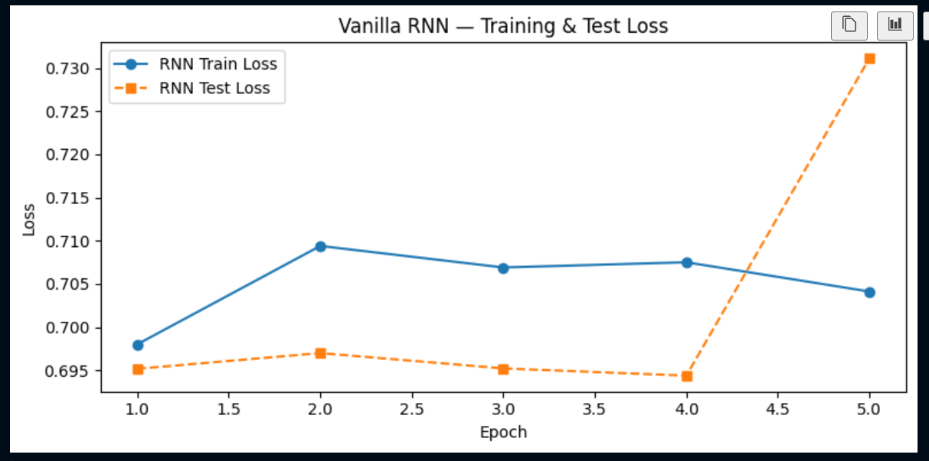
The LSTM performed similarly poorly with a final test accuracy of exactly 50.00% — equivalent to random guessing on a balanced binary classification task. Despite having 3,482,370 parameters and taking considerably longer to train (25s per epoch vs 3.6s for the RNN), its loss showed no downward trend across all 5 epochs.
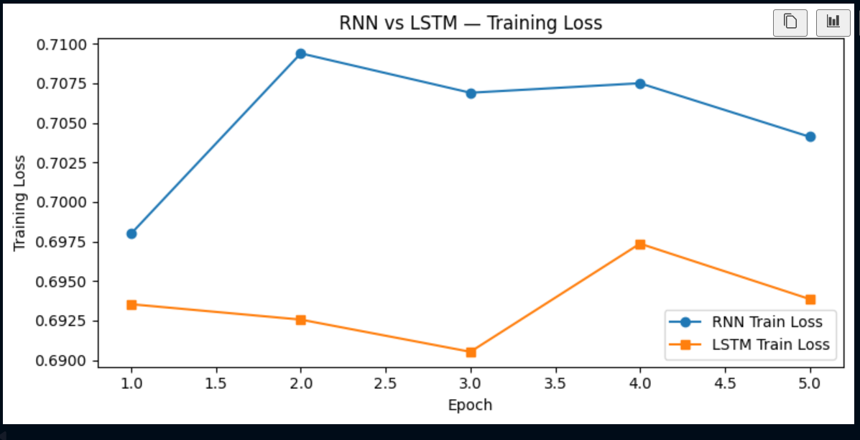
The BRNN was the clear standout, achieving 84.94% test accuracy with a steadily decreasing training loss and consistently improving test accuracy each epoch. With 4,928,770 parameters and an average epoch time of 54.9 seconds it was the most resource-intensive model, but the only one to demonstrate genuine learning.
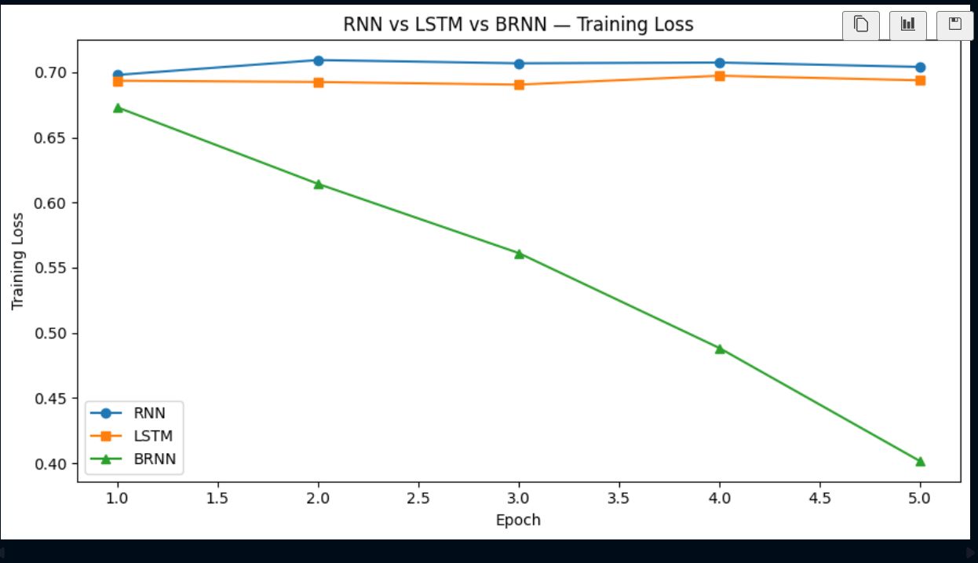

3. Discussion
Vanilla RNN and LSTM Failure to Learn
The most striking result was that both the Vanilla RNN and LSTM failed to learn effectively, achieving test accuracies close to random guessing. A likely reason is that both unidirectional models classified reviews using the final hidden state after padded sequences had been processed. Although padding tokens used a special embedding index, the recurrent layers still processed these extra timesteps, meaning the final hidden state for shorter reviews may have been influenced heavily by padding rather than meaningful review content. This likely weakened the sentiment signal and caused the loss to remain around 0.69–0.70 across all five epochs.
Why the BRNN Succeeded
The BRNN's success where the LSTM failed is particularly noteworthy given they share identical components — the same embedding layer, LSTM cells, dropout, and training loop. The key difference is bidirectionality. By processing the sequence in both directions simultaneously, the BRNN effectively provides two independent gradient pathways during backpropagation. This doubled gradient signal was sufficient to overcome the vanishing gradient problem that crippled the unidirectional models, allowing the BRNN to learn meaningful sentiment patterns and achieve 84.94% accuracy with a consistently decreasing loss across all 5 epochs.
Accuracy vs Efficiency Trade-off
The results highlight a clear trade-off between model complexity and performance. The Vanilla RNN was by far the fastest at 3.6 seconds per epoch, but its performance was unusable. The LSTM was 7x slower at 25 seconds per epoch yet offered no accuracy improvement. The BRNN at 54.9 seconds per epoch was the only model to justify its computational cost. In this case the trade-off is not really between accuracy and efficiency — it is between a model that works and models that do not.
Error Analysis
The BRNN misclassified 3,765 of the 25,000 test examples. Examining the misclassified samples revealed two consistent patterns. First, many negative reviews were written in a style that leads with positive-sounding language — praising the subject at length before delivering a negative verdict — causing the model to predict positive based on the early token representations. Second, sarcasm proved problematic, where ironic phrases like "can you feel the chills" carry no surface-level negative signal that the model can detect. These failure modes are inherent limitations of sequence models that lack world knowledge and pragmatic understanding.

