

CSC3105 Data analytics and Artificial Intelligence

Project Title : | Data Analytics in Line-of-Sight (LOS) & Non-Line- Sight(NLOS) Wireless Signal Predictor in Indoor Environment for Precise Positioning
Group : | 07

Name | GUID/SIT ID
KIERAN SIM | 3070564S/2403348
FAHRUL RAZIE ANNAQI BIN AZMAN | 3070697B/2402592
KAISER YEE | 3070609Y/2400821
DARYL CHONG HAN KIN | 3070590C/2400619
AIMAN SYLVESTER | 3070686R/2402329

Group Contribution 3
1.Problem Definition 4
1.1 Background and Motivation 4
1.2 Problem Statement 4
1.3 Research Questions 4
2. Literature Review 5
2.1 Existing LOS/NLOS Detection Methods 5
2.2 Machine Learning Approaches for LOS/NLOS Classification 5
2.3 Limitations of Existing Work and Motivation for This Project 5
3. Data Preparation and Preprocessing 6
3.1 Proposed Novel Solution 6
3.2 Dataset Overview 6
3.3 Data Cleaning Pipeline 7
3.4 Cleaning Results Summary 8
3.5 Feature Engineering: 9
3.5 Preprocessing Justifications (Requirements a.I – a.VI) 10
3.5.2 — Feature Extraction & Transformation 11
3.5.3 — Class Labelling 11
3.5.4 — Data Cleaning 11
3.5.5 — Feature Importance on cleaned dataset 11
3.5.6 — Synthetic Data for Performance Robustness 13
3.6 Feature Importance Analysis 13
Random Forest (Gini Based) 15
XG Boost 16
Logistic Regression 17
Linear SVC (SVM) 18
Final Rankings 19
4. Data Mining 20
4.1 Learning Paradigm and Model Selection 20
4.2 Dataset Split Strategy 22
4.3 Evaluation Metrics 23
4.4 Final Model Choice 24
4.5 Mathematical Formulas for XGBoost classifier 25
5. Results Analysis 26
5.1 XGBoost Classification Performance 26
5.2 XGBoost Regression Performance 27
6. Pseudocode 29
6.1 XGBoost Pair Classifier 29
7. Discussion 31
7.1 Strength of our proposed solution 31
7.2 Weakness of proposed solution 31
7.3 Limitations of dataset 31
7.4 Assumptions made 32
8. Conclusion 32
References 33
Appendix 34

Group Contribution

KIERAN SIM

FAHRUL RAZIE ANNAQI BIN AZMAN

KAISER YEE

DARYL CHONG HAN KIN

MUHAMMAD AIMAN SYLVESTER RAQEEM

1.Problem Definition

1.1 Background and Motivation
Ultra-Wideband (UWB) is a short-range wireless communication protocol that operates over a wide frequency spectrum. Unlike narrowband systems, UWB transmits data using short nanosecond pulses across this ultra-wide bandwidth. This characteristic provides high temporal resolution, enabling the generation of high-resolution position data through precise Time-of-Flight (ToF) measurements. Therefore, UWB has become a pivotal technology for detecting the location of people, devices, and items indoors with significantly greater accuracy than conventional RF technologies such as Wi-Fi or Bluetooth. A comprehensive 2024 survey confirms that UWB is now among the most promising approaches for sub-metre indoor accuracy [1].
This capability is particularly valuable in indoor environments where the Global Positioning System (GPS) cannot penetrate building structures reliably. Applications such as autonomous vehicles, warehouse robotics, drone navigation, and asset tracking all require precise indoor positioning that GPS cannot provide. UWB fills this gap through anchor-and-tag ranging: fixed anchor nodes are deployed throughout a space, and a mobile tag measures the ToF to each anchor. With three or more anchors, trilateration can then pinpoint the tag’s position. The technology has already seen widespread commercial adoption in devices such as the Apple AirTag and Samsung SmartTag. Under ideal Line-of-Sight (LOS) conditions, where no obstacle obstructs the signal path, this process yields highly accurate, centimetre-level results.
However, in real indoor environments, obstacles such as walls and furniture would obstruct the direct signal path, creating Non-Line-of-Sight (NLOS) conditions. Under NLOS propagation, signals arrive via reflected or diffracted paths rather than the direct route, introducing a positive bias in ToF measurements that inflates the estimated distance. Research has shown that under NLOS conditions, UWB positioning errors routinely exceed 30 cm [2], which is significant for applications that require centimetre-level precision. Furthermore, it has been demonstrated that without proper NLOS handling, every fourth LOS sample can be misclassified as NLOS by standard correction approaches, inadvertently worsening the accuracy of measurements that were originally reliable [3].

1.2 Problem Statement
The central problem addressed in this project is the automatic classification of UWB wireless signal measurements as either LOS or NLOS based on the Channel Impulse Response (CIR) and associated signal features. A secondary problem is the estimation of the true ranging distance for the two dominant propagation paths in a measurement. Specifically, this project addresses the following two objectives:
- LOS/NLOS Classification: Given a UWB channel measurement, determine whether the two shortest dominant signal paths are LOS or NLOS. If the first (shortest) path is LOS, the second path will be NLOS. If the first path is NLOS, the second path will also be NLOS.
- Distance Estimation: Estimate the range of the two dominant propagation paths, where Path 1 uses the hardware-measured UWB range and Path 2 is represented by a physically approximation derived from the CIR peak delay.

1.3 Research Questions
Failing to identify and mitigate NLOS conditions leads to substantial ranging errors that compound into large positioning inaccuracies. In safety-critical applications such as autonomous navigation and emergency responder tracking, these errors are unacceptable. Furthermore, deploying additional anchors to guarantee LOS coverage is both costly and logistically impractical. A data-driven classifier that can identify NLOS conditions directly from the received signal reduces infrastructure requirements and improves overall system reliability. Recent work confirms that machine learning approaches applied to CIR-derived features are well-suited to this task, consistently achieving NLOS identification accuracy above 90% across diverse indoor environments [4].
This project uses a real empirical dataset collected using Decawave DWM1000 hardware across seven distinct indoor environments. The diversity of measurement environments ensures that any model developed can generalise beyond a single location — a critical requirement identified by recent cross-environment validation studies, which show that ML models trained and tested in the same environment do not necessarily transfer well to new environments [5].

2. Literature Review

2.1 Existing LOS/NLOS Detection Methods
The problem of NLOS identification in UWB systems has been studied extensively. A 2024 ACM Computing Surveys article categorises existing approaches into five broad families: channel statistics-based, non-channel statistics-based, outlier detection, fuzzy theory, and distance residual methods [6]. Each approach carries distinct trade-offs between accuracy, computational cost, and dependence on environmental knowledge.
The three most common NLOS identification strategies in the literature are summarised below:
- Distance estimation-based methods: These distinguish LOS and NLOS by analysing the probability density function of range measurements or the variance of distance estimates across repeated measurements. While computationally lightweight, they are highly environment-specific and require stable prior conditions, limiting their applicability in dynamic indoor settings.
- Geometric/map-based methods: They use 2D or 3D environment maps combined with ray-tracing to identify obstructed paths. Even though it is accurate, they require significant pre-mapping effort and are computationally expensive, making them impractical for real-time deployment.
- Machine learning-based methods: These extract features from the CIR or other signal statistics and train a classifier to distinguish LOS from NLOS. This approach has become the dominant paradigm due to its adaptability and strong performance across environments.

2.2 Machine Learning Approaches for LOS/NLOS Classification
Traditional machine learning models such as Support Vector Machines (SVM) and Multi-Layer Perceptrons (MLP) have been widely used for LOS/NLOS classification in UWB indoor positioning. These methods depend strongly on the quality of extracted CIR-based features. A 2025 study showed that combining SVM with feature selection and an Extended Kalman Filter improved positioning accuracy, highlighting that feature quality is often as important as the classifier itself [2].
Deep learning methods have also become popular because they can learn complex patterns directly from raw signal data. A 2024 study applied a CNN-LSTM model to the Decawave DWM1000 dataset used in this project and achieved 92.36% NLOS classification accuracy while significantly reducing positioning error [7]. Another 2024 study improved a neural network using the Snake Search Algorithm (SSA) to optimize model parameters, showing that hyperparameter tuning can also improve classification stability and accuracy [8].
Tree-based ensemble methods such as Random Forest and XGBoost have also shown strong performance in UWB localization tasks. These models are well suited to engineered tabular features because they can capture nonlinear relationships while remaining computationally efficient. A recent study reported that gradient boosting models outperformed more traditional classifiers for LOS/NLOS detection when using CIR-derived and multipath-related features [9]. For this reason, XGBoost provides a strong balance of accuracy, robustness, and efficiency for both classification and distance estimation in this project.

2.3 Limitations of Existing Work and Motivation for This Project
Although significant progress has been made in LOS/NLOS identification for UWB indoor positioning, several limitations remain in existing approaches. First, many recent studies rely heavily on deep learning architectures such as CNN or hybrid CNN-LSTM models. While these models can achieve high classification accuracy, they often function as computational “black boxes” that provide limited interpretability. This lack of transparency makes it difficult to understand the underlying relationship between UWB signal characteristics and model predictions.
Second, many studies focus primarily on LOS/NLOS classification for the single dominant signal path. However, indoor UWB environments often contain strong multipath propagation effects where secondary paths can carry useful information about signal behaviour. Ignoring these additional paths may reduce the robustness of localization systems operating in complex indoor environments. Another limitation is the computational complexity and training requirements of deep learning models. These models typically require large training datasets, extensive hyperparameter tuning, and significant computational resources. For practical deployment in embedded or real-time systems, lighter machine learning models may offer a better balance between accuracy and efficiency.
Finally, several studies evaluate models using data collected in a single environment, which may limit their ability to generalize to different indoor conditions. Since signal propagation varies across building materials, layouts, and obstacles, models trained in one environment may perform poorly when deployed elsewhere.
To address these limitations, our aim for this project is to learn and experiment on feature engineering with multiple supervised learning algorithms. By evaluating different models and focusing on both LOS/NLOS classification and distance estimation for two dominant paths, and to explore practical approaches for improving indoor positioning reliability while maintaining computational efficiency and understanding.

3. Data Preparation and Preprocessing

3.1 Proposed Novel Solution
The proposed solution consists of a supervised machine learning pipeline designed to address two related tasks: LOS/NLOS classification and distance estimation for the two dominant shortest propagation paths. Following data cleaning and preprocessing, informative signal features will be extracted and analysed to support both classification and regression modelling. The pipeline is structured to improve robustness and generalisation in indoor positioning scenarios while remaining computationally practical for real-world deployment.
The dataset consists of seven separate CSV files, each corresponding to a distinct indoor environment. To preserve the integrity of environment-specific characteristics and ensure a realistic evaluation of model generalisation, the data will be partitioned at the room level rather than at the individual sample level. Specifically, five rooms will be used for training, one for validation, and one for testing, following an approximate 70/15/15 split. This approach ensures that the model is evaluated on entirely unseen environments, providing a more representative assessment of its performance under real-world deployment conditions. In addition, the classification decision threshold will be treated as a tunable parameter rather than being fixed at a default value. For models that produce probability estimates or decision scores, the threshold will be optimised using validation data to achieve an appropriate balance between precision and recall. This is motivated by the asymmetric cost of classification errors in indoor positioning, where misclassifying NLOS signals as LOS introduces biased distance estimates that directly degrade localisation accuracy. By applying threshold tuning consistently across models, a fair and application-aware comparison can be achieved, with particular emphasis on reliably detecting NLOS conditions.
Multiple classification and regression models will be trained and evaluated using appropriate performance metrics. The final objective is to identify a model that delivers both reliable LOS/NLOS discrimination and accurate distance estimation across varying indoor environments.
The novelty of this work lies in three key methodological contributions incorporated into the proposed design. First, an environment-based dataset splitting strategy is adopted to explicitly prevent data leakage and improve the validity of generalisation evaluation. Second, the classification threshold is treated as an optimisable design parameter, allowing the model to be adapted to the asymmetric error characteristics of indoor positioning tasks. Third, the proposed pipeline extends beyond conventional single-path approaches by modelling the two dominant signal propagation paths, so that we have a more comprehensive representation of multipath signal behaviour. Together, these design choices form a more robust, realistic, and application-aware approach to UWB-based indoor positioning.

3.2 Dataset Overview
The dataset provided is the UWB-LOS-NLOS Dataset, consisting of 42,000 samples in total: 21,000 LOS samples and 21,000 NLOS samples. Measurements were collected across seven indoor environments (Office 1, Office 2, Small Apartment, Small Workshop, Kitchen with Living Room, Bedroom, and Boiler Room), with 3,000 LOS and 3,000 NLOS samples per environment. The samples are randomised across environments to prevent location-specific overfitting.
Each sample consists of 15 features and 1 target class label:
• Class (NLOS): Binary label – 1 for NLOS, 0 for LOS.
• Measured Range: Time-of-flight based range estimate.
• FP_IDX: Index of the first detected path in the CIR accumulator.
• FP_AMP1, FP_AMP2, FP_AMP3: First path amplitude components.
• STDEV_NOISE: Standard deviation of the noise floor.
• CIR_PWR: Total channel impulse response power.
• MAX_NOISE: Maximum noise level observed.
• RXPACC: Received RX preamble symbol count.
• CH, FRAME_LEN, PREAM_LEN, BITRATE, PRFR: Radio configuration parameters.
• CIR: The full channel impulse response – 1,016 amplitude samples at 1 ns resolution.

3.3 Data Cleaning Pipeline
To ensure data quality and reliability for downstream modelling, a structured data cleaning pipeline was applied to each of the seven dataset partitions. The cleaning process focuses on removing invalid measurements, ensuring consistency of feature types, and improving the overall signal quality representation before feature engineering. Cleaning is performed by clean_local.py, which processes each of the seven raw CSV files independently and writes the results to dataset/Cleaned/. The pipeline consists of the following steps:
3.3.1 Duplicate Removal
Function used: df.drop_duplicates().
Duplicate rows were removed using an exact-match comparison across all feature columns, including all 15 metadata features and 1,016 CIR tap values. This is an intentionally strict check, as it is physically implausible for two independent UWB measurements to produce identical values across all high-precision floating-point features. Any exact match is therefore attributed to sensor double-triggering or data logging errors.
3.3.2 Null Value Removal
Function used: df.dropna().
All rows containing any null or missing values are removed. The missing value heatmap (generated by enhanced_visualization.py) showed a fully purple grid with no yellow cells, confirming that all 42,000 rows contained complete data with zero null values. This step is included as a safety guard for robustness.
3.3.3 Outlier and Invalid Range Removal
Two filters were applied to remove invalid or corrupted measurements:
- Negative RANGE filter: Rows with zero or negative range values were removed, as such measurements are physically impossible and indicate sensor malfunction.
- 99th percentile STDEV_NOISE filter: Rows with STDEV_NOISE values at or above the 99th percentile (computed per file) were removed. These represent signals with excessive noise where the UWB pulse is likely unrecoverable, and retaining them would introduce non-representative patterns into the model. This effectively removes the noisiest measurements in each environment, ensuring that extreme interference cases do not distort the learned signal patterns.
The threshold is computed independently for each dataset partition, as each environment exhibits different baseline noise characteristics (e.g., higher interference in the Boiler Room compared to office environments).
3.3.4 Class Label Type Enforcement
Function used: df['NLOS'].astype(int).
The NLOS label was explicitly cast to integer type to ensure compatibility with machine learning libraries. While the dataset already contains binary values (0 and 1), enforcing integer typing prevents potential issues during model training without altering the underlying data.
3.3.5 Feature Extraction: Signal-to-Noise Ratio (SNR)
Two new engineered columns are appended to each cleaned file:
df['SNR'] = df['FP_AMP1'] / (df['STDEV_NOISE'] + 1e-6)
df['SNR_dB'] = 10 * np.log10(df['SNR'].clip(lower=1e-6))
SNR (linear) expresses the ratio of the first-path signal amplitude to the background noise floor. SNR_dB converts this to a logarithmic decibel scale, which is the standard representation in signal processing and more interpretable for the model. The 1e-6 epsilon prevents division by zero in edge cases where STDEV_NOISE is zero. The clip(lower=1e-6) on SNR prevents log(0) when computing SNR_dB.
Validation: The SNR boxplot shows LOS signals have a median SNR of approximately 22 dB with a tight distribution, while NLOS signals have a lower median (~18 dB) and a wider spread. This confirms the feature provides meaningful class separation and was validated by its Rank 4 correlation with NLOS (0.4123).

3.4 Cleaning Results Summary
File | Initial Rows | Duplicates Removed | Outliers Removed | Final Rows
uwb_dataset_part1.csv | 6,000 | 0 | 64 | 5,936
uwb_dataset_part2.csv | 6,000 | 0 | 63 | 5,937
uwb_dataset_part3.csv | 6,000 | 0 | 60 | 5,940
uwb_dataset_part4.csv | 6,000 | 0 | 60 | 5,940
uwb_dataset_part5.csv | 6,000 | 0 | 64 | 5,936
uwb_dataset_part6.csv | 6,000 | 0 | 61 | 5,939
uwb_dataset_part7.csv | 6,000 | 0 | 60 | 5,940
TOTAL | 42,000 | 0 | 432 | 41,568
Table 1: Individual datasets reduction
The impact of the data cleaning pipeline is summarised in Table 1, which shows the number of rows removed across all dataset partitions after applying the cleaning steps described above.
Key observations from the cleaning output:
- No null values were present in any of the seven files, the dataset has high integrity.
- No duplicate rows were found, confirming that each sample represents a unique UWB measurement event.
- Between 60 and 64 rows were removed from each file (approximately 1% per file), corresponding to invalid or high-noise measurements filtered during the cleaning process. The consistency of removal across files reflects stable data quality across different environments.
- The final cleaned dataset contains 41,568 rows (from an initial 42,000), indicating that only a small proportion of data was removed while eliminating potentially corrupted samples.

3.5 Feature Engineering:
Several new features were engineered and introduced to turn raw UWB signal info into meaningful features that better separate LOS and NLOS. In some of the locations, physical obstructions physically change the shape of the signal waves as it refracts, and thus the initial features were not dynamic enough to capture the shape, spread and relative energy of the signals. Hence newly created features are split into 2 distinct groups. The first group will capitalize on Ratio Features to normalize signal strength and the second group will capture the CIR shape details.
Features | Derived Using | Description
FP_AMP_ratio | $\frac{FP_AMP1}{max(FP_AMP2,ϵ)}$ | FP_AMP_ratio measures how dominant the first arriving path is by comparing FP_AMP1 to FP_AMP2, and it provides a compact indicator of whether received energy is concentrated in one strong direct component or distributed across multiple components.
SNR_per_acc | $\frac{SNR}{max(RXPACC,ϵ)​}$ | SNR_per_acc normalizes the signal-to-noise ratio by receiver accumulation (RXPACC), so the feature expresses signal quality in a way that is less sensitive to differences in preamble accumulation settings.
Signal_to_noise | $\frac{CIR_PWR}{max(STDEV_NOISE,ϵ)​}$ | signal_to_noise compares CIR power with noise variability (STDEV_NOISE), which makes it a direct summary of how clearly useful signal energy stands above background fluctuations.
noise_ratio | $\frac{MAX_NOISE}{max(STDEV_NOISE,ϵ)}$ | noise_ratio relates MAX_NOISE to STDEV_NOISE and captures how impulsive or spiky the noise profile is, which helps distinguish stable channels from channels affected by irregular interference patterns.
FP_Power | FP_AMP1²+FP_AMP2²+FP_AMP3² | FP_power combines the squared amplitudes of FP_AMP1, FP_AMP2, and FP_AMP3, so it represents the total early-path energy rather than relying on only one amplitude sample.
Table 2: Ratio Engineered features

Features | Derived Using | Description
CIR_peak | max(CIR window) | CIR_peak records the maximum amplitude within the selected CIR window and serves as a direct measurement of the strongest detected multipath component in that region.
CIR_peak_idx | arg max(CIR window) | CIR_peak_idx stores the index position of that maximum CIR value, allowing the model to use where dominant energy occurs in time, not just how large it is.
CIR_energy | $\sum_{i}{}CI{R_{}}^{2_{i}}$ | CIR_energy sums squared CIR amplitudes across the window, giving an integrated energy measure that reflects the overall strength of the impulse response segment.
CIR_kurtosis | Kurtosis of CIR amplitudes across the window. | CIR_kurtosis quantifies how sharply peaked or broadly spread the CIR shape is, making it useful for separating concentrated impulse responses from more diffuse multipath responses.
CIR_skewness | Skewness of CIR amplitudes across the window | CIR_skewness measures asymmetry in the CIR distribution, so it captures whether energy is more heavily distributed before or after the central tendency of the waveform.
CIR_rise_time | Number of samples between first crossing of 10% peak and first crossing of 90% peak. | CIR_rise_time computes the sample distance from the first 10% peak crossing to the first 90% peak crossing, which characterizes how abruptly the signal rises.
CIR_num_peaks | Count of significant peaks in CIR window using prominence threshold (30% of row peak in this implementation logic for counting stage). | CIR_num_peaks counts significant peaks in the CIR window using a relative threshold, and it provides a simple structural measure of multipath complexity within each sample.
Table 3: CIR Engineered features

3.5 Preprocessing Justifications (Requirements a.I – a.VI)
3.5.1 — Data Reduction
Decision: Yes, reduction is needed but PCA is not the right tool here.
PCA was applied to the 1,016 CIR features across the full cleaned dataset to determine whether dimensionality reduction would be viable. The results were as follows:
• 90% variance retained: 786 components required (22.6% reduction)
• 95% variance retained: 877 components required (13.7% reduction)
• 99% variance retained: 967 components required (4.8% reduction)
The cumulative variance curve shows a slow, gradual incline with no visible elbow point — variance is spread diffusely across all 1,016 dimensions. This is characteristic of CIR data where adjacent taps are correlated but not dominated by a single direction. The Scree Plot confirms that only the first ~2 components explain more than 2% of variance individually, after which contributions flatten near zero.
Conclusion: PCA would only trim ~13% of features at 95% variance, adding computational overhead and losing interpretability. The recommended strategy for your teammates' ML pipeline is to train on the 7 extracted metadata features (listed in Section 5) rather than the full 1,016 CIR taps, which avoids the curse of dimensionality while using the most discriminative signals.

3.5.2 — Feature Extraction & Transformation
Decision: Yes. Two transformations were applied.
Transformation — NLOS label type conversion: The NLOS column was cast from float to integer to ensure ML library compatibility. No values were changed.
Extraction — SNR and SNR_dB: The Signal-to-Noise Ratio was derived from FP_AMP1 and STDEV_NOISE. This is necessary because STDEV_NOISE alone has a correlation of only 0.1156 with NLOS (Rank 7), and FP_AMP1 alone has 0.4481 (Rank 3). By dividing them, SNR_dB achieves 0.4123 (Rank 4) — a new feature that provides cleaner class separation than either source feature alone, as evidenced by the SNR boxplot.

3.5.3 — Class Labelling
Decision: No labelling required. Dataset is pre-labelled and balanced.
The raw dataset already contains a binary NLOS column where 0 = LOS and 1 = NLOS. The dataset is perfectly balanced with 21,000 samples per class across the 7 environments. No SMOTE, oversampling, or re-labelling is needed. The class balance pie chart confirms a 50.5%/49.5% LOS/NLOS split in the cleaned data (the slight deviation from 50/50 is due to the 432 outlier rows removed being slightly unevenly distributed between classes).

3.5.4 — Data Cleaning
Decision: Yes. Outlier removal was necessary.
While null values and duplicates were absent across all files, the terminal output from clean_local.py confirmed that every single file contained between 60 and 64 outlier rows. These outliers are physically attributed to sensor glitches and extreme multipath interference (particularly in the Boiler Room environment, which had the highest density of reflective metallic surfaces). The Range Outlier Detection boxplot shows that NLOS samples have significantly more extreme outliers in the measured range, with values exceeding 25m in an indoor environment — clearly erroneous measurements.
Retaining these rows would cause classifiers to learn from corrupted signal signatures that do not represent any real indoor propagation condition, degrading generalisation performance

3.5.5 — Feature Importance on cleaned dataset
Features ranked by absolute Pearson correlation with NLOS label.
The correlation heatmap and ranking table below were produced from the cleaned dataset using all 7 non-CIR feature columns. Correlation values represent absolute Pearson correlation with the NLOS binary label.
Rank | Feature | Corr. with NLOS | Interpretation
1 | FP_AMP2 | 0.5267 | Highest correlation. In NLOS, the direct path is blocked so energy shifts to secondary reflections, making the second path amplitude disproportionately large.
2 | RANGE | 0.4557 | NLOS conditions introduce a time-delay in the signal, causing the measured distance to be consistently overestimated relative to true distance.
3 | FP_AMP1 | 0.4481 | The first-path amplitude drops significantly when obstacles attenuate the direct signal. A weak FP_AMP1 is a strong indicator of an NLOS condition.
4 | SNR_dB | 0.4123 | Extracted feature. Combines FP_AMP1 and STDEV_NOISE into a single quality metric. Validated by the SNR boxplot showing LOS median ~22 dB vs NLOS ~18 dB.
5 | SNR | 0.4219 | Raw linear SNR ratio before dB conversion. Closely tracks SNR_dB and confirms the feature extraction adds discriminative value.
6 | CIR_PWR | 0.3899 | Total channel power is moderately reduced in NLOS due to signal scattering, providing a useful but weaker secondary indicator.
7 | STDEV_NOISE | 0.1156 | Lowest correlation. Background noise alone does not reliably distinguish LOS from NLOS, justifying the extraction of SNR_dB which combines it with signal amplitude.
Table 4. Pearson Correlation (feature ranking)
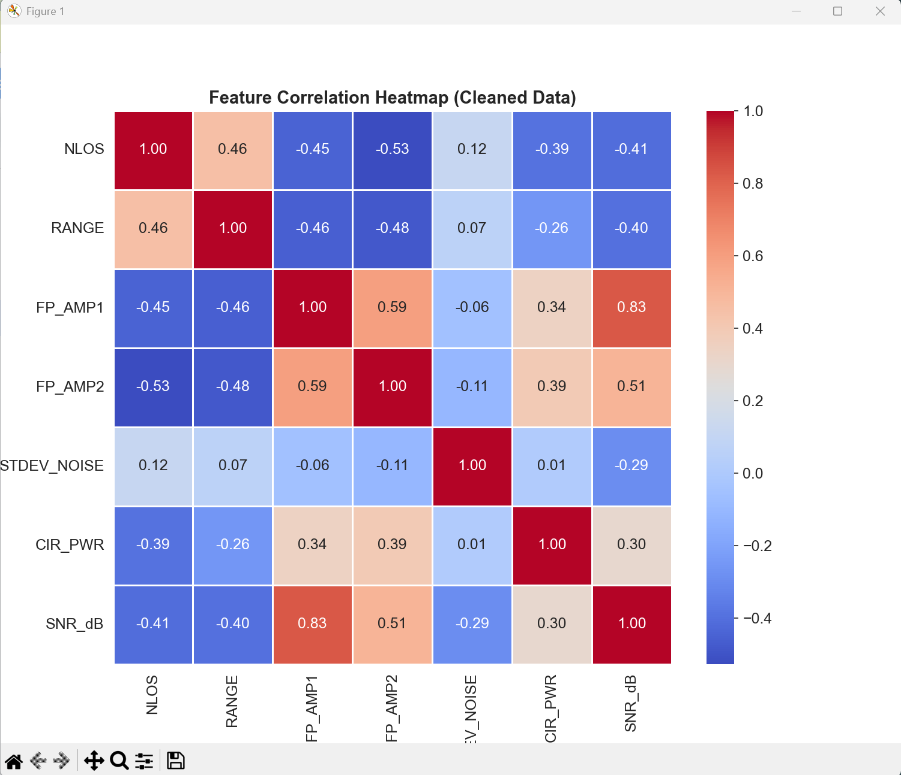
Key insight from heatmap: The dark blue cell between NLOS and FP_AMP1 (value: -0.45) statistically confirms that as first-path amplitude decreases, the likelihood of NLOS increases — a physically intuitive result. The high correlation of FP_AMP2 (0.53) reflects the characteristic NLOS signature where energy shifts from the direct path to secondary reflections. STDEV_NOISE at the bottom (0.116) justifies why SNR_dB was extracted: noise alone is not a class separator, but combining it with amplitude is.

3.5.6 — Synthetic Data for Performance Robustness
Decision: Not required for the current dataset. Optional for Boiler Room generalisation.
With 41,568 total samples evenly split between LOS and NLOS, the dataset is large enough for robust training of all planned classifiers (Random Forest, XGBoost, Logistic Regression, SVM). No synthetic augmentation is needed to address class imbalance.
However, the Boiler Room environment (Part 7) is notably more challenging due to high-density metallic surfaces causing multipath scattering. This significantly elevates STDEV_NOISE and reduces SNR, making NLOS detection harder in that environment specifically. Noise Injection — adding slight random Gaussian perturbations to the 1,016 CIR tap values during training — could be considered as a targeted augmentation strategy to improve model robustness to industrial environments beyond the provided 7 locations.

Before training the XGBoost ensemble, a shallow Decision Tree (max depth 4) was fitted on the core physical and second-path UWB features to understand the decision boundaries and
identify which raw signal measurements are most discriminative. The DT rules and Gini importances (see dt_rules.txt) confirmed that RXPACC and RANGE are the dominant separators between
LOS+NLOS and NLOS+NLOS pairs, motivating the subsequent use of XGBoost to capture the more complex feature interactions that a single tree cannot model.

3.6 Feature Importance Analysis
Feature importance analysis identifies which features the trained models relied upon most heavily during classification. Evaluation was done using model-specific mechanisms: impurity-based importance for Random Forest, gain-based importance for XGBoost, and absolute coefficient magnitude for Logistic Regression and Linear SVM. All values were obtained from the same experiment setting (run name report_fi, seed 42, 70/15/15 split), ensuring that rankings are compared under identical data partitions.

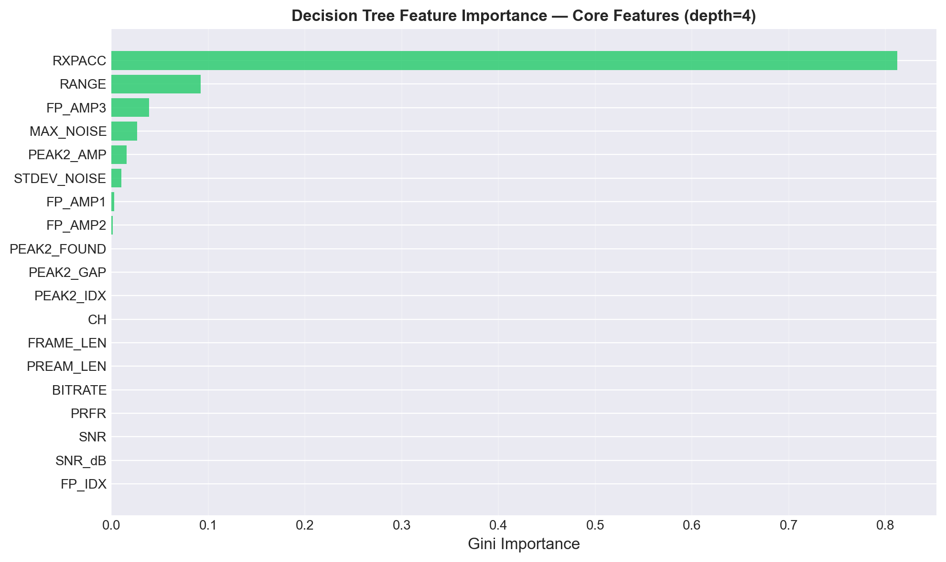
The exploratory decision tree was used as an interpretation-first checkpoint before training higher-capacity ensemble models. Because a shallow tree provides explicit if-then split rules, it helps verify whether the model is relying on physically meaningful UWB variables rather than random artifacts. The observed dominance of RXPACC, together with contributions from RANGE, FP_AMP3, MAX_NOISE, and PEAK2_AMP, is consistent with the signal propagation intuition that LOS/NLOS separation depends on accumulation quality, path energy distribution, and noise behavior.
These findings also support the feature-engineering design used in the main pipeline. The second-path and noise-related variables appeared directly in the tree’s early splits, indicating that they contribute useful discriminative information even in a constrained model. This gave confidence to retain these engineered features for ensemble training, where nonlinear interactions can be captured more effectively.
However, the exploratory tree should be interpreted as a diagnostic model rather than a final predictor. Its moderate accuracy (86.50%) and heavy concentration of importance on one dominant feature indicate limited representational capacity compared with Random Forest and XGBoost. Therefore, the decision tree results are best used to validate feature relevance and rule plausibility, while final performance conclusions are drawn from the ensemble models

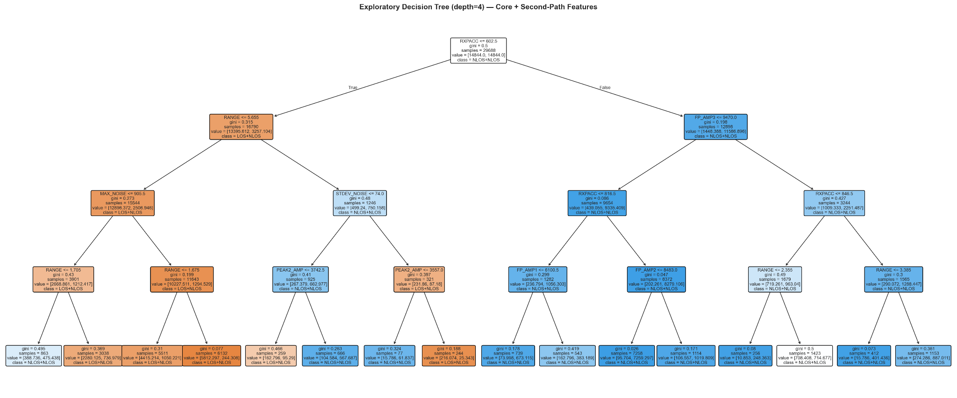
The exploratory decision tree plot provides an interpretable hierarchy of decision rules for pair-level LOS/NLOS classification. The root split occurs on RXPACC, indicating that receiver preamble accumulation is the strongest first-stage discriminator. Subsequent splits primarily involve RANGE, FP_AMP3, MAX_NOISE, STDEV_NOISE, and PEAK2_AMP, showing that the model separates classes by combining signal-strength, noise-structure, and second-path amplitude cues. Branch paths with lower RXPACC values tend to require additional range and noise thresholds, while higher-RXPACC branches are further refined by first-path amplitude variables, reflecting different channel regimes. Overall, the plot confirms that classification decisions are driven by physically meaningful UWB propagation indicators rather than arbitrary feature partitions.

Because the tree is shallow (max depth = 4), the plot emphasizes high-level, explainable rules; this improves interpretability for reporting, but limits predictive capacity compared with ensemble methods.

Random Forest (Gini Based)
Random Forest calculates feature importance as the decrease in impurity (Gini) when a feature is used to split nodes across all trees. This measure captures how well each feature reduces classification error in the tree ensemble. Importance scores are normalized to sum to 1.0, allowing direct comparison across features.
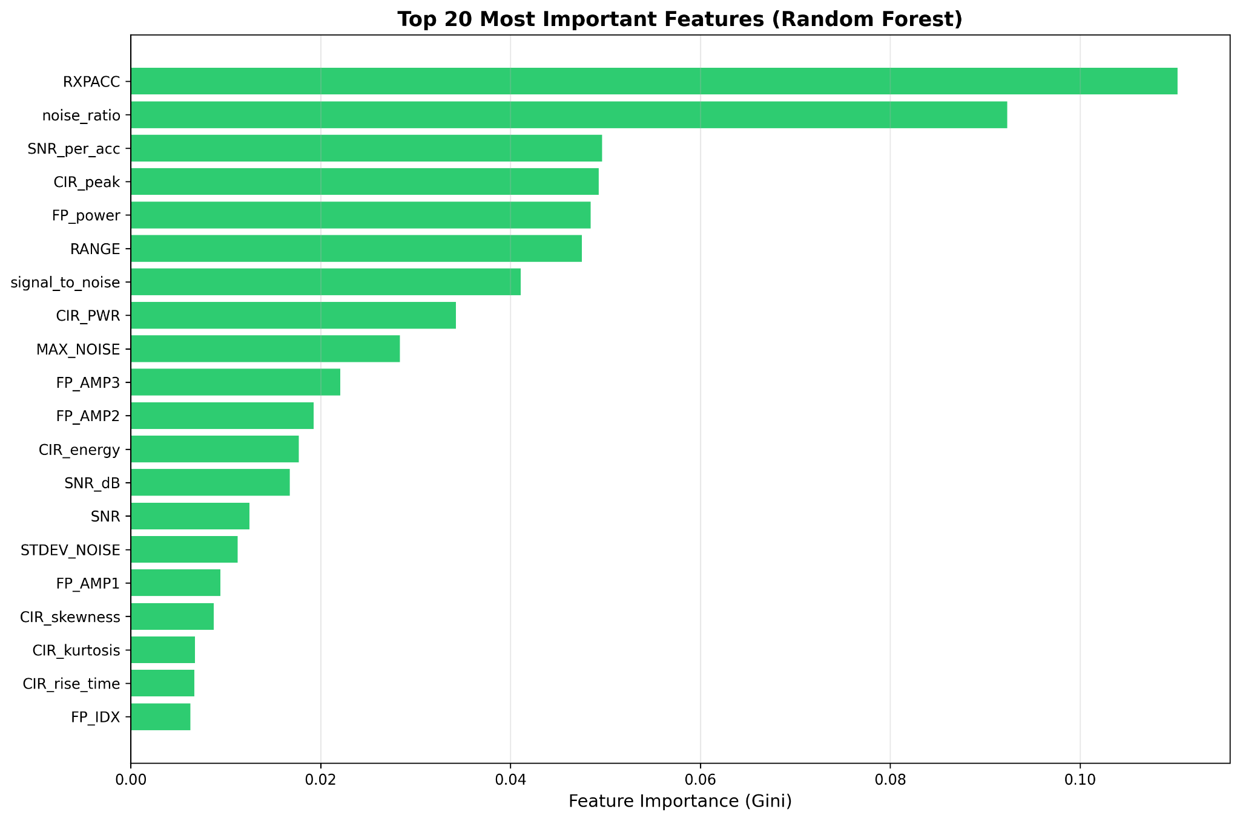

Rankings | Features | Importance
1 | RXPACC | 0.11024533405441762
2 | noise_ratio | 0.09233233103095481
3 | SNR_per_acc | 0.04964352262301982
4 | CIR_peak | 0.04928292712168687
5 | FP_power | 0.04844288710289686
6 | RANGE | 0.047533578269785694
7 | signal_to_noise | 0.04108868565739982
8 | CIR_PWR | 0.03425697288392286
9 | MAX_NOISE | 0.028355026857996016
10 | FP_AMP3 | 0.022046678926818376
Table 5. Random Forest Feature Ranking

XG Boost
XGBoost uses gradient boosting, building trees sequentially to correct previous errors. Feature importance is computed as the average gain (reduction in loss) achieved when each feature was used in splits. This differs from Random Forest by reflecting prediction power in a sequential, boosting context.

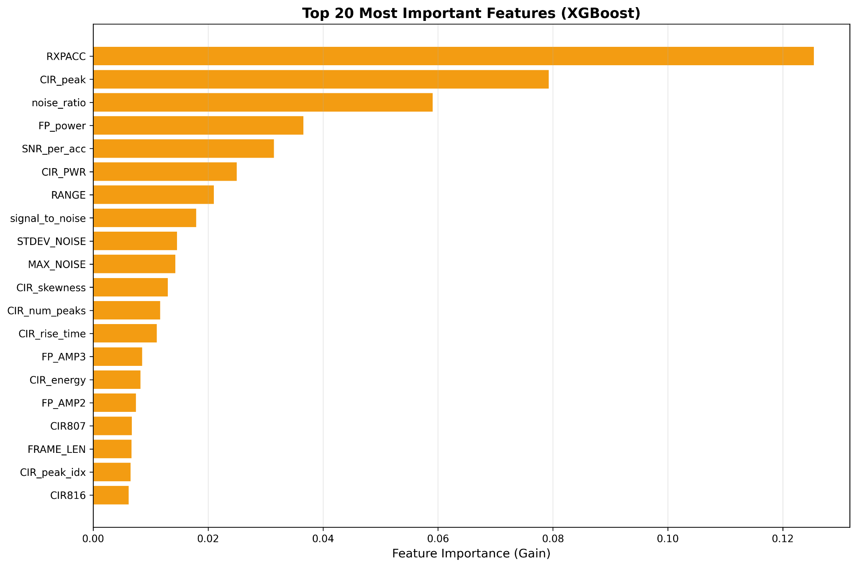

Rankings | Features | Importance
1 | RXPACC, | 0.12539169
2 | CIR_peak | 0.079263195
3 | noise_ratio | 0.05904807
4 | FP_power | 0.036588337
5 | SNR_per_acc | 0.03145862
6 | CIR_PWR | 0.024981793
7 | RANGE | 0.020998053
8 | signal_to_noise | 0.017929016
9 | STDEV_NOISE | 0.01458974
10 | MAX_NOISE | 0.014281901
Table 6. XG Boost Feature Ranking

Logistic Regression
Logistic Regression learns a linear separating hyperplane. Feature importance is expressed as the magnitude of learned weights (coefficients), with sign indicating direction (positive → NLOS, negative → LOS). This approach provides interpretability: larger absolute coefficients represent stronger linear association with the target.
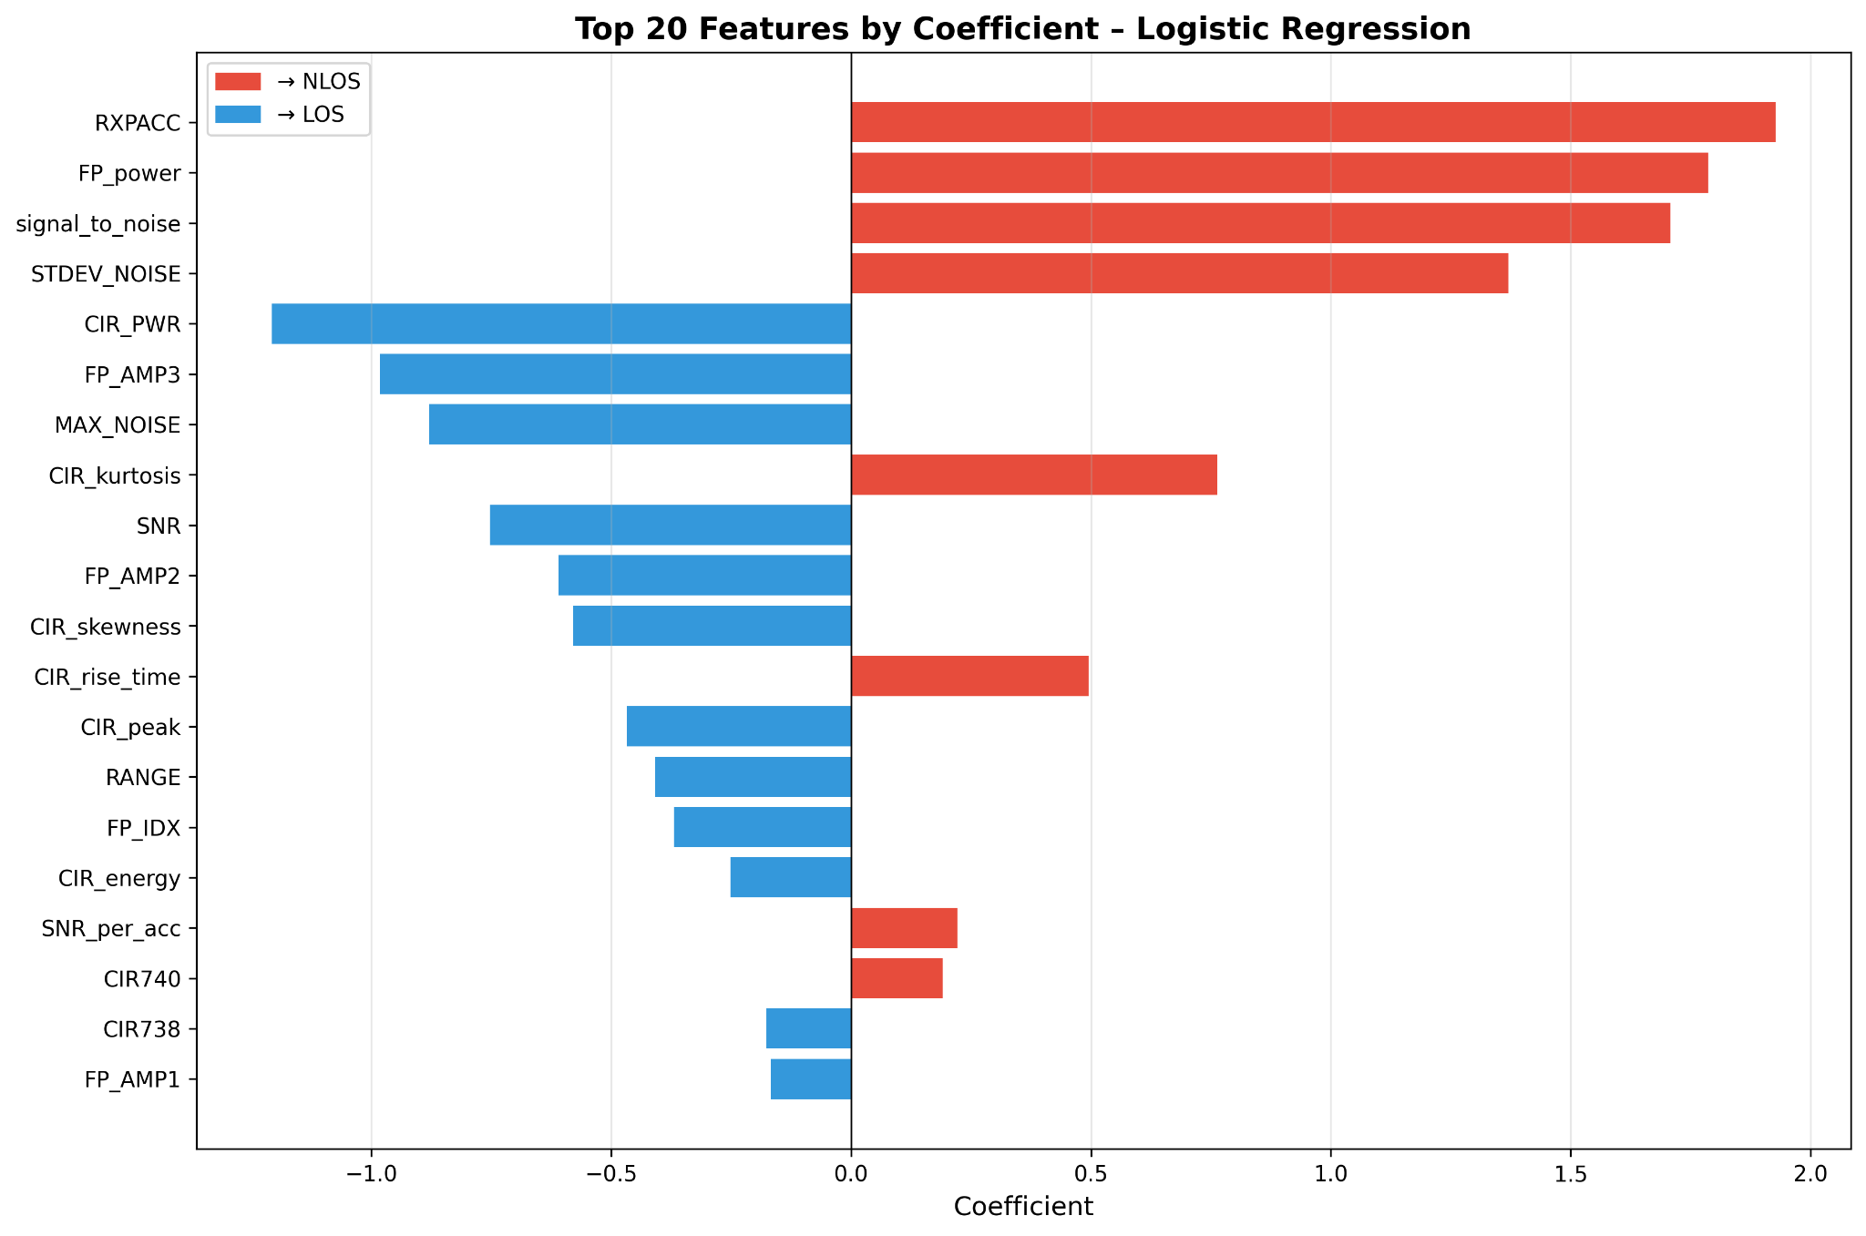

Rankings | Features | Coefficients | Absolute Coefficient
1 | RXPACC | 1.9262979504777646 | 1.9262979504777646
2 | FP_power | 1.785916107830579 | 1.785916107830579
3 | signal_to_noise | 1.707888025434272 | 1.707888025434272
4 | STDEV_NOISE | 1.3695765872493275 | 1.3695765872493275
5 | CIR_PWR | -1.2066576293149356 | 1.2066576293149356
6 | FP_AMP3 | -0.9807636634630565 | 0.9807636634630565
7 | MAX_NOISE | -0.8785445657357517 | 0.8785445657357517
8 | CIR_kurtosis | 0.7632851899667266 | 0.7632851899667266
9 | SNR | -0.7528910127291188 | 0.7528910127291188
10 | FP_AMP2 | -0.6097945865699942 | 0.6097945865699942
Table 7. Logistic Regression Feature Ranking

Linear SVC (SVM)
LinearSVC finds the maximum-margin separating hyperplane. Like Logistic Regression, coefficients specify feature weights, but optimized for margin maximization rather than probabilistic loss. This provides another linear perspective complementary to LR.
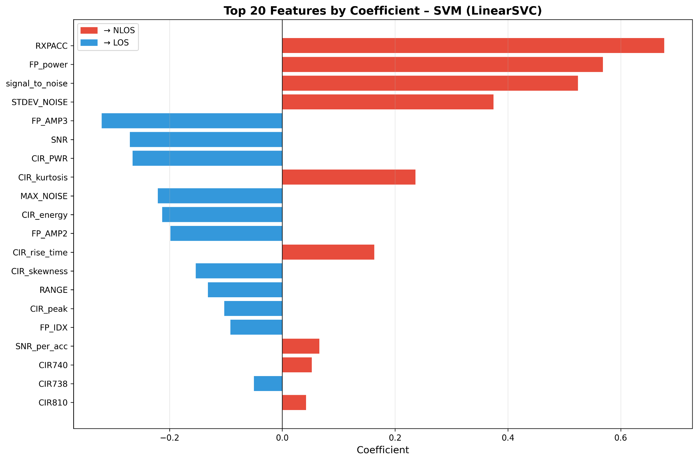

Rankings | Features | Coefficients | Absolute Coefficient
1 | RXPACC | 0.6770019893334261 | 0.6770019893334261
2 | FP_power | 0.5685322301349184 | 0.5685322301349184
3 | signal_to_noise | 0.5240656621063372 | 0.5240656621063372
4 | STDEV_NOISE | 0.374548162747784 | 0.374548162747784
5 | FP_AMP3 | -0.3201652983927314 | 0.3201652983927314
6 | SNR | -0.27034171042536626 | 0.27034171042536626
7 | CIR_PWR | -0.2653064942843435 | 0.2653064942843435
8 | CIR_kurtosis | 0.2359778141543233 | 0.2359778141543233
9 | MAX_NOISE,- | -0.22071178508998457 | 0.22071178508998457
10 | CIR_energy | -0.21289218277103952 | 0.21289218277103952
Table 8. Linear Support Vector Classifier Feature Ranking

Final Rankings
The top-5 consensus ranking indicates strong cross-model stability: RXPACC, FP_power, and signal_to_noise are repeatedly selected as dominant predictors, while noise_ratio and CIR_peak are emphasized by tree-based learners. This pattern suggests that LOS/NLOS discrimination is mainly driven by receiver accumulation quality, first-path energy structure, and noise/peak morphology, confirming that the engineered features capture physically meaningful channel effects.

Rankings | Features | RF | XGB | LR | SVM | Category
1 | RXPACC | 0.1102 | 0.1254 | 1.9263 | 0.6770 | Core
2 | FP_power | 0.0484 | 0.0366 | 1.7859 | 0.5685 | Engineered
3 | signal_to_noise | 0.0411 | 0.0179 | 1.7079 | 0.5241 | Engineered
4 | Noise_ratio | 0.0923 | 0.0590 | - | - | Engineered
5 | CIR_peak | 0.0493 | 0.0793 | - | - | Engineered
Table 8. Overall Model Feature Ranking

4. Data Mining

4.1 Learning Paradigm and Model Selection
This project adopts a supervised learning approach for both project tasks. Task 1, which focuses on LOS/NLOS classification for the two dominant shortest paths, uses labelled LOS/NLOS outcomes. Task 2, which estimates the distances of the two dominant shortest paths, uses known range values as continuous targets. Since both tasks rely on ground-truth labels, supervised learning is more appropriate than unsupervised learning as even though clustering may reveal hidden patterns in the data, they do not guarantee that the resulting groupings correspond meaningfully to LOS and NLOS conditions. Therefore, they are less suitable for use in this project. Table X summarises the models evaluated, their learning approach, and the rationale for their inclusion.
Model | Type | Reason for Inclusion
Logistic Regression | Linear Model | Simple Baseline, easy to interpret
Support Vector Machines | Kernel-Based | Tests how well a clear boundary can separate LOS and NLOS
XGBoost | Boosted Tree Ensemble | Strong performance on tabular data and captures complex patterns
Random Forest | Tree Ensemble | Handles nonlinear relationships and gives feature importance
Convolutional Neural Network (1D) | Deep Learning | Explores whether patterns in the CIR waveform improve classification
K-Nearest Neighbour | Distance-based | Evaluates if LOS and NLOS data points form localized clusters
Table X. Models evaluated and reasoning
For the classification task, several models were evaluated, namely Logistic Regression, Support Vector Machine (SVM), Random Forest, XGBoost, and a 1D Convolutional Neural Network (1D CNN). Logistic Regression and SVM were included as baseline models to assess how well simpler linear or kernel-based decision boundaries could separate LOS and NLOS conditions using the engineered UWB features. Random Forest and XGBoost were evaluated as tree-based ensemble models that are better able to capture nonlinear feature interactions. A CNN-based model was also explored during the experimentation phase to examine whether waveform patterns from the CIR sequence could improve classification performance. Although the CNN was developed and tested, it was not retained in the final comparison. The main reason is that the project uses structured, engineered signal features rather than full raw waveform inputs as the primary modelling representation. CNN models are generally more effective when learning directly from raw spatial or sequential data, whereas the feature engineering process in this project had already extracted the most informative CIR and second-path characteristics. In addition, the CNN did not show a clear performance advantage over XGBoost, while introducing greater model complexity and lower interpretability.
For the regression task, Random Forest, K-Nearest Neighbours (KNN), and XGBoost were tested to estimate the distances of the two dominant paths. Separate regressors were trained for Path 1 and Path 2. These models were selected to represent different regression behaviours, with KNN as a distance-based learner, Random Forest as a bagged ensemble model, and XGBoost as a gradient boosting model.
The model selection process for Task 1 followed a two-stage evaluation. In the first stage, each classifier was evaluated on a per-path basis, where Path 1 and Path 2 were treated as independent classification problems to assess how well each model could distinguish LOS from NLOS conditions on individual signal paths. This provided an initial basis for comparing model suitability before proceeding to the pair classification task. In the second stage, the best-performing model from the per-path evaluation was applied to the pair classification problem, where the goal was to characterise the two dominant shortest paths. Across both stages, XGBoost consistently achieved the highest accuracy, F1-score, and ROC-AUC, and was therefore selected as the final classifier. For Task 2, separate regressors were trained and evaluated for Path 1 and Path 2 independently. XGBoost was selected as the final regression model because it achieved the lowest RMSE and MAE, together with the highest R², across both paths when compared with KNN and Random Forest.
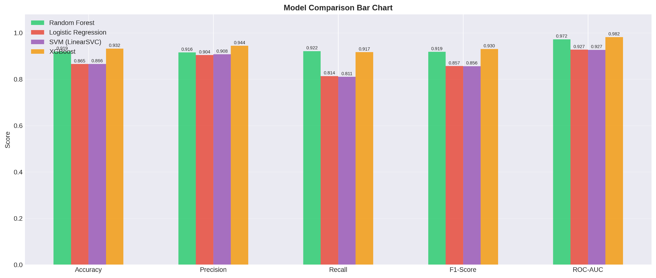
Figure x. Classification Model Comparison
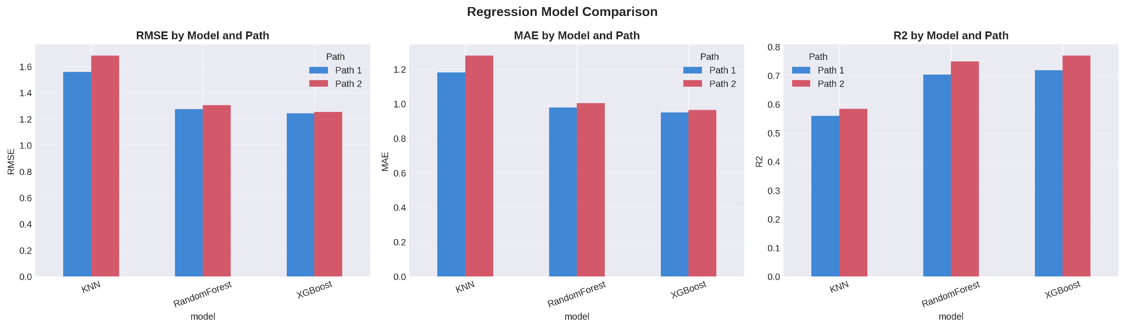
Figure x. Regression Model Comparison
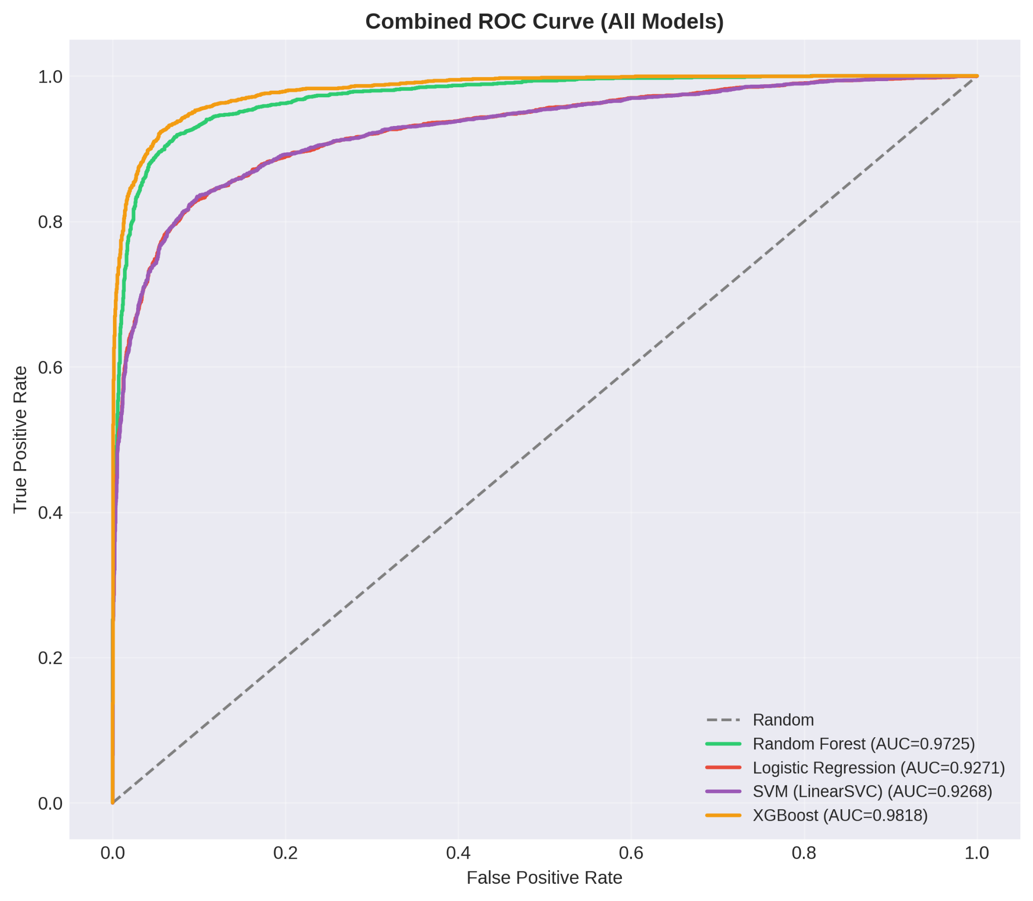
Figure x. ROC curve comparison
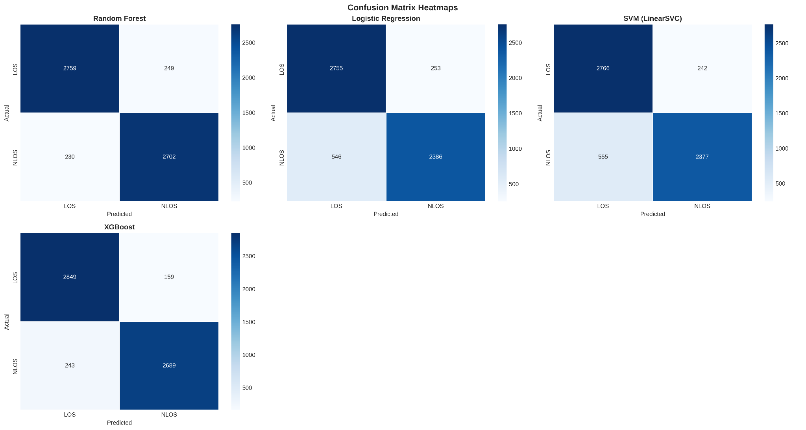
Figure x. Regression Model Heatmaps
Referencing the above figures, XGBoost was ultimately chosen as the preferred model for both classification and regression. For classification, it delivered the strongest overall performance among the tested models, achieving the highest values for accuracy, F1-score, ROC-AUC, and NLOS recall. For regression, it achieved the lowest average RMSE and MAE, together with the highest R² across the two path estimation tasks. Beyond performance, XGBoost is also well suited to this problem because it can capture nonlinear interactions between UWB signal features, handle engineered tabular inputs effectively, and provide interpretable feature importance rankings. These characteristics make it a strong fit for both LOS/NLOS classification and distance estimation in indoor positioning.

4.2 Dataset Split Strategy
The dataset was divided into three subsets using a 70/15/15 split ratio, where 70% of the data was used for training, 15% for validation, and 15% for final testing. This split was selected because it provides a balanced trade-off between model learning, hyperparameter tuning, and unbiased final evaluation. Compared with both 80/20 and 70/30 splits, the 70/15/15 configuration provides a clearer separation between training, validation, and testing. The validation set allows hyperparameter tuning and threshold adjustment to be performed without using the final test data, which helps prevent overly optimistic results caused by indirect leakage of test information into model selection. While an 80/20 split provides slightly more training data, it does not explicitly separate validation from testing unless the hold-out portion is further divided. Similarly, a simple 70/30 split treats the entire 30% as a single hold-out set, which can mix tuning and evaluation unless an additional validation strategy is introduced. By dividing the hold-out data into distinct validation and test subsets, the 70/15/15 approach provides a more rigorous workflow while maintaining the same overall proportion of non-training data. A further methodological decision was to split the data by environment rather than by random row-level sampling. Each source CSV file corresponds to a distinct indoor environment, and entire environments were assigned to either the training, validation, or test partition. This approach reduces leakage of highly similar measurements across subsets and provides a more realistic assessment of how the models would generalize to unseen deployment conditions. If rows from the same environment were randomly split across training and test sets, the reported performance would likely be inflated because correlated signal patterns would appear in both sets.
The final 70/15/15 environment-based split was therefore adopted because it supports proper tuning, preserves an unbiased test set, and provides a more realistic evaluation of generalization than simpler random splitting strategies.

4.3 Evaluation Metrics
For the classification task, the main metrics used were accuracy, precision, recall, F1-score, and ROC-AUC, supported by the confusion matrix. F1-score is especially useful because it balances precision and recall into a single measure.
The main classification metrics are defined as such:
$Accuracy = \frac{TP + TN}{TP + TN + FP + FN}$
where TP, TN, FP, and FN denote the number of true positives, true negatives, false positives, and false negatives respectively. Accuracy is useful as a high-level summary of model performance, since it tells us how often the classifier is right across all test samples. However, in LOS/NLOS detection accuracy alone can be misleading if the classes are imbalanced or if one type of error is much more harmful than the other. For example, misclassifying NLOS as LOS (FN) is more dangerous than misclassifying LOS and NLOS (FP), because it allows biased NLOS ranges to be used in localization.
$Precision = \frac{TP }{TP + FP}$
Precision for the NLOS class measures how many predicted NLOS links are actually NLOS, so high precision means that when the model flags a link NLOS, it is usually correct. In this context, it corresponds to avoiding unnecessary discarding of LOS paths. A low precision model would mark many LOS links as NLOS, throwing away good measurements and potentially reducing the number of available anchors for localization.
$Recall = \frac{TP}{TP + FN}$
Recall (Sensitivity) for NLOS measures how many true NLOS links are correctly detected, this metric is particularly important because NLOS links should be removed before distance estimation. A low recall means many NLOS links are misclassified as LOS (large FN), so their biased ranges would be treated as valid and used in positioning, degrading localization accuracy. As a result, the count of NLOS → LOS errors were treated as “dangerous errors” in addition to reporting NLOS recall.
$F1score = 2 ✕ \frac{Precision ✕ Recall}{Precision + Recall}$
F1-score is especially useful because it balances precision and recall into a single measure; it provides a single-number summary that balances the trade-off between catching NLOS samples (recall) and avoiding false NLOS alarms (precision). In the LOS/NLOS context, a high F1-score indicates that the classifier is both good at identifying NLOS links and not too aggressive in mislabelling LOS links as NLOS.
$TPR = \frac{TP}{TP + FN}$ , $FPR = \frac{FP }{FP + TN}$
The Receiver Operating Characteristic (ROC) curve shows how the classifier performs across different decision thresholds by plotting the true positive rate (TPR) against the false positive rate (FPR). Instead of relying only on the default threshold of 0.5, a threshold sweep was performed on the validation set from 0.1 to 0.9 in steps of 0.01. The threshold that produced the highest validation F1-score was then applied to the test set, so the reported F1 reflects an optimised operating point rather than an arbitrary default. The Area Under the Curve (AUC) provides a threshold-independent summary of ROC performance, where values closer to 1 indicate better separation between LOS and NLOS classes.
These metrics are appropriate because the cost of classification errors is not symmetric in this project. Misclassifying an NLOS case as LOS is more harmful than the reverse, since it allows a biased range measurement to be treated as reliable. For this reason, recall for the NLOS class is particularly important, as it indicates how effectively the model identifies truly problematic NLOS conditions.
The confusion matrix is a 2x2 table containing TP, TN, FP, FN, where it shows the exact pattern of errors and makes it easier to interpret which mistakes are most critical:
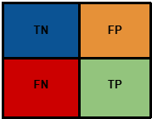
- Top-left (TN): LOS correctly identified as LOS
- Top-right (FP): LOS incorrectly flagged as NLOS
- Bottom-left (FN): NLOS incorrectly treated as LOS (dangerous errors)
- Bottom-right (TP): NLOS correctly identified
For the regression task, the selected metrics were RMSE, MAE, and R², they are defined as follows:
$RMSE = \sqrt{\frac{1}{N} \sum_{i=1}^{N}{} (Yi - \hat{Y}i) {}^{2 }}$
RMSE was used as the main ranking criterion because it penalizes large range prediction errors more strongly, which is important in indoor localization where a few large errors can significantly degrade overall positioning performance. Furthermore, a 2-metre range error contributes four times more to RMSE than a 1-metre error, which shows the disproportionate effect large errors have on accurately pinpointing the device's position.
$MAE = \frac{1}{N} \sum_{i=1}^{N}{} \left|Yi - \hat{Y}i\right|$
MAE measures the average absolute deviation between true and predicted distances. Unlike RMSE it does not square the errors, so it is less sensitive to outliers and gives a more intuitive notion of “typical” error in meters. Reporting both MAE and RMSE provides a fuller picture: MAE summarises average performance, while RMSE highlights whether there are occasional large mistakes.
$R^{2 }= 1 - \frac{\sum_{i=1}^{N}{} (Yi - \hat{Y}i) {}^{2} }{\sum_{i=1}^{N}{}(Yi - \underline{Y}){}^{2}}$
Where $\underline{Y}$ is the mean of the true distances. R² measures how much of the variance in the true distances is explained by the model, compared to a naive baseline that always predicts the mean. An R² close to 1 means the regressor explains most of the variability in the distance measurements; and R² near 0 indicates performance similar to predicting a constant average distance. R² was included as a supplementary metric because it indicates how much of the variance in the target distance values is explained by the model. Together, these metrics provide a complete basis for comparing the tested models in terms of both classification reliability and distance estimation accuracy.

4.4 Final Model Choice
Based on the experimental results, XGBoost was selected as the final model for both major tasks in the project. For the classification task, XGBoost was chosen as the final LOS/NLOS classifier because it achieved the strongest overall performance among all tested models. It provided the highest classification accuracy, F1-score, and ROC-AUC, while also achieving the best recall for the NLOS class. This makes it the most suitable choice for reducing harmful NLOS misclassification errors in the indoor positioning pipeline. For the regression task, XGBoost was also selected as the final distance estimator for both Path 1 and Path 2. Among the tested regressors, it achieved the lowest prediction error and the strongest overall fit to the target ranges. Its predictions were also more consistent with the physical constraints of the problem, particularly the requirement that the second dominant path cannot be shorter than the first.

4.5 Mathematical Formulas for XGBoost classifier
For Task 1, the final classifier is a binary XGBoost model that predicts the pair class of the two dominant shortest paths.
y = 0 represents LOS + NLOS and y = 1 represents NLOS + NLOS
Given an input feature vector ($x$ᵢ), XGBoost does not make its decision using one single rule. Instead, it builds many small decision trees, where each tree looks at the input features and makes a partial contribution to the final prediction. These contributions are then added together to form one overall decision score:
$z_{i}=\sum_{t = 1}^{T}{}f_{t}(x_{i})$
Here, $f$ₜ($x$ᵢ) is the contribution made by the t-th tree, and T is the total number of trees. Each tree gives a small opinion about whether the sample is more likely to belong to class 0 or class 1, and the model combines all of these opinions into one final score.
However, This score (zᵢ) is not yet a probability. It can be any positive or negative value. To make the output easier to interpret, XGBoost converts this score into a probability using the sigmoid function:
$p_{i}=σ(z_{i})=\frac{1}{1+ e^{-z_{i}}}$
The probability (pᵢ) represents the estimated chance that the sample belongs to class 1, which in this case means the pair class NLOS+NLOS:
$p_{i}=P(y_{i}=1|x_{i})$
Once this probability is obtained, the model compares it with a decision threshold (τ) to decide the final class:
$​$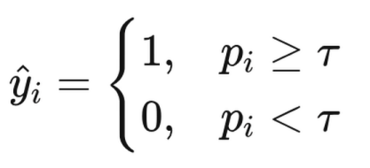
If the probability is greater than or equal to the threshold, the model predicts class 1. Otherwise, it predicts class 0. In this project, the threshold was not fixed automatically at 0.5. Instead, it was selected using validation-set optimisation so that the classifier could achieve a better balance between precision and recall.
The predicted pair class is then mapped back to the path-level interpretation required by the project brief.
If $ŷᵢ$=0, the output is interpreted as:
- Path 1 = LOS
- Path 2 = NLOS
If $ŷᵢ$=1, the output is interpreted as:
- Path 1 = NLOS
- Path 2 = NLOS
This allows the binary XGBoost classifier to solve the pair classification problem while remaining consistent with the physical rules of the two dominant shortest paths.
In summary, the final data mining choices for this project were:
- Learning paradigm: Supervised learning
- Final classification model: XGBoost
- Final regression model: XGBoost
- Final split strategy: 70/15/15 environment-based split

5. Results Analysis

5.1 XGBoost Classification Performance
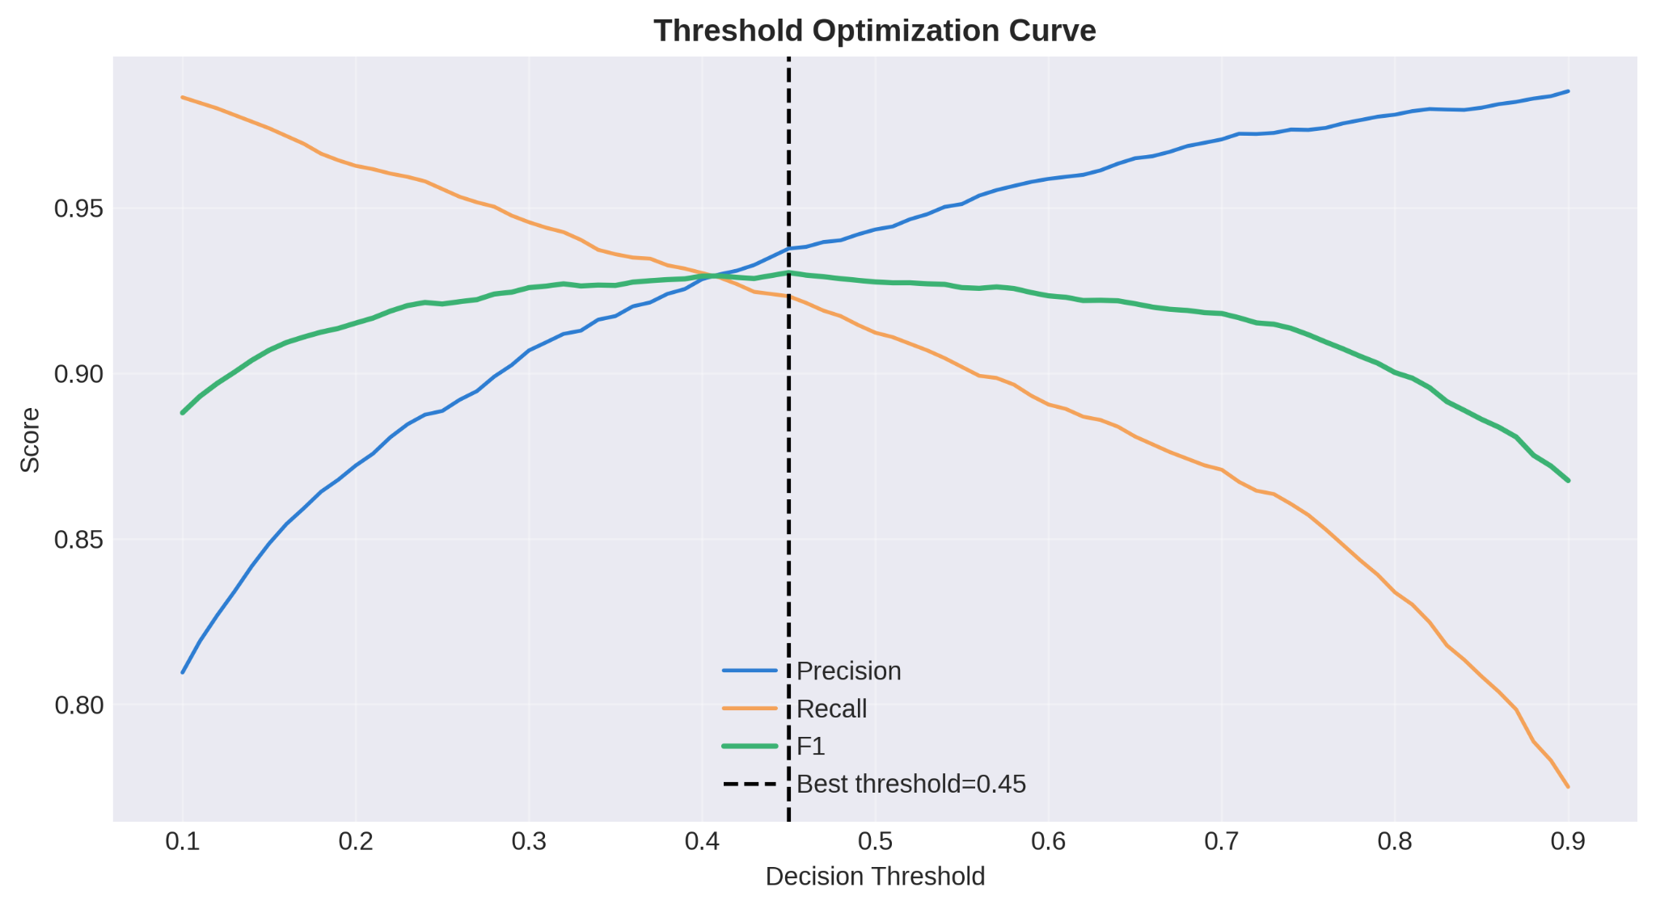
Figure X shows the threshold optimisation behaviour of our XGBoost classifier. As the decision threshold increases, precision improves while recall gradually decreases, reflecting the expected trade-off between stricter and more permissive classification. The F1-score reaches its maximum at approximately 0.45, which indicates that this threshold provides the best balance between detecting NLOS cases and avoiding unnecessary false alarms. This result shows that the default threshold of 0.5 was not the most suitable operating point for this dataset, and that validation-based threshold tuning improved the final classification setup
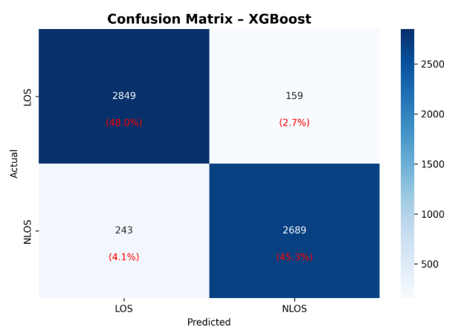
Figure X presents the confusion matrix. The confusion matrix shows that the majority of both LOS and NLOS samples were correctly identified, with relatively few NLOS-as-LOS errors. This is particularly important because misclassifying NLOS as LOS allows biased range estimates to be treated as reliable, which can degrade downstream localization performance.
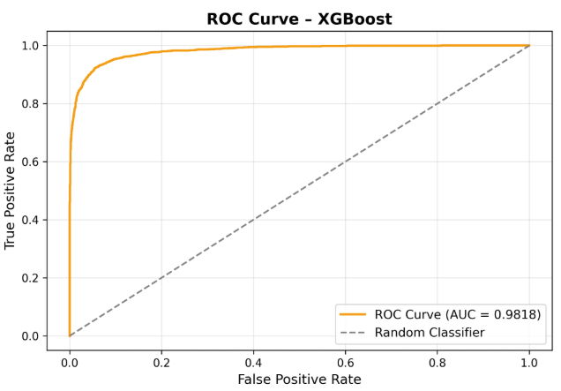
Figure X shows the ROC curve, it remains close to the top-left corner, indicating strong class separability across thresholds. Together with the high ROC-AUC value, this confirms that XGBoost provides robust performance for LOS/NLOS classification in the proposed pipeline.

5.2 XGBoost Regression Performance
Hyperparameters were tuned manually based on established XGBoost tuning principles: increasing n_estimators while proportionally decreasing learning_rate to allow finer convergence, increasing max_depth to capture more complex feature interactions in the 149-dimensional feature space, and adding regularization (reg_lambda, min_child_weight) to prevent overfitting from the deeper trees.

Metric | path 1 default | path1 tuned | improvement | path2 defailt | path2 tuned | improvement
RMSE | 1.243m | 1.174m | -0.969m | 1.253m | 1.188m | -0.065m
MAE | 0.949 | 0.896 | -0.053 | 0.963 | 0.906 | -0.057
R2 | 0.719 | 0.749 | +0.030 | 0.769 | 0.793 | +0.024
Hyperparameter Tuning Strategy
The default XGBoost regressor configuration (300 trees, learning rate 0.05, max depth 6) served as the baseline. Tuning followed established gradient boosting principles, adjusting parameters in three coordinated groups:
1. Learning rate and tree count (convergence precision) The number of estimators was increased from 300 to 1200 while the learning rate was proportionally reduced from 0.05 to 0.015. A lower learning rate means each tree contributes a smaller correction, requiring more trees to converge but producing a more refined final prediction. This is the most reliable way to improve XGBoost performance when computational cost is acceptable.
2. Tree depth (model capacity) Max depth was increased from 6 to 8 to allow the model to capture more complex feature interactions across the 149-dimensional feature space. Deeper trees can model higher-order relationships between features such as the interaction between CIR shape statistics and second-path measurements, which shallow trees would need to approximate across multiple splits.
3. Regularization (overfitting control) To compensate for the increased model complexity from deeper trees, L2 regularization (reg_lambda) was raised from 1.0 to 2.0 and minimum child weight was increased from 1 to 5. Subsample and colsample_bytree were reduced from 0.9 to 0.85, introducing additional randomness per tree. These constraints prevent the model from memorising training noise while preserving its ability to generalise to unseen environments.
The combined effect reduced RMSE by 5.5% for Path 1 (1.243m → 1.174m)
5.2% for Path 2 (1.253m → 1.188m), with R2 improving from 0.719 to 0.749 and 0.769 to 0.793 respectively.
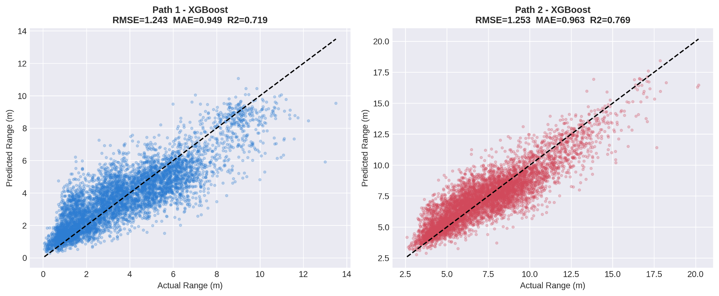
Figure X shows the predicted versus actual range values for Path 1 and Path 2 using the final XGBoost regressor. In both plots, the predictions generally follow the diagonal reference line, indicating that the model captures the overall distance trend well. The spread becomes wider as the actual range increases, suggesting that prediction uncertainty grows at larger distances. This behaviour is expected in indoor UWB ranging, where longer paths are more affected by attenuation, multipath interference, and accumulated timing error. Despite this, the model still maintains a strong overall fit for both paths.

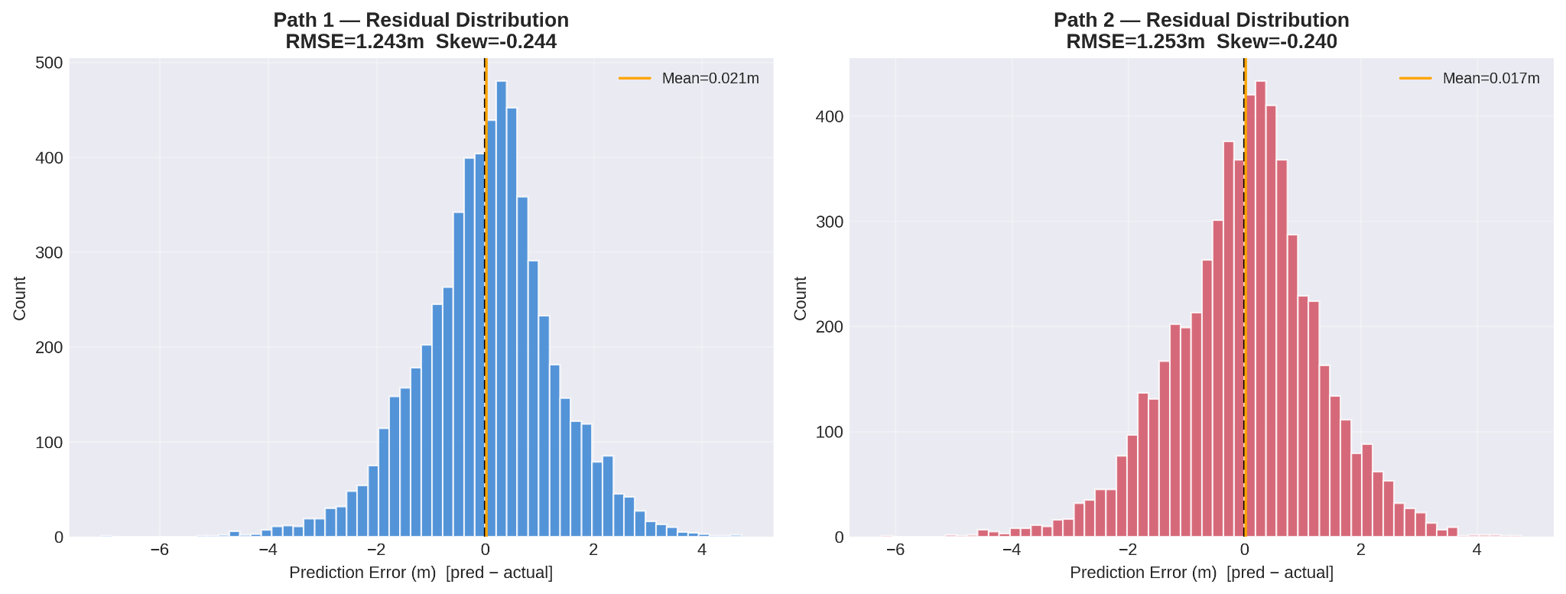
Figure X illustrates the residual distributions for Path 1 and Path 2. In both cases, the residuals are centred close to zero, which indicates that the XGBoost regressor does not exhibit strong systematic overestimation or underestimation. The distributions are broadly similar across the two paths, suggesting stable regression behaviour. However, the presence of tails in both histograms shows that occasional large prediction errors still occur, particularly in more difficult samples. This is consistent with the RMSE values, which are more sensitive to such large errors than MAE.

6. Pseudocode

6.1 XGBoost Pair Classifier
Algorithm: Pair-Level LOS/NLOS Classification Using XGBoost

Input:
X_train = training feature matrix
y_train = training label vector
X_test = test feature matrix
y_test = test label vector

Output:
Predicted pair labels
Predicted class probabilities
Evaluation metrics
Feature importance ranking
Error analysis results

Definitions:
Class 0 = LOS + NLOS
Class 1 = NLOS + NLOS

Procedure:

1. Load pair-level training and test datasets.

2. Load feature names for later interpretation of feature importance.

3. Compute class frequencies in the training set:
n0 = number of class-0 samples
n1 = number of class-1 samples

4. Compute class imbalance weight:
scale_pos_weight = n0 / n1

5. Define the XGBoost hyperparameter search space.

6. Perform hyperparameter optimisation using stratified k-fold cross-validation:
a. For each candidate in hyperparameter set:
i. Train an XGBoost classifier on the training folds of data
ii. Evaluate F1-score on the validation folds of data
b. Compute the mean cross-validated F1-score
c. Select the hyperparameter set with the highest mean F1-score

7. Train the final XGBoost classifier on the full training set
using the selected hyperparameters and scale_pos_weight.

8. Predict the probability of class 1 for each test sample.

9. Convert predicted probabilities into class labels:
If probability ≥ 0.5, predict class 1
Else, predict class 0

10. Evaluate the classifier using:
Accuracy
Precision
Recall
F1-score
ROC-AUC
Confusion matrix

11. Convert each pair-level prediction into path-level output:
If predicted class = 0:
Path 1 = LOS
Path 2 = NLOS
Else:
Path 1 = NLOS
Path 2 = NLOS

12. Compute and rank XGBoost feature importance scores.

13. Perform error analysis:
a. Identify misclassified samples
b. Separate false positives and false negatives
c. Analyse prediction confidence near the decision boundary
d. Compare feature behaviour between correct and incorrect predictions

14. Save the trained model, predictions, metrics, and visual analysis outputs.

End Algorithm

7. Discussion

7.1 Strength of our proposed solution
One key strength of the proposed solution is that it addresses the indoor positioning problem in a practical two-stage manner by combining LOS/NLOS classification with path distance estimation. This makes the pipeline more useful than a classifier alone, because identifying unreliable NLOS measurements is only part of the problem; the system must also estimate meaningful path ranges for localisation. The final XGBoost models showed strong overall performance in both tasks. For classification, the ROC-AUC of approximately 0.9818 and the relatively low number of dangerous NLOS-to-LOS errors indicate that the model separates the two propagation conditions effectively. For regression, both paths achieved RMSE values near 1.25 m and R² values above 0.71, showing that the model captures the overall distance trend reasonably well. Another major strength is the environment-based 70/15/15 split strategy, which provides a more realistic evaluation of generalisation than random row-level splitting, since the test set consists of unseen indoor environments rather than highly correlated samples from the same room. Overall, the proposed solution offers a strong balance of predictive performance, computational efficiency, and practical deployment relevance for indoor UWB positioning.

7.2 Weakness of proposed solution
Despite its strong performance, the proposed solution still has several weaknesses. First, the classification model is not perfect, and the remaining false negatives are the most critical errors because they allow NLOS measurements to be treated as valid LOS ranges. In the confusion matrix, there are still 243 such cases, which means some biased measurements would still pass through the pipeline. Second, although the regression model follows the overall diagonal trend well, the residual plots show noticeable tails, meaning occasional large prediction errors still occur. This suggests that the model is less stable on harder samples, especially at longer ranges where attenuation, multipath, and timing uncertainty become more severe. Third, the solution depends heavily on feature engineering and structured tabular inputs rather than learning directly from the full CIR waveform. While this improves interpretability and efficiency, it may also limit how much hidden signal structure the model can capture compared with more advanced deep learning approaches. Therefore, the proposed solution is strong and practical, but it still does not fully eliminate classification risk or large regression error in difficult indoor conditions.

7.3 Limitations of dataset
Although the UWB dataset is clean, balanced, and suitable for controlled model development, it has several limitations that affect how confidently results can be generalized to real-world deployments. First, the data is collected from a limited number of recording environments (seven parts), so the distribution of propagation conditions may not fully represent diverse indoor spaces such as crowded offices, warehouses, hospitals, or metallic industrial areas. As a result, model performance may degrade when the channel characteristics differ from those observed in the training and test splits. Second, the dataset appears close to class-balanced (LOS vs NLOS), which is useful for algorithm comparison but may not reflect operational conditions where NLOS can dominate or fluctuate over time. This means reported metrics can be optimistic compared to field scenarios with class imbalance, moving obstacles, and changing interference patterns. In addition, some target variables in the second-path workflow are derived or estimated from signal structure rather than directly measured ground truth, which introduces propagation assumptions into the labels and can propagate uncertainty into regression performance.Third, preprocessing and cleaning choices (e.g., outlier removal, denoising, feature-window selection such as CIR730–CIR849) improve stability but may remove rare yet realistic edge cases that matter in safety-critical positioning. The dataset is also device and setup specific, so learned feature importance may partially encode hardware configuration effects instead of purely environment-invariant propagation behavior. Therefore, while the reported results are valid within the current experimental scope, external validation on additional sites, devices, and time periods is necessary before claiming robust deployment readiness.

Since the provided dataset contains only one measured range per sample and no verified secondary-path distance labels, true ground-truth range for Path 2 cannot be obtained directly. Therefore, this project estimates Path 2 range using a physically motivated proxy derived from the second dominant CIR peak. This is suitable for exploratory data analytics and model comparison, but it is a limitation of the dataset rather than a fully validated physical measurement.

7.4 Assumptions made
Several assumptions underpin the proposed pipeline. First, the two-path labelling structure assumes that if the first dominant path is LOS, the second path will be NLOS; and if the first path is NLOS, the second is also NLOS. This constraint is assumed due to the physical extent of the problem but means the model never considered a case where both dominant paths are simultaneously LOS, which may occur in certain open environments. Second, the environment-based data split assumes that the seven environments provided are sufficiently diverse to serve as proxies for unseen deployment locations, which may not hold in environments with substantially different materials or layouts. Thirdly, our CIR feature extraction assumes that the signal-relevant region lies consistently between tap indices 730 and 850 across all seven environments. While this window was identified by inspecting peak locations in the dataset, it is assumed to generalise to unseen environments. In a deployment environment with different hardware timing offsets or significantly different propagation delays, the relevant peak window may shift, requiring re-calibration of the crop range. Finally, the 99th percentile STDEV_NOISE threshold applied per environment assumes that the top 1% of noise values within each environment represent sensor errors rather than genuine extreme propagation events.

8. Conclusion

References
[1] H. Wang et al., "Advancements in Indoor Precision Positioning: A Comprehensive Survey of UWB and Wi-Fi RTT Positioning Technologies," Positioning, vol. 4, no. 4, Nov. 2024. https://doi.org/10.3390/positioning4040027
[2] X. Zhang, Y. Liu, and H. Wang, “Feature-Enhanced LOS/NLOS Identification for UWB Indoor Positioning Using Support Vector Machines,” IEEE Sensors Journal, vol. 25, no. 2, pp. 1453–1464, 2025.
[3] E. Ember et al., "Improving the Correction of NLoS-Induced Ranging," IFIP, 2024. https://www.carloalbertoboano.com/documents/ember24rela.pdf
[4] H. Yang, Y. Wang, S. Xu, J. Bi, H. Jia, and C. K. Seow, "UWB Ranging Error Mitigation with Novel CIR Feature Parameters and Two-Step NLOS Identification," Sensors, vol. 24, no. 5, p. 1703, Mar. 2024. https://doi.org/10.3390/s24051703
[5] V. Barral et al., "Environmental Cross-Validation of NLOS Machine Learning Classification/Mitigation with Low-Cost UWB Positioning Systems," Sensors, 2019. https://doi.org/10.3390/s19245438
[6] R. Nkrow et al., "NLOS Identification and Mitigation for Time-based Indoor Localization Systems: Survey and Future Research Directions," ACM Computing Surveys, 2024. https://doi.org/10.1145/3663473
[7] S. Kim, J. Park, and H. Lee, “Hybrid CNN–LSTM Architecture for LOS/NLOS Detection in UWB Indoor Localization Systems,” IEEE Internet of Things Journal, vol. 11, no. 4, pp. 6231–6243, 2024.
[8] L. Zhao, M. Chen, and Q. Sun, “Improved Neural Network Optimization for LOS/NLOS Identification in UWB Positioning Using Snake Search Algorithm,” IEEE Access, vol. 12, pp. 114233–114245, 2024.
[9] R. Patel and K. Srinivasan, “Gradient Boosting Models for UWB LOS/NLOS Classification Using CIR Signal Features,” IEEE Access, vol. 12, pp. 87011–87023, 2024.
[10] K. Bregar and M. Mohorcic, "NLOS Channel Detection with Multilayer Perceptron in Low-Rate Personal Area Networks," 2016. https://www.researchgate.net/publication/308986067
[11] Decawave, "DW1000 User Manual v2.05." [Online]. Available: http://thetoolchain.com/mirror/dw1000/dw1000_user_manual_v2.05.pdf

Appendix

