|  |
| --- |
|  |
| Solent University |
| Faculty of Business, Law and Digital Technologies |
| BSc Software Engineering  2021 |
| Kieron Gillingham  Q14358891 |
| Dementia Voice Assistant |
| Progress Report  CDA600/COM616 AE1 |
| Tutor: Prins Butt  Date of submission: February 2021 |

Table of Contents

1. Introduction 3

2. Project Evaluation 4

3. Project Progress 6

4. Project Management 8

5. What Next? 10

Reference List 11

Appendix A – Draft Literature Survey 1

1. Method 1

2. Dementia 1

3. Assisted Living 2

4. Digital Divide 5

5. The State of VAs 7

Reference List 8

Appendix B – Evidence 1

1. Search Queries 1

2. Literature Review 2

3. Project Plan 3

4. Burndown Chart 4

5. Keywords 4

6. Concept Map 5

7. Roadmap 6

8. Risk Table 7

9. Prototype 7

10. Kanban Board 8

# 1. Introduction

Dementia is a leading healthcare concern throughout the world, most prevalent among the elderly, which causes the deterioration of cognitive functioning. People living with late-stage dementia require constant support to continue living safely, which burdens informal carers and healthcare services with considerable financial and resource strain. As the average age of the world’s population is rising, the total number of cases is expected to triple to 150 million by 2050 (World Health Organisation 2019). The impact dementia has on healthcare services can be lessened by supporting individuals to maintain their safe independence for longer. This also has the desirable effect of improving the quality-of-life of the individuals through increased self-reliance, social interactions, a sense of control, and general well-being.

Various assistive technologies exist to enable the elderly with mild cognitive impairment to maintain their autonomy and slow the further loss of cognitive functions, such as telecare systems and smart homes (Li, Lu, and McDonald-Maier 2015). This project aims to create the basis of a smart voice assistant (VA) that can reduce the rate of cognitive decline in the elderly. Such a VA could provide support through mental stimulation exercises, environmental monitoring and control, or facilitating communication with carers.

# 2. Project Evaluation

The first step of the project was to conduct a review of existing literature around dementia care and assistive technologies (Appendix A). I initially searched for literature on Google Scholar, however the results were difficult to extract, and many of the papers found were inaccessible. A second literature survey was instead done through multiple search queries on ScienceDirect (Appendix B.1), which ensured a consistent quality and number of sources that were accessible. Although limiting the search to a single database risks introducing bias to the results, it was deemed acceptable as the survey was primarily intended to summarise the state of research in the field, rather than scrutinize particular findings. Of 215 shortlisted results, 51 were selected for the review, with only 21 papers excluded for inaccessibility (Appendix B.2).

Because of the difficulty finding potential users with cognitive decline, obtaining their consent, and current social distancing restrictions, it will not be feasible to test the final product with actual users. Instead, the developed VA will be assessed by the suitability of its design. It is difficult to generally evaluate the effectiveness of a VA because of the range of functions and features and the varying implementations of them between providers (Jiang *et al.* 2015). As such, each of the primary features will be assessed independently. The basic interaction will be measured by the accuracy and response time of its intent analysis component against a library of sample commands.

This project will be managed using Agile practices, modified for a single developer. As the most common factors influencing the evaluation of Agile software projects are velocity and effort (Kupiainen, Mäntylä and Itkonen 2015), these will be the qualities used to gauge how successfully this project is handled. Velocity refers to the speed of deliverable products and effort refers to the amount of work required to complete a task. A record will be kept of hours of work expected and actually required to reach milestones throughout the project, which will be tracked in a table (Appendix B.3) and burndown chart (Appendix B.4). The burndown chart will aid the ongoing assessment of the project by representing the difference between the allocated and actual time required for each stage of the project. As the project is not funded, there are no budgeting goals to consider and financial return cannot be used as an evaluation metric.

# 3. Project Progress

Following early discussions with my supervisor, the idea and topic for the project was decided and the preliminary literature survey (Appendix A) was undertaken. By sorting and analysing common keywords (Appendix B.5) from the surveyed literature a concept map (Appendix B.6) was created to help structure the needs of the project. From this research, I learned about the barriers that limit the success of similar projects including the social stigma of cognitive decline and perceived complexity of technology that dissuade vulnerable persons from seeking help, and the high maintenance and cost of solutions which hinders wide-spread adoption. Although the scope of this project cannot fully address these issues, they were influential in determining the requirements of the VA.

Potential features and were then considered based on the acquired knowledge and the development stages of the project could be planned (Appendix B.7). The risks of the project were also considered during the planning stage (Appendix B.8).

As part of the design stage, an open-source VA – Mycroft (Mycroft AI Inc. n.d.) – was tested as a potential technology to power the proposed VA. A prototype (Appendix B.9) was created using Mycroft as an engine in a Docker container (Docker Inc. n.d.). This was created in an Ubuntu virtual machine I had prepared as a development environment. By creating this prototype and experimenting with Mycroft’s existing skills, I was able to assess the practicality of developing a VA from nothing, which was my original intention. I decided that it would be more productive for the project to expand on an existing third-party VA – such as Mycroft or Jasper (Jasper Project n.d.) – and develop features specific to users living with dementia.

As this project will not be evaluated with actual users there are no ethical obligations to consider regarding the testing stage. The developed software will however take into consideration the ethical responsibility of safeguarding user data. As privacy concerns were found among all users of VAs, it is imperative that the VA is designed with complete data transparency, and in-line with data protection regulations such as GDPR.

# 4. Project Management

A general roadmap (Appendix B.7) of the project was created early on which divided the development into stages. This roadmap was later populated with more detail following preliminary research. The first stage includes the planning and general research that has been completed thus far and the following stages cover the development of the basic interaction functionality, a brain-training feature, design considerations for elderly users, and a companionship/comfort feature. Each of these stages includes its own research, implementation, and evaluation sub-stages.

The project will utilise elements of agile workflows adapted for an individual to manage development. The stages of the roadmap are loosely planned across development sprints, with one stage per sprint, and a closing sprint for any overflow work and the final evaluation and write-up.

All project resources are tracked using Git for version control and the repository hosted on GitHub. GitHub built-in tools have also been used for managing the tasks and timeline of the project including an automated Kanban board (Appendix B.10) that updates when GitHub issues – representing tasks to complete – are created, updated, and closed. Each stage of the project has a corresponding milestone on the GitHub repository to track the progress of that stage proportional to the tasks within it, which will be used for the final project evaluation.

A risk assessment document (Appendix B.8) was created which analysed potential issues that could impact the completion of the project and their consequences. Each risk was assigned values representing the severity of its effect and likelihood of it occurring. Taken together, these values were used to determine that the most significant risks were poor planning, loss of work, and technology integration difficulties. With the risks organised, mitigation strategies were considered and prioritised. Data loss was mitigated through the use of version control and repository hosting, and the integration difficulties were addressed through the prototype investigation.

# 5. What Next?

With the research and planning completed for the project, the next step will be beginning the first sprint as outlined in the roadmap (Appendix B.7). This will involve implementing the basic speech-to-text, natural language processing, and text-to-speech architecture on which the remaining features can later be developed. Each of these three components will be based on open-source technologies.

Although one of the desired functions of the VA is the ability to maintain functionality while not connected to the internet, in the event that this is found to be impractical within the allocated timeframe an online only version based on the working prototype will instead be created as a contingency plan. This will minimise disruption to the remaining development sprints, and the offline functionality may be completed at a later date.

The upcoming sprints will continue to make use of the project management tools in place, in particular the Kanban board which will be updated with new tasks within each sprint. Additionally, at each of the discussed stages, sections the final report will be written covering the research for that feature, and details and evaluation of the work completed.

# Reference List

DOCKER INC., n.d. *Docker*Available from: [https://docker.com](https://docker.com/)

JASPER PROJECT, n.d. *Jasper*Available from: <https://jasperproject.github.io/>

JIANG, J.*et al.,* May 18, 2015. Automatic Online Evaluation of Intelligent Assistants. ACM, pp.506-516, <https://doi.org/10.1145/2736277.2741669>

KUPIAINEN, E., M.V. MÄNTYLÄ and J. ITKONEN, 2015. Using metrics in Agile and Lean Software Development – A systematic literature review of industrial studies. *Information and Software Technology,*62, 143-163, <https://doi.org/10.1016/j.infsof.2015.02.005>

LI, R., B. LU and K.D. MCDONALD-MAIER, 2015. Cognitive assisted living ambient system: a survey. *Digital Communications and Networks,*1(4), 229-252, <https://doi.org/10.1016/j.dcan.2015.10.003>

MYCROFT AI INC., n.d. *Mycroft AI*Available from: [https://mycroft.ai](https://mycroft.ai/)

WORLD HEALTH ORGANIZATION, 2019. Risk reduction of cognitive decline and dementia: WHO guidelines.

# Appendix A – Draft Literature Survey

## 1. Method

To assess the difficulties caused by cognitive decline and potential technologies that could mitigate them, a review of existing literature was conducted. The literature was gathered through multiple search queries on ScienceDirect using combinations of the following keywords: dementia, “caring for”, “home care”, palliative, helping, challenges, difficulties, needs, prevention, independence, enabling, preferences, “assistive technology”, “smart home”, capability, voice, assistant, “consumer product”, adoption, elderly, “digital immigrants”, design, “early onset”. Studies mentioning “social media”, student, or diagnosis were excluded. Each search query was refined until it produced 30 or fewer results and exclusion criteria were applied.

## 2. Dementia

Dementia is the impairment of higher brain functions such as memory and cognitive processing and is commonly caused by Alzheimer’s disease (AD). The World Health Organization (2019) estimated 50 million people worldwide living with dementia burdening individuals, caregivers, and healthcare services with an approximate global cost of US$ 818 billion in 2015. Dementia cases are expected to reach 82 million by 2030 and 152 million by 2050. This inflation is the result of a global aging population caused by increased life expectancy worldwide. Galende et al. (2021) assessed the social impact of dementia to advise healthcare policies in Spain, concluding that robust healthcare programs were essential. Their review found between 4% and 9% of people in Spain over 65 affected by dementia with rates increasing proportional to age. These proportions are typical of other countries.

The decline of cognitive functioning causes difficulties in safety, autonomy, and quality-of-life (QoL) affecting both patients and carers; and various focus groups, interviews, and workshops have attempted to formalise the design requirements of care services based on these concerns (Morgan et al. 2002; Thoma-Lürken et al. 2018; Lockerbie and Maiden 2020). Focus groups with formal and informal caregivers conducted by Thoma-Lürken et al. (2018) revealed 6 recurring domains of problems preventing aging-in-place for people living with dementia: Self-reliance, safety, social, behavioural, formal Services, and cognition; however they did not address the causal relationships between these domains. The most common issues raised were patients suffering a loss of independence and inability to perform activities of daily living (ADL). In a review by Alexopoulos et al. (2002), mid- and late-life depressions were found to exacerbate cognitive decline, and the increased loss of independence produced further depression. One study that focused on support for informal caregivers found that many felt they could continue to provide sufficient care for their dependant for longer if they were given better education and relief as they lacked appropriate training and were hindered by time constraints (Chi et al. 2020).

## 3. Assisted Living

As technologies such as robotics, the internet-of-things (IoT), and machine learning are developed worldwide, these innovations have been applied to improve the quality-of-life (QoL) for both the fully cognitive elderly and those suffering from cognitive decline (Li, Lu, and McDonald-Maier 2015). Traditionally, caring for people living with dementia would be performed at home by family members until they were unable and the dependent was moved into formal care (Kemp, Ball, and Perkins 2013); however financial pressure placed on both individuals and healthcare services has motivated research into assisted living (AL) technologies to promote “aging-in-place” and allowing dependents to maintain their autonomy. These advances aim to relieve pressure on healthcare services and informal carers.

Telecare refers to technologies that provide remote healthcare directly to patients in their own homes such as monitoring sensors (Barlow, Bayer, and Curry 2006; Roberts and Mort 2009). These approaches are also referred to as telemedicine and telehealth inconsistently across different authors. Some of the earliest telecare solutions include the EU-ACTION project that began in 1997 – a system intended to introduce ICT into home environments to educate home carers and dependants in correct care techniques (Magnusson et al. 2002).

The ubiquity of IoT devices has led to the notion of intra-connected smart homes in which multiple sensors and devices can communicate and be controlled through a unified interface such as a voice assistant. Cooper et al. (2008) describe “intelligent environments” similar to the newer idea of smart homes, noting how they could assist individuals with cognitive impairments using reminders, directional guidance, or monitoring. They recognise the importance of technology understanding the context of a situation (such as a user’s location or task), an issue that has been addressed more recently with machine learning. Other early work on smart homes also foresaw their use in telecare for elderly and disabled people including those with cognitive impairment (Chan et al. 2008; Chan et al. 2009). Belley et al. (2015) present a practical algorithm for detecting erratic behaviour in people with cognitive decline by analysing power usage of smart devices. Liu et al. (2016) also focused on the benefits of health monitoring of elderly in smart homes, however they conclude that smart homes were not capable of completely supporting the elderly. Rumeau et al. (2020) investigated co-living spaces for elders to reduce isolation with a tangential experiment related to smart home technology.

Shishehgar, Kerr, and Blake (2018) outline a variety of robotics projects for supporting elders including companion robots, mounted mechanical arms, electronic wheelchairs and walking assistants, domestic cleaning robots, and health and time management robots. Wilson et al. (2019) discuss how these robotics projects can be integrated with smart homes.

Despite the number of care projects that have been created, few have seen widespread adoption or made it past early pilot stages due to poor evidence of cost-effectiveness (Obi, Ishmatova, and Iwasaki 2013; Clarkson et al. 2017). The effectiveness of these solutions is difficult to measure because the majority of studies use qualitative means of assessment or failed to apply their findings to a formal framework (Siegel and Dorner 2017). Dodd et al. (2020) were also unable to find an existing measure for assessing the effectiveness of care solutions with respect to the key desired outcomes of stakeholders. Limited study sizes also question the validity of any positive findings in these studies. Among those projects that were deployed, adoption is likely hindered by the deep-rooted social stigma related to dementia and AL technologies; particularly in rural areas (Morgan et al. 2002).

End-of-life care should preserve an individual’s dignity and QoL. Östlund, Brown, and Johnston (2012) reviewed palliative care studies to assess how well recipient’s dignity was addressed. Palliative care includes solutions to ease the pain of conditions without addressing the cause of the problem. Dementia care is considered palliative as it improves the comfort of the patient and may reduce deterioration, but cannot reverse any existing damage. None of their reviewed studies addressed patients concerns regarding the impact of their own death on their surviving friends and family. Rich relationships, autonomy and control, knowledge, and improved mental health were identified as the desired outcomes of care solutions (Dodd et al. 2020). Lockerbie and Maiden (2020) created a model for defining the QoL goals for people with dementia through workshops with four experienced UK care workers, also concluding that improving independence and social connectivity were desirable outcomes of support. Gómez (2015) discusses the nature of autonomy for elders and the sustainability of solutions that support their independence, arguing that autonomy should not be accepted as a guaranteed improvement to QoL. Hersh (2014) developed a framework for assessing the outcomes of ICT support.

## 4. Digital Divide

The concept of a digital divide between elderly (digital immigrants) and younger (digital natives) users of technology is well documented. Digital immigrants are characterised by their struggle or resistance to adopt technology because of decreased learning capabilities, a rapidly changing industry, limited or poor experiences, or lack of confidence; instead using technology only when necessary.

Mobile phones have the capability of improving QoL for elders (Plaza et al. 2011). Many applications are available for encouraging personal health and wellbeing.

Despite the existence of tech-savvy elders and the inevitable generational shift as digital natives continue to age with technology, it is crucial to consider the difficulties caused by natural aging and late-life disabilities that are barriers to assistive technologies (Fischer et al. 2014). The results of a survey into motivations behind elder’s technology adoption by Sintonen and Immonen (2013) found that prior experience with technology their own physical limitations are key deciding factors for frail elderly. Their population had an approximately 1:2 split of frail and well-coping elderly. Hawley-Hague et al. (2014) found that concern for their own safety was a another crucial factor in elders adoption of AL technology. A review by Song and van der Cammen (2019) was concerned with how AL technology affects elders living alone.

The needs and preferences of elderly users should be considered before designing any AL technology. Jacelon and Hanson (2013) discuss the benefits of involving elders in the design process for smart homes to ensure they meet the practical needs of this specialist group. Gkouskos and Burgos (2017) also highlight the importance of involving elders in the design process of any AL technology.

Detweiler and Hindriks (2016) formalised a taxonomy for value sensitive design of AL technology and raise the issue of limited coverage of research into all permutations of their identified values, technologies, and contexts.

After interviewing elders who consider themselves technologically savvy, Kania-Lundholm and Torres (2015) question the importance of age as a factor in the Digital Divide; instead finding socio-economic explanations. The elders interviewed were generally highly educated and had used computers as early as the 1970s.

Castilla et al. (2013) created a software tool for the elderly that streamlines common computing features such as email and telecommunication. They realised that simply enlarging icons and text was insufficient for making software accessible. To better aid user’s synchronous learning of what capabilities were offered and how to perform them, they concluded that no more than three options should be available at any time. Similarly, Iancu and Iancu (2020) suggest principals to be considered when designing mobile phones for Elders and found that multiple paths of completing the same action were confusing to users. They recommend familiarity and consistency in the design of tasks. Alternative human computer interaction (HCI) technologies have been considered to facilitate digital immigrant’s engagement with modern devices.

Hsiao et al. (2017) present natural hand motion controls for desktop applications with limited success. Other means of natural HCI that have been used include voice control and eye tracking (Li, Lu, McDonald-Maier 2015).

## 5. The State of VAs

Recently, consumer VAs such as Google Assistant and Amazon’s Alexa have become familiar presences in households and on mobile devices (McLean and Osei-Frimpong 2019). These consumer VAs are frequently tasked with performing web queries and making online purchases. Current VAs are still somewhat limited, despite considerable advances in natural language processing, however, privacy concerns are a common factor restricting their usage (Ho-Sam-Sooi, Pieters, and Kroesen 2021).

VAs are able to integrate with Smart Home technology and provide a conversational means of controlling the devices within. Conversational controls are accessible even for elders with cognitive decline. Chatbots and natural language interaction computers have been used for various healthcare services (Adamopoulou and Moussiades 2020).

Trust in the VA is an essential requirement as carers and family members will be unwilling to place their dependent’s well-being in jeopardy. Poushneh (2021) explored the perception factors of artificial personalities in mobile voice assistants. Hu, Lu, and Gong (2021) investigate how user interactions with and trust of AI are affected by human-like qualities, determining that the humanness of voice output does not impact competence-related trust. However, Hu et al. (2021) found evidence that improving the perceived intelligence of VAs results in more frequent use. Chattaraman et al. (2019) conducted a usability experiment with elders and found that for users with cognitive impairment, an informal personality in a VA was less effective and caused difficulty.

Intent detection involves translating a natural language command into a digital instruction and is a crucial component of a VA. The varying nature of natural language in its terminology, intonation, speed, and context makes this a difficult task that is accomplished only through machine learning such as the multi-layered neural network used by Firdaus et al. (2019) or the deep neural network used by Lin and Xu (2019) to learn new intents.

Mulfari et al. (2021) approached the task of designing VA system for users with speech disorders by using keyword spotting algorithms for intent detection. Kumar, Deepak, and Santhanavijayan (2020) propose an efficient emotion detection algorithm, although limited. As dementia significantly impacts speech, an appropriate method of understanding a user’s request or inferring their need is crucial.

## Reference List

ADAMOPOULOU, E. and L. MOUSSIADES, 2020. Chatbots: History, technology, and applications. Machine Learning with Applications, 2, 100006

ALEXOPOULOS, G.S. et al., 2002. Comorbidity of late life depression: an opportunity for research on mechanisms and treatment. Biological psychiatry, 52(6), 543-558

BARLOW, J., S. BAYER and R. CURRY, 2006. Implementing complex innovations in fluid multi-stakeholder environments: Experiences of ‘telecare’. Technovation, 26(3), 396-406

BELLEY, C. et al., 2015. Nonintrusive system for assistance and guidance in smart homes based on electrical devices identification. Expert Systems with Applications, 42(19), 6552-6577

CASTILLA, D. et al., 2013. Process of design and usability evaluation of a telepsychology web and virtual reality system for the elderly: Butler. International Journal of Human-Computer Studies, 71(3), 350-362

CHAN, M. et al., 2009. Smart homes — Current features and future perspectives. Maturitas, 64(2), 90-97

CHAN, M. et al., 2008. A review of smart homes—Present state and future challenges. Computer methods and programs in biomedicine, 91(1), 55-81

CHATTARAMAN, V. et al., 2019. Should AI-Based, conversational digital assistants employ social- or task-oriented interaction style? A task-competency and reciprocity perspective for older adults. Computers in Human Behavior, 90, 315-330

CHI, N. et al., 2020. Interventions to Support Family Caregivers in Pain Management: A Systematic Review. Journal of pain and symptom management, 60(3), 630-656.e31

CLARKSON, P. et al., 2017. A Systematic Review of the Economic Evidence for Home Support Interventions in Dementia. Value in Health, 20(8), 1198-1209

COOPER, R.A. et al., 2008. A perspective on intelligent devices and environments in medical rehabilitation. Medical engineering & physics, 30(10), 1387-1398

D, N.K., G. DEEPAK and A. SANTHANAVIJAYAN, 2020. A Novel Semantic Approach for Intelligent Response Generation using Emotion Detection Incorporating NPMI Measure. Procedia Computer Science, 167, 571-579

DETWEILER, C.A. and K.V. HINDRIKS, 2016. A survey of values, technologies and contexts in pervasive healthcare. Pervasive and Mobile Computing, 27, 1-13

DODD, S.R. et al., 2020. Understanding the Outcomes of Supplementary Support Services in Palliative Care for Older People. A Scoping Review and Mapping Exercise. Journal of pain and symptom management, 60(2), 449-459.e21

FIRDAUS, M. et al., 2019. A Multi-Task Hierarchical Approach for Intent Detection and Slot Filling. Knowledge-Based Systems, 183, 104846

FISCHER, S.H. et al., 2014. Acceptance and use of health information technology by community-dwelling elders. International journal of medical informatics, 83(9), 624-635

GKOUSKOS, D. and J. BURGOS, 2017. I’m in! Towards participatory healthcare of elderly through IOT. Procedia Computer Science, 113, 647-652

HAWLEY-HAGUE, H. et al., 2014. Older adults’ perceptions of technologies aimed at falls prevention, detection or monitoring: A systematic review. International journal of medical informatics, 83(6), 416-426

HERSH, M., 2014. Evaluation framework for ICT-based learning technologies for disabled people. Computers & Education, 78, 30-47

HO-SAM-SOOI, N., W. PIETERS and M. KROESEN, 2021. Investigating the effect of security and privacy on IoT device purchase behaviour. Computers & Security, 102, 102132

HSIAO, S. et al., 2017. User interface based on natural interaction design for seniors. Computers in Human Behavior, 75, 147-159

HU, P., Y. LU and Y.(. GONG, 2021. Trust in Conversational AI: A Person-centered Approach. Computers in Human Behavior, , 106727

HU, Q. et al., 2021. Can AI artifacts influence human cognition? The effects of artificial autonomy in intelligent personal assistants. International Journal of Information Management, 56, 102250

IANCU, I. and B. IANCU, 2020. Designing mobile technology for elderly. A theoretical overview. Technological Forecasting and Social Change, 155, 119977

JACELON, C.S. and A. HANSON, 2013. Older adults' participation in the development of smart environments: An integrated review of the literature. Geriatric nursing, 34(2), 116-121

KANIA-LUNDHOLM, M. and S. TORRES, 2015. The divide within: Older active ICT users position themselves against different ‘Others’. Journal of Aging Studies, 35, 26-36

KEMP, C.L., M.M. BALL and M.M. PERKINS, 2013. Convoys of care: Theorizing intersections of formal and informal care. Journal of Aging Studies, 27(1), 15-29

LI, R., B. LU and K.D. MCDONALD-MAIER, 2015. Cognitive assisted living ambient system: a survey. Digital Communications and Networks, 1(4), 229-252

LIN, T. and H. XU, 2019. A post-processing method for detecting unknown intent of dialogue system via pre-trained deep neural network classifier. Knowledge-Based Systems, 186, 104979

LIU, L. et al., 2016. Smart homes and home health monitoring technologies for older adults: A systematic review. International journal of medical informatics, 91, 44-59

LOCKERBIE, J. and N. MAIDEN, 2020. Modelling the quality of life goals of people living with dementia. Information Systems, , 101578

LÓPEZ GÓMEZ, D., 2015. Little arrangements that matter. Rethinking autonomy-enabling innovations for later life. Technological Forecasting and Social Change, 93, 91-101

MAGNUSSON, L. et al., 2002. Supporting family carers through the use of information and communication technology—the EU project ACTION. International journal of nursing studies, 39(4), 369-381

MCLEAN, G. and K. OSEI-FRIMPONG, 2019. Hey Alexa … examine the variables influencing the use of artificial intelligent in-home voice assistants. Computers in Human Behavior, 99, 28-37

MORGAN, D.G. et al., 2002. Rural families caring for a relative with dementia: barriers to use of formal services. Social science & medicine, 55(7), 1129-1142

MULFARI, D. et al., 2021. Machine learning assistive application for users with speech disorders. Applied Soft Computing, 103, 107147

OBI, T., D. ISHMATOVA and N. IWASAKI, 2013. Promoting ICT innovations for the ageing population in Japan. International journal of medical informatics, 82(4), e47-e62

ÖSTLUND, U., H. BROWN and B. JOHNSTON, 2012. Dignity conserving care at end-of-life: A narrative review. European Journal of Oncology Nursing, 16(4), 353-367

PLAZA, I. et al., 2011. Mobile applications in an aging society: Status and trends. Journal of Systems and Software, 84(11), 1977-1988

POUSHNEH, A., 2021. Humanizing voice assistant: The impact of voice assistant personality on consumers’ attitudes and behaviors. Journal of Retailing and Consumer Services, 58, 102283

ROBERTS, C. and M. MORT, 2009. Reshaping what counts as care: Older people, work and new technologies. Alter, 3(2), 138-158

RUMEAU, P. et al., 2020. Technological Services in Shared Housing: Needs Elicitation Method from Home to Living Lab. IRBM,

SHISHEHGAR, M., D. KERR and J. BLAKE, 2018. A systematic review of research into how robotic technology can help older people. Smart Health, 7-8, 1-18

SIEGEL, C. and T.E. DORNER, 2017. Information technologies for active and assisted living—Influences to the quality of life of an ageing society. International journal of medical informatics, 100, 32-45

SINTONEN, S. and M. IMMONEN, 2013. Telecare services for aging people: Assessment of critical factors influencing the adoption intention. Computers in Human Behavior, 29(4), 1307-1317

SONG, Y. and VAN DER CAMMEN, TISCHA J. M., 2019. Electronic assistive technology for community-dwelling solo-living older adults: A systematic review. Maturitas, 125, 50-56

THOMA-LÜRKEN, T. et al., 2018. Facilitating aging in place: A qualitative study of practical problems preventing people with dementia from living at home. Geriatric nursing, 39(1), 29-38

VILLAREJO GALENDE, A. et al., 2021. Report by the Spanish Foundation of the Brain on the social impact of Alzheimer disease and other types of dementia. Neurología (English Edition), 36(1), 39-49

WILSON, G. et al., 2019. Robot-enabled support of daily activities in smart home environments. Cognitive Systems Research, 54, 258-272

WORLD HEALTH ORGANIZATION, 2019. Risk reduction of cognitive decline and dementia: WHO guidelines.

# Appendix B – Evidence

## 1. Search Queries

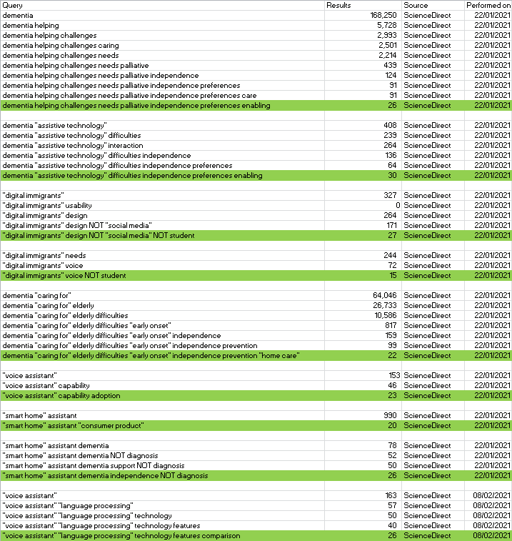

## 2. Literature Review

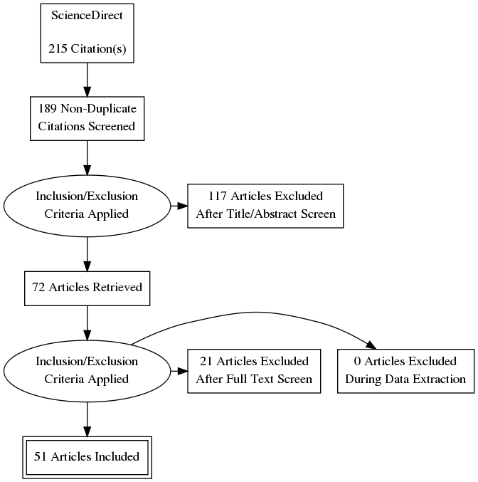

## 3. Project Plan

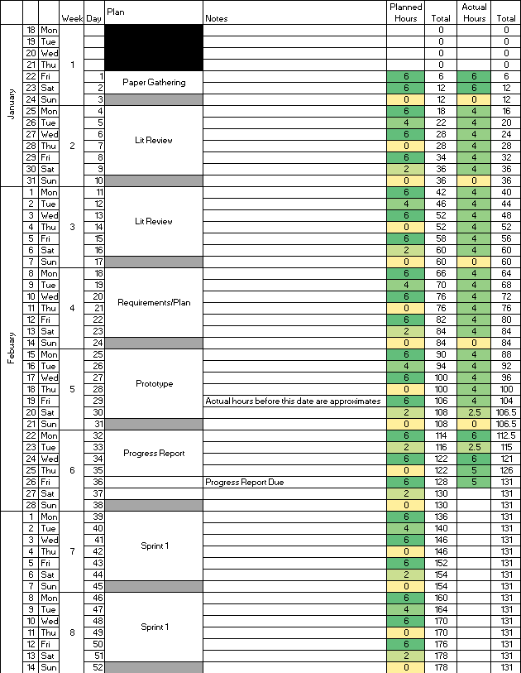

## 4. Burndown Chart

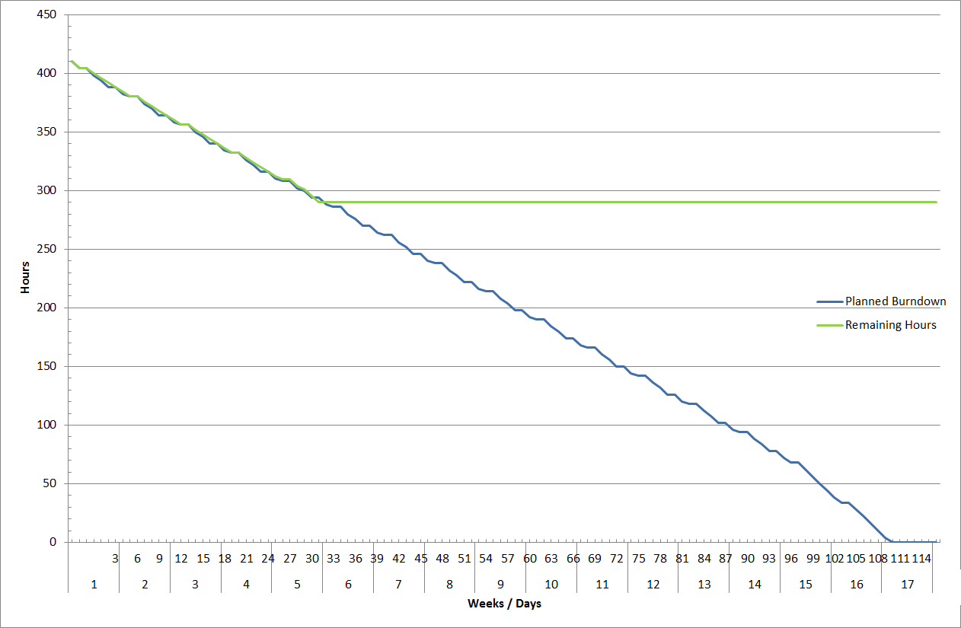

## 5. Keywords

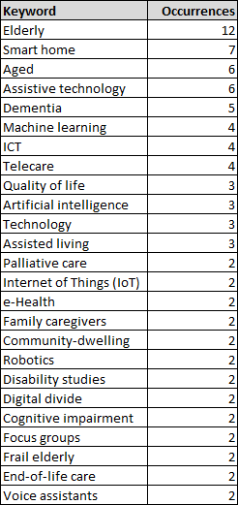

## 6. Concept Map

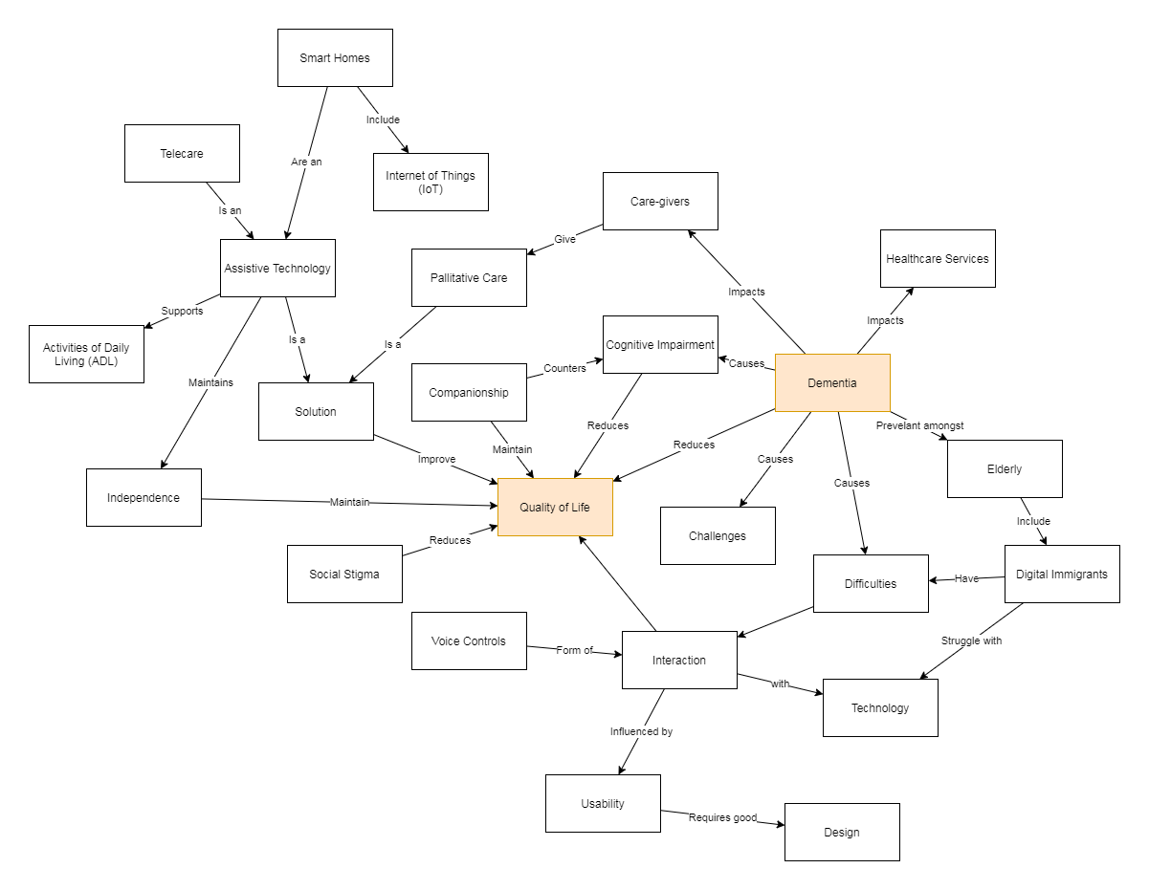

## 7. Roadmap

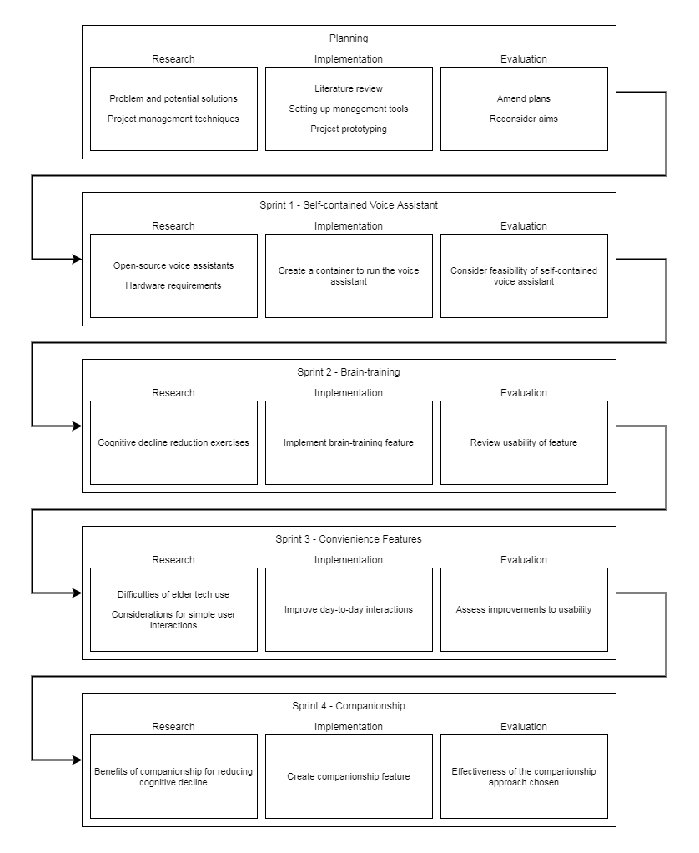

## 8. Risk Table

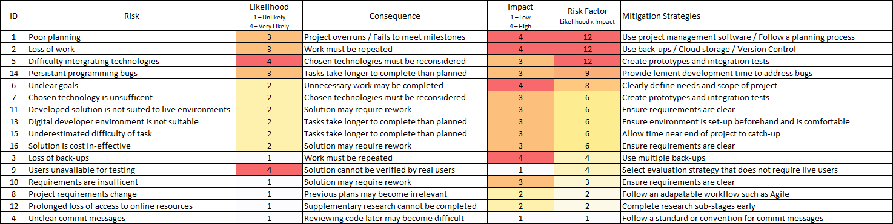

## 9. Prototype

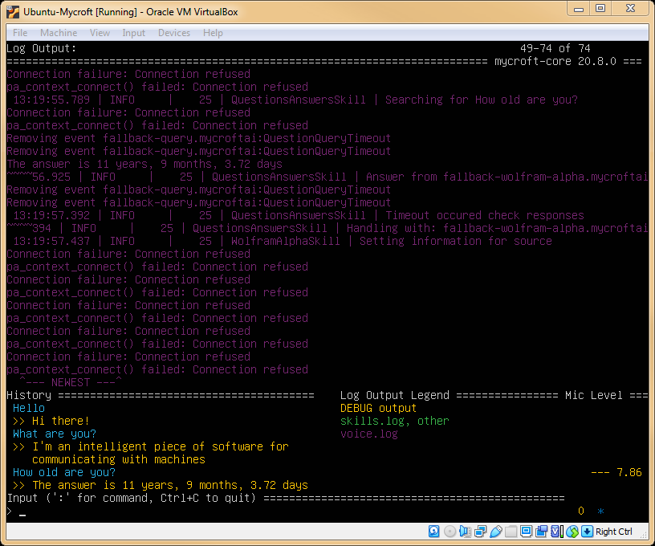

## 10. Kanban Board

