|  |  |  |
| --- | --- | --- |
| Version Description | Created By | Date |
| 1.0 First Version | Manoj sisodia,  Shivam Srivastava  Sushant,  Tribhuwan | 30-06-2017 |
| General Description |  |  |

*The ER Diagram designed here gives us the basic idea about the functionality of the E-checkout, the idea provided helps us in understanding the relations between the tables and what all attributes are needed their as the information, what will be managed by the administrator, what is the functionality of the system and the modules.*

**ER Diagram**

**1.** **ADMINISTRATOR**

1.1ADMINISTRATOR Manages Staff and Customer

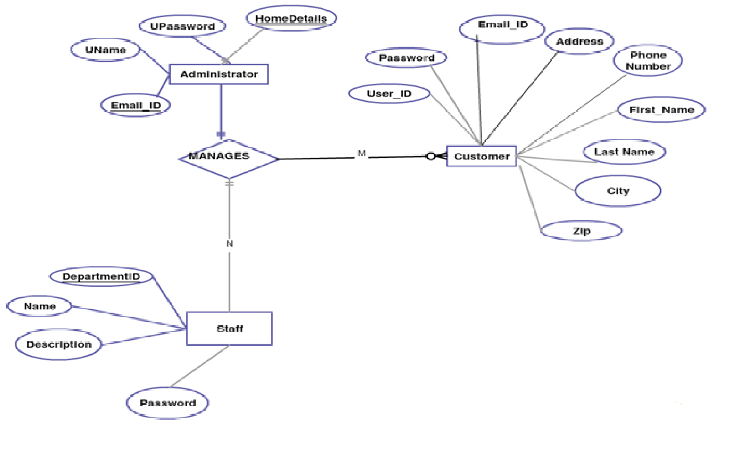

1.2 ADMINATOR upload MATERIAL, moderates comments COMMENT ON CUSTOMER , STAFF COMMENT; , LATESTSHAWLS

**2.STAFF**

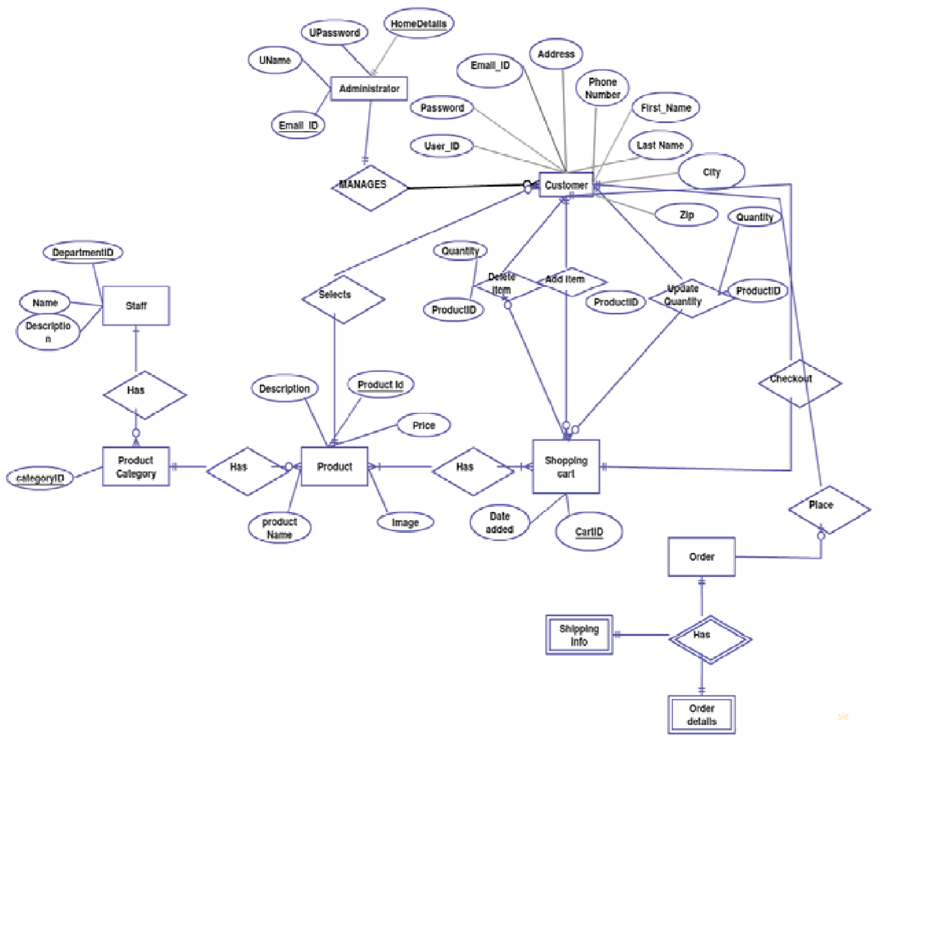

3.**CUSTOMER**

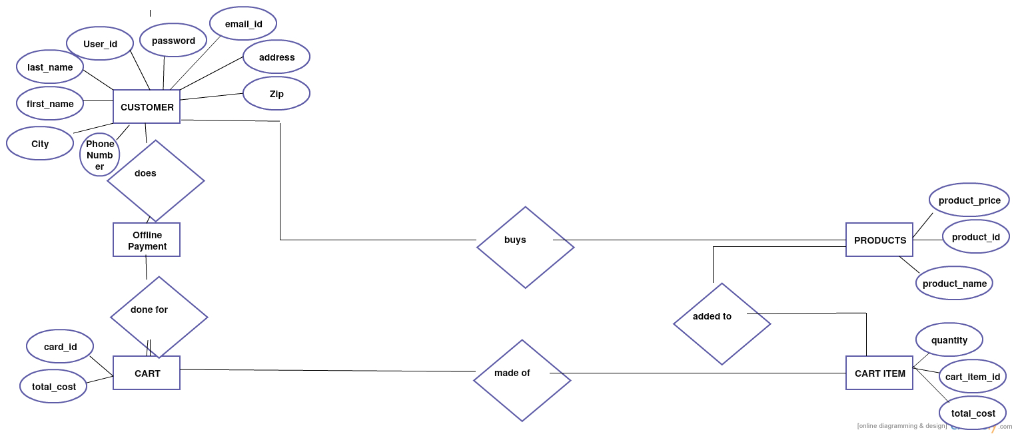

Basic flow of events: <a specific sequence of actions and interactions between actors and the system being discussed (happy path Or basic course of action)>

**Line System Actor Action System Response**

1. Administrator Manages(Deletes User, Staffs and Customers

Modifies User Details, Responses to E-Mail Requests)

1. Administrator Updates Latest item, Job Board, News.
2. Administrator Uploads offline Materials
3. Administrator Moderates Comments on Staff and Customer
4. Item Searches Customer
5. Customer Comments on Products/Items
6. Staff comments on Admin/Customer
7. Staff uploads Offline Materials

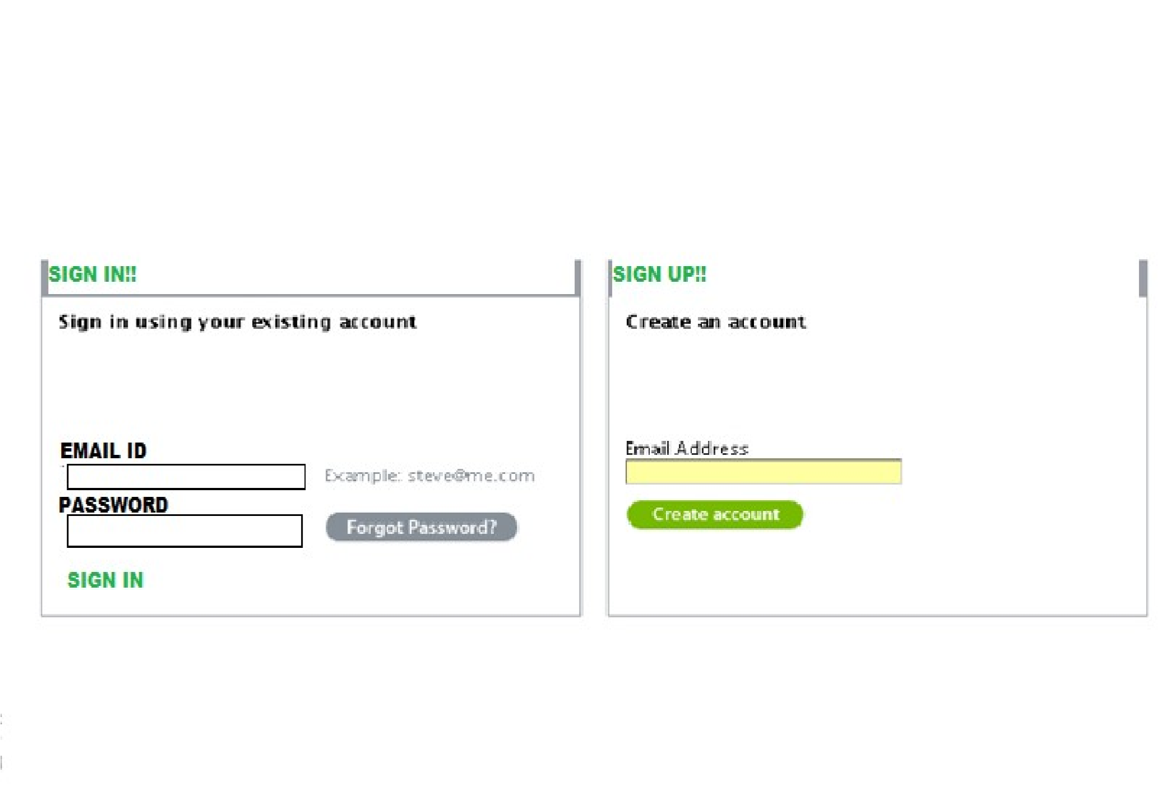

Screen ID: E-CHECKOUT – LOGIN PAGE



Screen ID: E-CHECKOUT – ADMIN PAGE

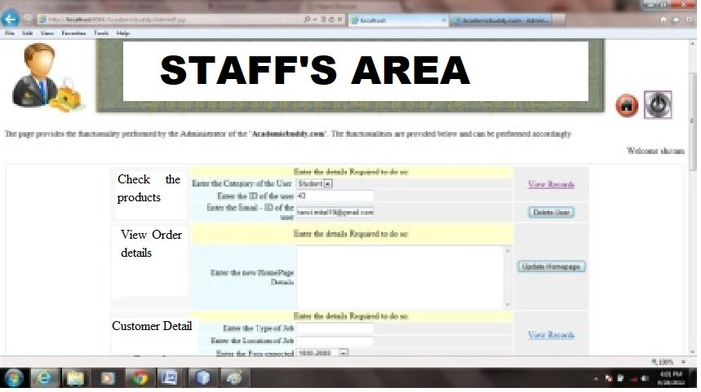

Screen ID: E-CHECKOUT – STAFF PAGE

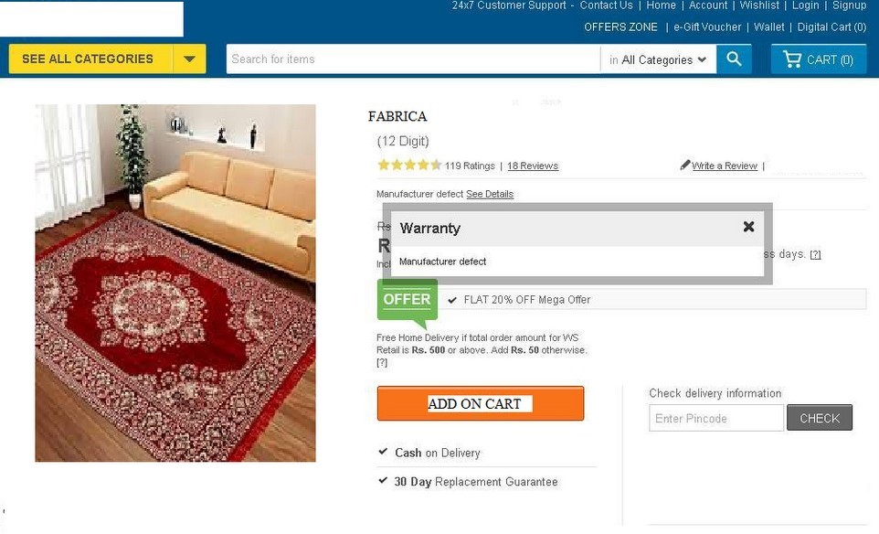

Screen ID: E-CHECKOUT – CUSTOMER PAGE

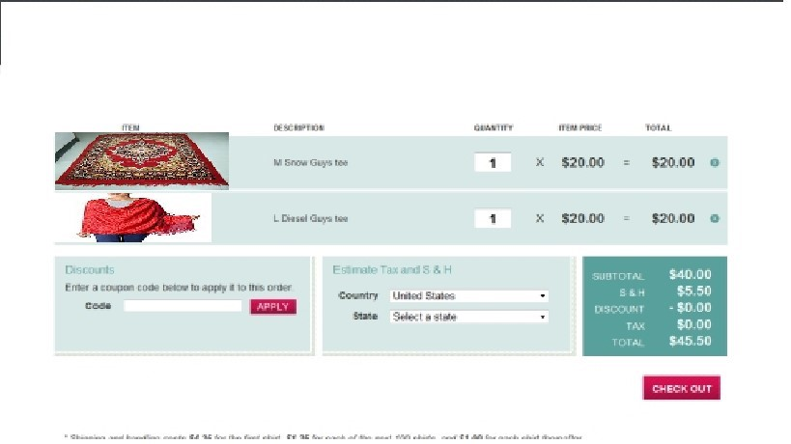

# Screen ID: E-CHECKOUT – CHECKOUT PAGE