Version |  |  | Description |  | Created By | Date
1.0 |  |  | First version of the system |  | Sushant , Tribhuwan , Manoj , Shivam | 29-06-2017
General Description
A use case is a methodology used in system analysis to identify, clarify, and organize system requirements. The use case is made up of a set of possible sequences of interactions between systems and users in a particular environment and related to a particular goal. It consists of a group of elements (for example, classes and interfaces) that can be used together in a way that will have an effect larger than the sum of the separate elements combined. The use case should contain all system activities that have significance to the users. A use case can be thought of as a collection of possible scenarios related to a particular goal, indeed, the use case and goal are sometimes considered to be synonymous.
A use case (or set of use cases) has these characteristics:
- Organizes functional requirements
- Models the goals of system/actor (user) interactions
- Records paths (called scenarios) from trigger events to goals
- Describes one main flow of events (also called a basic course of action), and possibly other ones, called exceptional flows of events (also called alternate courses of action)
- Is multi-level, so that one use case can use the functionality of another one.
Use cases can be employed during several stages of software development, such as planning system requirements, validating design, testing software, and creating an outline for online help and user manuals.

Actors <an entity that can interact with a system, invoking some behavior>
- Admin
- Staff
- Customer

Preconditions <the state(s) the system can be in before this use case starts>
- The System is functioning properly
- The System should have access to the database
- The Actor should have knowledge of working offline.
- The Actor must have a valid E-mail id.
- The Actor must have knowledge of their module.

Use Case Diagram <a specific sequence of actions and interactions between actors and the system being discussed>
E-CHECKOUT System(Major) Use Case Diagram
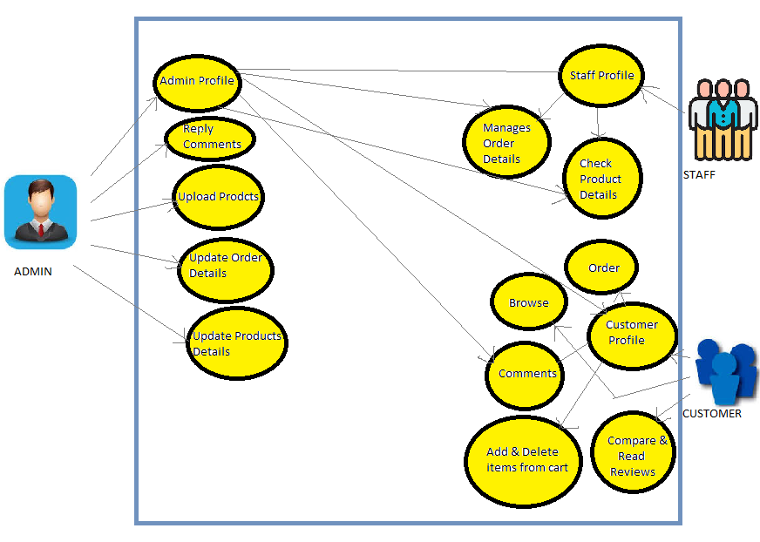

Basic flow of events: <a specific sequence of actions and interactions between actors and the system being discussed (happy path Or basic course of action)>
Line |  | System Actor Action |  | System Response
 |  | Admin can view & update his profile |  | Admin Profile
 |  | Admin Manages(Deletes & Modify User Details) |  | Staff , Customer
 |  | Admin Updates |  | Shawls and Carpets price
 |  | Admin view and update |  | Order Details
 |  | Admin Uploads |  | Latest Shawls and Carpets
 |  | Admin Moderates Comments on |  | Staff , Customer
 |  | Customer can view & update his profile |  | Customer Profile
 |  | Customer Browse |  | Shawls and Carpets
 |  | Customer Order |  | Shawls and Carpets
 |  | Customer Comments on |  | Shawls and Carpets
 |  | Customer add to cart |  | Shawls and Carpets
 |  | Customer delete to cart |  | Shawls and Carpets
 |  | Customer compare |  | Similar products
 |  | Customer read reviews |  | On shawls and Carpets
 |  | Staff can view & update his profile |  | Staff Profile
 |  | Staff Manages |  | Order Details
 |  | Staff Check |  | Product Details
Exceptional flow of events: <an alternate sequence of actions and interactions between the actors and the system (alternate course of action)>
1 | Admin Updates for staff, customers, products |  |  | Profile
2 | Admin manages |  |  | Staff, customer, product.
3 | Admin manages(moderate’s comments) |  |  | Comment customer on product
Post Conditions <the state(s) the system can be in when this use case ends>
The logout operation must enable the logout of the user from the current session.
The feedback provided by the user must be entertained in the system if applicable.
The maintenance of the system must be done regularly to keep the system running.
The system must be monitored regularly in order to avoid slow responsiveness and working of the system.

System Messages <all system generated messages that the system will prompt for the user>
1 | Login-Login successful or Login Failed: Re-enter your username and/or password.
2 | Search-Search Results not found. Please modify your search.
Appendix <List of any supporting documents attached>
- http://searchsoftwarequality.techtarget.com/definition/use-case
- http://en.wikipedia.org/wiki/Use_case
- Fundamentals of Software Engineering – Rajib Mall

