Project name: E-CHECKOUT

Database Design Specification

DOCUMENT VERSION HISTORY

Document Version | Date Issued | Comments
1.0 | 03-07-2017 | First version of the system

Table of Contents

Table of Contents 2
1 Introduction 3
2 Conventions followed 3
3 Abbreviations used 3
4 Entity Relationship Diagram 4
5 Tables 5

Introduction

The object/relationship pair is the cornerstone of the data model. These pairs can be represented graphically using the entity/relationship diagram. The ERD (Entity-Relationship Diagram) was originally proposed by Peter Chen. The primary purpose of the ERD is to represent entities (data objects) and their relationships with one another.
The ER Diagram of the assigned project E-CHECKOUT has three major entities namely: Administrator, Staff and Customer. These entities have their respective attributes enlisted with them. To make the working more clear few more entities have been added in this diagram namely, Staff Comment, Customer Comment, Latest Products, Offline Materials.
The Administrator as stated manages the operations such as Update, Manages, Moderates Comments, and Uploads. These operations are stated as relations and as applicable are joined to their respective entities to perform operations.
The Customer have major operations of Searching for products, reading reviews of products, making comments on the products. These operations are stated as relations and as applicable are joined to their respective entities to perform operations.
The Staff has major operation of removing Customers issues, commenting upon the Customers behavior. These operations are stated as relations and as applicable are joined to their respective entities to perform operations.

Conventions followed

HUNGARIAN CONVENTION

Abbreviations used

Sample abbreviations listed below -

- PK – Primary Key
- FK – Foreign Key
- AI – auto-incremented, the seed and increment values are 1 unless specified.
- Def – default value
- NN – Not Null (Required)
- UC – Unique Constraint
- SLT – Single Line of Text
- MLT – Multiple Lines of Text
- PG – Person or Group
- Yes/No (checkbox) – Yes/No
- CK-Composite Key
- AI-Auto Increment

Entity Relationship Diagram

  - ADMIN

1.1ADMIN manages STAFF AND CUSTOMER

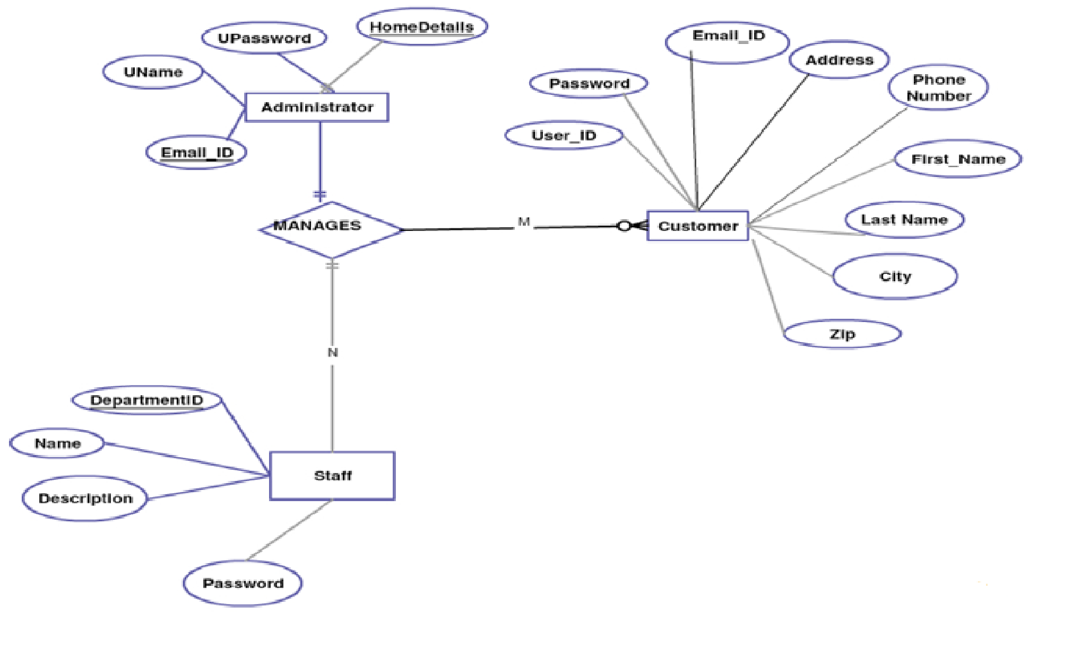

1.2 ADMIN uploads OFFLINEMATERIAL, moderates comments COMMENTPARENTONSTAFF , CUSTOMERCOMMENT; updates JOBBOARD, NEWS, LATESTTUTOR

2.Staff

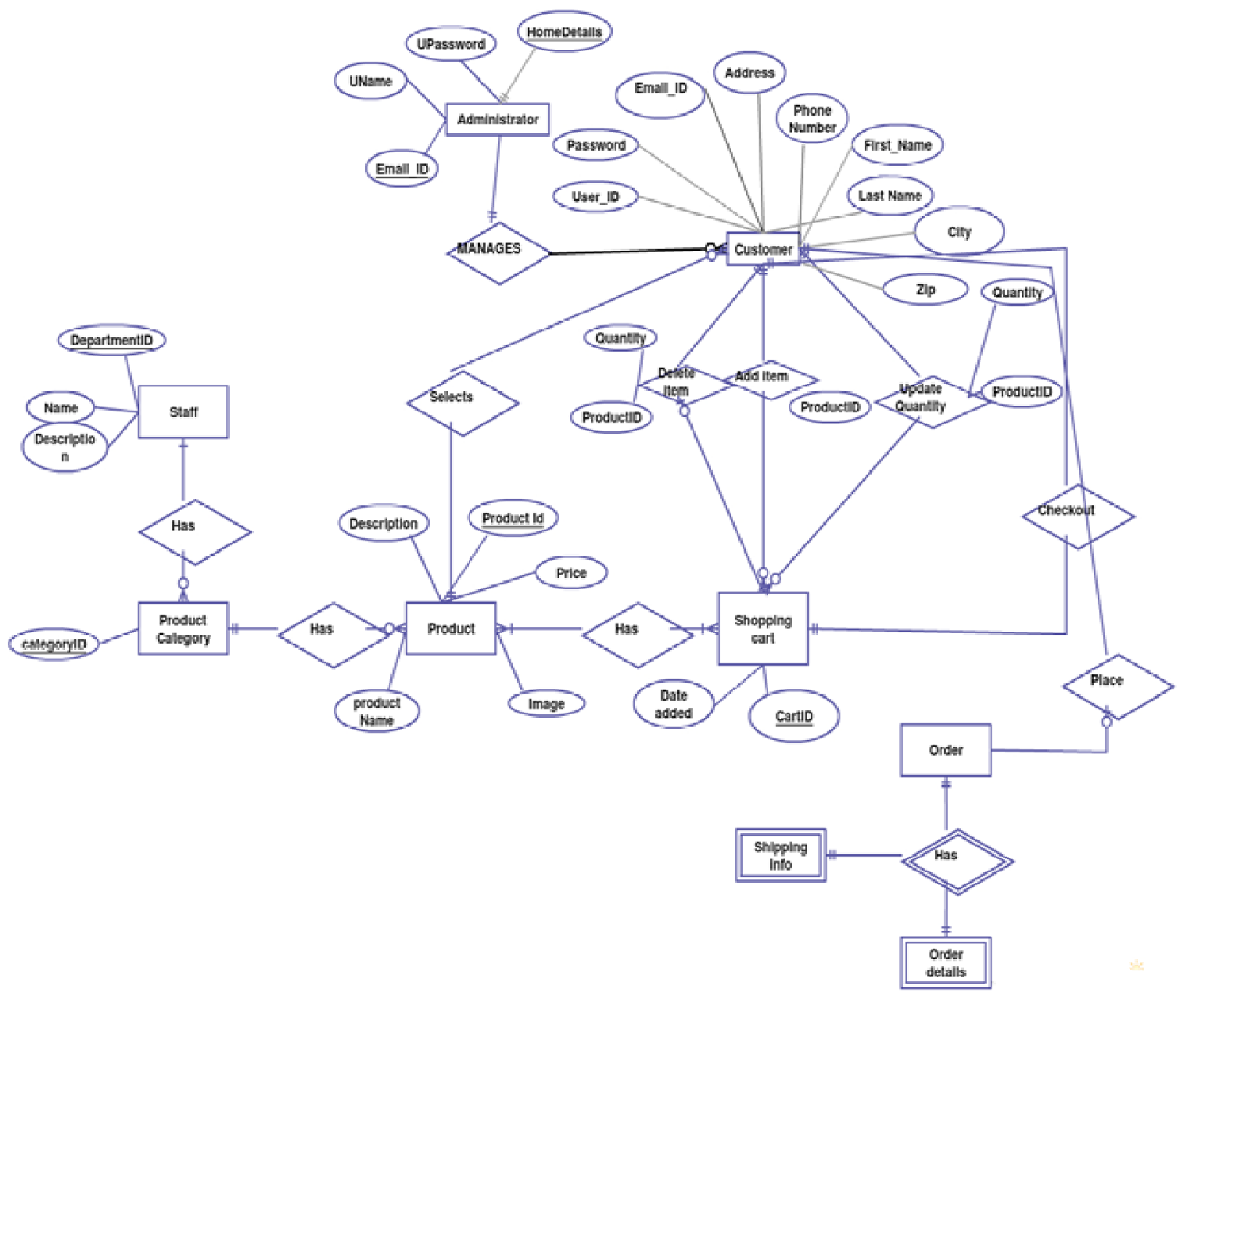

3 CUSTOMER

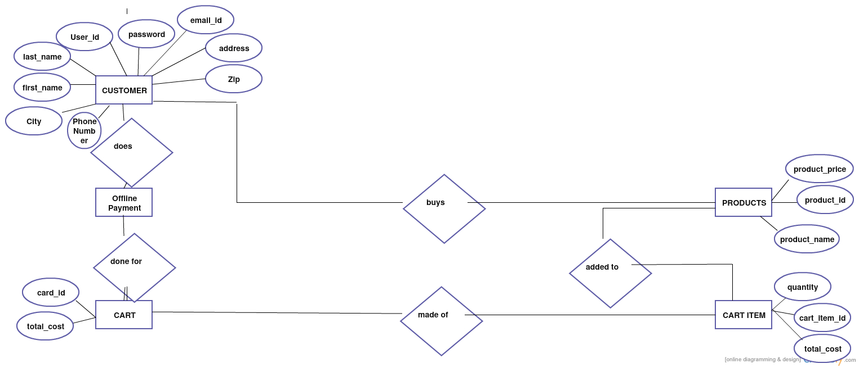

Tables

Tables are listed below –

ADMIN

Table Name | ADMIN
Description | This table will contain the basic information about the administrator and information about the Home Page
Primary Keys | User id
Foreign Keys
Field Name | Data type | Constraints | Comments
NAME | varchar2(50) | UC | Username of the administrator.
EMAILID | varchar2(50) | NN | E-mail ID of the administrator.
AGE | varchar2(50) | NN | Age of the administrator.
ADDRESS | varchar2(50) | NN | Address of the administrator.
GENDER | varchar2(50) | NN | Gender of the administrator.
CITY | varchar2(50) | NN | City of the administrator.
PINCODE | varchar2(50) | NN | Pin code of the administrator.

CUSTOMER

Table Name | CUSTOMER
Description | This table holds the information about the Customer who is to be registered into the database.
Primary Keys | CUSTOMERID
Foreign Keys
Field Name | Data type |  | Constraints |  | Comments
CUSTOMERID | number |  | PK, UC |  | Holds the CUSTOMERID
FIRST NAME | Varchar2(50) |  | NN |  | Holds the Name of the customer
LAST NAME | Varchar2(50) |  | NN |  | Holds the Username
AGE | Varchar2(4) |  | NN |  | Holds the age of the customer
GENDER | Varchar2(10) |  | NN |  | Holds the gender of the customer
PASSWORD | Varchar2(50) |  | NN |  | Holds the Password
EMAILID | Varchar2(50) |  | NN |  | Holds the Email id
ADDRESS | Varchar2(250) |  | NN |  | Address of the Customer
STATE |  | varchar2(50) |  | NN |  | State of the Customer.
CITY |  | varchar2(50) |  | NN |  | City of the Customer.
PINCODE |  | varchar2(50) |  | NN |  | Pin code of the administrator.

5.2.1 CUSTOMER COMMENT

Table Name | CUSTOMER COMMENT
Description | This table holds the comments done by Customer on the Staff
Primary Keys
Foreign Keys | CUSTOMERID
Field Name | Data type | Constraints | Comments
COMMENT DATE | date | NN | Stores current system date
CUSTOMERID | number | FK | Holds the Id of the customer
STAFFID | number | NN | Holds the id of the staff
COMMENT | varchar2(4000) | NN | Holds the comment done by the Customer/Staff

STAFF

Table Name | STAFF
Description | This table holds the data about the tutor which may be entered into the table.
Primary Keys | Staff ID
Foreign Keys
Field Name | Data type | Constraints | Comments
STAFFID | number | PK, UC | Holds the STAFFID
NAME | varchar2(50) | NN | Holds the name of the staff
AGE | varchar2(3) | NN | Holds the Age
GENDER | varchar2(10) | NN | Holds the Gender
USERNAME | varchar2(50) | NN | Holds the Username
PASSWORD | varchar2(50) | NN | Holds the Password
EMAILID | varchar2(50) | NN | Holds the Email id
CITY | varchar2(50) | NN | Holds the City
DATE OF JOINING | varchar2(50) | NN | Defines the date of joining
DATE OF LEAVING | varchar2(50) | NN | Defines the date of leaving

5.4.1 STAFF COMMENT

Table Name | STAFF COMMENT
Description | This table holds the comment about the comments posted by the staff on the review of customer.
Primary Keys
Foreign Keys | STAFFID
Field Name | Data type | Constraints | Comments
COMMENTDATE | date | NN
STAFFID | number | FK | Contains the staff ID
CUSTOMERID | number | NN | Contains the customer ID
STAFF COMMENT | varchar2(4000) | NN | Stores the comment on the customer.

