CONFIDENTIAL

Project name: E-CHECKOUT

Class Design Specification

DOCUMENT VERSION HISTORY

Document Version | Date Issued | Comments
1.0 | 02-07-2017 | First version of the Web Portal

Table of Contents

Table of Contents 2
Class Design
1 Introduction 3
2 Conventions followed 3
3 Class Diagrams 4

Introduction

The class diagram is the main building block of object oriented modelling. It is used both for general conceptual modelling of the systematics of the application, and for detailed modelling translating the models into programming code. Class diagrams can also be used for data modeling. The classes in a class diagram represent both the main objects and or interactions in the application and the objects to be programmed. In the class diagram these classes are represented with boxes which contain three parts:
A class with three sections:
- The upper part holds the name of the class
- The middle part contains the attributes of the class
- The bottom part gives the methods or operations the class can take or undertake

Conventions followed

Hungarian Convention

Class Diagrams

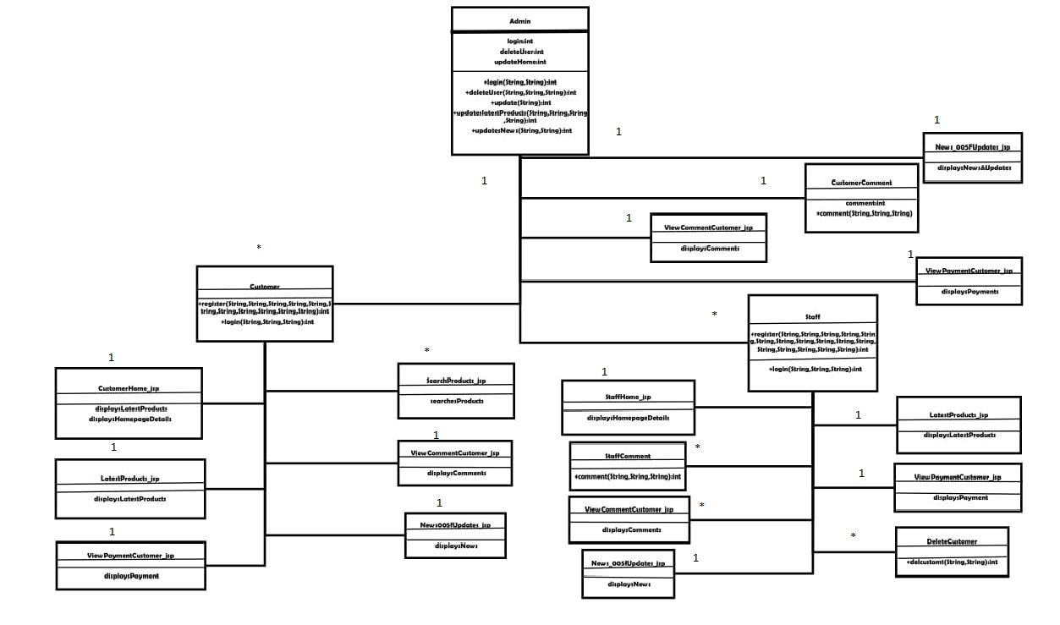

Classes

Admin

Class Description:
The Administrator class holds those attributes and functions which may be used for the functioning of the system. The administrator manages staffs and customers. The administrator uploads offline materials and review comments.

Methods
 | sFunction | OutPut Parameters | Description
1 | Delete User (String, String, String) | int | This function deletes the existing user from the database
2 | Login (String, String) | int | checks for the authentic username and password and provides the login
3 | Update Data (String, String, String, String, String) | int | the administrator make changes in the user details.
4 | Receive Payment (String, String, String, String, String) | int | enables to receive payments from the user
5 | Upload Products (String, String, String) | int | the administrator uploads materials which can be accessed offline or see detail of products.
6 | Add Staffs (String, String) | int | the administrator add new staffs .
7 | Display Customer(String) | int | Display list of Customer.
8 | Delete Customer(String) | int | Delete list of Customer .

Customers

Class Description:
The Customer class contains the attributes and related functionality for the customers

Methods
 | Function | OutPut  Parameters | Description
1 | Register (String, String, String, String, String, String, String, String, String, String, String) | int | registers the new customer in the portal
2 | login (String, String, String) | int | authenticates the customer and to login
3 | Add to Cart ( String) | int | Authenticates the customer to add on the cart.

Forget
Class Description :
The Forget class enables the student user to reset his username and password if he/she has forget it.

Methods
 | Function | OutPut Parameters | Description
1 | Forget (String, String, String, String) | int | This function enables the Customers to reset his password.  updates the password to the new one

Customers Service

Class Description :
This class holds the business logic to display the values stored in the database.

Methods
 | Function | OutPut Parameters | Description
1 | Displays Latest product | displays the latest product
2 | Display Latest Discount | displays the Latest Discount
3 | Displays Home Page Details | displays the homepage details

Search Product.

Class Description :
This class holds the business logic to display the values stored in the database.

Methods
 | Function | OutPut Parameters | Description
1 | Searches Products | displays the list of product on the searched query

Latest Product_jsp

Class Description :
This class holds the business logic to display the values stored in the database.

Methods
 | Function | OutPut Parameters | Description
1 | Display Latest Products | displays the latest product added in the portal

Payment

Class Description :
This class holds the business logic to display the values stored in the database.

Methods
 | Function | OutPut Parameters | Description
1 | Payment (String, String, String, String, String) | int | enables the customer to make payments for product.

View Offline payment Customer_jsp

Class Description :
This class holds the business logic to display the values stored in the database.

Methods
 | Function | OutPut Parameters | Description
1 | Display Payment | displays the payment done by the customer for product

Staffs

Class Description :
The Customer class contains the attributes and related functionality for the parent

Methods
 | Function | OutPut Parameters | Description
1 | Register (String, String, String, String, String, String, String, String, String, String, String) | int | registers the new parent in the portal
2 | Login (String, String, String) | int | authenticates the staffs to login

Forget

Class Description :
The Forgot class enables the parent user to reset his username and password if he/she has forget it.

Methods
 | Function | OutPut Parameters | Description
1 | Forget (String, String, String, String) | int | This function enables the staffs to reset his password.

Staffs Home_jsp

Class Description :
This class holds the business logic to display the values stored in the database.

Methods
 | Function | OutPut Parameters | Description
1 | Display Latest product | displays the Latest Product
2 | displays Home Page Details | displays the homepage details

Search Product_jsp

Class Description :
This class holds the business logic to display the values stored in the database.

Methods
 | Function | OutPut Parameters | Description
1 | Displays Product | displays the List of product on the searched query
2 | Display Customer | Display the list of customer on the searched query

Latest Product_jsp

Class Description :
This class holds the business logic to display the values stored in the database.

Methods
 | Function | OutPut Parameters | Description
1 | Display Latest product | displays the latest tutors added in the portal

News_005fUpdates_jsp

Class Description :
This class holds the business logic to display the values stored in the database.

Methods
 | Function | OutPut Parameters | Description
1 | Display News | displays the latest news subjects and their links

Display Customers

Class Description :
This class holds the business logic to display the values stored in the database.

Methods
 | Function | OutPut Parameters | Description
1 | Display Customer (String, String, String, String, String):int | enables the customer’s ward to get register.

View comment admin_jsp

Class Description :
This class holds the business logic to display the values stored in the database.

Methods
 | Function | OutPut Parameters | Description
1 | Display Comments () | displays the comments done by the admin on the product.

Payment

Class Description :
This class holds the business logic to display the values stored in the database.

Methods
 | Function | OutPut Parameters | Description
1 | Payment (String, String, String, String, String) | int | enables the customer to make payment.

Delete Customer

Class Description :
This class enables the tutor to delete the student from the batch.

Methods
 | Function | OutPut Parameters | Description
1 | DeleteCustomer1(String, String) | int | enables the staffs to delete the customers from the list.

View comment Customer_jsp

Class Description :
This class holds the business logic to display the values stored in the database.

Methods
 | Function | OutPut Parameters | Description
1 | Display Comments () | displays the comments done by the admin and customer on the product.

View Offlinepayment Customer_jsp

Class Description :
This class holds the business logic to display the values stored in the database.

Methods
 | Function | OutPut Parameters | Description
1 | display Payment | displays the payment done by the customer for various reasons

Check CustomerPayment

Class Description :
This class enables the tutor to check for payments made by the Tutor.

Methods
 | Function | OutPut Parameters | Description
1 | Check CustomerPayment (String, String) | int | enables the customer to check for the payments made

