Example
Text and integers 12345; decimal 3.14159; Vietnamese Unicode: Toán học.
Inline math: $x^{2}+2x+1\text{=}{\text{(}x+1\text{)}}^{2}$.
$$\int_{0}^{1}{x^{2}dx}\text{=}\frac{1}{3}.$$
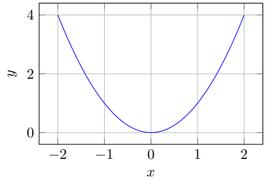
Hình / Bảng: Illustrative plot generated with PGFPlots.
Item | Value
A | 25
B | 35

