Example
Text and integers 12345; decimal 3.14159; Vietnamese Unicode: Toán học. Inline math: $x^{2}+2x+1=(x+1)^{2}$.
$$\int_{0}^{1}{x^{2}} dx=\frac{1}{3}.$$
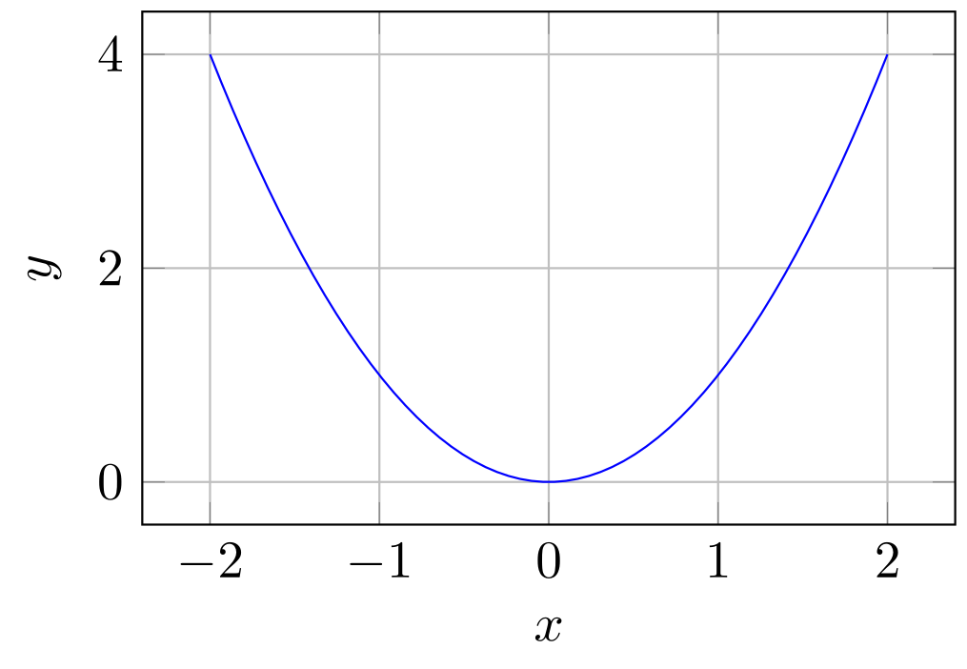
Illustrative plot generated with PGFPlots.
Item | Value
A | 25
B | 35

