Student Management System

Date: <<09/10/2021>>

Copyright Notice
This document contains proprietary information of HCL Technologies Ltd. No part of this document may be reproduced, stored, copied, or transmitted in any form or by means of electronic, mechanical, photocopying or otherwise, without the express consent of HCL Technologies. This document is intended for internal circulation only and not meant for external distribution.

Revision History
Version No | Date | Prepared by / Modified by | Significant Changes
1.0 | 09/10/2021 | Hoai Vu

Table Of Contents

1.1 Project Overview 3
1.2 Scope 3
1.3 Out of Scope 3
1.4 Intended Audience 3
1.5 High Level Use Cases 3
1.6 Use Cases detailed 3
1.7 User Interface Modules 3
1.8 Technical Architecture 3
1.9 Technical Detailed Description 3
1.10 Sequence Diagram 3
1.11 Database Entity Relationship Diagram 3
1.12 Standards 3
1.13 Non Functional Requirements 3

Project Overview
A student management system (also known as a student information system or SIS) helps a school manage data, communications, and scheduling. A student management system helps schools to store, manage, and distribute this information. Some student management systems are designed to serve all of a school’s student data management needs. Other student management systems are specialized. These specialized solutions target specific needs, such as school applications or student behavior tracking. Student management systems provide many benefits to educational institutions, mostly stemming from centralized data management and accessibility. Teachers can more easily input, manage, and access student data. Parental guardians get better visibility into how their student is performing in classes. State-level compliance and other regulatory requirements are also much easier to fulfill.
This project is created for manual testing at the end of term three in HLC the first career program. It is a basic program we used to manage student information based on the CRUD functions such as creating a new student, updating a student, displaying all students in database, delete a student and search student. This document has identified the high-level needs and feature of the program.

Scope
The Student Management System is basically focused on basic operations in local system so that its program do not have the user interface and we do not need to set up internet to implement the program. This program is specifically designed for practicing all knowledges we have learn during this course .

Out of Scope
Not other than mentioned above in section 1.2

Intended Audience
The Student Management System is designed for use of admins with student’s information

Name | Description | Responsibilities
Admin | The person manages student’s information | Create, update, search, view and delete student’s information

High Level Use Cases
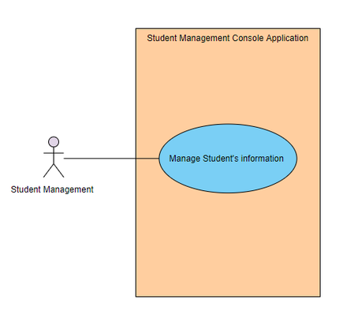

Use Cases detailed

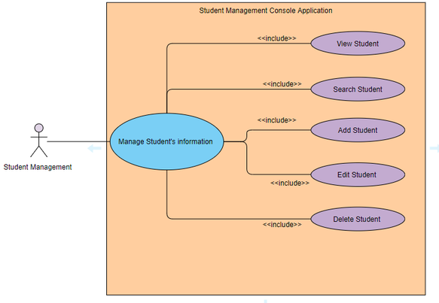

User Interface Modules
This system only has the local interface which is easy for user to use:

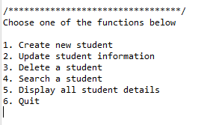
1.7.1. List of options

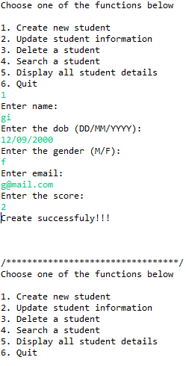
1.7.2. Create function

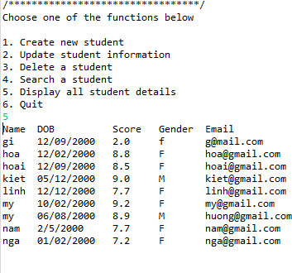
1.7.3. Display all student details
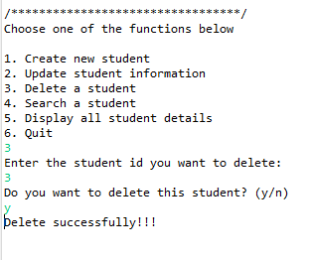
1.7.4. Delete function
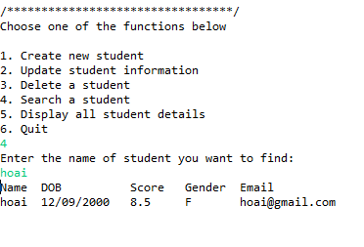
1.7.5. Search function
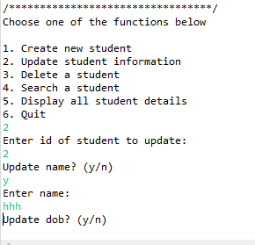
1.7.6. Update function
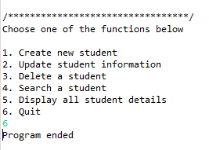
1.7.7. Quit

Technical Architecture
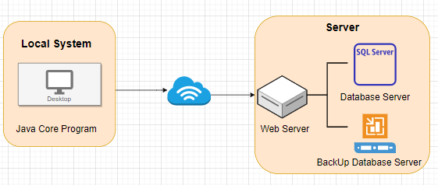

Technical Detailed Description
Local System | Web Server | Database Server
- Interface of console program  - Provide all user interaction  - Communicate with Web Server to process the information | - Receive request from local system  - Communicate with database server  - Respond to local system  - Applied business logic | - Manage data interaction  - Respond to Web Server  - Connect with SQL server  - Contain all data of application

Sequence Diagram
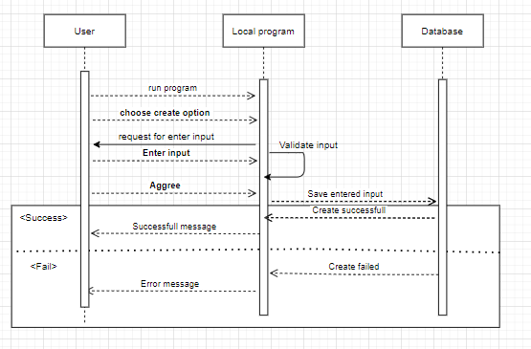
Add new students

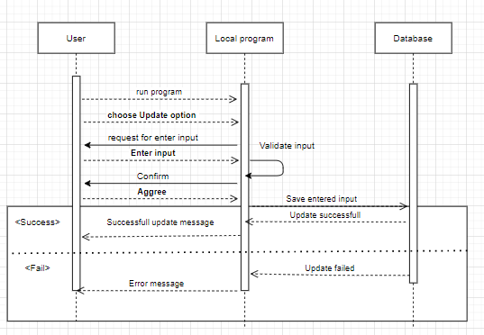

Database Entity Relationship Diagram
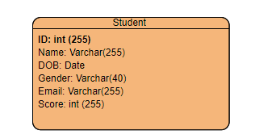

Update a student
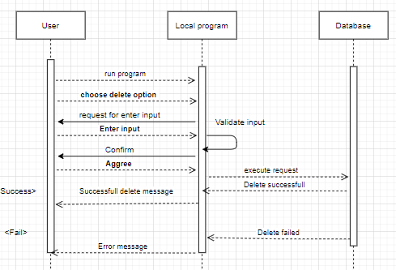
Delete a student

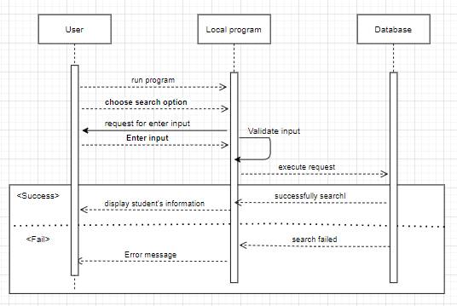
Search a student

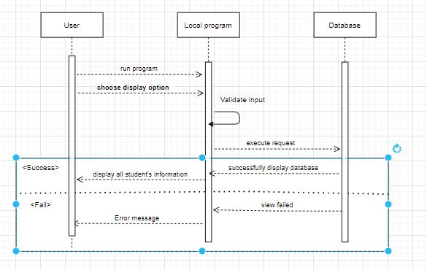
Display all student’s information

Standards

Non Functional Requirements
None

