**LAB 6: XÂY DỰNG MẠNG NƠ-RON SÂU**

Yêu cầu:

* Sinh viên tự thực hiện xây dựng mạng nơ-ron sâu cho bài toán nhận dạng quần áo giày dép thời trang với bộ dữ liệu FASHION-MNIST tương tự Lab 5.

**Câu 1:**

**Câu 2:**

**Câu 3:**

**Câu 4:**

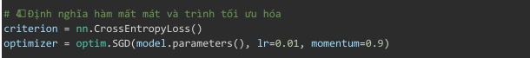

**Câu 5:**

**Câu 6:**

**Câu 7:**

**Câu 8:**



**Kết quả:**

* Sinh viên chọn 1 đề tài tương tự Lab 5, Lab 6 để thực hiện đồ án môn học.

Đề tài: Phân loại ảnh động vật

**Kết quả:**

