ĐẠI HỌC QUỐC GIA THÀNH PHỐ HỒ CHÍ MINH
TRƯỜNG ĐẠI HỌC BÁCH KHOA
----------


BÀI TẬP LỚN ĐIỆN TỬ CÔNG SUẤT ỨNG DỤNG
GVHD: HỒ THANH PHƯƠNG
LỚP: L01

STT | HỌ VÀ TÊN | MSSV | ĐÁNH GIÁ
1 | Nguyễn Gia Long | 2311905 | 100%
2 | Lê Đoàn Hồng Nam | 2312161 | 100%
3 | Hà Anh Kiệt | 2311755 | 100%
4 | Trương Quang Đức | 2310811 | 100%
5 | Nguyễn Thân Khôi | 2311688 | 100%

Design of Fuzzy Logic Controller for Speed Regulation of BLDC motor using MATLAB
TRUONG QUANG DUC, HA ANH KIET,NGUYEN GIA LONG,NGUYEN THAN KHOI and LE HONG NAM Faculty of Electrical and Electronics Engieering, Ho Chi Minh City University of Technology – Vietnam National University in Ho Chi Minh City, Vietnam

Abstract—Due to their superior efficiency, robust dynamic response, and minimal maintenance requirements, Brushless DC (BLDC) motor drives have become increasingly prevalent in the electrical drive sector. This study details the design and implementation of a BLDC drive system specifically engineered for commercial use. This study presents the implementation of a Fuzzy Logic Controller (FLC) for Brushless DC (BLDC) motors within the MATLAB/Simulink environment. The development process involves configuring a .FIS file via the Fuzzy Logic Toolbox to define specific membership functions and rule bases. This controller is then integrated with an inverter-fed drive system. Simulation results demonstrate that the proposed fuzzy approach significantly enhances the motor's dynamic response and ensures reliable operation, making it highly suitable for modern commercial applications.

Introduction
A. Problem Statement:
Industrial drive systems are predominantly categorized into two types: conventional brushed DC motors and Brushless DC (BLDC) motors. Unlike traditional motors that rely on mechanical brushes and field coils, BLDC motors utilize permanent magnets to generate air gap flux and employ electronic commutation. This design, characterized by its trapezoidal Back-EMF, has become the standard for high-performance applications such as electric vehicles and advanced industrial robotics. However, controlling these systems presents significant challenges. While PID controllers remain the industry's most common choice due to their simplicity and reliability, they often struggle with the inherent non-linearity, parameter variability, and unpredictable uncertainties of modern industrial processes. These limitations make it difficult to achieve optimal performance using traditional mathematical modeling and fixed-gain tuning, especially under complex operating conditions.
B.Objective:
To overcome the limitations of classical control, this study introduces an advanced control strategy based on Fuzzy Logic Control (FLC) for BLDC motor speed regulation. The primary objective is to develop a robust simulation model that utilizes linguistic variables and a rule-based inference system to regulate the motor's input voltage in real-time, bypassing the need for a precise mathematical model. Specifically, this research aims to demonstrate the superior dynamic speed response of an FLC-based drive in maintaining constant operational speed during significant load perturbations. Ultimately, the study seeks to provide a comparative analysis through MATLAB/Simulink simulations to confirm that the Fuzzy Logic approach offers enhanced stability, reduced overshoot, and quicker recovery times compared to conventional PI/PID controllers.

THEORY AND PRINCIPLE DIAGRAM
The speed control architecture of a three-phase BLDC motor is illustrated in the block diagram in Fig. 1. The system fundamentally operates through two primary control loops: an inner loop and an outer loop. The inner loop is responsible for synchronizing the inverter gate signals with the motor's Back-EMF to ensure precise commutation. Meanwhile, the outer loop regulates the motor's rotational speed by modulating the DC bus voltage.
The driving circuitry comprises a three-phase power converter utilizing six power transistors (MOSFETs) to energize two phases of the BLDC motor simultaneously. To determine the correct switching sequence, the instantaneous rotor position is detected via three Hall-effect sensors integrated into the stator. By processing the Hall sensor feedback alongside the reference current signals, a decoder block generates the Back-EMF signal vectors. Furthermore, directional control is achieved by reversing the current polarity; this operational logic for both clockwise rotation and gate signal transformation is detailed in Table I and Table II, respectively.
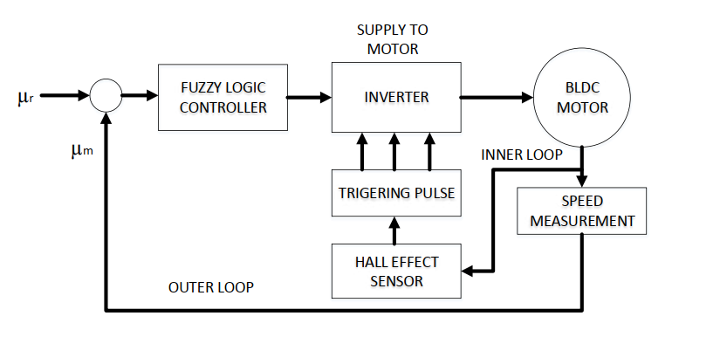
Fig.1: Block Diagram of speed control of BLDC Motor
Hall sensor A | Hall sensor B | Hall sensor C | EMF A | EMF B | EMF C
0 | 0 | 0 | 0 | 0 | 0
0 | 0 | 1 | 0 | -1 | +1
0 | 1 | 0 | -1 | +1 | 0
0 | 1 | 1 | -1 | 0 | +1
1 | 0 | 0 | +1 | 0 | -1
1 | 0 | 1 | +1 | -1 | 0
1 | 1 | 0 | 0 | +1 | -1
1 | 1 | 1 | 0 | 0 | 0
Table.1: Clockwise Rolation

EMF A | EMF B | EMF C | Q1 | Q2 | Q3 | Q4 | Q5 | Q6
0 | 0 | 0 | 0 | 0 | 0 | 0 | 0 | 0
0 | -1 | 1 | 0 | 0 | 0 | 1 | 1 | 0
-1 | 1 | 0 | 0 | 1 | 1 | 0 | 0 | 0
-1 | 0 | 1 | 0 | 1 | 0 | 0 | 1 | 0
1 | 0 | -1 | 1 | 0 | 0 | 0 | 0 | 1
1 | -1 | 0 | 1 | 0 | 0 | 1 | 0 | 0
0 | 1 | -1 | 0 | 0 | 1 | 0 | 0 | 1
0 | 0 | 0 | 0 | 0 | 0 | 0 | 0 | 0
Table.2: Gate Logic

COMPONENT SELECTION & CALCULATIONS
In fuzzy logic systems, linguistic variables are primarily implemented through logical implications, commonly structured as "If-Then" rules. These rules categorize input data into various ranges defined by fuzzy membership functions. Depending on the system requirements, these functions can take several geometric forms, such as triangular, trapezoidal, or Gaussian (bell-shaped) curves. As illustrated in Figure 2, the fuzzy controller continuously monitors the system performance by calculating the "error" value, which is defined as the instantaneous difference between the desired reference speed and the actual motor speed.
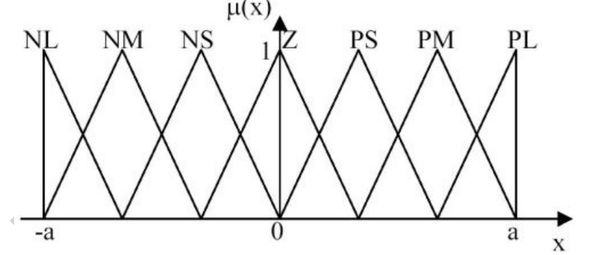
Fig.2: Membership functions of fuzzy controller
To achieve precise control, the system employs seven distinct linguistic variables for each membership function, categorized as follows: Negative Big (NB), Negative Medium (NM), Negative Small (NS), Zero (Z), Positive Small (PS), Positive Medium (PM), and Positive Big (PB). These functions form a comprehensive rule base consisting of 49 "If-Then" logical implications, as detailed in Table III. The fuzzy inference system utilizes the Mamdani-style min-max composition method to process the linguistic rules. Finally, the Center of Gravity (CoG) method is implemented during the defuzzification stage to convert fuzzy outputs into a crisp control signal ($u$). Examples of the operational logic include:
- If error e is NB and change in error e is NB, then output u is PB;
- If e is NB and Δe is NM, then u is PB;
- If e is NB and Δe is NS, then u is PM.
……………………………….
And go on for all inputs
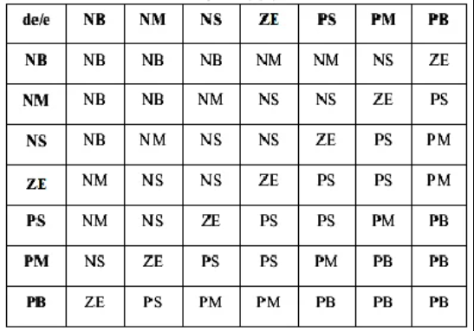
Tag.3: Fuzzy Rule Table
The MATLAB/Fuzzy Logic Toolbox serves as the core platform for simulating the FLC, allowing for seamless integration with Simulink-based drive models. The design process begins in the FIS Editor, where the controller's logic is defined and subsequently transferred to the MATLAB Workspace using the "Export to File" command. This procedure generates a standalone .FIS file, which is then called by the "Fuzzy Logic Controller" block within the Simulink environment.
To ensure successful execution, the specific filename of the .FIS structure must be defined within the block parameters, and the file itself must be stored in the same directory as the primary Simulink model file. As illustrated in Fig. 6.10, the comprehensive MATLAB model integrates these components to form a robust framework for implementing fuzzy logic control on a BLDC motor. This workflow ensures that the linguistic rules and membership functions are accurately translated into real-time control signals for the inverter-fed motor system.
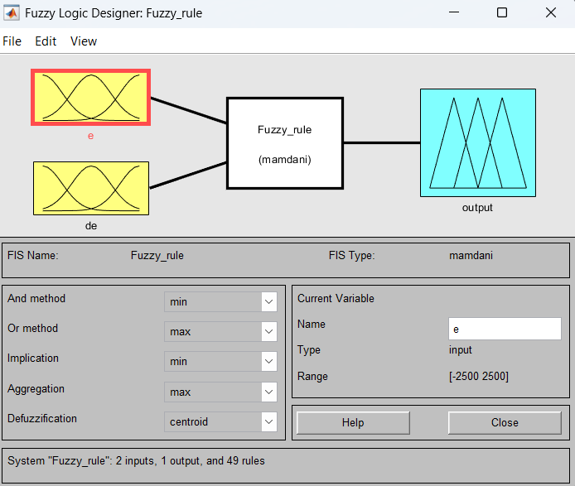
Fig.3: FIS Editor for Creating FIS file

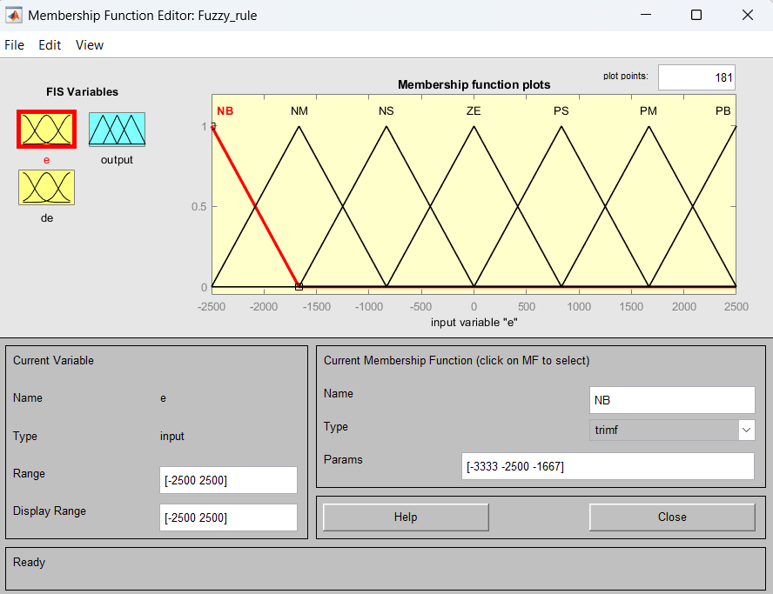
Fig.4: Membership Function Plot for Input-1
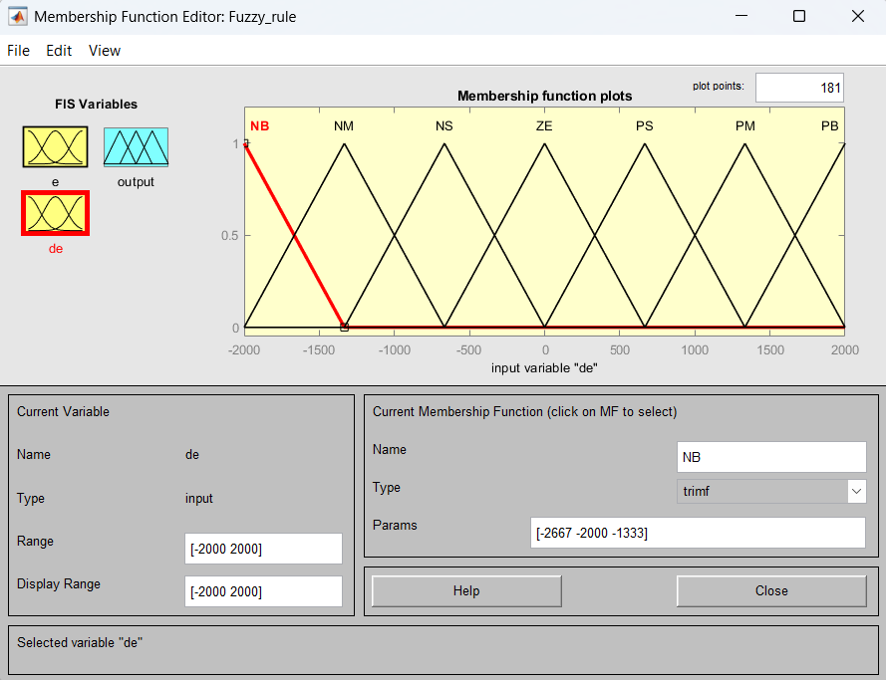
Fig.5: Membership Function Plot for Input-2

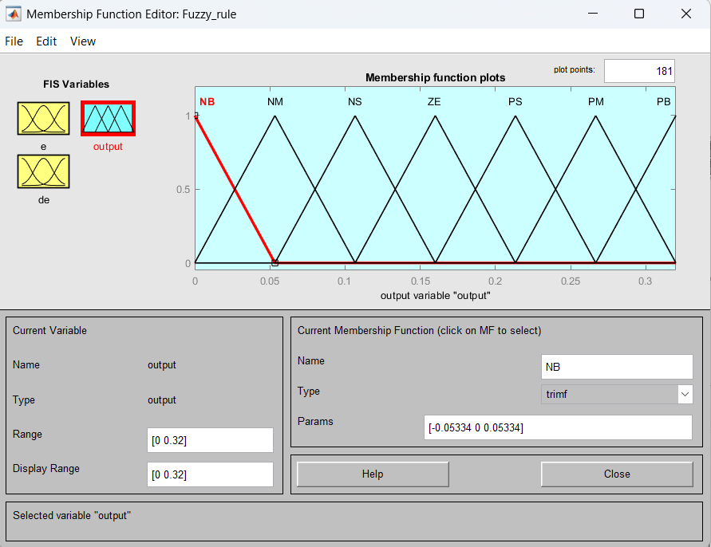
Fig.6: Membership Function Plot for Output
Once the inputs and outputs are defined within the FIS Editor, the system's logic is established by configuring the rule base. In this study, a total of 49 rules were implemented. The final configuration was then exported as a .fis file for further integration.
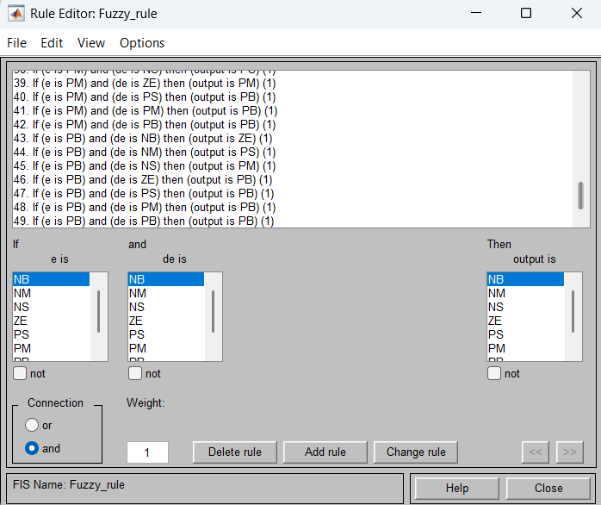
Fig.7: Rule base view of all 49 rules

SIMULATION RESULTS
In this simulation, the control architecture is centered around maintaining the BLDC motor at a constant reference speed of 1000 rpm under a steady-state load torque of 2 N.m. To achieve this level of precision, a Fuzzy Logic Controller (FLC) is integrated into the closed-loop system as the primary regulatory mechanism. The control process begins with the acquisition of the speed error e, which is defined as the instantaneous deviation between the setpoint (reference speed) and the measured angular velocity. Simultaneously, the controller computes the change in error Δe by evaluating the difference between the current error and the error recorded in the preceding sampling interval. These two parameters serve as the linguistic inputs for the FLC, which, through its internal inference system and rule base, determines the optimal control signal (voltage change) required to compensate for disturbances and ensure the motor converges to its target speed

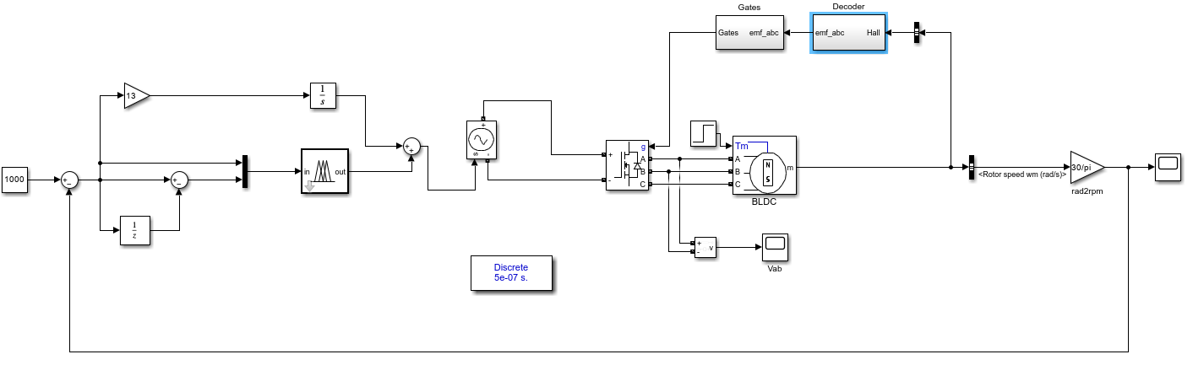
Fig.8: Matlab simulation model for BLDC with Fuzzy Controller

- Simulation Results

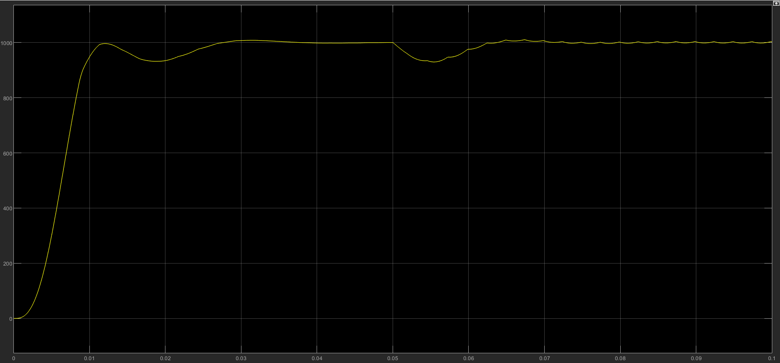
Fig.9: Rotor speed in rpm

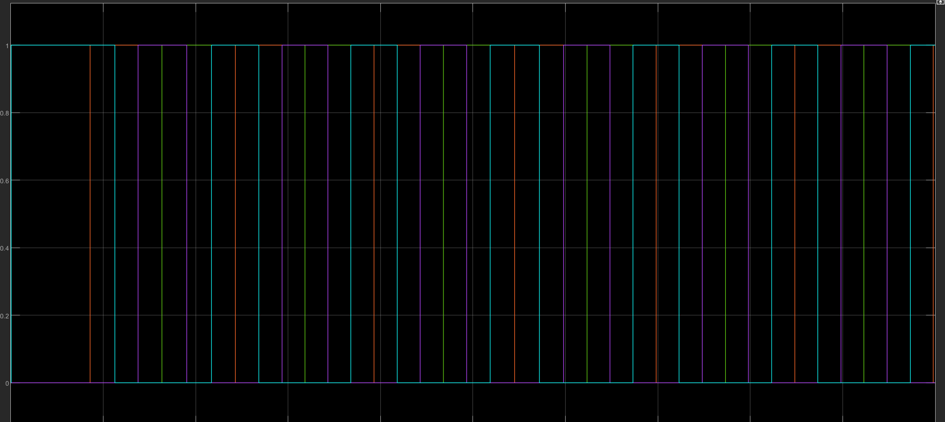
Fig.10: Gate input waveform
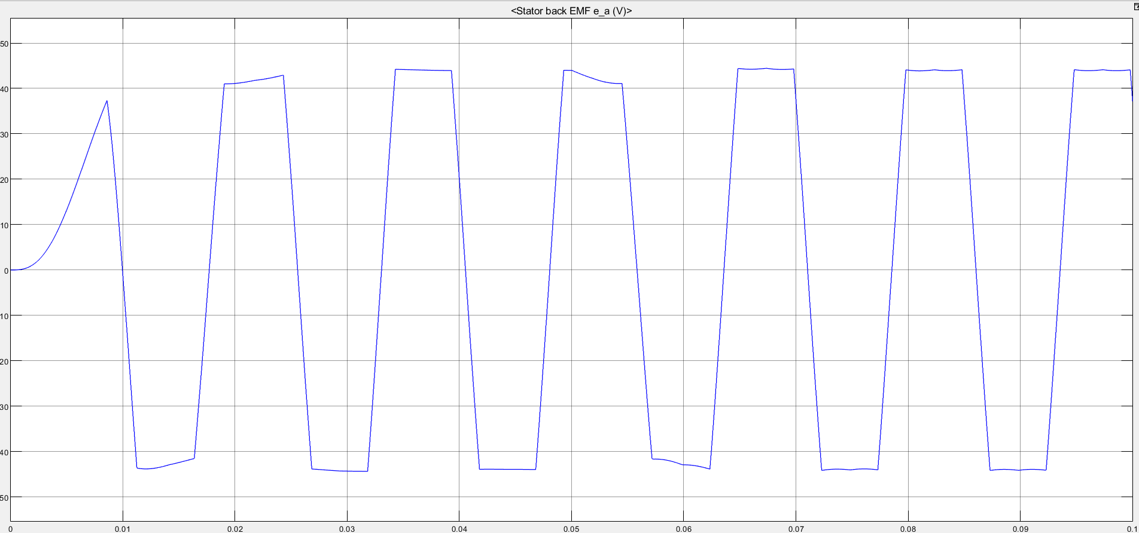
Fig.11: Back EMF Voltage E for Phase A

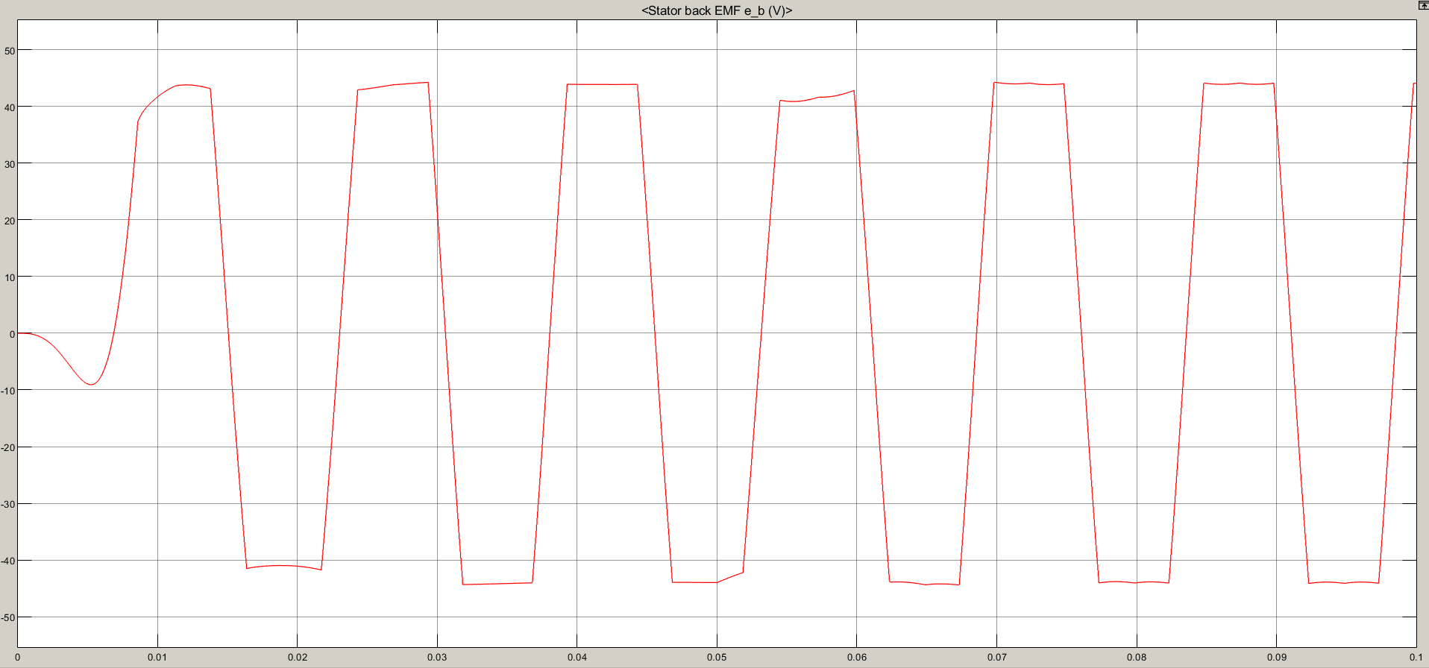
Fig.12: Back EMF Voltage E for Phase B

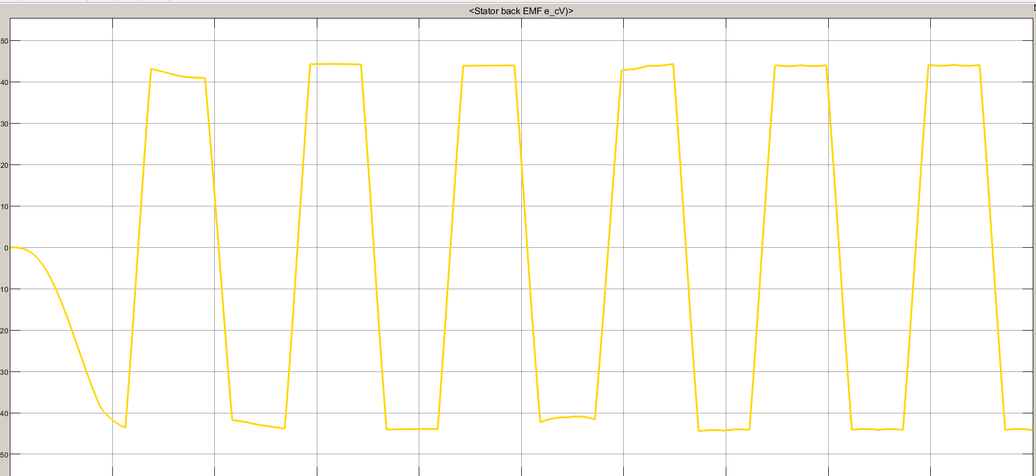
Fig.13: Back EMF Voltage E for Phase C

References
The template will number citations consecutively within brackets [1]. The sentence punctuation follows the bracket [2]. Refer simply to the reference number, as in [3]—do not use “Ref. [3]” or “reference [3]” except at the beginning of a sentence: “Reference [3] was the first ...”
Number footnotes separately in superscripts. Place the actual footnote at the bottom of the column in which it was cited. Do not put footnotes in the abstract or reference list. Use letters for table footnotes.
Unless there are six authors or more give all authors’ names; do not use “et al.”. Papers that have not been published, even if they have been submitted for publication, should be cited as “unpublished” [4]. Papers that have been accepted for publication should be cited as “in press” [5]. Capitalize only the first word in a paper title, except for proper nouns and element symbols.
For papers published in translation journals, please give the English citation first, followed by the original foreign-language citation [6].

- “Modeling and simulation of three level inverter FED PMBLDC drive using AI technique”, Narmadha T.V, vol.2, NO.1, 2010, PP.69-82.
- “Efficient Modeling for a Brushless DC Motor Drive”, P C K Luk' , C K Lee IEEE conference on industrial electronics (IECON), 1994.
- “fuzzy logic in control systems: fuzzy logic control part 1 & part 2”, C.C.Lee,IEEE Trans. Syst., man,cybren,vol.20,no.2,pp.404-435, mar./apr.1990
- M. Young, The Technical Writer’s Handbook. Mill Valley, CA: University Science, 1989.
- “Design of a Hybrid Fuzzy Logic Proportional Plus Conventional Integral-Derivative Controller” Wei Li, IEEE TRANSACTIONS ON FUZZY SYSTEMS, VOL. 6, NO. 4, NOVEMBER 1998 449-463
- “Fuzzy Logic Based Position-Sensor less Speed Control of Multi Level Inverter Fed PMBLDC Drive”, Narmadha T.V, Thyagarajan T. JOURNAL OF ADVANCES IN INFORMATION TECHNOLOGY, VOL. 1, NO. 1, FEBRUARY 2010 52-58
- “Realization of Fuzzy Logic Controlled BLDC motor drive using Matlab/Simulink” Mehmet Çunkaş and Omer Aydoğdu, Mathematical and Computational Applications , Vol. 15, No. 2, pp. 218-229, 2010.
- MATLAB/SIMULINK Documentations.

