SWR302

Presentation Lab

Leader: Nguyen Quang Kiet

Member: Huan, Vy, Huy, Tan

# 

# [**Slide**](https://www.canva.com/design/DAGrv3tNPlI/o8C4dNu8JcWzA2chANF1KQ/edit?utm_content=DAGrv3tNPlI&utm_campaign=designshare&utm_medium=link2&utm_source=sharebutton) **Fitness Class Booking System**

The gym and wellness center wants to develop a **Fitness Class Booking System** to help members book fitness classes (e.g., yoga, Zumba, HIIT) online. The system allows users to browse upcoming classes, view trainer profiles (expertise, certifications), and reserve available time slots. Each class has a defined capacity.

Payment must be completed online before the booking is confirmed. If a class is full, users are placed on a **waitlist**. If another member cancels, the system automatically promotes the next waitlisted user. Cancellations made at least **6 hours** before the class start time are eligible for refund.

If a user does not select a trainer, the system will assign one based on the selected class type. Confirmation and reminders are sent via email or app notification.

Users can view class history, leave feedback, and rate the trainer. Trainers can submit availability and view participant lists. Gym Managers approve trainer schedules and monitor class utilization. All accounts support encrypted login and optional third-party login (e.g., Google). A help section is available to guide new users.

## **Requirement:**

### **1.1. Context Diagram:**

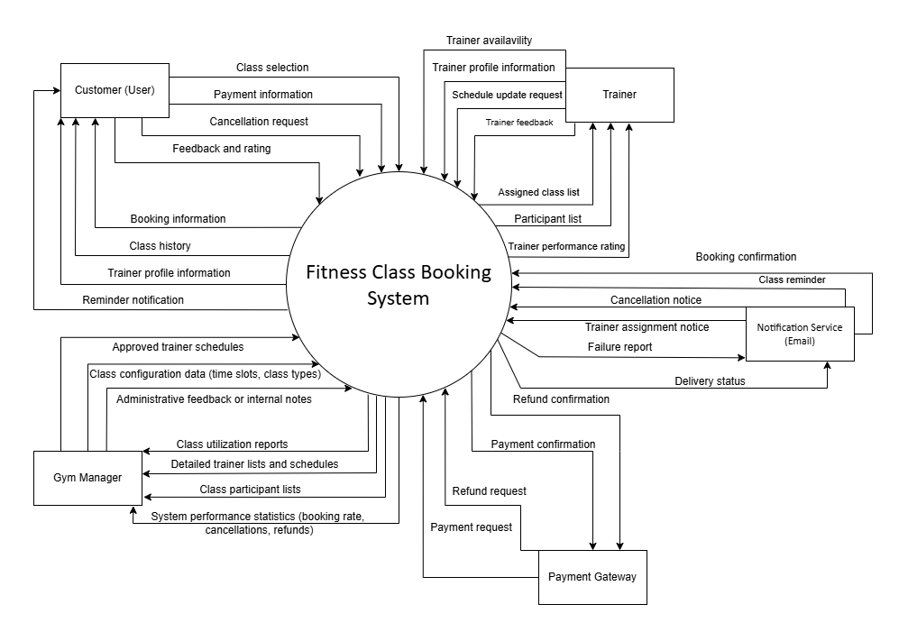

#### **1. Customer**

· **To system**:

o Class selection

o Payment information

o Cancellation request

o Feedback and rating

· **Form system**:

o Booking confirmation

o Class history

o Trainer profile information

o Reminder notification

#### **2. Trainer**

· **To system**:

o Trainer availability

o Trainer profile information

o Schedule update request

o Trainer feedback

· **From system**:

o Assigned class list

o Participant list

o Booking summary

o System notifications

o Performance ratings

#### **3. Gym Manager**

· **To system**:

o Approved trainer schedules

o Schedule update requests

o Class configuration

o Administrative notes

· **From system**:

o Class utilization reports

o Trainer list and schedule

o Participant list

o System performance statistics

o System alerts

#### **4. Payment Gateway**

· **To system**:

o Payment request

o Refund request

· **From system**:

o Payment confirmation

o Refund confirmation

#### **5. Notification Service (Email/App)**

· **To system**:

o Booking confirmation

o Class reminder

o Cancellation notice

o Trainer assignment notice

· **From system**:

o Delivery status

o Failure report

### **1.2. Swimlane Diagram:**

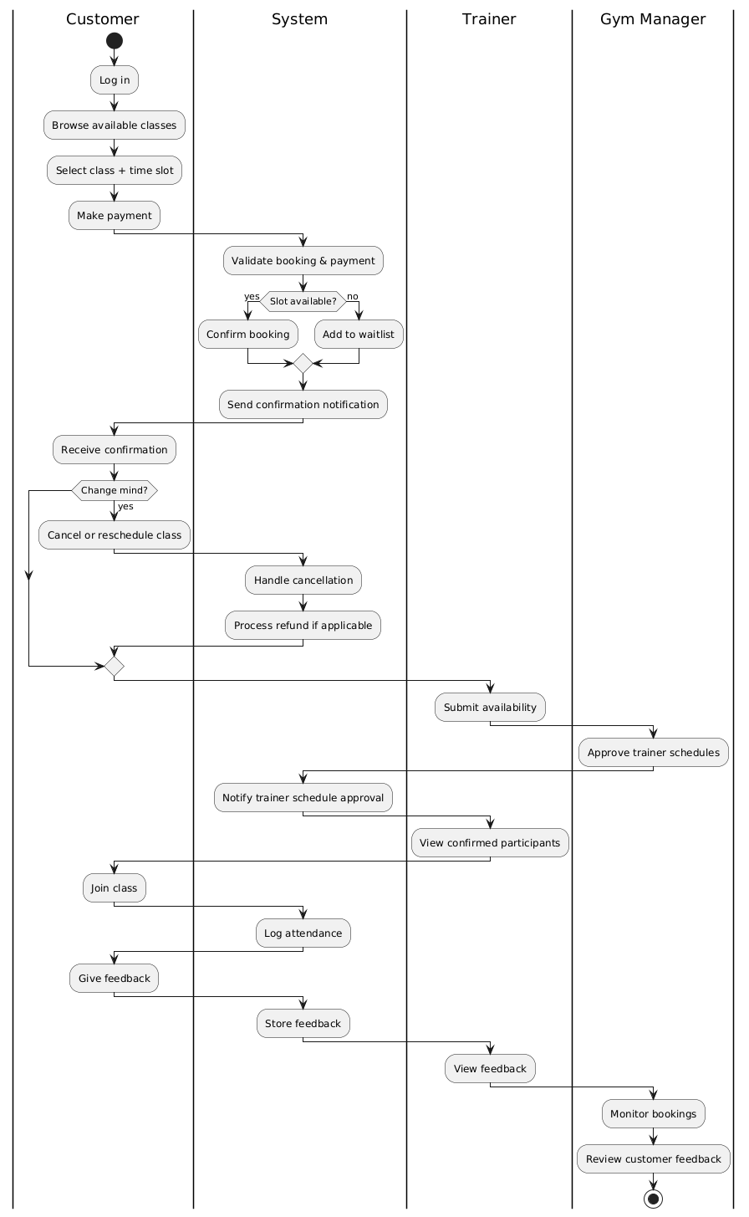

Here is the detailed summary of the Swimlane Diagram flow that was previously represented using PlantUML. The diagram illustrates the fitness class booking process through the main actors: Customer, System, Trainer, and Gym Manager.

## 

#### **1.2.1 Customer**

* Log in to the system
* Browse available fitness classes
* Select a class and time slot
* Make payment
* Receive confirmation or be waitlisted
* Optionally cancel or reschedule the class
* Join the class
* Submit feedback after the session

#### **1.2.2 System**

* Validate the booking and payment
* Check class availability  
  + If slots are available → confirm booking
  + If full → add user to waitlist
* Send confirmation notifications to the customer
* Process cancellations and handle refunds if applicable
* Send schedule confirmation to Trainer
* Log class attendance
* Store feedback submitted by the customer

#### **1.2.3. Trainer**

* Submit availability for teaching
* Receive approved schedule from Gym Manager
* View list of confirmed participants
* Deliver the class
* View feedback from participants

#### **1.2.4. Gym Manager**

* Approve trainer schedules
* Monitor class bookings and participation
* Review customer feedback to evaluate class quality

### **1.3. State Diagram:**

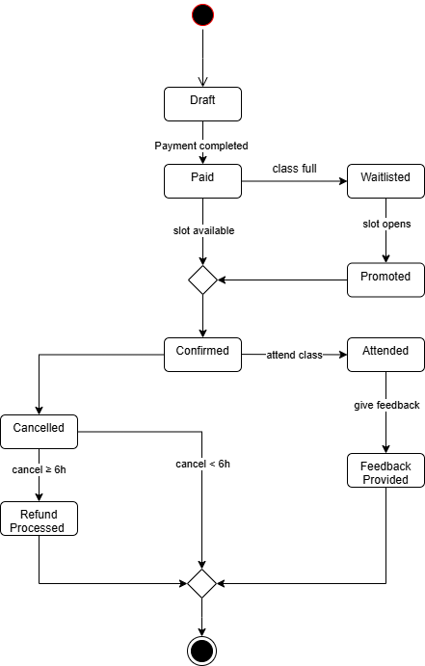

#### **Analysis of State Flow in System**

1. **Draft**: The initial state when a user starts booking a class but hasn’t completed payment.
2. **Paid**: After the user completes the online payment.
3. **Confirmed**: When the class has available slots and the booking is confirmed.
4. **Waitlisted**: If the class is full, the booking goes on a waitlist.
5. **Promoted**: If a slot becomes available due to someone’s cancellation, a user on the waitlist is promoted.
6. **Cancelled (≥6h)**: The user cancels at least 6 hours before class start, eligible for a refund.
7. **Cancelled (<6h)**: The user cancels less than 6 hours before class, no refund.
8. **Attended**: The user attends the class.
9. **Feedback Provided**: The user leaves feedback after attending the class.