BÀI TẬP BUỔI 8
Xây dựng database
create database QuanLyBanSach
use QuanLyBanSach

CREATE TABLE NHAXUATBAN (
MaNXB CHAR(10) PRIMARY KEY,
TenNXB NVARCHAR(100),
DiaChi NVARCHAR(500)
);

CREATE TABLE SACH (
MaSach CHAR(10) PRIMARY KEY,
TenSach NVARCHAR(300),
MaNXB CHAR(10),
TenTacGia NVARCHAR(100),
NamXuatBan DATETIME,
GhiChu NVARCHAR(500),
FOREIGN KEY (MaNXB) REFERENCES NHAXUATBAN(MaNXB)
);

Thực hành 1: Hiển thị danh sách nhà xuất bản sách.
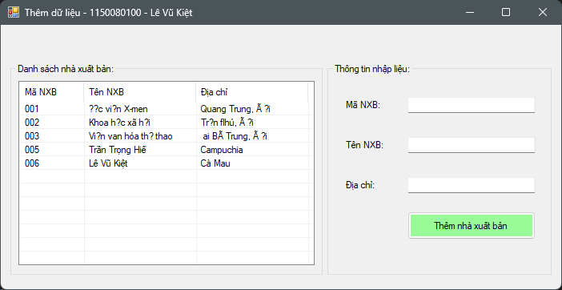

Code stored procedure:
CREATE PROC HienThiNXB
AS
BEGIN
SELECT * FROM NhaXuatBan
END

CREATE PROC HienThiChiTietNXB
@maNXB CHAR(10)
AS
BEGIN
SELECT * FROM NhaXuatBan
WHERE MANXB = @maNXB
END

Code logic:
using System;
using System.Data;
using System.Data.SqlClient;
using System.Windows.Forms;

namespace Buoi8
{
public partial class Form1 : Form
{
// Chuỗi kết nối — thay bằng của bạn
string strCon = @"Data Source=DESKTOP-D6KN1UQ\SQLSV_CON1;Initial Catalog=QuanLyBanSach;User ID=sa;Password=123";

SqlConnection sqlCon = null;

public Form1()
{
InitializeComponent();
}

private void MoKetNoi()
{
if (sqlCon == null)
sqlCon = new SqlConnection(strCon);
if (sqlCon.State == ConnectionState.Closed)
sqlCon.Open();
}

private void DongKetNoi()
{
if (sqlCon != null && sqlCon.State == ConnectionState.Open)
sqlCon.Close();
}

private void HienThiDanhSachNXB()
{
MoKetNoi();
SqlCommand sqlCmd = new SqlCommand
{
CommandType = CommandType.StoredProcedure,
CommandText = "HienThiNXB",
Connection = sqlCon
};

SqlDataReader reader = sqlCmd.ExecuteReader();
lsvDanhSach.Items.Clear();

while (reader.Read())
{
string maNXB = reader.GetString(0);
string tenNXB = reader.GetString(1);
string diaChi = reader.GetString(2);

ListViewItem lvi = new ListViewItem(maNXB);
lvi.SubItems.Add(tenNXB);
lvi.SubItems.Add(diaChi);

lsvDanhSach.Items.Add(lvi);
}
reader.Close();
DongKetNoi();
}

private void Form1_Load(object sender, EventArgs e)
{
HienThiDanhSachNXB();
}

private void lsvDanhSach_SelectedIndexChanged(object sender, EventArgs e)
{
if (lsvDanhSach.SelectedItems.Count == 0) return;

ListViewItem lvi = lsvDanhSach.SelectedItems[0];
string maNXB = lvi.SubItems[0].Text;

HienThiThongTinNXBTheoMa(maNXB);
}

private void HienThiThongTinNXBTheoMa(string maNXB)
{
MoKetNoi();
SqlCommand sqlCmd = new SqlCommand
{
CommandType = CommandType.StoredProcedure,
CommandText = "HienThiChiTietNXB",
Connection = sqlCon
};

sqlCmd.Parameters.Add(new SqlParameter("@MaNXB", SqlDbType.Char, 10) { Value = maNXB });

SqlDataReader reader = sqlCmd.ExecuteReader();
txtMaNXB.Text = txtTenNXB.Text = txtDiaChi.Text = "";

if (reader.Read())
{
txtMaNXB.Text = reader.GetString(0);
txtTenNXB.Text = reader.GetString(1);
txtDiaChi.Text = reader.GetString(2);
}
reader.Close();
DongKetNoi();
}

private void ThemNXB()
{
string maNXB = txtMaNXB.Text.Trim();
string tenNXB = txtTenNXB.Text.Trim();
string diaChi = txtDiaChi.Text.Trim();

if (maNXB == "" || tenNXB == "" || diaChi == "")
{
MessageBox.Show("Vui lòng nhập đầy đủ thông tin!", "Thông báo", MessageBoxButtons.OK, MessageBoxIcon.Warning);
return;
}

try
{
MoKetNoi();
SqlCommand sqlCmd = new SqlCommand
{
CommandType = CommandType.StoredProcedure,
CommandText = "ThemDuLieu",
Connection = sqlCon
};

sqlCmd.Parameters.Add(new SqlParameter("@MaNXB", SqlDbType.Char, 10)).Value = maNXB;
sqlCmd.Parameters.Add(new SqlParameter("@TenNXB", SqlDbType.NVarChar, 100)).Value = tenNXB;
sqlCmd.Parameters.Add(new SqlParameter("@DiaChi", SqlDbType.NVarChar, 200)).Value = diaChi;

int result = sqlCmd.ExecuteNonQuery();
DongKetNoi();

if (result > 0)
{
MessageBox.Show("Thêm nhà xuất bản thành công!", "Thông báo", MessageBoxButtons.OK, MessageBoxIcon.Information);
HienThiDanhSachNXB();
txtMaNXB.Text = "";
txtTenNXB.Text = "";
txtDiaChi.Text = "";
}
else
{
MessageBox.Show("Thêm thất bại!", "Lỗi", MessageBoxButtons.OK, MessageBoxIcon.Error);
}
}
catch (Exception ex)
{
MessageBox.Show("Lỗi: " + ex.Message, "Lỗi", MessageBoxButtons.OK, MessageBoxIcon.Error);
}
}
}
}

Thực hành 2: Thêm dữ liệu cho bảng Nhà xuất bản

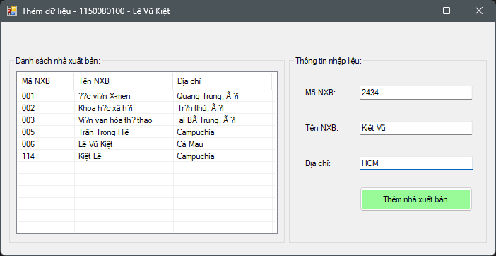
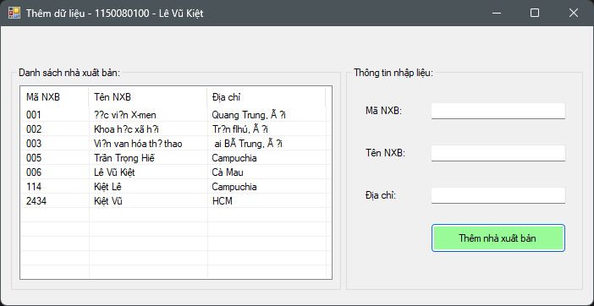

Code stored procedure:
CREATE PROC ThemDuLieu
@maNXB CHAR(10),
@tenNXB NVARCHAR(100),
@diaChi NVARCHAR(500)
AS
BEGIN
INSERT INTO NhaXuatBan (MaNXB, TenNXB, DiaChi)
VALUES (@maNXB, @tenNXB, @diaChi);
END
GO
Code logic:
using System;
using System.Data;
using System.Data.SqlClient;
using System.Windows.Forms;

namespace Buoi8
{
public partial class Form1 : Form
{
// ✅ Chuỗi kết nối — thay bằng của bạn
string strCon = @"Data Source=DESKTOP-D6KN1UQ\SQLSV_CON1;Initial Catalog=QuanLyBanSach;User ID=sa;Password=123";

SqlConnection sqlCon = null;

public Form1()
{
InitializeComponent();
}

private void MoKetNoi()
{
if (sqlCon == null)
sqlCon = new SqlConnection(strCon);
if (sqlCon.State == ConnectionState.Closed)
sqlCon.Open();
}

private void DongKetNoi()
{
if (sqlCon != null && sqlCon.State == ConnectionState.Open)
sqlCon.Close();
}

private void HienThiDanhSachNXB()
{
MoKetNoi();
SqlCommand sqlCmd = new SqlCommand
{
CommandType = CommandType.StoredProcedure,
CommandText = "HienThiNXB",
Connection = sqlCon
};

SqlDataReader reader = sqlCmd.ExecuteReader();
lsvDanhSach.Items.Clear();

while (reader.Read())
{
string maNXB = reader.GetString(0);
string tenNXB = reader.GetString(1);
string diaChi = reader.GetString(2);

ListViewItem lvi = new ListViewItem(maNXB);
lvi.SubItems.Add(tenNXB);
lvi.SubItems.Add(diaChi);

lsvDanhSach.Items.Add(lvi);
}
reader.Close();
DongKetNoi();
}

private void Form1_Load(object sender, EventArgs e)
{
HienThiDanhSachNXB();
}

private void lsvDanhSach_SelectedIndexChanged(object sender, EventArgs e)
{
if (lsvDanhSach.SelectedItems.Count == 0) return;

ListViewItem lvi = lsvDanhSach.SelectedItems[0];
string maNXB = lvi.SubItems[0].Text;

HienThiThongTinNXBTheoMa(maNXB);
}

private void HienThiThongTinNXBTheoMa(string maNXB)
{
MoKetNoi();
SqlCommand sqlCmd = new SqlCommand
{
CommandType = CommandType.StoredProcedure,
CommandText = "HienThiChiTietNXB",
Connection = sqlCon
};

sqlCmd.Parameters.Add(new SqlParameter("@MaNXB", SqlDbType.Char, 10) { Value = maNXB });

SqlDataReader reader = sqlCmd.ExecuteReader();
txtMaNXB.Text = txtTenNXB.Text = txtDiaChi.Text = "";

if (reader.Read())
{
txtMaNXB.Text = reader.GetString(0);
txtTenNXB.Text = reader.GetString(1);
txtDiaChi.Text = reader.GetString(2);
}
reader.Close();
DongKetNoi();
}

private void ThemNXB()
{
string maNXB = txtMaNXB.Text.Trim();
string tenNXB = txtTenNXB.Text.Trim();
string diaChi = txtDiaChi.Text.Trim();

if (maNXB == "" || tenNXB == "" || diaChi == "")
{
MessageBox.Show("Vui lòng nhập đầy đủ thông tin!", "Thông báo", MessageBoxButtons.OK, MessageBoxIcon.Warning);
return;
}

try
{
MoKetNoi();
SqlCommand sqlCmd = new SqlCommand
{
CommandType = CommandType.StoredProcedure,
CommandText = "ThemDuLieu",
Connection = sqlCon
};

sqlCmd.Parameters.Add(new SqlParameter("@MaNXB", SqlDbType.Char, 10)).Value = maNXB;
sqlCmd.Parameters.Add(new SqlParameter("@TenNXB", SqlDbType.NVarChar, 100)).Value = tenNXB;
sqlCmd.Parameters.Add(new SqlParameter("@DiaChi", SqlDbType.NVarChar, 200)).Value = diaChi;

int result = sqlCmd.ExecuteNonQuery();
DongKetNoi();

if (result > 0)
{
MessageBox.Show("Thêm nhà xuất bản thành công!", "Thông báo", MessageBoxButtons.OK, MessageBoxIcon.Information);
HienThiDanhSachNXB();
txtMaNXB.Text = "";
txtTenNXB.Text = "";
txtDiaChi.Text = "";
}
else
{
MessageBox.Show("Thêm thất bại!", "Lỗi", MessageBoxButtons.OK, MessageBoxIcon.Error);
}
}
catch (Exception ex)
{
MessageBox.Show("Lỗi: " + ex.Message, "Lỗi", MessageBoxButtons.OK, MessageBoxIcon.Error);
}
}
}
}
Thực hành 3: Sửa dữ liệu cho bảng Nhà Xuất bản.
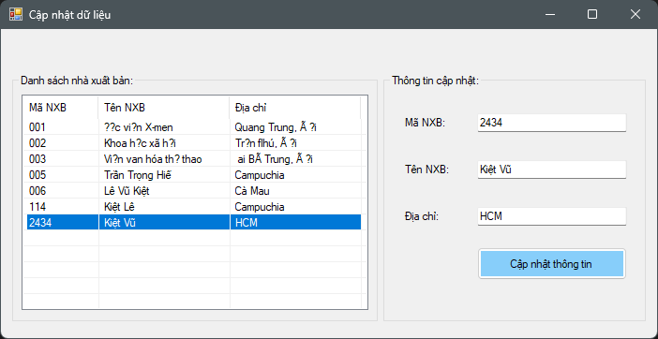
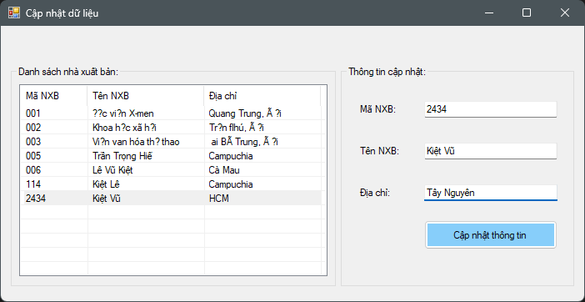
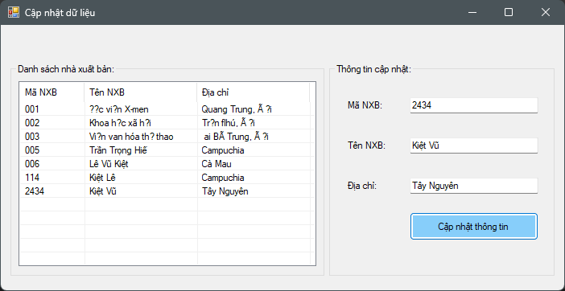

Code stored procedure:
CREATE PROC CapNhatThongTin
@maNXB CHAR(10),
@tenNXB NVARCHAR(100),
@diaChi NVARCHAR(500)
AS
BEGIN
UPDATE NhaXuatBan
SET
TenNXB = @tenNXB,
DiaChi = @diaChi
WHERE MaNXB = @maNXB;
END
GO

Code logic:
using System;
using System.Data;
using System.Data.SqlClient;
using System.Windows.Forms;

namespace Buoi8
{
public partial class Form2 : Form
{
string strCon = @"Data Source=DESKTOP-D6KN1UQ\SQLSV_CON1;Initial Catalog=QuanLyBanSach;User ID=sa;Password=123";
SqlConnection sqlCon = null;

public Form2()
{
InitializeComponent();
}

private void MoKetNoi()
{
if (sqlCon == null)
sqlCon = new SqlConnection(strCon);
if (sqlCon.State == ConnectionState.Closed)
sqlCon.Open();
}

private void DongKetNoi()
{
if (sqlCon != null && sqlCon.State == ConnectionState.Open)
sqlCon.Close();
}

private void Form2_Load(object sender, EventArgs e)
{
HienThiDanhSachNXB();
}

private void HienThiDanhSachNXB()
{
MoKetNoi();
SqlCommand cmd = new SqlCommand
{
CommandType = CommandType.StoredProcedure,
CommandText = "HienThiNXB",
Connection = sqlCon
};

SqlDataReader reader = cmd.ExecuteReader();
lsvDanhSach.Items.Clear();

while (reader.Read())
{
ListViewItem lvi = new ListViewItem(reader.GetString(0));
lvi.SubItems.Add(reader.GetString(1));
lvi.SubItems.Add(reader.GetString(2));
lsvDanhSach.Items.Add(lvi);
}
reader.Close();
DongKetNoi();
}

private void lsvDanhSach_SelectedIndexChanged(object sender, EventArgs e)
{
if (lsvDanhSach.SelectedItems.Count == 0) return;

string maNXB = lsvDanhSach.SelectedItems[0].SubItems[0].Text;
HienThiThongTinNXBTheoMa(maNXB);
}

private void HienThiThongTinNXBTheoMa(string maNXB)
{
MoKetNoi();
SqlCommand cmd = new SqlCommand
{
CommandType = CommandType.StoredProcedure,
CommandText = "HienThiChiTietNXB",
Connection = sqlCon
};
cmd.Parameters.Add(new SqlParameter("@MaNXB", SqlDbType.Char, 10)).Value = maNXB;

SqlDataReader reader = cmd.ExecuteReader();
if (reader.Read())
{
txtMaNXB.Text = reader.GetString(0);
txtTenNXB.Text = reader.GetString(1);
txtDiaChi.Text = reader.GetString(2);
}
reader.Close();
DongKetNoi();
}

private void btnCapNhat_Click(object sender, EventArgs e)
{
CapNhatNXB();
}

private void CapNhatNXB()
{
string ma = txtMaNXB.Text.Trim();
string ten = txtTenNXB.Text.Trim();
string diachi = txtDiaChi.Text.Trim();

if (ma == "" || ten == "" || diachi == "")
{
MessageBox.Show("Vui lòng nhập đầy đủ thông tin!", "Thông báo", MessageBoxButtons.OK, MessageBoxIcon.Warning);
return;
}

try
{
MoKetNoi();
SqlCommand cmd = new SqlCommand
{
CommandType = CommandType.StoredProcedure,
CommandText = "CapNhatThongTin",
Connection = sqlCon
};

cmd.Parameters.Add(new SqlParameter("@MaNXB", SqlDbType.Char, 10)).Value = ma;
cmd.Parameters.Add(new SqlParameter("@TenNXB", SqlDbType.NVarChar, 100)).Value = ten;
cmd.Parameters.Add(new SqlParameter("@DiaChi", SqlDbType.NVarChar, 200)).Value = diachi;

int result = cmd.ExecuteNonQuery();
DongKetNoi();

if (result > 0)
{
MessageBox.Show("Cập nhật thông tin thành công!", "Thông báo", MessageBoxButtons.OK, MessageBoxIcon.Information);
HienThiDanhSachNXB();
}
else
{
MessageBox.Show("Không tìm thấy mã NXB để cập nhật!", "Lỗi", MessageBoxButtons.OK, MessageBoxIcon.Warning);
}
}
catch (Exception ex)
{
MessageBox.Show("Lỗi: " + ex.Message, "Lỗi", MessageBoxButtons.OK, MessageBoxIcon.Error);
}
}
}
}

Thực hành 4: Xóa dữ liệu cho bảng Nhà xuất bản.
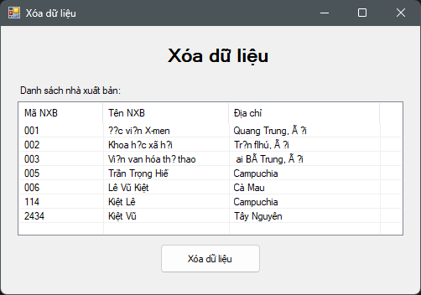
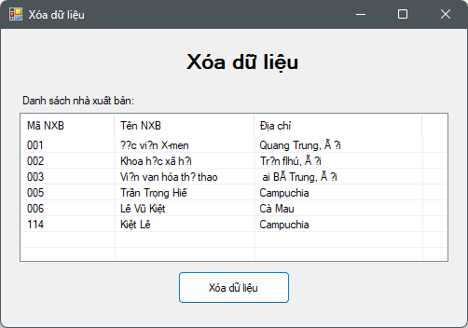

Code stored procedure:
CREATE PROC XoaNXB
@maNXB CHAR(10)
AS
BEGIN
DELETE FROM NhaXuatBan
WHERE MaNXB = @maNXB;
END
GO

Code logic:
using System;
using System.Data;
using System.Data.SqlClient;
using System.Windows.Forms;

namespace Buoi8
{
public partial class Form3 : Form
{
// 🔗 Chuỗi kết nối — thay bằng của bạn
string strCon = @"Data Source=DESKTOP-D6KN1UQ\SQLSV_CON1;Initial Catalog=QuanLyBanSach;User ID=sa;Password=123";
SqlConnection sqlCon = null;

public Form3()
{
InitializeComponent();
}

private void MoKetNoi()
{
if (sqlCon == null)
sqlCon = new SqlConnection(strCon);
if (sqlCon.State == ConnectionState.Closed)
sqlCon.Open();
}

private void DongKetNoi()
{
if (sqlCon != null && sqlCon.State == ConnectionState.Open)
sqlCon.Close();
}

// ✅ Hiển thị danh sách nhà xuất bản
private void HienThiDanhSachNXB()
{
MoKetNoi();
SqlCommand cmd = new SqlCommand
{
CommandType = CommandType.StoredProcedure,
CommandText = "HienThiNXB",
Connection = sqlCon
};

SqlDataReader reader = cmd.ExecuteReader();
lsvDanhSach.Items.Clear();

while (reader.Read())
{
string maNXB = reader.GetString(0);
string tenNXB = reader.GetString(1);
string diaChi = reader.GetString(2);

ListViewItem lvi = new ListViewItem(maNXB);
lvi.SubItems.Add(tenNXB);
lvi.SubItems.Add(diaChi);

lsvDanhSach.Items.Add(lvi);
}
reader.Close();
DongKetNoi();
}

// 🗑️ Hàm xóa NXB được chọn
private void XoaNXB(string maNXB)
{
try
{
MoKetNoi();
SqlCommand cmd = new SqlCommand
{
CommandType = CommandType.StoredProcedure,
CommandText = "XoaNXB",
Connection = sqlCon
};
cmd.Parameters.Add(new SqlParameter("@MaNXB", SqlDbType.Char, 10)).Value = maNXB;

int result = cmd.ExecuteNonQuery();
DongKetNoi();

if (result > 0)
MessageBox.Show("Xóa nhà xuất bản thành công!", "Thông báo", MessageBoxButtons.OK, MessageBoxIcon.Information);
else
MessageBox.Show("Không thể xóa nhà xuất bản!", "Thông báo", MessageBoxButtons.OK, MessageBoxIcon.Warning);

HienThiDanhSachNXB();
}
catch (Exception ex)
{
MessageBox.Show("Lỗi: " + ex.Message, "Lỗi", MessageBoxButtons.OK, MessageBoxIcon.Error);
}
}

private void Form3_Load(object sender, EventArgs e)
{
HienThiDanhSachNXB();
}

private void btnXoa_Click(object sender, EventArgs e)
{
if (lsvDanhSach.SelectedItems.Count == 0)
{
MessageBox.Show("Vui lòng chọn dòng cần xóa!", "Thông báo", MessageBoxButtons.OK, MessageBoxIcon.Warning);
return;
}

string maNXB = lsvDanhSach.SelectedItems[0].SubItems[0].Text;

DialogResult dr = MessageBox.Show($"Bạn có chắc chắn muốn xóa NXB [{maNXB}] không?",
"Xác nhận xóa",
MessageBoxButtons.YesNo,
MessageBoxIcon.Question);

if (dr == DialogResult.Yes)
{
XoaNXB(maNXB);
}
}
}
}

