BÀI TẬP TUẦN 8

Bài 1:

package dtm;
import io.github.bonigarcia.wdm.WebDriverManager;
import org.openqa.selenium.By;
import org.openqa.selenium.WebDriver;
import org.openqa.selenium.WebElement;
import org.openqa.selenium.chrome.ChromeDriver;
import org.testng.Assert;
import org.testng.annotations.AfterMethod;
import org.testng.annotations.BeforeMethod;
import org.testng.annotations.Test;
public class TitleTest {
WebDriver driver;
@BeforeMethod
public void setUp() {
WebDriverManager.chromedriver().setup();
driver = new ChromeDriver();
driver.manage().window().maximize();
driver.get("https://www.saucedemo.com");
}
@Test(description = "Kiem thu tieu de trang chu")
public void testTitle() {
String expectedTitle = "Swag Labs";
String actualTitle = driver.getTitle();
Assert.assertEquals(actualTitle, expectedTitle, "Tieu de trang khong dung!");
}
@Test(description = "Kiem thu URL trang chu")
public void testURL() {
String actualUrl = driver.getCurrentUrl();
Assert.assertTrue(actualUrl.contains("saucedemo"), "URL khong hop le!");
}
@Test(description = "Kiem thu page source co chua noi dung mong doi")
public void testPageSource() {
String pageSource = driver.getPageSource();
Assert.assertTrue(pageSource.contains("Swag Labs"), "Page source khong chua noi dung mong doi!");
}
@Test(description = "Kiem thu form dang nhap co hien thi hay khong")
public void testLoginFormDisplayed() {
WebElement usernameField = driver.findElement(By.id("user-name"));
WebElement passwordField = driver.findElement(By.id("password"));
WebElement loginButton = driver.findElement(By.id("login-button"));
Assert.assertTrue(usernameField.isDisplayed(), "O username khong hien thi!");
Assert.assertTrue(passwordField.isDisplayed(), "O password khong hien thi!");
Assert.assertTrue(loginButton.isDisplayed(), "Nut login khong hien thi!");
}
@AfterMethod
public void tearDown() {
if (driver != null) {
driver.quit();
}
}
}
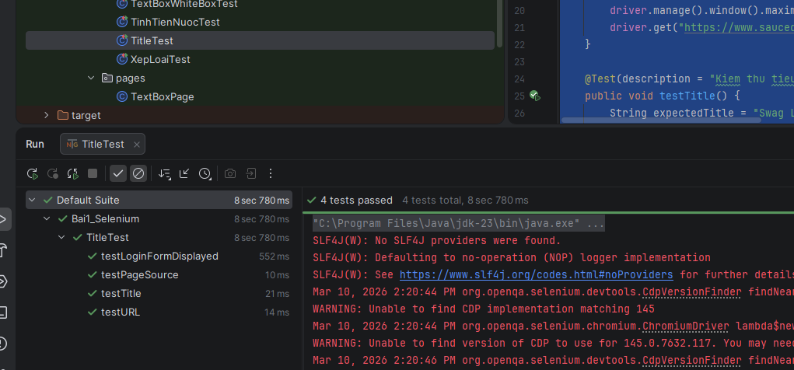

package dtm;

import io.github.bonigarcia.wdm.WebDriverManager;
import org.openqa.selenium.By;
import org.openqa.selenium.WebDriver;
import org.openqa.selenium.WebElement;
import org.openqa.selenium.chrome.ChromeDriver;
import org.openqa.selenium.support.ui.ExpectedConditions;
import org.openqa.selenium.support.ui.WebDriverWait;
import org.testng.Assert;
import org.testng.annotations.AfterMethod;
import org.testng.annotations.BeforeMethod;
import org.testng.annotations.Test;

import java.time.Duration;

public class LoginTest {
WebDriver driver;
WebDriverWait wait;

@BeforeMethod(alwaysRun = true)
public void setUp() {
WebDriverManager.chromedriver().setup();
driver = new ChromeDriver();
driver.manage().window().maximize();
driver.get("https://www.saucedemo.com");
wait = new WebDriverWait(driver, Duration.ofSeconds(10));
}

public void login(String username, String password) {
WebElement usernameField = wait.until(
ExpectedConditions.visibilityOfElementLocated(By.id("user-name")));
WebElement passwordField = wait.until(
ExpectedConditions.visibilityOfElementLocated(By.id("password")));
WebElement loginButton = wait.until(
ExpectedConditions.elementToBeClickable(By.id("login-button")));

usernameField.clear();
usernameField.sendKeys(username);

passwordField.clear();
passwordField.sendKeys(password);

loginButton.click();
}

@Test(groups = {"smoke", "regression"})
public void testLoginSuccess() {
login("standard_user", "secret_sauce");
wait.until(ExpectedConditions.urlContains("inventory.html"));
Assert.assertTrue(driver.getCurrentUrl().contains("inventory.html"),
"Dang nhap thanh cong nhung khong chuyen den trang inventory!");
}

@Test(groups = {"regression"})
public void testLoginWrongPassword() {
login("standard_user", "wrong_password");
WebElement errorMessage = wait.until(
ExpectedConditions.visibilityOfElementLocated(By.cssSelector("[data-test='error']")));
Assert.assertTrue(errorMessage.isDisplayed(),
"Khong hien thi thong bao loi khi nhap sai mat khau!");
}

@Test(groups = {"regression"})
public void testLoginEmptyUsername() {
login("", "secret_sauce");
WebElement errorMessage = wait.until(
ExpectedConditions.visibilityOfElementLocated(By.cssSelector("[data-test='error']")));
Assert.assertTrue(errorMessage.getText().contains("Username is required"),
"Thong bao loi khi de trong username khong dung!");
}

@Test(groups = {"regression"})
public void testLoginEmptyPassword() {
login("standard_user", "");
WebElement errorMessage = wait.until(
ExpectedConditions.visibilityOfElementLocated(By.cssSelector("[data-test='error']")));
Assert.assertTrue(errorMessage.getText().contains("Password is required"),
"Thong bao loi khi de trong password khong dung!");
}

@Test(groups = {"regression"})
public void testLoginLockedUser() {
login("locked_out_user", "secret_sauce");
WebElement errorMessage = wait.until(
ExpectedConditions.visibilityOfElementLocated(By.cssSelector("[data-test='error']")));
Assert.assertTrue(errorMessage.getText().contains("Sorry, this user has been locked out"),
"Thong bao loi tai khoan bi khoa khong dung!");
}

@AfterMethod(alwaysRun = true)
public void tearDown() {
if (driver != null) {
driver.quit();
}
}
}

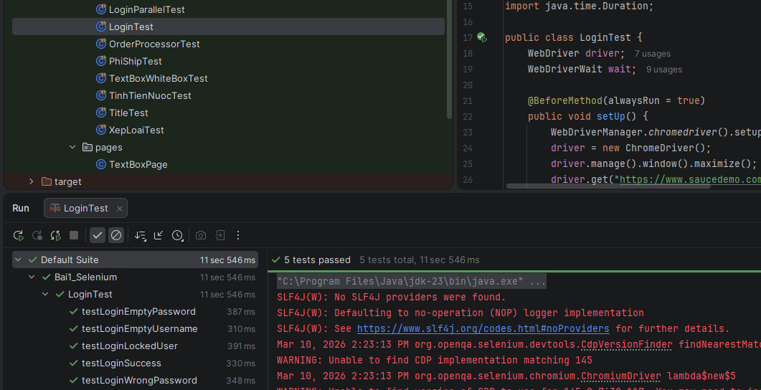

Bài 2:
2.1.
<?xml version="1.0" encoding="UTF-8"?>
<!DOCTYPE suite SYSTEM "https://testng.org/testng-1.0.dtd">
<suite name="SauceDemo_Suite" verbose="1">
<test name="All Smoke Tests">
<groups>
<run>
<include name="regression"/>
</run>
</groups>
<classes>
<class name="dtm.LoginTest"/>
<class name="dtm.CartTest"/>
<class name="dtm.CheckoutTest"/>
</classes>
</test>
</suite>

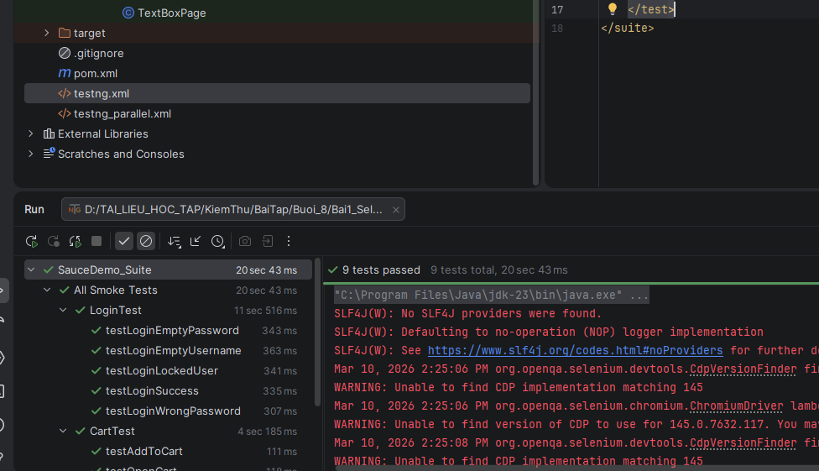

<?xml version="1.0" encoding="UTF-8"?>
<!DOCTYPE suite SYSTEM "https://testng.org/testng-1.0.dtd">
<suite name="SauceDemo_Suite" verbose="1">
<test name="All Smoke Tests">
<groups>
<run>
<include name="smoke"/>
</run>
</groups>
<classes>
<class name="dtm.LoginTest"/>
<class name="dtm.CartTest"/>
<class name="dtm.CheckoutTest"/>
</classes>
</test>
</suite>

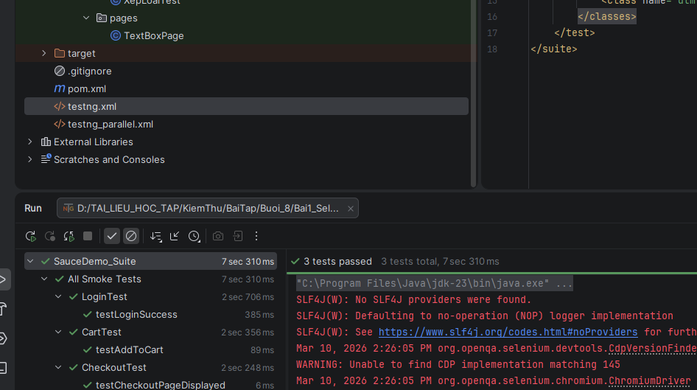

2.2.
package dtm;
import io.github.bonigarcia.wdm.WebDriverManager;
import org.openqa.selenium.WebDriver;
import org.openqa.selenium.chrome.ChromeDriver;
import org.openqa.selenium.firefox.FirefoxDriver;
public class DriverFactory {
private static ThreadLocal<WebDriver> tlDriver = new ThreadLocal<>();
public static void initDriver(String browser) {
WebDriver driver;
switch (browser.toLowerCase()) {
case "firefox":
WebDriverManager.firefoxdriver().setup();
driver = new FirefoxDriver();
break;
default:
WebDriverManager.chromedriver().setup();
driver = new ChromeDriver();
break;
}
driver.manage().window().maximize();
tlDriver.set(driver);
}
public static WebDriver getDriver() {
return tlDriver.get();
}
public static void quitDriver() {
if (tlDriver.get() != null) {
tlDriver.get().quit();
tlDriver.remove();
}
}
}
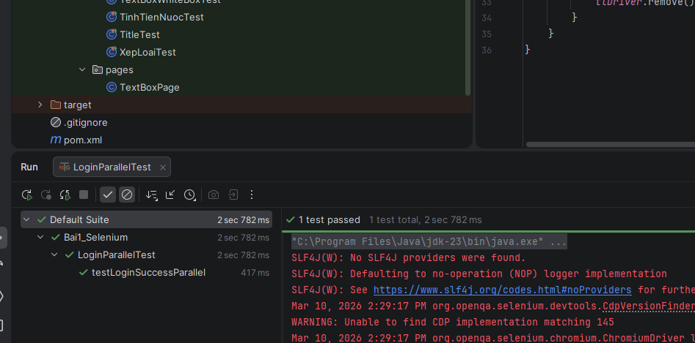

Bài 3:
3.1.
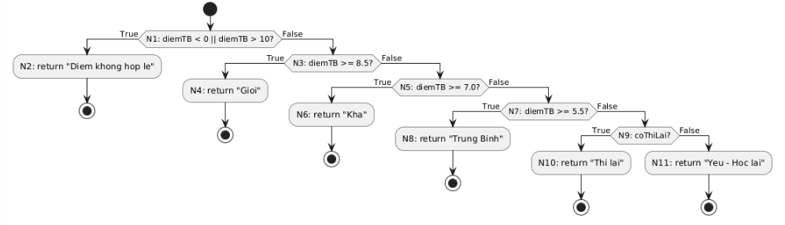
TC | diemTB | coThiLai | Kết quả mong đợi | Đường đi CFG
TC1 | -1 | false | Diem khong hop le | N0 → N1(T) → N2 → N12
TC2 | 9.0 | false | Gioi | N0 → N1(F) → N3(T) → N4 → N12
TC3 | 7.5 | false | Kha | N0 → N1(F) → N3(F) → N5(T) → N6 → N12
TC4 | 6.0 | false | Trung Binh | N0 → N1(F) → N3(F) → N5(F) → N7(T) → N8 → N12
TC5 | 4.0 | true | Thi lai | N0 → N1(F) → N3(F) → N5(F) → N7(F) → N9(T) → N10 → N12
TC6 | 4.0 | false | Yeu - Hoc lai | N0 → N1(F) → N3(F) → N5(F) → N7(F) → N9(F) → N11 → N12

package dtm;

import org.testng.Assert;
import org.testng.annotations.Test;
import vn.shopvn.XepLoai;

public class XepLoaiTest {

@Test(description = "TC1 - Diem khong hop le")
public void testInvalidScore() {
String actual = XepLoai.xepLoai(-1, false);
Assert.assertEquals(actual, "Diem khong hop le",
"Diem am phai tra ve 'Diem khong hop le'");
}

@Test(description = "TC2 - Xep loai Gioi")
public void testGioi() {
String actual = XepLoai.xepLoai(9.0, false);
Assert.assertEquals(actual, "Gioi",
"Diem >= 8.5 phai xep loai Gioi");
}

@Test(description = "TC3 - Xep loai Kha")
public void testKha() {
String actual = XepLoai.xepLoai(7.5, false);
Assert.assertEquals(actual, "Kha",
"Diem tu 7.0 den duoi 8.5 phai xep loai Kha");
}

@Test(description = "TC4 - Xep loai Trung Binh")
public void testTrungBinh() {
String actual = XepLoai.xepLoai(6.0, false);
Assert.assertEquals(actual, "Trung Binh",
"Diem tu 5.5 den duoi 7.0 phai xep loai Trung Binh");
}

@Test(description = "TC5 - Thi lai")
public void testThiLai() {
String actual = XepLoai.xepLoai(4.0, true);
Assert.assertEquals(actual, "Thi lai",
"Diem duoi 5.5 va co thi lai phai tra ve 'Thi lai'");
}

@Test(description = "TC6 - Yeu hoc lai")
public void testYeuHocLai() {
String actual = XepLoai.xepLoai(4.0, false);
Assert.assertEquals(actual, "Yeu - Hoc lai",
"Diem duoi 5.5 va khong thi lai phai tra ve 'Yeu - Hoc lai'");
}
}

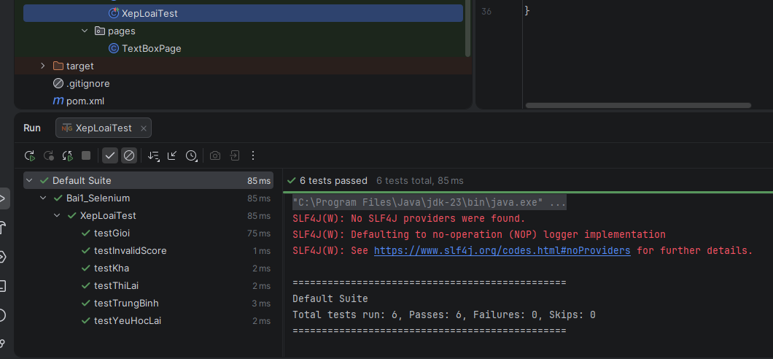

3.2.
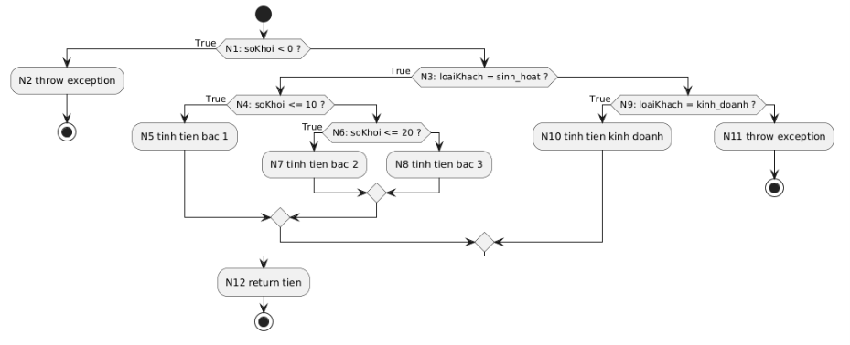
Bảng test case
TC | soKhoi | loaiKhach | Expected
TC1 | -1 | sinh_hoat | exception
TC2 | 5 | sinh_hoat | 25000
TC3 | 15 | sinh_hoat | 80000
TC4 | 25 | sinh_hoat | 180000
TC5 | 10 | kinh_doanh | 100000
TC6 | 10 | abc | exception

Bao phủ nhánh
Decision | True | False
D1 | TC1 | TC2
D2 | TC2 | TC5
D3 | TC2 | TC3
D4 | TC3 | TC4
D5 | TC5 | TC6

public class TinhTienNuocTest {

@Test(expectedExceptions = IllegalArgumentException.class)
public void testSoKhoiAm() {
TinhTienNuoc.tinhTienNuoc(-1, "sinh_hoat");
}

@Test
public void testBac1() {
double result = TinhTienNuoc.tinhTienNuoc(5, "sinh_hoat");
Assert.assertEquals(result, 25000);
}

@Test
public void testBac2() {
double result = TinhTienNuoc.tinhTienNuoc(15, "sinh_hoat");
Assert.assertEquals(result, 80000);
}

@Test
public void testBac3() {
double result = TinhTienNuoc.tinhTienNuoc(25, "sinh_hoat");
Assert.assertEquals(result, 180000);
}

@Test
public void testKinhDoanh() {
double result = TinhTienNuoc.tinhTienNuoc(10, "kinh_doanh");
Assert.assertEquals(result, 100000);
}

@Test(expectedExceptions = IllegalArgumentException.class)
public void testLoaiKhachSai() {
TinhTienNuoc.tinhTienNuoc(10, "abc");
}
}

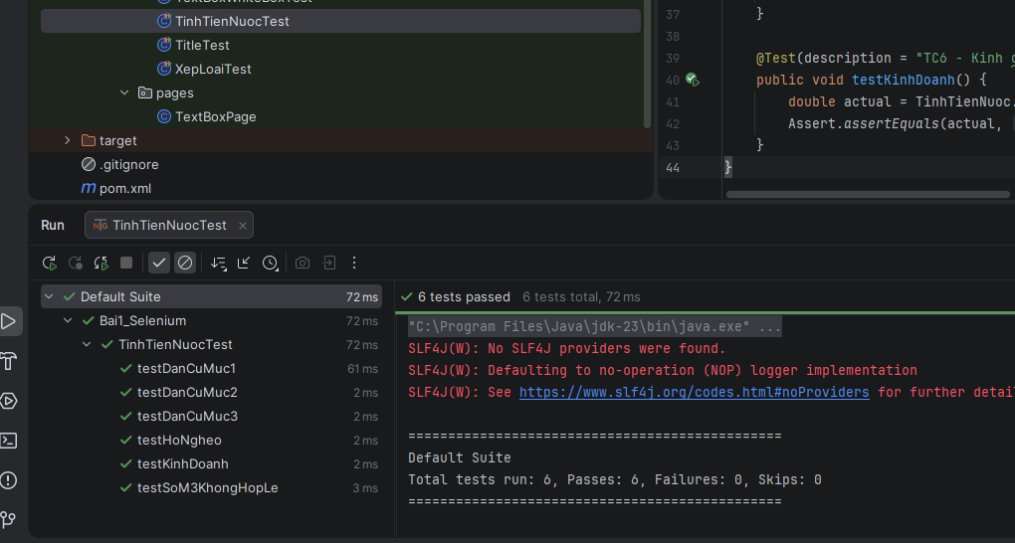

Bài 4:
Công thức:
CC = số decision + 1
Áp dụng:
CC = 7 + 1 = 8
Vậy:
Cyclomatic Complexity = 8
=> Cần tối thiểu 8 basis paths.

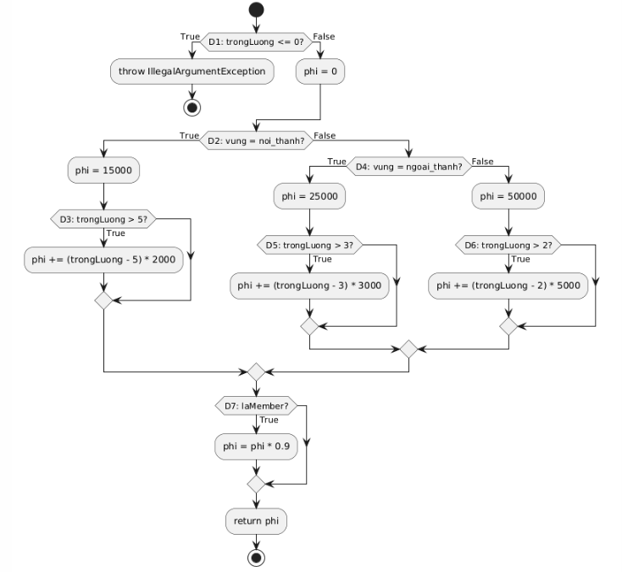
package dtm;

import org.testng.Assert;
import org.testng.annotations.Test;
import vn.shopvn.PhiShip;

public class PhiShipTest {

@Test(expectedExceptions = IllegalArgumentException.class)
public void testInvalidWeight() {
PhiShip.tinhPhiShip(-1, "noi_thanh", false);
}

@Test
public void testNoiThanhBasic() {
Assert.assertEquals(PhiShip.tinhPhiShip(4, "noi_thanh", false), 15000.0);
}

@Test
public void testNoiThanhExtra() {
Assert.assertEquals(PhiShip.tinhPhiShip(7, "noi_thanh", false), 19000.0);
}

@Test
public void testNgoaiThanhBasic() {
Assert.assertEquals(PhiShip.tinhPhiShip(2, "ngoai_thanh", false), 25000.0);
}

@Test
public void testNgoaiThanhExtra() {
Assert.assertEquals(PhiShip.tinhPhiShip(6, "ngoai_thanh", false), 34000.0);
}
@Test
public void testTinhKhacBasic() {
Assert.assertEquals(PhiShip.tinhPhiShip(1, "tinh_khac", false), 50000.0);
}
@Test
public void testTinhKhacExtra() {
Assert.assertEquals(PhiShip.tinhPhiShip(5, "tinh_khac", false), 65000.0);
}
@Test
public void testMemberDiscount() {
Assert.assertEquals(PhiShip.tinhPhiShip(5, "noi_thanh", true), 13500.0);
}
}

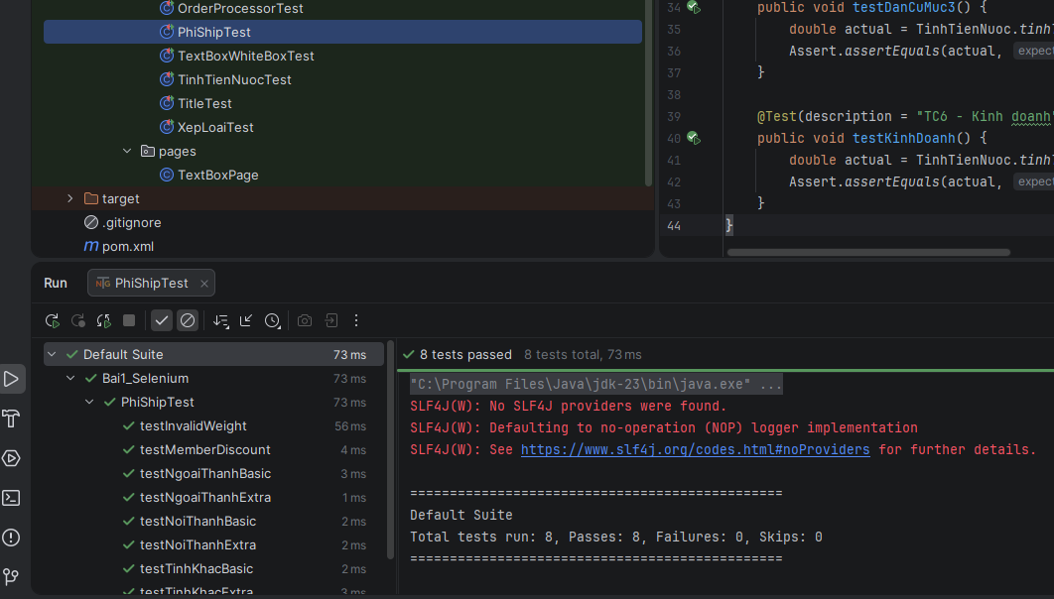

Bài 5:
5.1.
Các điều kiện đơn
Ký hiệu | Điều kiện đơn | Ý nghĩa
A | tuoi >= 22 | khách hàng đủ tuổi
B | thuNhap >= 10_000_000 | thu nhập đạt yêu cầu
C | coTaiSanBaoLanh | có tài sản bảo lãnh
D | diemTinDung >= 700 | điểm tín dụng tốt

Do có 4 điều kiện nên số rule là 2^4 = 16
Chọn tập test tối thiểu cho MC/DC
TC | tuoi | thuNhap | coTaiSanBaoLanh | diemTinDung | A | B | C | D | F
TC1 | 25 | 12_000_000 | true | 650 | T | T | T | F | T
TC2 | 20 | 12_000_000 | true | 650 | F | T | T | F | F
TC3 | 25 | 8_000_000 | true | 650 | T | F | T | F | F
TC4 | 25 | 12_000_000 | false | 650 | T | T | F | F | F
TC5 | 25 | 12_000_000 | false | 750 | T | T | F | T | T

Chứng minh MC/DC cho từng điều kiện
Điều kiện A độc lập
So sánh TC1 và TC2:
TC | A | B | C | D | F
TC1 | T | T | T | F | T
TC2 | F | T | T | F | F

Điều kiện B độc lập
So sánh TC1 và TC3:
TC | A | B | C | D | F
TC1 | T | T | T | F | T
TC3 | T | F | T | F | F

Điều kiện C độc lập
So sánh TC1 và TC4:
TC | A | B | C | D | F
TC1 | T | T | T | F | T
TC4 | T | T | F | F | F

Điều kiện D độc lập
So sánh TC4 và TC5:
TC | A | B | C | D | F
TC4 | T | T | F | F | F
TC5 | T | T | F | T | T

package dtm;

import org.testng.Assert;
import org.testng.annotations.Test;
import vn.shopvn.VayVon;

public class VayVonMCDCTest {

@Test(description = "MC/DC - Dieu kien tuoi doc lap")
public void testMCDC_TuoiDocLap() {
boolean actual = VayVon.duDieuKienVay(20, 12_000_000, true, 650);
Assert.assertFalse(actual,
"Tuoi < 22 thi khong du dieu kien vay");
}

@Test(description = "MC/DC - Dieu kien thu nhap doc lap")
public void testMCDC_ThuNhapDocLap() {
boolean actual = VayVon.duDieuKienVay(25, 8_000_000, true, 650);
Assert.assertFalse(actual,
"Thu nhap < 10 trieu thi khong du dieu kien vay");
}

@Test(description = "MC/DC - Dieu kien tai san bao lanh doc lap")
public void testMCDC_TaiSanDocLap() {
boolean actual = VayVon.duDieuKienVay(25, 12_000_000, false, 650);
Assert.assertFalse(actual,
"Khong co tai san va diem tin dung thap thi khong du dieu kien vay");
}

@Test(description = "MC/DC - Dieu kien diem tin dung doc lap")
public void testMCDC_DiemTinDungDocLap() {
boolean actual = VayVon.duDieuKienVay(25, 12_000_000, false, 750);
Assert.assertTrue(actual,
"Diem tin dung >= 700 thi du dieu kien vay khi cac dieu kien khac hop le");
}

@Test(description = "MC/DC - Truong hop co so de so sanh")
public void testMCDC_BaseCase() {
boolean actual = VayVon.duDieuKienVay(25, 12_000_000, true, 650);
Assert.assertTrue(actual,
"Truong hop co so phai du dieu kien vay");
}
}

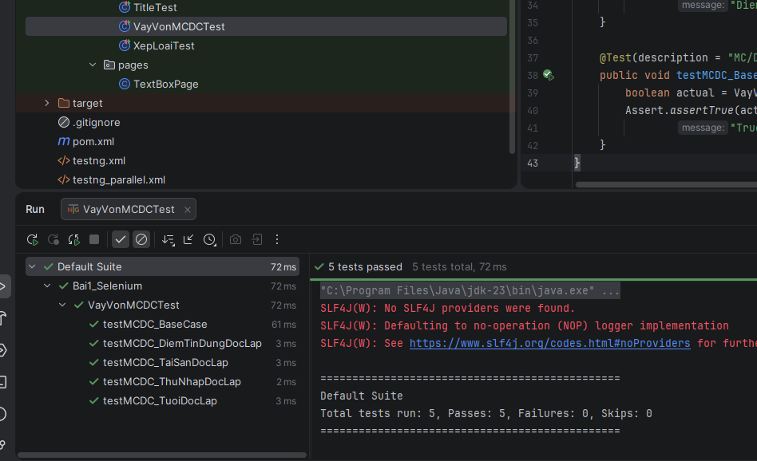

Bài 6:
6.1.
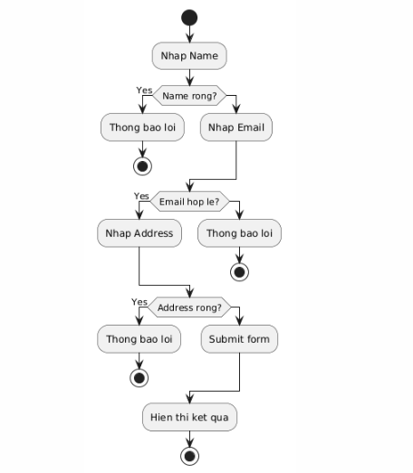
Thiết kế test case:
TC | Name | Email | Address | Expected
TC1 | Nguyen Van A | test@gmail.com | HCM | hiển thị kết quả
TC2 | "" | test@gmail.com | HCM | lỗi name
TC3 | Nguyen | invalid_email | HCM | lỗi email
TC4 | Nguyen | test@gmail.com | "" | lỗi address
TC5 | " " | test@gmail.com | HCM | lỗi name
TC6 | Nguyen@123 | test@gmail.com | HCM | chấp nhận

Bao phủ luồng CFG

Decision | True | False
Name empty | TC2 | TC1
Email valid | TC1 | TC3
Address empty | TC4 | TC1

6.2.
package dtm;

import org.openqa.selenium.WebDriver;
import org.openqa.selenium.chrome.ChromeDriver;
import org.testng.Assert;
import org.testng.annotations.*;

import pages.TextBoxPage;

public class TextBoxWhiteBoxTest {

WebDriver driver;
TextBoxPage page;

@BeforeMethod
public void setup() {

driver = new ChromeDriver();
driver.manage().window().maximize();

driver.get("https://demoqa.com/text-box");

page = new TextBoxPage(driver);
}

@Test(description = "Valid input")
public void testValidInput() {

page.fillForm(
"Nguyen Van A",
"test@gmail.com",
"Ho Chi Minh"
);

page.submitForm();

Assert.assertTrue(
page.getResultText().contains("Nguyen Van A")
);
}

@Test(description = "Invalid email")
public void testInvalidEmail() {

page.fillForm(
"Nguyen",
"invalid_email",
"HCM"
);

page.submitForm();

Assert.assertFalse(
page.getResultText().contains("invalid_email")
);
}

@Test(description = "Empty name")
public void testEmptyName() {

page.fillForm(
"",
"test@gmail.com",
"HCM"
);

page.submitForm();

Assert.assertFalse(
page.getResultText().contains("Name")
);
}

@AfterMethod
public void teardown() {
driver.quit();
}
}

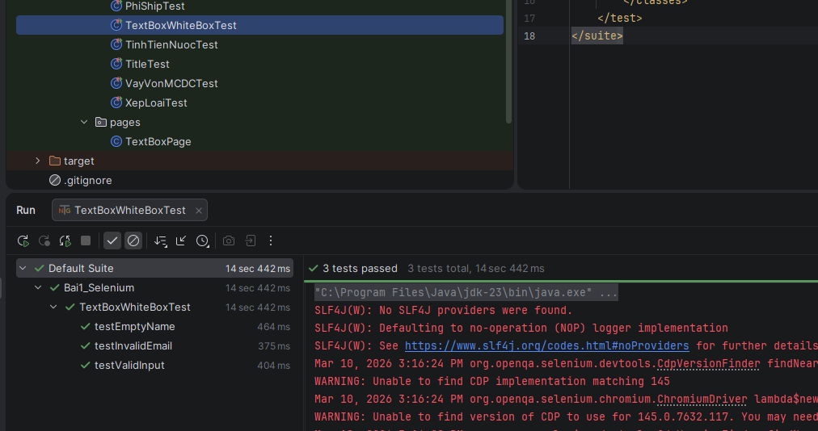

Bài 7:

