**REPORT**

1. **Workflow**

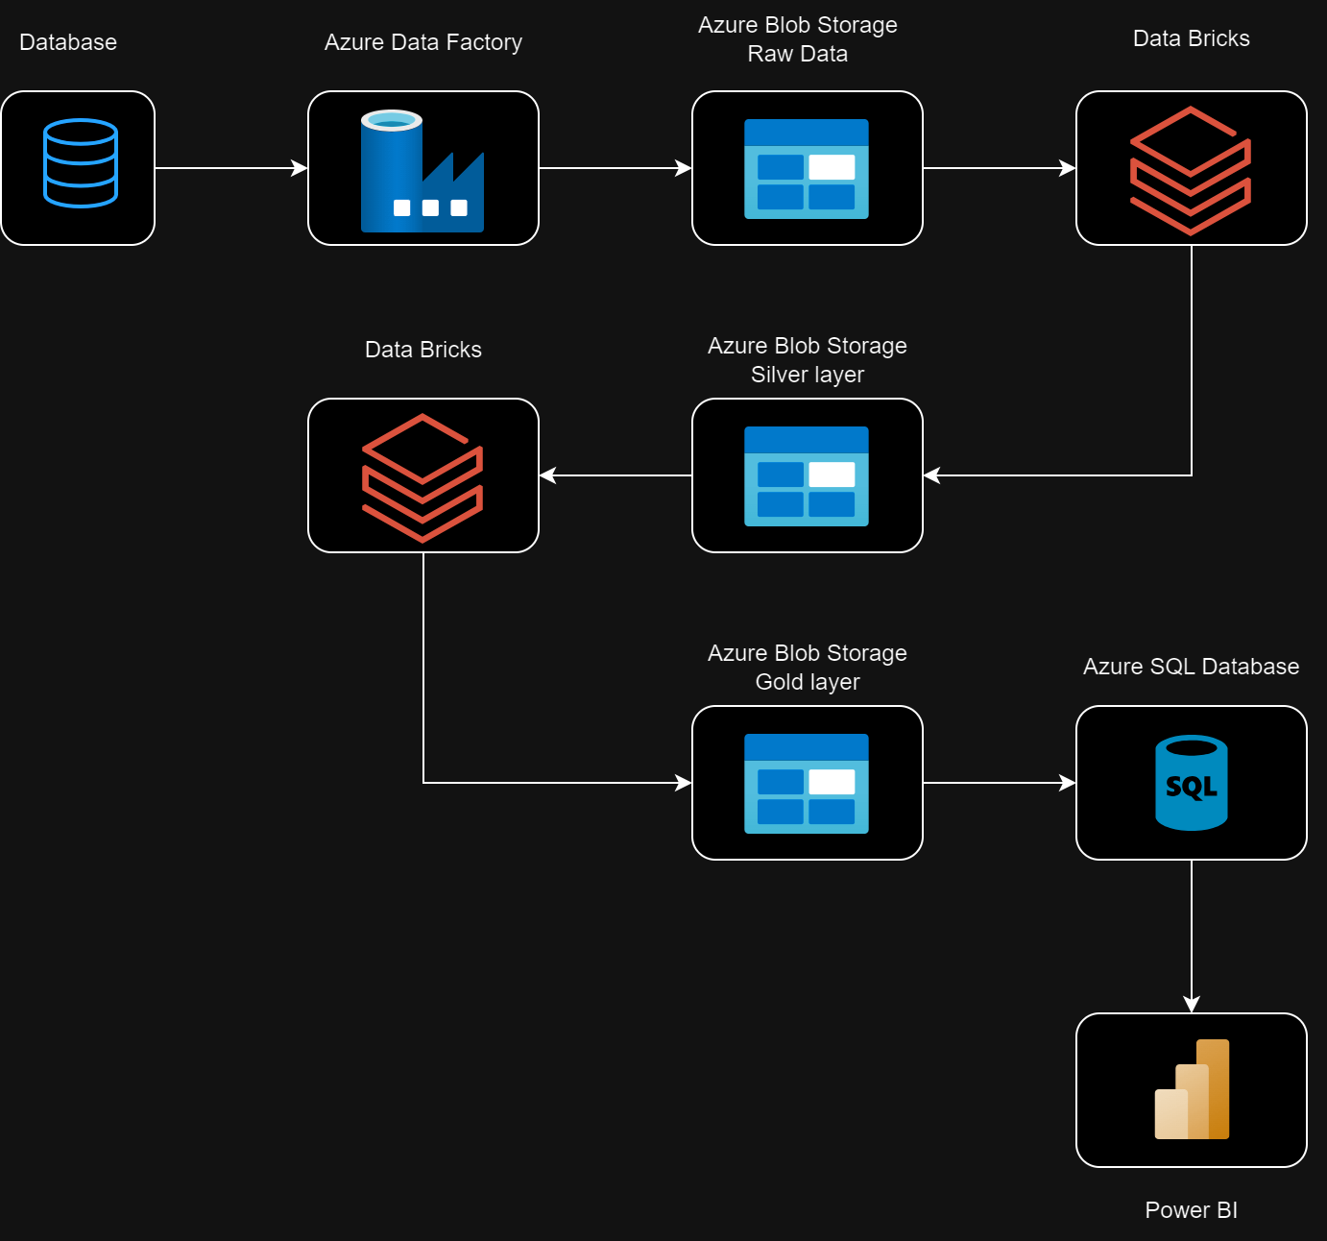

1. **Create a pipeline from local to Blob Storage**

If you want to bring data from local to data blob you have to create a pipeline from SQL local to Data Factory to Blob Storage. And to do that we have to configure the integration runtimes and links.

* 1. Create integration runtime

It provides the infrastructure to perform data integration activities, including data transformation, data migration, and data workflow management.

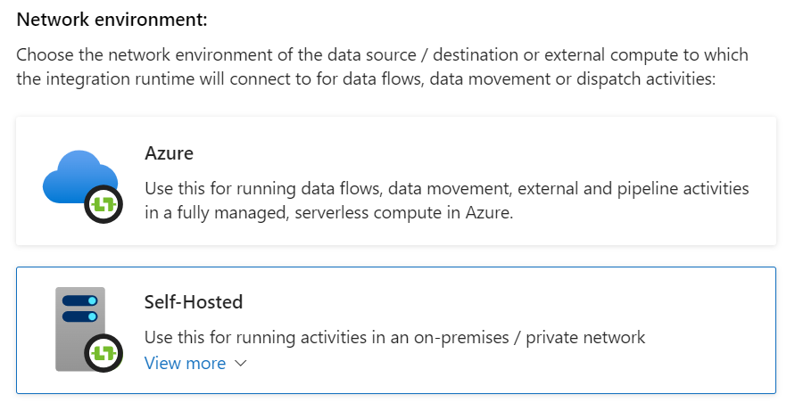

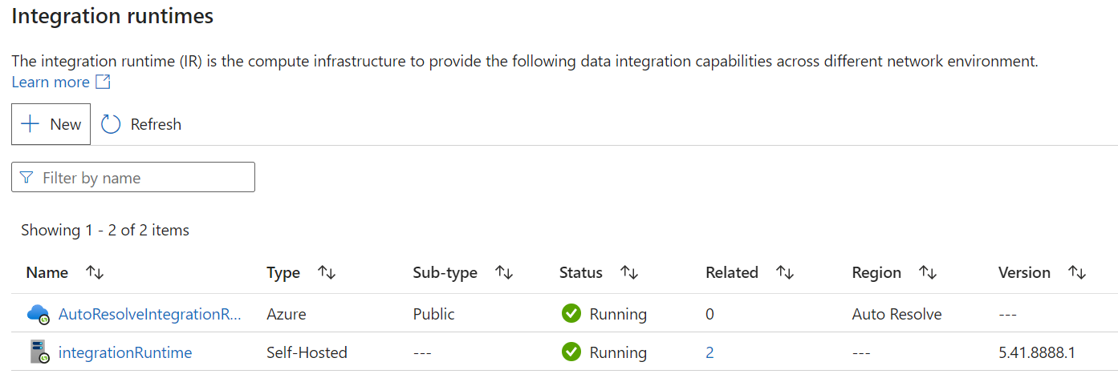

* 1. Create Linked services to the SQL Server

Create link to link from SQL local to Data Factory.

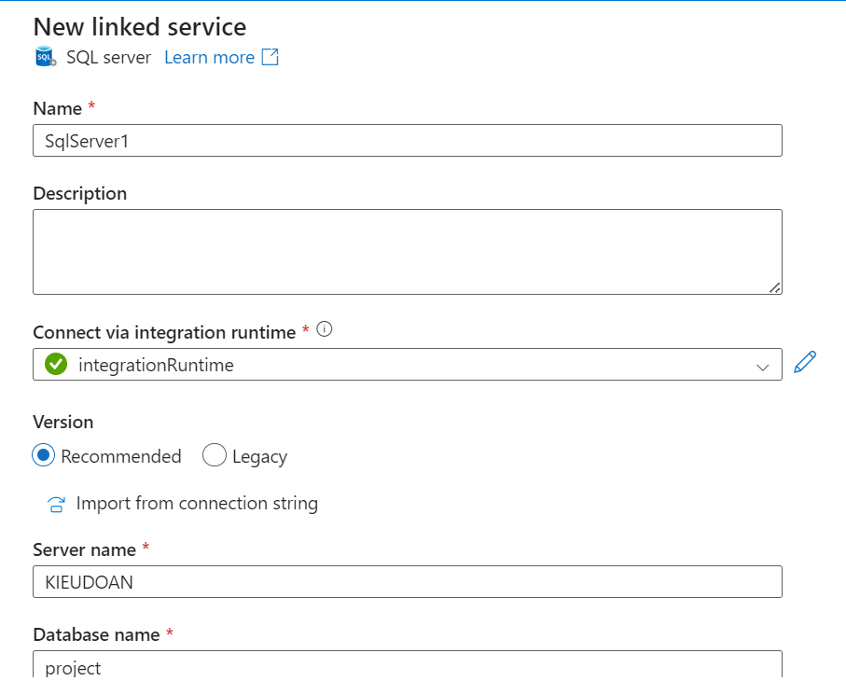

* 1. Create Linked services to the Blob Storage

Create a link to link from Data Factory to Blob Storage.

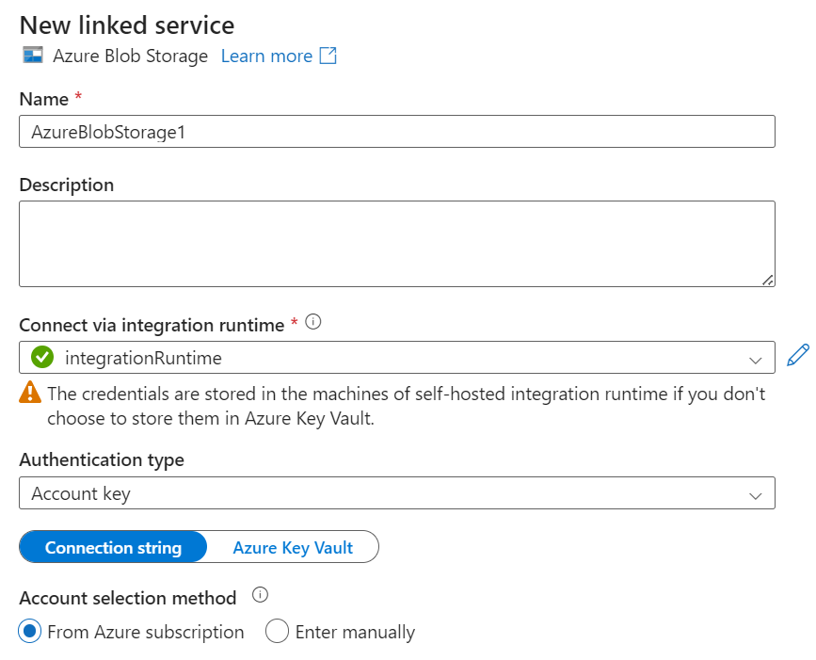

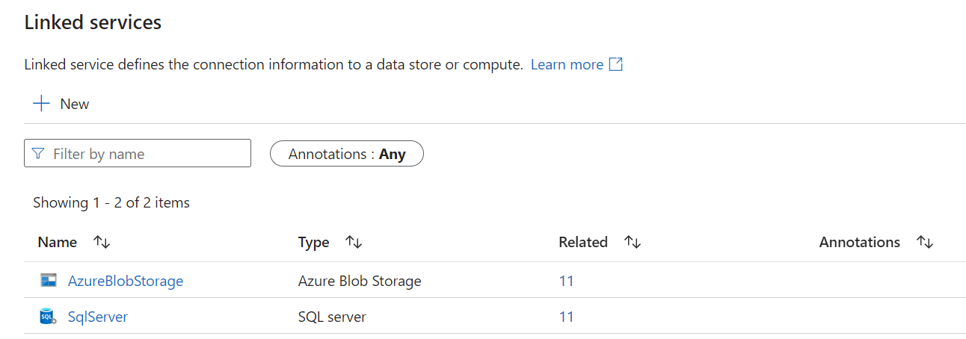

* 1. Create Pipeline

Configure input and output for each data in the pipeline from the created links.

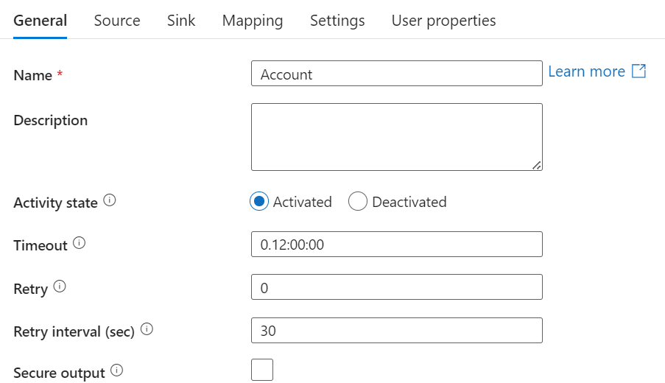

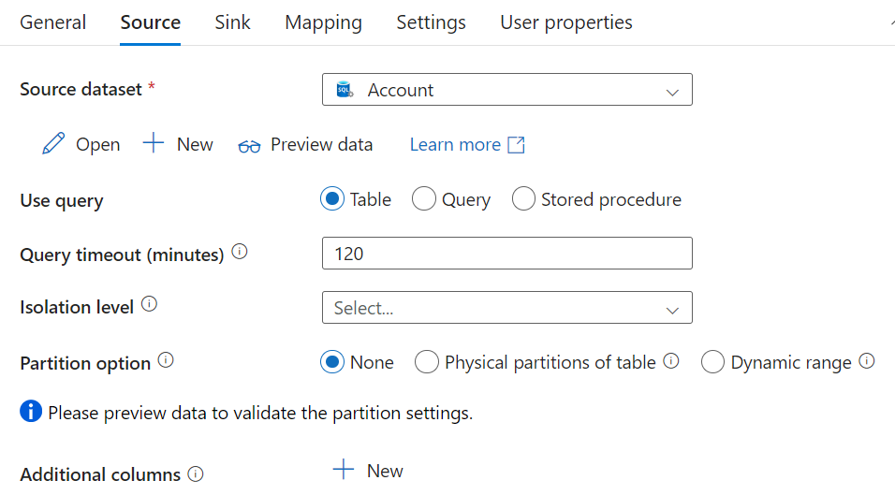

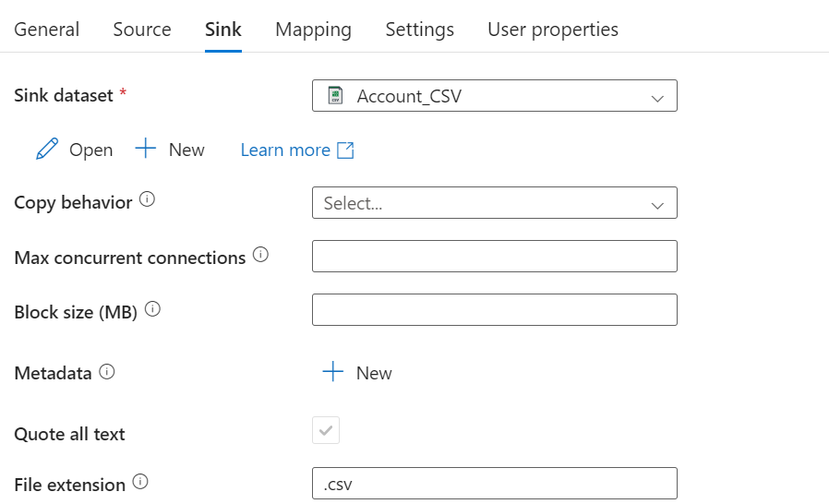

After completing the pipeline, we will have a data pipeline as follows.

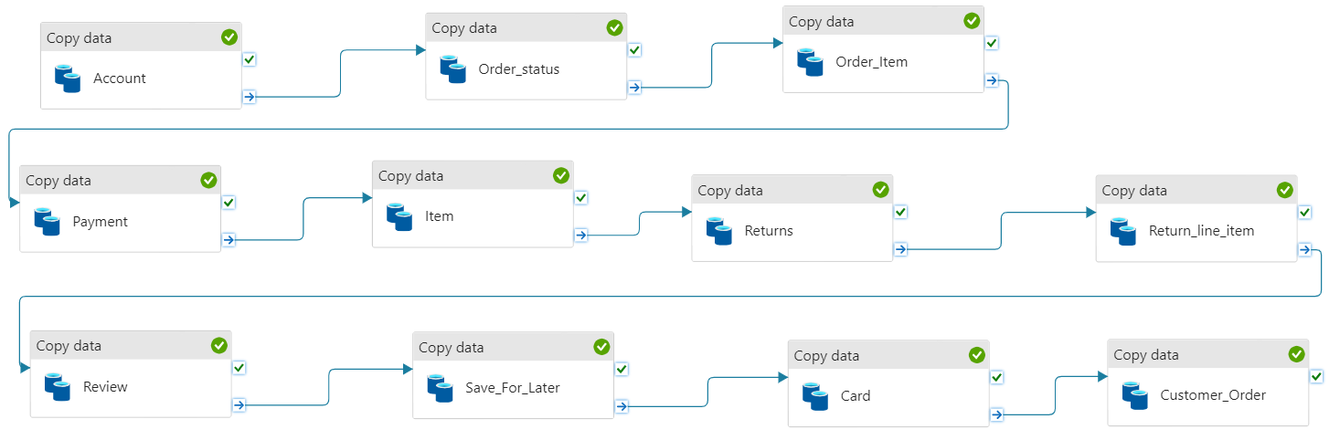

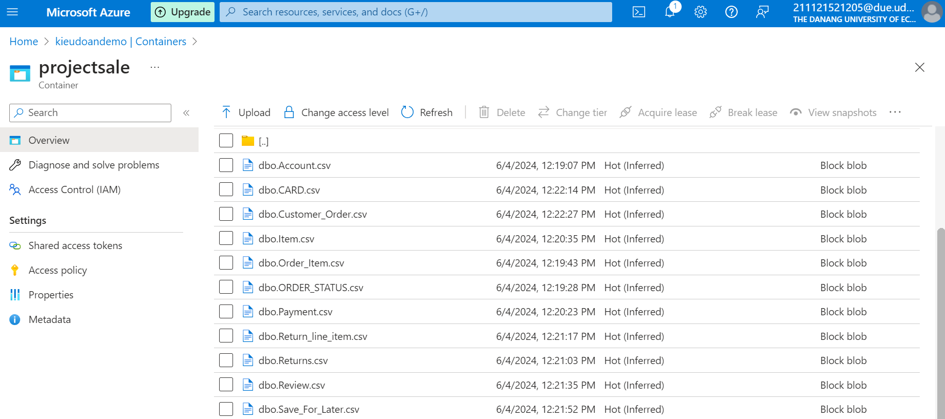

1. **Link from Blob Storage to DataBricks**

Link from Blob Storage to DataBricks so that the data in the notebook can be processed.

