**TASK REPORT**

1. **The Pareto principle**
2. Definition

The Pareto principle, also known as the 80/20 rule, is a theory maintaining that 80 percent of the output from a given situation or system is determined by 20 percent of the input.

1. Purpose

Our time is limited, so use the 80/20 principle to allocate time appropriately. Spending time on activities, habits, and people will determine 80% of our success and ignore unnecessary things.

*Example:* 20% of work tasks determine 80% of work performances

20% of causes determine 80% of results

1. **The butterfly effect**
2. Definition

The butterfly effect is the idea that small, seemingly trivial events may ultimately result in something with much larger consequences.

1. Purpose

Because our small actions today will have a big impact on the future, if possible, let's do positive things to change our lives today.

*Example:* A small error in system security that is overlooked can result in the loss of customer data later.

1. **The 5W1H method**
2. Definition
3. What?

This question focuses on the issue, task, or goal at hand. What problem or objective needs to be addressed?

1. Why?

This question helps uncover the root cause or underlying purpose of the situation. Why is the problem happening, or why is the goal important?

1. Who?

This question helps identify the people involved or affected by the situation. Who are the stakeholders, decision-makers, or team members?

1. When?

This question concerns timeframes and deadlines. Please tell me when actions should be taken or goalsachieved. Are there specific milestones or deadlines to consider?

1. Where?

This question pertains to the location or context in which the situation occurs. Where is the problem occurring, or where will the actions be implemented?

1. How?

This question focuses on the methods, tools, or processes needed to address the situation. How can the problem be solved or the goal be achieved?

1. Purpose

By breaking down complex problems into smaller, more manageable components, the 5W1H method can help you save time, reduce costs, and improve the quality of your work.

*Example:* Problem: I want to have a TOEIC certificate.

* What is the goal I need to achieve in the test?
* Why must I get that score?
* When will I take the TOEIC test?
* Where will I take the TOEIC test?
* Who should I study to get that score?
* How should goals be broken down to stay motivated?

1. **Notion**
2. What is Notion?

Notion is a note-taking application that helps users easily plan, take notes, make schedules, etc. All of the above data will be stored in the same space so you can easily Search again when needed.

1. Features

* Customizable workspaces



* Task management tools



* Rich text editor with advanced formatting options

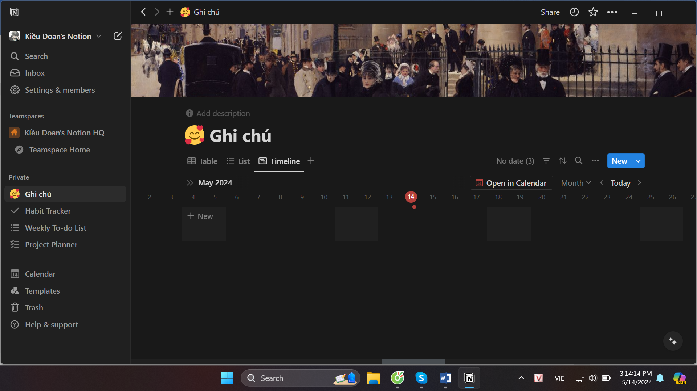

* Database management tools

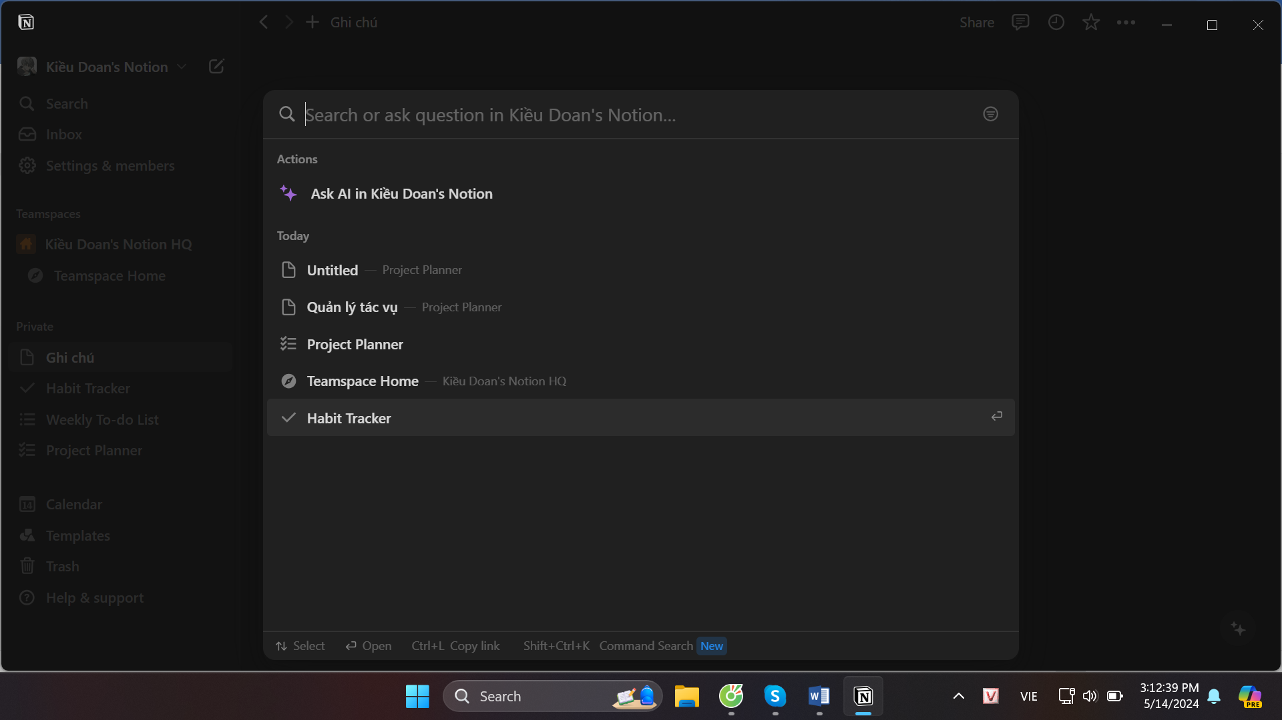

* Team collaboration features

