**TASK 2 REPORT**

1. **Difference between interpreter and compiler**
2. Similar

Both compilers and interpreters are used to convert a program written in a high-level language into machine code understood by computers.

1. Different

|  |  |
| --- | --- |
| **Interpreter** | **Compiler** |
| Translates program one statement at a time. | Compilers scan the entire program in one go. |
| Interpreters usually take less amount of time to analyze the source code. However, the overall execution time is comparatively slower than compilers. | Compilers usually take a large amount of time to analyze the source code. However, the overall execution time is comparatively faster than interpreters. |
| Interpreter checks the syntactic errors only. | Compiler can check syntactic and semantic errors in the program simultaneously. |
| Interpreters are relatively flexible. | Compilers are not flexible. |
| Interpreters are less efficient. | Compilers are more efficient. |
| Programming languages like JavaScript, Python, Ruby use interpreters. | Programming languages like C, C++, Java use compilers. |

1. **Python**

Python is a **high-level, multi-purpose, interpreted**programming language.

1. **High-level**

* Close to natural language
* It easy to learn

1. **Multi-purpose**

You can use Python in various domains including:

* **Web applications**
* **Big data applications**
* **Testing**
* **Automation**
* **Data science, machine learning, and AI**
* **Desktop software**
* **Mobile apps**

1. **Interpreted**

The Python **interpreter**turns the source code, line by line, once at a time, into the machine code when the Python program executes.

1. Data types, if else statement, loop
2. Data types

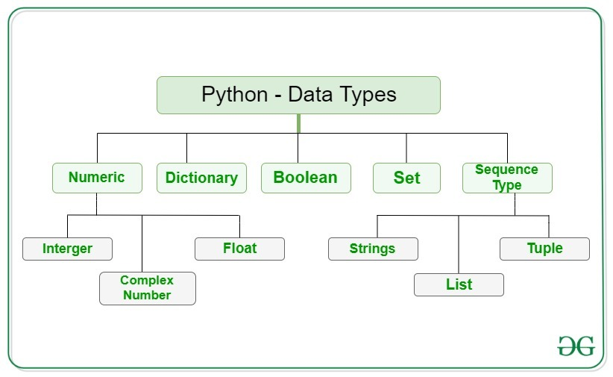

1. Numeric

* **Int:** Integer type, stores integers without limit in size.
* **Float:** Real numbers use floating point, stores real numbers with finite precision.
* **Complex:** Complex number type, stores complex numbers with real and imaginary parts.

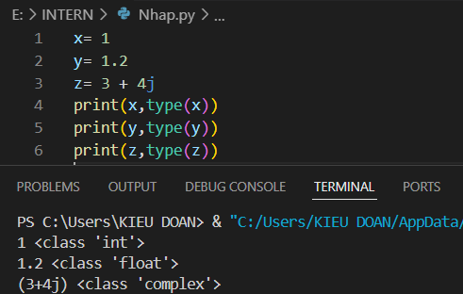

1. Dictionary

* Dictionaries are used to store data values in key: value pairs.
* Dictionary items are ordered, changeable, and do not allow duplicates.

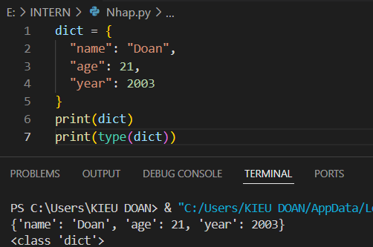

1. Boolean

Booleans represent one of two values: **True** or **False**.

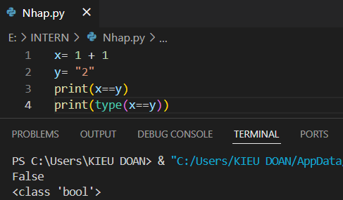

1. Set

* Sets are used to store multiple items in a single variable.
* A set is a collection which is unordered, unchangeable but you can remove items and add new items, and unindexed.

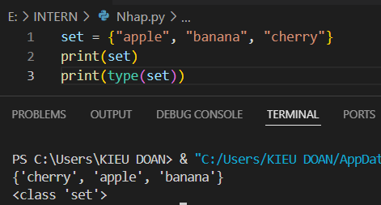

1. String

* Strings in python are surrounded by either single quotation marks, or double quotation marks.

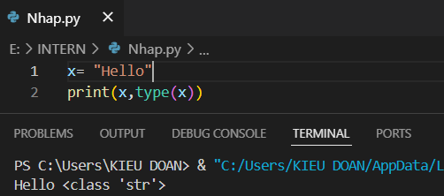

1. List

* Lists are used to store multiple items in a single variable.
* List items are ordered, changeable, and allow duplicate values.
* List items are indexed, the first item has index [0], the second item has index [1] etc.

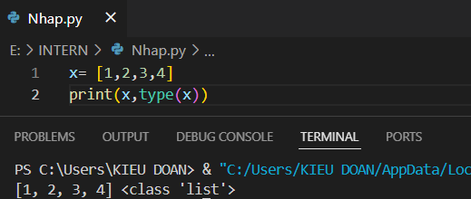

1. If else statement

Python supports the usual logical conditions from mathematics:

* Equals: a == b
* Not Equals: a != b
* Less than: a < b
* Less than or equal to: a <= b
* Greater than: a > b
* Greater than or equal to: a >= b

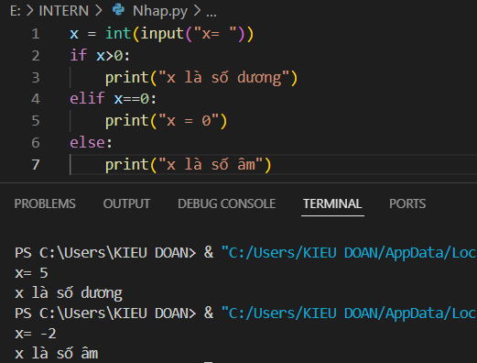

1. Loops

* While loops: we can execute a set of statements as long as a condition is true.

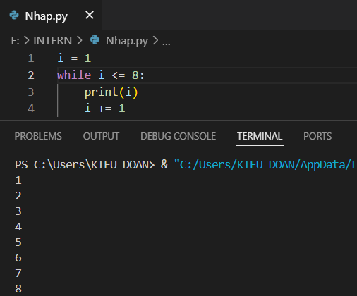

* For loops: A for loop is used for iterating over a sequence (that is either a list, a tuple, a dictionary, a set, or a string).

