**TASK 3 REPORT**

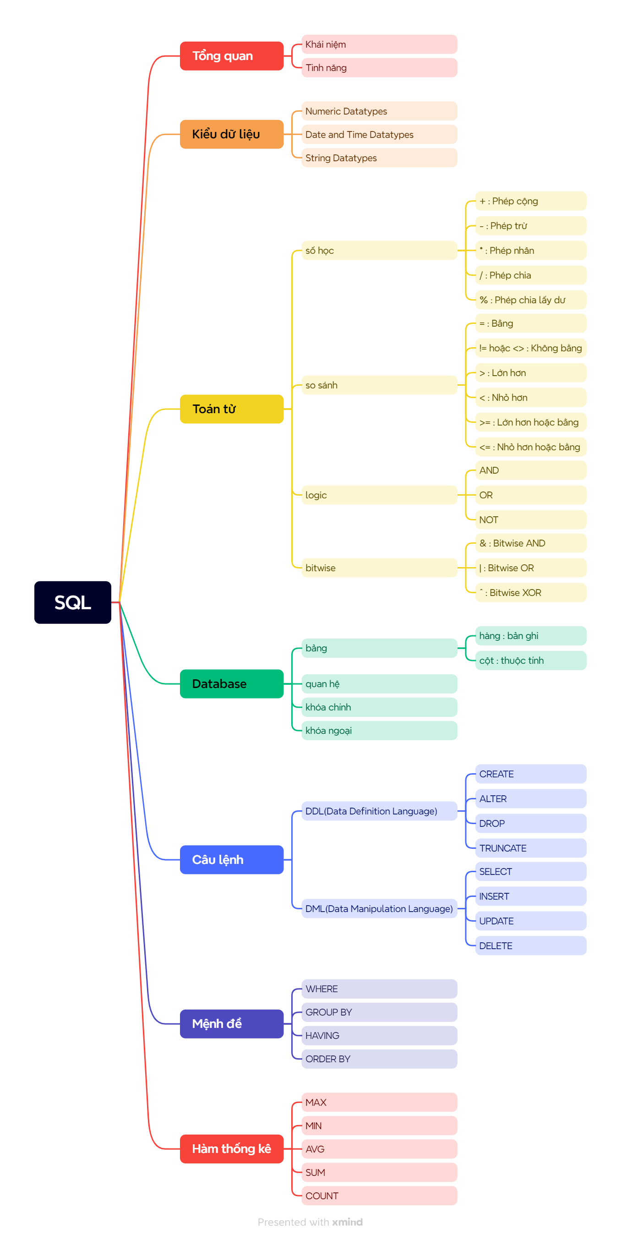

1. **Definition**

* SQL stands for Structured Query Language
* SQL lets you access and manipulate databases

1. **Feature**

* Execute queries against a database
* Insert, update, delete, retrieve records from a database
* Create new databases, new tables, stored procedures, views in a database
* Set permissions on tables, procedures, and views

1. **SQL datatypes**
   1. Numeric datatypes

|  |  |
| --- | --- |
| **Data type** | **Description** |
| bit | Integer that can be 0, 1, or NULL |
| int | Allows whole numbers between -2,147,483,648 and 2,147,483,647 |
| bigint | Allows whole numbers between -9,223,372,036,854,775,808 and 9,223,372,036,854,775,807 |
| decimal(p,s) | Fixed precision and scale numbers.  Allows numbers from -10^38 +1 to 10^38 –1. |
| numeric(p,s) | Fixed precision and scale numbers.  Allows numbers from -10^38 +1 to 10^38 –1. |
| money | Monetary data from -922,337,203,685,477.5808 to 922,337,203,685,477.5807 |
| float(n) | Floating precision number data from -1.79E + 308 to 1.79E + 308. |

* 1. String datatypes

|  |  |  |
| --- | --- | --- |
| **Data type** | **Description** | **Max size** |
| char(n) | Fixed width character string | 8,000 characters |
| varchar(n) | Variable width character string | 8,000 characters |
| varchar(max) | Variable width character string | 1,073,741,824 characters |
| text | Variable width character string | 2GB of text data |
| nchar | Fixed width Unicode string | 4,000 characters |
| nvarchar | Variable width Unicode string | 4,000 characters |
| binary(n) | Fixed width binary string | 8,000 bytes |

* 1. Date and Time datatypes

|  |  |  |
| --- | --- | --- |
| **Data type** | **Description** | **Storage** |
| datetime | From January 1, 1753 to December 31, 9999 with an accuracy of 3.33 milliseconds | 8 bytes |
| date | Store a date only. From January 1, 0001 to December 31, 9999 | 3 bytes |
| time | Store a time only to an accuracy of 100 nanoseconds | 3-5 bytes |

1. **Operators**
   1. SQL Arithmetic Operators

|  |  |
| --- | --- |
| **Operator** | **Description** |
| + | Add |
| - | Subtract |
| * | Multiply |
| / | Divide |
| % | Modulo |

* 1. SQL Logical Operators

|  |  |
| --- | --- |
| **Operator** | **Description** |
| ALL | TRUE if all of the subquery values meet the condition |
| AND | TRUE if all the conditions separated by AND is TRUE |
| ANY | TRUE if any of the subquery values meet the condition |
| BETWEEN | TRUE if the operand is within the range of comparisons |
| EXISTS | TRUE if the subquery returns one or more records |
| IN | TRUE if the operand is equal to one of a list of expressions |
| LIKE | TRUE if the operand matches a pattern |
| NOT | Displays a record if the condition(s) is NOT TRUE |
| OR | TRUE if any of the conditions separated by OR is TRUE |
| SOME | TRUE if any of the subquery values meet the condition |

* 1. SQL Comparison Operators

|  |  |
| --- | --- |
| **Operator** | **Description** |
| = | Equal to |
| > | Greater than |
| < | Less than |
| >= | Greater than or equal to |
| <= | Less than or equal to |
| <> | Not equal to |

* 1. SQL Bitwise Operators

|  |  |
| --- | --- |
| **Operator** | **Description** |
| & | Bitwise AND |
| | | Bitwise OR |
| ^ | Bitwise exclusive OR |

1. **Database**
   1. Table

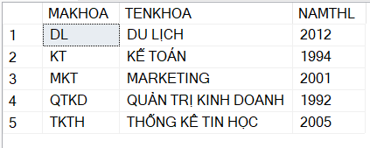

* 1. Relation

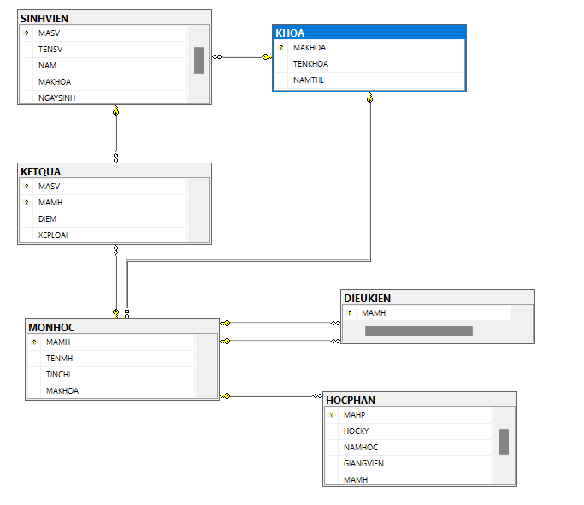

* 1. Primary key
* The PRIMARY KEY constraint uniquely identifies each record in a table.
* Primary keys must contain UNIQUE values, and cannot contain NULL values.
* A table can have only ONE primary key; and in the table, this primary key can consist of single or multiple columns (fields).

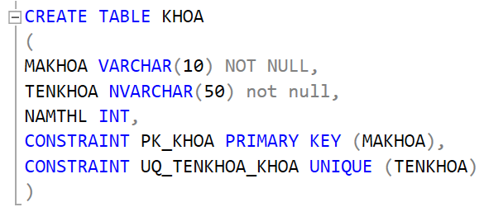

* 1. Foriegn key
* The FOREIGN KEY constraint is used to prevent actions that would destroy links between tables.
* A FOREIGN KEY is a field (or collection of fields) in one table, that refers to the PRIMARY KEY in another table.
* The table with the foreign key is called the child table, and the table with the primary key is called the referenced or parent table.



1. SQL Statements
   1. Data Definition Language (DDL)

* CREATE

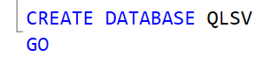

* ALTER

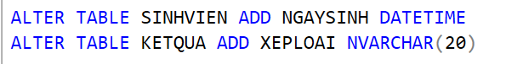

* DROP



* 1. Data Manipulation Language (DML)
* SELECT



* INSERT

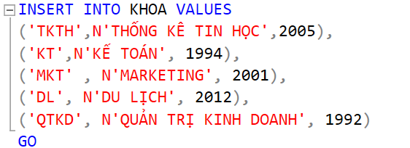

* UPDATE

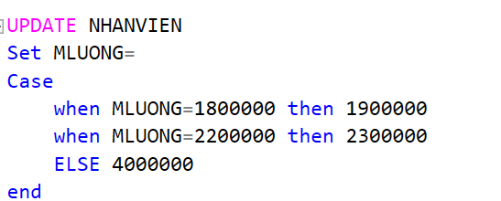

* DELETE

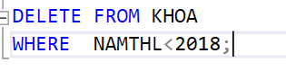

1. SQL Clauses

* WHERE

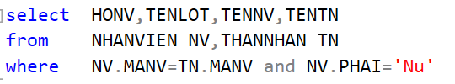

* GROUP BY

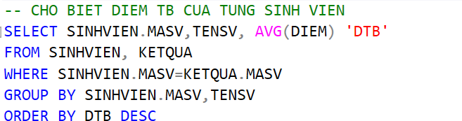

* HAVING

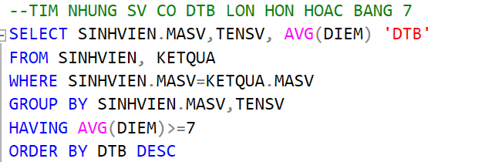

* ORDER BY

