**CLOUD COMPUTING**

1. What is cloud computing?

* Cloud computing is the delivery of computing services over the internet.
* Cloud computing operates on a consumption-based model
* Include:
* Common IT infrastructure: virtual machines, storage, databases, and networking
* The traditional IT: IoT, AI and ML

1. The shared responsibility model
   1. Responsibility always retained by the customer

* Information and data
* Devices (Mobile and PCs)
* Accounts and identities
  1. Responsibility transfers to cloud provider (except On-premises)
* Physical hosts
* Physical network
* Physical datacenter
  1. Responsibility varies by type
* Identity and directory infrastructure
* Applications
* Network controls
* Operating system
  + 1. SaaS (Software as a Service)

The consumer is responsible for Identity and directory infrastructure

* Less need to worry about basic infrastructure and security
  + 1. PaaS (Platform as a Service)

The consumer is responsible for: Identity and directory infrastructure, Applications, Network controls

* Customers have more responsibility for managing applications and data

* + 1. IaaS (Infrastructure as a Service)

The consumer is responsible for all

* Customers must manage more operating systems, networks and applications.
  + 1. On-premises

The consumer is responsible for all

* Take full responsibility for all components from infrastructure to applications and security

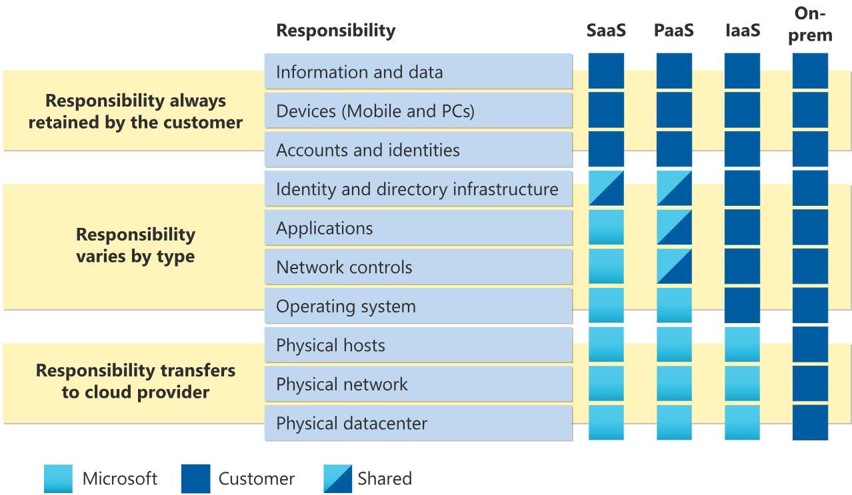

1. Cloud models

* Private cloud
* Public cloud
* Hybrid cloud

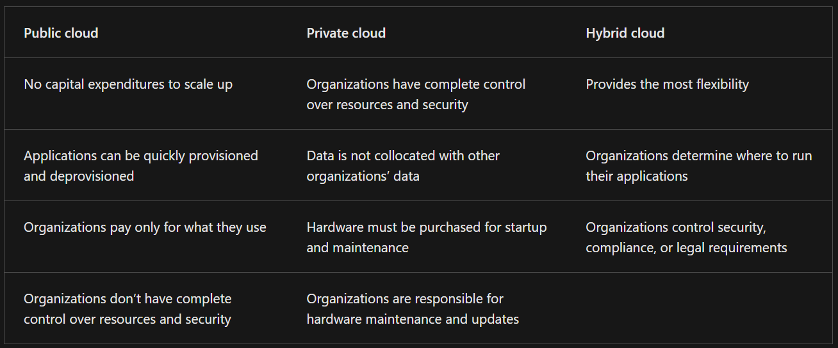

* Multi-cloud: you use multiple public cloud providers. Maybe you use different features from different cloud providers
* Azure Arc: Azure Arc can help manage your cloud environment, whether it's a public cloud solely on Azure, a private cloud in your datacenter, a hybrid configuration, or even a multi-cloud environment running on multiple cloud providers at once.
* Azure VMware Solution: Azure VMware Solution lets you run your VMware workloads in Azure with seamless integration and scalability.