**REPORT**

# Workflow

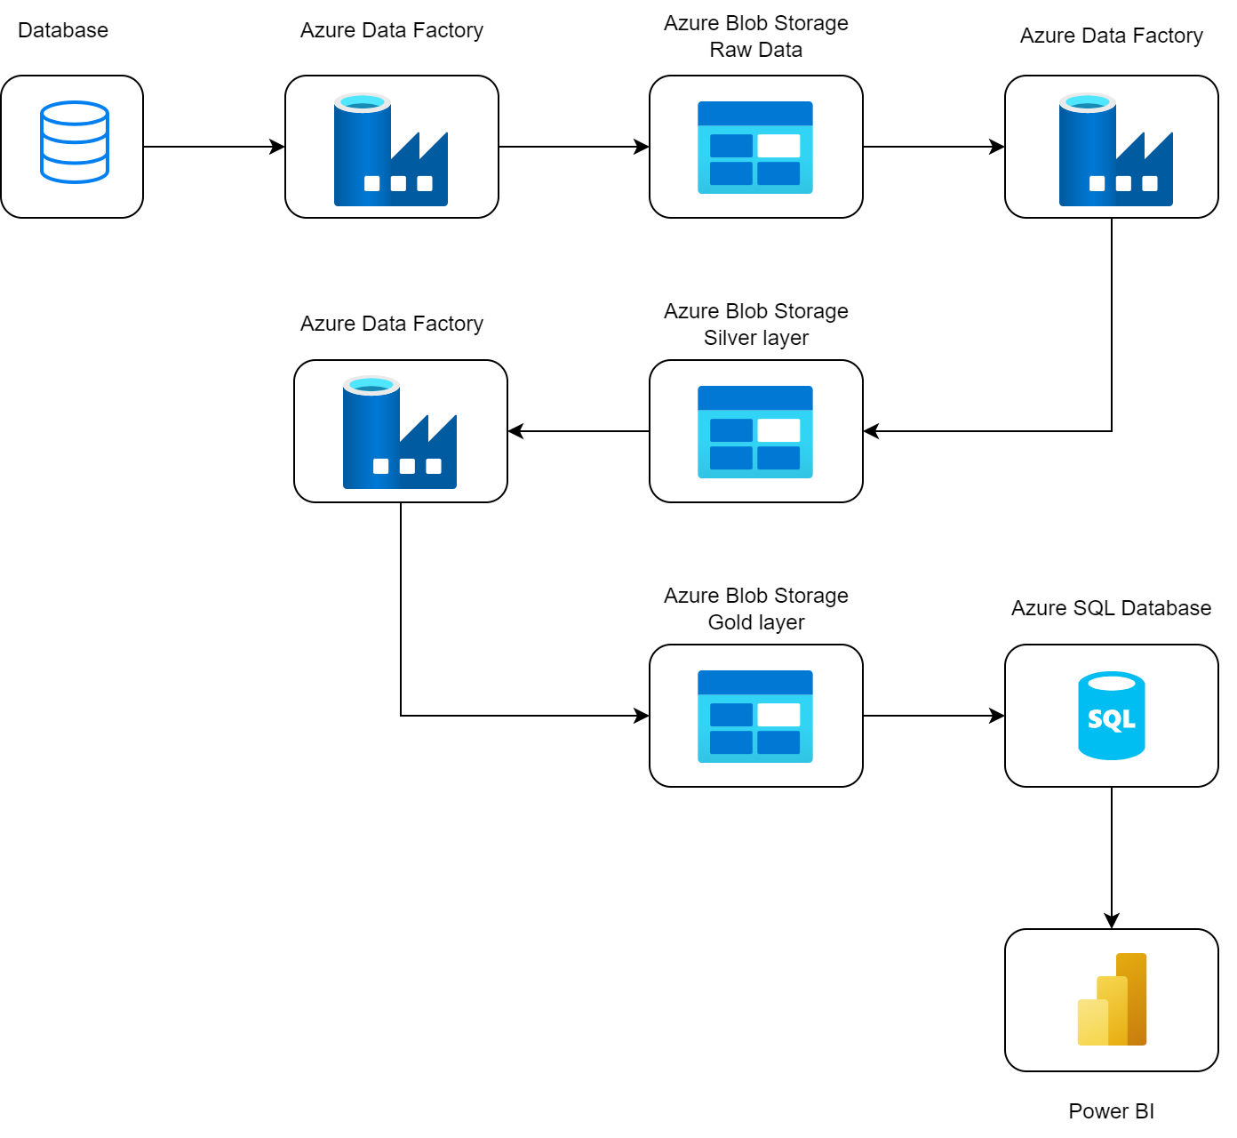

# Database



# Create a pipeline from local to layer Raw data Blob Storage on Azure Data Factory

If you want to bring data from local to data blob you have to create a pipeline from SQL local to Data Factory to Blob Storage. And to do that we have to configure the integration runtimes and links.

## Create integration runtime

It provides the infrastructure to perform data integration activities, including data transformation, data migration, and data workflow management.

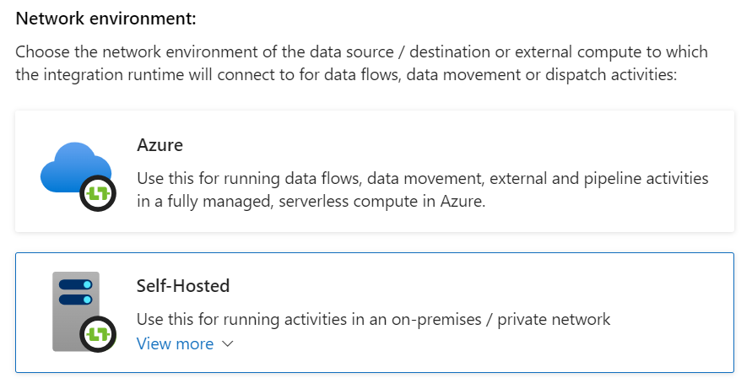

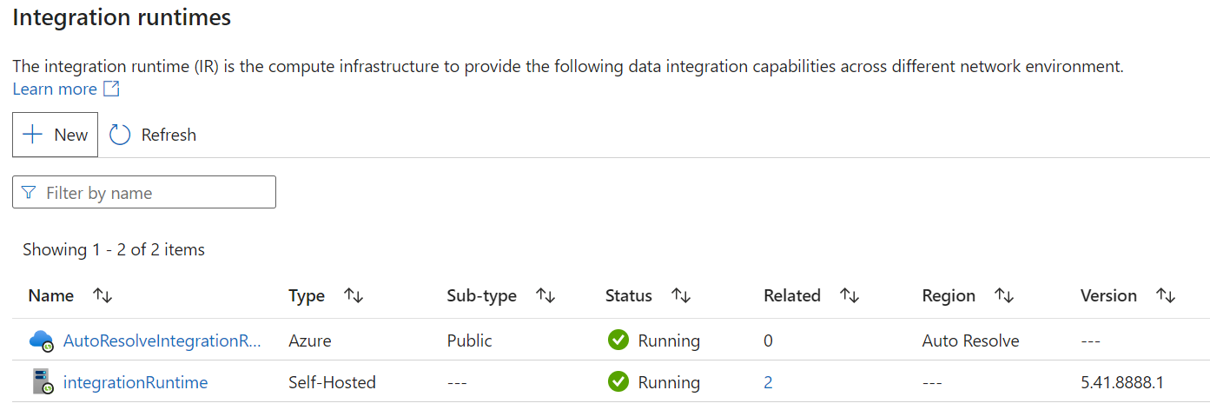

## Create Linked services to the SQL Server

Create link to link from SQL local to Data Factory.

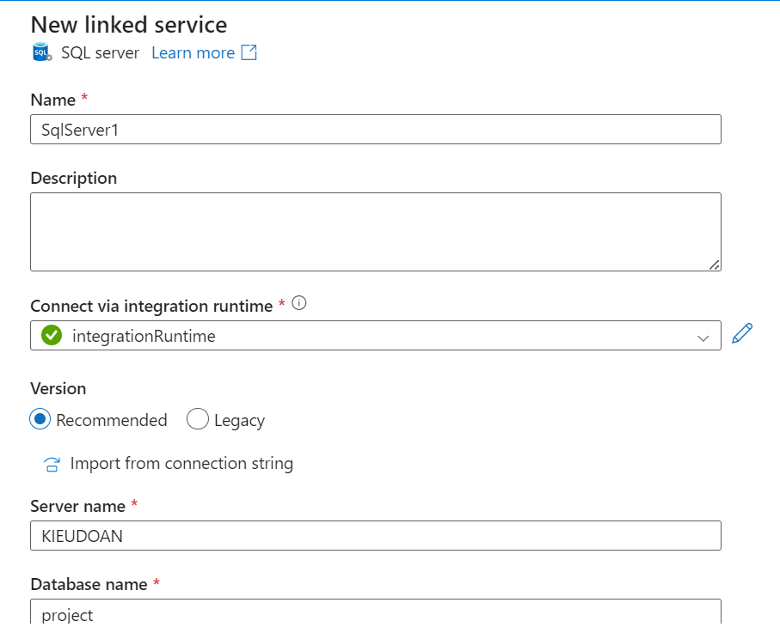

## Create Linked services to the Blob Storage

Create a link to link from Data Factory to Blob Storage.

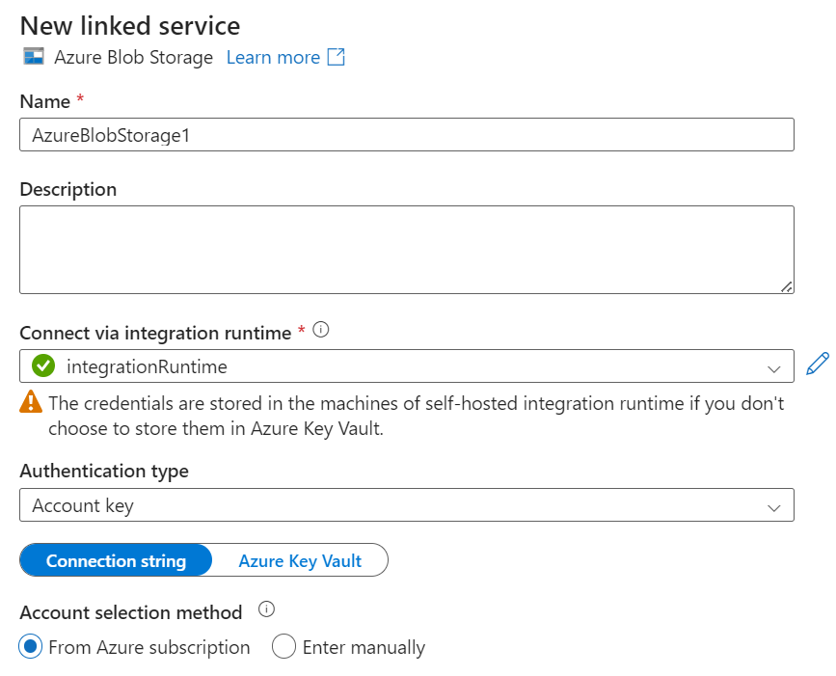

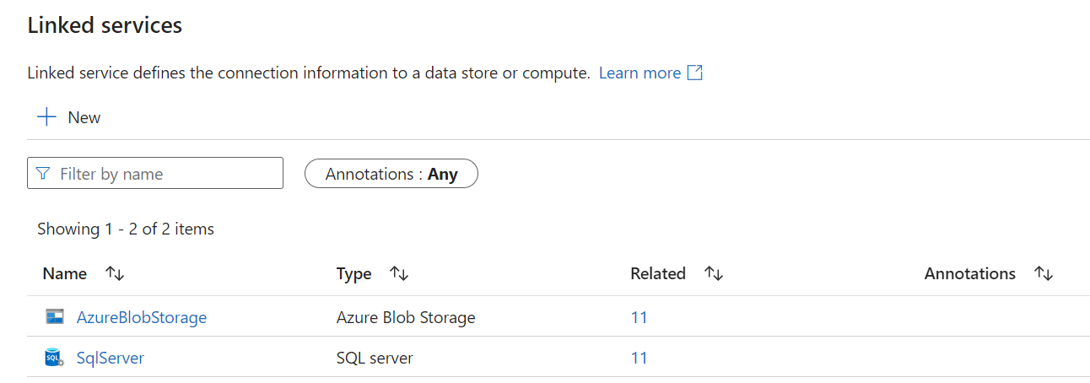

## Create Pipeline

Configure input and output for each data in the pipeline from the created links.

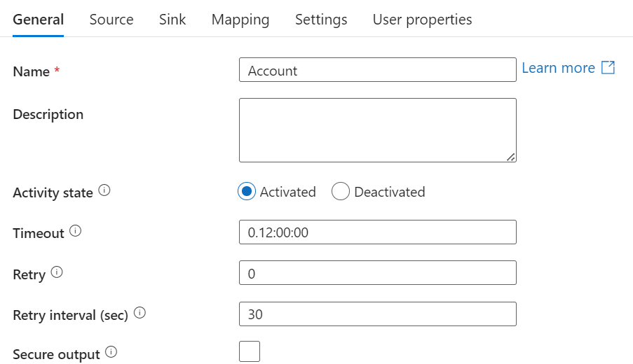

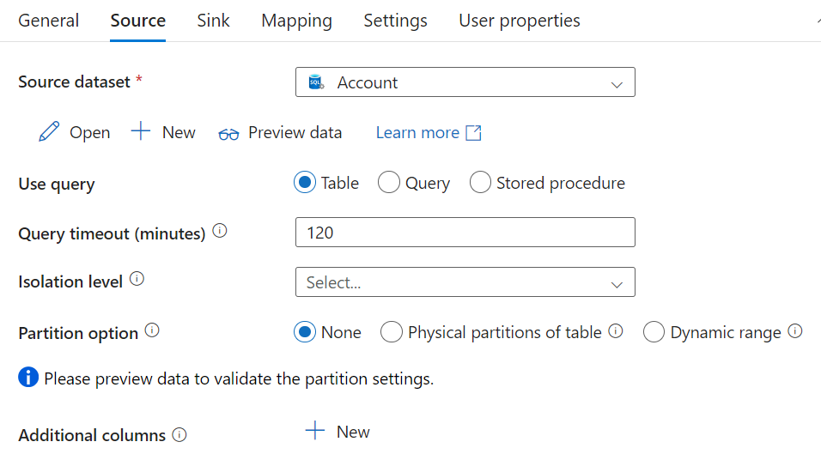

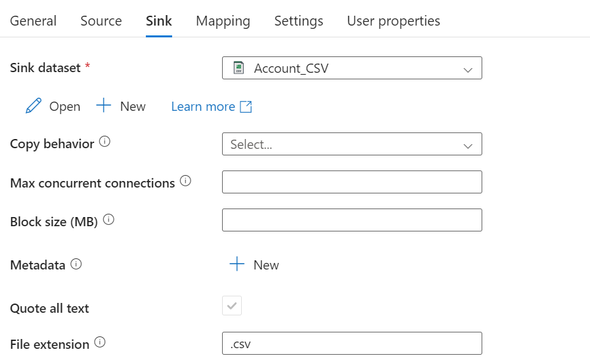

After completing the pipeline, we will have a data pipeline as follows.

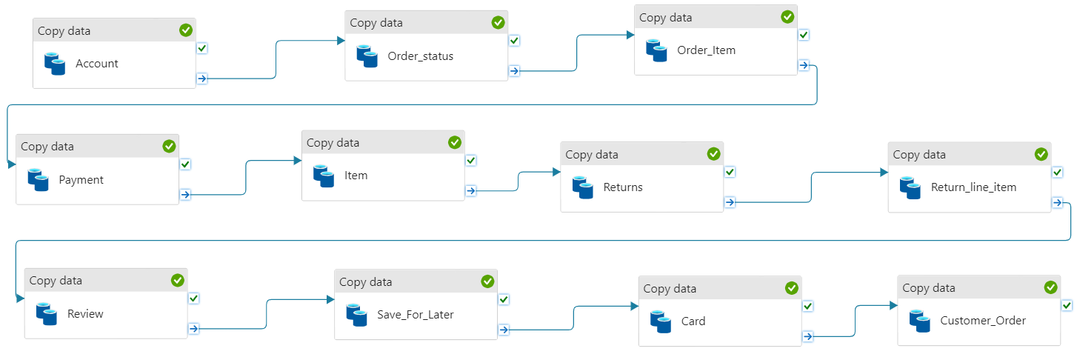

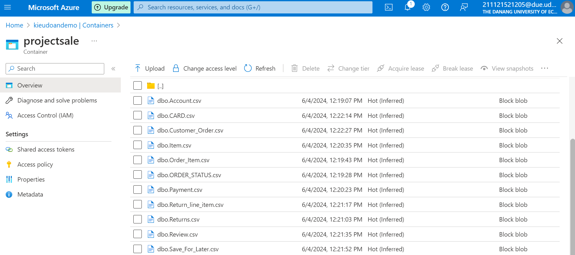

# Process data using Data Factory to put into silver layer in Blob Storage

## Create data flow

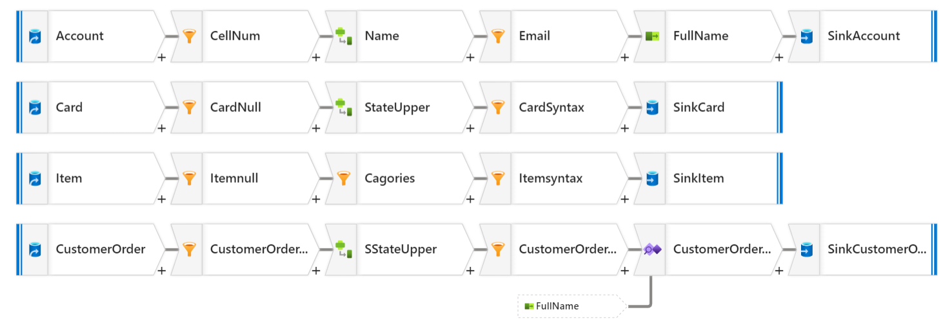

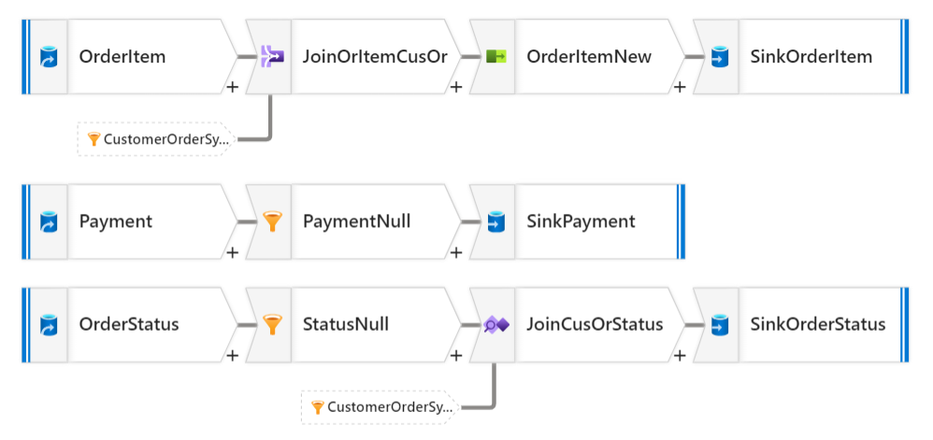

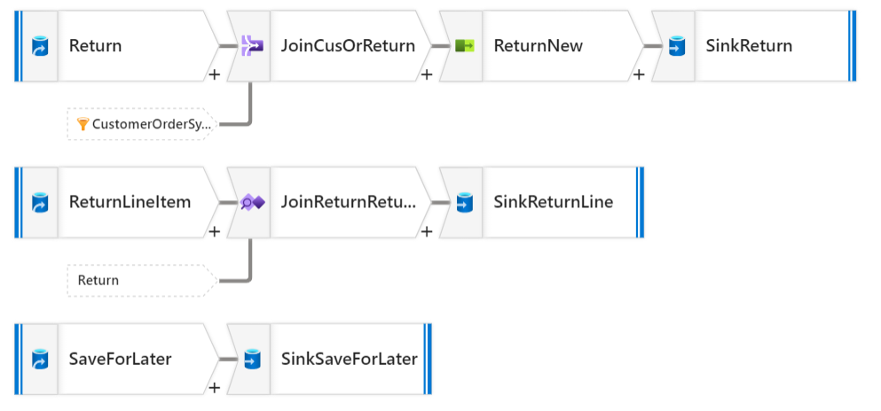

### Import data source

After bringing in the source data, we transform the data type as desired. You can save the data type proposed by the system or transform it yourself according to certain rules that are suitable for later processing and analysis steps.

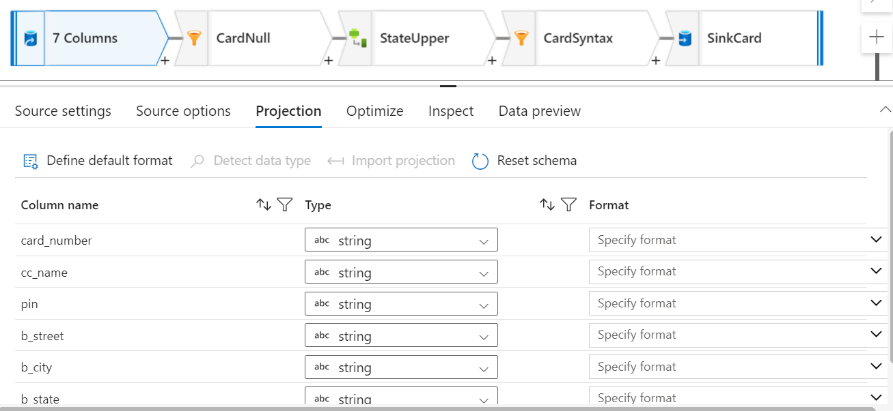

### Handle null data using the filter function.

To facilitate analysis according to customer requirements, we should remove null data from the tables.

Use the filter function and write commands into the filter on box to filter out records with null values.

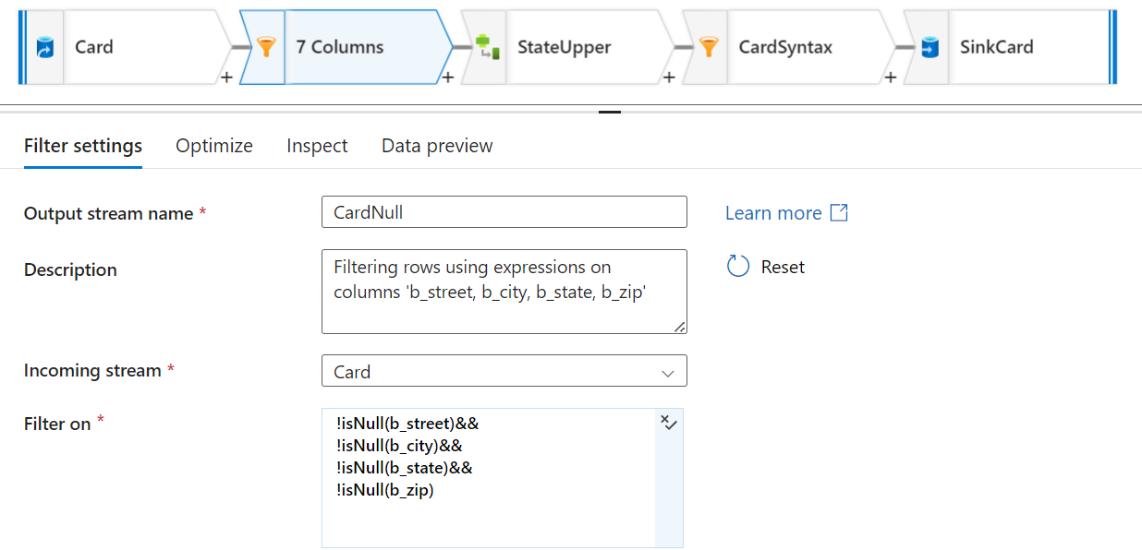

### Update the column using the delivered function.

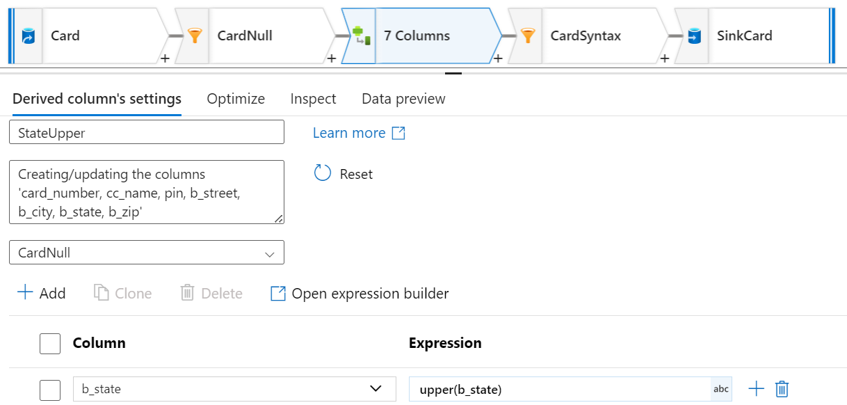

### Remove records containing syntax errors.

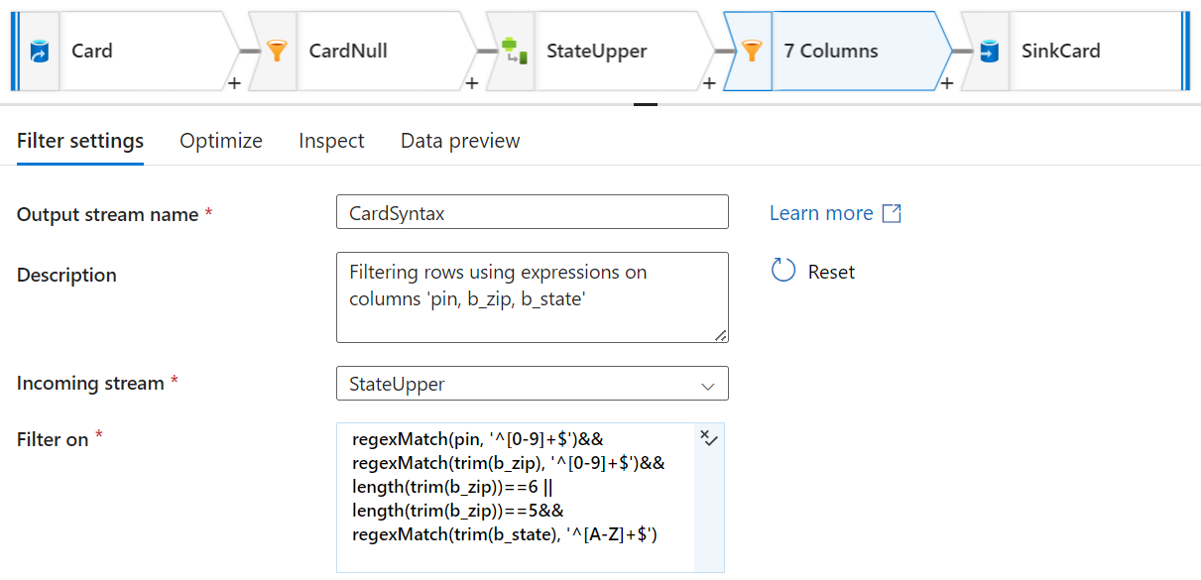

### Merge columns using the delivered function.

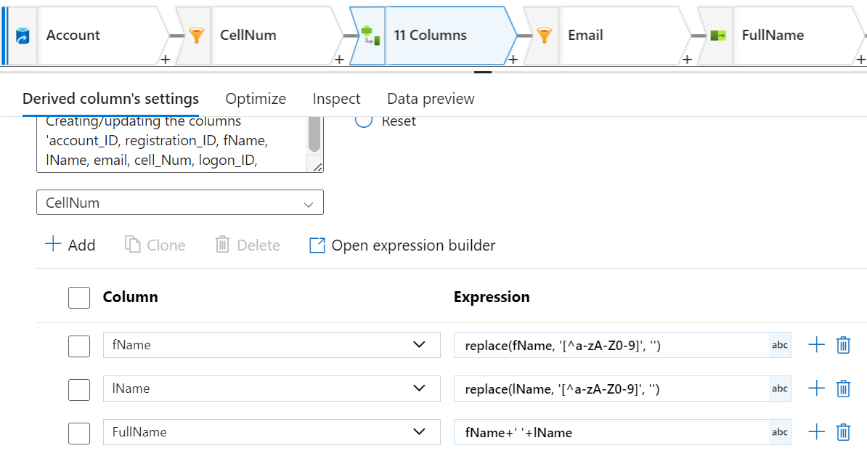

### Select columns using select function.

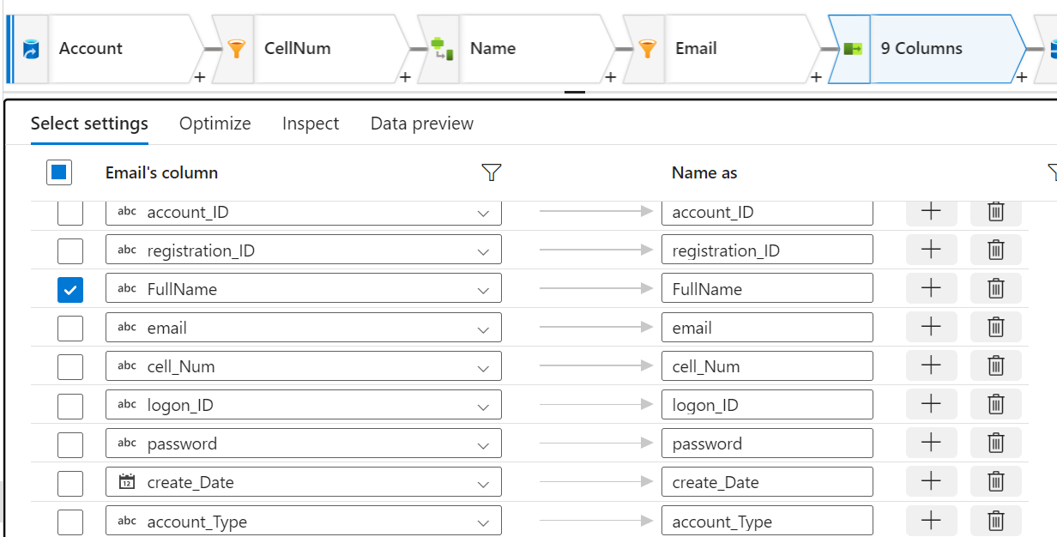

### Join the table using the join function.

Join tables to remove records that do not match the relationships between tables in the database. There are different types of joins so you can use them for the right purpose.

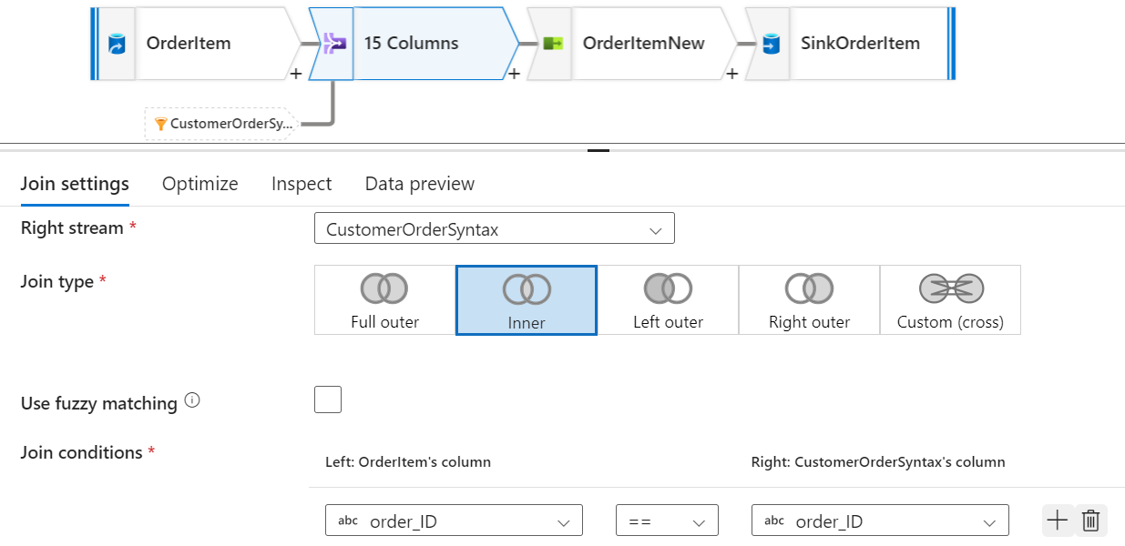

### Remove records that do not exist in 2 table using exists function.

In principle, the exists and join inner functions are the same, but there is one difference: if you use inner join, you need to use one more select step to get the fields of the old table because inner join will merge the two tables. together and exists only retrieves records that satisfy the conditions in the two tables without having to merge.

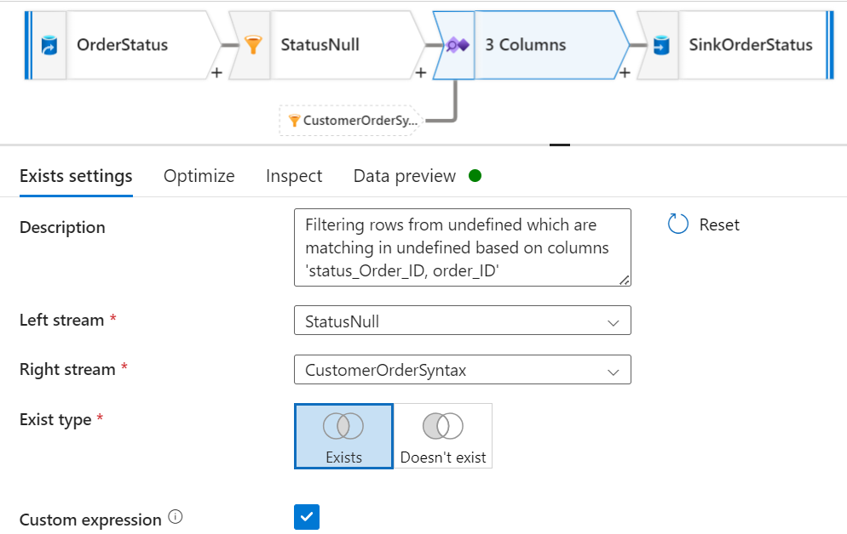

### Send processed data to the sink.

Put data into silver data to store and process in the following steps.

