*1. What is python and key features that make it popular among developers*

Python is a high-level programming language known for its simplicity and readability. Some of the key features that make python popular include:

* Easy to learn – its simple syntax and readability makes it a good choice for many developers
* Interpreted language – python is executed line by line making it easy and quick to debug
* Extensive standard library – python supports many tasks including web, data science etc

*2. Installing python (installation for windows)*

First download python from the official website ( <https://www.python.org/downloads/> ) and after download is complete run the installer.   
Check the path during installation and then add it to the environment variables.

To check whether python is installed, open the command line and type, “ python –version ”

Alternatively, you can check using the “ python -v ”.

*3. Python syntax and semantics*

Below is a simple line to print a hello world statement:

print(“Hello world”)

**print():** is built-in function that outputs text to the console.

**"Hello, World!":** is string literal enclosed in double quotes.

*4. Data types and Variables*

There are different types of datatypes in programming and specifically in python, they include:

* **int** - Integer numbers
* **float** - Floating-point numbers
* str: String (text) data
* **bool** - Boolean values (True or False)
* **list** - Ordered, mutable collection of items
* **tuple -** Ordered, immutable collection of items
* **dict** - Unordered collection of key-value pairs
* **set -** Unordered collection of unique items

*5. Control Structures*

Conditional statements: used to perform different actions based on different conditions. Below is an example:

# if-else statement

num = 10

if num > 0:

print("Positive number")

else:

print("Non-positive number")

Loops: iterate over a sequence (e.g. list, tuple, string) or other iterable objects

# for loop

numbers = [1, 2, 3, 4, 5]

for num in numbers:

print(num)

Switch statements: allows the value of a variable or expression to be tested against a list of values, with each value having a corresponding block of code to be executed.

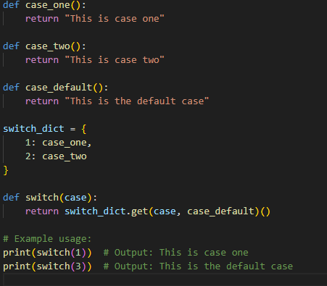

*6. Functions in Python*

A function is a reusable blocks of code that perform a specific task. They help in modularizing and organizing code, making it more readable and maintainable.

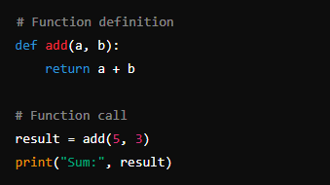

*7. Lists and Dictionaries*

**Lists:** Ordered, mutable collections of items. Accessed by index.

**Dictionaries:** Unordered, mutable collections of key-value pairs. Accessed by key.

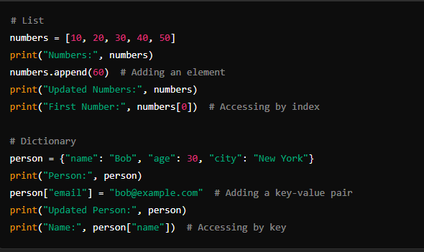

*8. Exception handling*

It’s a mechanism to handle runtime errors, allowing the program to continue executing or gracefully terminate. Below is a simple snippet of exception handling:

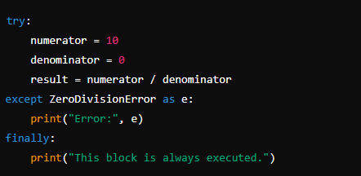

*9. Modules and Packages.*

Model: A module is a file containing python definitions and statements.

Package: A package is a way of structuring Python’s module namespace by using "dotted module names"

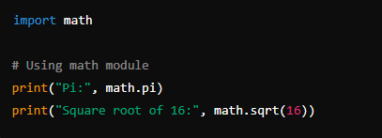

*10. File IO*

Snippet of code to read a file

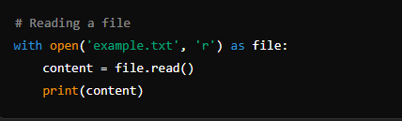

Snippet for writing into a file

