Assignment Tracker Final Project Report
By: Dakota Neafus

Purpose and Approved Scope
The Assignment Tracker is a C# and .NET Windows Forms application for one student. It records assignment titles, descriptions, courses, due dates, and completion status. A selected deadline determines the total assignments due, the completed count, and the remaining count. The implementation follows the proposal and class design: three business classes, a fixed course list, and a single main form. Data remains in memory for the current session.

Updated Business Class UML
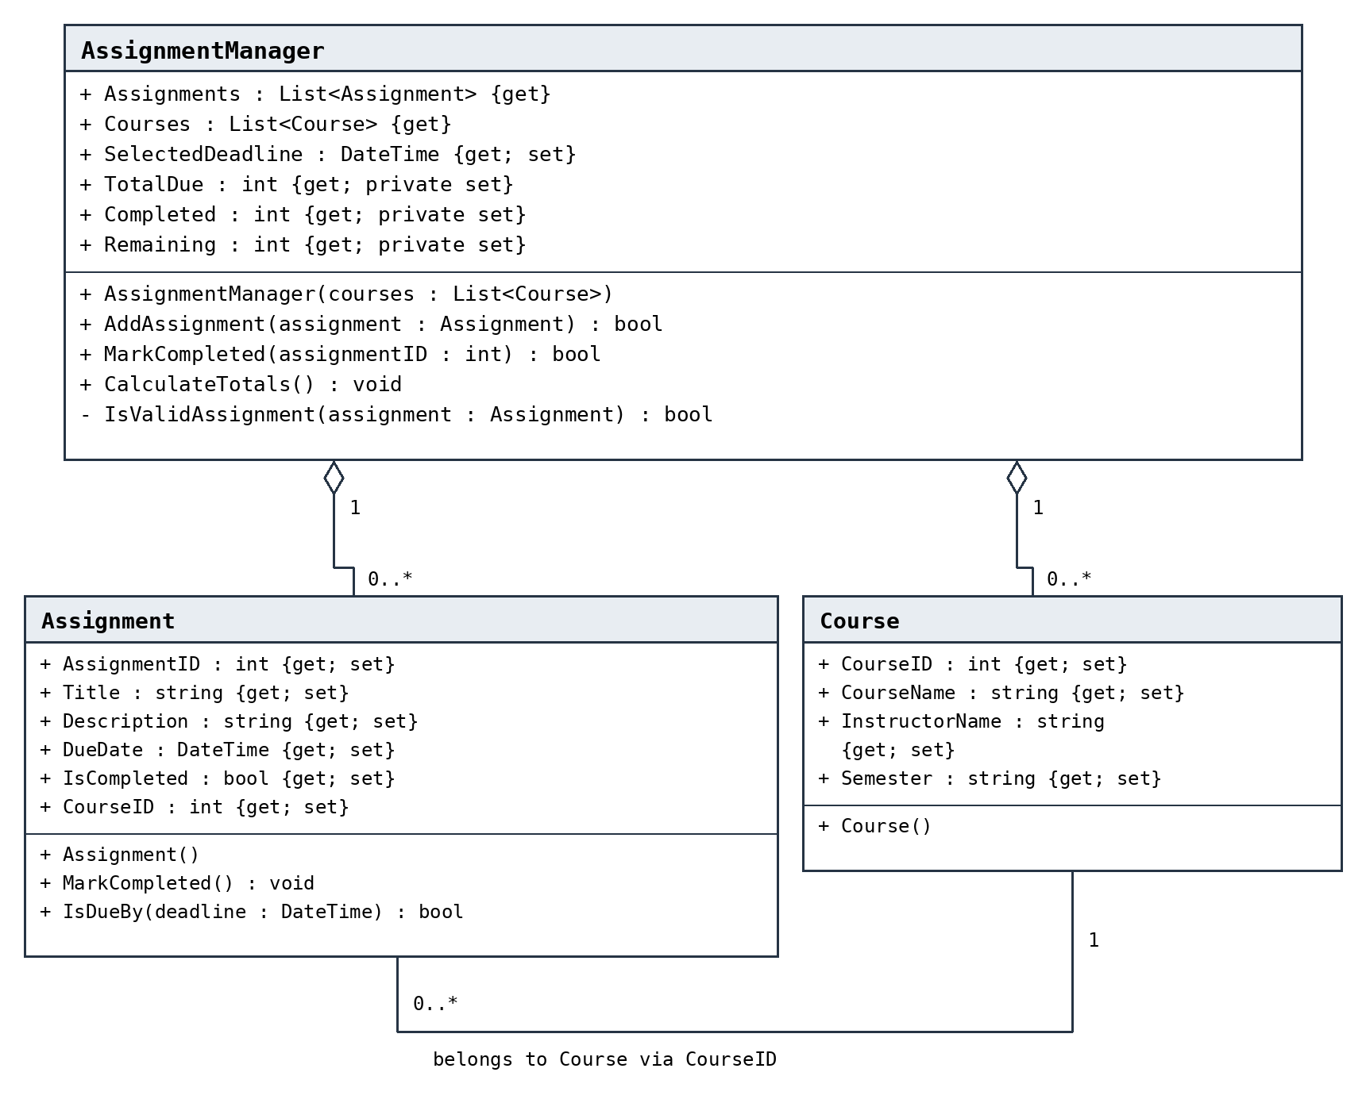
Legend: + public; - private. Hollow diamonds represent aggregation. Getter and setter access are shown in the diagram. Each Assignment belongs to one Course through CourseID; each Course can be associated with zero or more assignments. No business class inheritance or custom interface is used.

Updated GUI Integration UML
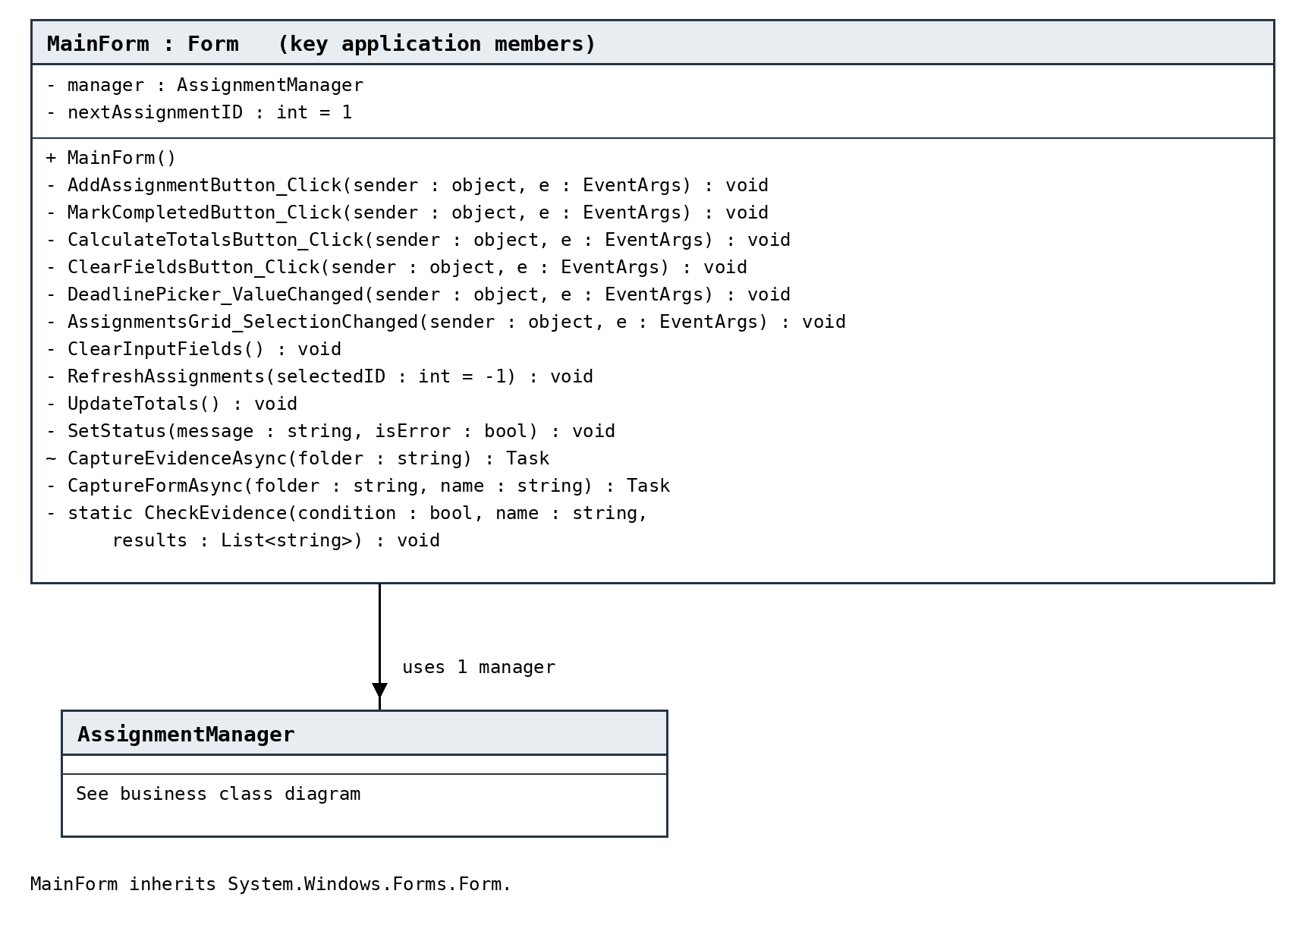
Legend: ~ internal. MainForm uses one AssignmentManager and inherits the framework Form class. The diagram shows the application fields and event/helper methods. Designer control fields and standard layout/disposal helpers are listed in MainForm.Designer.cs. The two diagrams and editable Mermaid source are included with this report.

Controls and Program Flow
The form contains title and description text boxes, a course combo box, due-date and cutoff-date pickers, a completion checkbox, an assignment grid, a read-only description area, three count labels, status feedback, and an ErrorProvider. The principal buttons are Add Assignment, Mark Completed, Calculate Totals, and Clear Fields.
Add Assignment validates the title and course before calling the manager. Mark Completed targets the selected record by its stored identifier. Calculate Totals sets SelectedDeadline and refreshes the count labels. A date-change event also refreshes counts. Selection displays the assignment description. Clearing input does not remove existing assignments.

Testing and Verification
All four projects were compiled from source using the .NET 8 SDK C# compiler with warnings treated as errors. The Windows Forms source was compiled against Windows Desktop reference assemblies. The 24 maintained business tests were executed successfully. These checks cover class initialization, property values, invalid entries, duplicate identifiers, completion updates, inclusive calendar-date comparisons, repeated calculations, empty lists, and cutoff changes.

Windows Verification Results to Complete
Build result on Windows:
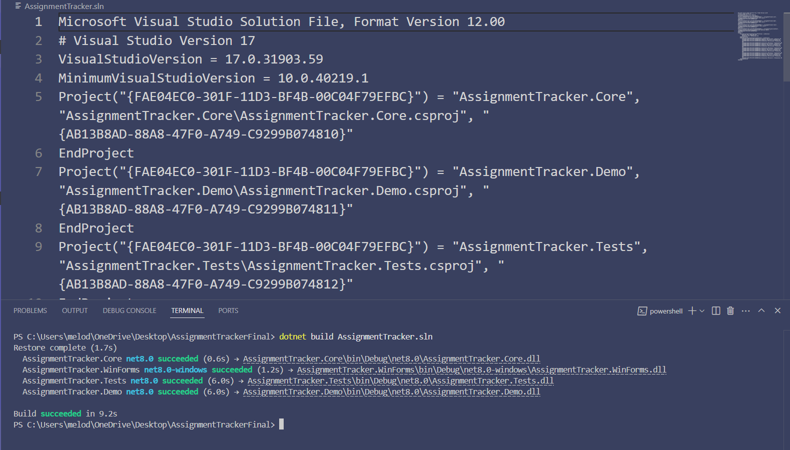
Business tests on Windows:
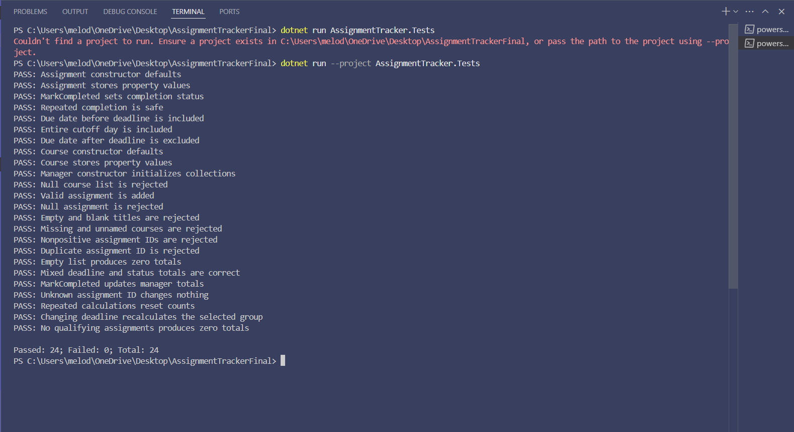
GUI checks on Windows:
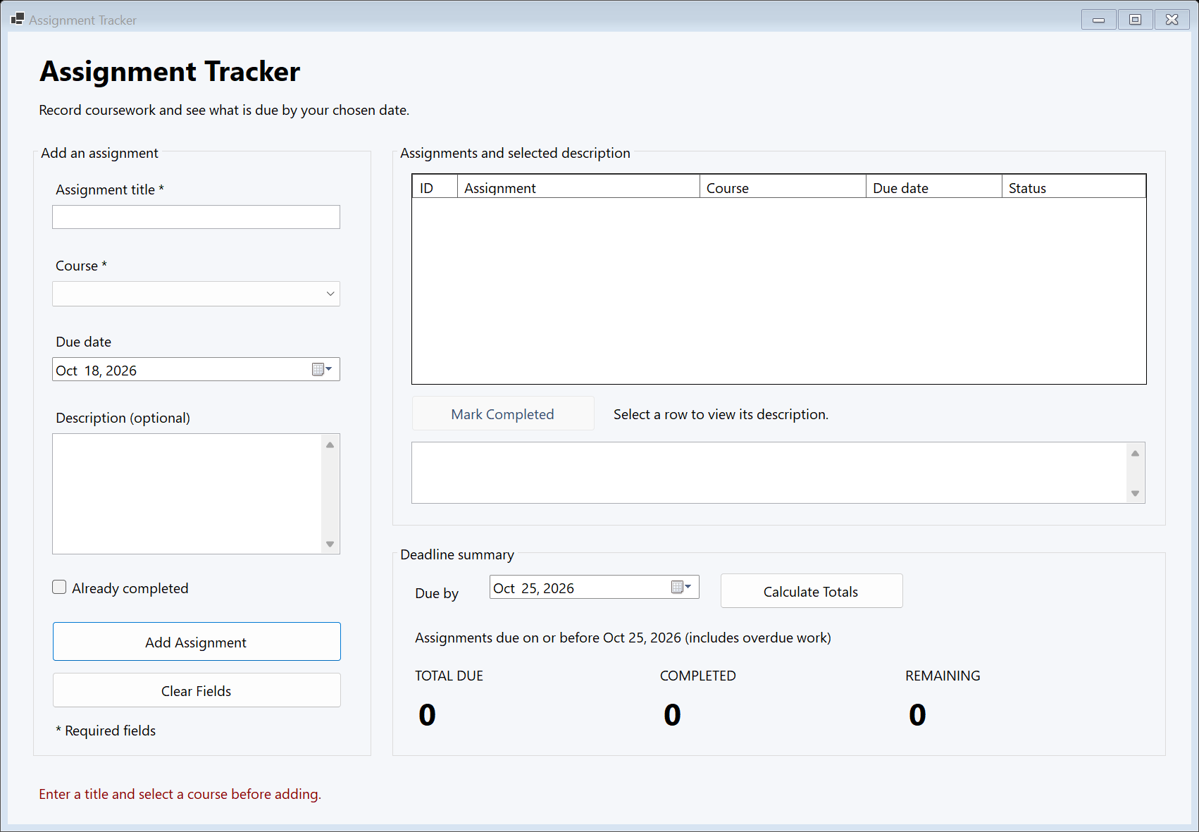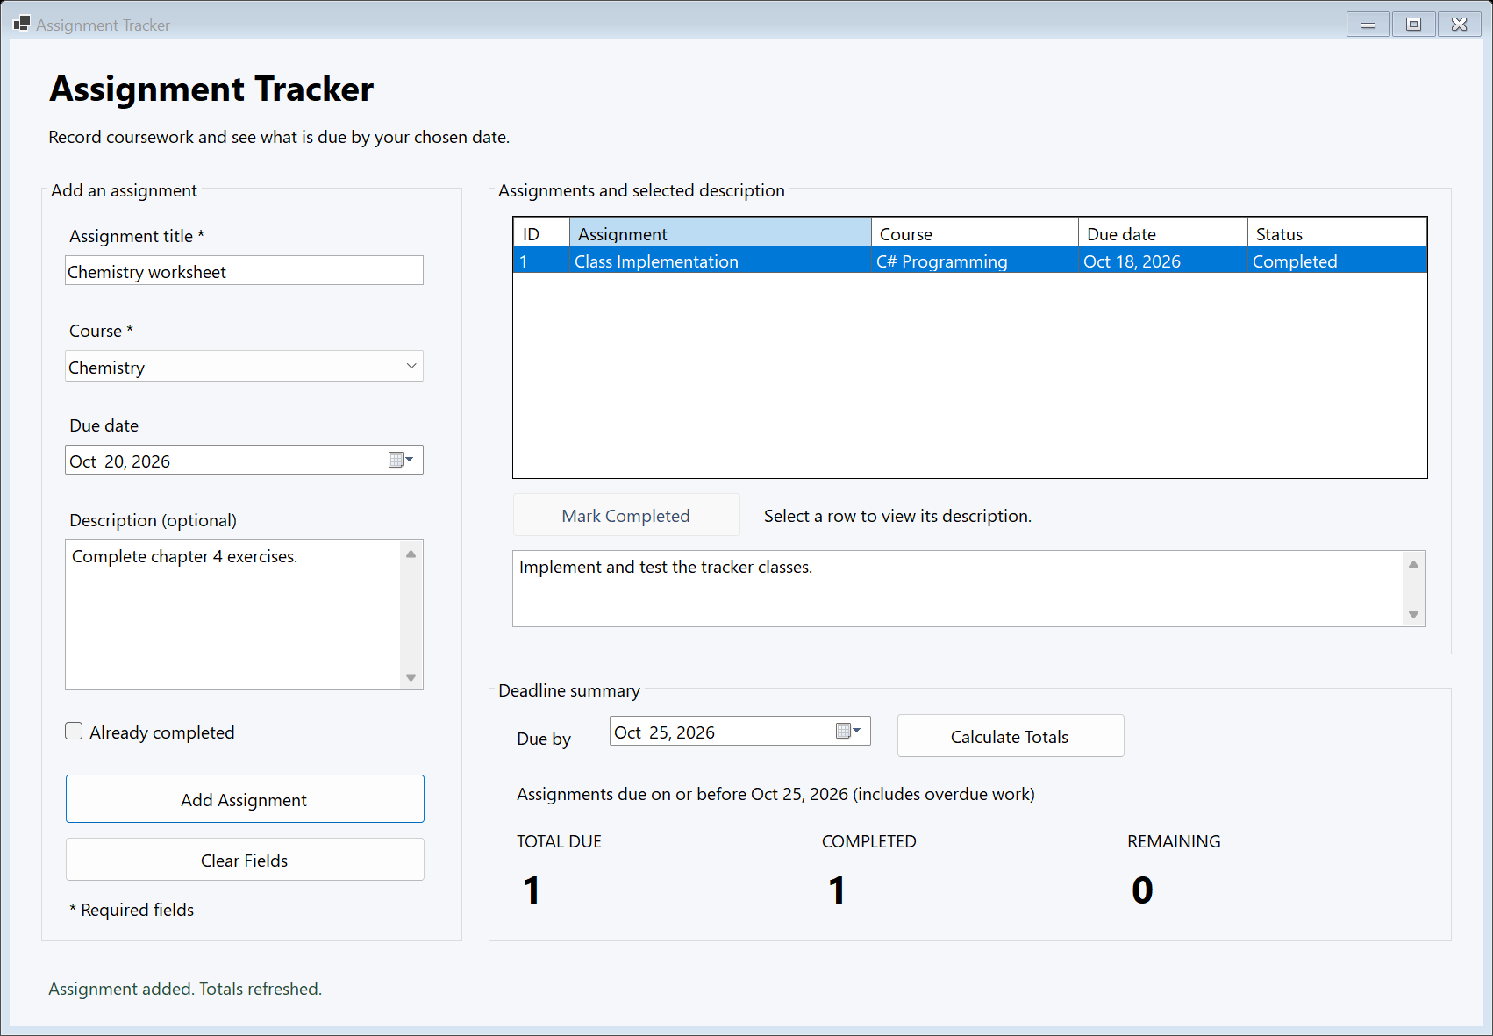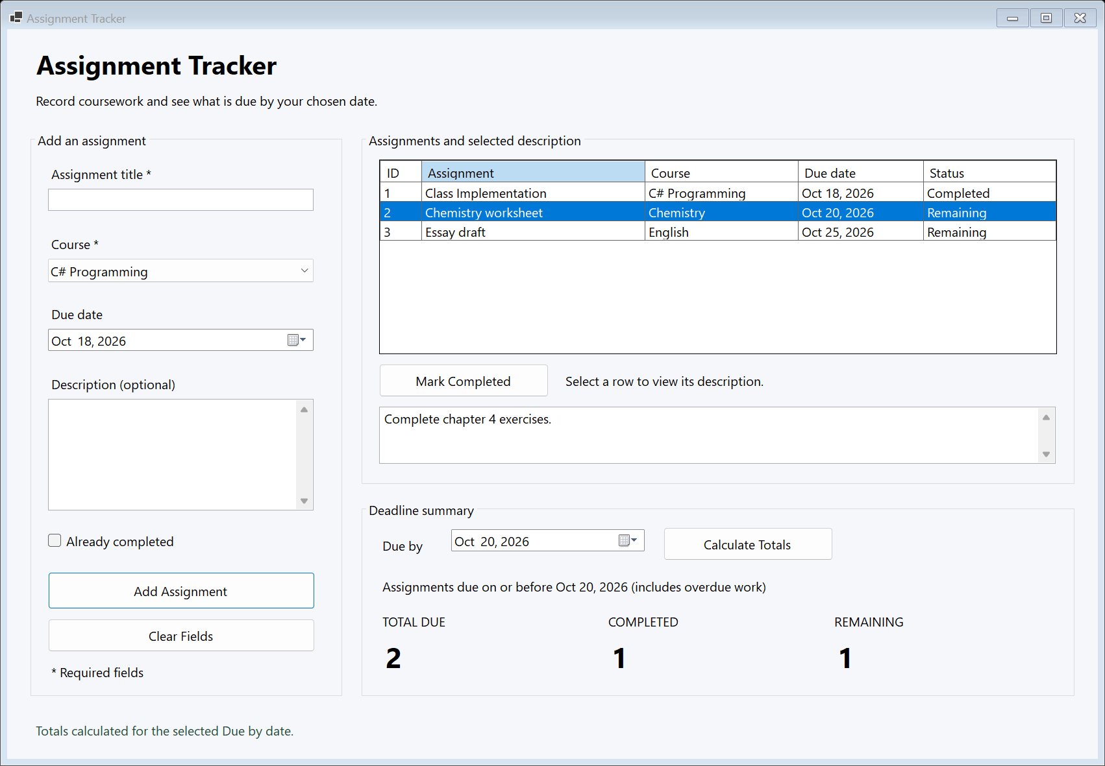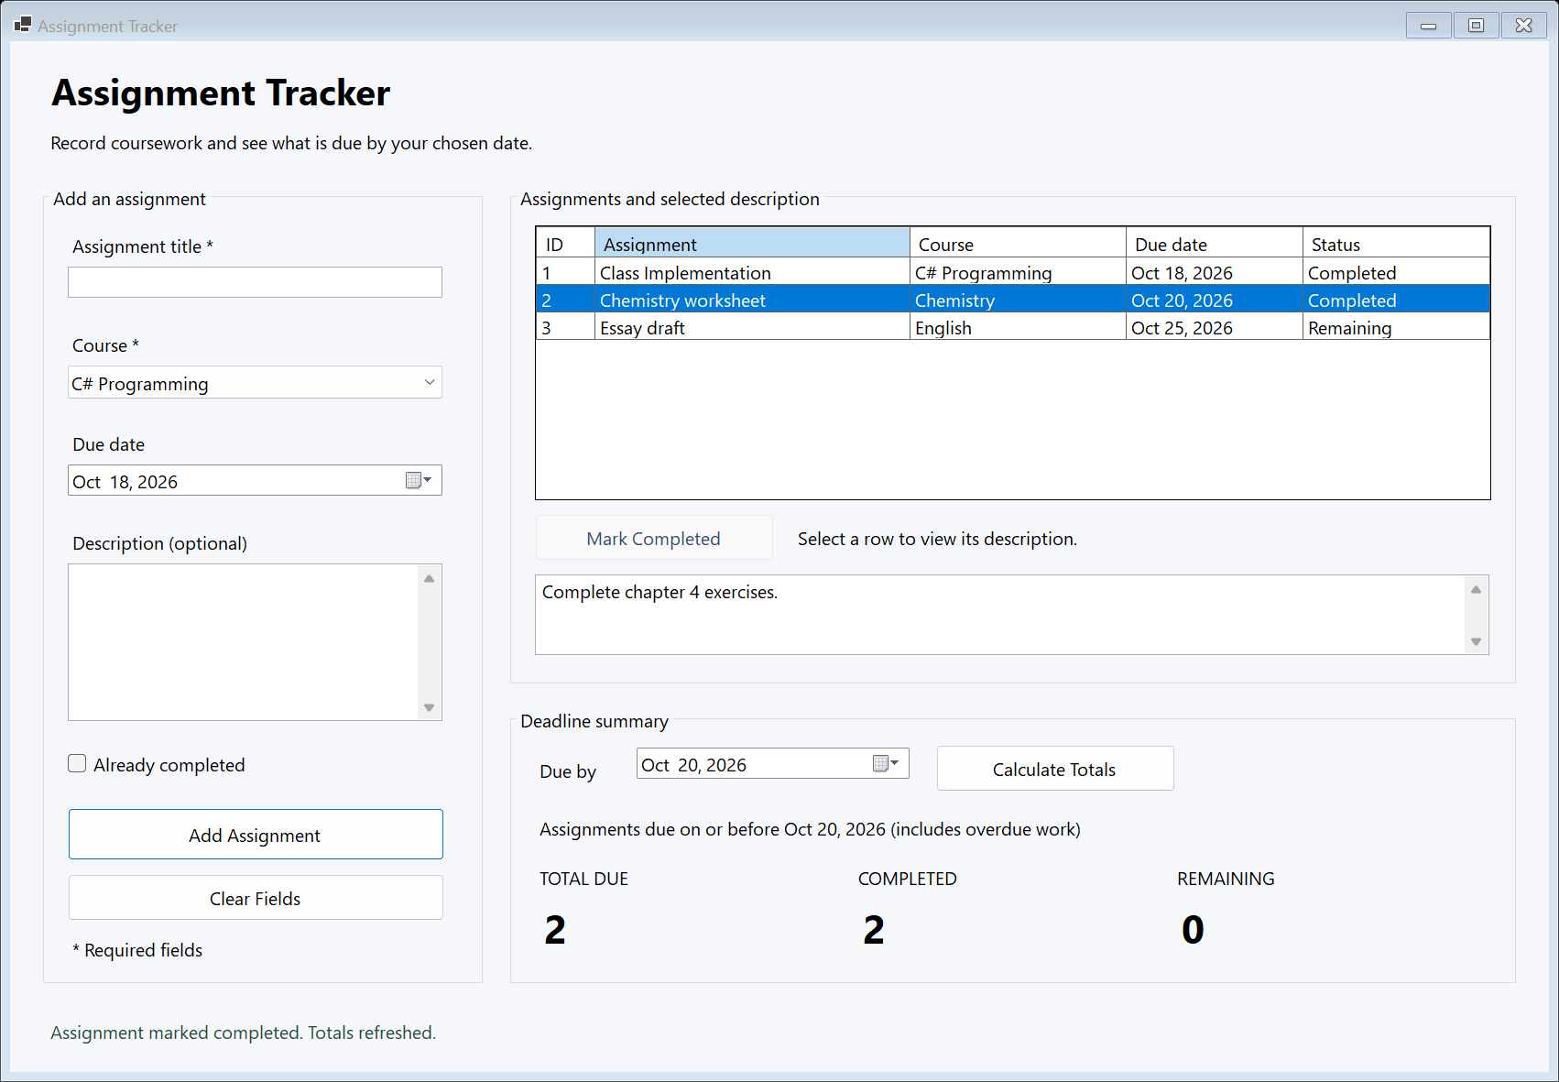

For better visual of screenshots: Please see Evidence/Screenshots folder.

Manual GUI Tests
PASS: Fresh session is empty
PASS: Add button rejects missing title and course
PASS: Add button creates three records
PASS: Calculate button includes cutoff day and excludes later work
PASS: Row selection displays description
PASS: Completion button refreshes status, counts, and button state
PASS: Date change event refreshes counts
PASS: Clear button resets input and preserves existing records
PASS: Earlier cutoff produces zero counts
Passed: 9; Failed: 0
Actual Windows Forms captures from the running application.
(A .txt file with these same results can be found in Evidence/Screenshots folder)

Scope and Design Notes
The three business classes retain the approved properties, constructors, methods, and relationships. The form adds interface code that calls those classes. The optional evidence capture helpers support final documentation and testing; they do not add coursework features. Editing, deletion, reminders, accounts, synchronization, and persistence remain outside the approved scope.

