COSC363 Assignment 1

# Scene Description

This Scene shows a bunny statue factory in a post-nuke environment. There are 2 machines, 2 conveying belt, 1 clock, 1 robot, 1 UFO and 1 vacuum tube in the scene. The machine to the left of the robot produced solid marble cubes, the robot moves the produced cube from one machine’s conveying belt to another machine. The machine to the right of the robot sculpts the marble cube into a marble bunny, then it gets sucked up by the big vacuum tube at the end. The UFO’s purpose is to provide a spot light on the marble cube and bunny. The direction of the bunny is directly downwards. There is also a clock on the wall to measure how long the scene has been running for.

# Screen Shots

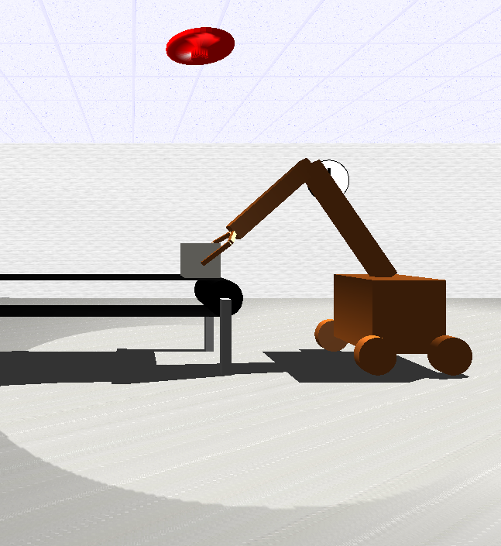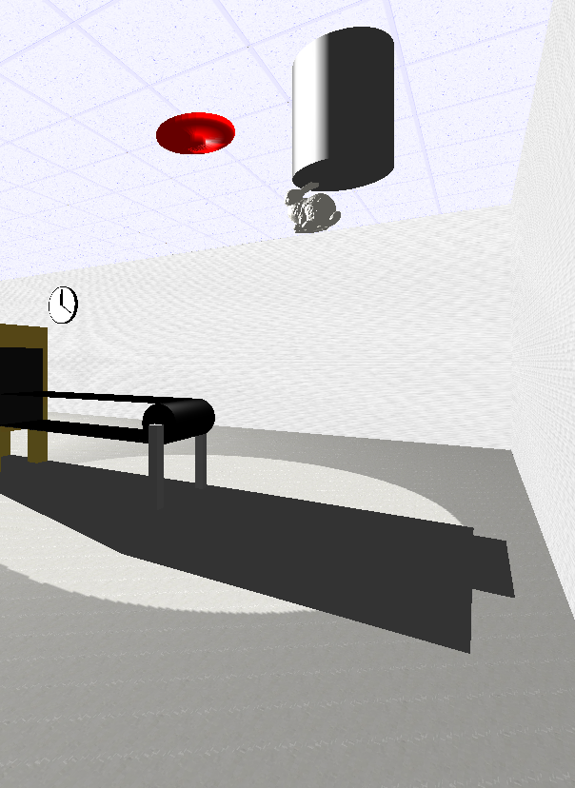

The screen shot on the left shows the robot has grabbed the marble cube with its claws and is about to move the marble cube to the other machine

The screen shot on the right shows the marble has been sculpted into a bunny, which is being sucked up by the vacuum

# Extra features

Planar shadows: The scene includes planar shadows cast by multiple objects such as the robot, the 2 machines and the 2 conveying belts. There is a slight bug with the scene where the planar shadow cast by the machine on the left goes outside the walls of the factory

Physics Engine: the motion of the bunny being sucked by the vacuum is governed by a set of very simple physics equation: displacement=velocity*time and velocity=acceleration*time. The acceleration is set to a fix constant and time is passed by the timer function. These equations make the bunny follow a parabolic path instead of linear

Sky Box: There is a skybox implement on the outside of the factory. It shows a post-nuke scene where everything is in ruins.

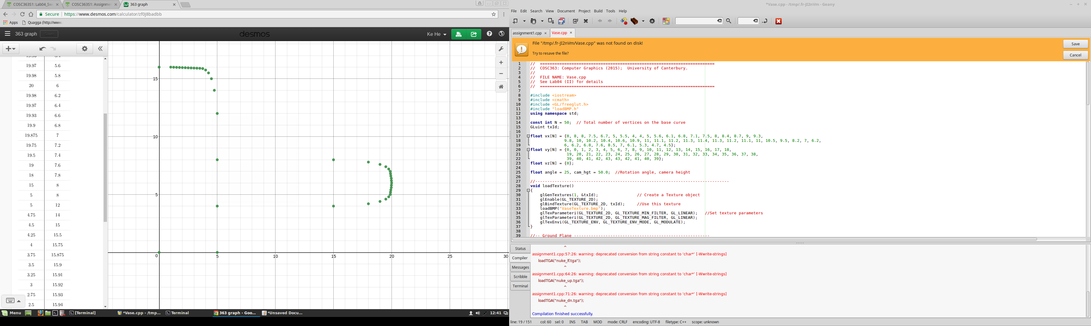Custom built sweep surface: The UFO which is used for giving spot light is made from sweep surface. The points are plotted in Desmos calculator:

And then built by rotating the curve 10 degrees each time

Moving Spotlight: There is a spot light associated with the UFO. It moves with the UFO and shines a spotlight directly down onto the cube/statue

Collision detection(well not really): When the claws are grabbing the cube, it looks like it has collision detection but in reality I just hard coded the angle which the claws have to turn for to grab the cube.

# Control Functions

Move the camera forward and backward: up arrow and down arrow

Rotate the camera left and right: left arrow and right arrow

Move the camera up and down: Page up and Page down key

# Random Extra Features

In this scene, there is a Buddha floating in Lissajous curve given by the equation x(t)=8*cos(5*t), y(t)=5*sin(4*t). The only problem is that it is 1000 units up, since the camera moves only 0.2 units up every press, it takes a while to see this Buddha.

# Reference

The skybox texture are from <http://www.custommapmakers.org/skyboxes.php>

The bunny model are from <http://visionair.ge.imati.cnr.it/ontologies/shapes/>