COSC363 Assignment 1

Scene Description
This Scene shows a bunny statue factory in a post-nuke environment. There are 2 machines, 2 conveying belt, 1 clock, 1 robot, 1 UFO and 1 vacuum tube in the scene. The machine to the left of the robot produced solid marble cubes, the robot moves the produced cube from one machine’s conveying belt to another machine. The machine to the right of the robot sculpts the marble cube into a marble bunny, then it gets sucked up by the big vacuum tube at the end. The UFO’s purpose is to provide a spot light on the marble cube and bunny. The direction of the bunny is directly downwards. There is also a clock on the wall to measure how long the scene has been running for.

Screen Shots
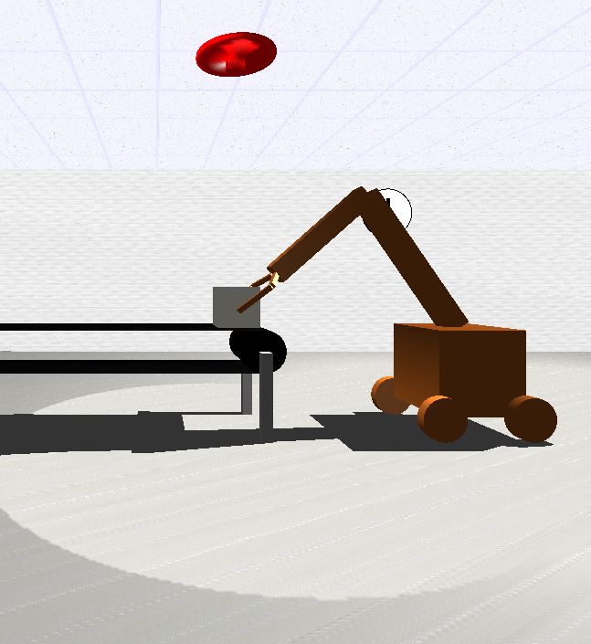
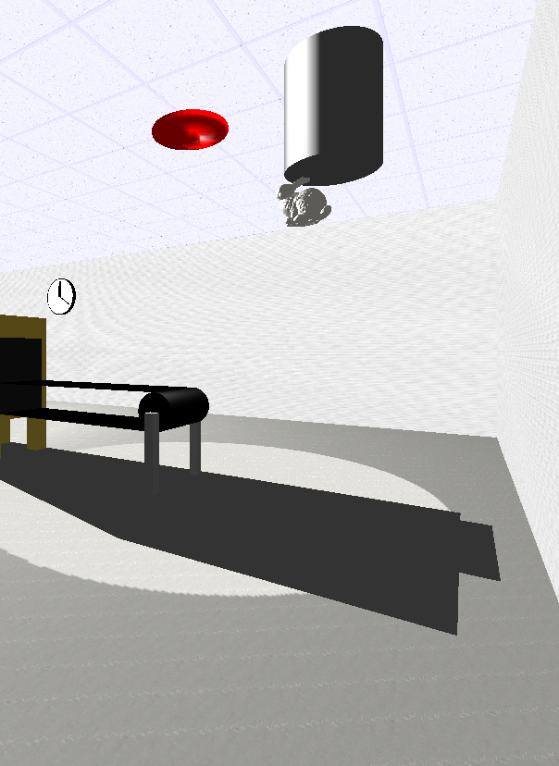
The screen shot on the left shows the robot has grabbed the marble cube with its claws and is about to move the marble cube to the other machine
The screen shot on the right shows the marble has been sculpted into a bunny, which is being sucked up by the vacuum

Extra features
Planar shadows: The scene includes planar shadows cast by multiple objects such as the robot, the 2 machines and the 2 conveying belts. There is a slight bug with the scene where the planar shadow cast by the machine on the left goes outside the walls of the factory
Physics Engine: the motion of the bunny being sucked by the vacuum is governed by a set of very simple physics equation: displacement=velocity*time and velocity=acceleration*time. The acceleration is set to a fix constant and time is passed by the timer function. These equations make the bunny follow a parabolic path instead of linear

Sky Box: There is a skybox implement on the outside of the factory. It shows a post-nuke scene where everything is in ruins.
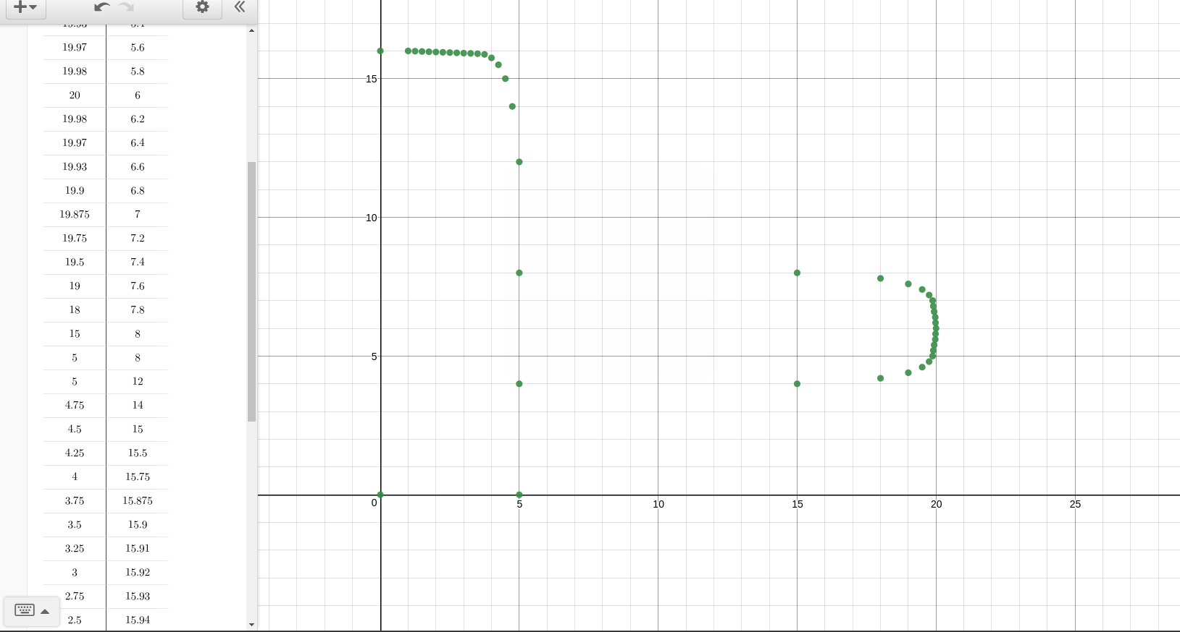
Custom built sweep surface: The UFO which is used for giving spot light is made from sweep surface. The points are plotted in Desmos calculator:
And then built by rotating the curve 10 degrees each time
Moving Spotlight: There is a spot light associated with the UFO. It moves with the UFO and shines a spotlight directly down onto the cube/statue
Collision detection(well not really): When the claws are grabbing the cube, it looks like it has collision detection but in reality I just hard coded the angle which the claws have to turn for to grab the cube.

Control Functions
Move the camera forward and backward: up arrow and down arrow
Rotate the camera left and right: left arrow and right arrow
Move the camera up and down: Page up and Page down key

Reference
The skybox texture are from http://www.custommapmakers.org/skyboxes.php
The bunny model are from http://visionair.ge.imati.cnr.it/ontologies/shapes/

