HANOI UNIVERSITY
Faculty of Information Technology

Project 4: Tweet Sentiment Phrase Extraction
Name: Nguyễn Mai Phương - 2201140066
Nguyễn Trung Kiên -2201140042
Nguyễn Xuân Huy – 2201140036
Course: ATI
Class: CLC02
Submission date: 16/12/2025

Fall 2025
- Overview
This project solves tweet sentiment phrase extraction: given a tweet and its sentiment label (positive/negative/neutral), extract the phrase that justifies the sentiment. We model the task as extractive question answering, where the sentiment label acts as the “question” and the tweet is the “context.” A fine-tuned Transformer predicts start/end token indices, which are mapped back to character spans to generate the final selected_text.
Model: cardiffnlp/twitter-roberta-base with a QA head.
Data: 27,480 training samples and 3,534 test samples; validation split: 2,748 samples.
- Data and Exploratory Findings
A key pattern is the strong asymmetry between neutral and non-neutral labels. Neutral tweets are frequently annotated with selected_text that covers almost the entire tweet, while positive and negative tweets typically highlight a short phrase. This means the dominant source of error is usually boundary precision for positive/negative examples, not whether the model can locate the general region. These observations motivated reporting results both with the “neutral rule” disabled (to assess model capability) and enabled (to match the submission policy).
The training distribution contains 7,781 negative, 11,117 neutral, and 8,582 positive tweets. A key dataset property is that neutral targets are typically close to the full tweet, while positive/negative targets are shorter and require accurate boundary detection.
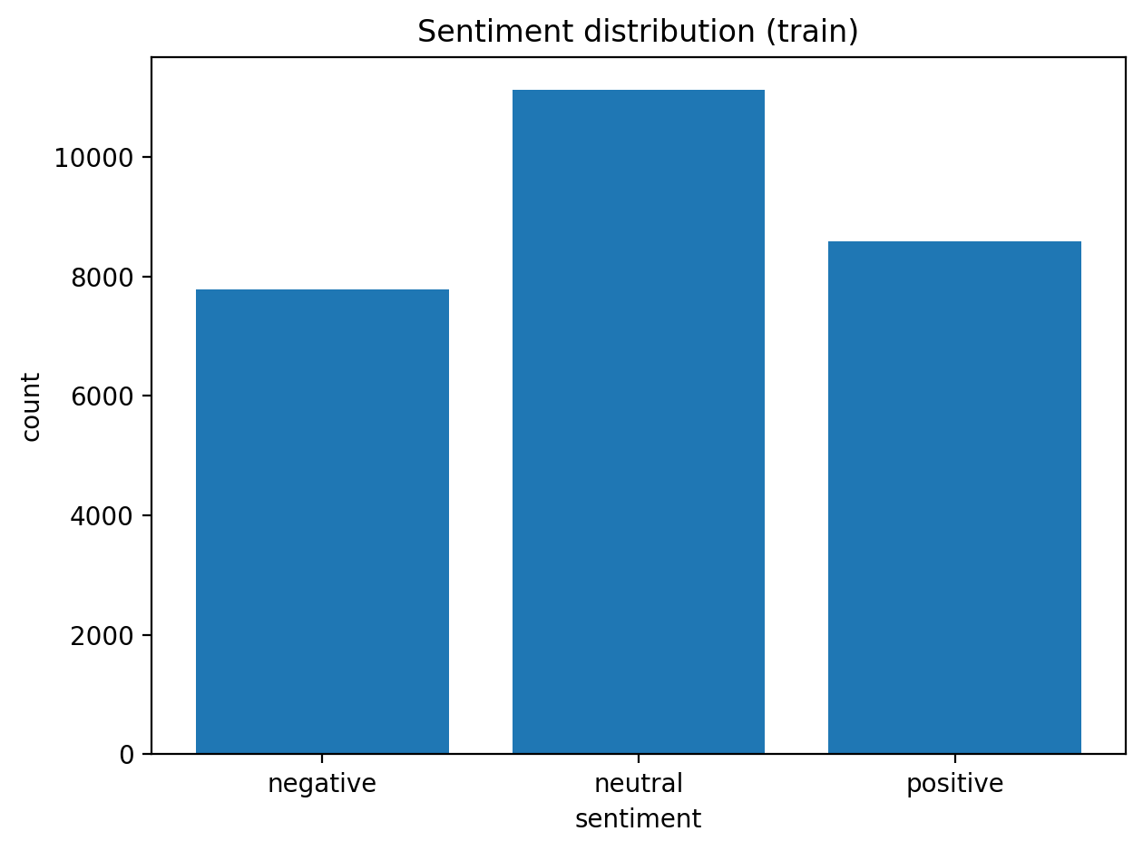
Figure 1. Sentiment distribution (train).
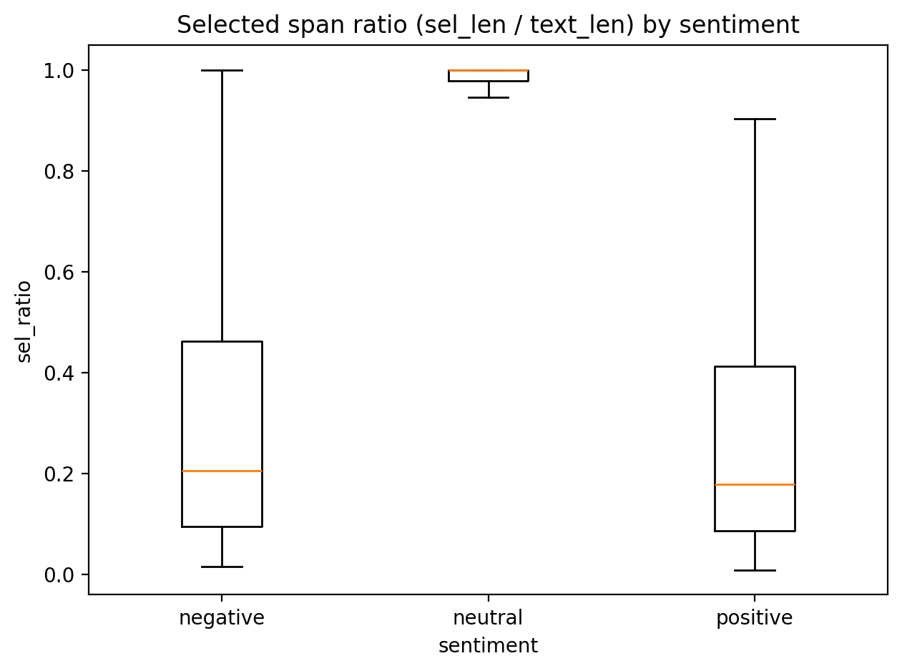
Figure 2. Selected span ratio (selected_length / text_length) by sentiment.
Figure 2 explains the evaluation gap across sentiments: neutral spans cluster near ratio 1.0, while positive/negative spans often cover roughly 10%–40% of the tweet. Therefore, most errors come from small boundary shifts on positive/negative tweets.
In addition to Word Jaccard, we compute character-level precision/recall/F1 and IoU using the true and predicted character spans. We also summarize errors using a character-level confusion matrix where each character position is classified as IN (inside the selected span) or OUT (outside the span). Under this view, false positives indicate spans that are overly long (including irrelevant characters), while false negatives indicate spans that are too short or miss part of the justification. This representation makes boundary errors visible and is easy to interpret in slides.
- Model, Training, and Optimization
The final fine-tuning setup combines several practical optimizations. Learning rate warmup and weight decay provide stable convergence. Layer-wise learning rate decay (LLRD) assigns larger updates to higher Transformer layers and the QA head while protecting lower layers from over-updating, which is useful when transferring a strong pre-trained model to a moderately sized dataset. Gradient accumulation increases the effective batch size under GPU memory constraints, improving gradient estimates without requiring larger per-device batches.
We fine-tuned RoBERTa for span prediction using cross-entropy losses on start/end indices. Inputs follow a QA template: [CLS] sentiment [SEP] tweet [SEP], truncated/padded to max length 192.
Final hyperparameters: learning rate 2e-5, epochs 4, batch size 16 with gradient accumulation 2 (effective 32), weight decay 0.01, warmup ratio 0.06.
Optimization techniques:
- Layer-wise learning rate decay (LLRD): lower layers update more conservatively; decay factor 0.9.
- Constrained decoding: top-k (k=50) search over start/end candidates with a mild length penalty and a mid-length bonus (2–10 tokens) to reduce invalid or overly short/long spans.
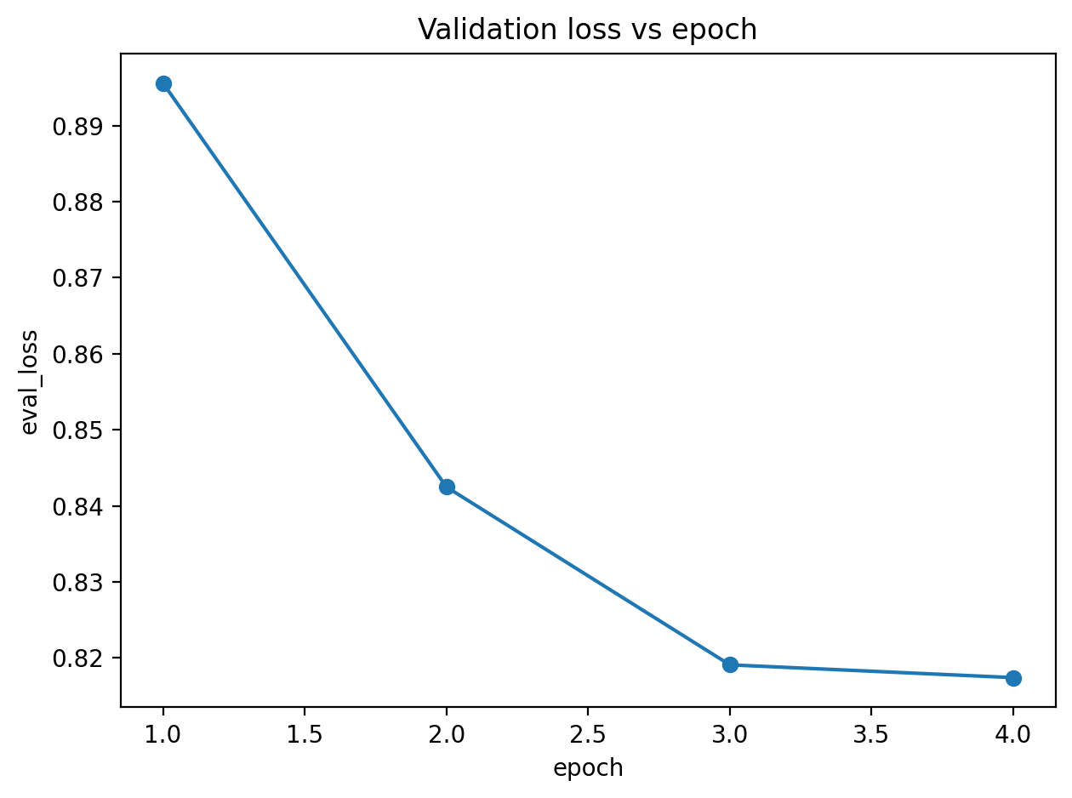
Figure 3. Validation loss by epoch (decreases from 0.8956 to 0.8174).
Validation loss decreases steadily across epochs, indicating stable fine-tuning without obvious divergence. Training loss also decreases (from 0.9632 to 0.7335 by epoch), consistent with improved span alignment.
- Evaluation and Results
We evaluate with word-level Jaccard similarity and character-level metrics (precision/recall/F1/IoU) computed on IN/OUT character masks. Character-level evaluation is more sensitive to boundary errors, which are common in span extraction.
Setting | Macro Jaccard | Macro Char-F1 | Micro Char-F1 | Notes
Neutral rule OFF | 0.7248 | 0.7885 | 0.8650 | Most honest measure of model capability
Neutral rule ON | 0.7257 | 0.7874 | 0.8648 | Matches final submission policy (neutral→full tweet)

Per-sentiment (neutral rule OFF): positive Jaccard 0.5500 (Char-F1 0.6494), negative Jaccard 0.5580 (Char-F1 0.6673), neutral Jaccard 0.9763 (Char-F1 0.9805). Neutral remains much easier because the target span is near the full tweet.
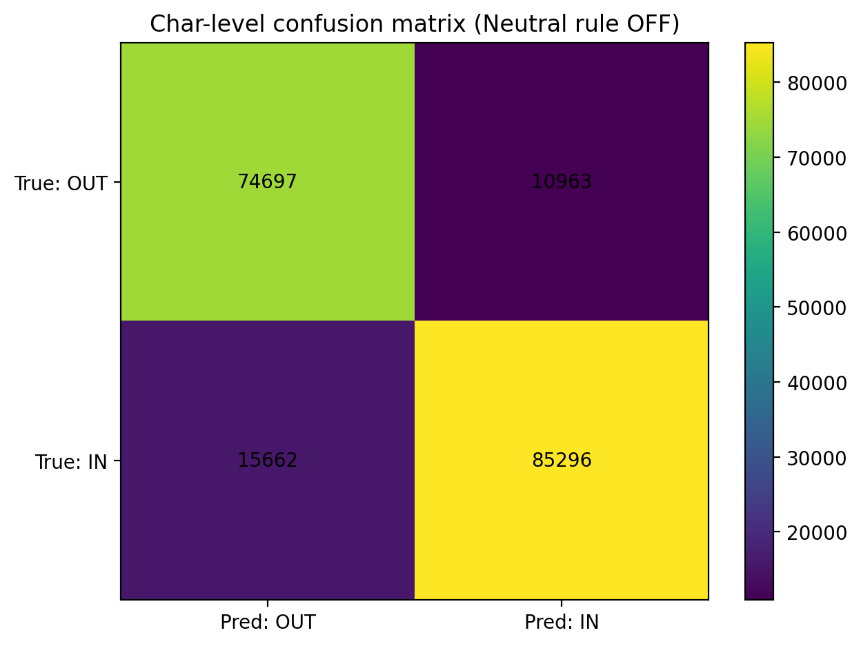
Figure 4. Character-level confusion matrix (Neutral rule OFF).
The confusion matrix aggregates character-level overlap. False negatives (true IN predicted OUT) are slightly larger than false positives, meaning the model more often predicts spans that are a bit too short (missing some sentiment-bearing characters) rather than too long.
Common error patterns observed in samples:
(1) Truncation to a single keyword (e.g., predicting only the most salient word).
(2) Slight over/under-extension at punctuation or clause boundaries.
(3) Ambiguity when multiple substrings could justify the same sentiment.
- Conclusion
Most remaining errors are attributable to boundary ambiguity, especially when multiple sentiment cues exist in the same tweet or when the gold span is a partial phrase. Examples in the notebook show that the model sometimes predicts a strict subset of the true phrase (too short) or includes adjacent words (too long). Future improvements would likely come from stronger ensembling (e.g., more seeds or folds), more systematic decoding calibration, and additional post-processing that prefers clean whitespace-aligned boundaries.
We implemented a complete deep learning workflow for Transformer-based span extraction and achieved macro Jaccard ~0.725 and macro char-F1 ~0.788 on a held-out validation set. The primary limitation is boundary precision on positive/negative tweets. Future work could explore sentiment-specific constraints, stronger regularization, or objectives that more directly optimize span overlap.

