
JOMO KENYATTA UNIVERSITY OF AGRICULTURE
AND TECHNOLOGY (JKUAT)

NAME: MITCHELL MUTHONI KIIGE

REGISTRATION NUMBER: ENE211-0010/2024

YEAR: 2026
TITLE: OBJECT ORIENTED PROGRAMMING PROJECT
SMART HOME MANAGEMENT SYSTEM

1. BACKGROUND OF THE PROJECT
Many households still rely on manual or disjointed approaches to managing connected devices. Lights are controlled from separate apps, climate devices have no coordination, and there is no centralised view of power consumption. This leads to several challenges:
- Energy waste – Devices are left on unnecessarily because there is no centralcontrol.
- No device tracking – Difficult to know the status of every device at a glance.
- Fragmented control – Each device type requires a separate interface.
- Manual effort – Switching multiple devices requires repeated individual actions.
- Poor scalability – Adding new device types is difficult without a unifiedarchitecture.
The main goal of this project is to create a console-based Smart Home Management System using C++ that effectively handles lighting and climate devices through a unified interface. It showcases OOP concepts: inheritance, polymorphism, virtual functions, and smart pointers (shared_ptr).

2. FUNCTIONAL REQUIREMENTS
Add Lighting Device
User enters device details (name, location, power, brightness 0–100, color). System auto-generates a unique Device ID.
Add Climate Device
User enters device details (name, location, power, target temperature, mode). System auto-generates a unique Device ID.
Display All Devices
User views all registered devices with full status — brightness, color, temperature, and mode shown per device.
Turn ON Device
User enters a Device ID to turn ON that device. System confirms activation or shows error if ID not found.
Turn OFF Device
User enters a Device ID to turn OFF that device. System confirms deactivation or shows error if ID not found.
Input Validation
System validates Device IDs before ON/OFF operations and ensures brightness is within 0–100.
User-Friendly Menu
System provides a clear numbered menu (options 1–6) for easy navigation through all features including exit.

SYSTEM ARCHITECTURE

The system uses a simple 2-tier layered architecture with a console-based presentation layer and an application layer built around the SmartHomeSystem class, with an in-memory data layer using C++ vectors and smart pointers. All three classes (SmartDevice, LightingDevice, ClimateDevice) work together under the SmartHomeSystem controller without external dependencies.
SMART HOME MANAGEMENT SYSTEM – SYSTEM ARCHITECTURE
SmartHomeSystem
-
>>
devices : vector<shared_ptr<SmartDevice
-
nextDeviceId : int
()
+
addLightingDevice() + addClimateDevice() + displayAllDevices
+
turnOnDevice() + turnOffDevice() + showMenu
()
+
lightingMenu() + climateMenu() + deviceMenu
()
SmartDevice (Base)
deviceID : string
-
-
deviceName : string
-
location : string
-
isOn : bool
powerConsumption : int
-
+
turnOn() : void
+
turnOff() : void
+
displayStatus() =
0
+
getDeviceType() =
0
LightingDevice
-
brightness : int
-
color : string
+
setBrightness(int
)
+
)
setColor(string
()
+
displayStatus
+
getDeviceType
()
ClimateDevice
-
currentTemp : float
-
targetTemp : float
mode : string
-
)
setTargetTemp(float
+
setMode(string
+
)
+
displayStatus
()
+
getDeviceType
()
Devices Vector
vector<shared_ptr
>>
SmartDevice
<
+
push_back(device
)
size() : int
+
operator
[]
+
begin() / end
()
+
USER INTERFACE (CONSOLE MENU)
Main Menu
1
. Device Mgmt
• Add Lighting
• Add Climate
• Display All
• Back
2
. Control
• Turn ON Device
• Turn OFF Device
• Back
. Settings
3
• Change Location
• Set Power
• Back
4
. Exit
• Exit System

MAJOR COMPONENTS

The major components of the Smart Home Management System are:

1. Lighting Device Management Component
This component handles all operations related to smart lighting devices.
Functions:
- Add new lighting devices
- Configure brightness (0–100%)
- Set light color
- Turn ON / Turn OFF
Main Class:
- LightingDevice (inherits SmartDevice)
Purpose:
- Stores: Device ID, Name, Location, Power, Brightness, Color.
- Enables granular lighting control across the smart home.
2. Climate Device Management Component This component manages smart climate control devices.
Functions:
- Add new climate devices
- Set target temperature
- Configure mode (Cooling / Heating / Fan)
- Turn ON / Turn OFF
Main Class:
- ClimateDevice (inherits SmartDevice)
Purpose:
- Stores: Device ID, Name, Location, Power, Current Temp, Target Temp,Mode.
- Provides automated climate management.

3. Device Control Component
This component handles unified ON/OFF control across all device types.
Functions:
- Turn ON a device by ID
- Turn OFF a device by ID
- Search devices vector by Device ID
Purpose:
- Uses polymorphic virtual dispatch — correct method invoked automaticallyfor any device type.

4. Display / Status Component
This component gives the user a complete view of all registered devices.
Functions:
- Iterate over all registered devices
- Call virtual displayStatus() on each
- Output formatted device information
Purpose:
- Provides full system transparency. Each device type overridesdisplayStatus() to show its specific attributes.

5. User Interface Component
This is the console-based interaction layer between the user and the system.
Functions:
- Display numbered menus
- Accept user input via cin
- Navigate between device-type and control menus
Purpose:
- Allows users to interact through Main Menu, Lighting Menu, Climate Menu,and Control Menu.

6. Data Storage Component
This component temporarily stores all device data during program execution.
Data Structures Used:
- vector>
- Polymorphic access via base class pointer
Purpose:
- Keeps device records in memory. Smart pointers ensure automatic, safememory management.

7. Core System Controller
This is the central component coordinating the entire system.
Main Class:
- SmartHomeSystem Class
Purpose:
- Controls all modules
- Manages the devices vector
- Handles communication between classes
- Acts as the 'brain' of the entire application

SYSTEM BLOCK DIAGRAM

The system block diagram shows an overview of how the system runs and how data is taken and flows.
SMART HOME MANAGEMENT SYSTEM
SYSTEM BLOCK DIAGRAM
USER
USER INTERFACE (Console Menu)
Display Menus
Get User Input
Show Output
. LIGHTING
1
MANAGEMENT
• Add Lighting Device
• Set Brightness
• Set Color
• Turn ON/OFF
. CLIMATE
2
MANAGEMENT
• Add Climate Device
• Set Target Temp
• Set Mode
• Turn ON/OFF
3
. DEVICE
CONTROL
• Turn ON Device
• Turn OFF Device
• Display All
• Search by ID
. POWER /
4
STATUS
• Power Consumption
• Total Devices
• Device Status
5
. EXIT
• Terminate System
SYSTEM CONTROLLER (SmartHomeSystem Class)
Controls all modules
Manages device vector
Handles all operations
Coordinates classes
DATA STORAGE (In-Memory)
LIGHTING DEVICES
Stored as:
vector<LightingDevice>
CLIMATE DEVICES
Stored as:
vector<ClimateDevice>
DEVICE REGISTRY
Stored as:
vector<SmartDevice*>
LEGEND
Data / Control Flow
Two Way Flow
Data in STL vectors (in-memory)
The system block diagram begins with the initialization of the SmartHomeSystem Class, which acts as the central controller. During initialization the system creates the devices vector using smart pointers to store all registered devices in memory.
After initialization, the user interacts through the User Interface (Console Menu) where operations such as adding devices, controlling them, and viewing status can be selected. The System Controller processes requests and communicates with functional modules:
- Lighting Management handles all lighting device operations.
- Climate Management manages all climate control devices.
- Device Control handles unified ON/OFF operations.
- Display provides full status output for all registered devices.

PROGRAM OUTPUT
Figure 1:ADD LIGHTING DEVICE

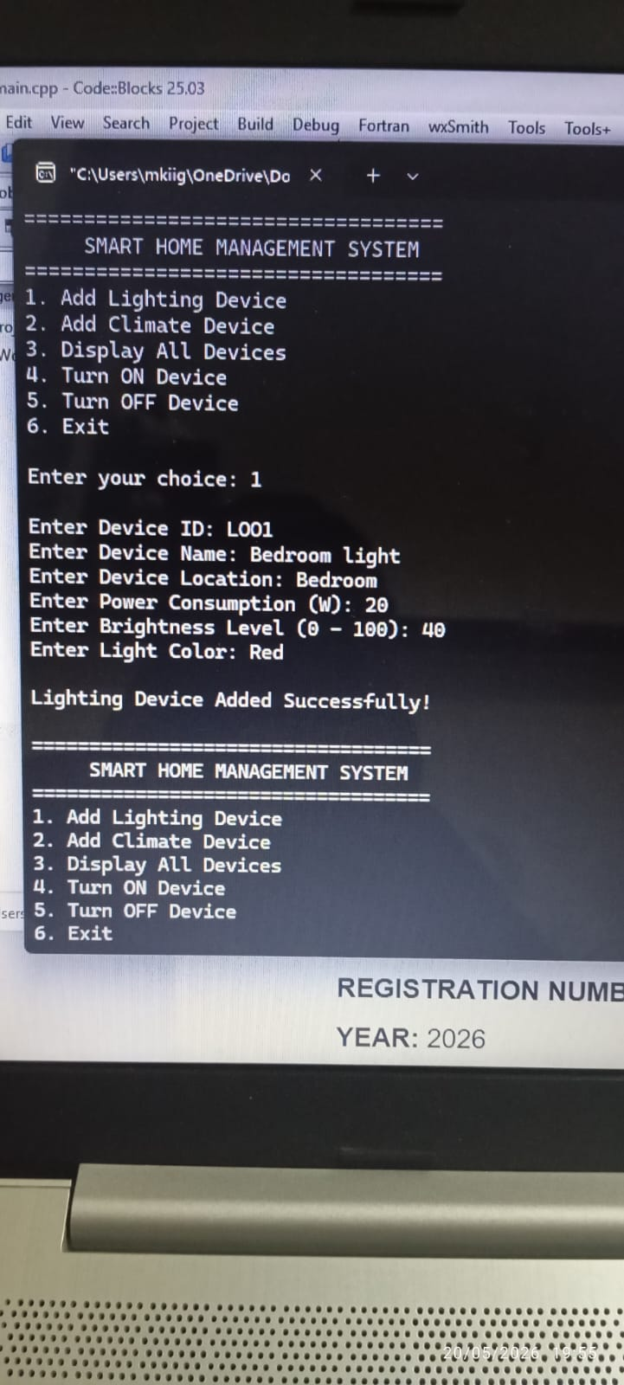

Figure 2:ADD CLIMATE DEVICE

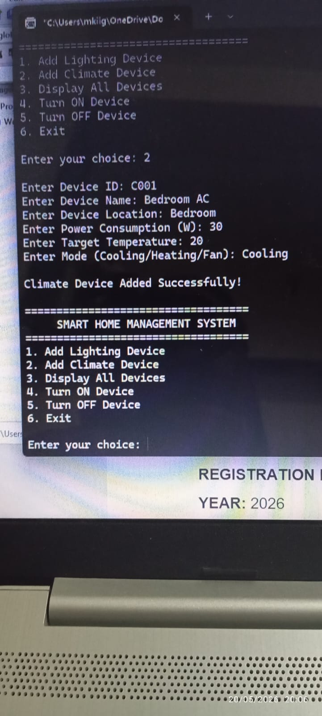

Figure 3:DISPLAY ALL DEVICES

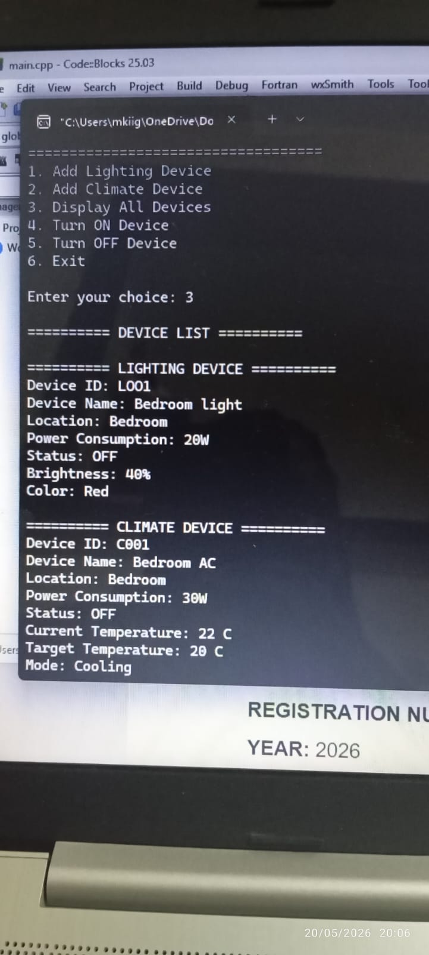

Figure 4:TURN ON DEVICE

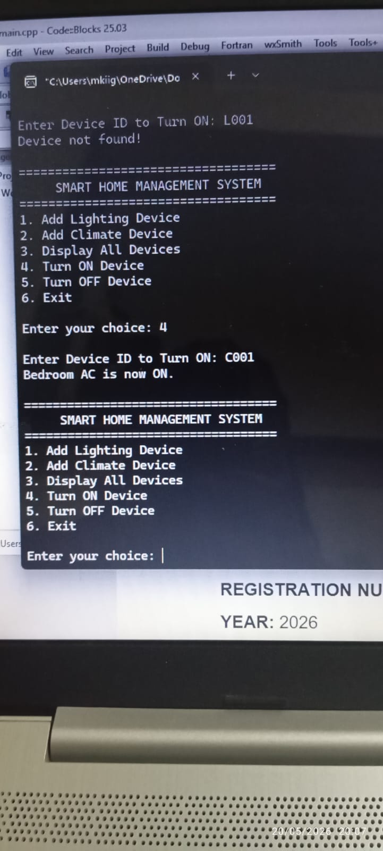

Figure 5:TURN OFF DEVICE

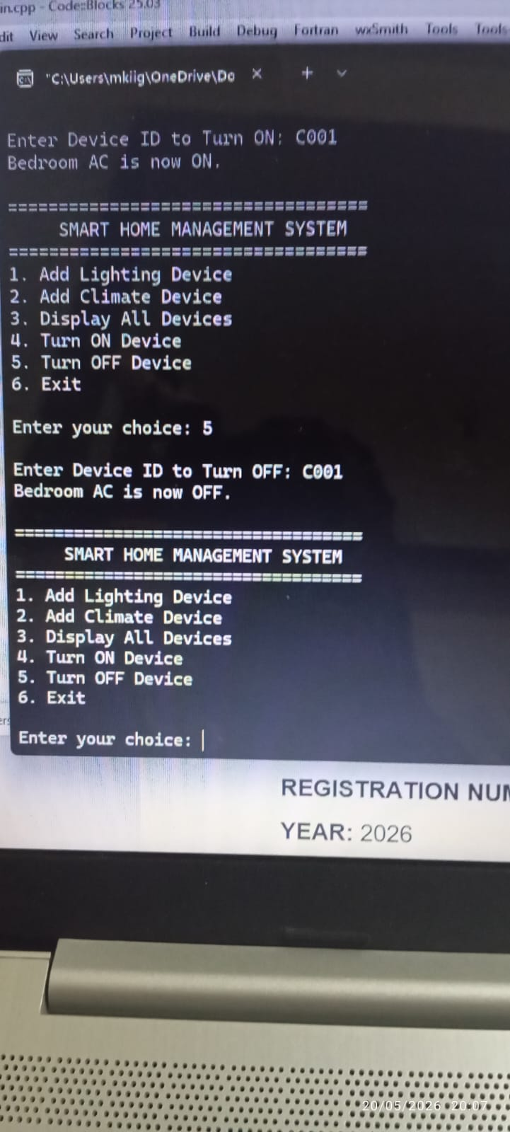

Figure 6:EXIT SYSTEM

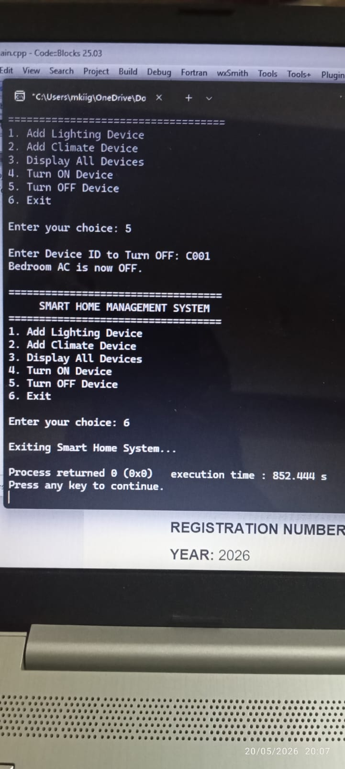

OOP CONCEPTS USED

The following OOP concepts were used in the Smart Home Management System:
- Encapsulation – Data and functions grouped inside SmartDevice,LightingDevice, ClimateDevice.
- Abstraction – Complex logic hidden behind simple virtual functions: turnOn(),turnOff(), displayStatus().
- Inheritance – LightingDevice and ClimateDevice inherit shared behaviour fromSmartDevice.
- Polymorphism – Virtual dispatch calls the correct method per device type atruntime.
- Classes and Objects – Classes instantiated to represent real-world smart homedevices.
- Constructors – Objects initialized with default or user-provided values.
- Data Hiding – Attributes declared protected/private; accessed via publicgetters/setters.
- Composition – SmartHomeSystem contains smart pointers to SmartDeviceobjects via a vector.
- Smart Pointers – shared_ptr ensures automatic, safe memory management.

ADVANTAGES OF THE SYSTEM

- Faster management of lighting and climate device records.
- Reduces manual effort through a unified control interface.
- Easy ON/OFF control of individual devices by ID.
- Real-time display of all device statuses and attributes.
- Organised in-memory storage of all smart home devices.
- Improves efficiency in home device management.
- Simple and user-friendly numbered menu interface.
- Extensible architecture — new device types added by inheriting SmartDevice.
- Safe memory management through C++ smart pointers.

CONCLUSION

In conclusion, the Smart Home Management System successfully demonstrates the application of object-oriented programming concepts in solving real-world smart home automation problems. The system improves the efficiency of managing lighting and climate devices through an organised, user-friendly console interface. Its modular design based on inheritance and polymorphism, combined with safe memory management through smart pointers, helps reduce errors, save time, and enhance overall system reliability and extensibility.

