**User Documentation**

Online Tool for Fieldwork Planning and Risk Assessment

Group M – CITS3200

October 2017

Table of Contents

**General Information** 3

1.1 System Overview 3

1.2 Developers 3

**Getting Started** 4

2.1 Logging In 4

2.2 Creating an Account 4

2.3 Forgot Your Password 4

**Using the System (Participant)** 5

3.1 Account Menu 5

3.2 Create/Submit Forms 5

3.2.1 Form 1 – Fieldwork Participation Declaration 6

3.2.3 Risk Assessment Form 6

3.3 Upload/View Licence Information 7

3.4 View Your Forms 7

**Using the System (Admin)** 9

4.1 Admin Dashboard 9

4.1.1 Admin Dashboard Landing Page 9

4.1.2 User Forms 10

4.2 View Forms Submitted 10

# 

# **General Information**

## **1.1 System Overview**

An online tool for fieldwork planning and risk assessment:

* A software system based on internet browser
* Allows seamless form approval
* Collects and stores forms in a database
* Converts forms to PDF
* System name or title: Online Tool for Fieldwork Planning
* Operational Status: Fully operational

## **1.2 Developers**

|  |  |  |
| --- | --- | --- |
| Terence Leong |  | 21707741@student.uwa.edu.au |
| Hamish St George |  | 21726517@student.uwa.edu.au |
| Victor Oloworaran |  | 21976342@student.uwa.edu.au |
| Louis White |  | 21500209@student.uwa.edu.au |
| Robert Gross |  | 20495129@student.uwa.edu.au |

**1.3 User Access Levels**

The primary user of the system will be participants of fieldwork at UWA. These users are able to:

* Submit forms and upload PDFs regarding their licences
* View forms that they have submitted in the past.

Admin users will be able to submit forms and licences in addition to other features. They will be able to:

* Access a separate dashboard that list all users in the database
* See all forms and licences submitted by a user
* See all forms pending for approval on their dashboard

# **Getting Started**

This section provides a general walkthrough of the system’s landing page and account management.

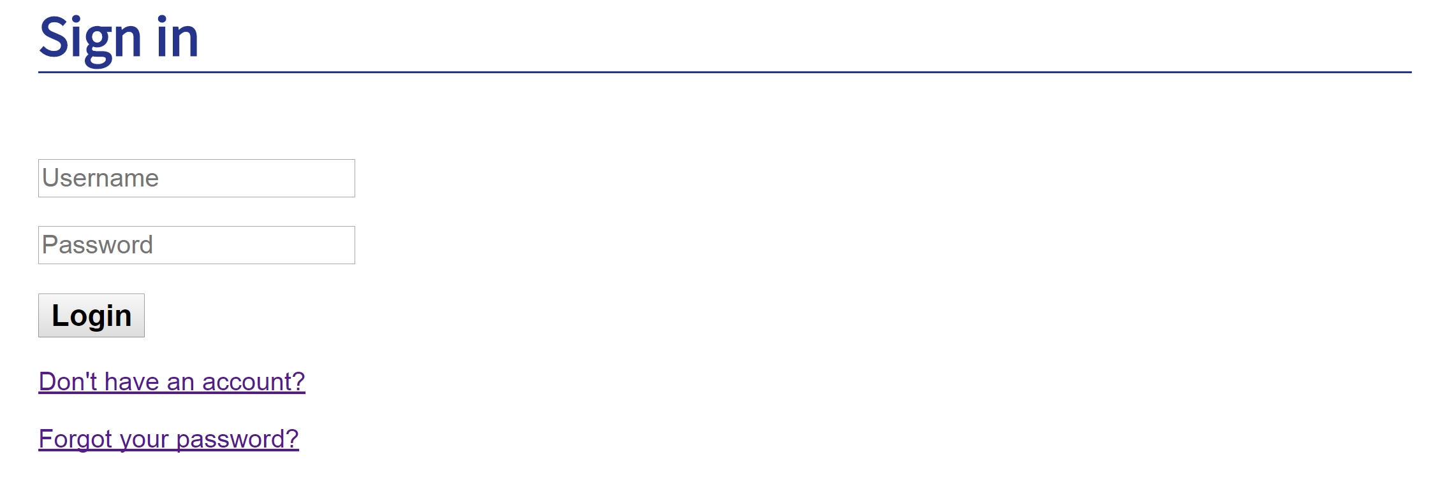

## **2.1 Logging In**

A UWA email address is required to log onto the web interface.

## **2.2 Creating an Account**

From the landing page above, follow the *Don’t have an account?* link. This would prompt you to create an account with the fields: username, password and name. If the account already exist in the system, you will be redirected to the same page. If the password given for both fields are not the same, an error notification will appear on creation. If account was successfully created, you will be automatically logged in to your new account.

## **2.3 Forgot Your Password**

Your password can be reset by following the *Forgot your password?* link. This would prompt you to enter your UWA email address. Entering an email address that exist will redirect you to the landing page. Entering an email address that doesn’t exist in the system will redirect you to the same page.

If successful, an email from no.reply.uwafieldwork@gmail.com would be sent to the given email. Following the link provided in the email would redirect you to the change password page.

# **Using the System (Participant)**

This section provides a general walkthrough of the system’s dashboard and the features available in the main system for participant users.

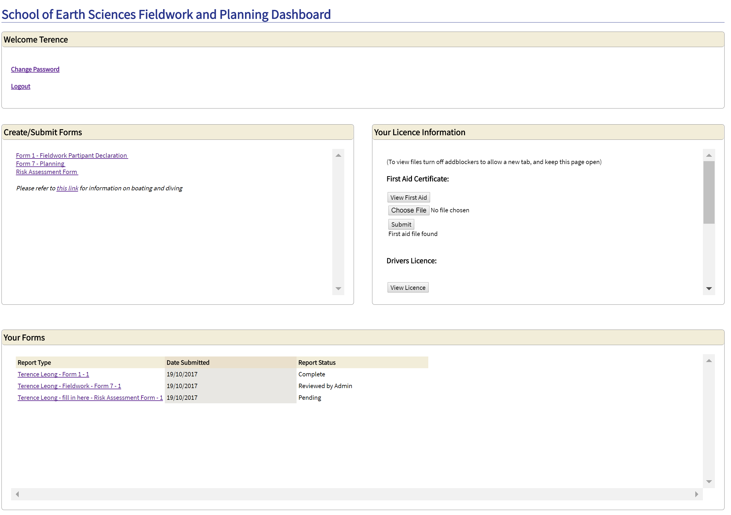

## **3.1 Account Menu**

This section includes the *change password* and *logout* option. The first option will redirect you to a separate page which prompts for a new password and confirmation of password. A different input for both would generate an error notification outlining the “passwords are not the same”. If successfully changed, the system would update the information and redirect you back to the dashboard. To abort password changing, use the back button on your browser.

The second option will successfully log you out of your account.

## **3.2 Create/Submit Forms**

Forms to be filled out can be found in this section of the dashboard. There are three forms within the system: Form 1, Form 7 and the Risk Assessment Form. Form 1 only has to be completed once at the start of every year.

Note that Form 7 and Risk Assessment Form will not appear before a Form 1 has been completed for that year.For information regarding boating and diving forms, follow the link provided on screen.

### **3.2.1 Form 1 – Fieldwork Participation Declaration**

This form entails filling in personal information and making sure that all terms and conditions are comprehended. All policies listed in the form includes a link to the safety.uwa.edu.au page providing more information regarding said policy.

To submit the form, all fields have to be completed and all necessary checkboxes ticked. Failure to do so will generate an error notification on submission.

#### **3.2.2 Form 7 – Planning**

This form entails filling in information regarding an upcoming fieldwork trip. Each section of the form contains a button to toggle extra information regarding it. A *PDF Upload* section is also available for you to include a previous *Risk Assessment Form* of extension .PDF. Note that the system will only accept PDF uploads 10MB or smaller, any other file type or larger files will allow submission, but not entered into database.

All available fields have to be completed and necessary checkboxes ticked before submission. Failure to do so will generate an error notification on submission.

### **3.2.3 Risk Assessment Form**

This form entails filling in information regarding an upcoming fieldwork trip. All information required to fill out the risk assessment table is provided on the page.

The risk assessment table consist of an embedded PDF including all common risk. Each sub-section has to be filled out with at least one risk and control. The initial risk generated with the form cannot be removed and the initial control generated with each risk cannot be removed either.

All available fields have to be completed and a minimum of one for each type of risk in the risk assessment table has to be completed. Failure to do so will generate an error notification on submission.

## **3.3 Upload/View Licence Information**

Document uploading can be found in this section of the dashboard. The three documents to be uploaded are: first aid certificate, driver licence and off-road/4WD training document.

Each sub-section includes three buttons *view File, choose File* and *Submit*. The first button will allow you to see the previous file uploaded for that sub-section. As stated on the dashboard itself, your adblocker has to be disabled for viewing PDFs. This is due to adblocker stopping the browser from opening the PDF in a different tab. Note that you may have to reload the browser until the selected PDF has been uploaded completely, which is indicated by the text below the third button.

The *choose file* button allows you to browse through files on your computer and select the desired document. You are allowed to select any document type during this process, but note that only documents with extension .PDF and 10MB or smaller will be entered into the database.

Use the submit button to submit your PDF. If the document is not of extension .PDF, no alerts will be generated, but nothing will be entered into the database.

## **3.4 View Your Forms**

The final section displayed on the dashboard consist of all forms that you have submitted. Each row includes the report type, date submitted and report status. The format of the report type column is as follow: *Full Name – Project Title – Form Type – Number of Submitted Form Type*.

There are three types of report statuses: *pending*, *reviewed by user*, *reviewed by admin* and *completed*. *Pending* indicates that the form has been submitted to the supervisor for checking. *Reviewed by* user indicates that the form has been sent back to admin after revision. Reviewed *by admin* indicates that the form has been sent back to you and requires your attention before resubmitting. *Completed* indicates that the form has been successfully filled in and sent to the Head of School. After clicking on a form in this section, you will be redirected to the selected form.

When the form is in the *pending*, *reviewed by user* and *completed* stage, you would not be able to edit any fields on it. However, you would be able to print the form to PDF while in this stage.

When the form is in *the reviewed by admin* stage, you would be able to edit all previously available fields. Supervisor comments will also be shown in all section of each form. To view a PDF that has been uploaded in form 7, adblocker has to be disabled to allow a new tab to be opened. Each instance of PDF uploading will overwrite previous uploads. If the selected document is not of extension .PDF or larger than 10MB, no alerts will be generated, but the document will not be entered into the database. A submit button will be available at the bottom of the form for resubmission.

# **Using the System (Admin)**

This section will provide a general walkthrough of the extra features included in an admin account. All other functionality not outlined here are the same as a participant account.

## **4.1 Admin Dashboard**

The admin dashboard can be found below the account menu. Following the link will allow you access to it.

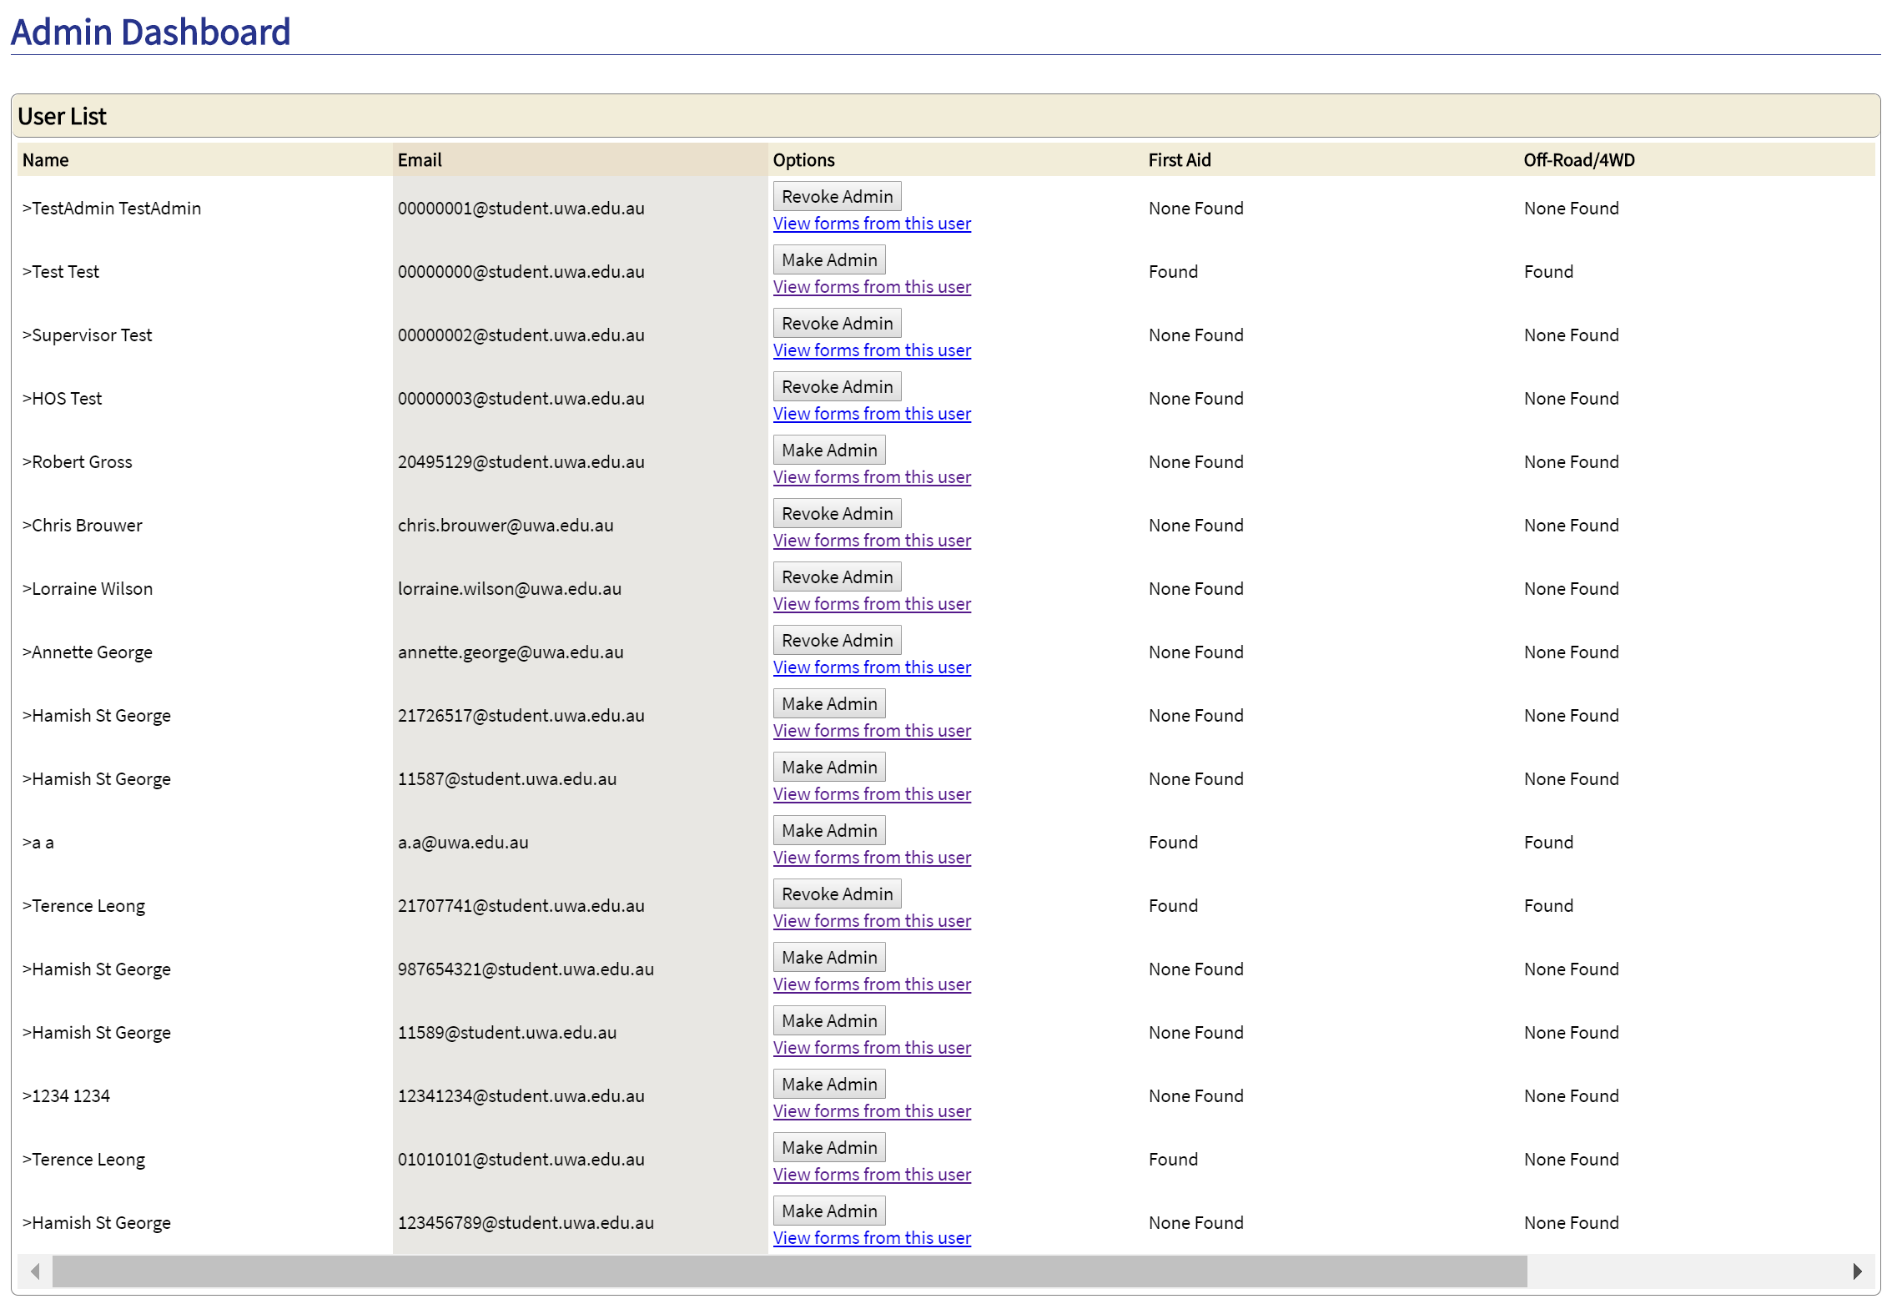

### **4.1.1 Admin Dashboard Landing Page**

The admin dashboard consist of a single section. This section presents all users currently in the database. Each row includes the user’s full name, email address, options, first aid, off-road/4WD and licence.

Under the Options section, you can make a user an admin or revoke admin rights from a user. For participant accounts, the *make admin* button will be present. For admin accounts, the *revoke admin* button will be present. Following the *View forms/licences from this user* will redirect you to a separate admin dashboard. This will be outlined in the section below.

For the last three columns: first aid, off-road/4WD and licence, *None found* or *Found* will be present, indicating that a PDF for each column is as implied.

### **4.1.2 User Forms**

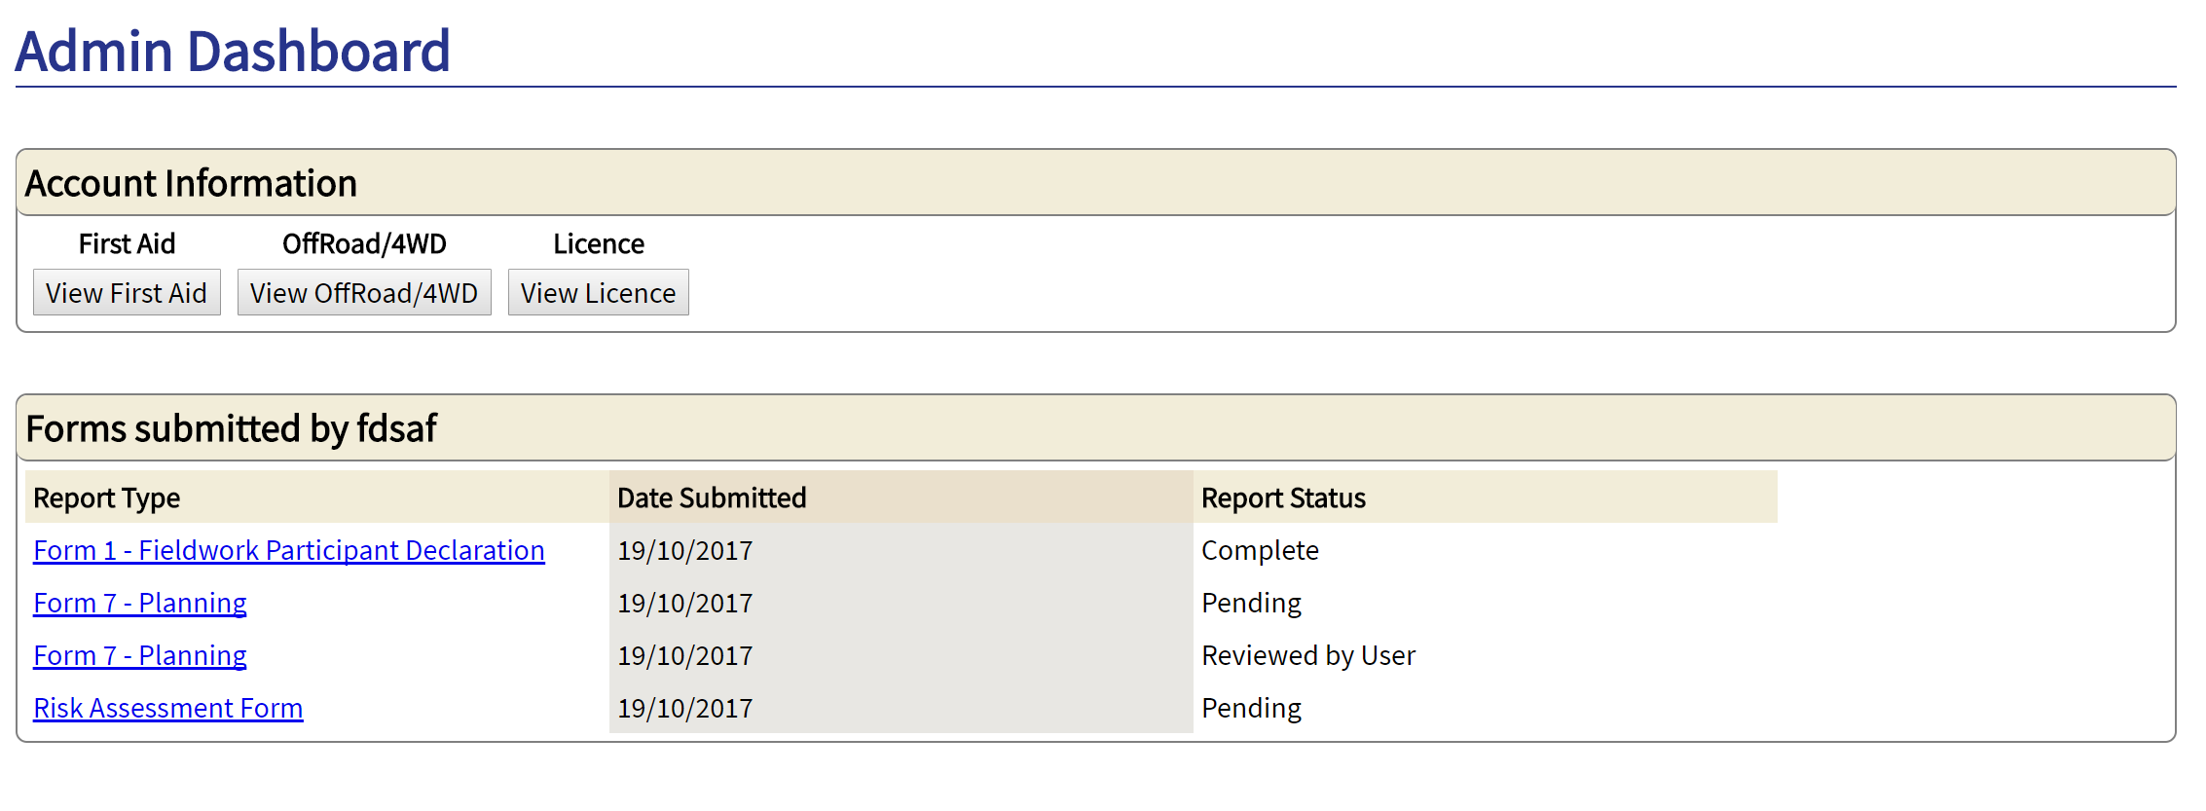

Following the *View forms/licences from this user* link on the landing page will redirect you to all licences and forms submitted by that user. There are two separate sections on this dashboard: account information and forms submitted by user.

The three licence uploads are in the first section. If no PDF is uploaded to the given licence, clicking the *view* button will do nothing. If there is a PDF uploaded, the view button will open the PDF in a different tab. Note that adblocker has to be disabled for this feature to work, as adblocker will stop the browser from opening a new tab.

The second section consist of all forms that the user has submitted. By clicking on the form, you will be able to see the content inside. All the forms listed in this section can be viewed, but not edited. Clicking the button at the bottom of the opened form will print it to PDF.

## **4.2 View Forms Submitted**

The *Your Forms* section of the dashboard allows you to see all forms that have been submitted for review. Each row includes the report type, date submitted and report status. The format of the report type column is as follow: *Full Name – Project Title – Form Type – Number of Submitted Form Type*.

There are two types of report statuses: *pending* and *reviewed by user*. *Pending* indicates that the form has been submitted by a participant and needs to be reviewed by you. *Reviewed by user* indicates that the form has been resubmitted by the participant and needs to be reviewed again by you.

When the form is in the pending and reviewed by user stage, you would be able to edit all fields on the form. A comment box will also be available at the end of each section. The *PDF upload* button in form 7 is disabled. Fields that are empty in the final section of all forms should be filled out.

At the end of all forms are two buttons: *send back to user* and *sign off on form*. The first button will send the current form back to the participant for revision. The second one will send the form to the Head of School. After clicking on any of the two buttons, the form will no longer show in this section of your dashboard.