Queries
- KPI’s
1.Total sales
SELECT
CONCAT(CAST(SUM(total_sales)/1000000 AS DECIMAL(10,2)),'Million')
AS "Total_Sales_in_millions" FROM blinkit_grocery_data;
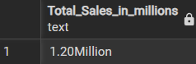

2. AVERAGE SALES
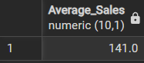
SELECT CAST(AVG(total_sales) AS DECIMAL(10,1)) AS "Average_Sales" FROM blinkit_grocery_data;

3. Number of Items sold
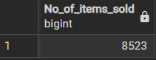

4. AVERAGE RATING
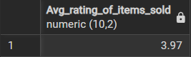

BUSNESS REQUIREMENTS
- Total Sales by Fat Content
SELECT item_fat_content,
CAST(SUM(total_sales) AS DECIMAL (10,2)) AS "Total_Sales_By_Fat_content_in_thousands",
CAST(AVG(rating) AS DECIMAL(10,2)) AS "Avg_rating_of_items_sold",
COUNT(*) AS "No_of_items_sold"
FROM blinkit_grocery_data
GROUP BY item_fat_content
ORDER BY "Total_Sales_By_Fat_content_in_thousands" DESC;
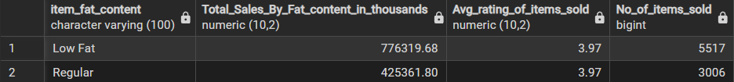

- Total Sales by Item Type:
SELECT item_type,
CAST(SUM(total_sales) AS DECIMAL (10,2)) AS "Total_Sales_By_Fat_content_in_thousands",
CAST(AVG(rating) AS DECIMAL(10,2)) AS "Avg_rating_of_items_sold",
COUNT(*) AS "No_of_items_sold"
FROM blinkit_grocery_data
GROUP BY item_type
ORDER BY "Total_Sales_By_Fat_content_in_thousands" ASC
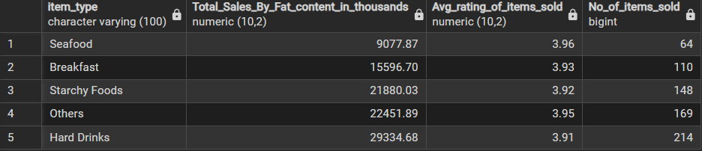
LIMIT 5;
- Fat Content by Outlet for Total Sales:
SELECT
outlet_location_type,
CAST(SUM(CASE WHEN item_fat_content = 'Low Fat' THEN total_sales END) AS DECIMAL(10,2)) AS low_fat_sales,
CAST(SUM(CASE WHEN item_fat_content = 'Regular' THEN total_sales END) AS DECIMAL(10,2)) AS regular_sales
FROM blinkit_grocery_data
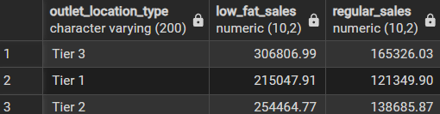
GROUP BY outlet_location_type
- Total Sales by Outlet Establishment
SELECT outlet_establishment_year,
CAST(SUM(total_sales) AS DECIMAL (10,2)) AS Total_sales
FROM blinkit_grocery_data
GROUP BY outlet_establishment_year
ORDER BY outlet_establishment_year ASC;

SELECT DISTINCT outlet_establishment_year,
SUM(total_sales) OVER (PARTITION BY outlet_establishment_year) AS total_sales
FROM blinkit_grocery_data
ORDER BY outlet_establishment_year ASC

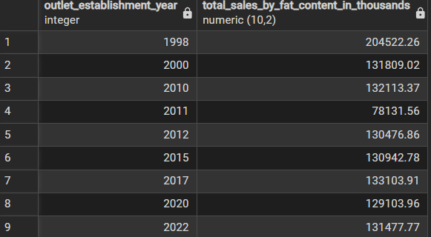

5.Percentage of Sales by Outlet Size

SELECT
DISTINCT outlet_size,
CAST(SUM(total_sales) OVER (PARTITION BY outlet_size) AS DECIMAL(10,2)) AS total_sales_per_size,
CAST(
(SUM(total_sales) OVER (PARTITION BY outlet_size) * 100.0 /
SUM(total_sales) OVER ()) AS DECIMAL(10,2)
) AS percentage_of_total_sales
FROM blinkit_grocery_data
ORDER BY total_sales_per_size DESC;
SELECT
outlet_size,
CAST(SUM(total_sales) AS DECIMAL(10,2)) AS total_sales,
CAST(SUM(total_sales) * 100.0 / (SELECT SUM(total_sales) FROM blinkit_grocery_data) AS DECIMAL(10,2)) AS percent_of_total
FROM blinkit_grocery_data
GROUP BY outlet_size
ORDER BY total_sales DESC;
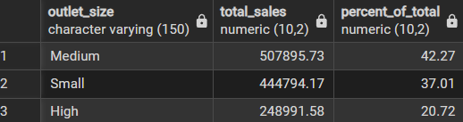

6. Sales by Outlet Location and 7. All Metrics by Outlet Type
SELECT DISTINCT outlet_location_type,SUM(total_sales) AS TOTAL_SALES_PER_LOCATION_TYPE
FROM blinkit_grocery_data
GROUP BY outlet_location_type
ORDER BY outlet_location_type ASC

SELECT DISTINCT outlet_location_type,
CAST(SUM(total_sales) AS DECIMAL(10,2)) AS TOTAL_SALES_PER_LOCATION_TYPE,
CAST(AVG(total_sales) AS DECIMAL(10,2)) AS AVG_SALES_PER_LOCATION_TYPE,
COUNT (*) AS No_of_items,
CAST(AVG(rating) AS DECIMAL(10,2)) AS AVG_RATING_PER_LOCATION_TYPE
FROM blinkit_grocery_data
GROUP BY outlet_location_type
ORDER BY outlet_location_type ASC

SELECT DISTINCT outlet_location_type,
CAST(SUM(total_sales) OVER (PARTITION BY outlet_location_type) AS DECIMAL(10,2)) AS TOTAL_SALES_PER_LOCATION_TYPE,
CAST(AVG(total_sales) OVER (PARTITION BY outlet_location_type) AS DECIMAL(10,2)) AS AVG_SALES_PER_LOCATION_TYPE,
COUNT (*)OVER (PARTITION BY outlet_location_type) AS No_of_items,
CAST(AVG(rating )OVER (PARTITION BY outlet_location_type) AS DECIMAL(10,2)) AS AVG_RATING_PER_LOCATION_TYPE
FROM blinkit_grocery_data
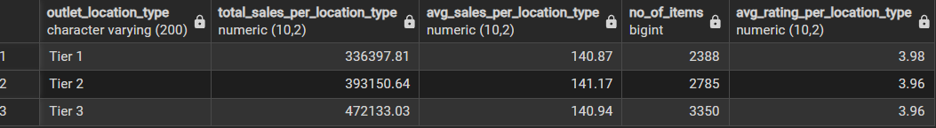
ORDER BY outlet_location_type ASC

