|  |  |  |  |  |  |  |  |  |
| --- | --- | --- | --- | --- | --- | --- | --- | --- |
|  | **count** | **mean** | **std** | **min** | **25%** | **50%** | **75%** | **max** |
| **VendorNumber** | 10692.00 | 10650.65 | 18753.52 | 2.00 | 3951.00 | 7153.00 | 9552.00 | 201359.00 |
| **Brand** | 10692.00 | 18039.23 | 12662.19 | 58.00 | 5793.50 | 18761.50 | 25514.25 | 90631.00 |
| **PurchasePrice** | 10692.00 | 24.39 | 109.27 | 0.36 | 6.84 | 10.46 | 19.48 | 5681.81 |
| **actualPrice** | 10692.00 | 35.64 | 148.25 | 0.49 | 10.99 | 15.99 | 28.99 | 7499.99 |
| **totalquantity** | 10692.00 | 3140.89 | 11095.09 | 1.00 | 36.00 | 262.00 | 1975.75 | 337660.00 |
| **totalpurchasedollars** | 10692.00 | 30106.69 | 123067.80 | 0.71 | 453.46 | 3655.47 | 20738.25 | 3811252.00 |
| **totalsalesprice** | 10692.00 | 18793.78 | 44952.77 | 0.00 | 289.71 | 2857.80 | 16059.56 | 672819.30 |
| **totalsalesquantity** | 10692.00 | 3077.48 | 10952.85 | 0.00 | 33.00 | 261.00 | 1929.25 | 334939.00 |
| **totalsalesdollars** | 10692.00 | 42239.07 | 167655.27 | 0.00 | 729.22 | 5298.05 | 28396.92 | 5101920.00 |
| **totalexcisetax** | 10692.00 | 1774.23 | 10975.58 | 0.00 | 4.80 | 46.57 | 418.65 | 368242.80 |
| **total_freight** | 10692.00 | 61433.76 | 60938.46 | 0.09 | 14069.87 | 50293.62 | 79528.99 | 257032.10 |
| **Gross_Profit** | 10692.00 | 12132.38 | 46224.34 | -52002.78 | 52.92 | 1399.64 | 8660.20 | 1290668.00 |
| **Profimargin** | 10692.00 | -inf | NaN | -inf | 13.32 | 30.41 | 39.96 | 99.72 |
| **StockTurover** | 10692.00 | 1.71 | 6.02 | 0.00 | 0.81 | 0.98 | 1.04 | 274.50 |
| **Sales_to_Purchase_Ratio** | 10692.00 | 2.50 | 8.46 | 0.00 | 1.15 | 1.44 | 1.67 | 352.93 |

**EXPLORATORY DATA ANALYSIS**

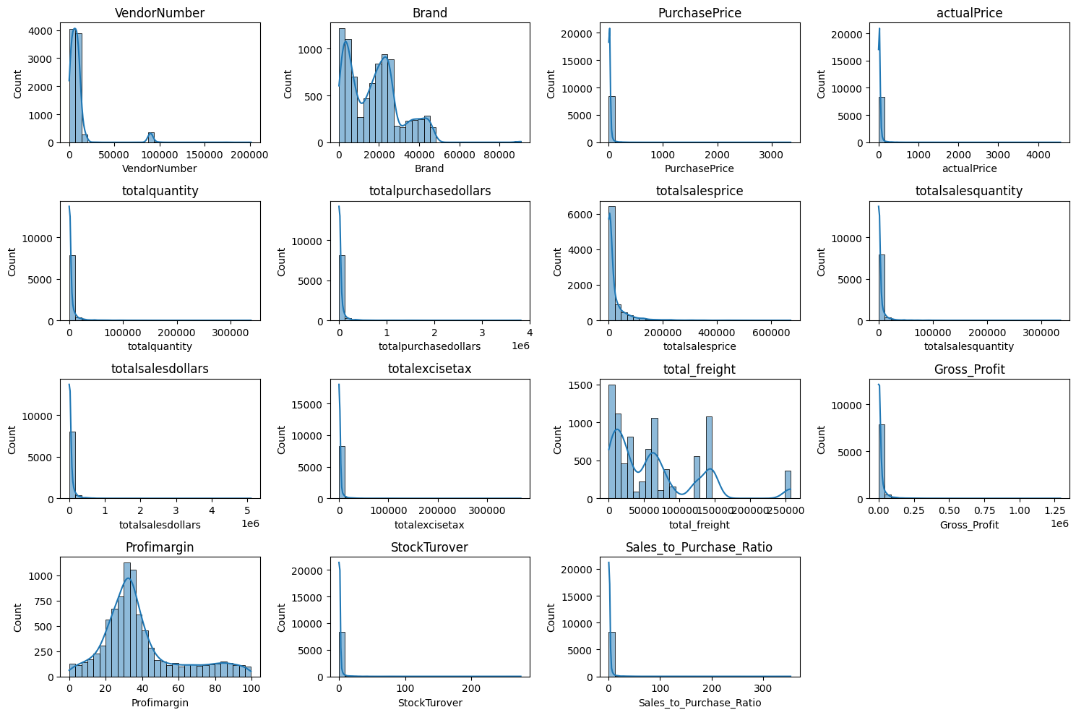**SUMMARY STATISTICS**

**Negative & Zero values:**

**Gross Profit:** Minimum of -52,002.78**,** indicating potential losses due to high direct operating cost or heavy discounts being provided and also low selling of goods below purchase cost.

**Profit Margin:** Profit margin has minimum of - ∞ due to 0 revenue and high total cost. Also, this possible result of selling product below cost.

**Total Sales Quantity & Sales Dollars:** Some products have zero sales this is indicating they were purchased but never sold. These may obsolete or slow-moving goods, leading to inventory inefficiency.

**Outliers Detected by High Standard Deviations:**

**Purchase & Actual Prices:** The maximum values (5681.81 & 7499.99) are significantly higher than the mean (24.39 & 35.64) indicating premium product offerings.

**Freight costs:** Extreme variation from 0.99 to 257032.07 suggests logistics inefficiencies, bulk shipments, or erratic cost shipping costs across products.

**Stock Turnover:** Ranges from 0 to 274.5, suggest some products are sold immediately and other remains unsold for long time and value greater than 1 means older stock fulfilling orders.

**DATA FILTERING**

To enhance reliability and accuracy, we removed inconsistent data where:

* Gross Profit < 0 (Exclude which was not contributing to gross profit)
* Profit Marfin <0 (to ensure analysis focuses on profitable transactions)
* Total sales quantity = 0 (to eliminate inventory which was never sold)

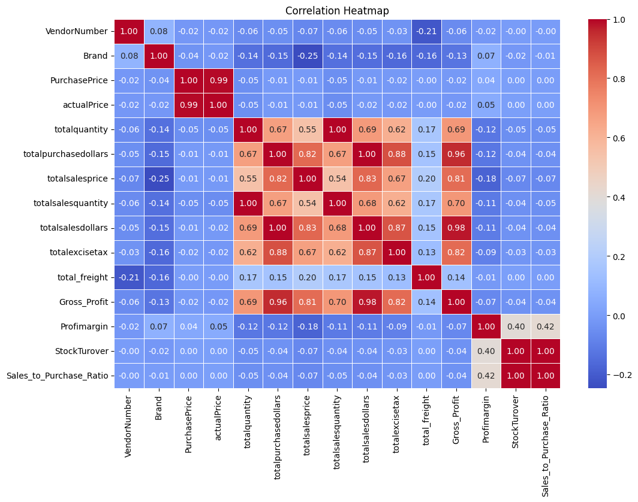**CORRELATION INSIGHTS**

**Purchase price vs. Total Sales Dollars & Gross Profit:** Weak Correlation (-0.01 & -0.02) indicating that price variations do not significantly impact sales revenue and profit.

**Total Purchase quantity vs. Total Sales quantity:** Strong correlation (0.999), confirming efficient inventory.

**Profit Margin vs. Total sales price:** Weak negative correlation (-0.18) indicating that increasing sales price would not improve profit margin but it would decrease margin, possibly due to competitive pricing measures.

**Stock Turnover vs. Gross Profit & Profit Margin:** Weak correlation (-0.04 & 0.40) this indicates increasing stock turnover doesn’t increase profitability margins.

**RESEARCH QUESTIONS AND FINDINGS**

1. **Brands for Promotional or Pricing adjustments**

Brands with Low Sales but High Profit Margins:

|  |  |  |
| --- | --- | --- |
| **Description** | **totalsalesdollars** | **Profimargin** |
| **Santa Rita Organic Svgn Bl** | **9.99** | **66.46646647** |
| **Debauchery Pnt Nr** | **11.58** | **65.97582038** |
| **Concannon Glen Ellen Wh Zin** | **15.95** | **83.44827586** |
| **Crown Royal Apple** | **27.86** | **89.80617373** |
| **Sauza Sprklg Wild Berry Marg** | **27.96** | **82.15307582** |
| **Merry Irish Cream Liqueur** | **35.97** | **73.53350014** |
| **Tracia Syrah** | **44.94** | **88.49577214** |
| **Basilica Amaretto** | **47.45** | **85.07903056** |
| **Flag Hill Heritage Rd NH** | **49.96** | **65.53242594** |
| **New Amsterdam Red Berry Vdka** | **63.96** | **81.20700438** |

**198 rows x 3 cols 10 per page Page 1 of 20**

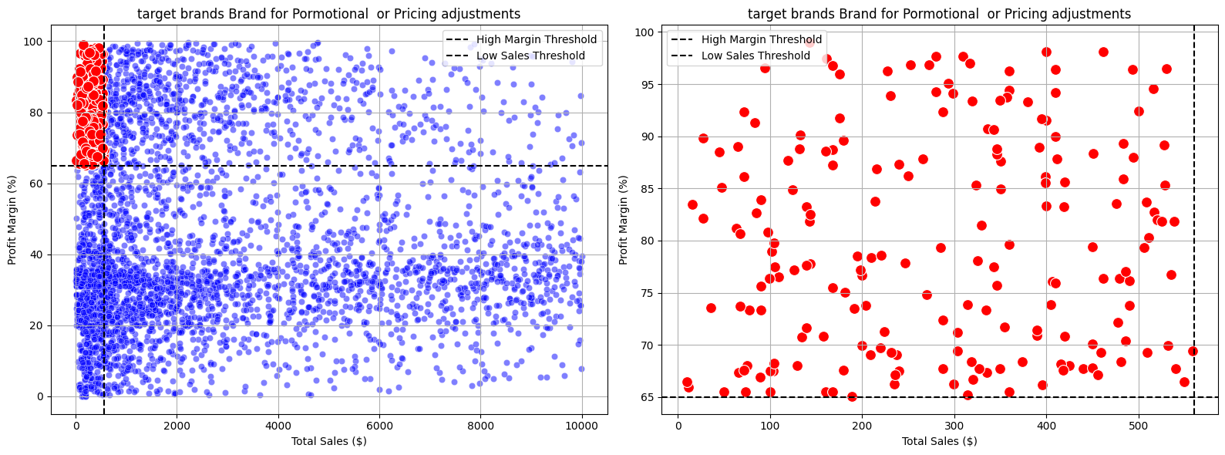198 brands exhibit lower sales but higher profit margins, which could benefit from promotions, distribution channels, target marketing to increase sales volume rather than pricing to improve profitability.

1. **Top Vendors by Sales and Purchase Contribution**

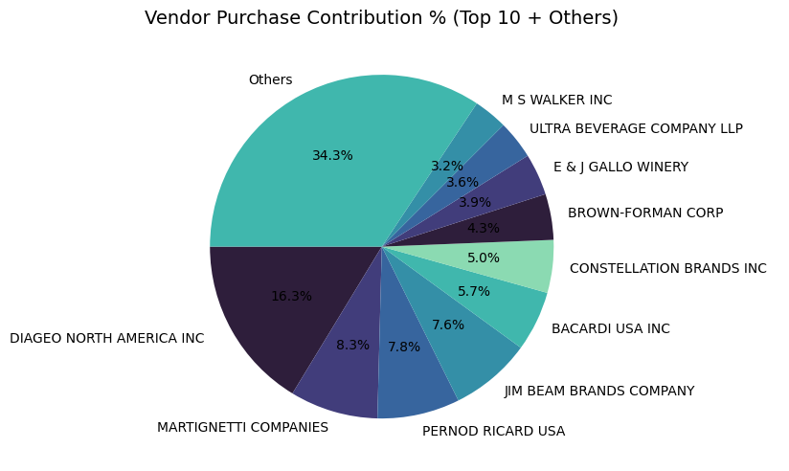The top 10 vendors contribute 65.68% of total purchases, while the remaining vendors contribute only 34.32%. This over -reliance on a few vendors may bring the risk of supply chain disruptions, indicating a need of diversification.

1. **Impact of Bulk purchasing on cost savings**

Vendors buying in large quantities receive a 72% lower unit cost ($ 10.78 per unit vs higher unit cost in smaller orders)

Bulk pricing strategies encourage larger orders, increasing total sales while maintaining profitability.

|  |  |
| --- | --- |
| Ordersize | UnitPurchasePrice |
| Small | 39.07 |
| Medium | 15.49 |
| Large | 10.78 |

1. **Identify Vendors with Low Inventory turnover**

Total unsold Inventory Capital: $2.71M

Slow moving inventory increases storage costs, reduces cash flow efficiency and affects overall profitability.

Identify vendors with low inventory turnover enables better stock management, minimizing financial strain.

|  |  |
| --- | --- |
| VendorName | StockTurover |
| ALISA CARR BEVERAGES | 0.62 |
| HIGHLAND WINE MERCHANTS LLC | 0.71 |
| PARK STREET IMPORTS LLC | 0.75 |
| Circa Wines | 0.76 |
| Dunn Wine Brokers | 0.77 |
| CENTEUR IMPORTS LLC | 0.77 |
| SMOKY QUARTZ DISTILLERY LLC | 0.78 |
| TAMWORTH DISTILLING | 0.80 |
| THE IMPORTED GRAPE LLC | 0.81 |
| WALPOLE MTN VIEW WINERY | 0.82 |

1. **Profit Margin Comparison: High vs. Low-Performing**

Top Vendor’s Profit Margin (95% CI): (30.74%, 31.61%), Mean=31.18%

Low Vendor’s Profit Margin (95% CI) :(40.50%, 42.64%), Mean=41.57%

Low performing vendor maintains high margin but struggle to maintain higher margins, indicating potential pricing differences inefficiencies or market reach issues.

Actionable insights:

* Top – performing vendors: optimize profitability through pricing adjustment and cost reduction and product and market diversification.
* Low – performing vendors: Improve marketing efforts, market expansion, enhance distribution channel strategies.

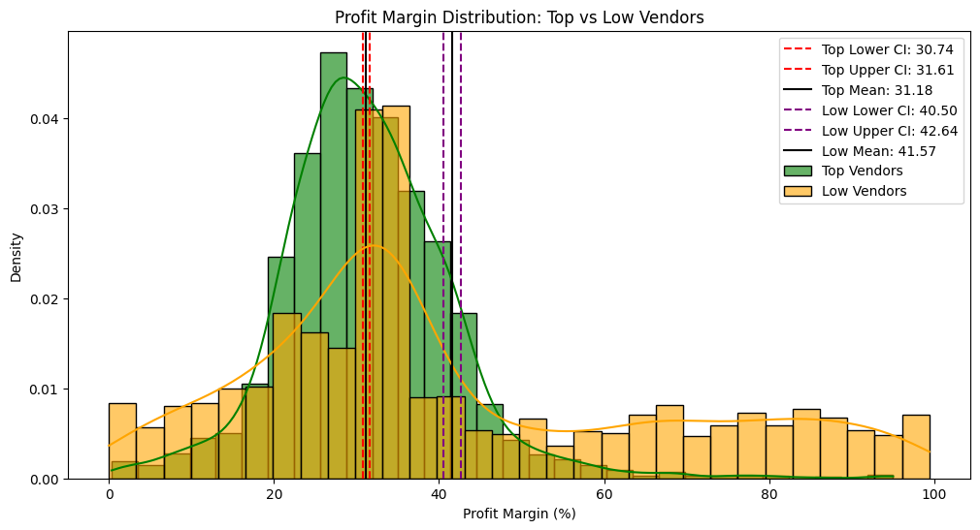

1. **Statistical Validation of Profit Margin differences**

**Hypothesis testing:**

Ho (Null Hypothesis): No significant difference in profit margins between top and low-performing vendors.

H1(Alternative Hypothesis): significant difference in profit margins between top and low-performing vendors.

**Result:** The Ho is rejected, confirming that the two groups operate under distinctly different profitability models.

Implication: High-margin vendors may benefit from better pricing strategies, while top selling could focus on cost efficiency.

**Final Recommendations:**

* Re-evaluate pricing strategies for low sales, high margin brands to boost sales volume without sacrificing profitability.
* Diversify vendor partnerships to reduce dependency on few suppliers and mitigate supply chain risks.
* Leverage bulk purchases advantages to maintain competitive pricing while optimizing inventory management.
* Optimize slow-moving inventory by adjusting purchase quantities, special discounts/Clearance sale or revising inventory strategies.
* Improve promotion and distribution strategies for low-performing vendors to drive higher sales without compromising profit margins.