Question 1

1.This code is saved in Assignment-Q1.py

2.This program approximates the square root of a number n

(such as n=5,37)

3.Execute as followings:



Question 2

1.This code is saved in Assignment-Q2.py

2.This program displays the first 100 emirps

3.Execute as followings:

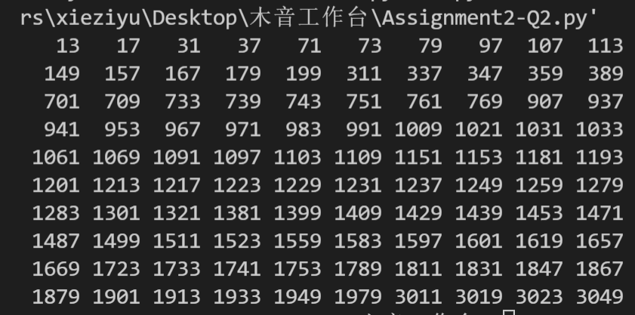

Question 3

1.This code is saved in Assignment-Q3.py

2.This program Display whether the credit number is valid or invalid.

(such as 4388576018402626 and 4388576018410707)

3.Execute as followings:

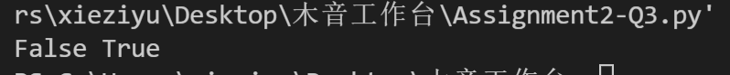

Question 4

1.This code is saved in Assignment-Q4.py

2.This program checks whether two words are anagrams.

(such as listen&slient, car&rat, anagram&nagaram, a&an, ttttttta&tatttttt)

3.Execute as followings:

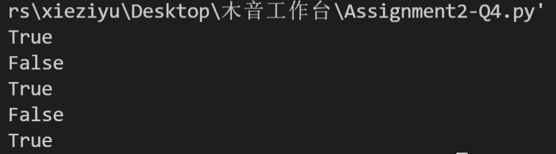

Question 5

1.This code is saved in Assignment-Q5.py

2.This program displays which lockers are open, after all the students have passed through the building and changed the lockers.

3.Execute as followings:



Question 6

1.This code is saved in Assignment-Q6.py

2.This program displays one solution randomly such that no two queens are in the same row, same column, or same diagonal.

3.Execute as followings:

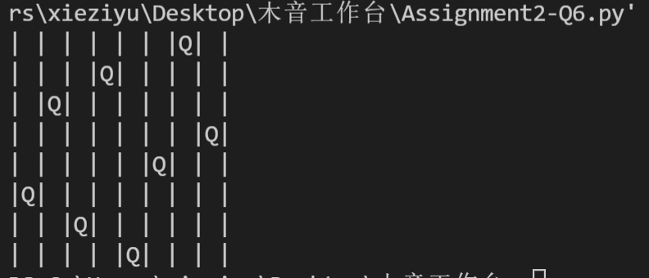Or 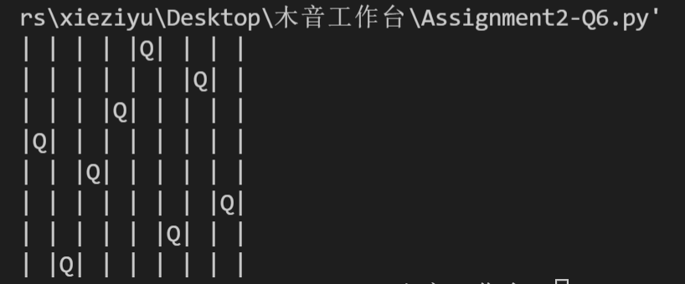

And so on.