Andy Guan's Project for strategy studying
DualMA Strategy(双均线策略—非日内) 1
重要回测参数 12
最大回撤 & 最大回撤发生时间 14
最大使用资金 & 有效收益率 15
总天数 & 年度收益率 & 收益风险比 15
参数分析 16
end 18

DualMA Strategy(双均线策略—非日内)
%%此程序用来进行DualMA双均线(日线非日内)策略回测
%%原始数据命名为data，从TB中获取数据，时间为单独分出来的一列，剩下分别是
%%1开盘价 2最高价 3最低价 4收盘价 5成交量 6持仓量
%%样本为Cu888
%% 计算相关指标
[data,date]=xlsread('1.xls');%提取日期数据和数值数据
close=data(:,4);%提取收盘价
high=data(:,2);%提取最高价
open=data(:,1);%提取开盘价
low=data(:,3);%提取最低价
%定义参数
margin_rate=0.1; %定义保证金率
m=length(close);
no_risk_rate=0.02;
shortPeriod=5;%定义收盘价短期（快速）平滑移动平均计算长度
longPeriod=20;%定义收盘价长期（慢速）平滑移动平均计算长度
fee=0.0003; %手续费
weight=5; %合约的吨数
%建立占位矩阵，提高程序运行效率
shortline=zeros(length(close),1);
longline=zeros(length(close),1);
%用循环语句计算各个指标
for i=1:longPeriod
shortline(i)=close(i);%初始化shortline第一值
longline(i)=close(i);%初始化longline第一个值
end
%计算双均线值
M=0;N=0;
for t=longPeriod:length(close)
%计算短期均线
M=0;N=0;
for i=1:shortPeriod
M=close(t-i+1)+M;
end
shortline(t)=M/shortPeriod;
%计算长期均线
for j=1:longPeriod
N=close(t-j+1)+N;
end
longline(t)=N/longPeriod;
end
%画K线图
figure(1);
set(gcf,'units','normalized','position',[0 0 1 1]);
time=datenum(date);
candle(high,low,close,open,'b',date,'XXXX/YY/ZZ');
% plot(time,close,'b');
datetick('x',29);
xlabel('Date');
ylabel('Close Price');
title('Time Series of Stock');
hold on;
plot(time,longline,'r');
datetick('x',29);
hold on;
plot(time,shortline,'g');
datetick('x',29);
grid on;
legend('close','up','down','longline','shortline')
%% 策略回测仿真
%%一个最简单的策略：1）shortline上穿longline 做多 2）longline下穿shortline 做空
%初始资金1000000元
initial=1000000;
%定义仓位：1表示多头，0表示空仓, -1表示空头
pos=zeros(length(close),1);
%定义收益序列
Long=zeros(length(close),1);
Short=zeros(length(close),1);
Timepoint=zeros(length(close),1);
Account=zeros(length(close),1);
Total=zeros(length(close),1);
Fee=zeros(length(close),1);
figure(2);
set(gcf,'units','normalized','position',[0 0 1 1]);
plot(time,close,'r');
datetick('x',29);
xlabel('Date');
ylabel('Close Price');
title('Time Series of Stock');
grid on;
hold on;
%策略计算
for t=2:length(close)
%定义买卖信号
signalBuy= shortline(t-1)>longline(t-1);
signalSell= shortline(t-1)<longline(t-1);
%如果是买入信号且为零仓，则做多
if (signalBuy==1 && pos(t-1)==0)
pos(t)=1;
text(time(t),close(t),'\leftarrow多');
plot(time(t),close(t),'go');
datetick('x',29);
Timepoint(t-1)=time(t);
%如果是买入信号且为空仓，则平仓后做多
elseif (signalBuy==1 && pos(t-1)<0)
pos(t)=1;
text(time(t),close(t),'\leftarrow平多');
plot(time(t),close(t),'bo');
datetick('x',29);
Timepoint(t-1)=time(t);
datestr(Timepoint(t),29);
%如果是卖出信号且为零仓，则做空
elseif (signalSell==1 && pos(t-1)==0)
pos(t)=-1;
text(time(t),close(t),'\leftarrow空');
plot(time(t),close(t),'ro');
datetick('x',29);
Timepoint(t-1)=time(t);
%如果是卖出信号且为多仓，则平仓后做空
elseif (signalSell==1 && pos(t-1)>0)
pos(t)=-1;
text(time(t),close(t),'\leftarrow平空');
plot(time(t),close(t),'yo');
datetick('x',29);
Timepoint(t-1)=time(t);
%其它情况一律不进行任何操作
else pos(t)=pos(t-1);
% 最后平所有仓
end
if t==length(close)
text(time(t),close(t),'\leftarrow全部平仓');
plot(time(t),close(t),'yo');
datetick('x',29);
Timepoint(t-1)=time(t);
end
end
%计算资金变化情况，交易成本假设为单边千分之三
Account(1)=initial; %现金金额
Long(1)=0; %多头价值
Short(1)=0; %空头价值
Total(1)=initial;
for t=2:length(close)
%1.零仓且没有买入信号
if pos(t)==0 && pos(t-1)==0
Account(t)=Account(t-1);
Long(t)=Long(t-1);
Short(t)=Short(t-1);
continue;
end
%2.做多
if pos(t)==1 && pos(t-1)==0
Account(t)=Account(t-1)-open(t)*weight*(1+fee);
Long(t)=Long(t-1)+weight*open(t);
Short(t)=Short(t-1);
Fee(t)=open(t)*weight*fee;
continue;
end
%3.做空
if pos(t)==-1 && pos(t-1)==0
Account(t)=Account(t-1)+open(t)*weight*(1-fee);
Long(t)=Long(t-1);
Short(t)=Short(t-1)+weight*open(t);
Fee(t)=open(t)*weight*fee;
continue;
end
%4.持多仓并且无卖出信号
if pos(t)==1 && pos(t-1)==1
Long(t)=Long(t-1)+weight*open(t)-weight*open(t-1);
Short(t)=Short(t-1);
Account(t)=Account(t-1);
continue;
end
%5.持多仓反转
if pos(t)==-1 && pos(t-1)==1
Long(t)=Long(t-1)-weight*open(t-1);
Short(t)=Short(t-1)+weight*open(t);
Account(t)=Account(t-1)+weight*open(t)*(1-fee)*2;
Fee(t)=open(t)*weight*fee*2;
continue;
end
%6.持多仓平仓
if pos(t)==0 && pos(t-1)==1
Long(t)=Long(t-1)-weight*open(t-1);
Short(t)=Short(t-1);
Account(t)=Account(t-1)+weight*open(t)*(1-fee);
Fee(t)=open(t)*weight*fee;
continue;
end
%7.持空仓并且无卖出信号
if pos(t)==-1 && pos(t-1)==-1
Long(t)=Long(t-1);
Short(t)=Short(t-1)+weight*open(t)-weight*open(t-1);
Account(t)=Account(t-1);
continue;
end
%8.持空仓反转
if pos(t)==1 && pos(t-1)==-1
Long(t)=Long(t-1)+weight*open(t);
Short(t)=Short(t-1)-weight*open(t-1);
Account(t)=Account(t-1)-weight*open(t)*(1+fee)*2;
Fee(t)=open(t)*weight*fee*2;
continue;
end
%9.持空仓平仓
if pos(t)==0 && pos(t-1)==-1
Long(t)=Long(t-1);
Short(t)=Short(t-1)-weight*open(t-1);
Account(t)=Account(t-1)-weight*open(t)*(1+fee);
Fee(t)=open(t)*weight*fee;
continue;
end
end
% 处理最后时刻平仓
if pos(m)==0
elseif pos(m)>0
Long(m+1)=Long(m)-weight*open(m);
Short(m+1)=Short(m);
Account(m+1)=Account(m)+weight*open(m)*(1-fee);
Fee(m+1)=open(m)*weight*fee;
elseif pos(m)<0
Long(m+1)=Long(m);
Short(m+1)=Short(m)-weight*open(m);
Account(m+1)=Account(m)-weight*open(m)*(1+fee);
Fee(m+1)=open(m)*weight*fee;
end
Total=Account+Long-Short-initial;
%找出所有交易时间
Timepoint_plus=Timepoint;
Timepoint(find(Timepoint(:,1)==0),:)=[]; %删除0值
TimePoint=datestr(Timepoint,29);
%% 模型评价：收益率，夏普比率，最大回撤等一些列指标，这里只画资金变化曲线
%画出资金变化曲线
Total_plus=Total;
Total(m)=Total(m+1);
Total(m+1)=[];
hold off;
figure(3);
set(gcf,'units','normalized','position',[0 0 1 1]);
plot(time,Total,'r');
datetick('x',29);
xlabel('Date');
ylabel('Your Money');
title('The Return of Stock');
grid on
%画出持仓情况
figure(4);
set(gcf,'units','normalized','position',[0 0 1 1]);
plot(time,pos,'o');
datetick('x',29);
xlabel('Date');
ylabel('The state of your account');
grid on
%计算收益率
[m,~]=size(Total);
for i=1:m
yield(i)=Total(i)/initial;
end
Yield_rate=yield(m);
%计算净利润
net_profit=Total(m);
%计算交易成本
trade_cost=sum(Fee);
%交易手数
[number_of_trade,~]=size(Timepoint);
%计算年化收益率
Yield_rate_year=Yield_rate/number_of_trade*365;
%% 计算盈亏
profit=zeros(length(close),1); %初始化利润矩阵
holding=zeros(length(close),1); %初始化持仓矩阵
price_end=0; %初始化最终价格
price_start=0; %初始化最初价格
price=zeros(length(close),2); %交易价格矩阵
gain=0; %初始化盈利次数
loss=0; %初始化亏损次数
equal=0; %初始化相等次数
%处理盈亏
for i=2:m
if pos(i)==pos(i-1)
holding(i)=1;
elseif pos(i)<pos(i-1)
price_end=open(i);
profit(i)=(price_end-price_start)*weight-(price_end+price_start)*weight*fee;
price(i,1)=price_start;
price(i,2)=price_end;
price_start=price_end;
elseif pos(i)>pos(i-1)
price_end=open(i);
profit(i)=-(price_end-price_start)*weight-(price_end+price_start)*weight*fee;
price(i,1)=price_start;
price(i,2)=price_end;
price_start=price_end;
end
end
%处理最后平仓
if pos(m)==0
elseif pos(m)>0
profit(m+1)=(open(m)-price_end)*weight-(open(m)+price_end)*weight*fee;
elseif pos(m)<0
profit(m+1)=-(open(m)-price_end)*weight-(open(m)+price_end)*weight*fee;
end
%计算盈利手数
for i=1:m+1
if profit(i)>0
gain=gain+1;
elseif profit(i)<0
loss=loss+1;
end
end
%处理最后平仓
profit(find(profit(:,1)==0),:)=[];
%修正最后一步数据
if profit(1)>0
gain=gain-1;
else
loss=loss-1;
end
profit(1)=[];
price(find(price(:,1)==0),:)=[];
price(number_of_trade,1)=price_end;
price(number_of_trade,2)=open(m);
profit';
equal=number_of_trade-(gain+loss);
%计算夏普比率
day_rate=zeros(m-1,1);
for i=2:m
day_rate(i-1)=(Total(i)-Total(i-1))/(Total(i-1)+initial);
end
net_day_rate=(day_rate-no_risk_rate/365);
Sharp_rate=sqrt(365)*mean(net_day_rate)/sqrt(var(net_day_rate));
%计算最大回撤
max_total=zeros(m,1);
max_total(1)=Total(1);
for i=2:m
if Total(i)>max_total(i-1)
max_total(i)=Total(i);
else
max_total(i)=max_total(i-1);
end
end
max_total;
difff=max_total-Total;
[maximum_drawdown,p]=max(difff);
maximum_drawdown;
maximum_drawdown_time=datestr(time(p-1),29);
%计算最大使用资金=最大收盘价计算的持仓保证金
max_use=max(close)*weight*margin_rate;
第一幅图画出行情图以及双均线，第二幅图标注多空买卖情况，第三幅图得出最终盈亏结果，第四幅图表示持仓情况
DualMA2
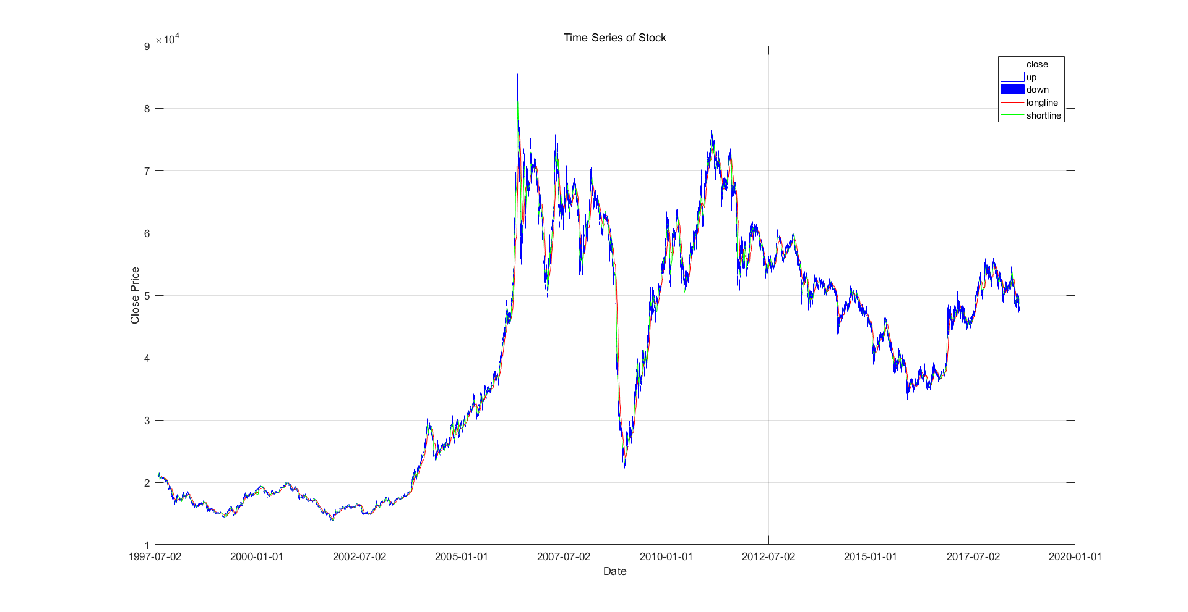
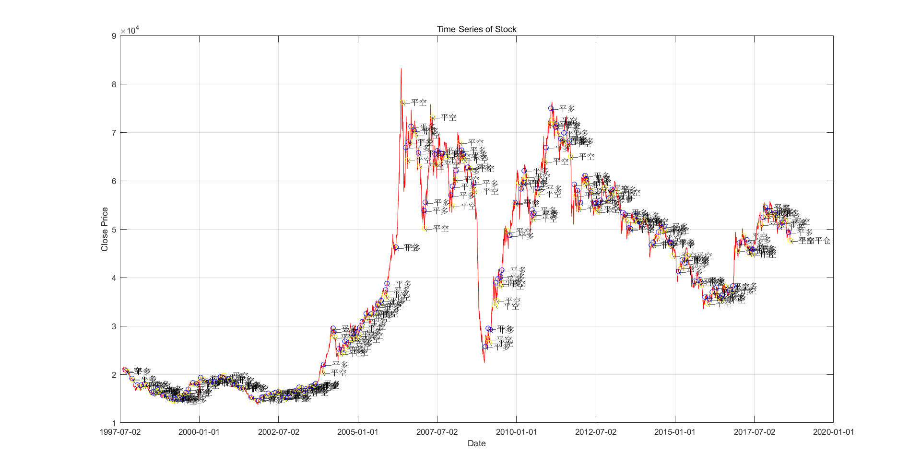
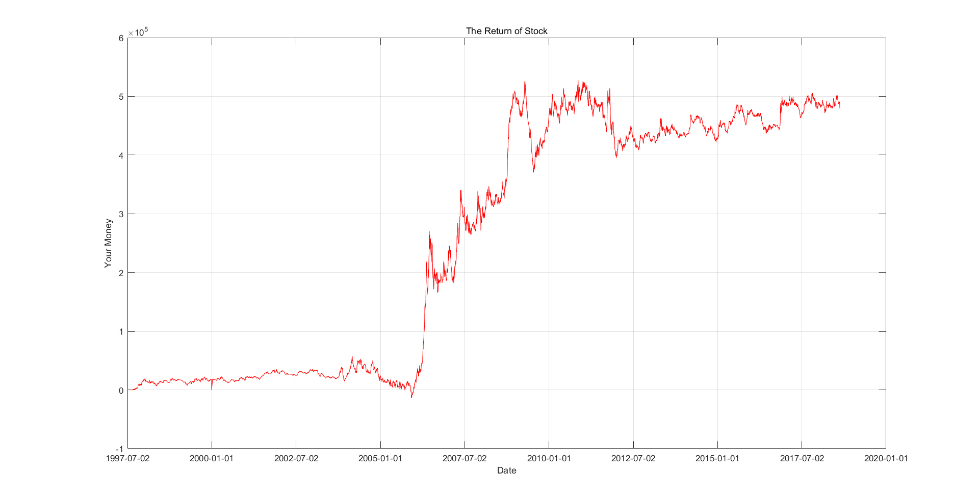
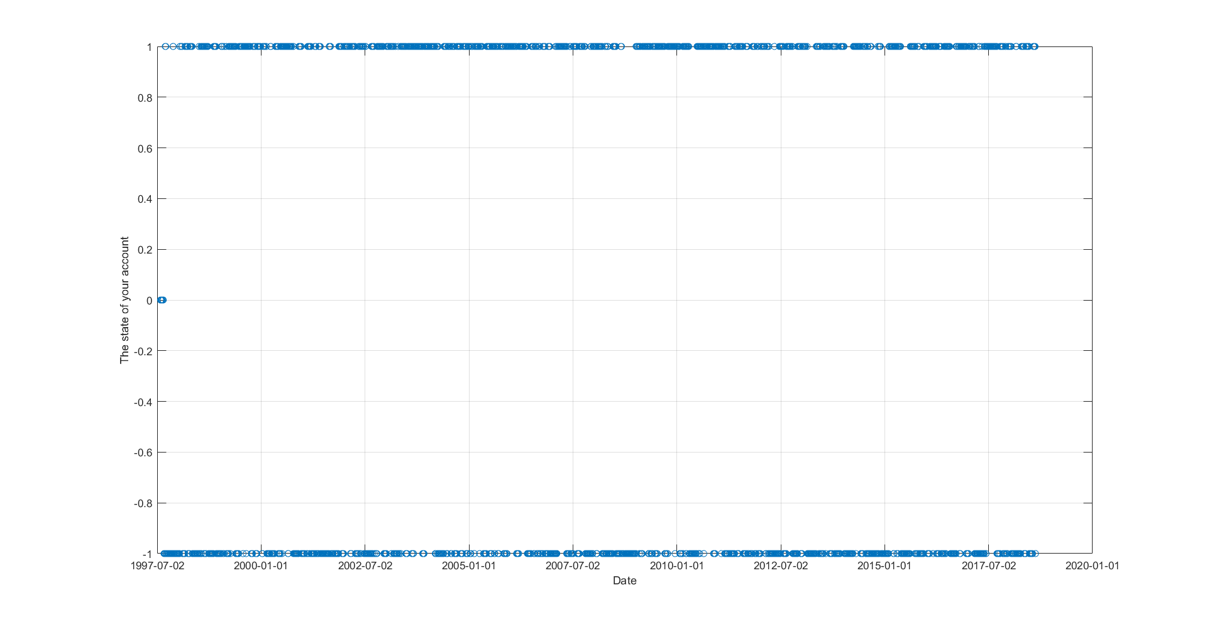

重要回测参数
收益率 & 计算净利润 & 计算交易成本
format short g
Yield_rate
net_profit
trade_cost
Yield_rate =
0.47938
net_profit =
4.7938e+05
trade_cost =
39217
夏普比率
Sharp_rate
Sharp_rate =
0.17947
%计算年化收益率
Yield_rate_year
Yield_rate_year =
0.53184
交易手数 & 盈利次数 & 亏损次数 & 持平次数
number_of_trade
gain
loss
equal
number_of_trade =
329
gain =
121
loss =
208
equal =
0
盈利比例 & 平均利润
gain_rate=gain/number_of_trade
average_profit=vpa(net_profit/number_of_trade,5)
gain_rate =
0.36778
average_profit =
1457.1

最大回撤 & 最大回撤发生时间
maximum_drawdown
maximum_drawdown_time
maximum_drawdown =
1.5517e+05
maximum_drawdown_time =
2009-07-16

最大使用资金 & 有效收益率
max_use
effective_yield=net_profit/max_use
max_use =
41640
effective_yield =
11.513

总天数 & 年度收益率 & 收益风险比
Total_days=time(m)-time(1)+1
return_of_year=net_profit/Total_days*365
rate_of_return_and_risk=return_of_year/maximum_drawdown
Total_days =
7687
return_of_year =
22762
rate_of_return_and_risk =
0.14669

参数分析
测试长短周期的最佳值：从1到30
result=zeros(900,5);
for i=1:30
for j=1:30
if j>i
[aa,bb,cc,dd,ee]=DualMA_function(i,j);
result(30*(i-1)+j,1)=aa;
result(30*(i-1)+j,2)=bb;
result(30*(i-1)+j,3)=cc;
result(30*(i-1)+j,4)=dd;
result(30*(i-1)+j,5)=ee;
else
result(30*(i-1)+j,1)=i;
result(30*(i-1)+j,2)=j;
end
end
end
result(isnan(result)) = 0;
myown1(result,30,30);
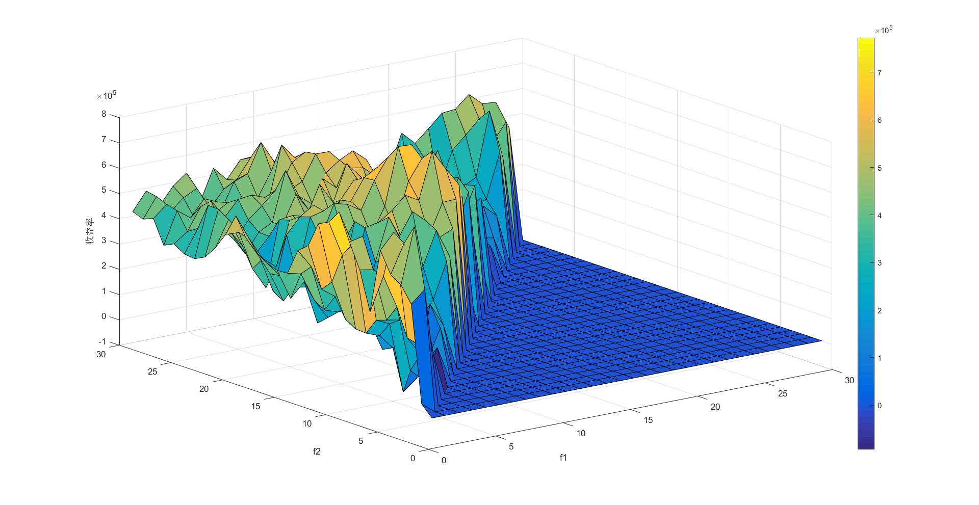
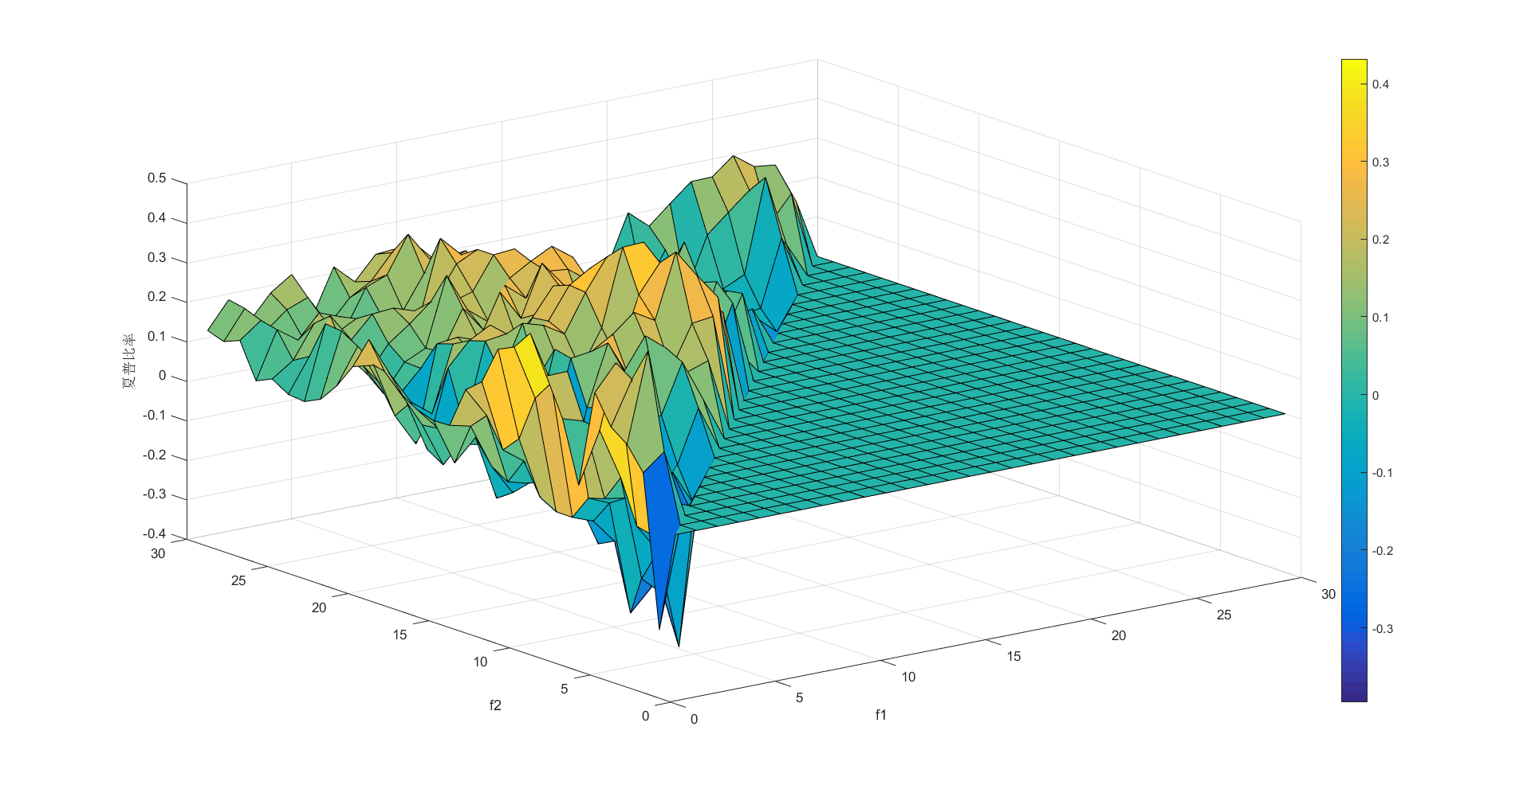
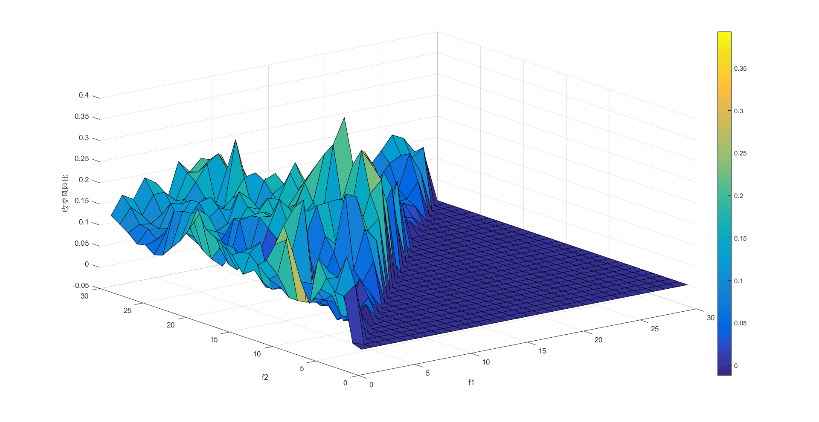

end
close all
Published with MATLAB® R2016b

