RugbyMAS: Autonomous Agents and Multi-Agent Systems

Implementation of an Autonomous Multi-Agent System in Rugby

David Huber, 105692  
 Computer Science and Engineering  
 Instituto Superior Técnico Lisboa  
 david.huber@ulisboa.tecnico.pt

Francisco Silva, 97433  
 Computer Science and Engineering  
 Instituto Superior Técnico  
 Lisboa  
ist97433@tecnico.ulisboa.pt

ABSTRACT

In this project we aim to develop a multi-agent system for simulating a rugby match. Our approach includes defining rules for player positioning, passing and scoring goals, and developing intelligent agents that can look for gaps in the opponent's defensive line and pass the ball to other agents. Our system architecture will enable communication and coordination between agents, and we will evaluate our system using metrics such as successful attempts, number of passes and average time of possession.

INTRODUCTION

Rugby is a complex team sport that requires coordination, strategy and individual skills. With the advent of artificial intelligence and multi-agent systems, there is growing interest in using these technologies to simulate sports games and improve team performance. In this project, we focus on Rugby Sevens, a fast-paced and dynamic variation of rugby involving two teams of seven players each. The problem we address is how to design and implement a multiagent system that can simulate a realistic rugby sevens game. We aim to create intelligent agents that can make decisions based on the current state of the game, the position of the opponents, and the location of the ball. Our system will allow for communication and coordination between agents, and we will explore different strategies for cooperation and negotiation.

RELATED WORK

There are several works on sports simulations, but few have focused on Rugby Sevens. Most of them have used either rule-based or machine learning approaches to model player behavior and decision-making. One of the biggest challenges in sports simulations is to create agents that can act autonomously, considering the game situation and the actions of the opponent. This project aims to overcome this challenge by developing agents that can adapt to different scenarios and make decisions based on the current state of the game

PROBLEM DEFINITION AND RELEVANCE

The problem that this project aims to address is the lack of tools to investigate and test different strategies for rugby sevens games. By developing a multi-agent system that can simulate rugby sevens matches, we can provide coaches, players and analysts with a platform to test different strategies and tactics. This is particularly important given the growing popularity of rugby sevens, which has become an Olympic sport in recent years.

Objectives

The main objective of this project is to develop a multi-agent system for simulating rugby sevens matches. This system should be able to:

● Design and implementation of a multi-agent system to simulate a rugby sevens match.

● Evaluate the performance of the multi-agent system in terms of game dynamics, team coordination and strategy effectiveness.

● Analyze the behavior of the agents and the system under different conditions, such as different team compositions, field divisions and opposing strategies.

● Develop and test communication and coordination mechanisms between agents to improve teamwork and cooperation, such as passing, support and tackling.

● Comparing the performance of the multi-agent system with other existing approaches or systems in the literature, such as other multi-agent game simulations or sports analysis tools

APPROACH

The environment is a simulated rugby field with defined rules for player positioning, ball possession, passing, and scoring depending on the strategies adopted. The multiagent system consists of intelligent agents that can perceive the environment through sensors and act on it through actuators. The system architecture provides a framework for communication and coordination between agents, as well as for decision-making and planning. To address the problem of designing intelligent agents, we will implement several features. First, agents will have conflicting goals, such as the need to score a try versus the need to protect the try area. Second, agents will have a variety of sensors, including vision, position, and ball possession. Third, agents will have communication and coordination mechanisms, such as passing and moving towards the ball carrier. The actions performed by the agents are [*DOWN, UP, RIGHT, LEFT, PASS*], note that just the agent that has the ball can perform the [*PASS*]. The *tackle* is an environment rule, that means, when a player from one of the teams has the ball and the opponent performs an action that would put himself in the ball carrier square, the *tackle* is performed, and the ball possession changes to the opponent team.

The goal of the agents it to score a rugby rehearsal as quick as possible, that means, to reach the adversary yellow area with the ball carrier, as may be seen at figure 2.

The strategies depend on if each team is either attacking or defending and are:

**Random Agent**:

* Has no strategy behind the actions of the agent, as the action is chosen randomly.

**Dummy Greedy Agents**:

* When attacking tries to go straight forward, and when it finds an opponent at a Manhattan distance ≤ 2, passes to the nearest colleague either beside or behind him.
* When defending assumes a random action excluding the *PASS*.

**Greedy Agents**:

* When attacking tries to go straight forward, and when finds an opponent at Manhattan distance ≤ 2, passes to the colleague. If it needs to pass:

1. Each agent identifies the 2 nearest opponents to measure the angle between them.
2. Each agent checks if it hasn’t opponents in Manhattan distance ≤ 2. If they haven’t, they may receive the ball.
3. The agent that has the ball after having the information above, will choose the agent that has 1. The biggest angle between teammate agent and the 2 opponents; 2. Hasn’t opponents in a range of Manhattan distance ≤ 2.

* When defending the strategy is as simple as having all the teammates going straight forward to the ball carrier.

**Role Agents**:

* When attacking, the team assumes a diamond position as may be seen at figure 1. The roles are BALL_CARRIER (BC), SUPPORTED_RIGHT (S_R), SUPPORTER_LEFT (S_L), SUB_SUPPORTER_RIGHT (SS_R), SUB_SUPPORTER_LEFT (SS_L), WINGER_RIGHT (W_R) and WINGER_LEFT (W_L). The diamond will be formed using the roles above and assigning a position to each one. To assign the roles we propose the following algorithm:

1. Create an array with tuples in the form (Agent, DM), where the DM corresponds to the distance of Manhattan from the Agent to our teammate ball carrier.
2. Calculate the positions of the diamond, the refence should be the *BALL_CARRIER*, for instance image it’s position as (x,y). The other roles position should be:
   * *S_L*→ (x-1, y-1)
   * *S_R*→ (x-1, y+1)
   * *SS_L*→ (x-2, y-2)

* *SS_R*→ (x-2, y+2)
* *W_L*→ (x-3, y-3)
* *W_R*→ (x-3, y+3)

In the case the coordinates calculated go outside the [21x11] grid, we do a floor or ceiling functions in order maintain the coordinates possible to be reached.

|  |  |  |  |  |
| --- | --- | --- | --- | --- |
| y\x | 1 | 2 | 3 | 4 |
| 1 | W_L |  |  |  |
| 2 |  | SS_L |  |  |
| 3 |  |  | S_L |  |
| 4 |  |  |  | BC |
| 5 |  |  | S_R |  |
| 6 |  | SS_R |  |  |
| 7 | W_R |  |  |  |

Figure 1 - Diamond attack strategy

1. Sort the array from “1.” and attribute the roles *BC ≽ S_R ≽ S_L ≽ SS_R ≽ SS_L ≽W_R ≽ W_L*.
2. After assigning all the roles the *BALL_CARRIER* must go straight forward until it has opponents in a range of Manhattan distance ≤ 2. If any opponent enters in a range of Manhattan distance ≤ 2, the *BALL_CARRIER* must pass the ball following the Greedy Agent criteria.

* When defending we have as roles, *FORWARD_DEFENDER* and *BACKWARD_DEFENDER* absorbing respectively 4 and 3 agents from the 7 team agent. The algorithm proposed to defend is:

1. There will be 4 *FORWARD_DEFENDER*, that the main goal will be chase the opponent’s player ball.
2. There will be 3 *BACKWARD_DEFENDER*, that the main goal is to be 4 Manhattan squares behind the *BALL_CARRIER.* We also have created a User Interface to better understand the behavior of the agents, that may be seen at figure 2. When the ball possession is under the blue team, the ball carrier color will be turquoise. When the ball possession is under the red team, the ball carrier color will be orange.

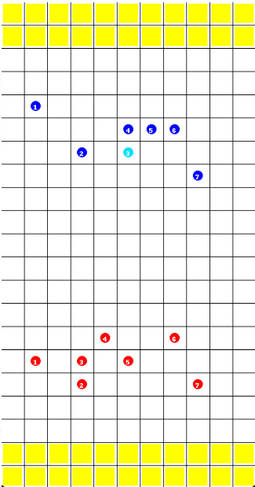

Figure 2 – RugbyMAS: Graphical User Interface

EMPIRICAL EVALUATION

To evaluate our system, we have defined a set of metrics to check our goals. These metrics are calculated by episode, an episode is defined either by reaching the goal or reaching the max number of steps allowed. In our testing the maximum number of steps allowed are 1000. This number is justified due our community of agents being large, and so a few steps like 100 in some scenarios would never reach the goal, in other words, it gives us an unbiased context to all approaches as all strategies have opportunity to reach the goal.

These include the:

1. Average number of steps to have a successful attempt by episode, that says how much effort is put from the team to have rehearsal.
2. Average number of passes, that indicates how well an agent perceives if he must pass to maintain ball possession in order to keep trying to reach the rehearsal.
3. Average number of tackles by episode, that tells us how competitive were both teams trying to reach their goal. Furthermore, it also tells us how good a team is either attacking or defending. Attacking because if there are no tackles it means the Team had a good performance reaching the goal and not allowing the opponents Team to steal ball. Defending because if there are tackles it means the opponents Team is having the chance to catch up the ball carrier and steal/recover the ball.

EVALUATION TOURNAMENTS

Random Tournament

To evaluate the Random Agents Team performance, we had to increase the number of maximum steps to 1000 and started the Random Agent Team as defenders. This way, we could analyze the real difference between the metrics of each game. This is an indicative that the algorithm is not the best.

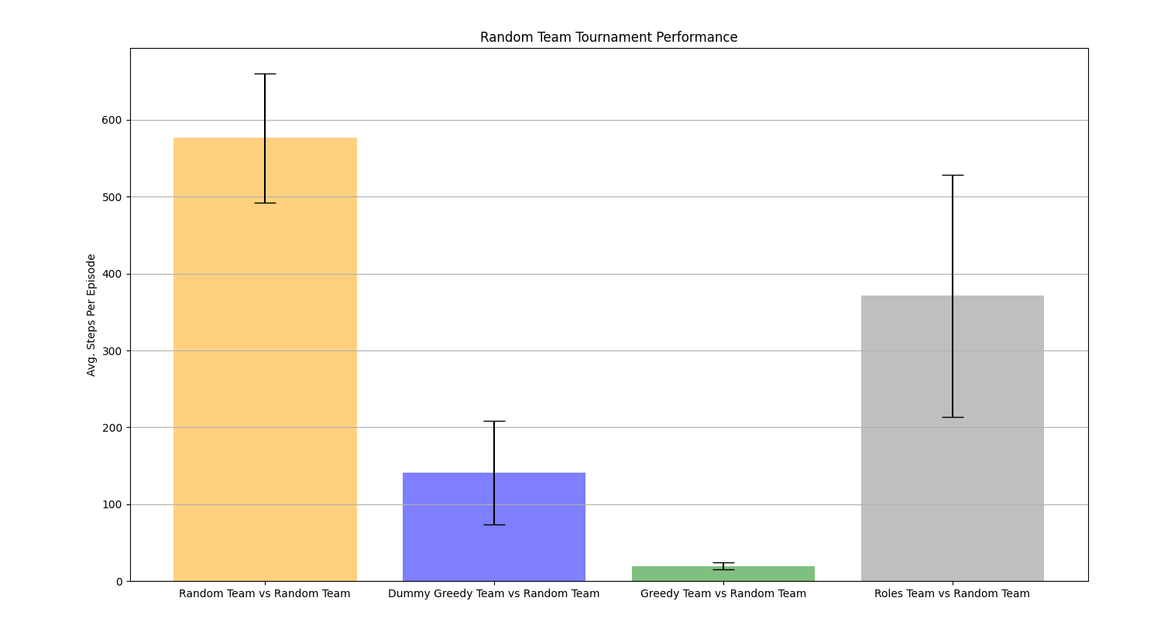

Figure 3 - Steps from the Random Agent tournament

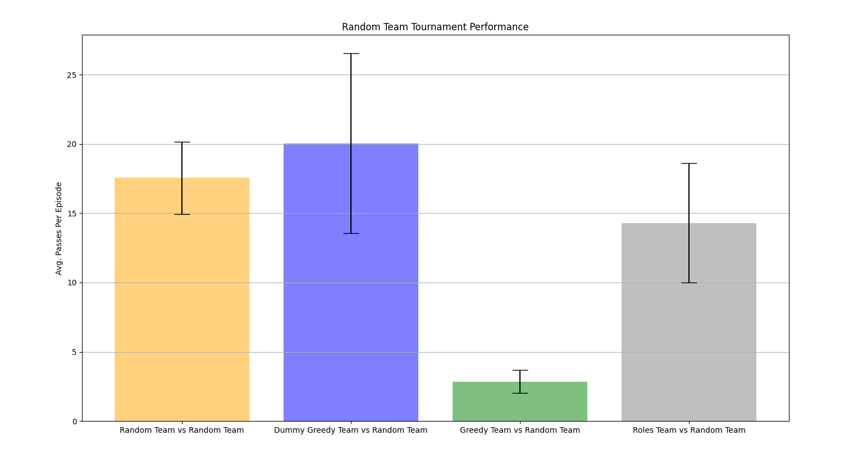

Figure 4 - Passes done from the Random Agent tournament

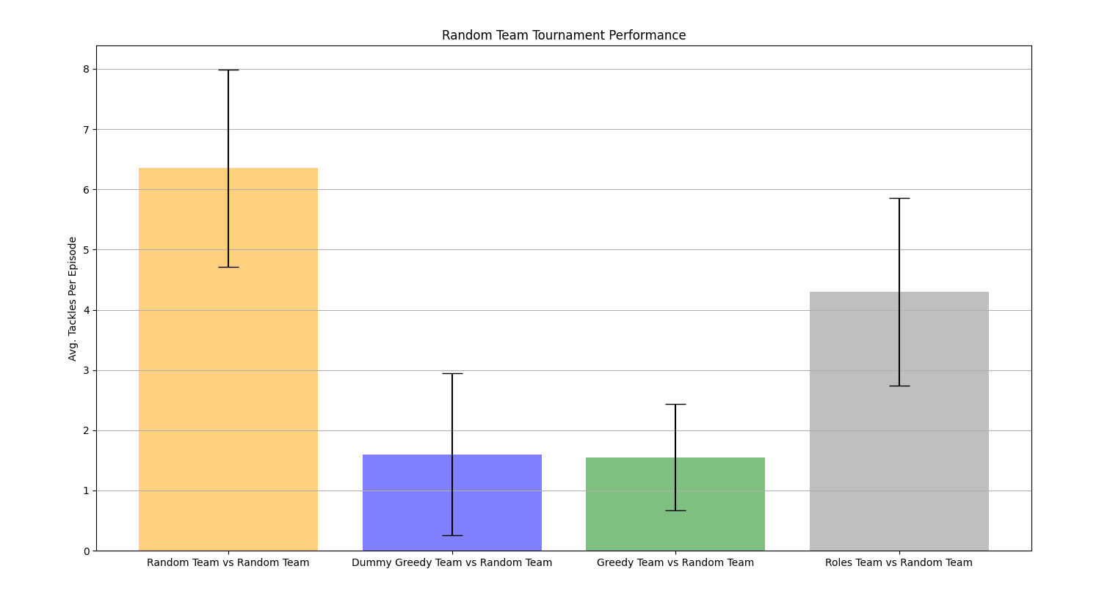

Figure 5 - Tackles done from the Random Agent tournament

Random vs Random

If the agent is the ball carrier, his actions have 20% of probability to be chosen, else they have 25% of probability. This will lead to having teammates in front of the ball carrier (invalid players), it cannot pass the ball to them. This framework will reduce the number of passes, as we expected to be a lot more because of the number of steps it takes per episode.

Dummy Greedy vs Random

We start to see that the number of steps decreased a lot because of the “greedy” algorithm (if the agent is the ball carrier and has space to go, goes toward the try line else pass; if the agent is not the ball carrier choses a random action). Now the agent does a more intelligent decision considering the environment, so the number of passes increase once it has notion of when to pass and the number of tackles decreased because of the ball carrier awareness.

Greedy vs Random

The greedy has a similar approach to the dummy greedy algorithm but has some improvements. When passing the ball, it chooses the teammate in the best position to reach the goal. This reduces the number of passes and steps. As the greedy algorithms are very good attacking, the number of tackles will be lower than any other approach.

Roles vs Random

If the assigned roles are rigid and do not allow for adaptation to new situations or unforeseen challenges, the system's quality suffers. Agents struggle to adjust their roles in response to changing conditions, leading to suboptimal performance. So, the number of steps increases, comparing with the greedy algorithms. The agents take into consideration the ball carrier to choose the position to adopt (according to each role) at time step t, but at time step t the ball carrier already chose if it will either pass or go to other position and so makes a discrepancy of 1 time step between the roles that each agent should adopt. To resolve this, this would involve creating an algorithm that detects which would be the action done by the ball carrier and adapt the behavior of each agent depending on its role.

Dummy Greedy Tournament

To evaluate the Dummy Greedy Agents Team performance, we started the Dummy Greedy Agent Team as defenders. When defending the agent chooses random action.

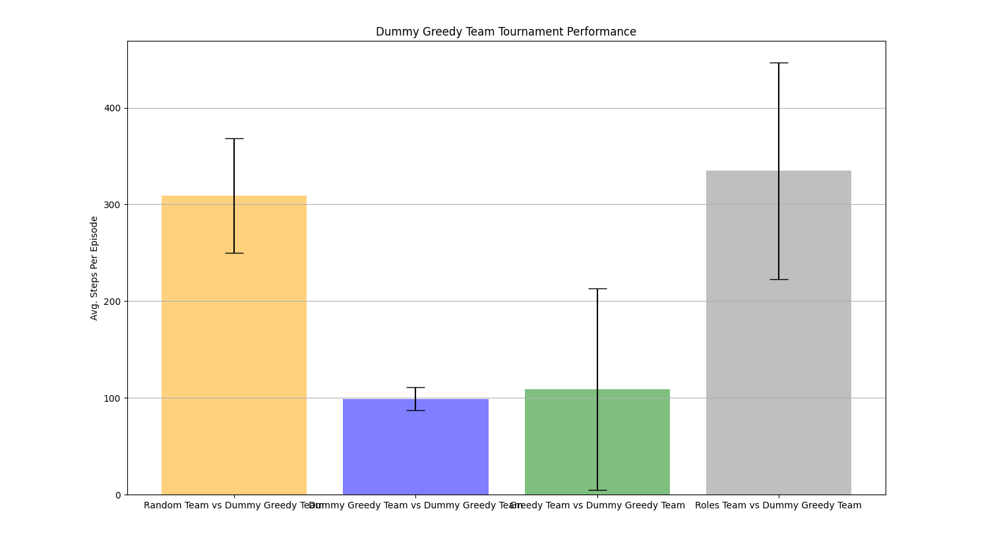

Figure 6 - Steps from the Dummy Greedy Agent tournament

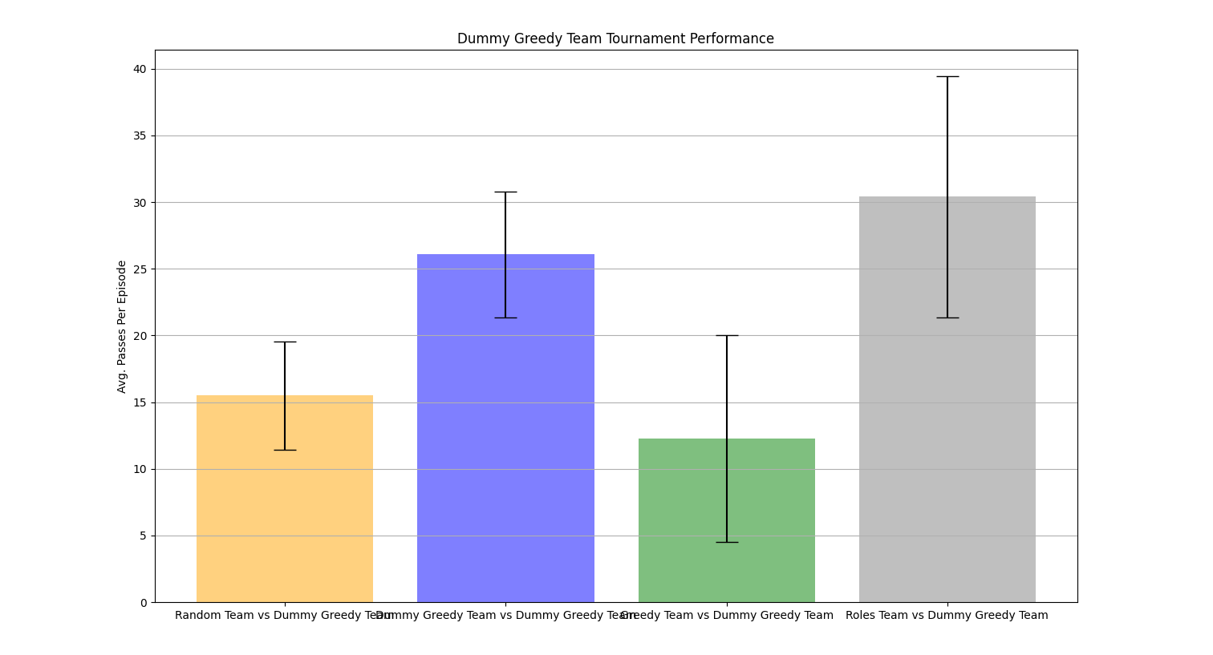

Figure 7 - Passes done from the Dummy Greedy Agent tournament

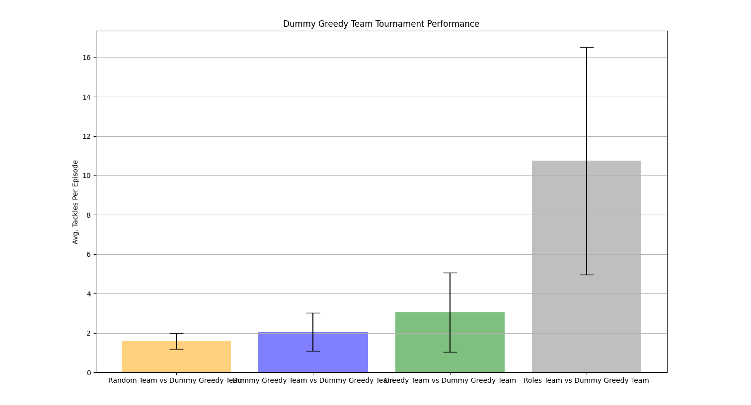

Figure 8 - Tackles done from the Dummy Greedy Agent tournament

Random vs Dummy Greedy

Both agent teams take random actions, so the numbers of steps will increase, but the number of tackles will be lowest comparing with the other teams.

Dummy Greedy vs Dummy Greedy

We start by seeing the number of passes increases since the teammates are not in the best positions for attacking the defence line, also the number of tackles is higher than then in the Random approach because the agents tend to attack more (go towards the try area, where there are more opponents).

Greedy vs Dummy Greedy

Greedy Agents have a better defense strategy than the Dummy Greedy Agents, they chase the ball carrier. This strategy will increase the number of tackles, then obviously the number of steps per team will increase as well. The number of passes is the lowest because they tend to pass to the teammate who in the best position to reach the goal.

Roles vs Dummy Greedy

Role Agents relies on the information taken from the environment, in our case the ball carrier. In our scenario the agents cannot share the same position, and so we noticed that in the case the ball carrier needs to pass the ball by having an opponent too close it will change drastically the roles. The volatility of the roles changes when a pass is done causes the agents to block themselves as they get into conflict when going to their new roles. Therefore, the number of steps will increase and the scenarios where the combination of actions generates PASSES and TACKLES increases as well. The imposition of rules in order to each agent get in his role position assigned on the diamond limits the agent’s behavior and turns out the system to be defective, that is justified by lack of flexibility (roles restrict flexibility of movement for each agent), and dependency on an agent that may vary dramatically in a single time step (the ball carrier).

Greedy Tournament

To evaluate the Greedy Agents Team performance, we started the Greedy Agent Team as defenders. When defending the agent go towards the ball carrier.

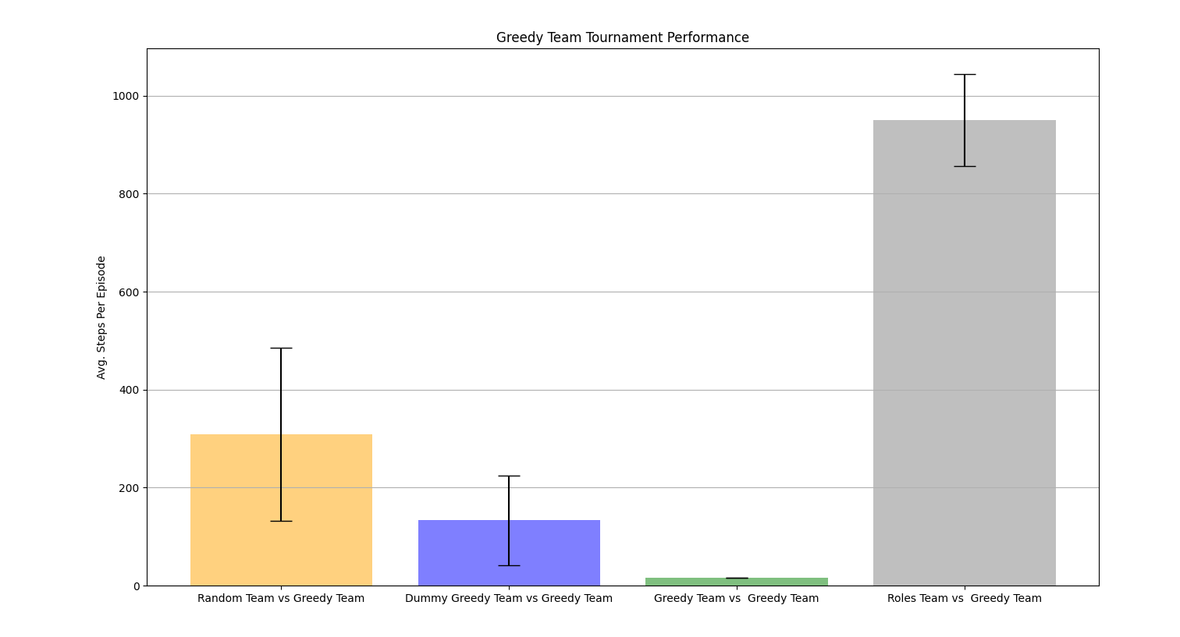

Figure 9 - Steps from the Greedy Agent tournament

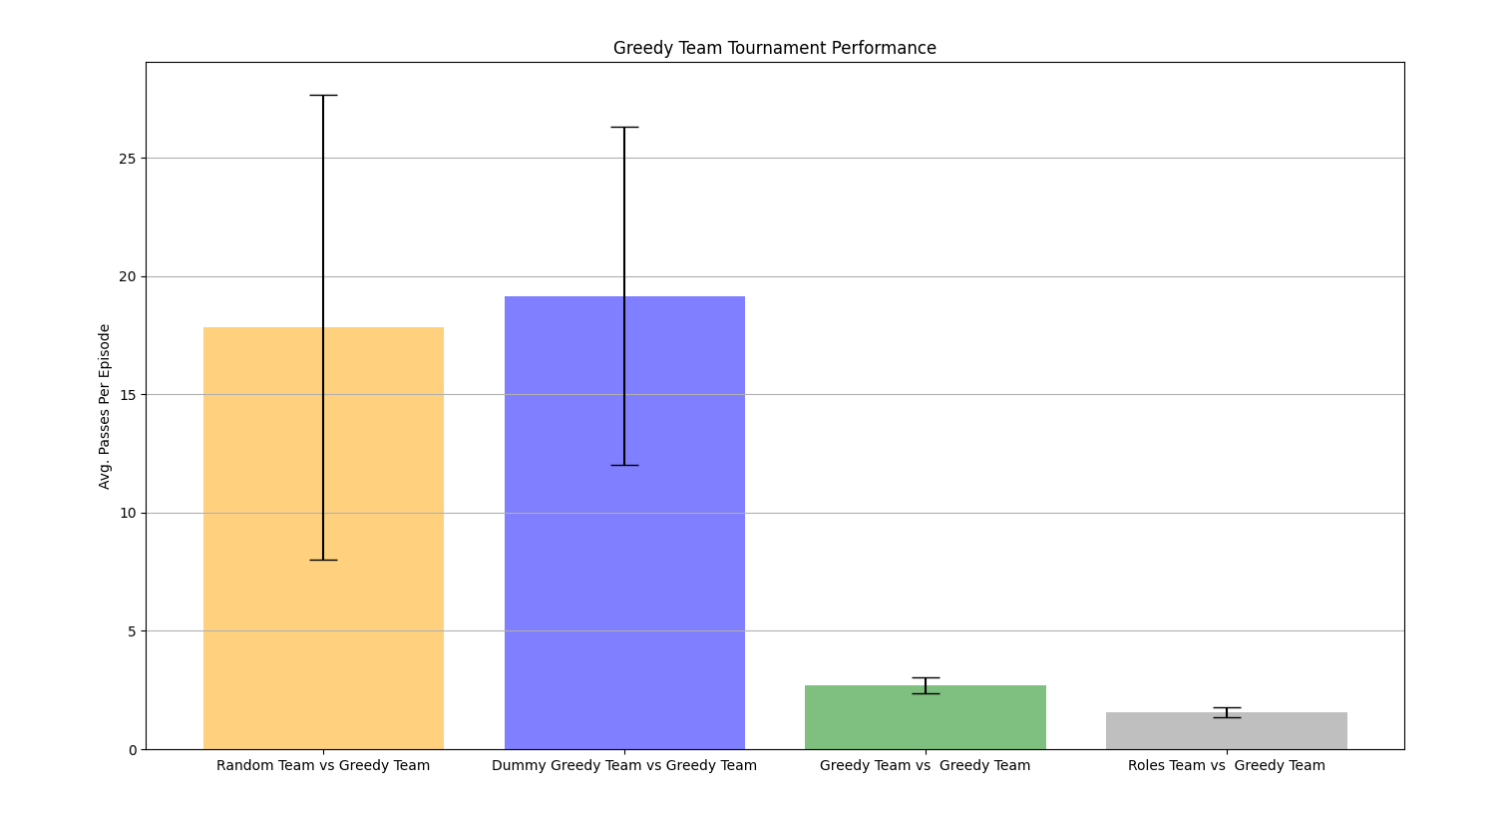

Figure 10 - Passes done from the Greedy Agent tournament

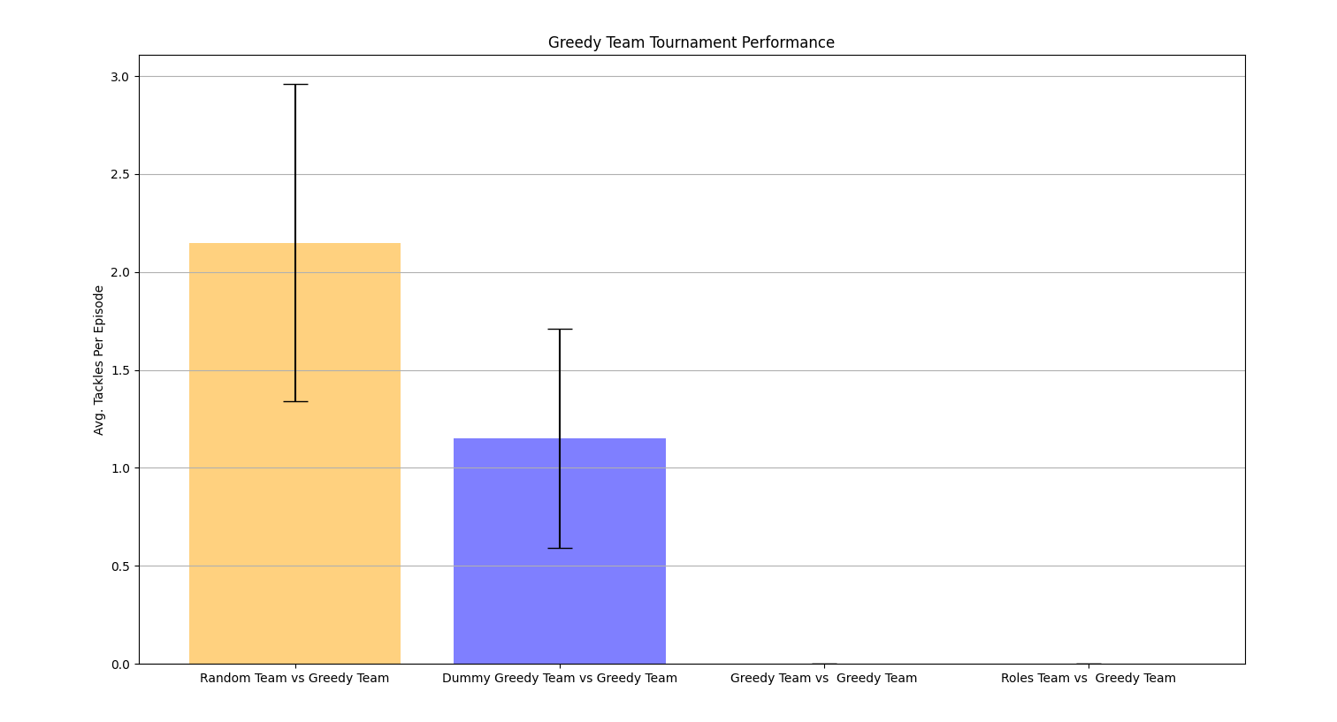

Figure 11 - Tackles done from the Greedy Agent tournament

Random vs Greedy

The Random Agents passes the ball randomly so it might make the Greedy Agents do more steps to tackle the ball carrier if the passes are done to players spread around the field. This behavior will lead to less number of tackles and more steps comparing to other tournaments, because it is more difficult to reach the ball carrier.

Dummy Greedy vs Greedy

Dummy Greedy Agents pass the ball to the nearest teammate, the tackles still exists because they do not take in consideration the opponent’s position. As far as the tackles exists, the number of steps is bigger comparing to other approaches. The Greedy Agents have the best defense strategy overall so the Dummy Greedy Agents will pass more the ball to avoid being tackled.

Greedy vs Greedy

Overall, with the data that we have collected, the greedy approach shows to have a better attack than defense strategy, this leaves us with the opinion that the defense algorithm can be improved in the future. As we can see the steps and passes are minimal to reach the goal because there are no tackles proving that our attack algorithm was perfect applied to our environment details.

Roles vs Greedy

Looking to the three graphs we can observe that the episodes finish reaching the maximum steps possible, there are no tackles and very few passes made. The reason behind this is that role-based agents tend to enter in conflict (because of the volatility from the roles changes during the first passes) too early. The Greedy Agents go towards the ball carrier, they converge to the same position, but since the ball carrier is blocked by the teammates it is not reachable to get tackled. The teammates have no notion that they are being blocked by the other colleagues, and so they keep choosing the same action even being impossible to move themselves to positions of the desired role. This will block the entire environment. There is an improvement opportunity here, the agents should have notion that action they are taking has no effect and so an algorithm for this situation must be developed.

Roles Tournament

To evaluate the Role-based Agents Team performance, we started the Role based Agents Team as defenders. When defending there is a forward line with 4 agents and a backward line with 3 agents.

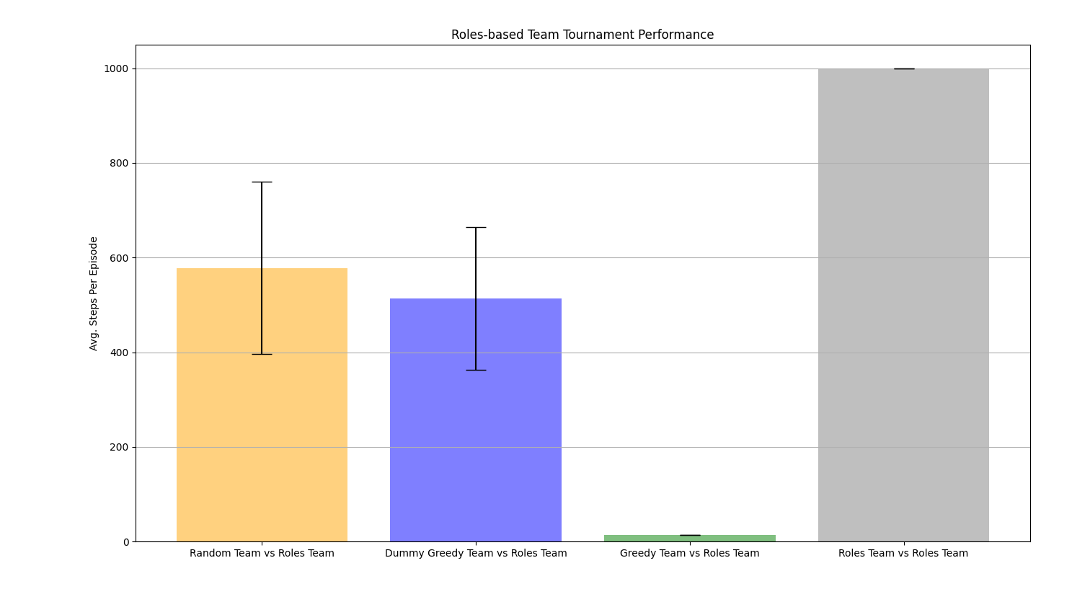

Figure 12 - Steps from the Roles Agent tournament

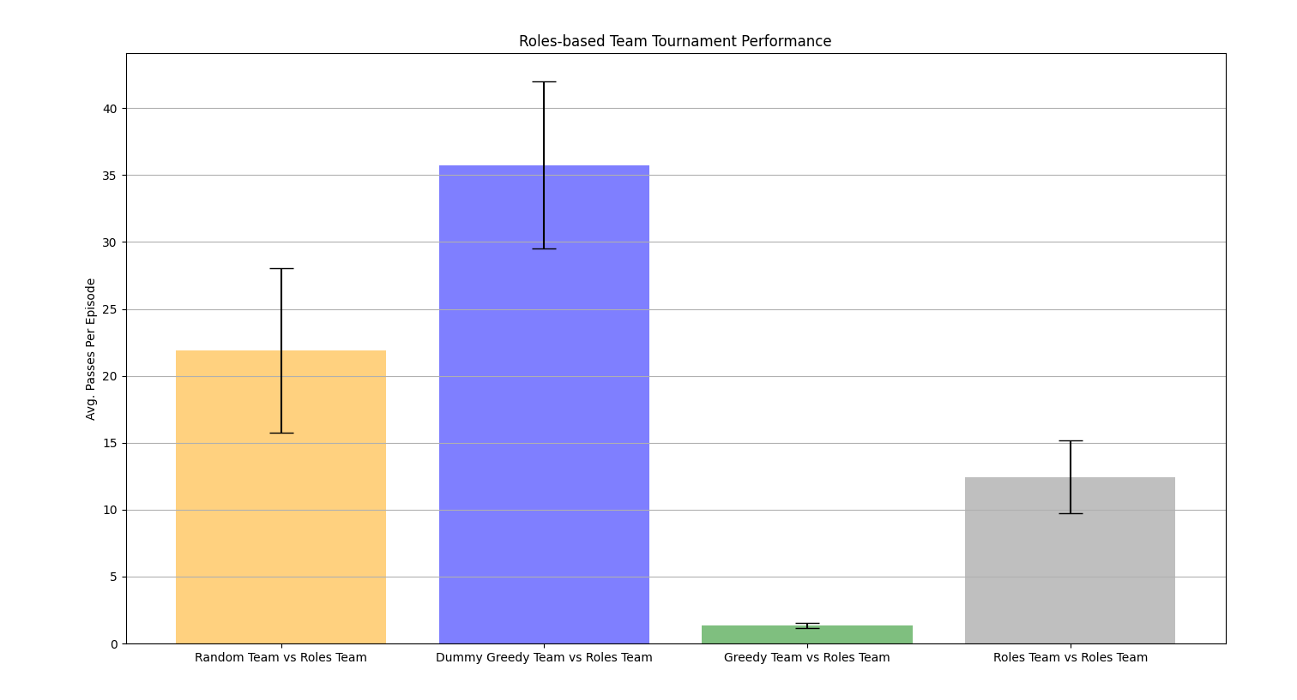

Figure 13 - Passes done from the Roles Agent tournament

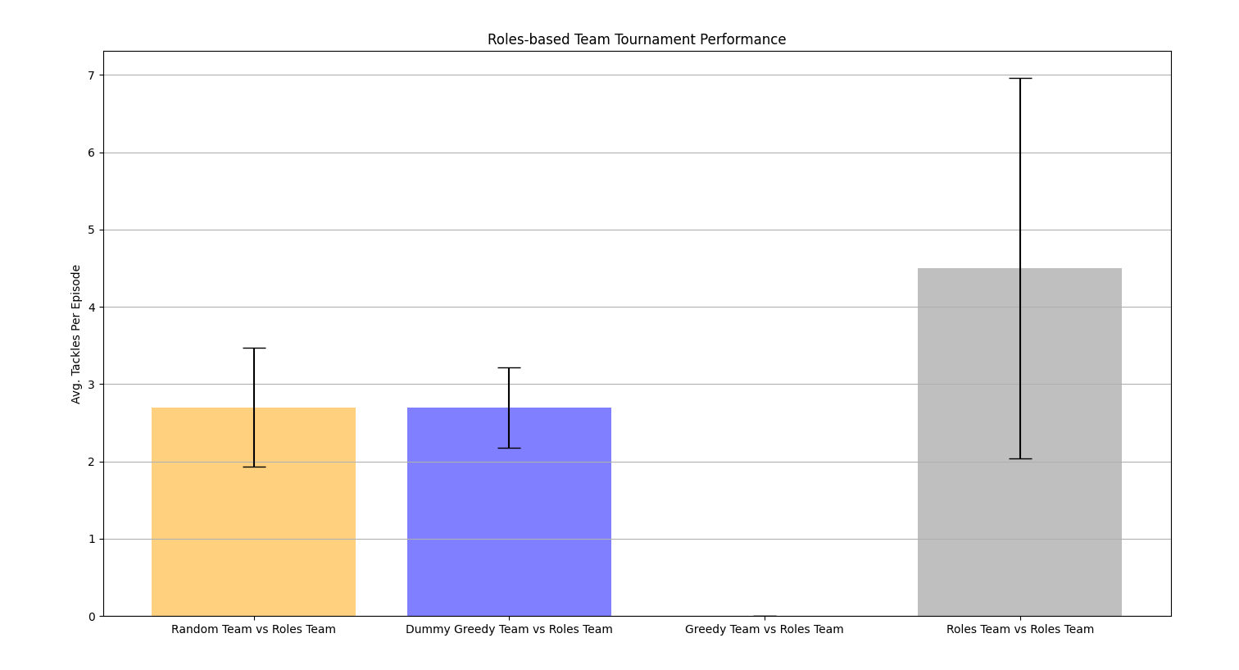

Figure 14 - Tackles done from the Roles Agent tournament

Random vs Roles

The Random Agents passes the ball randomly so it might make the Role-based Agents do more steps to tackle the ball carrier if the passes are done to players spread around the field. This behavior will lead to a smaller number of tackles and more steps, because it is more difficult to reach the ball carrier. In comparison with Greedy Team Tournament, there are more steps because the first defense line is smaller than the Greedy one.

Dummy Greedy vs Roles

Dummy Greedy Agents pass the ball to the nearest teammate, the tackles still exists because they do not take in consideration the opponent’s position. As far as the tackles exists, the number of steps is bigger comparing to other approaches. The Greedy Agents have the best defense strategy overall so the Dummy Greedy Agents will pass more the ball to avoid being tackled. In comparison with Greedy Team Tournament, there are more steps because the first defense line is smaller than the Greedy one.

Greedy vs Roles

Overall, with the data that we have collected, the greedy approach shows to have a better attack than defense strategy, this leaves us with the opinion that the defense algorithm can be improved in the future. As we can see the steps and passes are minimal to reach the goal because there are no tackles proving that our attack algorithm was perfect applied to our environment details.

Roles vs Roles

Looking to the three graphs we can observe that the episodes finish reaching the maximum steps possible, there are no tackles and very few passes made. The reason behind this is that role-based agents tend to enter in conflict (because of the volatility from the roles changes during the first passes) too early. The Role-based Agents go towards the ball carrier, they converge to the same position, but since the ball carrier is blocked by the teammates it is not reachable to get tackled. The teammates have no notion that they are being blocked by the other colleagues, and so they keep choosing the same action even being impossible to move themselves to positions of the desired role. This will block the entire environment. There is an improvement opportunity here, the agents should have notion that action they are taking has no effect and so an algorithm for this situation must be developed.

CONCLUSION

The Implementation of an Autonomous Multi-Agent System is a complex task. It involves knowing the 1. rules of the system that we want to simulate, 2. the actions that the agents can perform, 3. the situations where the agents can perform each action, 4. structure the agents to adapt to the current environment according to their goal. In the RugbyMAS case, after analyzing all the tournaments we noticed that the Greedy Agent according to its performance metrics, number of tackles, passes and steps. The optimal solution may also be found on him, as he performs the optimal policy (minimize the passes, and steps to reach a rehearsal), what helped to this performance was essentially the pass strategy as he passes to the player who has the biggest angle between the 2 nearest opponents and it gives chances to his colleagues to advance further. The random tournament shown us that a random strategy either for attacking or defending is not efficient to reach the goal. Dummy Greedy shown to be an agent good attacking and contributes a lot to reach the rehearsal but the fact of doing the passes to the nearest colleague when it has the ball and doing random actions when it hasn’t made the agent performance worse. The roles tournaments shown us that stablishing roles in a Multi-Agent System is a complex task, and in our case, it was proven that roles may generate a lot of conflicts that leads the system to don’t be effective and efficient- in other words to block the goal reachability and staying stock between states that are not productive.

REFERENCES

[1] Smith, J. (2021).Awesome Project Repository. [Online]

. Available at: <https://github.com/exampleuser/awesome-project> (Accessed: 9 June 2023). Ribeiro, J. and Santos, P (2023). Autonomous Agents & Multi-Agent Systems. [Online] Available at: <https://github.com/GAIPS/aasma-spring-2023>