
Start
1 Bridgestone Mobility Solutions LINK 245
Requirements & price
Appendix
Contents | Introduction | Summary | Features | Benefits



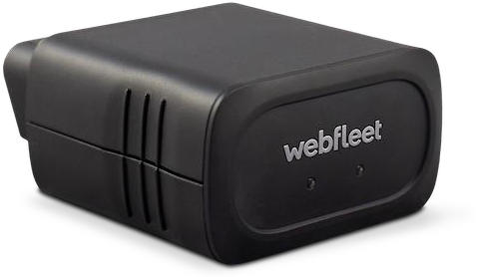

LINK 245
Plug and play vehicle tracking with Bluetooth

Start
Requirements & price
Appendix
Contents | Introduction | Summary | Features | Benefits


The simplest way to efficient fleet management

LINK 245 is a plug and play vehicle tracking device for cars and light commercial vehicles. Benefit from Bluetooth connectivity to optimise your workflow, improve fleet performance and help your business advance to the next level.

Contents
Requirements & price
Appendix
Introduction | Summary | Features | Benefits

Contents
Start
- Introduction
  - What’s new
- Summary
  - LINK 245 highlights
  - Service integration: Webfleet LITE vs. Webfleet
- Features
  - Overview
  - Fuel level and consumption
  - Maintenance tasks
  - Electric vehicle support
  - Driving behaviour support: OptiDrive 360 KPIs
- Benefits
- Requirements and price

- Appendix
  - Specifications: LINK 245
  - Why OBD-II
  - LINK 245: Activation
  - LINK 245: Vehicle Compatibility Checker

What’s new
Requirements & price
Appendix
Summary | Features | Benefits

Introduction

LINK 245 is the successor of LINK 240. In addition to all of the functionalities of LINK 240, LINK 245 brings:
Start
Contents
- Availability in all regions: International and Europe
- Bluetooth connectivity with Driver Terminals for better order workflow management
- LINK.connect¹ for use of third-party Bluetooth devices (e.g. cabin printer)
- Electric vehicle support² with access to Webfleet EV fleet management features (e.g. real-time battery levels to plan better daily jobs; energy consumption reports to understand electric fleet performance)
- Connection to Webfleet Work App, where drivers can use their own mobile devices to access Driver Terminal functionalities
- 4G antenna with better performance worldwide
- Extended internal memory with up to 30 hours of data buffering in case of disconnection
- Support for all tariffs: LITE/ TRACK³ / LINK/ECO/NAV/LIVE

- LINK.connect requires ECO tariff or above.
- To check all available features, use vehicle compatibility check to verify supported vehicle/model.
- TRACK tariff is only available for the UKI market.

Summary
Start
Contents
Introduction
Features
Benefits
Requirements & price
Appendix

LINK 245 highlights
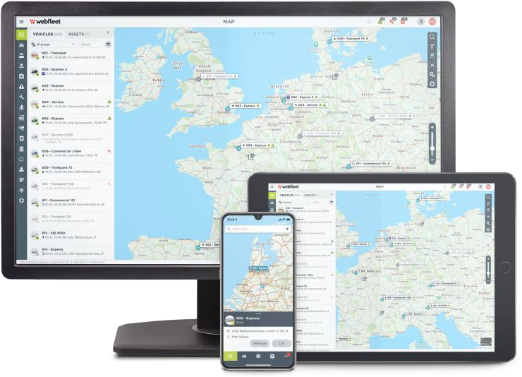
LINK 245 is the plug and play vehicle tracking device for small businesses, leased vehicles, subcontractors and temporary vehicles or drivers. It features:
- Simple self-installation via the OBD-II port
- Bluetooth connectivity with Driver Terminals, Work App and third-party devices¹
- Electric vehicle support
- Real-time vehicle track and trace history with real vehicle odometer²
- Detailed trip reports and fuel & battery level and fuel/energy consumption³ reports
- Notifications when:
  - Vehicles enter or leave a defined area
  - An accident is detected
  - LINK 245 is disconnected from the vehicle
  - A vehicle diagnostic system incident (MIL notification or DTC^{2,4}) is reported
- Driving behaviour support with up to eight OptiDrive 360 KPIs^{2,5}
- Automatic service reminders based on real-time mileage information⁵
- Compatibility with all Webfleet tariffs⁶.
- LINK.connect requires an ECO tariff or above.
- Available subject to vehicle/model and only accessible with a Webfleet (not Webfleet LITE) subscription.
- Fuel consumption/level reports and automatic service reminders are supported with the Webfleet ECO tariff and are subject to vehicle/model.
- MIL: Malfunction Indicator Lamp; DTC: Diagnostic Trouble Code.
- OptiDrive 360 KPIs: Speeding, constant speed, driving events, coasting, idling, green speed, fuel consumption and gear shifting.
- Webfleet LITE is available only in Europe.

Summary
Features
Benefits
Requirements & price
Appendix

Service integration: Webfleet LITE vs. Webfleet

Basic reports


✔ ✔ • Trips (logbook)
  - Notifications

  - TomTom map
  - No traffic

    - 10 area alerts

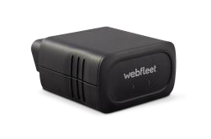






    - 100 addresses
OBD
Track
and trace
Mileage
registration
Reporting
Maps
Other
Webfleet
TELEMATICS SERVICE PLATFORM
Cars/LCVs
via LINK 245
> 20 additional
types of report
•
•
•
•
Map
Google map Satellite map With traffic
Dashboard
✔
✔
- Logbook with real vehicle odometer
•
•
•
•
•
•
•
•
OptiDrive 360
KPIs^{4,5}
Trips (logbook)
Notifications Administrative Driving performance Location Maintenance
Fuel level1 For EVs2:
- Energy consumption report
- Charging report
Maintenance tasks
•
Automatic service
reminders1
•
•
•
•
Speeding
Green speed Constant speed Driving events: steering, harsh breaking etc. Idling
Fuel consumption1 Coasting1
Gear shifting1
•
Integration
with Driver Terminals and Work App
•
Advanced area
setting Unlimited addresses
Webfleet UI
Additional features
MIL notifications
and DTCs^{3,5}
•
•
•
•
- Messages
- Driver
- Maintenance
- Connect (API)

Start
Contents
Introduction

PRO 7/8

- Fuel consumption/level reports and automatic service reminders are supported with the Webfleet ECO tariff and are subject to vehicle/model.
- Use the vehicle compatibility check to verify supported vehicles/models.
- MIL: Malfunction Indicator Lamp; DTCs: Diagnostic Trouble Codes.
- OptiDrive 360 KPIs: speeding, constant speed, driving events, coasting, idling, green speed, fuel consumption and gear shifting.
- Available subject to vehicle/model and only accessible with a Webfleet (not Webfleet LITE) subscription.

Features
Requirements & price
Appendix
Benefits

Overview

Track and trace
View the driving times, mileage and locations of your fleet in real time or over a chosen time period.

Alerts and crash detection
Receive a notification whenever a vehicle enters or leaves a previously designated area, or when an accident is detected.

Fleet performance reporting
Get 24/7 access to comprehensive vehicle and driver insights such as trip
and fuel consumption/level reports¹.

Driving behaviour
OptiDrive 360 provides driving style insights on up to eight performance indicators^{2,3}.

Mileage view and logbook
Analyse mileage and trip data per group or per fleet. The odometer is reported directly from the vehicle and therefore identical to the readings from the on-board equipment.

Maintenance tasks
Monitor fleet health status with instant vehicle diagnostic system incident reporting (MIL and DTC notifications^{3,4}). Automatic reminders¹ will let you know when vehicles need to be serviced.

Start
Contents
Introduction
Summary

- Fuel consumption/level reports and automatic service reminders are supported with the Webfleet ECO tariff and are subject to vehicle/model.
- OptiDrive 360 KPIs: speeding, constant speed, driving events, coasting, idling, green speed, fuel consumption and gear shifting.
- Available subject to vehicle/model and only accessible with a Webfleet (not Webfleet LITE) subscription.
- MIL: Malfunction Indicator Lamp; DTCs: Diagnostic Trouble Codes.

Features
Requirements & price
Appendix
Benefits

Overview

Bluetooth integration
Your PRO Driver Terminals can connect with Bluetooth for advanced workflow management: e.g. order dispatch, navigation and more.

Work App integration
Let your drivers use their own mobile devices to access Driver Terminal functionalities.

Fuel level and consumption¹
Analyse real-time and historical insights on your fleet’s fuel usage.

Power disconnected events
Get notified immediately when LINK 245 is disconnected from the OBD-II port.

Battery-powered operation
The internal battery provides traceability when it is disconnected from the OBD-II port or in stand-by mode while the battery lasts.

Electric vehicle support²
Get real-time battery levels, driving ranges, charging status and remaining charging times. Insightful reports in Webfleet on charging and energy consumption let you stay on top of your electric fleet’s performance.

Start
Contents
Introduction
Summary

- Fuel consumption/level reports and automatic service reminders are supported with the Webfleet ECO tariff and are subject to vehicle/model.
- ECO tariff or above required. Use the vehicle compatibility check to verify supported vehicles/models. More information on electric vehicle support on slide 12

Features
Start
Contents
Introduction
Summary
Requirements & price
Appendix
Benefits

Fuel level and consumption
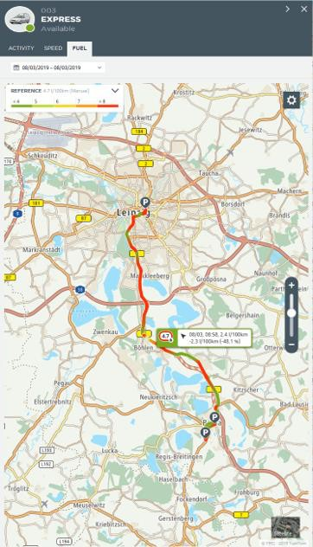
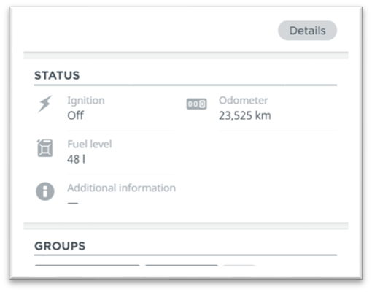
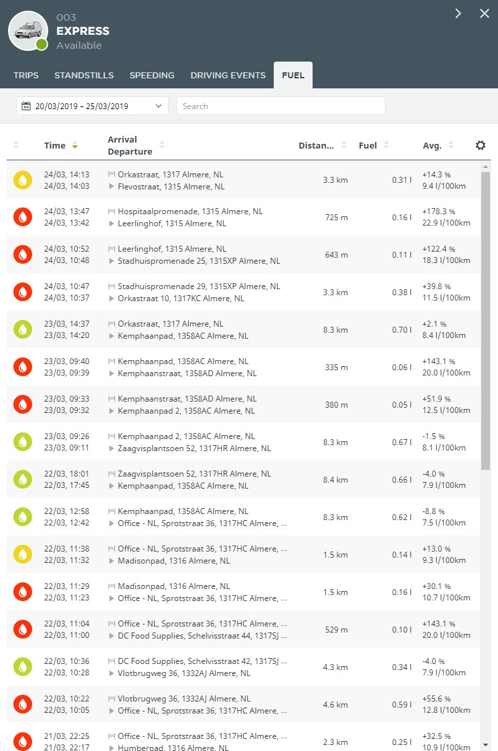
LINK 245 feeds fuel level and consumption data into Webfleet reports and dashboards to help fleet managers take action.

 Fuel KPIs dashboard
Helps to spot trends, benchmark performance and take action if needed.

 Fuel level and consumption report
Provides a detailed overview of daily fuel usage over a set period, allowing you to easily monitor your fuel consumption.

 OptiDrive report
Graphically shows OptiDrive performance indicators for fuel
consumption, idling, harsh steering and speeding and provides comprehensive distance, driving time and fuel consumption summaries.

Features
Start
Contents
Introduction
Summary
Requirements & price
Appendix
Benefits

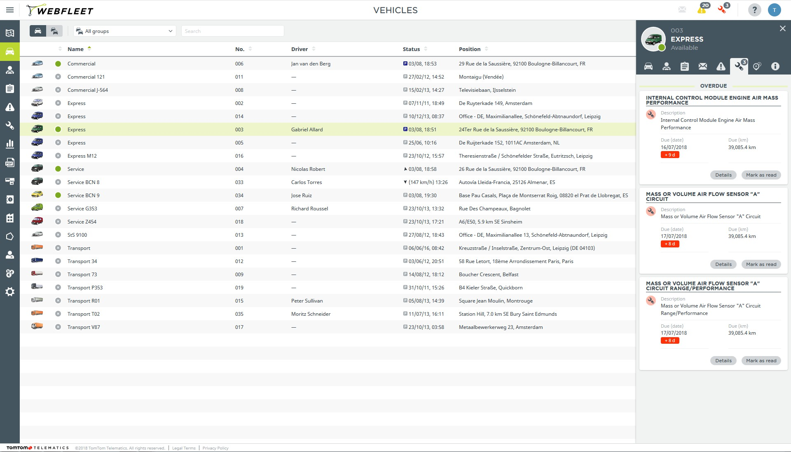
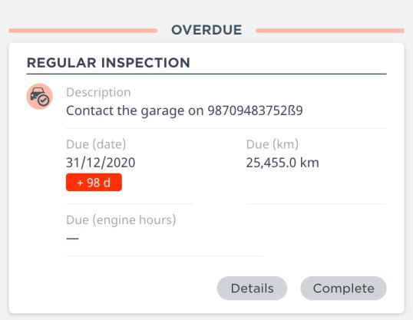
Maintenance tasks

Webfleet shows a maintenance task when LINK 245 reports a DTC or when a vehicle service needs to be scheduled
Malfunction Indicator Lamp (MIL) alert¹
- LINK 245 reports an active MIL (a.k.a. check engine light) on Webfleet as a warning notification.
Diagnostic Trouble Code (DTC) handling¹
- LINK 245 detects a DTC and shows a maintenance task on Webfleet with its vehicle fault code.

Service reminders²
- LINK 245 reads the service information from the vehicle. When a vehicle service needs to be scheduled, a maintenance task will be automatically created in Webfleet.

Benefits
- Always stay informed about the condition of your vehicles
- Take immediate action to prevent further vehicle damage
- Schedule and monitor your maintenance tasks easier
- Improve the safety of your drivers

1 Available subject to vehicle/model and only accessible with a Webfleet (not Webfleet LITE) subscription.
2 Fuel consumption/level reports and automatic service reminders are supported with the Webfleet ECO tariff and are subject to vehicle/model.

Features
Requirements & price
Appendix
Benefits

Driving behaviour support: OptiDrive 360 KPIs¹

OptiDrive 360 monitors up to eight driving performance indicators to help drivers continuously improve and help you maintain a greener, safer and more efficient fleet.


Speeding
Shows whether vehicles are within or above the speed limit.


Driving events
Shows incidents such as harsh steering, sudden braking and cornering.

Constant speed
Offers driving assistance with keeping a constant speed in urban areas, extra urban areas and motorways.

Green speed
Shows whether your driver is following the proposed speed limit for optimal fuel usage and road safety.

Idling
Helps you prevent fuel wastage.

Fuel consumption
Shows your actual fuel consumption and fuel efficiency.

Coasting
Shows the deceleration and coasting time for each trip. This helps you improve driving style and reduce fuel usage.

Gear shifting
Shows whether your driver used the optimal gear for reducing high fuel consumption and unnecessary engine wear.

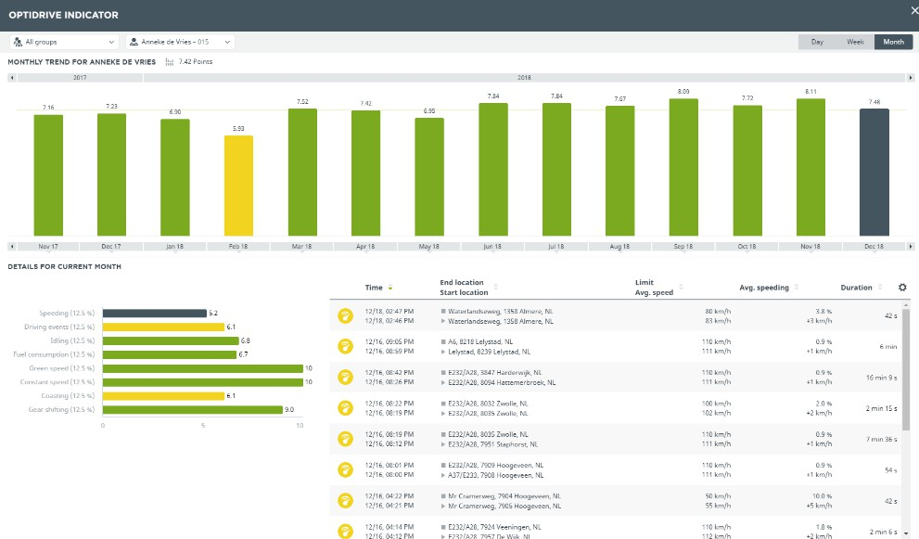

OptiDrive’s performance indicators help to identify areas for improvement

Start
Contents
Introduction
Summary

1 Available subject to vehicle/model and only accessible with a Webfleet (not Webfleet LITE) subscription.

Features
Requirements & price
Appendix
Benefits

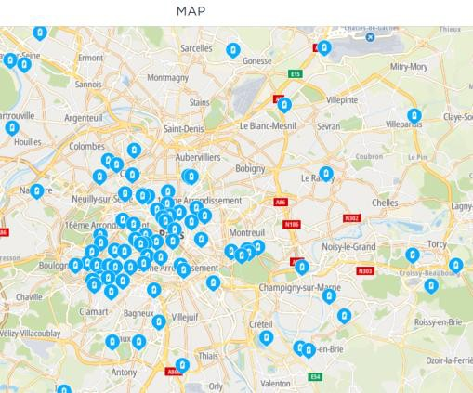
Electric vehicle support

- LINK 245 also supports EV fleet management by connecting fully electric and plug-in hybrid vehicles to Webfleet. This helps you get the most value from your EVs¹.
  - Identify charging locations on the map and see their details and availability
  - Check the real-time battery levels of your fleet and their remaining range²
  - Set alerts for critical battery levels and get notified when a vehicle needs to be charged
  - Get insights on EV fleet behaviour:
    - Charging report: learn about charging times and your fleet charging routine
    - Energy consumption report: learn how much energy your vehicles consume on
average
- If you’re thinking about updating your fleet and would like to know
whether it’s time to make the switch to electric, Webfleet provides you the Fleet Electrification Planning Report.
  - The report proposes which vehicles from your fleet could be switched to an EV, based on their average daily run.
Find charging stations on the Webfleet map and get detailed information such as: opening hours, plug type, number of available charging plugs

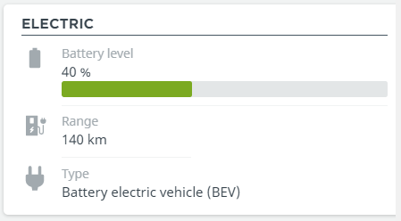

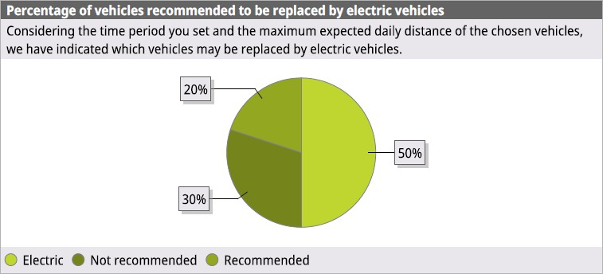
The Fleet Electrification Planning Report recommends which vehicles could be replaced with an electric model, as well as their current CO2 emissions and potential fuel consumption reduction

Real-time battery level, remaining driving range for BEVs and PHEVs¹

Start
Contents
Introduction
Summary
- Use the vehicle compatibility check to verify supported vehicles/models.
- Energy consumption/level reports and automatic service reminders are supported with the Webfleet ECO tariff and are subject to vehicle/model. Use vehicle compatibility check to verify offered features.

Benefits
Start
Contents
Introduction
Summary
Features
Requirements & price
Appendix


Customer benefits

 Stay connected with your fleet and drivers
  - Always know where your vehicles are and where your drivers have been.
  - Get started easily by simply plugging LINK 245 into the vehicle’s OBD-II port.
  - Take advantage of stronger data coverage with support for LTE-M and GPRS technology¹.

 Make drivers more accountable and efficient
  - Improve your drivers’ performance and safety with driving style insights.

 Reduce your costs
  - Reduce running costs by monitoring fuel level and consumption and encouraging fuel-
efficient driving.
  - Minimise vehicle downtime with instant vehicle malfunction alerts and automatic maintenance notifications.
  - Improve your fleet performance using precise and up-to-date vehicle data.

1 Depends on the availability of local network infrastructure.

Benefits
Start
Contents
Introduction
Summary
Features
Requirements & price
Appendix


Customer benefits

 Stay in control of your fleet and business
- Receive a notification when a vehicle is used without permission.
- Manage your tax responsibilities more easily using automatic logbook.
- Identify areas where improvements can be made using comprehensive reports.

 Get the most from broad integration
- Use Bluetooth to integrate easily with additional Webfleet hardware and software such as PRO Driver Terminals and Work App.
- Access a wide range of business applications via third-party devices with Bluetooth.

 Keep on top of your electrified fleet¹
- Manage your EV battery levels and driving ranges.
- Know when to charge with critical battery notifications.
- Find the closest charging stations on the map.
- Improve the performance of your electric fleet with the Energy Consumption Report.
- Learn the optimal time of day to recharge your fleet with the Charging Report.

1 Use the vehicle compatibility check to verify supported vehicles/models and offered features.

Requirements & price
Start
Contents
Introduction
Appendix
Summary | Features | Benefits


Availability, requirements and pricing
- Availability
  - Supported Webfleet tariffs: LITE, TRACK¹, LINK, ECO, NAV and LIVE
  - Supported sales regions: Europe and International¹

- Features requirements
  - Real vehicle odometer: TRACK¹, LINK tariff or higher
  - Enhanced vehicle data features (e.g. full OptiDrive support): ECO tariff or higher
  - PRO Driver Terminal 7XXX or 8XXX: NAV tariff or higher
  - Webfleet EV fleet management: ECO tariff or higher

- Commercial terms
  - Device standalone price:
    - LINK 245 device: 179 EUR / 149 GBP (rental available)
  - Accessories:
    - OBD extension cable: 19.95 EUR / 15.95 BP

1 Webfleet LITE tariff not available in International region.

Appendix
Start
Contents
Introduction
Summary | Features | Benefits | Requirements & price

Specifications: LINK 245
Dimensions | 57 × 48 × 27 mm/2.24 × 1.89 × 1.06 inches
Weight | 55g/1.98oz
Material | Injection moulded plastic PC/ABS
Supply voltage | 12 V / 24 V (min. 9 V to max. 30 V)
Temperature | Operation:-20 °C to +50 °C / -4 °F to +122 °F Storage: -20 °C to +50 °C / -4 °F to +122 °F
Protection class | IP 20
Mobile networks | Integrated mobile network module with LTE-M and GPRS technology Micro SIM only accessible with opened housing
GNSS | Integrated GNSS antenna and GNSS receiver
Bluetooth® | Integrated Bluetooth® (class 2)
Rechargeable battery | A 250mAh lithium-ion battery is used for operational use
OBD protocols supported | ISO15765 (CAN) on Pins 6/14, ISO9141  ISO14230 (K-Line) on Pins 7/15 and Pin 12 HS-CAN on Pins 1/9, 3/8 and 3/11

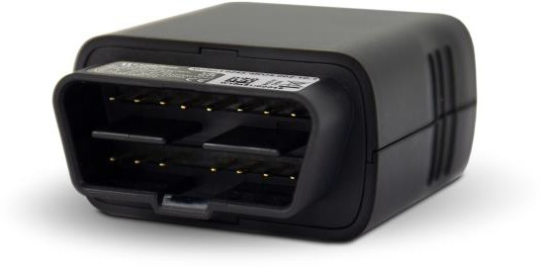
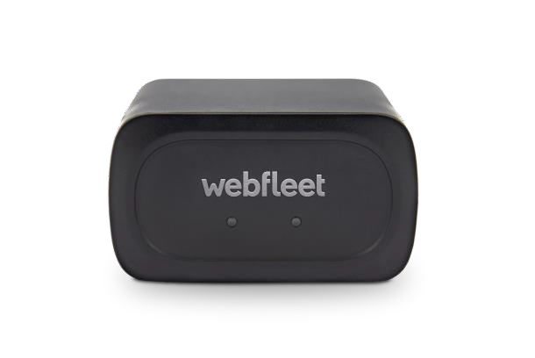


2
1
OBD-II connector
2 x LEDs for system and connection status
1
2

If the OBD-II connector of the vehicle does not provide enough space to insert the LINK 245, an OBD-II extension cable¹ can be used.

1 An OBD-II extension cable is available as an accessory, including sticky pads to secure the device to the vehicle.
The details listed in the product specifications are intended to provide a general description of the product and are subject to change.

Appendix
Start
Contents
Introduction
Summary | Features | Benefits | Requirements & price

Why OBD-II

 Standardised
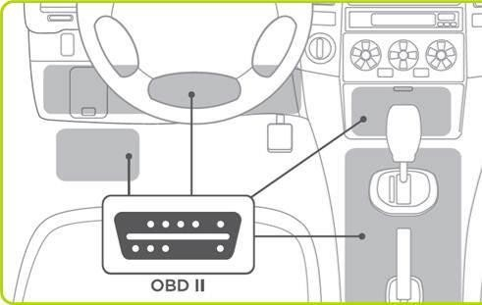
The OBD interface is defined by ISO and SAE international standards to provide engine information to third-party tools.

 Future ready
In the EU, based on the directive 98/69/EC, every new vehicle since 2001 (2004 for diesel cars) must have an OBD port.

 Easy installation
Simply insert the LINK 245 into the OBD-II connector of a vehicle without the
need for extensive on-board wiring.

 Warranty
Contrary to more intrusive means that tap into the vehicle, the LINK 245 does
not influence the vehicle’s wiring.

LINK 245: Activation
Summary | Features | Benefits | Requirements & price

LINK 245 must be activated before being installed and used. This can be done via computer or mobile. The activation requires:
- The contract confirmation letter including the activation code and customer number.
- The LINK device serial number and device activation key as printed on the device labels.
Appendix

Computer activation
Go to https://Webfleet.com/activation and follow the instructions.

Mobile activation
Go to your mobile app store, install LINK Toolkit and follow the instructions.

Start
Contents
Introduction
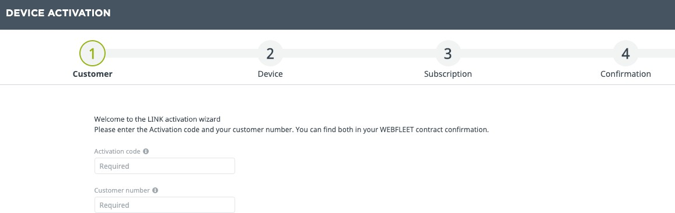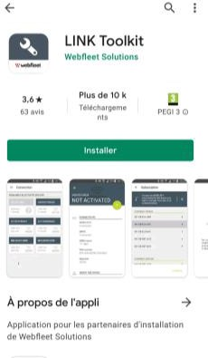

Appendix
Start
Contents
Introduction
Summary | Features | Benefits | Requirements & price

LINK 245: Vehicle Compatibility Checker
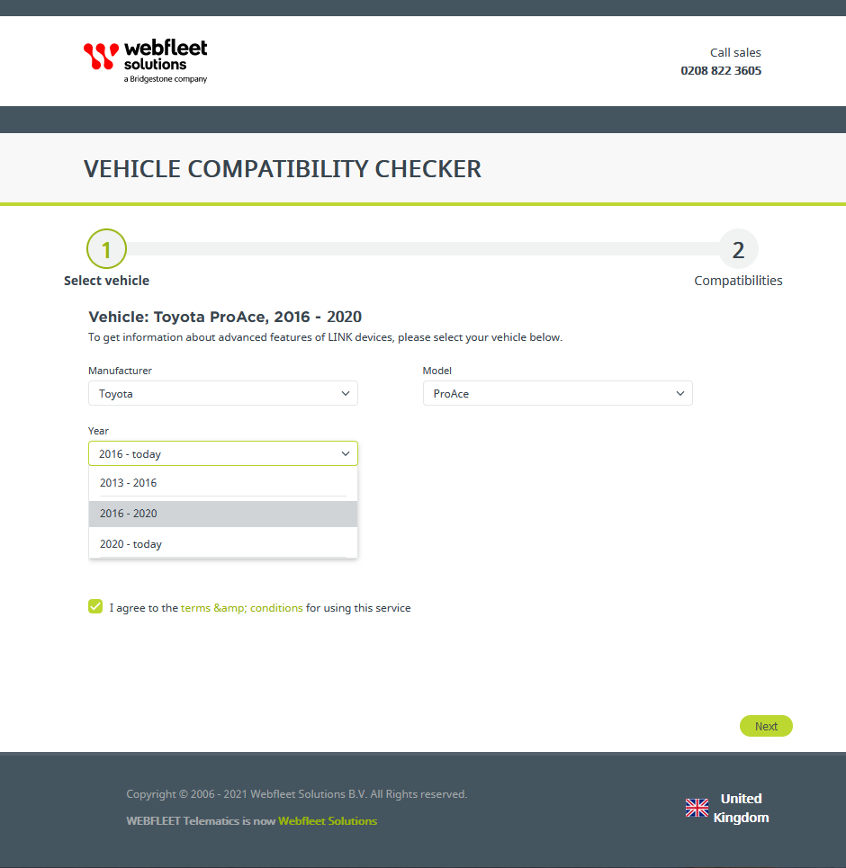
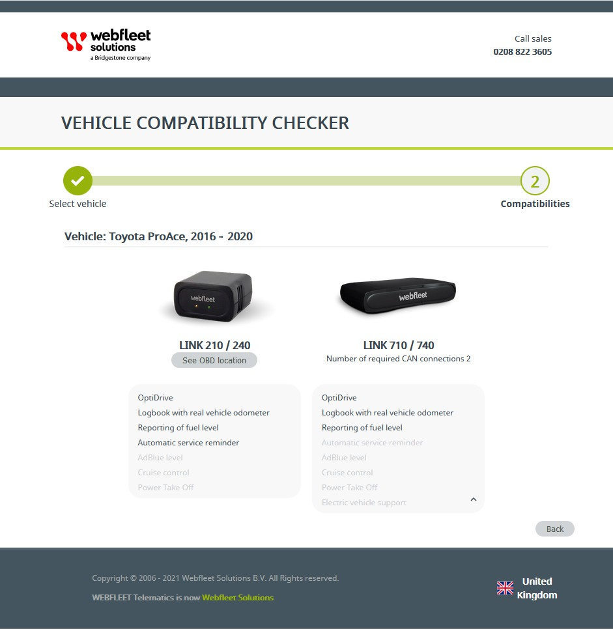
Enhanced OBD data like fuel level, service reminders or real vehicle odometer are vehicle/model-specific.
LINK 245
Almost 900 vehicle models are already supported by Webfleet Solutions.
To check LINK 245 compatibility with your vehicles, please go to https://link-compatibility.Webfleet.com and follow the instructions.
If you have electric vehicles, you can also check which features are available for your EV (e.g. battery levels, driving ranges, remaining charging time, charging state¹).

1 Use the vehicle compatibility check to verify supported models and offered features. EV features are supported with the Webfleet ECO tariff or above and are subject to vehicle/model.



Copyright © Bridgestone Corporation

