NAME: KIKUMU SCOTT KIKUMU

STUDENT NUMBER: 201602664

TITLE: ELECTRONICS AND INTERFACING REPORT

DATE PUBLISHED: 27/11/18

Contents

Introduction 3

Setting up the project 3

Program Flowchart for counter using “<TimerOne.h>” library. 4

Program flowchart and explanation of segment selection and number selection. 4

Infrared Radio Receiver circuit. 5

IR Receiver Program flowchart and System Flowchart 5

# Introduction

This report will cover the main methodologies and software type that was used in the making of a sports timer. An Arduino Uno R3 was used as the main hardware and a collection of libraries that will be covered on this report. Some of the hardware used in my project was a remote control of model “Car mp3”, a seven segment 4-digit display, an infrared radio(IR) receiver module, several resistors, buttons, a breadboard and jumper wires. An overall flowchart of the program will also be provided.

# Setting up the project

I used an 830 Tie-Points Breadboard and attached to the breadboard a seven-segment 4-digit display which was connected and powered by the Arduino Uno R3. All the pins that were connecting the 7-segment display to the Arduino were all digital pins, however, all the wiring except for the pins connecting the individual digits were connected to the Arduino using a 330K ohm resistors. The resistors are used in the circuit to prevent the risk of overloading the 4-digit seven segment display. Starting from digital pin 2 all the way to digital pin 12. An outline of the wiring is shown below.

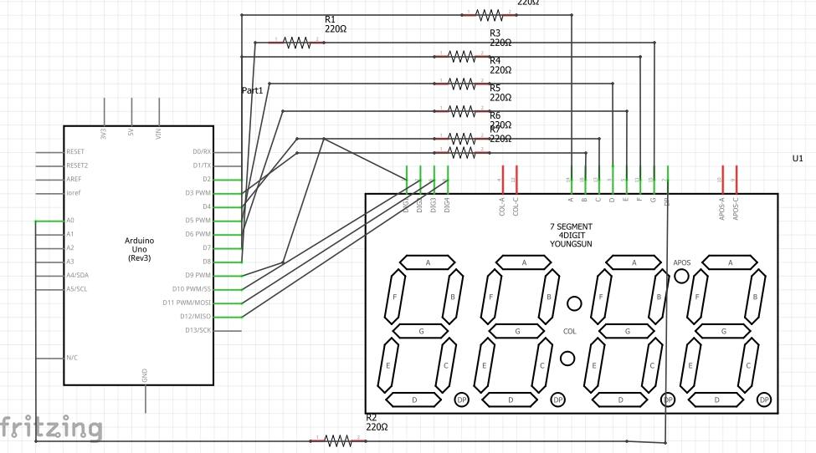

The Infrared Radio receiver is connected to pin 13 of the digital pin. The infrared radio receiver will be used to receive signals from the car mp3 remote which will be then converted into hexadecimal digits by the Arduino which in turn will be used to manipulate values in the 4-digit seven segment display.

# Program Flowchart for counter using “<TimerOne.h>” library.

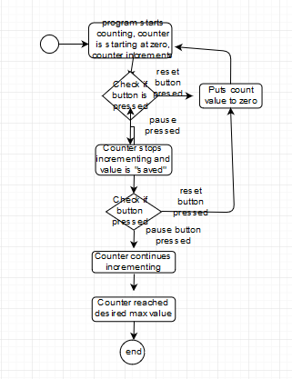

The TimerOne library was used to program to count the digits in the program and output the numbers into the 4-digit seven segment display. Remote buttons were used to send signals to the Arduino to tell the Arduino when to stop incrementing the counter hence pausing it, and when to reset the counter by setting the counter value to zero as shown in the program flowchart.

# Program flowchart and explanation of segment selection and number selection.

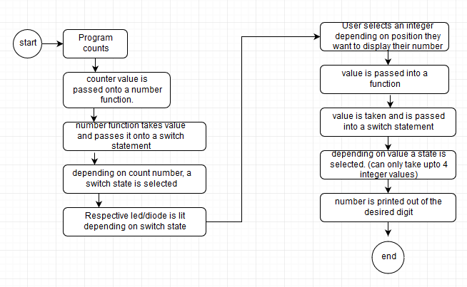

Numbers which are integers from the counter values are passed onto a user-defined number function. The number function then takes up the integer values and passes it onto an argument which are integers. The values inside the argument are measured against a series of switch statements. Each switch case is different and instruct the Arduino to light up different parts of the segment display depending on the value of the counter. After this is done, the Arduino is then instructed to light up different segments depending on the value or integer chosen. It follows the same principle as the “numbers” function.

# Infrared Radio Receiver circuit.

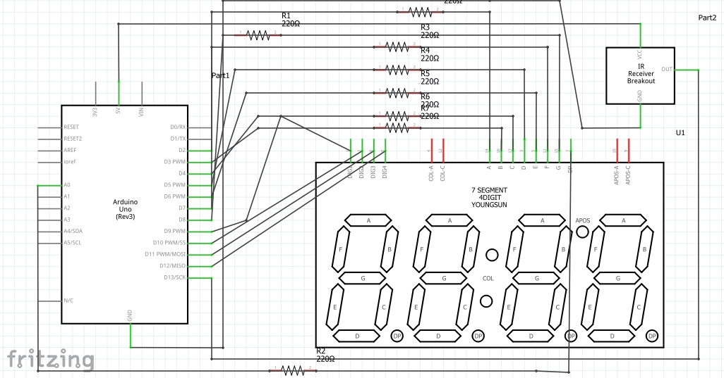

The IR receiver is connected to pin 13 in the Arduino as shown. It will be receiving signals from the remote and convert the infrared signals into hexadecimal values in which will now be used to switch between statements and each case statement within the switch statement will make the Arduino pause time, start time, reset the time and save time to its in built serial monitor depending on the button being pressed on the remote.

# IR Receiver Program flowchart and System Flowchart

