Dohn Michael B. Varquez BSCS-2 Fundamentals in Database Systems

Student Database Management System

Entering IP Address

Adding Record

Deleting Record

Editing Record

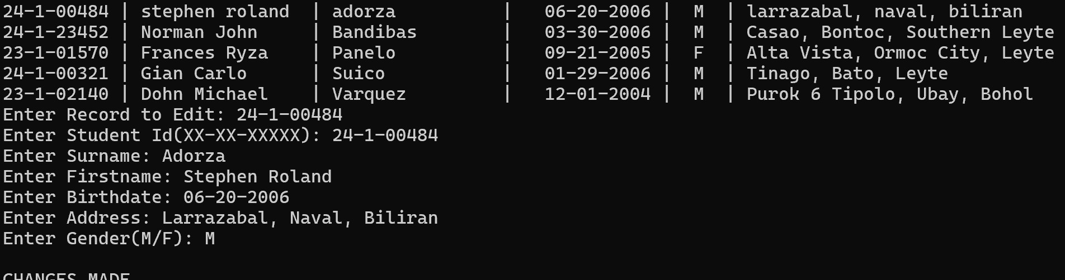

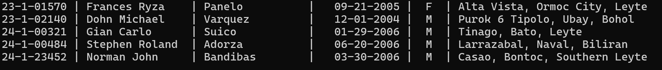

Viewing Record

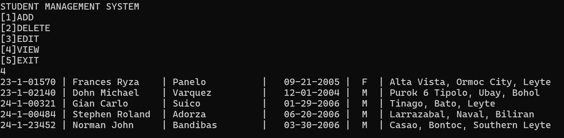

Viewing Sorted Record

Source Code

#include <iostream>

#include <windows.h>

#include <mysql.h>

#include <iomanip>

#include <sstream>

#include <ctype.h>

#include <string>

using namespace std;

void addRec(string ipAdd);

void delRec(string ipAdd);

void viewRec(string ipAdd);

void editRec(string ipAdd);

void viewSort(string ipAdd);

MYSQL* connect(string ipAdd);

int main()

{

/*MYSQL* conn;

conn = mysql_init(0);

conn = mysql_real_connect(conn, "10.214.3.15", "admin", "admin", "test1", 0, NULL, 0);

if(conn)

cout<<"CONNECTED\n";

else

cout<<"ERROR";

int qstate = 0;

stringstream ss;

string name = "rhuel gwapo";

ss<<"INSERT INTO testt1(name) VALUES('"<< name <<"')";

string query = ss.str();

const char* q = query.c_str();

qstate = mysql_query(conn, q);

if(qstate == 0)

{

cout<<"RECORD INSERTED...";

}

else

cout<<"FAILED to insert";

*/

string ipAdd;

cout<<"Enter Ip Address: ";

cin>>ipAdd;

int checkRun = 0;

while(checkRun == 0)

{

int choice;

cout<<"STUDENT MANAGEMENT SYSTEM"<<endl<<"[1]ADD"<<endl<<"[2]DELETE"<<endl<<"[3]EDIT"<<endl<<"[4]VIEW"<<endl<<"[5]EXIT"<<endl;

cin>>choice;

switch(choice)

{

case 1:

addRec(ipAdd);

system("pause");

system("cls");

break;

case 2:

delRec(ipAdd);

system("pause");

system("cls");

break;

case 3:

editRec(ipAdd);

system("pause");

system("cls");

break;

case 4:

viewRec(ipAdd);

system("pause");

system("cls");

break;

case 5:

checkRun = 1;

break;

default:

cout<<"Command not Available...\n";

system("pause");

system("cls");

break;

}

cin.ignore();

}

}

MYSQL* connect(string ipAdd)

{

MYSQL* conn;

conn = mysql_init(0);

const char* q = ipAdd.c_str();

conn = mysql_real_connect(conn, q, "admin", "admin", "dbms", 0, NULL, 0);

return conn;

}

void addRec(string ipAdd)

{

MYSQL* checkCon = connect(ipAdd);

if(checkCon)

{

string studentID, surname, firstname, birthdate, address, gender;

int qstate = 0;

cout << "Enter Student Id(XX-X-XXXXX): ";

cin >> studentID;

cout << "Enter Surname: ";

cin.ignore();

getline(cin, surname);

cout << "Enter Firstname: ";

getline(cin, firstname);

cout << "Enter Birthdate(MM-DD-YYYY): ";

getline(cin, birthdate);

cout << "Enter Address(Baranggay, Town, Province): ";

getline(cin, address);

cout << "Enter Gender(M/F): ";

cin >> gender;

if(studentID.length() > 10 || studentID.length() < 10)

{

cout<<"Record failed to insert. Invalid input on Student Id.\n";

return;

}

else if(birthdate.length() > 10 || birthdate.length() < 10)

{

cout<<"Record failed to insert. Invalid input on Birthdate.\n";

return;

}

else if(gender.length() > 1 || gender.length() < 1)

{

cout<<"Record failed to insert. Invalid input on Gender.\n";

return;

}

stringstream ss;

ss<<"INSERT INTO student(studentID, surname, firstname, birthdate, address, gender) VALUES('"<<studentID<<"','"

<<surname<<"','"<<firstname<<"','"<<birthdate<<"','"<<address<<"','"<<gender<<"')";

string query = ss.str();

const char* q = query.c_str();

qstate = mysql_query(checkCon, q);

cout<<endl;

if(qstate == 0)

cout<<"RECORD INSERTED...\n"<<endl;

else

cout<<"FAILED TO INSERT...\n"<<endl;

}

else

cout<<"FAILED TO ESTABLISH CONNECTION...\n";

}

void viewRec(string ipAdd)

{

MYSQL* checkCon = connect(ipAdd);

MYSQL_ROW row;

MYSQL_RES* res;

char ans;

if(checkCon)

{

int qstate = mysql_query(checkCon, "SELECT studentID, firstname, surname, birthdate, gender, address FROM student");

if(!qstate)

{

res = mysql_store_result(checkCon);

while((row = mysql_fetch_row(res)))

cout<<setw(10)<<left<<row[0]<<" | "<<setw(15)<<left<<row[1]<<" | "<<setw(15)<<left<<row[2]<<" | "<<setw(10)<<left<<row[3]<<" | "<<setw(2)<<left<<row[4]<<" | "<<setw(15)<<left<<row[5]<<endl;

}

cout<<"\nDo you wish to sort data? (y/n): ";

cin>>ans;

if(ans == 'y')

{

system("cls");

viewSort(ipAdd);

}

}

}

void delRec(string ipAdd)

{

MYSQL* checkCon = connect(ipAdd);

if(checkCon)

{

viewSort(ipAdd);

string studentID;

cout<<"\n Enter StudentId to delete: ";

cin>>studentID;

stringstream ss;

ss<<"DELETE FROM student WHERE studentID = '"+ studentID +"'";

string query = ss.str();

const char* q = query.c_str();

int qstate = mysql_query(checkCon,q);

if(qstate == 0)

cout<<"ROW DELETED...\n";

else

cout<<"ROW FAILED TO DELETE...\n";

}

else

cout<<"FAILED TO ESTABLISH CONNECTION...\n";

}

void editRec(string ipAdd)

{

MYSQL *checkCon = connect(ipAdd);

if(checkCon)

{

viewRec(ipAdd);

string studentIDTE, studentID, surname, firstname, birthdate, address, gender;

int qstate = 0;

cout<<"Enter Record to Edit: ";

cin>>studentIDTE;

cout << "Enter Student Id(XX-XX-XXXXX): ";

cin >> studentID;

cout << "Enter Surname: ";

cin.ignore();

getline(cin, surname);

cout << "Enter Firstname: ";

getline(cin, firstname);

cout << "Enter Birthdate: ";

getline(cin, birthdate);

cout << "Enter Address: ";

getline(cin, address);

cout << "Enter Gender(M/F): ";

cin >> gender;

stringstream ss;

ss << "UPDATE student SET studentID = '" << studentID << "', surname = '" << surname << "', firstname = '" << firstname << "', birthdate = '" << birthdate << "', address = '" << address << "', gender = '" << gender << "' WHERE studentID = '" << studentIDTE << "'";

string query = ss.str();

const char* q = query.c_str();

qstate = mysql_query(checkCon, q);

cout<<endl;

if(qstate == 0)

cout<<"CHANGES MADE...\n"<<endl;

else

cout<<"FAILED TO CHANGE DATA...\n"<<endl;

}

else

cout<<"FAILED TO ESTABLISH DATA...\n";

}

void viewSort(string ipAdd)

{

MYSQL *checkCon = connect(ipAdd);

MYSQL_ROW row;

MYSQL_RES* res;

if(checkCon)

{

int qstate = mysql_query(checkCon, "SELECT studentID, firstname, surname, birthdate, gender, address FROM student ORDER BY surname");

if(!qstate)

{

res = mysql_store_result(checkCon);

while((row = mysql_fetch_row(res)))

cout<<setw(10)<<left<<row[0]<<" | "<<setw(15)<<left<<row[1]<<" | "<<setw(15)<<left<<row[2]<<" | "<<setw(10)<<left<<row[3]<<" | "<<setw(2)<<left<<row[4]<<" | "<<setw(15)<<left<<row[5]<<endl;

}

}

else

cout<<"FAILED TO ESTABLISH DATA...\n";

}