14/11/2024 – Linux Some basic Commands

1. Echo “Hello World”

Works like Print Statement



1. echo $HOME

print environment variable



1. date

print current date or time



1. cal

print this months calendar

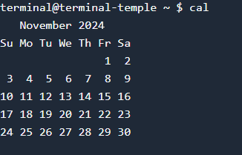\

1. whoami

gives the loginname

6)hostname

Gives the hostname

**Selected text processing utilities**

1. awk : pattern scanning and processing language

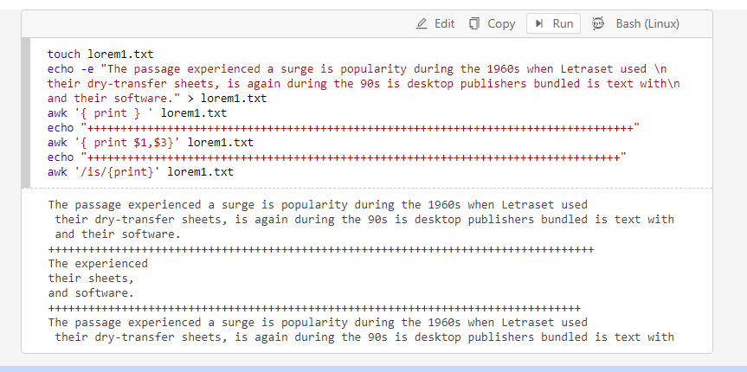

1. cat : Display file(s)

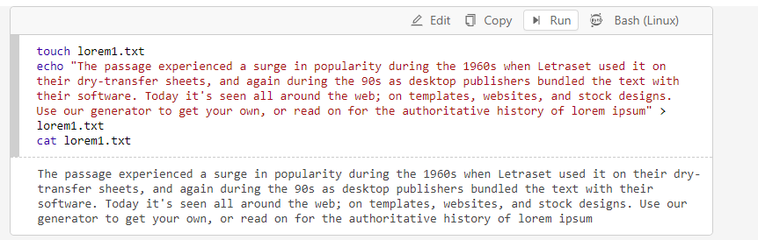

1. cut : Extract selected files of each line of file
2. diff : Compare two files

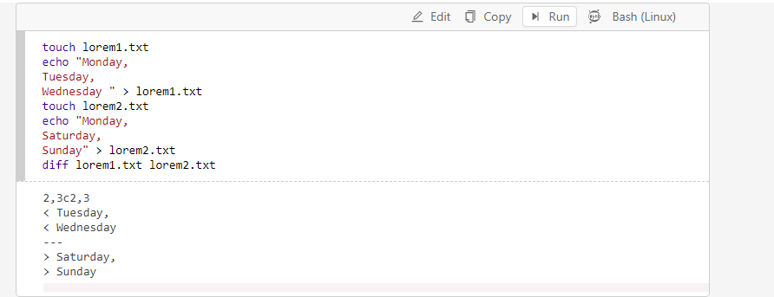

1. grep : search text for a pattern

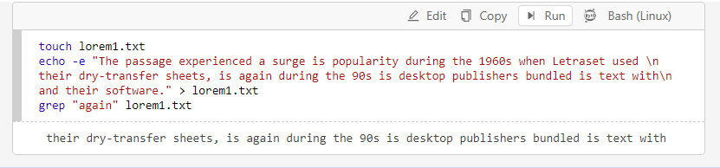

Case – insensitive :

1. uniq : filter out repeated lines of file

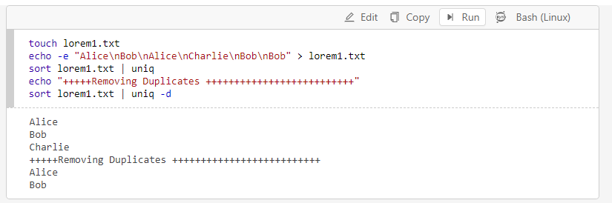

1. wc : line, word and character count

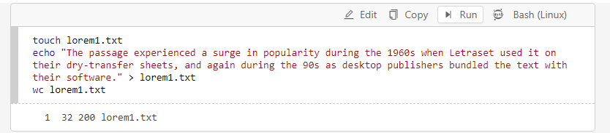

1line, 32 words, 200 bytes present

8)head : Display first part of files

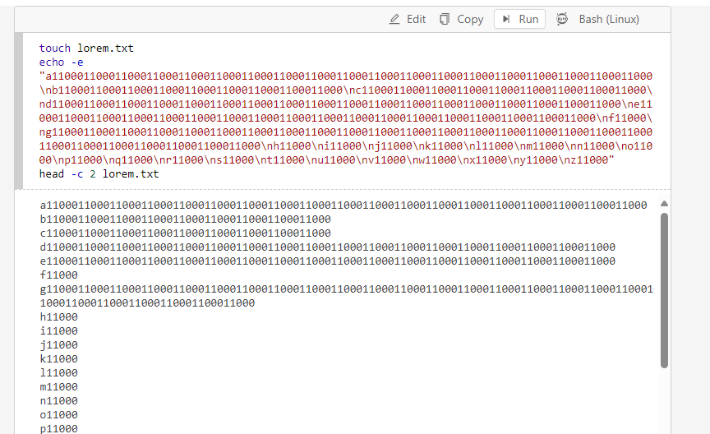

9) less : Display files on page-by-page basis

10) sed : Stream editor(esp.search and replace)

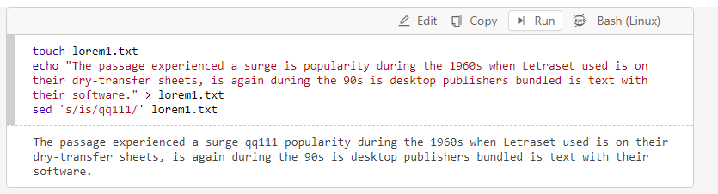

11) sort : Sort text files

12) split : Split files

13) tail : Display last part of file

14) tr : Translate / delete characters