KAJIADO NORTH
VOTER REGISTRATION ANALYSIS
A Demographic and Comparative Assessment of Registered Voters
Kajiado North Constituency, Kajiado County, Kenya
Prepared by Christopher Kileta
Data Analysis Report
July 2026

Executive Summary
This report presents a demographic analysis of registered voters in Kajiado North constituency, drawn from the official Kajiado County voter register. The analysis covers 134,880 records for Kajiado North out of 463,273 records for the county as a whole, examining the sex composition, age structure, and ward-level (CAW) distribution of the electorate, alongside data quality checks that inform confidence in the underlying register.
Kajiado North represents approximately 29% of all registered voters in Kajiado County, making it the county's largest constituency by voter count. The constituency's demographic profile — a modest male majority and a voter base concentrated in the 25–54 age range — closely mirrors that of the county overall, suggesting Kajiado North is broadly representative of countywide registration patterns rather than a demographic outlier.
134,880  Registered voters — Kajiado North | 29.11%  Share of Kajiado County total | 41 yrs  Median voter age

1. Background and Objectives
Understanding the size, spread, and composition of a constituency's electorate supports evidence-based planning for civic engagement, resource allocation, and electoral administration. This analysis was undertaken to build a clear, data-driven picture of the Kajiado North voter base and to place it in context against Kajiado County as a whole.
The analysis addresses four core questions:
- What is the size and share of Kajiado North's registered voter population relative to Kajiado County?
- How is the electorate distributed by sex and age?
- Which Civic Administrative Wards (CAWs) hold the largest concentrations of registered voters?
- How reliable is the underlying register, and what data quality issues, if any, require attention?

2. Data and Methodology

2.1 Data Source
The analysis is based on the Kajiado County voter register (source file: 034 - 034.csv), comprising 463,273 individual voter records across twelve fields, including county, constituency, ward (CAW), polling center and station, date of birth, name, sex, and national ID / passport number.

2.2 Processing Steps
- Loaded the raw register with all fields treated as text to prevent silent type-conversion errors.
- Standardized text fields (trimmed whitespace, upper-cased, normalized blank/NULL markers) for consistent grouping and filtering.
- Derived a full name field and parsed dates of birth into birth year and age, using 2026 as the reference year.
- Filtered the cleaned dataset to isolate the 134,880 records belonging to Kajiado North constituency.
- Ran data quality checks: missing-value counts on key fields, duplicate national ID detection, and age range validation.
- Bucketed voters into standard age bands (18–24, 25–34, 35–44, 45–54, 55–64, 65+) for both Kajiado North and the county as a whole, enabling direct comparison.
The county-wide comparison was performed using chunked processing (100,000 rows at a time) to keep memory usage manageable while still producing exact counts across the full 463,273-record register.

3. Findings

3.1 Sex Distribution
Within Kajiado North, male voters (69,864) outnumber female voters (65,016) by roughly four percentage points — a 51.8% / 48.2% split. This mirrors the pattern observed across Kajiado County overall (52.5% male / 47.5% female), indicating that Kajiado North's sex composition is consistent with, and very slightly more balanced than, the countywide norm.
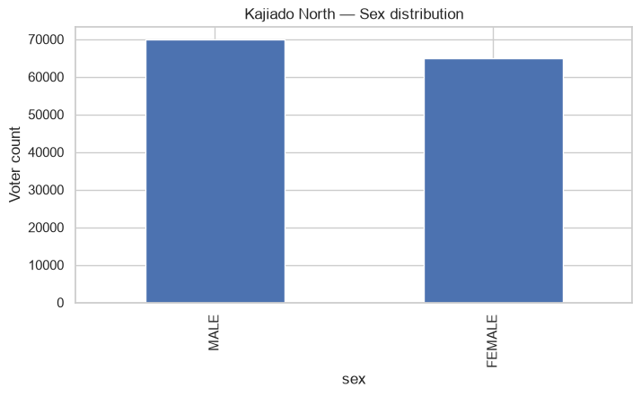
Figure 1. Registered voters by sex, Kajiado North.
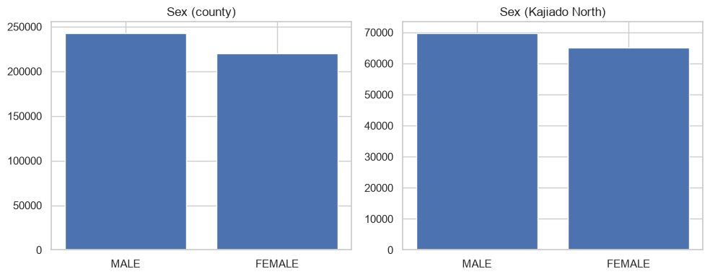
Figure 2. Sex distribution, Kajiado County vs. Kajiado North, side by side.

3.2 Age Distribution
The age profile of Kajiado North voters is right-skewed, peaking among voters in their early thirties to mid-forties. The mean age is 44 years and the median is 41 years, with the middle 50% of voters falling between 35 and 51 years old. Voter numbers taper off steadily beyond age 55, with the smallest share (65+) accounting for roughly 7.7% of the constituency's registered voters.
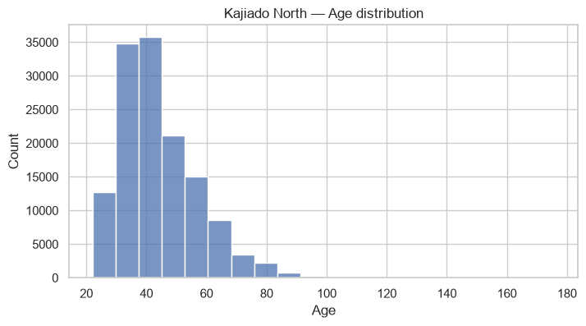
Figure 3. Age distribution of registered voters, Kajiado North.
Comparing age bands directly, Kajiado North's structure closely tracks the countywide pattern: the 25–44 bands dominate in both scopes, and the relative proportions in each band are nearly identical between the constituency and the county. This reinforces that Kajiado North is not demographically distinct from the wider county — it scales with, rather than diverges from, countywide trends.
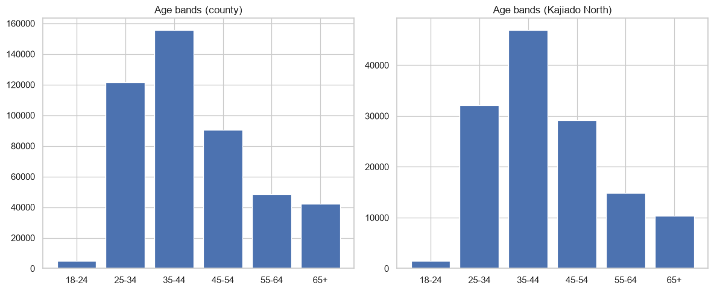
Figure 4. Age band distribution, Kajiado County vs. Kajiado North.

3.3 Ward (CAW) Concentration
Voter registration within Kajiado North is concentrated in a handful of wards. The top five Civic Administrative Wards — Nkaimurunya, Olkeri, Ongata Rongai, Ngong, and Oloolua — together account for the large majority of the constituency's registered voters, with Nkaimurunya and Olkeri leading at roughly 33,200 and 31,500 registered voters respectively.
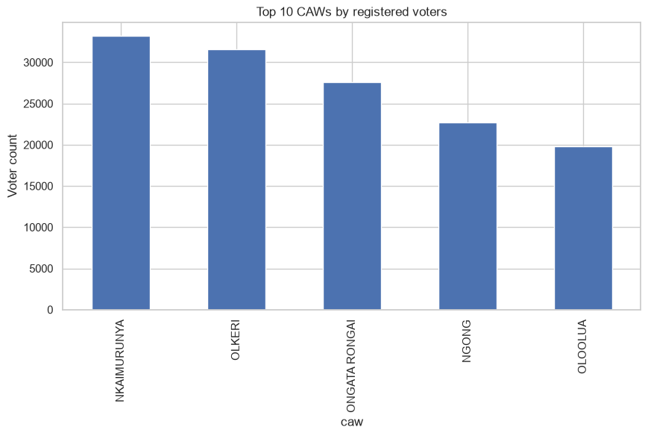
Figure 5. Top 10 CAWs in Kajiado North by registered voter count.

3.4 Data Quality Observations
- No missing values were found in date of birth, sex, or national ID / passport number for the Kajiado North subset — indicating strong completeness on these core fields.
- 58 records share a duplicate national ID / passport number within Kajiado North, warranting review before the register is used for downstream decision-making.
- A small number of records produce implausible ages (up to 176 years), pointing to likely data-entry errors in date of birth that should be corrected or excluded from age-based analysis.

4. Summary Data Tables

4.1 Sex Distribution — County vs. Kajiado North
Scope | Sex | Count | Share
Kajiado County | Male | 243,125 | 52.48%
Kajiado County | Female | 220,148 | 47.52%
Kajiado North | Male | 69,864 | 51.80%
Kajiado North | Female | 65,016 | 48.20%

4.2 Age Band Distribution — Kajiado North
Age Band | Registered Voters | Share of Constituency
Under 18 | 0 | 0.00%
18–24 | 1,449 | 1.07%
25–34 | 32,128 | 23.82%
35–44 | 46,868 | 34.75%
45–54 | 29,179 | 21.63%
55–64 | 14,860 | 11.02%
65+ | 10,396 | 7.71%

5. Conclusions
Kajiado North is the largest constituency in Kajiado County by registered voter count, contributing nearly a third of the county's total electorate. Its demographic profile — sex ratio and age structure alike — closely mirrors the county as a whole, suggesting that engagement, planning, or resourcing strategies calibrated at the county level are likely to translate reasonably well to Kajiado North specifically.
From a technical standpoint, the following data-hygiene actions are recommended before the register is used for further decision-making:
- Investigate and resolve the 58 duplicate national ID / passport number records to ensure register integrity.
- Audit records with implausible ages (e.g., derived from invalid or placeholder dates of birth) and correct or flag them prior to any age-based analysis or communication.
- Extend the analysis to polling-station-level granularity and sex-by-age-band cross-tabs for more targeted, localized planning.
- Repeat this analysis against future voter register updates to track registration growth and demographic shifts over time.

6. Insights and Strategic Recommendations for Political Stakeholders
The section below translates the demographic findings into insights and engagement strategies that an elected official, candidate, or campaign team could act on. These are turnout and outreach recommendations grounded strictly in the voter registration data — they concern where and how to allocate engagement resources, not any policy position or messaging content.

6.1 Key Insights
- Kajiado North is the single largest voting bloc in Kajiado County, holding 29.11% of the county's registered voters. A strong showing here has an outsized effect on any county-wide result, and the constituency merits resourcing and attention proportional to that weight.
- Voter registration is highly concentrated: the top five wards (Nkaimurunya, Olkeri, Ongata Rongai, Ngong, Oloolua) account for a large majority of the constituency's registered voters. Ground campaign reach in these five wards effectively reaches most of the electorate.
- Youth registration (18–24) is strikingly low at just 1,449 voters — 1.07% of the constituency. Given typical population pyramids, this almost certainly reflects under-registration among eligible young people rather than a small youth population, representing a significant untapped registration and mobilization opportunity.
- The working-age core (25–54) makes up 80% of registered voters, with the 35–44 band alone accounting for over a third. This is the group most likely to decide outcomes and the one whose turnout matters most on election day.
- Older voters (55+) make up 18.7% of the register. This segment typically turns out reliably but can be sensitive to polling-day logistics (distance, mobility, queue time).
- The sex split is close to even (51.8% male / 48.2% female), meaning neither broad outreach nor GOTV efforts should be designed around one sex to the exclusion of the other.
- Register data-quality gaps (duplicate IDs, invalid ages) create legitimacy risk: if unaddressed, they can be used to question result credibility after a close race.

6.2 Recommended Engagement Strategies
Ward-level resource allocation
- Weight ground campaign staffing, rally locations, and transport budgets by each ward's share of registered voters, prioritizing Nkaimurunya, Olkeri, Ongata Rongai, Ngong, and Oloolua first.
- Use the ward ranking (Figure 5) to set visit frequency — higher-registration wards warrant more repeat ground visits and local agent coverage than lower-registration wards.
Youth registration and turnout drive
- Launch a targeted voter registration campaign aimed at 18–24-year-olds ahead of key registration windows — this is the single largest gap between the current register and the constituency's likely eligible population.
- Partner with schools, colleges, boda boda associations, and youth groups in the top five wards to run mobile registration and civic-education drives.
- Lean on digital and social-media channels for this segment, alongside in-person drives, since younger voters are disproportionately reached through mobile-first platforms.
Core working-age (25–54) mobilization
- Since this group represents 80% of the register, prioritize turnout-focused activity (reminders, transport support, workplace and market-day outreach) over persuasion activity for this segment — the larger gain is getting already-registered voters to the polls.
- Time major ground events around market days and commuter patterns in peri-urban wards like Ongata Rongai and Nkaimurunya, where this age group is concentrated.
Older-voter (55+) accessibility
- Coordinate with community and religious leaders (chiefs' barazas, churches) who have strong reach with older voters for both civic engagement and logistics communication.
- Advocate for polling-station accessibility improvements (proximity, seating, priority queues) in wards with higher shares of older registrants, to protect this segment's historically reliable turnout.
Balanced, non-skewed outreach
- Given the near-even sex split, run outreach and GOTV logistics that serve both male and female voters equitably rather than concentrating resources on one group.
Register integrity as a credibility safeguard
- Publicly support or request an electoral-body review of the 58 duplicate ID records and implausible-age entries well ahead of election day — addressing this proactively reduces the risk of the register itself becoming a post-election dispute.
Ongoing measurement
- Re-run this analysis each time the register is updated to track whether registration drives (particularly among youth) are closing the gaps identified here, and to catch emerging shifts in ward-level voter concentration early.

Source: Kajiado County voter register (034 - 034.csv). Reference year for age calculations: 2026. Analysis and report prepared by Christopher Kileta.

