**Name: Mariam Kili Bechir**

**Personal Library Database Assignment-Day7**

**Table Design:**

Design a table named Books with the following columns:

* BookID, Title, Author, YearPublished, Genre

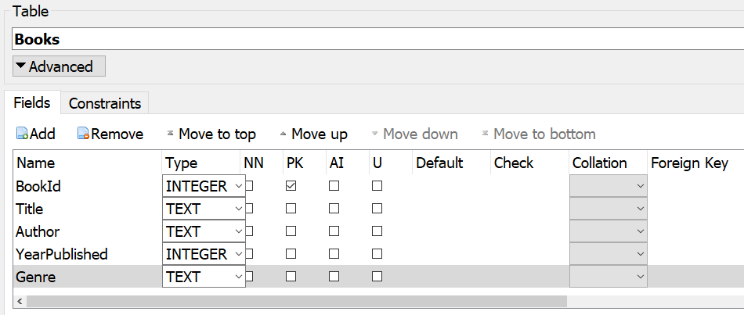

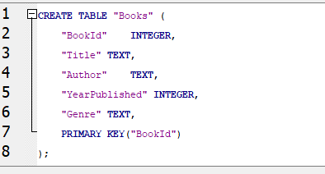

**Data Insertion**

Add at least five of your favorite books to the Books table.

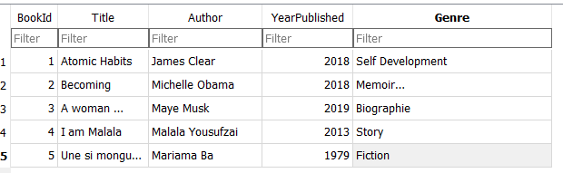

1. Write and execute an SQL query to list all books in the database.

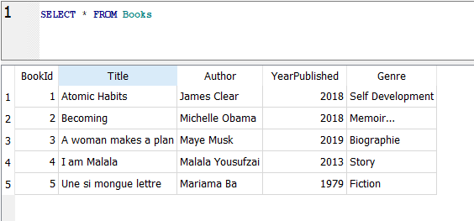

1. Write and execute an SQL query to find all books published after the year 2000.

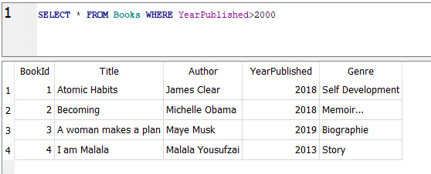

1. Write and execute an SQL query to find all books in the "Fiction" genre.

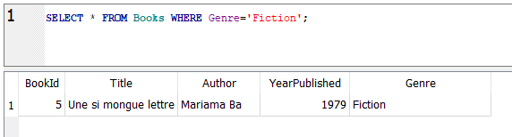

**\*\* Data Manipulation\*\***

Choose one book from your database and update its YearPublished to the current year.



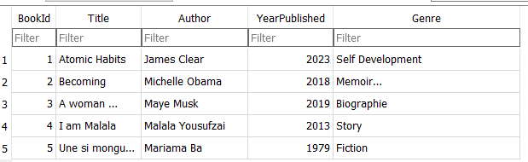

* Delete a book from the database.



