**Pizza Sales Sql queries**

**NB : Write the same requirements in DAX also**

1. **Key performance Indicator (KPI)**

* **Total Revenue**

select SUM(total_price) as total_revenue from pizza_sales

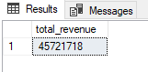

* **Average order value:**

select SUM(total_price) / count(distinct order_id) as avg_orders_value from pizza_sales



* **Total pizza solds**

select sum(quantity) as Total_pizza_sold from pizza_sales

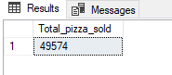

* **Total orders place**

select COUNT(distinct order_id) as total_orders from pizza_sales

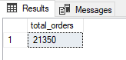

* **Average pizzas per order**

select CAST(CAST(sum(quantity) AS Decimal(10,2)) / CAST(COUNT(distinct order_id) AS DECIMAL(10,2)) AS DECIMAL(10,2)) as avg_pizza_per_order from pizza_sales



**CHARTS REQUIREMENTS**

* **Daily trend for total orders:**

SELECT DATENAME(DW, order_date) as week_day, COUNT(distinct order_id) as daily_order from pizza_sales GROUP BY DATENAME(DW, order_date)

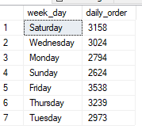

**Monthly trend for total orders**

SELECT DATENAME(MONTH, order_date) as Month_name, COUNT(distinct order_id) as Total_orders from pizza_sales GROUP BY DATENAME(MONTH, order_date) ORDER BY Total_orders DESC

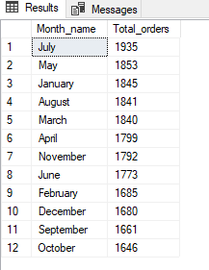

**Percentage of Sales by Pizza category**

SELECT pizza_category, SUM(total_price)*100/ (SELECT SUM(total_price) from pizza_sales) as sale_percentage

from pizza_sales

GROUP BY pizza_category

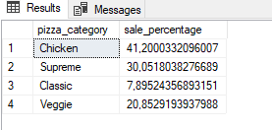

SELECT pizza_category,SUM(total_price) as total_Sales, SUM(total_price)*100/ (SELECT SUM(total_price) from pizza_sales) as sale_percentage

from pizza_sales

GROUP BY pizza_category

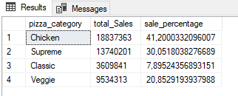

**Sales for January**

SELECT pizza_category,SUM(total_price) as total_Sales, SUM(total_price)*100/ (SELECT SUM(total_price) from pizza_sales WHERE MONTH(order_date)=1) as sale_percentage

from pizza_sales

WHERE MONTH(order_date)=1

GROUP BY pizza_category

**Percentage of Sales by Pizza Size**

SELECT pizza_size,SUM(total_price) as total_Sales, SUM(total_price)*100/ (SELECT SUM(total_price) from pizza_sales) as sale_percentage

from pizza_sales

GROUP BY pizza_size

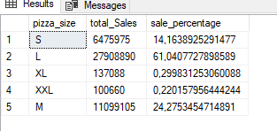

SELECT pizza_size,CAST(SUM(total_price) AS DECIMAL(10,2)) as total_Sales, CAST(SUM(total_price)*100/ (SELECT SUM(total_price) from pizza_sales) as DECIMAL(10,2)) as sale_percentage

from pizza_sales

GROUP BY pizza_size

ORDER BY sale_percentage

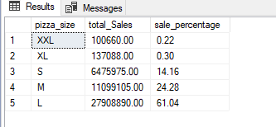

**Top 5 best sellers by revenue, Total quantity and total orders**

SELECT TOP 5 pizza_name, sum(total_price) AS total_revenue from pizza_sales

GROUP BY pizza_name

ORDER BY total_revenue DESC

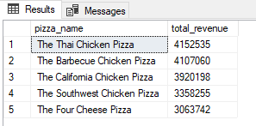

**Bottom/worst 5 best sellers by revenue,**

SELECT TOP 5 pizza_name, sum(total_price) AS total_revenue from pizza_sales

GROUP BY pizza_name

ORDER BY total_revenue ASC

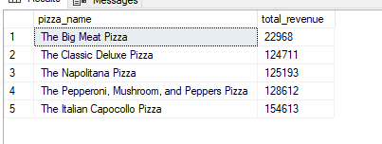

**TOP 5 best sellers by Quantity**

SELECT TOP 5 pizza_name, sum(quantity) AS total_quantity from pizza_sales

GROUP BY pizza_name

ORDER BY total_quantity DESC

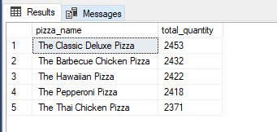

**Bottom/worst 5 best sellers by quantity,**

SELECT TOP 5 pizza_name, sum(quantity) AS total_quantity from pizza_sales

GROUP BY pizza_name

ORDER BY total_quantity

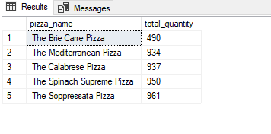

**TOP 5 best sellers by Order**

SELECT TOP 5 pizza_name, count(distinct order_id ) AS total_orders from pizza_sales

GROUP BY pizza_name

ORDER BY total_orders DESC

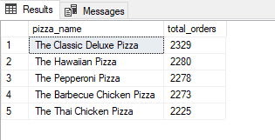

**Bottom/worst 5 best sellers by Orders**

SELECT TOP 5 pizza_name, count(distinct order_id ) AS total_orders from pizza_sales

GROUP BY pizza_name

ORDER BY total_orders

