Intensified Emotions due to 3D Audio? Comparative Reanalysis of a Data set on the Emotional Listening Experience in Stereo, 5.1 Surround Sound and 3D Audio

Kilian Sander, Yves Wycisk, Reinhard Kopiez

2022

# Data set from Hahn (2018)

## Preparation

### Data, Packages, and Design

Load the data:

load("data/data_raw.Rda")

Load relevant packages:

sapply(c("tidyverse", "MANOVA.RM", "rstatix", "ggpubr"), require, character.only = T)

Prepare the design with vectors:

formats <- c("stereo", "surround", "auro")  
gems_factors <- c("wonder", "transcendence", "tenderness", "nostalgia",  
 "peacefulness", "power", "joyful_activation", "tension",  
 "sadness")  
# item to factor mapping  
wonder <- c("moved", "filled_with_wonder", "allured")  
transcendence <- c("feeling_of_transcendence", "fascinated", "overwhelmed")  
tenderness <- c("affectionate", "tender", "mellowed")  
nostalgia <- c("sentimental", "dreamy", "nostalgic")  
peacefulness <- c("calm", "serene", "soothed")  
power <- c("energetic", "triumphant", "strong")  
joyful_activation <- c("joyful", "animated", "bouncy")  
tension <- c("agitated", "nervous", "tense")  
sadness <- c("sad", "sorrowful", "tearful")

### Filtering

Exclude a participant if there are at least two NAs for a GEMS factor of one stimulus:

data_raw$complete <- TRUE  
for (p in data_raw$participant) {  
 part_data <- data_raw %>% filter(participant == p)  
 for (excerpt in c("a", "b")) {  
 for (format in formats) {  
 for (factor in gems_factors) {  
 temp_data <- part_data %>%  
 dplyr::select(starts_with(paste(excerpt, format, get(factor), sep = "_")))  
 nas <- temp_data %>% t() %>% is.na() %>% sum()  
 if (nas > 1) {  
 data_raw$complete[p] <- FALSE  
 }  
 }  
 }  
 }  
}  
rm(part_data, temp_data, nas, p, format, excerpt)  
data_filtered <- data_raw %>% filter(complete==TRUE)  
N <- length(data_filtered$participant)

After removing incomplete cases the data set contains 52 participants.

### Scoring

Calculate mean values for each item per format:

for (format in formats) {  
 for (factor in gems_factors) {  
 for (item in get(factor)) {  
 item_mean_vector <- data_filtered %>%  
 select(ends_with(paste0(format, "_", item))) %>%  
 rowMeans(na.rm = TRUE)  
 eval(str2expression(paste0("data_filtered$",  
 format, "_", item,  
 " <- item_mean_vector")))  
 }  
 }  
}  
rm(item, item_mean_vector)  
data_filtered <- data_filtered %>% mutate_all(~ifelse(is.nan(.), NA, .))

Calculate the mean of each factor per format across its items:

for (format in formats) {  
 for (factor in gems_factors) {  
 factor_mean_vector <- data_filtered %>%  
 select(paste0(format, "_", get(factor))) %>%   
 rowMeans(na.rm = TRUE)  
 eval(str2expression(paste0("data_filtered$",  
 format, "_", factor,  
 " <- factor_mean_vector")))  
 }  
}  
rm(format, factor, factor_mean_vector)

### Long format

vars_vector <- sapply(formats,  
 function(format) {  
 paste0(format, "_", gems_factors)  
 },  
 USE.NAMES = F) %>% as.vector()  
data_long_mult <- data_filtered %>% select(participant, vars_vector)  
names(data_long_mult) <- names(data_long_mult) %>%  
 gsub("joyful_activation", "joyfulactivation", .)  
data_long_mult <- data_long_mult %>%  
 pivot_longer(!participant,  
 names_to = c("format", ".value"),  
 names_pattern = "(.*)_(.*)")  
data_long_single <- data_long_mult %>%  
 pivot_longer(!c(participant, format),  
 values_to = "score",  
 names_to = "factor") %>%   
 mutate(factor = recode(factor,  
 joyfulactivation = "joyful activation") %>% tools::toTitleCase(),  
 format = format %>% tools::toTitleCase() %>% as_factor())  
names(data_long_mult) <- names(data_long_mult) %>%  
 gsub("joyfulactivation", "joyful_activation", .)  
data_long_mult$format <- data_long_mult$format %>% as_factor()

## Analyses

### Descriptives

Out of the 52 participants 17 indicated “female” as their gender whereas 35 indicated “male”. The participants’ age ranged from 15 to 69 with a mean of 30.1346154 (*SD* = 12.4601779).

| GEMS Factor | Format | $M$ | $SD$ |
| --- | --- | --- | --- |
| Joyful Activation | Stereo | 2.189103 | 0.5649810 |
| Joyful Activation | Surround | 2.285256 | 0.5980511 |
| Joyful Activation | Auro | 2.336539 | 0.6072281 |
| Nostalgia | Stereo | 2.333333 | 0.5977445 |
| Nostalgia | Surround | 2.410256 | 0.6538486 |
| Nostalgia | Auro | 2.490385 | 0.6504678 |
| Peacefulness | Stereo | 2.429487 | 0.6133466 |
| Peacefulness | Surround | 2.439103 | 0.6658728 |
| Peacefulness | Auro | 2.480769 | 0.5919337 |
| Power | Stereo | 2.272436 | 0.7691129 |
| Power | Surround | 2.384615 | 0.7302508 |
| Power | Auro | 2.480769 | 0.8680067 |
| Sadness | Stereo | 1.897436 | 0.6932242 |
| Sadness | Surround | 1.894231 | 0.6584699 |
| Sadness | Auro | 2.003205 | 0.7616133 |
| Tenderness | Stereo | 2.275641 | 0.5629101 |
| Tenderness | Surround | 2.336539 | 0.6695122 |
| Tenderness | Auro | 2.375000 | 0.6039765 |
| Tension | Stereo | 2.248397 | 0.6396678 |
| Tension | Surround | 2.342949 | 0.6763299 |
| Tension | Auro | 2.306090 | 0.6180653 |
| Transcendence | Stereo | 2.586539 | 0.7601817 |
| Transcendence | Surround | 2.769231 | 0.7577873 |
| Transcendence | Auro | 3.000000 | 0.8769625 |
| Wonder | Stereo | 2.692308 | 0.6981025 |
| Wonder | Surround | 2.823718 | 0.6855285 |
| Wonder | Auro | 2.996795 | 0.8565335 |

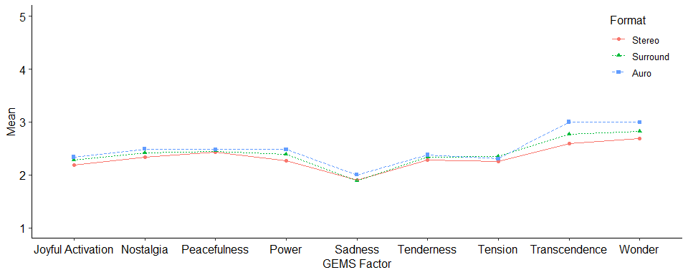

### Multivariate Analysis of Variance

#rm_manova <-  
# multRM(formula = cbind(wonder, transcendence, tenderness,  
# nostalgia, peacefulness, power,  
# joyful_activation, tension, sadness) ~ format,  
# data = data_long_mult,  
# subject = "participant",  
# within = "format",  
# para = TRUE,  
# iter = 50000,  
# dec = 5,  
# seed = 987)  
load(file = "results/rm_manova.Rda")  
summary(rm_manova)

## Call:   
## cbind(wonder, transcendence, tenderness, nostalgia, peacefulness,   
## power, joyful_activation, tension, sadness) ~ format  
## A multivariate repeated measures analysis with 1 within-subject factor(s) ( format )and 0 between-subject factor(s).   
##   
## Descriptive:  
## format n wonder transcendence tenderness nostalgia peacefulness  
## 1 stereo 52 2.69231 2.58654 2.27564 2.33333 2.42949  
## 2 surround 52 2.82372 2.76923 2.33654 2.41026 2.43910  
## 3 auro 52 2.99679 3.00000 2.37500 2.49038 2.48077  
## power joyful_activation tension sadness  
## 1 2.27244 2.18910 2.24840 1.89744  
## 2 2.38462 2.28526 2.34295 1.89423  
## 3 2.48077 2.33654 2.30609 2.00321  
##   
## Wald-Type Statistic (WTS):  
## Test statistic df p-value   
## format "40.78519" "18" "0.00163"  
##   
## modified ANOVA-Type Statistic (MATS):  
## Test statistic  
## format 17.90262  
##   
## p-values resampling:  
## paramBS (WTS) paramBS (MATS)  
## format "0.14638" "0.00386"

### Analysis of Variance for *Transcendence*

#### Assumption Checks

##### Extreme Outliers

data_long_mult %>% group_by(format) %>%  
 select(format, participant, transcendence) %>%  
 identify_outliers(transcendence) %>%   
 filter(is.outlier)

## # A tibble: 10 x 5  
## format participant transcendence is.outlier is.extreme  
## <fct> <int> <dbl> <lgl> <lgl>   
## 1 stereo 1 1.33 TRUE FALSE   
## 2 stereo 6 1.17 TRUE FALSE   
## 3 stereo 8 4.17 TRUE FALSE   
## 4 stereo 11 1 TRUE FALSE   
## 5 stereo 43 1 TRUE FALSE   
## 6 surround 6 1.17 TRUE FALSE   
## 7 surround 11 1.17 TRUE FALSE   
## 8 surround 43 1.33 TRUE FALSE   
## 9 surround 47 4.67 TRUE FALSE   
## 10 surround 48 1.17 TRUE FALSE

ggboxplot(data_long_mult, x = "format", y = "transcendence", add = "point")

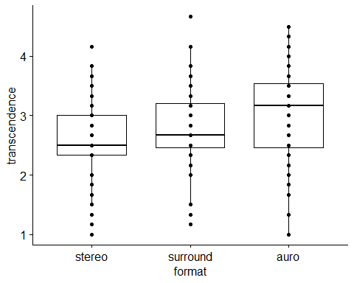

##### Normality: Shapiro-Wilk Test and QQ-Plots

| Version | Test Statistic | $p$ |
| --- | --- | --- |
| stereo | 0.9719007 | 0.2539826 |
| surround | 0.9624311 | 0.0997768 |
| auro | 0.9670579 | 0.1581975 |

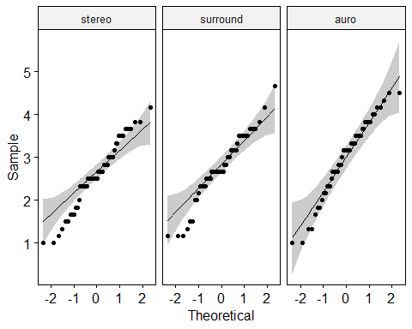

##### Mauchly’s Test for Sphericity

transcendence_anova <-  
 anova_test(data = data_long_mult,  
 dv = transcendence,  
 wid = participant,  
 within = format,  
 type = 3,  
 effect.size = "pes")  
transcendence_ges <- anova_test(data = data_long_mult,  
 dv = transcendence,  
 wid = participant,  
 within = format,  
 type = 3,  
 effect.size = "ges")$ANOVA$ges  
transcendence_anova$`Mauchly's Test for Sphericity` %>%  
 knitr::kable(col.names = c("Effect", "$W$", "$p$", "$p<.05$"),  
 align = "lccc")

| Effect | $W$ | $p$ | $p<.05$ |
| --- | --- | --- | --- |
| format | 0.931 | 0.169 |  |

#### Results

| Effect | DFn | DFd | $F$ | $p$ | $η_{p}^{2}$ | $η_{G}^{2}$ |
| --- | --- | --- | --- | --- | --- | --- |
| format | 2 | 102 | 13.209 | 7.9e-06 | 0.206 | 0.044 |

*Note.* Error bars represent 95% confidence intervals. GEMS factors are on a 5-point Likert scale coded from 1 to 5. Plot was exported from JASP (JASP Team, 2021).

| Contrasts | Estimate | CI LL | CI UL | SE | df | $t$ | $p$ |
| --- | --- | --- | --- | --- | --- | --- | --- |
| Surround – Stereo | 0.183 | 0.023 | 0.343 | 0.081 | 102 | 2.266 | 0.026 |
| Auro – Stereo | 0.413 | 0.254 | 0.573 | 0.081 | 102 | 5.128 | 1.397e-6 |
| Auro – Surround | 0.231 | 0.071 | 0.391 | 0.081 | 102 | 2.862 | 0.005 |

*Note.* Contrasts were calculated in JASP (JASP Team, 2021).

### Correlations for *Transcendence*

#### Correlations Between the Formats

| Formats | $r$ | $p$ | CI LL | CI UL | Fisher’s $z$ |
| --- | --- | --- | --- | --- | --- |
| Stereo – Surround | 0.7010 | < .001 | 0.5610 | 1 | 0.8692 |
| Stereo – Auro | 0.7018 | < .001 | 0.5621 | 1 | 0.8709 |
| Surround – Auro | 0.8163 | < .001 | 0.7215 | 1 | 1.1457 |

#### Average Correlation

To get a mean correlation individual correlation coefficients have to be Fisher $z$-transformed (Corey et al., 1998). The Fisher $z$-transformation is equivalent to the inverse hyperbolic tangent.

avg_cor_z <- mean(cor_table$`Fisher's z`)  
avg_cor_r <- tanh(avg_cor_z)

Taking the averaged Fisher $z$-transformed values results in a value of 0.9619. Back-transformed to Person’s $r$ the average correlation between the three audio formats for the GEMS factor Transcendence is 0.7451.

### Common Language Effect Sizes for *Transcendence*

The common language effect size (CLE) expresses “the probability that an individual has a higher value on one measurement than the other” (Lakens, 2013, p. 4). The CLE is therefore the probability that a $Z$-score is greater than a specific $Z_{\text{CLE}}$ (given a standard normal distribution). For repeated measures the $Z_{\text{CLE}}$ is calculated from the means and standard deviations from two measurements as well as their correlation (McGraw & Wong, 1992):

$$Z_{\text{CLE}}=\frac{M_{2}−M_{1}}{\sqrt{SD_{1}^{2}+SD_{2}^{2}−2⋅​SD_{1}⋅​SD_{2}⋅​r_{12}}}$$

get_cle <- function(mean1, mean2, sd1, sd2, r12) {  
 Z_cle <- (mean2 - mean1) / sqrt(sd1^2 + sd2^2 - 2 * sd1 * sd2 * r12)  
 Z_cle %>% pnorm(lower.tail = F)  
}

cle_table <- data.frame(format1 = c("Auro", "Auro", "Surround"),  
 format2 = c("Surround", "Stereo", "Stereo"))  
cle_table$cle <-  
 mapply(function(f1, f2) {  
 desc <- descriptives %>% filter(factor == "Transcendence")  
 get_cle(mean1 = desc$M[desc$format == f1],  
 mean2 = desc$M[desc$format == f2],  
 sd1 = desc$SD[desc$format == f1],  
 sd2 = desc$SD[desc$format == f2],  
 r12 = cor_table$r[cor_table$Formats == paste(f2, f1,  
 sep = " -- ")])  
 },  
 cle_table$format1, cle_table$format2)  
cle_table %>% mutate(across(where(is.numeric), round, digits = 4)) %>%   
 knitr::kable(col.names = c("Format 1", "Format 2", "CLE"),  
 align = "llc")

| Format 1 | Format 2 | CLE |
| --- | --- | --- |
| Auro | Surround | 0.6751 |
| Auro | Stereo | 0.7405 |
| Surround | Stereo | 0.6222 |

Using the correction formula for multiple groups from McGraw & Wong (1992), the CLE for higher values in Auro than in Stereo and Surround is:

p_auro <- .88 * prod(cle_table$cle[cle_table$format1 == "Auro"]) + .11  
p_auro

## [1] 0.5498967

Thus, the probability that a random participant scored higher in Auro than in Stereo and Surround is 54.99%.

# Data set from Wycisk et al. (2022)

## Preparation

Load the outlier-adjusted data from Wycisk et al. (2022) containing *N* = 190 participants. Then calculate the IMEI score, i.e., the average of the ten items, as well as the mean IMEI score per audio format.

imei_data <- read.csv("data/imei_data_outlier_adjusted.csv")  
imei_items <- paste0("imei", c(15,8,12,21,19,6,11,5,7,4))  
imei_data_long <- imei_data %>% select(participant, piece,  
 version, all_of(imei_items)) %>%  
 mutate(piece = piece %>% recode("1" = "radio", "2" = "hantel",  
 "3" = "jene", "4" = "rokoko"),  
 version = version %>% recode("1" = "mono", "2" = "stereo",  
 "3" = "3d") %>% as_factor())  
imei_data_long$imei <- imei_data_long %>%  
 select(all_of(imei_items)) %>% rowMeans()  
imei_data_wide <- imei_data_long %>%  
 pivot_wider(id_cols = participant,  
 names_from = c(piece, version),  
 values_from = imei,  
 names_glue = "{piece}_{version}_imei")  
for (v in c("mono", "stereo", "3d")) {  
 temp <- imei_data_wide %>% select(contains(v)) %>% rowMeans()  
 eval(str2expression(paste0("imei_data_wide$mean_", v, "_imei <- temp")))  
}  
rm(temp, v)

## IMEI Correlations Across Audio Formats

|  | $r$ | $p$ | CI LL | CI UL | Fisher’s $z$ |
| --- | --- | --- | --- | --- | --- |
| Mono – Stereo | 0.7886444 | < .001 | 0.7386729 | 1 | 1.0678358 |
| Mono – 3D | 0.6753984 | < .001 | 0.6045710 | 1 | 0.8206039 |
| Stereo – 3D | 0.8731923 | < .001 | 0.8414386 | 1 | 1.3463639 |
| Average | 0.7790784 |  |  |  | 1.0782678 |
| Back-transformed Fisher’s $z$ average | 0.7925559 |  |  |  |  |

## IMEI ANOVA

### IMEI Descriptives

| Version | $M$ | $SD$ |
| --- | --- | --- |
| Mono | 2.173 | 0.679 |
| Stereo | 2.505 | 0.622 |
| 3D | 2.577 | 0.674 |

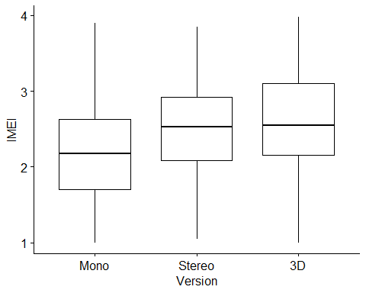

### Outliers

imei_data_long_anova %>% group_by(version) %>% identify_outliers(imei)

## [1] version participant imei is.outlier is.extreme   
## <0 rows> (or 0-length row.names)

### Normality: Shapiro-Wilk Test and QQ-Plots

| Version | Test Statistic | $p$ |
| --- | --- | --- |
| Mono | 0.9791451 | 0.0061678 |
| Stereo | 0.9906810 | 0.2566218 |
| 3D | 0.9843966 | 0.0331309 |

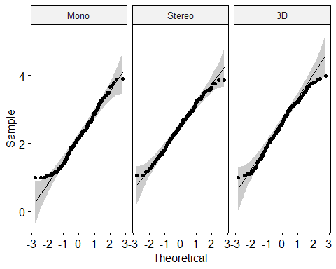

### Mauchly’s Test for Sphericity

| Effect | $W$ | $p$ | $p<.05$ |
| --- | --- | --- | --- |
| version | 0.687 | 0 | * |

| Effect | Grennhouse-Geisser $ϵ$ | df(G-G) | $p$ (G-G) | Huynh-Feldt $ϵ$ | df(H-F) | $p$ (H-F) |
| --- | --- | --- | --- | --- | --- | --- |
| version | 0.762 | 1.52, 287.95 | 0 | 0.767 | 1.53, 289.81 | 0 |

### Results

| Effect | DFn | DFd | $F$ | $p$ | $η_{p}^{2}$ | $η_{G}^{2}$ |
| --- | --- | --- | --- | --- | --- | --- |
| version | 1.52 | 287.95 | 89.882 | < .001 | 0.322 | 0.067 |

## IMEI CLEs

| Format 1 | Format 2 | CLE |
| --- | --- | --- |
| 3D | Stereo | 0.5861 |
| 3D | Mono | 0.7705 |
| Stereo | Mono | 0.7818 |

p_3d <- .88 * prod(imei_cle_table$cle[imei_cle_table$format1 == "3D"]) + .11

Once again using the correction formula for multiple conditions from McGraw & Wong (1992), the CLE for 3D versus Stereo and Mono is 0.5073903.

# References

Corey, D. M., Dunlap, W. P., & Burke, M. J. (1998). Averaging correlations: Expected values and bias in combined pearson *r*s and Fisher’s *z* transformations. *The Journal of General Psychology*, *125*(3), 245–261. <https://doi.org/10.1080/00221309809595548>

Hahn, E. (2018). *Musical emotions evoked by 3D audio. Conference paper*. AES conference on spatial reproduction. <http://www.aes.org/e-lib/browse.cfm?elib=19640>

JASP Team. (2021). *JASP* (Version 16.0.0) [Computer software]. <https://jasp-stats.org/>

Lakens, D. (2013). Calculating and reporting effect sizes to facilitate cumulative science: A practical primer for t-tests and ANOVAs. *Frontiers in Psychology*, *4*. <https://doi.org/10.3389/fpsyg.2013.00863>

McGraw, K. O., & Wong, S. P. (1992). A common language effect size statistic. *Psychological Bulletin*, *111*(2), 361–365. <https://doi.org/10.1037/0033-2909.111.2.361>

Wycisk, Y., Sander, K., Kopiez, R., Platz, F., Preihs, S., & Peissig, J. (2022). Wrapped into sound: Development of the immersive music experience inventory (IMEI). *Frontiers in Psychology*. <https://doi.org/10.3389/fpsyg.2022.951161>