Aureos: Software Validation

**Error Analysis Document**

*B. Ruiz Sabido Bryan F.,  B. Lizarraga Franco Mauro J., B. De la Cruz Ramos Carlos J. & B. Martinez Contreras Yeshua Javier.  Universidad Politécnica de Yucatán, Tablaje Catastral 4448, Carretera Mérida-Tetiz. Km.4.5, 97357 Ucú, Yuc.* *Embedded Systems Engineering. Advanced Programming. November, 2018.*

All rights reserved. Universidad Politécnica de Yucatán. 2018.

**Abstract**

Although software validation is merely ‘right things should be done’, the importance of having a report in which were the errors that unable to achieve in the validation itself. Besides, the requirements that are needed either functional or non-functional, sort up the panorama of the lowest specification needed to be released in the market.

1. REQUIREMENTS MATRIX

|  |  |  |  |
| --- | --- | --- | --- |
| REQUIREMENT | Functional design | Requirement description | DESCRIPTION |
| B1: Camera and sound permissions given by the user. | Required | When opening the application, it must display an advertisement window to the user asking for permissions to allow the app to use the camera on the phone. | **Customer:**  For using the app the customer must agree with the use of the camera and sound of the mobile. |
| B2: Vuforia Database | Required | All the targets must be stored on vuforia’s database. | **Owner:**  The owner must have control of the database in order to change a target or the image displayed. |
| B3: Crossplatform | Required | Aureos must run on both iOS and android operating systems. | **Customer:**  The application must work on both systems and it must have the same behavior on both OS. |
| B4: Support for iOS since 9.0, and iPhone 6s and above. | Required | For iOS operating system, every iPhone must have iOS 9.0 or above. | **Customer:**  For using the application, customers with iOS devices must have iOS 9.0 or above with 2GB RAM (since 6S). |
| B5: Android version since 4.1 and devices with at least 2GB of RAM (for recommended latency stability). | Required | For Android systems, Aureos application must run efficiently. | **Customer:**  For using the application any customer with Android system must have an android version 4.1 or above and with 2 GB of RAM. |
| B6: No logging system to enter the app is required. | Required | Application doesn’t need an account to access. | **Customer:** No customer needs to create an account or login with any kind of account.    **Manager:**  No account is needed. |
| B7: Display proper information from the target. | Function | The target must display the proper file when focusing the camera on it. | **Customer:**  When the customer focuses the cellphone, the camera must display the correct image for the target in focus. |
| B8: Aureos Logo Overview | Required | After taping on the application icon, the Aureos logo must be displayed once. | **Customer:**  Any customer must see the Aureos logo after tap on the icon application. |
| B9: Display MULTIPLE targets | Function | When focusing Cellphone camera with multiple targets, the camera must display each target at the same time without interference. | **Customer:**  If the customer wants to watch two or more targets at the same time, the application must display the correct image for any target when it is focused. |

1. ERROR ANALYSIS REPORT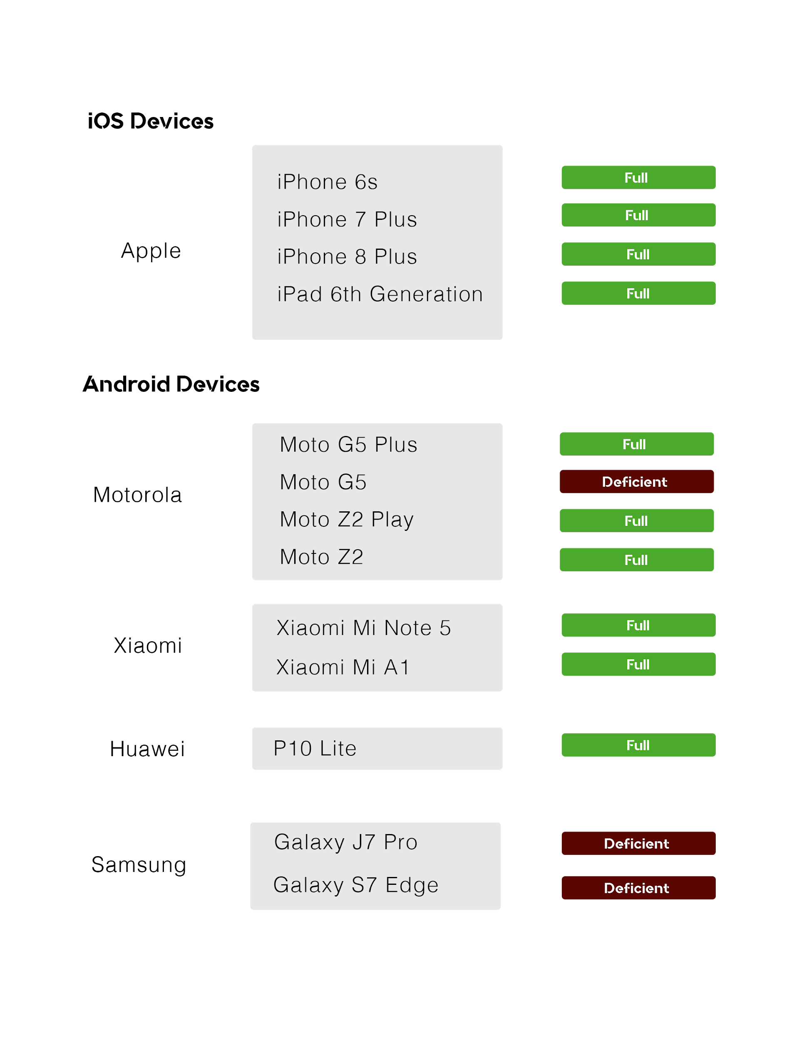

* *Apple devices were running iOS 12 and above.*
* *All Android devices were running Nougat, except on Galaxy S7 Edge.*

1. TEST CASES REPORT

**3.1. Test Cases Description**

* Test Case #1. Check if the music sounds when opening Aureos.
* Test Case #2. Check if the targets display the overview.
* Test Case #3. Attend a notification, then, return to the App.
* Test Case #4. Answer a message from notification while using the App.
* Test Case #5. Display 3 targets.
* Test Case #6. Change quickly the target that is being scanned.
* Test Case #7. The App is tested on the night and with low light.
* Test Case #8. Under the rain.
* Test Case #9. Scan all the targets then put the App in second plane and then return to the App.

**3.2. Statistic Report**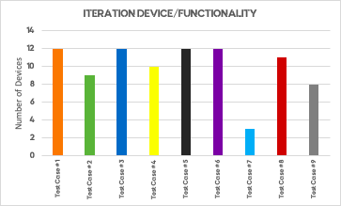

*Chart 1. Iteration Device/Functionality*

As it was shown in the chart above, the amount of devices that succeed in the test case previously defined was quite high. It should be mentioned that there were 4 out of 9 test cases where every device ran as it was expected. Nevertheless, the Test Case #7 was the case with lower success rate by testing Aureos functionality on low light conditions.

**3.3. Photographic Memory** 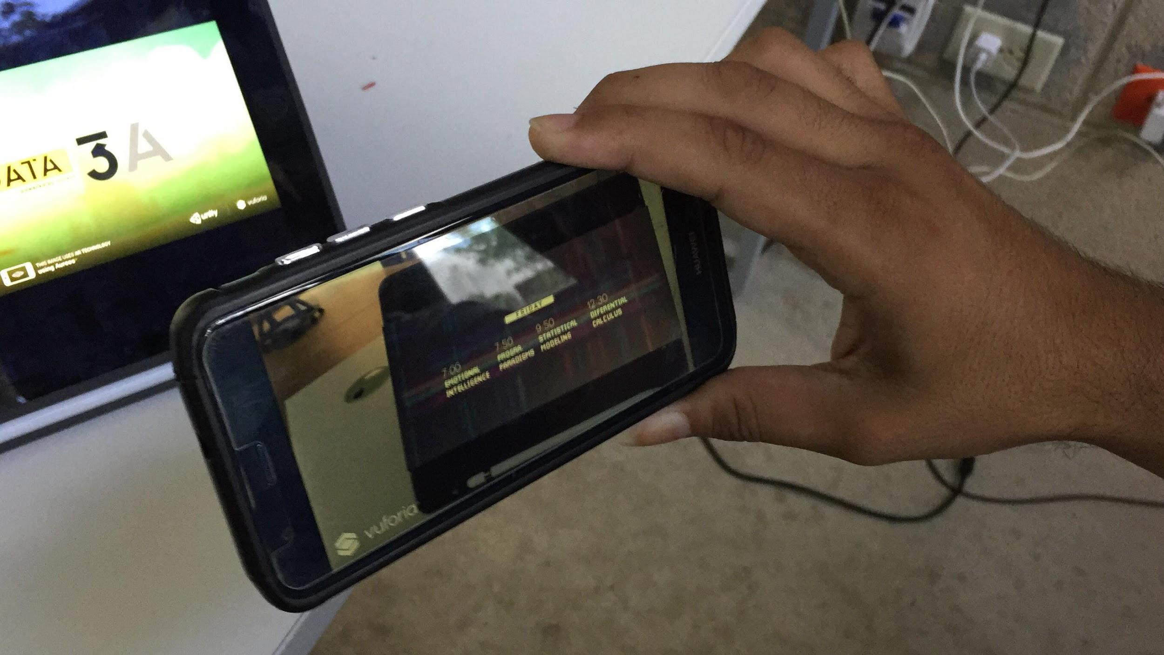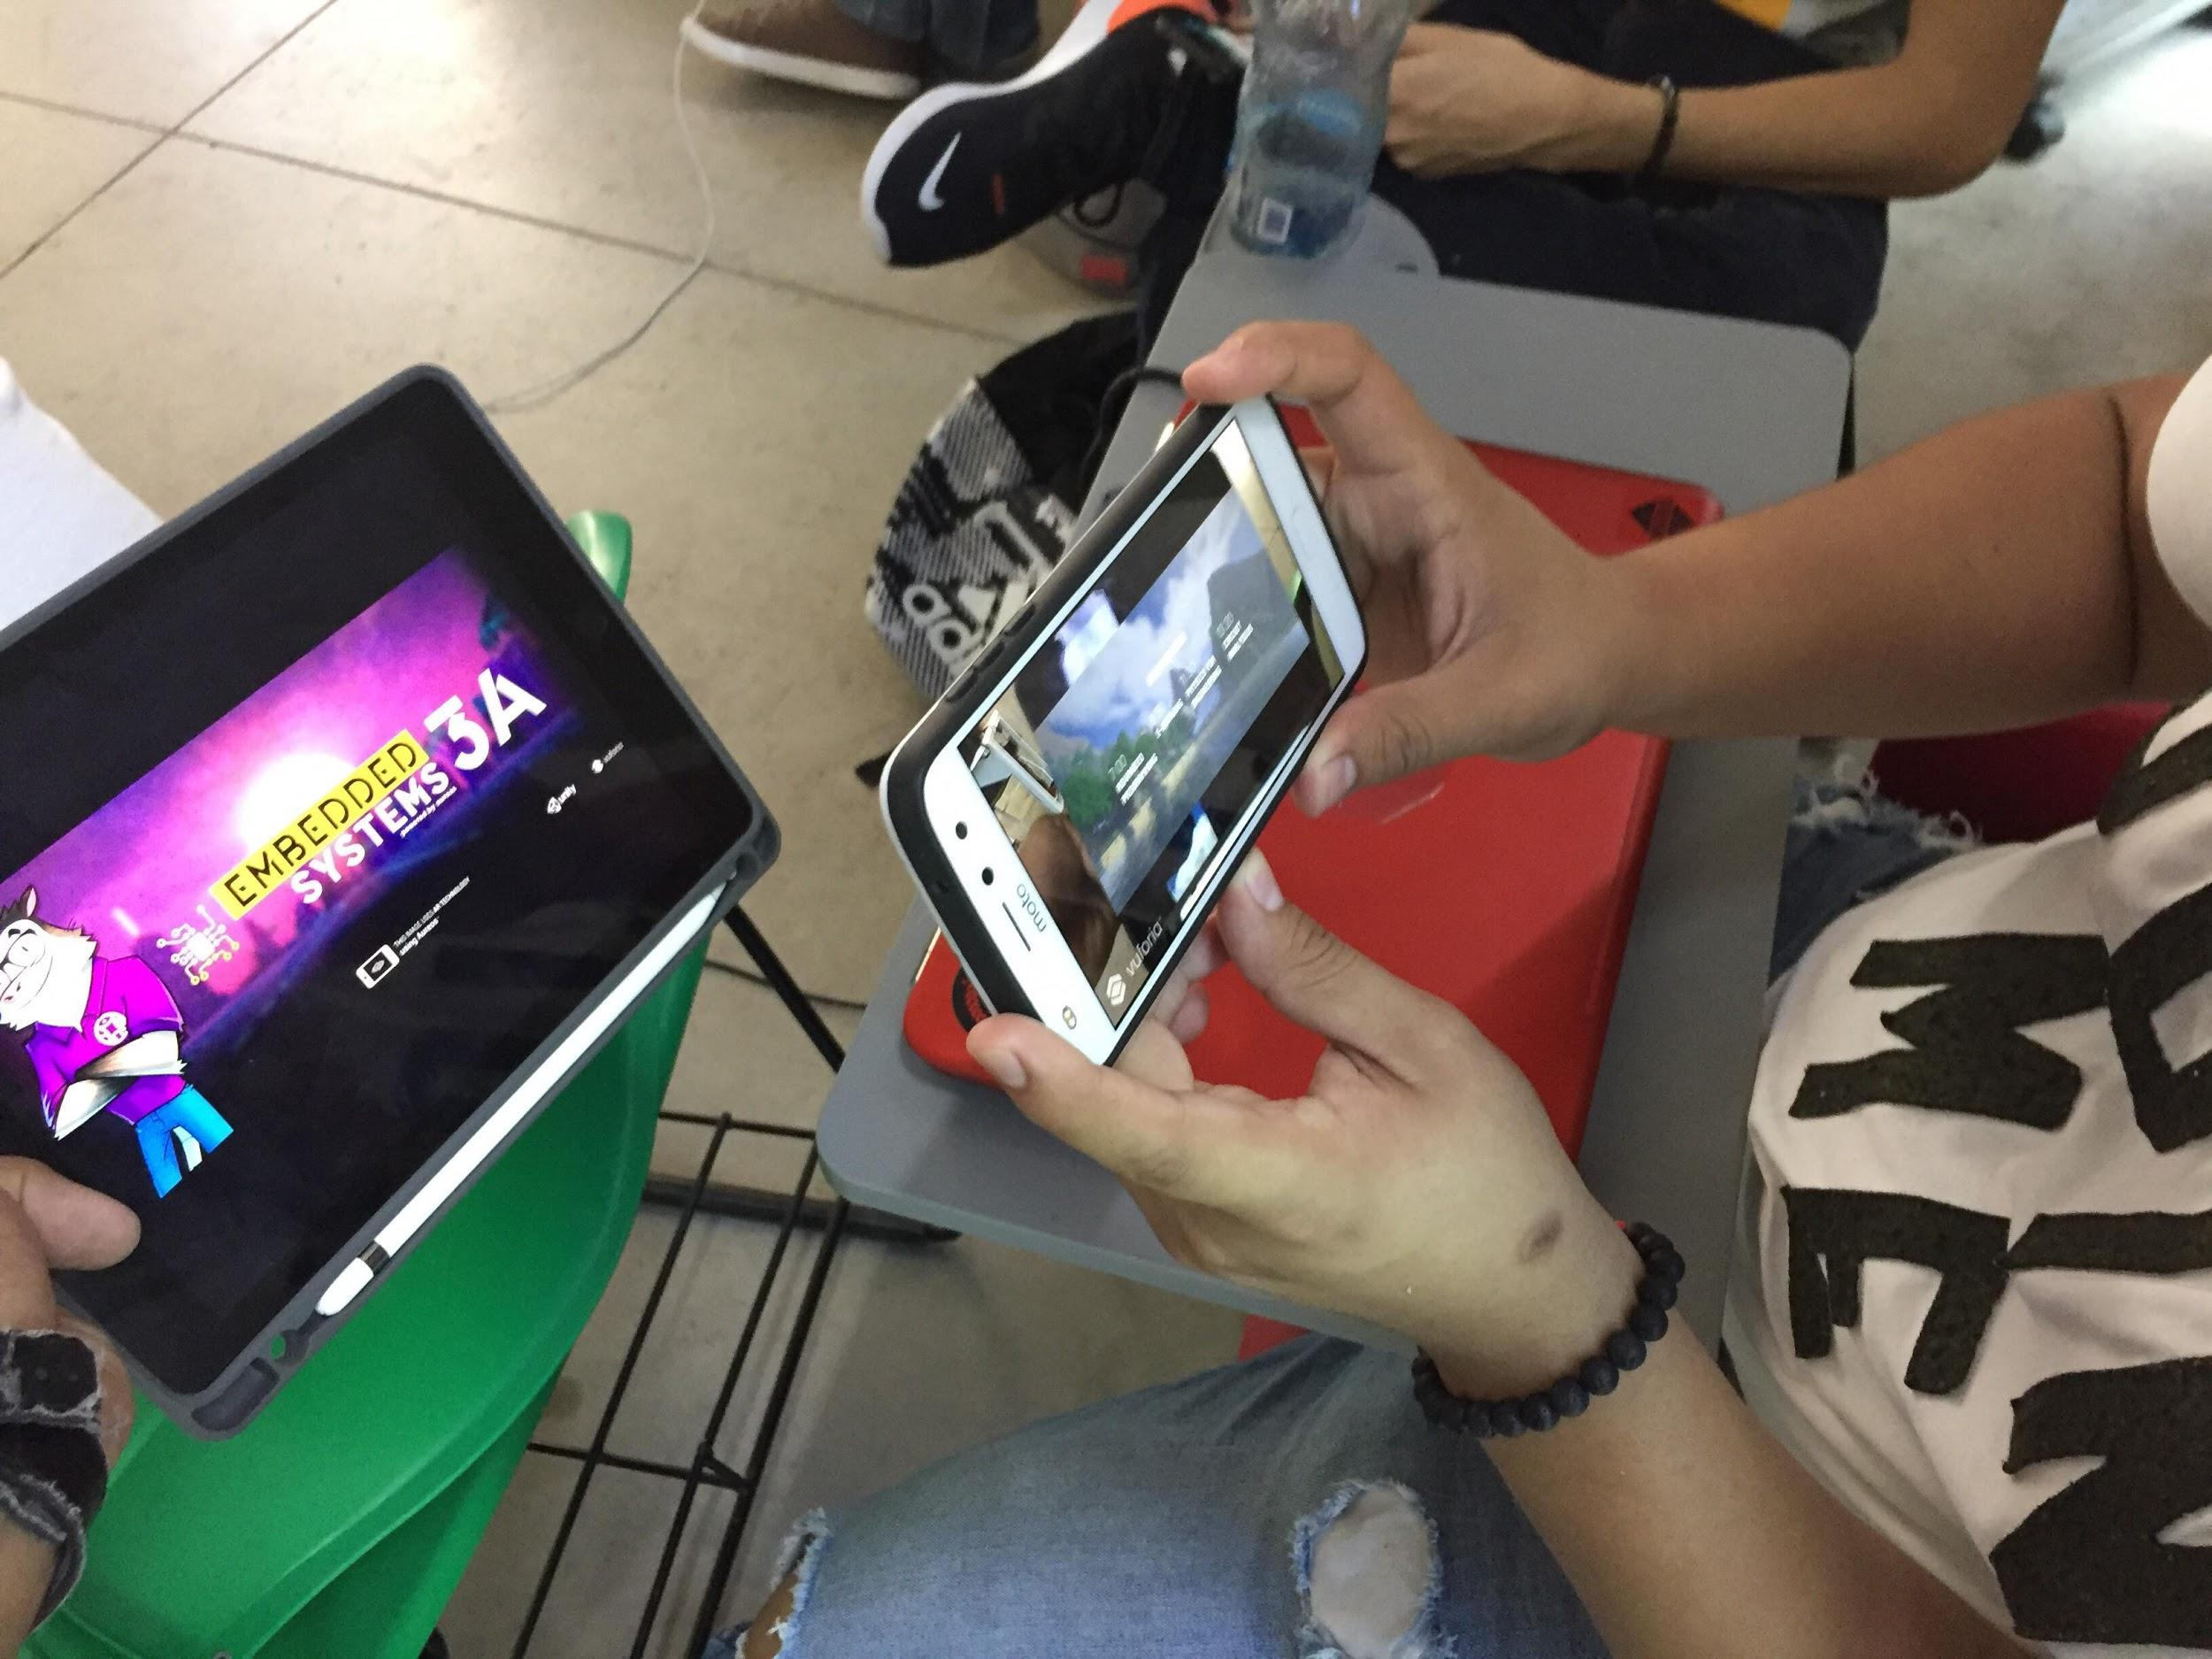

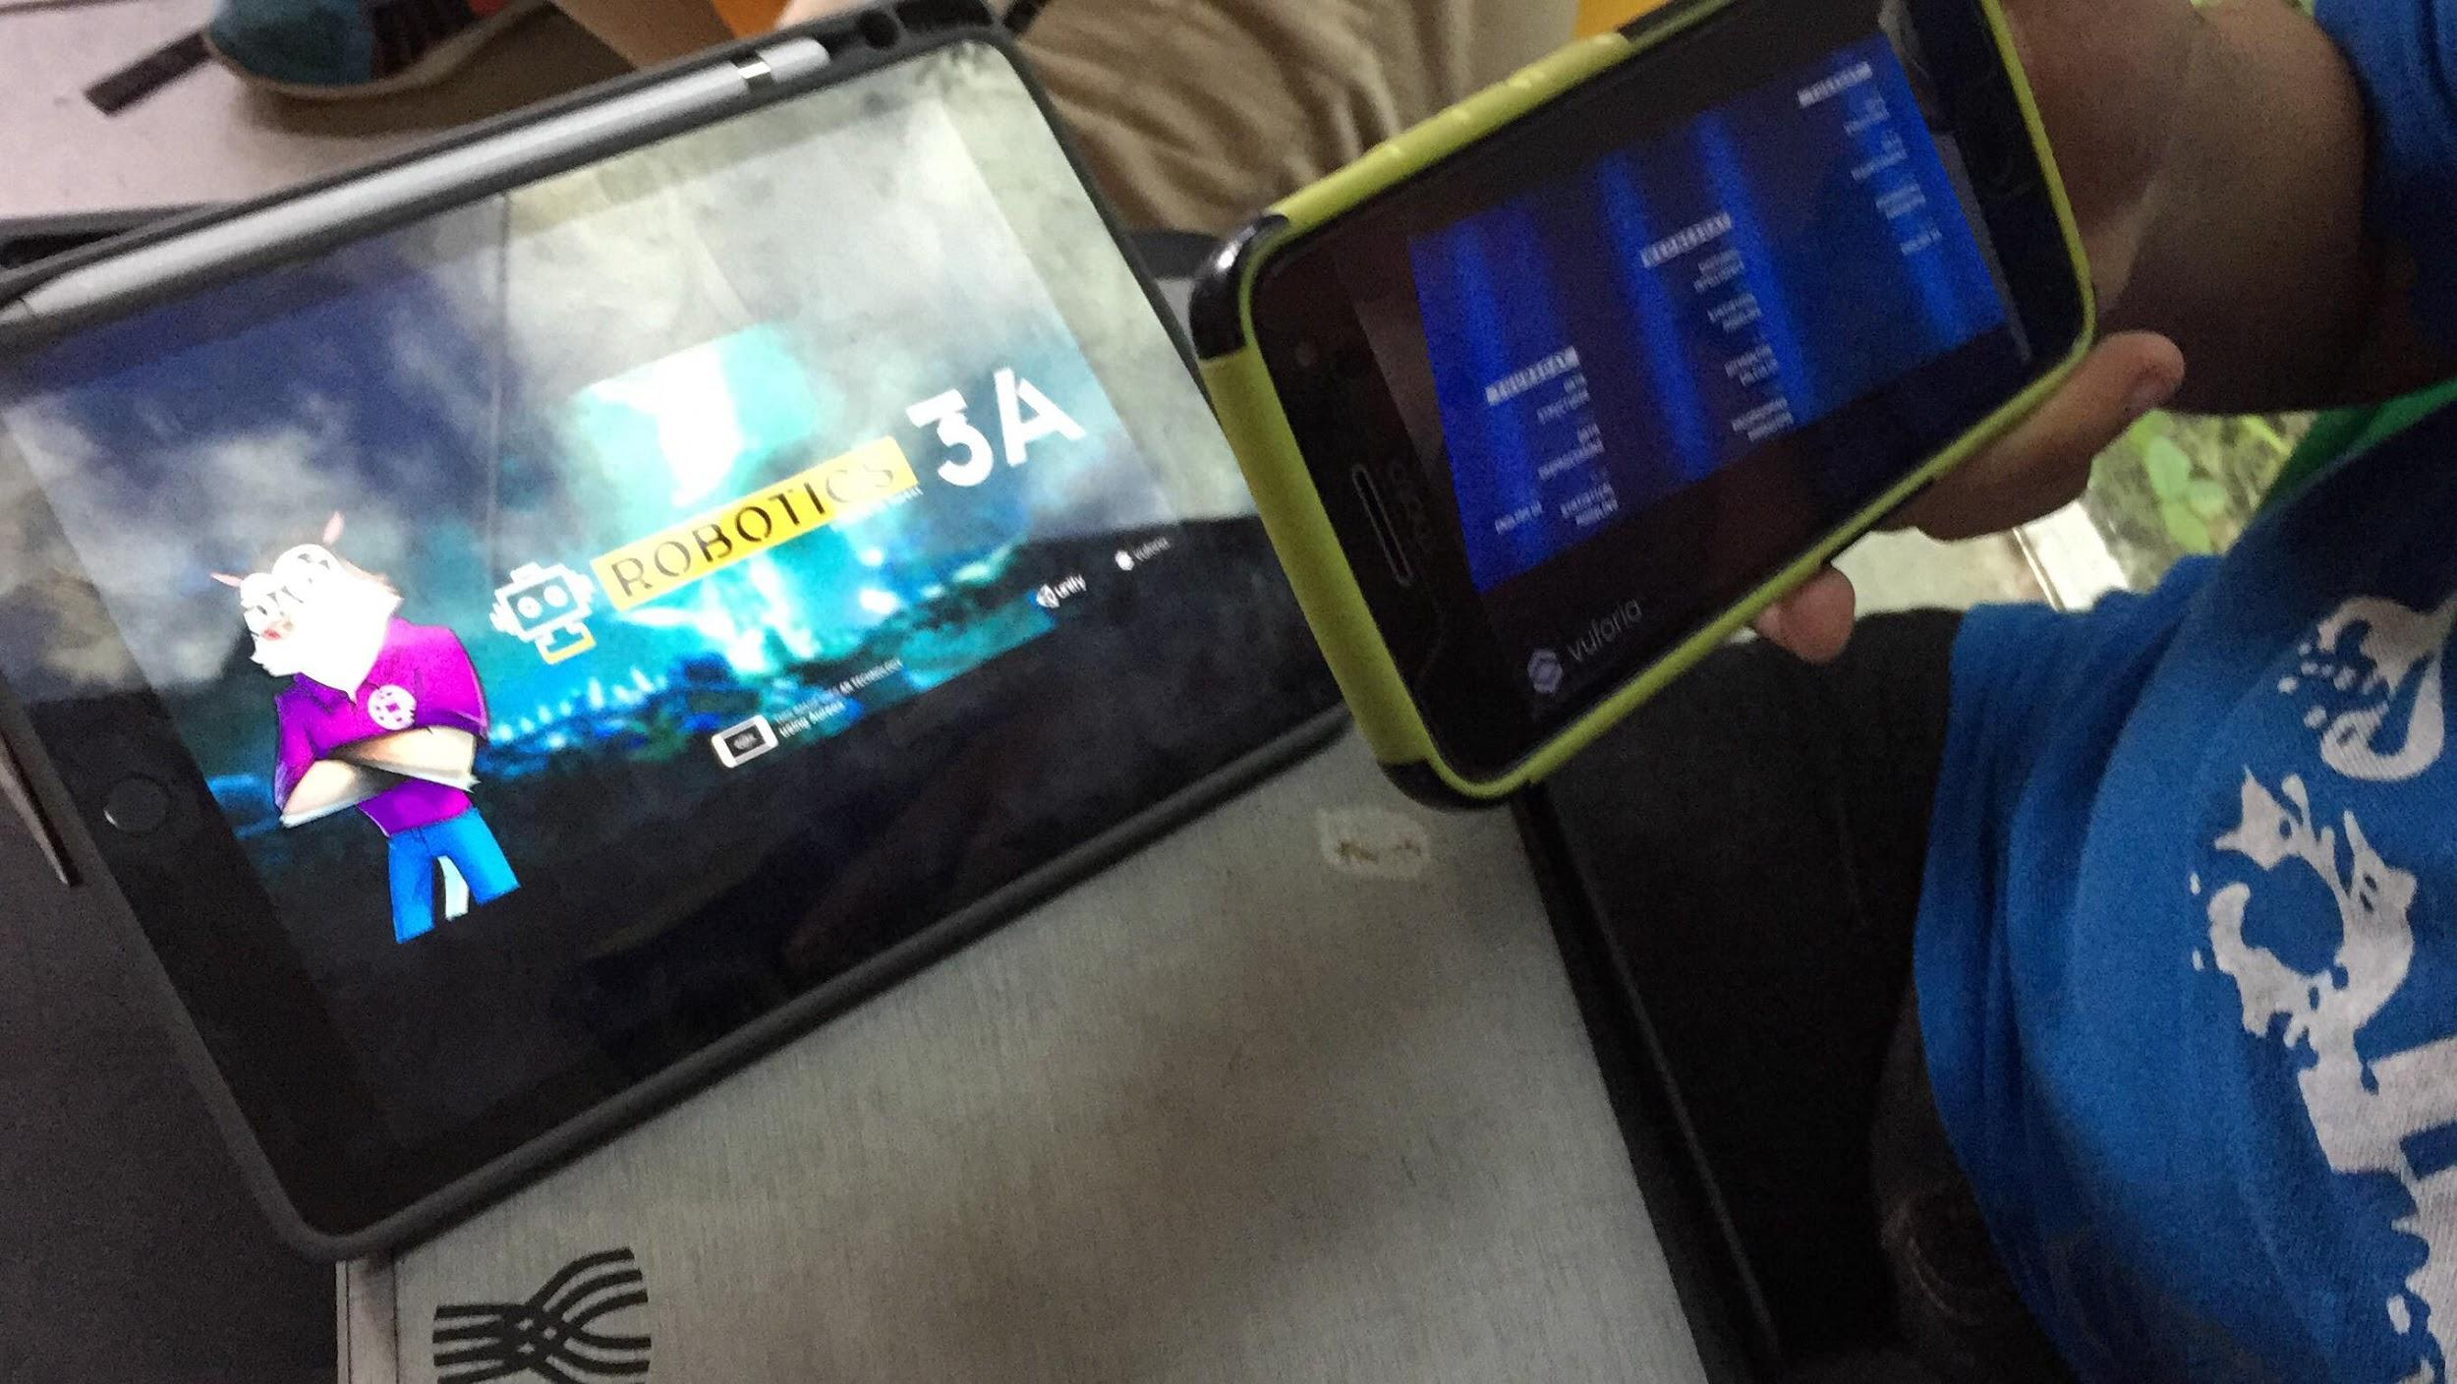

**3.4. Events Binnacle**

**Monday, November 5, 2018**

The design team was figuring out a way to perform the same functionality through cloud storage. Using Dropbox, we did some of the first developer tests.

Through a cloud storage service, in this case, Dropbox, the videos that targets should display are stored in the cloud and not in the app. This way we can make the app weigh less since the displayed videos are streamed from the cloud and not from the app itself.

**Friday, November 9, 2018**

On iOS devices, we tested many devices and the lower and higher devices were iPhone 8 Plus and iPhone 6S. The rest of iOS devices between the mentioned before were also tested during the same lapse. This gave us an idea of the devices that are in the edge of testing. That means Aureos won’t work on devices before iPhone 6S and it will probably have some issues on devices above iPhone 8 Plus.

**Saturday, November 10, 2018**

Although the team developer had set up the different test cases that can be applied through our methodology, they had not been written in the document, yet.

**Wednesday, November 13, 2018**

We had the opportunity with some new devices that we never tested before, those are Motorola and Huawei. Besides, the rainy day that the team faced, made possible to run out the Test Case #8. Data was gathered and some photos were taken as evidence.

1. VALIDATION STANDARD AND EMPLOYEES PERFORMANCE

# 

# **IEEE Std. 1061**

## 

Identification of software quality metrics

Implementation of software quality metrics

Analysis of the results of software metrics

Validation of software quality metrics

**Methodology**

* Scope of quality goals
* Establish quality requirements
* Establish Criteria
* Evaluate quality level
* Detect Anomalies
* Monitor Changes
* Validate system control
* Purpose of the Standard Protocol
* IEEE Std 1061

1. ERROR STATISTIC REPORT

The level of support in devices, either fully functional, partially functional or nonfunctional, collected a considerable amount of data for the system requirements that we can use. As a matter of fact, the iOS devices performed and passed run tests with no issue. On the other hand, Android devices were quite stable in the majority of smartphones. Nevertheless, Samsung phones did an non efficient performance. The results are shown below: 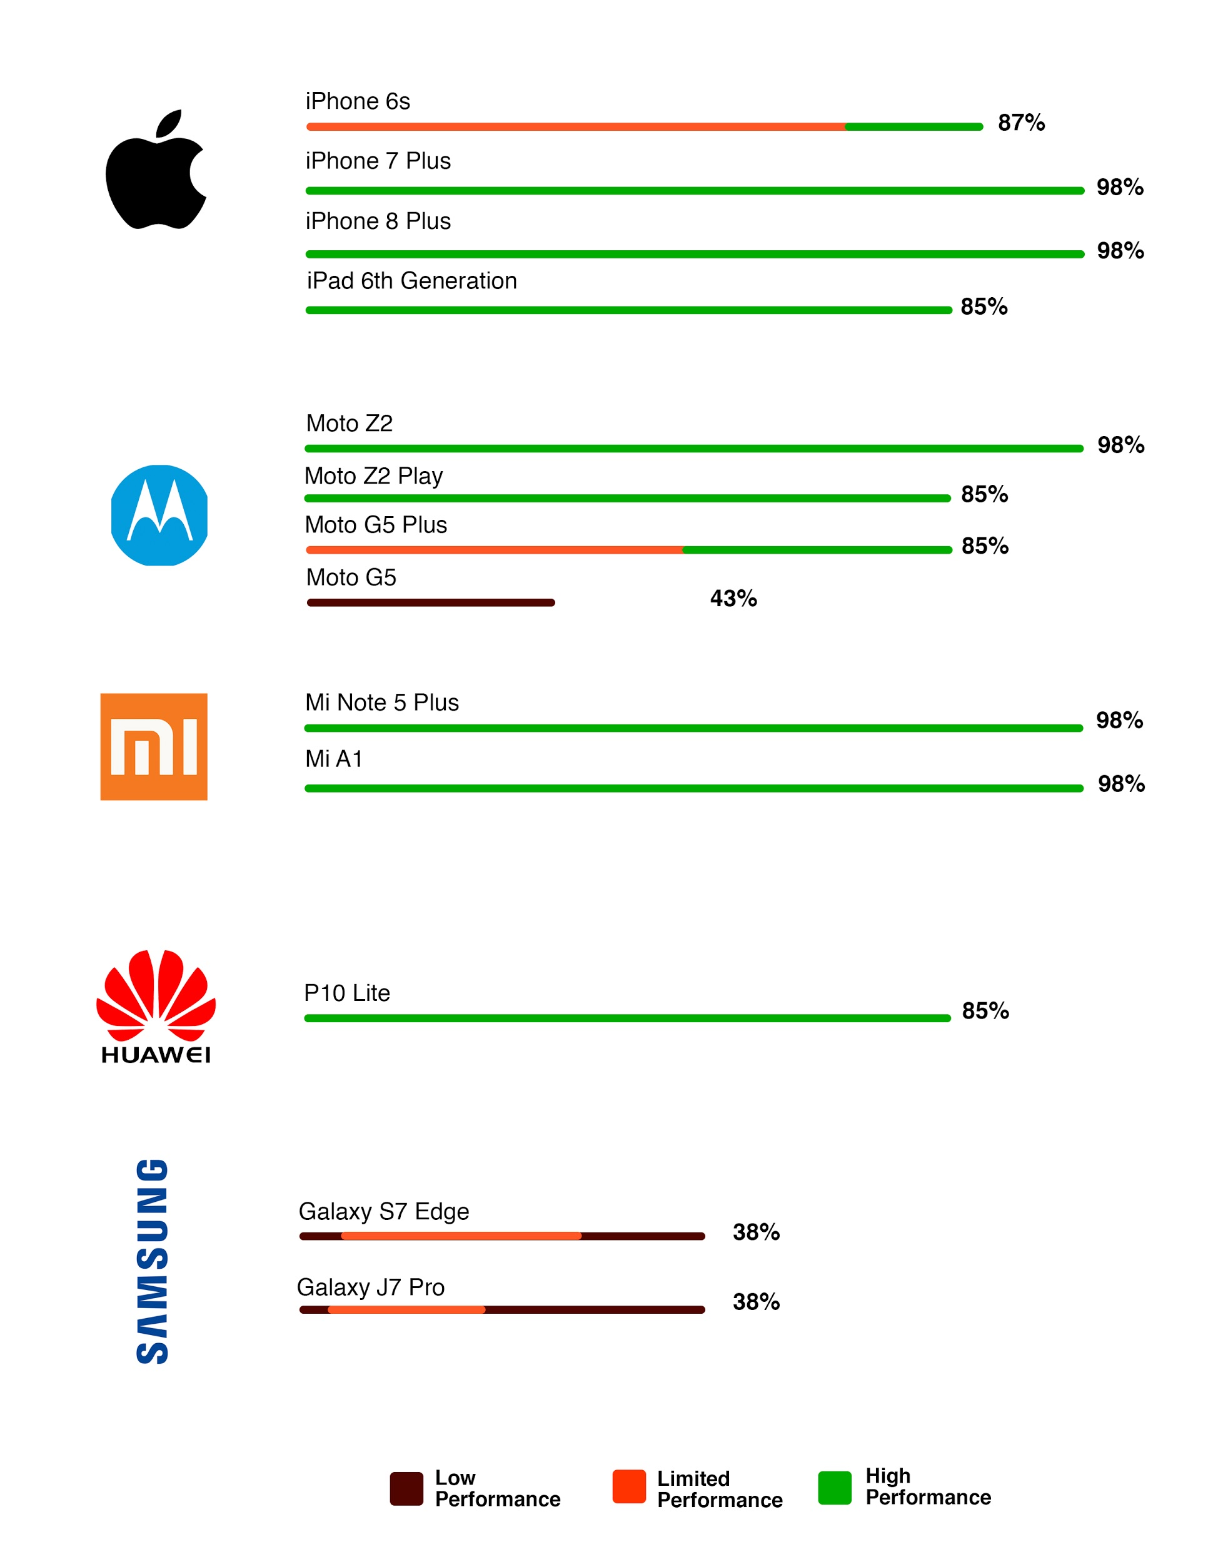



1. TEST RESULTS ANALYSIS

Based on the tests done in several brands of phones, we got the followings percentages: Xiaomi (95% - 98%), iOS (85% - 98%). On Motorola G5 Plus, Moto Z2 Play and Moto Z2: The results were the expected, the targets were displayed so quickly and talking about the part of testing they behaved quite well, and the only different aspect were the specs of the phones, opening the app and returning to it was where the MotoZ 2 had the advantage on speed.

Samsung j7 pro, s7 edge, (and other samsung devices): Here the behavior of the each phone was the same, taking into account devices from the lower gama to the highest one the results were the same, the targets were not displayed by the Aureos app.

