**Rust Quick Reference**

1. **Overview**

**1.1 Characteristics**

* Precompiled just like C.
* zero-cost abstractions: higher-level features that compile to lower-level code as fast as code written manually.
* Includes the official building system & packet manager **Cargo**, allowing the user to control and build dependencies.
* Snake case as the conventional style for function and variable names. In snake case, all letters are lowercase and underscores separate words. E.g. variable_name;

**1.2 Developer tools in Rust**

* **Cargo**: the included dependency manager and build tool, makes adding, compiling, and managing dependencies painless and consistent across the Rust ecosystem.

Cargo has a mechanism that ensures you can rebuild the same artifact every build (Cargo.TOML). Cargo will use only the versions of the dependencies you specified until you indicate otherwise. To ignore manual versions, use cargo update which will update dependencies to latest versions.

* **Rustfmt**: ensures a consistent coding style across developers.
* The Rust **Language Server**: powers Integrated Development Environment (IDE) integration for code completion and inline error messages.
* **Crate**: collection of Rust source code files (Basically a library).
* The ***Prelude*** is a list of functionalities that Rust imports into every program, it includes traits of fundamental types, destructors and overloading, heap allocation, ownership, clone, comparison traits, generic conversions, iterators, heap allocated strings and vectors.

**1.3 Fields on Rust**

Command line tools, web services, DevOps tooling, embedded devices, audio and video analysis and transcoding, cryptocurrencies, bioinformatics, search engines, Internet of Things applications, machine learning, and even major parts of the Firefox web browser.

1. **Rust Fundamentals**
   1. **Variables**

let -> Creates a variable.

**{}**  -> Curly brackets are the format specifiers (called % in C) of Rust. In Rust they are just a place holder.

E.g. println! ("x = {} and y = {}", x, y);

**Conversion**

Rust will not automatically try to convert non-Boolean types to a Boolean, it must be explicit and provide a Boolean value for safety. Note that if doesn’t require parenthesis.

E.g. let number = 3;

if number { println!("number was three"); }//expected bool, found integer

2.1.1 Data Types

Rust is a statically typed language, which means that it must know the types of all variables at compile time. The compiler can usually infer what type we want to use based on the value and how we use it. In cases when many types are possible, such as when we converting a String to a numeric type using parse, we must add a type annotation.

E.g. let number = 13; //implicit data type

let number: i32 = 13; //explicit data type

|  |  |  |
| --- | --- | --- |
| **Integer Types** | | |
| **Length** | **Signed** | **Unsigned** |
| 8-bit | i8 | u8 |
| 16-bit | i16 | u16 |
| 32-bit | i32 | u32 |
| 64-bit | i64 | u64 |
| 128-bit | i128 | u128 |
| arch | isize | usize |

Rust’s **char** type is four bytes in size and represents a Unicode Scalar Value, which means it can represent a lot more than just ASCII.

2.1.2 Arrays vs Vectors

Arrays are useful when you want your data allocated on the stack rather than the heap or when you want to ensure you always have a fixed number of elements. E.g. let a: [i32; 5] = [1, 2, 3, 4, 5]; //array with type

An array isn’t as flexible as the vector type, though. A vector is a similar collection type provided by the standard library that is allowed to grow or shrink in size

**Tuple**

A tuple is a general way of grouping together a number of values with a variety of types into one compound type. Tuples have a fixed length: once declared, they cannot grow or shrink in size.

E.g. let tup: (i32, f64, u8) = (500, 6.4, 1);

**Shadowing:** Shadowing lets us reuse variables with same name, rather than forcing us to create two unique variables. The second variable’s value is what appears when the variable is used. It’s also possible to change the type of the variable since we’re effectively creating a new variable. E.g. let x = 5; let x = x + 1; // x=6

* 1. **Traits**

--**mut**: Assigns mutable (modifiable, non-static content) attribute. In Rust variables are **immutable** by **default** in order to enforce safety and easy concurrency. E.g.: let mut guess = 5;

--**match:** allows us to compare a value against a series of patterns and then execute code based on which pattern matches. Returns an enum with 3 possible values: Less, Greater, Equal.

E.g. match number1.cmp(&number2) {

Ordering::Less => println!("Number 1 is smaller"),

Ordering::Greater => println!("Number 1 is larger!") }

--**const**: constants are ALWAYS immutable. Furthermore, constants require annotated type and can only be set to a constant expression computed in compile time. const MAX_POINTS: u32 = 100_000;

* 1. **Compiling**

|  |  |
| --- | --- |
| Instruction | Description |
| Cargo new {name} | Generates the packet manager folder for Cargo to manage your rust project |
| Cargo build  --release | Compiles rust program.  Compiles with optimizations (superfast code however is slower compilation time) |
| ./target/debug/{Cargo_File} | Creates executable of the cargo project on the target |
| Cargo run |  |
| Cargo check | Check correct compiling without producing an executable (speed-up the process) |
| Use | Import library |

Figure 2.3.1 Compiling your project

* 1. **Input/output**

println!() -> Macro to print a string on screen.

* 1. **Strings**

The String type is the most common type that has ownership over the contents of the string. Growable and UTF-8 encoded.

* 1. **Functions & Methods**

**Functions**

Rust doesn’t care where you define your functions, only that they’re defined somewhere (unlike C, where you must define a function before use it).

In function signatures, you must declare the type of each parameter, this means in the annotated form. E.g. fn example_function(x: i32, y: i32){

println!(“value of x is: {}”, x) …}

Functions with returning values:

Return type goes after an arrow (**->**). Functions can return early by using the return keyword and specifying a value, but most functions return the last expression implicitly, by not adding semicolon (this means that this is the return value).

fn plus_one(x: i32) **->** i32 { x + 1 } //no semicolon on x + 1

plus_one(5); //6

**Methods**

**object::method**() -> ´´method´´ is an associated function of an object type (static method).

E.g.: let guess = String::new(); //method that creates a new instance of a String

instance::method.submethod() -> Calls sub-method on method handle. E.g.: io::stdin().read_line();

* 1. **Failures**

Result types are enumerations. For Result, the variants are Ok or Err. The Ok variant indicates the operation was successful, and inside Ok is the successfully generated value. The Err variant means the operation failed and Err contains information about how or why the operation failed. The purpose of these Result types is to encode error-handling information.

E.g.: .expect(“failed”) -> Expect Unwraps a result, yielding the content of an [Ok](https://doc.rust-lang.org/std/result/enum.Result.html#variant.Ok). Otherwise panics and includes message and content of Err.

* 1. **Scope {}**
  2. **Loops**

|  |  |  |
| --- | --- | --- |
| **For** | **While** | **Loop** |
| Increased safety of the code and eliminated the chance of bugs that might result from going beyond the end of the array or not going far enough and missing some items. | Useful to evaluate a condition within a loop. However, is slower because the compiler adds runtime code to perform the conditional check on every element on every iteration through the loop. | Executes a block of code over and over again forever or until you explicitly tell it to stop. |

1. **Stack & Heap**

**Stack-allocated data has a known, fixed size**. Data with an **unknown size at compile time or a size that might change must be stored on the heap instead.** The heap is less organized: when you put data on the heap, you request a certain amount of space. The operating system finds an empty spot in the heap that is big enough, marks it as being in use, and returns a pointer, which is the address of that location. This process is called allocating on the heap and is sometimes abbreviated as just allocating. Pushing values onto the stack is not considered allocating. Because the pointer is a known, fixed size, you can store the pointer on the stack, but when you want the actual data, you must follow the pointer.

1. **Ownership**

All programs have to manage the way they use a computer’s memory while running. Some languages have garbage collection that constantly looks for no longer used memory as the program runs; in other languages, the programmer must explicitly allocate and free the memory. Rust uses a third approach: memory is managed through a system of ownership with a set of rules that the compiler checks at compile time. None of the ownership features slow down your program while it’s running.

### 4.1 [Ownership Rules](https://doc.rust-lang.org/book/ch04-01-what-is-ownership.html#ownership-rules)

* Each value in Rust has a **variable** that’s called its **owner**.
* There can only be **one** owner at a time.
* When the **owner** goes **out of scope**, the value will be dropped hence the memory is freed.

Note: Ownership rules applies to variable as well as functions.

**4.2 Interacting with data: Move if Heap, Copy if Stack,**

Rust will never automatically create “deep” copies of your heap allocated data. Instead Rust performs a “move” operation, on which:

* Stack-allocated Data is Copied with an internal clone.
* Heap-allocated Data copies just the reference to the same location.
* Previous variable is **invalidated.**

This way, the previous owner will not try to drop memory when goes out of scope because it’s invalid; the new owner will now oversee the value dropping. In the next example, known size values like length and capacity are stored on the Stack so they are copied and dynamic values like String data is allocated on heap so only the pointer is copied as shown on F4.1.1.

let s1 = String::from("hello"); //String stores some values on **Heap** and some on **Stack**

let s2 = s1; //s1 is now invalid for safety. Now S2 has ownership

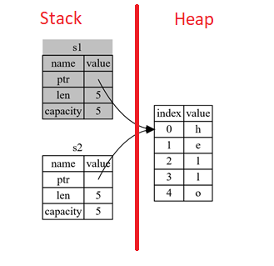

F4.1.1 Representation in memory after s1 has been invalidated.

|  |  |
| --- | --- |
| Ownership in functions | |
| Pass **copy** | Pass **ownership** |
| // x is created on stack  let x = 5;  // x (i32) is Copied into function  makes_copy(x);  //x is still valid here | // s is created on the heap  let s = String::from("hello");  //s pass ownership to the function...  take_ownership(s);  //s is no longer valid here |

1. **Reference (&) and borrowing**

**& ->** Get memory address: operator that gets the memory address (in hexadecimal) of a piece of data.

**5.1 The Rules of References**

* At any given time, you can have *either* one mutable reference *or* any number of immutable references.
* References must always be valid.

**5.2 Borrowing**

It’s also possible to use a value without taking ownership, by using references (&), we call having references as function parameters **borrowing**. The scope in which the variable is valid isn’t affected by the borrowing variable/function, so we don’t have to drop what the reference points to when it goes out of scope because we **didn’t had ownership** in the first place.

let s1 = String::from("hello");

let len = calculate_length(&s1);

fn calculate_length(s: &String) -> usize { s.len()}

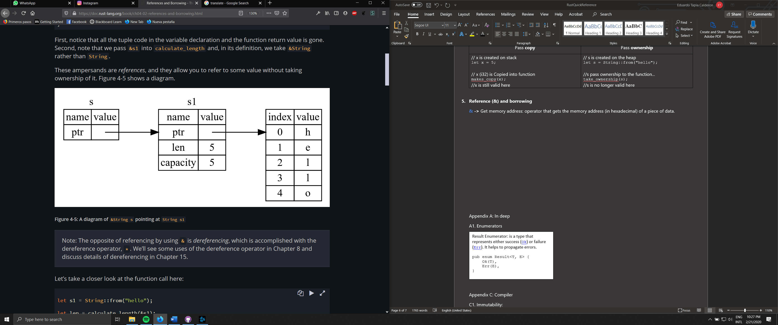

5.1.1 Function borrowing variable s1

**5.3 Mutable references**

Note that references are immutable by default, to create a mutable reference, just add &mut s trait.

A big restriction on mutable references is that you can have **only ONE mutable reference** to a value in the **same scope** also is not possible to have mutable and immutable references in the same scope. This restriction allows mutation in a very controlled fashion, avoiding race conditions, simultaneous access to the same piece of data, synchronization problems and sudden changes.

**5.4 Dangling references**

if you have a reference to some data, the compiler will ensure that the data will not go out of scope before the reference to the data does, at compile time!.

**5.5 Slice Type**

Slices let you reference a contiguous sequence of elements in a collection rather than the whole collection. Slice method from in String tracks a starting and an ending index. E.g.

let s = String::from("hello world");

let hello = &s[0..5];

let world = &s[6..11];

**Slice Program:** write a function that takes a string and returns the first word it finds in that string

fn first_word(s: &String) -> &str {

let bytes = s.as_bytes();

for (i, &item) in bytes.iter().enumerate() {

if item == b' ' {

return &s[0..i]; } }

&s[..] }

Appendix A: In deep

A1. Enumerators

Result Enumerator: is a type that represents either success ([Ok](https://doc.rust-lang.org/std/result/enum.Result.html#variant.Ok)) or failure ([Err](https://doc.rust-lang.org/std/result/enum.Result.html#variant.Err)). It helps to propagate errors.

pub enum Result<T, E> {

Ok(T),

Err(E),

}

Appendix C: Compiler

C1. Immutability:

The compiler guarantees that when you state immutable variables, the value really won’t change. This is done by getting compiler errors.

Note that mutating an instance in place is faster than copying and returning newly allocated instances.