**Practice 3: Temperature sensor reporting via UART**

1. **Objective**

Read temperature via lm35 sensor and report the sensor status to the console via UART. The sensor status must be reported each 0.5s using interrupts. There should be 2 thresholds for the temperature and 1 LED per threshold shall show the status of each threshold. Finally create a user configuration mode to permit the user to change the threshold values.

1. **Requirements**

ADC sampling every 0.1s.

Allow the user to enter a configure mode to customize thresholds.

Print LED status every 0.5 s only if the user does not enter to configuration mode.

Show if the thresholds have been reached via LEDs.

1. **Development**

★ **2.1 ADC triggering and temperature reading**

Read lm35 temperature values and set 2 thresholds to indicate that the sensor has reached upper or lower limits of temperature(28º and 24º C respectively). A LED must indicate that upper or lower limit has been reached.

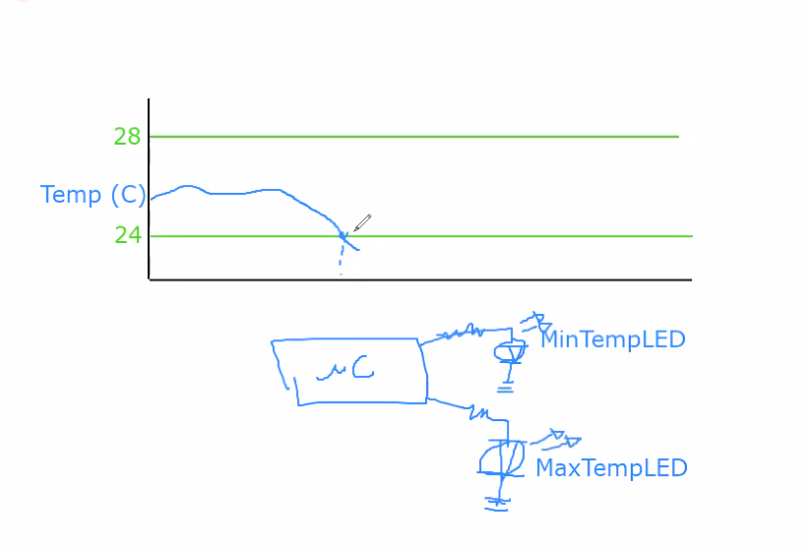

Figure 1.1. lm35 triggering points

As usual the first thing to do is to enable ADC1,2 module (connected to APB2) by setting up ADC prescaler and ADCCLK as shown in the clock tree.

The configuration of ADCCLK is given by the cascade:

HSI clk = 8MHz.

AHB preescaler = HSI/1.

APB2 prescaler = AHB/1.

ADCPRE -> APB2 / 2 => ADCclk = **4MHz**.

Also, don’t forget to enable ADC interface.

**Interrupts and events**

Interrupts are handled via Nested Vectored Interrupt Controller (NVIC). Search for section 10.1.2 Interrupt and exception vectors to lookup your interruption.

**ADC**

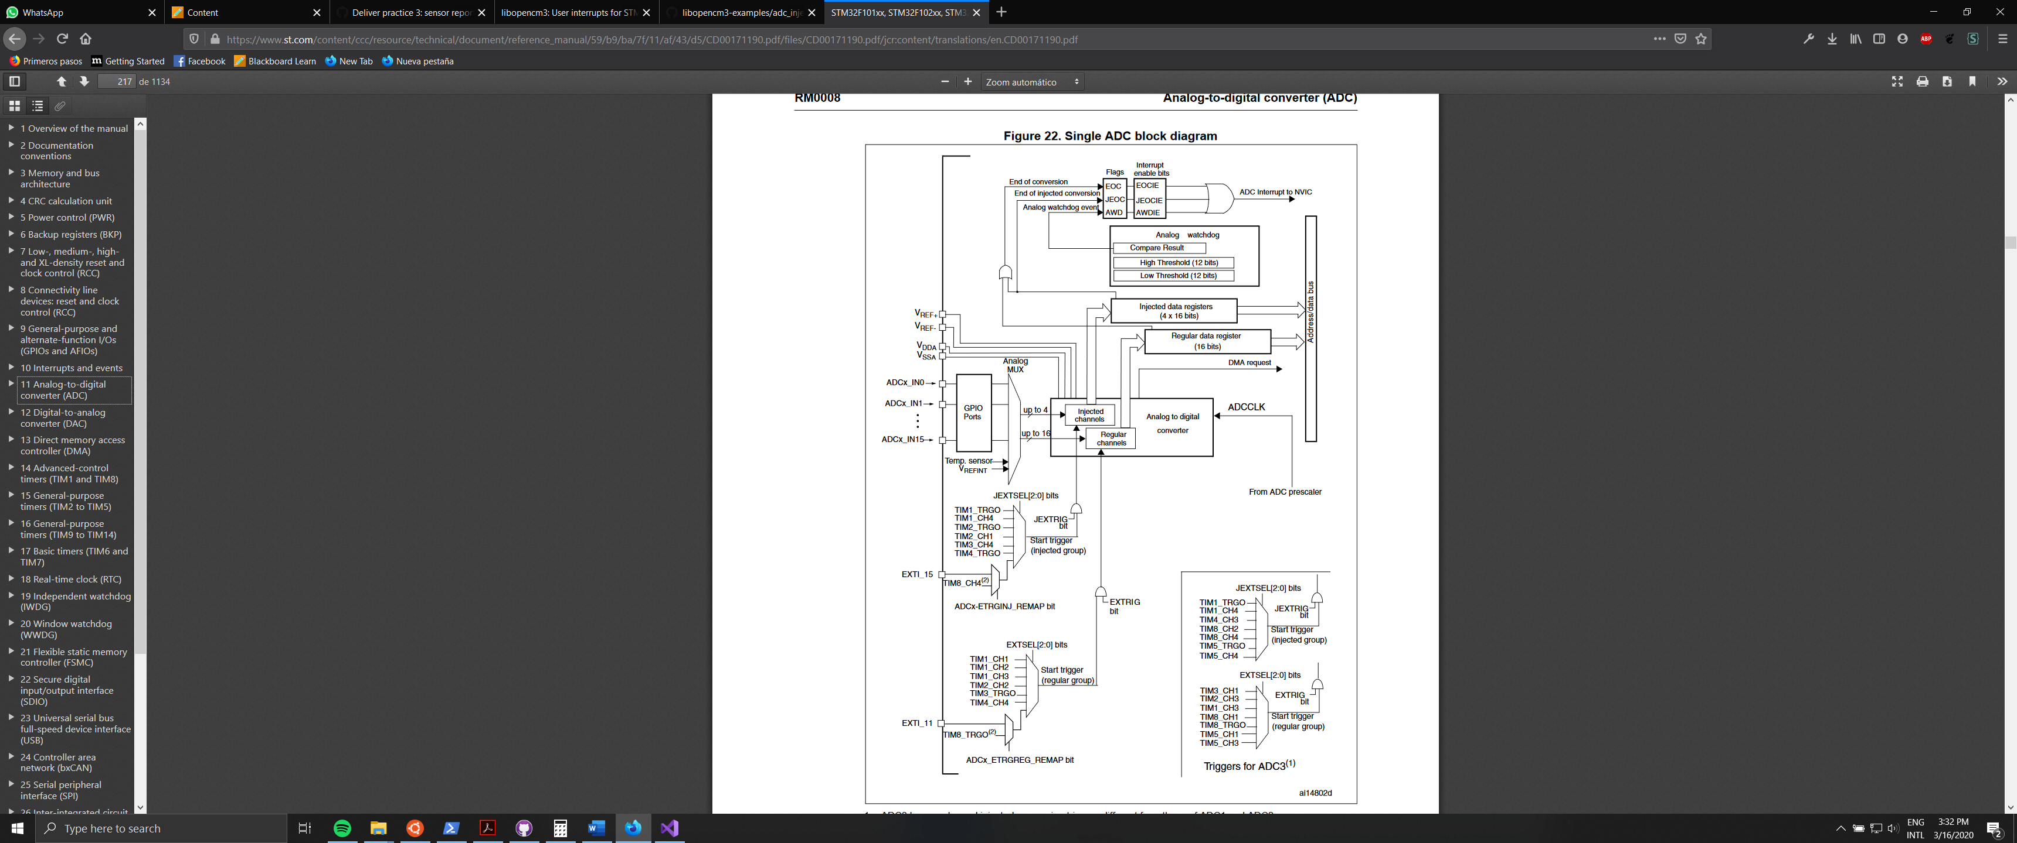

11.3.4 Single conversion mode(regular)

In Single conversion mode the ADC does one conversion. This mode is started by

setting the **ADON** bit in the ADC_CR2.

Once the conversion of the selected channel is complete:

• since I choose a regular channel:

– The converted data is stored in the 16-bit **ADC_DR** register

– The **EOC** (End Of Conversion) flag is set

– and an interrupt is generated if the **EOCIE** is set.

11.5 Data alignment

**ALIGN** bit in the ADC_CR2 register selects the alignment of data stored after conversion.

Data can be left or right aligned.

11.6 Channel-by-channel programmable sample time

ADC samples the input voltage for a number of ADC_CLK cycles which can be modified using

the **SMP**[2:0] bits in the ADC_SMPR. Example: With an ADCCLK = 14 MHz and a sampling time of 1.5 cycles: Tconv = 1.5 + 12.5 = 14 cycles = 1 μs

In our case, ADCCLK = 4 MHz, sampling time set to 3.5us(using default 1.5 cycles).

11.11 ADC interrupts

An interrupt can be produced on end of conversion for regular.

★ **2.2 UART communication**

Connect the microcontroller to the computer via UART making use of the UART2USB converter. Generate an interruption each time the user writes a character and send the same character to console.

★**2.3 Integration: temperature reporting on GUI using UART**

As shown in Figure 2, print sensor status every 0.5s into console(via UART). The status message should be formatted as: “Temp:25C, MaxTempTh: 28C, MinTempTh: 24C, MaxTemp: Off, MinTemp: Off” 