Problem 1:

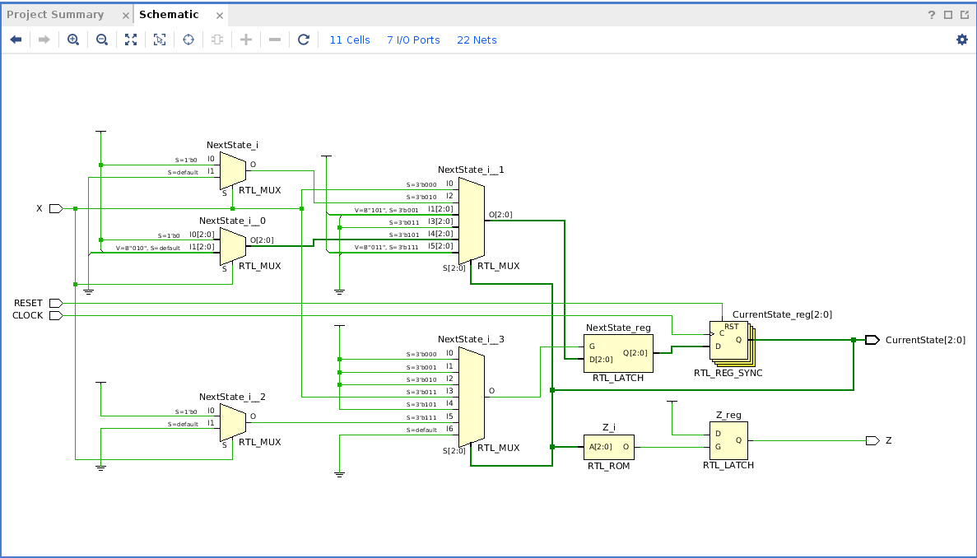
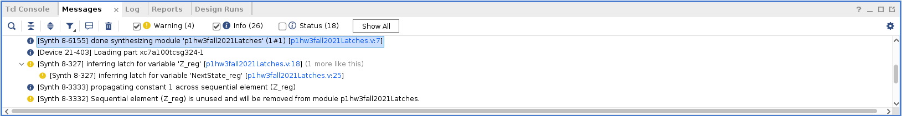
Latches were created because the output logic only specifies that Z is 1 in state 1010 and does not include an else to set Z back to zero. This is the same reasoning for the latch created for the next state variable as well as it is missing a couple else statements and has no default case for the switch statement. A solution to the problem is adding these else statements and a default case for the switch statement.
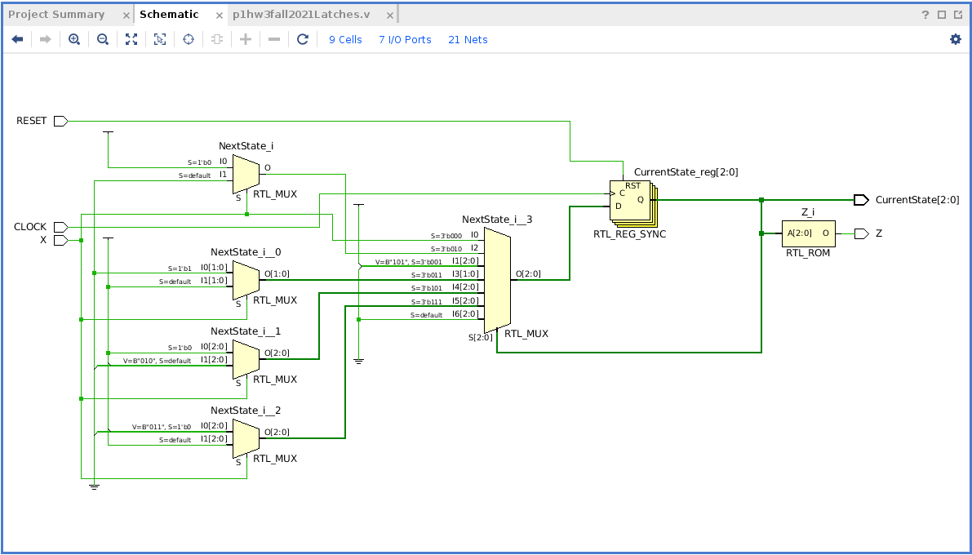
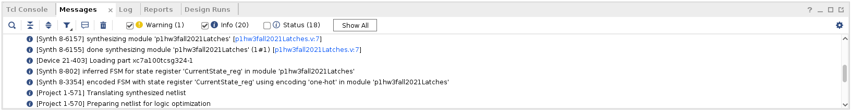

`timescale 1ns / 100ps
// File name : p1hw3fall2021Latches.v
// Jianjian Song
//ECE433 Fall 2021
// Verify this circuit has latches

module p1hw3fall2021Latches(input X, RESET, CLOCK,
output reg Z,
// State variables
output reg [2:0] CurrentState);
reg [2:0] NextState;

// State codes
parameter State1=0, State0=1, State011=2, State01=3, State10=5, State1010=7;

// Output logic
always @ (CurrentState)
if (CurrentState == State1010) Z <= 1; else Z <= 0;

// State registers
always @ (posedge CLOCK)
if (RESET==1) CurrentState <= State1; else CurrentState <= NextState;

always @ (CurrentState, X)
case (CurrentState)
State1: if (X==1) NextState <= State0; else NextState <= State1;
State0: if (X==1) NextState <= State10; else NextState <= State10;
State011: if (X==0) NextState <= State0; else NextState <= State1;
State01: if (X==1) NextState <= State1; else NextState <= State01;
State10: if(X==0) NextState <= State1010; else NextState <= State011;
State1010: if(X==0) NextState <= State01; else NextState <= State1010;
default: NextState <= State1;
endcase

endmodule

Problem 4:
`timescale 1ns / 1ps

//name: skyler Cleland
//cm: 2284
//date: 2021-11-27
//ece433hw3p4

module p4hw3ece433counter #(parameter Bit_length=5, StartCount=6, EndCount=22)(
input [1:0] control,
input CLK,
input RST,
output reg [Bit_length-1:0] counter
);
reg [Bit_length-1:0] nextCnt;

always @ (posedge CLK or posedge RST) begin
if(RST==1) counter <= StartCount; else counter <= nextCnt;
end

always @ (control, counter) begin
case(control)
0:case (counter)
EndCount:nextCnt <= StartCount;
default: nextCnt <= counter + 1;
endcase
1:case (counter)
31: nextCnt <= 0;
EndCount: nextCnt <= StartCount;
EndCount-1: nextCnt <= StartCount;
default: nextCnt <= counter + 2;
endcase
2:case (counter)
31: nextCnt <= 0;
30: nextCnt <= 0;
EndCount: nextCnt <= StartCount;
EndCount-1: nextCnt <= StartCount;
EndCount-2: nextCnt <= StartCount;
default: nextCnt <= counter + 3;
endcase
3:case (counter)
StartCount: nextCnt <= EndCount;
StartCount+1: nextCnt <= EndCount;
default: nextCnt <= counter - 2;
endcase
endcase
end

endmodule

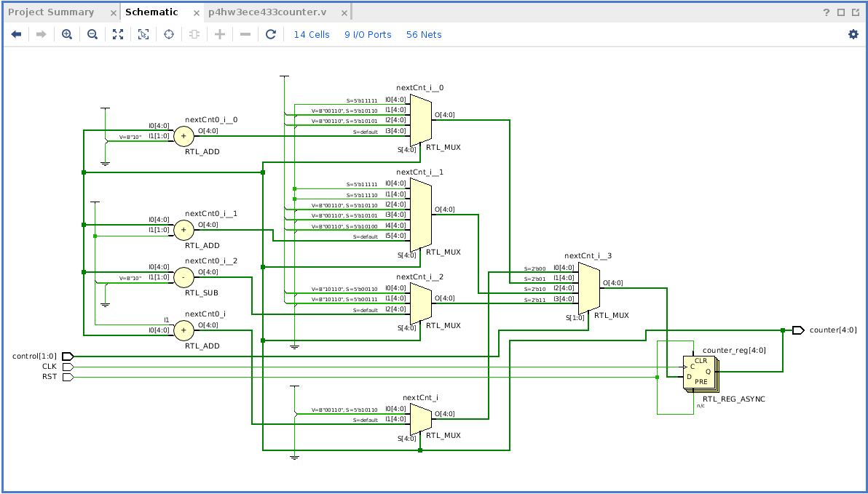
`timescale 1ns / 1ps
module p4hw3fall2021counterTB;
reg Reset, CLOCK;
reg [1:0] Control;
wire [4:0] count;
p4hw3ece433counter uut (Control, CLOCK, Reset, count);
initial begin Reset = 0; CLOCK = 0; Control = 0; end

initial fork
#4 Reset=1; #21 Reset=0; #123 Reset=1; #141 Reset=0;
#311 Reset=0; #343 Reset=1;
#0 Control=0; #63 Control =1; #128 Control =2;
#183 Control=3; #248 Control=2; #298 Control=0;
#354 Control=1;
#350 $stop;
join
always #5 CLOCK=!CLOCK;
endmodule

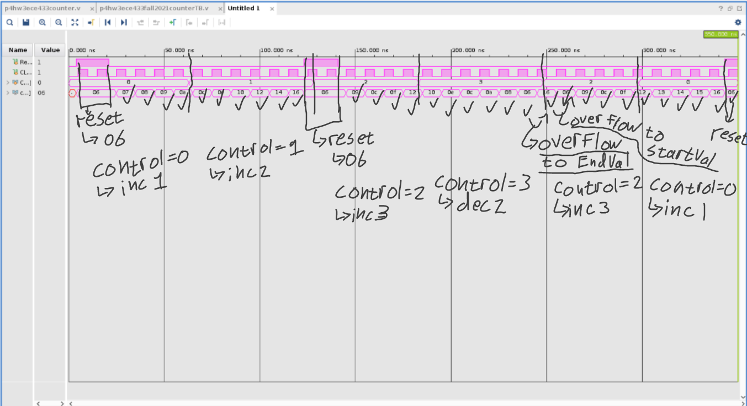
Problem 5:
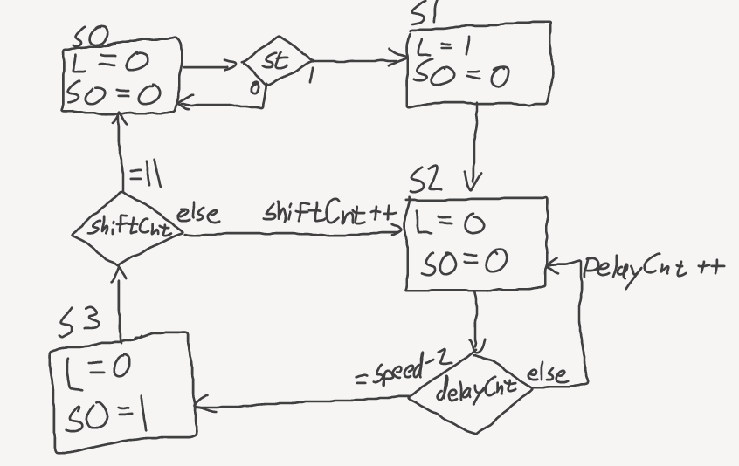
`timescale 1ns / 1ps
//name: Skyler cleland
//CM: 2284
//Date: 2021-11-28
//ECE433hw3p5

module TxController_ece433fall2021 #(parameter BitLength = 12)(
input start, RST, CLK,
input [3:0] Speed,
output reg load, shiftOut
);

reg [3:0] delayCnt;
reg [3:0] shiftCnt;

reg [1:0] curState;
reg [1:0] nextState;

always @(posedge CLK) begin
if(RST==1) curState <= 0; else curState <= nextState;
case (curState)
2: delayCnt <= delayCnt + 1;
3: delayCnt <= 0;
0: delayCnt <= 0;
default: delayCnt <= delayCnt;
endcase
case (curState)
3: shiftCnt <= shiftCnt + 1;
0: shiftCnt <= 0;
default: shiftCnt <= shiftCnt;
endcase
end

always @(start, curState, delayCnt, shiftCnt, Speed) begin
case (curState)
0: if(start==1) nextState <= 1; else nextState <= 0;
1: nextState <= 2;
2: if(delayCnt==Speed-2) nextState <= 3; else nextState <= 2;
3: if(shiftCnt==BitLength-1) nextState <= 0; else nextState <= 2;
endcase
end

always @ (curState) begin
case (curState)
1: begin load <= 1; shiftOut <= 0; end
3: begin load <= 0; shiftOut <= 1; end
default: begin load <= 0; shiftOut <= 0; end
endcase
end

endmodule

`timescale 1ns / 1ps

//name: Skyler cleland
//CM: 2284
//Date: 2021-11-28
//ECE433hw3p5

module TxController_ece433TB();

reg start, RST, CLK;
reg [3:0] Speed;

wire load, shiftOut;

TxController_ece433fall2021 uut(start, RST, CLK, Speed, load, shiftOut);

initial begin start = 0; RST = 0; CLK = 0; Speed = 2; end
always begin CLK <= ~CLK; #5; end
initial begin
#5;
RST <= 1;
#10;
RST <= 0;
#10;
start <= 1;
#10;
start <= 0;
#750;
$stop;
end

endmodule

