|  |
| --- |
| Technical Specification (TS) |
| IP AES 256 |

**Table of distribution**

|  |  |  |
| --- | --- | --- |
| **Elsys Design** | **Name - function** | **Contact** |
|  | Killian Michaud – SoC Design/Verif Engineer | [killian.michaud@elsys-design.com](mailto:killian.michaud@elsys-design.com)  +33 6 29 47 54 13 |

**Revision History**

| **Date** | **Version** | **Description** | **Author** |
| --- | --- | --- | --- |
| 24/10/2024 | 0.1 | Document creation | Killian MICHAUD |

Table of content

Table of content 4

Table of figures 5

Scope 6

A. Mentioned documents 7

1. Reference documents 7

B. Acronyms and abbreviations 8

C. Module Description 9

1. Interfaces block diagram 9

a. Interfaces description 9

2. Functional description 10

a. CLOCK and resets 10

b. Encryption Algorithm 11

c. Decryption Algorithm 13

D. Functional specification 14

1. Features 15

a. AXI4-Lite Interface 15

b. FIFO CIPHER TEXT 15

c. FIFO CIPHER KEY 15

d. FIFO PLAIN TEXT 15

e. FIFO DECIPHER TEXT 15

f. FIFO DECIPHER KEY 16

g. FIFO TO_DECIPHER TEXT 16

h. ENCRYPT CORE 16

i. DECRYPT CORE 16

2. Mapping 17

3. Registers 17

4. Timings 22

a. Encrypt text timing 22

b. Decrypt text timing 22

Table of figures

Figure 1 : Block Diagram IP AES 256 9

Figure 2 : Pseudo-code for Encryption Algorithm from document [R1] 11

Figure 3 : Pseudo-code for Key Expansion Algorithm from document [R1] 12

Figure 4 : Pseudo-code for Decryption Algorithm from document [R1] 13

Figure 5 : Functional Block Diagram 14

Figure 6 : STATUS 17

Figure 7 : CONTROL 18

Figure 8 : VERSION 19

Figure 9 : SCRPAD 19

Figure 10 : KEY_CIPHER 19

Figure 11 : KEY_DECIPHER 20

Figure 12 : PLAIN_WORD 20

Figure 13 : TO_DECIPHER_WORD 20

Figure 14 : CIPHER_WORD 21

Figure 15 : DECIPHER_WORD 21

Figure 16 : Encrypt text timing signals 22

Figure 17 : Decrypt text timing signals 22

Scope

This document aims at providing the requirement specifications for the IP AES 256.

The **Advanced Encryption Standard (AES)** with a 256-bit key length, commonly known as **AES-256**, is a symmetric encryption algorithm used to secure data. It operates on a block size of 128 bits and uses a series of transformations, including substitution, permutation, and mixing, to encrypt and decrypt data. The process involves multiple rounds (14 for AES-256) of these transformations, making it highly secure against brute-force attacks. AES-256 is widely used in various applications, including securing sensitive data in financial transactions, communications, and data storage.

1. Mentioned documents
   1. Reference documents

|  |  |  |  |
| --- | --- | --- | --- |
| **Index** | **Title** | **Reference** | **Date** |
| [R1] | ADVANCED ENCRYPTION STANDARD (AES) | nist.fips.197.pdf | 26/11/2001 |

1. Acronyms and abbreviations

|  |  |
| --- | --- |
| Acronyms and abbreviations | Meaning |
| FPGA | Field Programmable Gate Array |
| AXI | Advanced eXtensible Interface |
| IP | Intellectual Property |
| FIFO | First In First Out |
| AES | Advanced Encryption Standard |

1. Module Description
   1. Interfaces block diagram

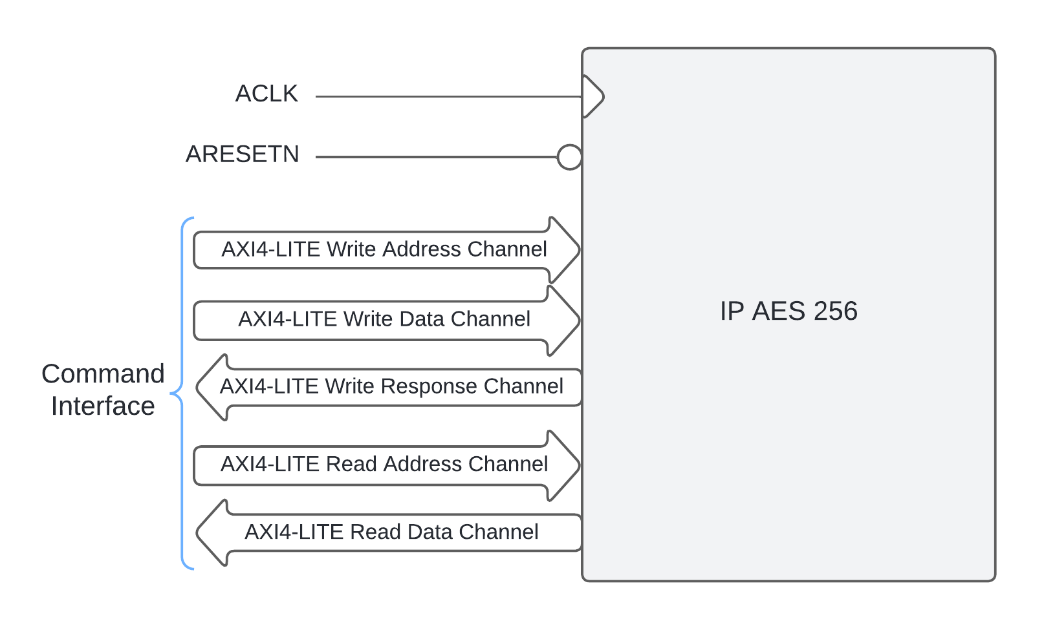

Figure 1 : Block Diagram IP AES 256

* + 1. Interfaces description

Table 1 : IP AES 256 interfaces signals

|  |  |  |  |
| --- | --- | --- | --- |
| **Signal Name** | **Length** | **Type** | **Signal description** |
| Clock Reset | | | |
| AXI4_Lite_Clk | 1 | INPUT | AXI Lite Clock |
| AXI4_Lite_Rst_n | 1 | INPUT | Asynchronous global reset active low. |
| AXI4 LITE WRITE ADDRESS CHANNEL | | | |
| Awaddr | 32 | INPUT | Write address. The write address bus gives the address of the transaction. |
| Awvalid | 1 | INPUT | Write address valid. This signal indicates that the valid write address and control information are available. |
| Awready | 1 | OUTPUT | Write address ready. This signal indicates that the slave is ready to accept address and associated control signals. |
| AXI4 LITE WRITE DATA CHANNEL | | | |
| Wdata | 32 | INPUT | Write data. It’s a 32 bits bus. |
| Wvalid | 1 | INPUT | Write valid. This signal indicates that write data and strobes are available. |
| Wready | 1 | OUTPUT | Write ready. This signal indicates that the slave can accept the write data. |
| AXI4 LITE WRITE RESPONSE CHANNEL | | | |
| Bresp | 2 | OUTPUT | Write response. This signal indicates the status of the write transaction. The allowable responses are OKAY, EXOKAY, SLVERR and DECERR. |
| Bvalid | 1 | OUTPUT | Write response valid. This signal indicates that a valid write response is available. |
| Bready | 1 | INPUT | Response ready. This signal indicates that the master can accept the response information. |
| AXI4 LITE READ ADDRESS CHANNEL | | | |
| Araddr | 32 | INPUT | Read address. The read address bus gives the address of the transaction. |
| Arvalid | 1 | INPUT | Read address valid. This signal indicates that the valid read address and control information are available. |
| Arready | 1 | OUTPUT | Read address ready. This signal indicates that the slave is ready to accept address and associated control signals. |
| AXI4 LITE READ DATA CHANNEL | | | |
| Rdata | 32 | OUTPUT | Read data. It’s a 32 bit bus. |
| Rresp | 2 | OUTPUT | Read response. This signal indicates the status of the read transfer. The allowable responses are OKAY, EXOKAY, SLVERR and DECERR. |
| Rvalid | 1 | OUTPUT | Read valid. This signal indicates that the required read data is available and the transfer can complete. |
| Rready | 1 | INPUT | Read ready. This signal indicates that the master can accept the read data and response information. |

* 1. Functional description
     1. CLOCK and resets

SYS_CLK: system clock. This clock is used for the AXI Lite interface.

RESET_N: synchronous reset of the system clock. This input is subsequently used as an asynchronous reset for the various modules. Reset active in low state.

* + 1. Encryption Algorithm

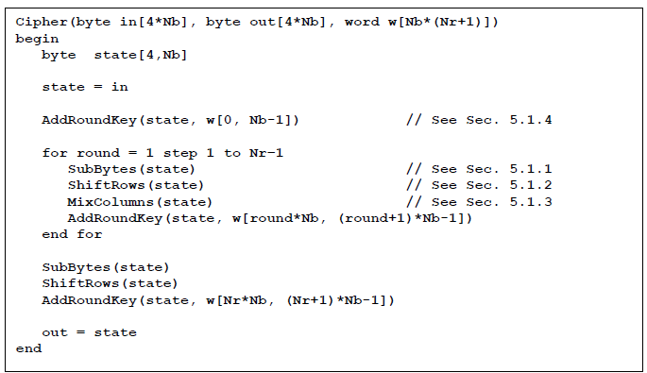

Figure 2 : Pseudo-code for Encryption Algorithm from document [R1]

In the Encryption Algorithm, the first step is to create all the 15 keys required to complete all the functions. This step is done with a new Algorithm, named Key Expansion ( Figure 3).

In AES-256, 15 rounds is needed to complete Encryption Algorithm. The first round is a XOR operation between the first key, create with Key Expansion, and plain text.

The round 2 to 14, there a succession of methods named :

* SubBytes
* ShiftRows
* MixColumns
* AddRoundKeys

Finally the last round is a succession of methods, like the previous rounds but the MixColumns method isn’t include in this round.

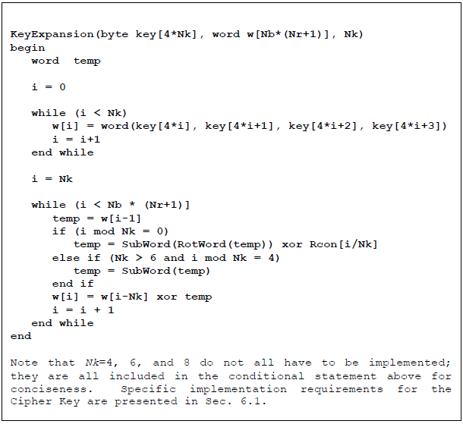

Figure 3 : Pseudo-code for Key Expansion Algorithm from document [R1]

* + 1. Decryption Algorithm

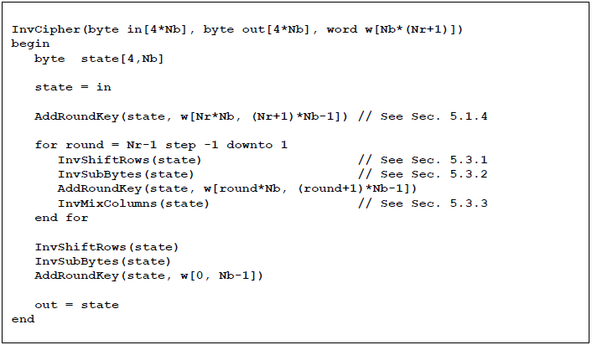

Figure 4 : Pseudo-code for Decryption Algorithm from document [R1]

In the Decryption Algorithm, the first step is to create all the 15 keys required to complete all the functions, the Key Expansion Algorithm is also use.

In AES-256, 15 rounds is needed to complete Encryption Algorithm. The first round is a XOR operation between the last key, create with Key Expansion, and cipher text.

The round 2 to 14, there a succession of methods named :

* InvShiftRows
* InvSubBytes
* AddRoundKeys
* InvMixColumns

Finally the last round is a succession of methods, like the previous rounds but the InvMixColumns method isn’t include in this round.

1. Functional specification

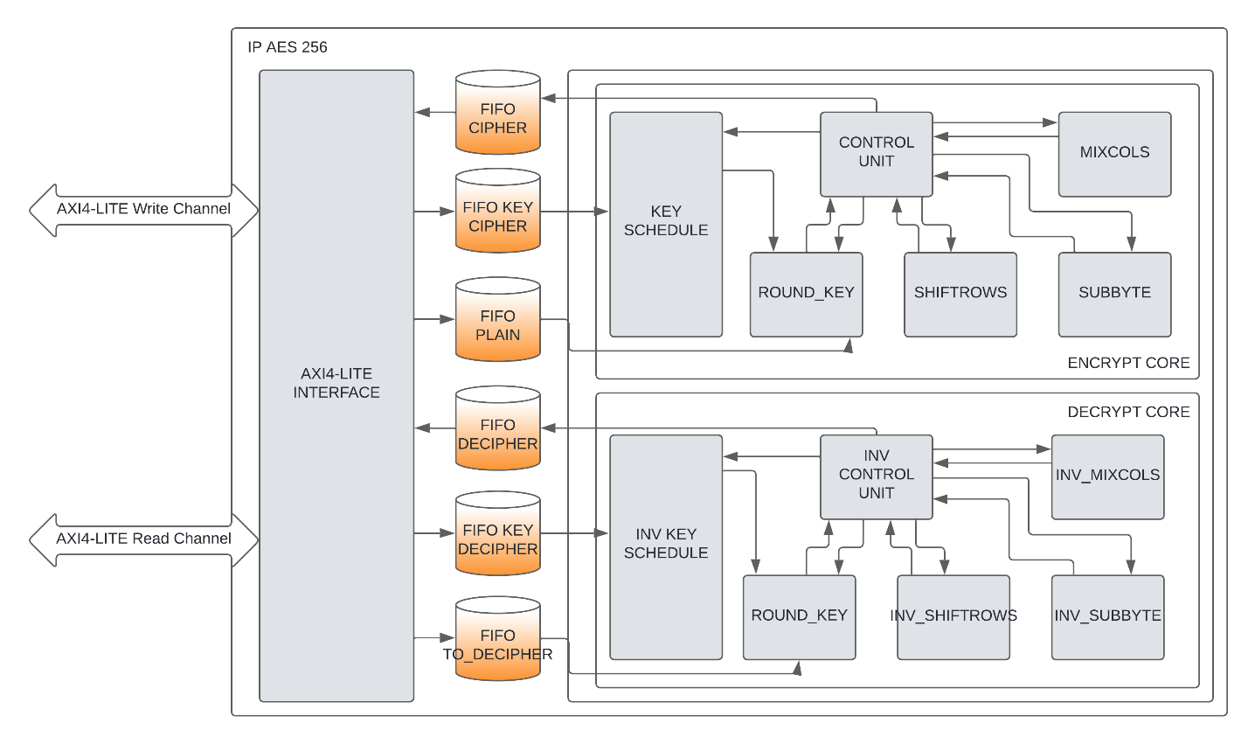

Figure 5 : Functional Block Diagram

This IP AES 256 is composed of 9 modules :

* AXI4-Lite Interface
* FIFO CIPHER TEXT
* FIFO CIPHER KEY
* FIFO PLAIN TEXT
* FIFO DECIPHER TEXT
* FIFO DECIPHER KEY
* FIFO TO_DECIPHER TEXT
* ENCRYPT CORE
* DECRYPT CORE
  1. Features
     1. AXI4-Lite Interface
* Full forward and reverse direction flow control of AXI protocol-defined READY/VALID handshake.
* AXI4 memory mapped burst lengths of:
  + 1 to 256 bits for incrementing burst and
  + 1 to 16 bits for wrap burst
* For AXI4-Lite, the supported data width is 32 bits only.
* The use of Read/Write, Read-only, or Write-only interfaces.
* No support for locked transfers.
* The use of user bits is discouraged in general purpose due to interoperability concerns.
* Holding AXI ARESETN asserted for 16 cycles of the AXI clock is generally a sufficient reset pulse width.
  + 1. FIFO CIPHER TEXT
* First input data, first output data
* 128bits length input data
* 32bits length output data
  + 1. FIFO CIPHER KEY
* First input data, first output data
* 32bits length input data
* 256bits length output data
  + 1. FIFO PLAIN TEXT
* First input data, first output data
* 32bits length input data
* 128bits length output data
  + 1. FIFO DECIPHER TEXT
  + First input data, first output data
  + 128bits length input data
  + 32bits length output data
    1. FIFO DECIPHER KEY
    - First input data, first output data
    - 32bits length input data
    - 256bits length output data
    1. FIFO TO_DECIPHER TEXT
* First input data, first output data
* 32bits length input data
* 128bits length output data
  + 1. ENCRYPT CORE
* Take a 256bits Cipher key and 128bits Plain text
* A start bit is set to enable the encrypt algorithm :
  + Follow the steps of the AES specification document :
    - Key Expansion
    - Add Round Keys
    - Sub byte
    - Shift rows
    - Mix columns
* A Control unit is there to insure the proper operation of the algorithm
* 128bits Cipher text output
* 1bit done status algorithm
  + 1. DECRYPT CORE
* Take a 256bits Decipher Key and 128bits Cipher text
* A start bit is set to enable the decrypt algorithm :
  + Follow the steps of the AES specification document :
    - Key Expansion
    - Add Round Keys
    - Inverse Shift Rows
    - Inverse Sub byte
    - Inverse Mix columns
* A Control unit is there to insure the proper operation of the algorithm
* 128bits Plain text output
* 1bit done status algorithm
  1. Mapping

Table 2 : Memory mapping IP AES 256

|  |  |  |  |
| --- | --- | --- | --- |
| Address Offset * | Name | Access | Description |
| 00h | STATUS | RO | Status register |
| 04h | CONTROL | R/W | Control register |
| 08h | VERSION | RO | Version register |
| 0Ch | SCRPAD | R/W | Scratchpad register |
| 10h | KEY_CIPHER | WO | Cipher key register |
| 14h | KEY_DECIPHER | WO | Decipher key register |
| 18h | PLAIN_WORD | WO | Plain text register |
| 1Ch | TO_DECIPHER_WORD | WO | To decipher text register |
| 20h | CIPHER_WORD | RO | Cipher text register |
| 24h | DECIPHER_WORD | RO | Decipher text register |

Notes: * Address offset is relative to IP AES 256 base address

* 1. Registers

**STATUS (Status register Address – Offset 00h)**

This register provides the status signals of the IP AES 256.

|  |
| --- |
| 31 0 |
| STATUS |

Figure 6 : STATUS

Table 3 : STATUS details

|  |  |  |  |  |
| --- | --- | --- | --- | --- |
| Bits | Fields Name | Default Value | Access Type | Description |
| 0 | Done_cipher | 0 | RO | Status of the Encrypt Algorithm |
| 1 | Done_decipher | 0 | RO | Status of the Decrypt Algorithm |
| 2 | Cipher_text_empty | 0 | RO | Flag FIFO TO_DECIPHER TEXT empty |
| 3 | Cipher_text_full | 0 | RO | Flag FIFO TO_DECIPHER TEXT full |
| 4 | Plain_text_empty | 0 | RO | Flag FIFO PLAIN TEXT empty |
| 5 | Plain_text_full | 0 | RO | Flag FIFO PLAIN TEXT full |
| 6 | Cipher_key_empty | 0 | RO | Flag FIFO CIPHER KEY empty |
| 7 | Cipher_key_full | 0 | RO | Flag FIFO CIPHER KEY full |
| 8 | Decipher_key_empty | 0 | RO | Flag FIFO DECIPHER KEY empty |
| 9 | Decipher_key_full | 0 | RO | Flag FIFO DECIPHER KEY full |
| 10 | Decipher_text_empty | 0 | RO | Flag FIFO DECIPHER TEXT empty |
| 11 | Decipher_text_full | 0 | RO | Flag FIFO DECIPHER TEXT full |
| 12 | Enc_text_empty | 0 | RO | Flag FIFO CIPHER TEXT empty |
| 13 | Enc_text_full | 0 | RO | Flag FIFO CIPHER TEXT full |

**CONTROL (Control register Address – Offset 04h)**

This register provides the control signals of the IP AES 256.

|  |
| --- |
| 31 0 |
| CONTROL |

Figure 7 : CONTROL

Table 4 : CONTROL details

|  |  |  |  |  |
| --- | --- | --- | --- | --- |
| Bits | Fields Name | Default Value | Access Type | Description |
| 0 | Start_cipher | 0 | RW | Enable a encrypt algorithm |
| 1 | Start_decipher | 0 | RW | Enable a encrypt algorithm |
| 2 | Flush_cipher | 0 | RW | Reset to zero FIFO TO_DECIPHER TEXT |
| 3 | Flush_plain | 0 | RW | Reset to zero FIFO PLAIN TEXT |
| 4 | Flush_cipher_key | 0 | RW | Reset to zero FIFO CIPHER KEY |
| 5 | Flush_decipher_key | 0 | RW | Reset to zero FIFO DECIPHER KEY |
| 6 | Flush_enc | 0 | RW | Reset to zero FIFO CIPHER TEXT |
| 7 | Flush_dec | 0 | RW | Reset to zero FIFO DECIPHER TEXT |
| 31 to 8 | Reserved | 0 | RW | N/A |

**VERSION (Version register Address – Offset 08h)**

This register provides the version of the IP AES 256.

|  |
| --- |
| 31 0 |
| Version |

Figure 8 : VERSION

Table 5 : VERSION details

|  |  |  |  |  |
| --- | --- | --- | --- | --- |
| Bits | Fields Name | Default Value | Access Type | Description |
| 31 to 0 | Version | 0 | RO | Number of version of the IP |

**SCRATCHPAD (Scratchpad register Address – Offset 0Ch)**

This register provides a scratchpad area for the IP AES 256.

|  |
| --- |
| 31 0 |
| SCRPAD |

Figure 9 : SCRPAD

Table 6 : SCRPAD details

|  |  |  |  |  |
| --- | --- | --- | --- | --- |
| Bits | Fields Name | Default Value | Access Type | Description |
| 31 to 0 | SCRPAD | 0 | R/W | Scratchpad data |

**KEY_CIPHER (KEY_CIPHER register Address – Offset 10h)**

This register provides the cipher key to the FIFO CIPHER KEY of the IP AES 256.

|  |
| --- |
| 31 0 |
| KEY_CIPHER |

Figure 10 : KEY_CIPHER

Table 7 : KEY_CIPHER details

|  |  |  |  |  |
| --- | --- | --- | --- | --- |
| Bits | Fields Name | Default Value | Access Type | Description |
| 31 to 0 | KEY_CIPHER | 0 | WO | Data transmitted to the ENCRYPT CORE module |

**KEY_DECIPHER (KEY_DECIPHER register Address – Offset 14h)**

This register provides the cipher key to the FIFO CIPHER KEY of the IP AES 256.

|  |
| --- |
| 31 0 |
| KEY_DECIPHER |

Figure 11 : KEY_DECIPHER

Table 8 : KEY_DECIPHER details

|  |  |  |  |  |
| --- | --- | --- | --- | --- |
| Bits | Fields Name | Default Value | Access Type | Description |
| 31 to 0 | KEY_DECIPHER | 0 | WO | Data transmitted to the DECRYPT CORE module |

**PLAIN_WORD (Plain Text register Address – Offset 18h)**

This register provides the cipher key to the FIFO CIPHER KEY of the IP AES 256.

|  |
| --- |
| 31 0 |
| PLAIN_WORD |

Figure 12 : PLAIN_WORD

Table 9 : PLAIN_WORD details

|  |  |  |  |  |
| --- | --- | --- | --- | --- |
| Bits | Fields Name | Default Value | Access Type | Description |
| 31 to 0 | PLAIN_WORD | 0 | WO | Data transmitted to the ENCRYPT CORE module |

**TO_DECIPHER_WORD (To decipher text register Address – Offset 1Ch)**

This register provides the cipher key to the FIFO CIPHER KEY of the IP AES 256.

|  |
| --- |
| 31 0 |
| TO_DECIPHER_WORD |

Figure 13 : TO_DECIPHER_WORD

Table 10 : TO_DECIPHER_WORD details

|  |  |  |  |  |
| --- | --- | --- | --- | --- |
| Bits | Fields Name | Default Value | Access Type | Description |
| 31 to 0 | TO_DECIPHER_WORD | 0 | WO | Data transmitted to the DECRYPT CORE module |

**CIPHER_WORD (Cipher text register Address – Offset 20h)**

This register provides the cipher key to the FIFO CIPHER KEY of the IP AES 256.

|  |
| --- |
| 31 0 |
| CIPHER_WORD |

Figure 14 : CIPHER_WORD

Table 11 : CIPHER_WORD details

|  |  |  |  |  |
| --- | --- | --- | --- | --- |
| Bits | Fields Name | Default Value | Access Type | Description |
| 31 to 0 | CIPHER_WORD | 0 | RO | Data from the ENCRYPT CORE module |

**DECIPHER_WORD (Decipher text register Address – Offset 24h)**

This register provides the cipher key to the FIFO CIPHER KEY of the IP AES 256.

|  |
| --- |
| 31 0 |
| DECIPHER_WORD |

Figure 15 : DECIPHER_WORD

Table 12 : DECIPHER_WORD details

|  |  |  |  |  |
| --- | --- | --- | --- | --- |
| Bits | Fields Name | Default Value | Access Type | Description |
| 31 to 0 | DECIPHER_WORD | 0 | RO | Data from the DECRYPT CORE module |

* 1. Timings
     1. Encrypt text timing

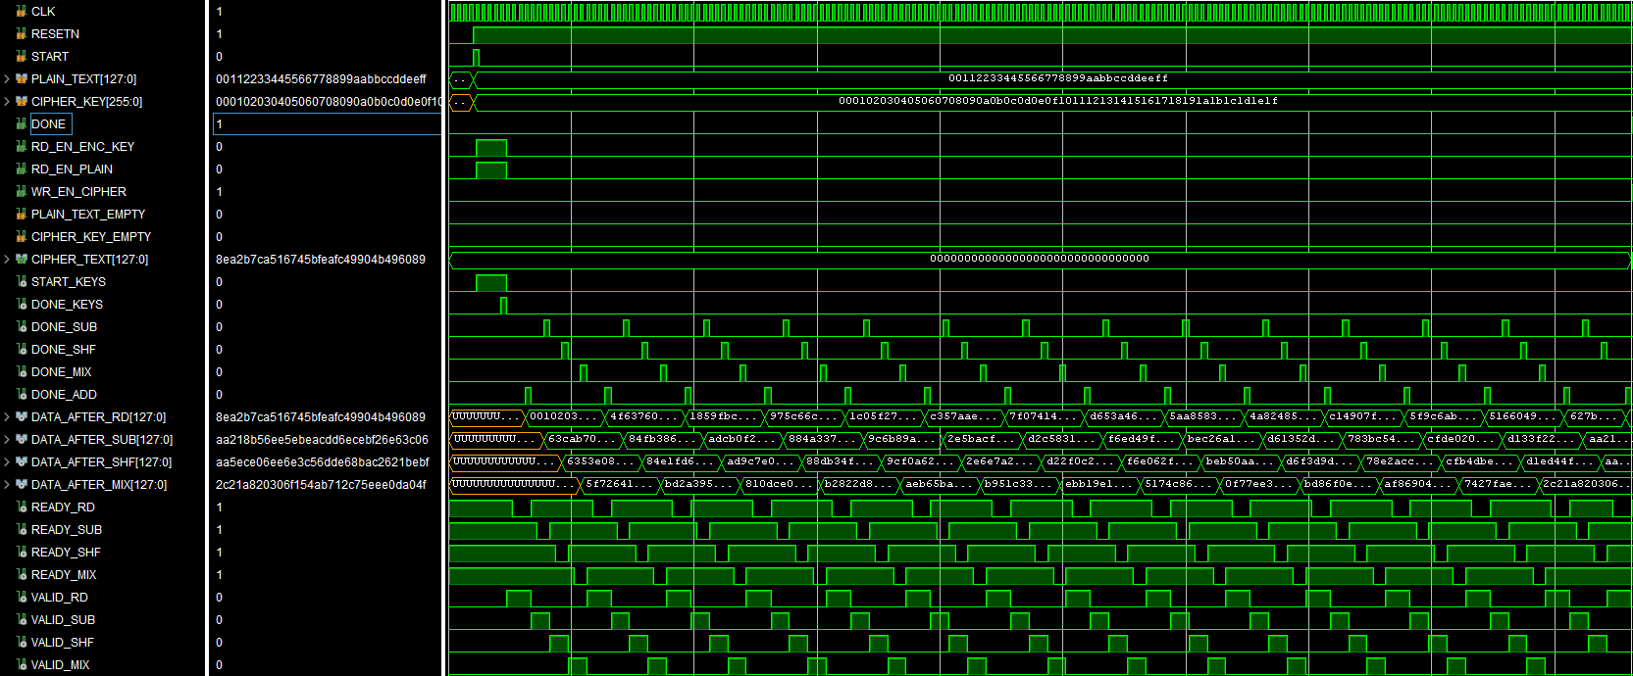

Figure 16 : Encrypt text timing signals

* + 1. Decrypt text timing

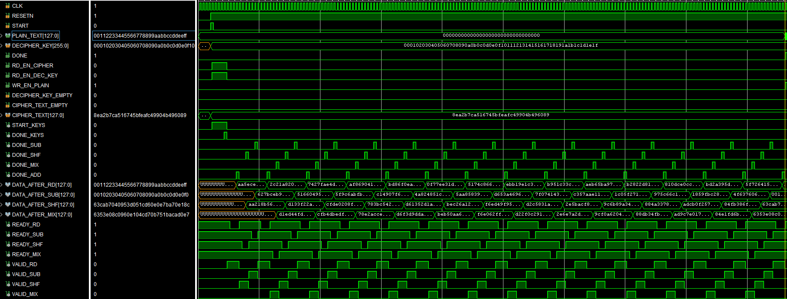

Figure 17 : Decrypt text timing signals