C++ in Telecommunication – Project UE

Specification

|  |  |  |  |
| --- | --- | --- | --- |
|  | | |  |
| Author | Piotr Nycz, … |
|  | |  |
|  | | |  |

This material, including documentation and any related computer programs, is protected by copyright controlled by Nokia Solutions and Networks. All rights are reserved. Copying, including reproducing, storing, adapting or translating, any or all of this material requires the prior written consent of Nokia Solutions and Networks. This material also contains confidential information, which may not be disclosed to others without the prior written consent of Nokia Solutions and Networks.

Contents

1 Basic information 6

1.1 Project elements 6

1.2 Communication scheme 6

1.3 BTS 7

1.4 UE 8

1.5 COMMON 8

2 UE basic information 8

2.1 Actors 9

2.1.1 UE 9

2.1.2 User 9

2.1.3 BTS 9

2.1.4 SMS DB 9

2.1.5 Timer 10

2.2 States 10

3 UE messages from/to BTS 11

3.1 Constructing and reading messages 11

3.1.1 Field types 12

3.1.2 Bytes order 12

3.2 UE ⬄ BTS messages 12

3.2.1 SIB message 12

3.2.2 Attach messages 12

3.3 UE ⬄ BTS ⬄ UE messages 13

3.3.1 From/To 13

3.3.2 Encryption 13

3.3.3 SMS message 14

3.3.4 Call messages 14

3.4 BTS 🡺 UE errors indication messages 15

3.4.1 Unknown Recipient 15

3.4.2 Unknown Sender 16

4 UE features (to implement) 16

4.1 UE basic features 16

4.1.1 Attach to BTS 16

4.1.2 Re-Attach to BTS 20

4.1.3 Receiving SMS 21

4.1.4 Viewing SMS 22

4.1.5 Sending SMS 23

4.1.6 Receiving Call Request 26

4.1.7 Sending Call Request 31

4.1.8 Dropping Call 38

4.1.9 Call (talking) 40

4.2 UE basic interactions 45

4.2.1 Interaction with Attach to BTS procedure. 45

4.2.2 Interactions with Re-Attach 48

4.2.3 Interactions with Receiving SMS 49

4.2.4 Interactions with Viewing SMS 49

4.2.5 Interactions with Sending SMS 50

4.2.6 Interactions with Receiving Call Request 51

4.2.7 Interactions with Sending Call Request 51

4.2.8 Interactions with Dropping Call 53

4.2.9 Interactions with Call (Talking) 53

4.3 UE advanced features 53

5 List of figures 55

6 List of tables 56

7 List of acronyms 56

# Basic information

## Project elements

One can view telecommunication as a network of communicating elements.

Project described in this specification consists of two network elements (NE), where naming is taken from LTE/3GPP standards:

* BTS – Base Transceiver Station
* UE – User Equipment (like mobile phone)

Besides of NEs, there is one common to BTS and UE software library:

* COMMON – BTS/UE Common library

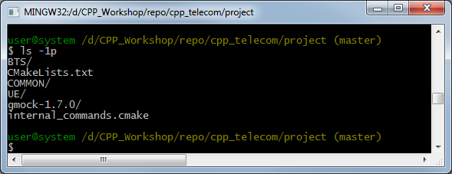

Figure 1 Project directory structure

## Communication scheme

The communication scheme between NEs is as follows:

* UE communicates with only one BTS.
* BTS communicates with many UEs.
* UEs communicate to each other only via BTS.
* BTS do not communicate to each other (at least in the current phase of project)

There is no limitation on *how many NEs can be deployed on how many computers* other than types used to represent UE ID (PhoneNumber) or BTS ID (BtsId). Both types are defined by COMMON library.

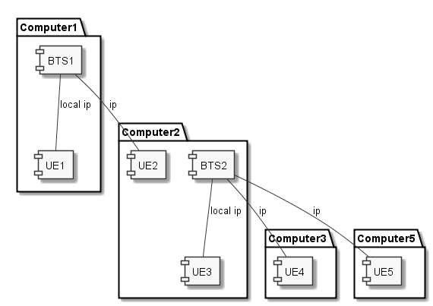

Figure 2 Possible deployment

Looking at *Figure 2 Possible deployment* the following communication are possible:

* UE1 and BTS1
* UE1 and UE2 (via BTS1)
* UE2 and BTS1
* UE3 and BTS2
* UE3 and UE4 (via BTS2)
* UE3 and UE5 (via BTS2)
* U4 and BTS2
* UE4 and UE5 (via BTS2)
* UE5 and BTS2

## BTS

BTS is fully implemented and it is given as it is.

**It is not student task to change or extend BTS functionalities.**

## UE

Student task is to implement UE as it is specified in subsequent chapters of this specification.

## COMMON

Student can use COMMON library in a way as it is used by BTS.

**Student can extend COMMON library; but student shall not remove or change this library in a way that changes BTS behavior.**

The COMMON library unit tests and interface documentations present in header files are available to help understand how this library can be used.

# UE basic information

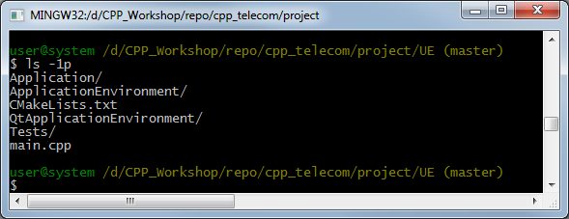

Figure 3 UE directory structure

UE is left partially unimplemented:

* To be implemented:
  + Application code (Application directory)
  + main.cpp: it already starts ApplicationEnvironment, but using of Application is missing.
* Already implemented:
  + ApplicationEnvironment: interface library
    - interface documentation is present in header files to help understand how to use this interface library.
  + QtApplicationEnvironment: implementation library
    - It is just one of possible implementation of ApplicationEnvironment

**Student shall be aware that one of possible checks of their project is to test if it works with other implementation of ApplicationEnvironment, other than QtApplicationEnvironment!**

It is important:

* Not to use Qt library in Application directly
* Not to add anything new to ApplicationEnvironment

## Actors

In subsequent chapters UML Sequence or Use Case Diagrams are used to describe requirements. In current chapter – list of actors used in these diagrams are briefly described.

### UE

The UE application to be written by students.

In UML Diagrams, UE represents only Application part of UE.

Moreover, some parts of this application are represented by some other actors, like SMS DB or Timer.

### User

Real UE user, but seen from UE Application POV as ue::IUeGui interface from ApplicationEnvironment.

The User actor actions are not just functions from ue::IUeGui, but rather some descriptions of real UE User actions.

### BTS

BTS NE, but seen from UE Application POV as ue::ITransport interface from ApplicationEnvironment.

The BTS actor actions are just simplified description of real messages that can be sent between UE and BTS, or between UE and other UE via BTS.

### SMS DB

Part of UE Application.

Responsibilities of this actor are to represent operations on SMS repository within UE Application.

**SMS DB is an Actor, but this does not mean, that it shall be implemented as single object or single module. It can be as well: set of objects, or part of some bigger object.**

### 

### Timer

Part of UE Application.

Responsibilities of this actor is to represent operations on timers’ machinery within UE Application.

Operations:

* start (UE🡪Timer)
* cancel (UE🡪Timer)
* timeout (Timer🡪UE)

It is student decision if UE Application implementation will require one or many timers being active at the same time.

**Timer is an Actor, but this does not mean, that it shall be implemented as single object or single module. It can be as well: set of objects, or part of some bigger object.**

## States

In subsequent chapters UML Sequence or Use Case Diagrams are used to describe requirements. In current chapter – states and their transitions are presented in *Figure 4 UE Application States*.

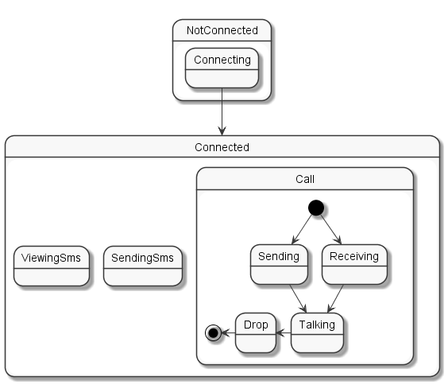

Figure 4 UE Application States

# UE messages from/to BTS

## Constructing and reading messages

Messages are to be sent and received as a stream of bytes.

Messages shall be constructed and read by using of COMMON library:

* class IncomingMessage for reading message
* class OutgoingMessage for constructing message

**There is no padding or special alignment between fields in messages, so student cannot just define C++ struct type “representing” message and cast bytes stream to it.**

**Moreover, endianness format of received messages might differ from your CPU endianness format.**

### Field types

All types used to describe messages (like MessageId or PhoneNumber) are defined in COMMON library.

### Bytes order

Bytes in messages are and should be ordered according to big endian format, i.e. in two bytes word, the most significant byte is first. Big endian format is the network standard.

Be aware that architecture of some processors are not big endian format (e.g. Intel processors are little endian format – the least significant byte is first).

Fortunately, already mentioned COMMON classes will do all necessary conversion between endianness formats in the background, no special action needed.

## UE ⬄ BTS messages

### SIB message

|  |  |  |  |  |
| --- | --- | --- | --- | --- |
| Direction | | BTS🡪UE | | |
| **Field** | | **Type** | **Value** | **Comment** |
| Header | messageId | MessageId | MessageId::Sib |  |
| from | PhoneNumber |  | value not used |
| to | PhoneNumber |  | value not used |
| btsId | | BtsId | Sender ID |  |

Table 1 SIB (System Information Broadcast) message

### Attach messages

|  |  |  |  |  |
| --- | --- | --- | --- | --- |
| Direction | | UE🡪BTS | | |
| **Field** | | **Type** | **Value** | **Comment** |
| Header | messageId | MessageId | MessageId::AttachRequest |  |
| from | PhoneNumber | UE Number |  |
| to | PhoneNumber |  | value not used |
| btsId | | BtsId | Receiver ID |  |

Table 2 Attach Request

|  |  |  |  |  |
| --- | --- | --- | --- | --- |
| Direction | | BTS🡪UE | | |
| **Field** | | **Type** | **Value** | **Comment** |
| Header | messageId | MessageId | MessageId::AttachResponse |  |
| from | PhoneNumber |  | value not used |
| to | PhoneNumber | UE Number |  |
| accepted | | bool  (implemented as std::uint_8) |  | accepted(true)  rejected(false) |

Table 3 Attach Response

## UE ⬄ BTS ⬄ UE messages

### From/To

All the UE⬄UE messages can be received on UE or sent from UE. Depending on it – Message header fields From/To mean:

|  |  |  |
| --- | --- | --- |
| Direction | | UE🡪BTS |
| **Field** | | **Meaning** |
| Header | from | UE own Number |
| to | Receiver UE number |

Table 4 Message header from/to fields meaning when message is sent from UE

### Encryption

Method of encryption can be specified in free form as sequence of bytes – as long as both UE understand it.

The predefined methods of encryption:

1. “no encryption” represented as one byte containing value of zero.
2. “XOR encryption” represented as one byte containing value of one.
3. “Cesar encryption” represented as one byte containing value of two.
4. “RSA encryption” represented as one byte containing value of three.

|  |  |  |  |
| --- | --- | --- | --- |
| Field | Type | Value | Comment |
| Mode | std::uint8_t | Differ from 0 |  |
| Data | std::uint8_t[N] | Unspecified | N is unspecified – might be zero. Interpretation depends on mode value. |

Table 5 Encryption for encrypted communication

#### No encryption

|  |  |  |  |
| --- | --- | --- | --- |
| Field | Type | Value | Comment |
| mode | std::uint8_t | 0 | N=0 (no data) |

Table 6 Encryption for not encrypted communication

#### XOR encryption

Every byte is XORed with key.

|  |  |  |  |
| --- | --- | --- | --- |
| Field | Type | Value | Comment |
| Mode | std::uint8_t | 1 |  |
| Data | std::uint8_t | 0-255 | Encryption “key” |

Table 6.1 Encryption for XOR encrypted communication

**Encryption “key” shall be used to encrypt Text field of subsequent Call Talk or SMS messages.**

**Be aware that two UEs may use different values as their encryption “key”.**

#### Cesar encryption

Every byte is encoded as <original value> + <key>.

|  |  |  |  |
| --- | --- | --- | --- |
| Field | Type | Value | Comment |
| Mode | std::uint8_t | 2 |  |
| Data | std::uint8_t | 0-255 | Encryption “key” |

Table 6.2 Encryption for Cesar encrypted communication

**Encryption “key” shall be used to encrypt Text field of subsequent Call Talk or SMS messages.**

**Be aware that two UEs may use different values as their encryption “key”.**

#### RSA encryption

Entire message is encrypted with a RSA private or public key.

|  |  |  |  |
| --- | --- | --- | --- |
| Field | Type | Value | Comment |
| Mode | std::uint8_t | 3 |  |
| KeyLength | std::uint16_t | >0 | Length of public key |
| Data | std::uint8_t[KeyLength] | 0-255 | Public RSA key in PEM format |

Table 6.3 Encryption for RSA encrypted communication

RSA encryption/decryption rules for Call Talk messages are different from those for SMS messages.

|  |  |  |
| --- | --- | --- |
| MessageId | Encryption method | Decryption method |
| SMS | Encrypt with own private key | Decrypt with peer public key |
| CallTalk | Encrypt with peer public key | Decrypt with own private key |

### SMS message

|  |  |  |  |  |
| --- | --- | --- | --- | --- |
| Field | | Type | Value | Comment |
| Header | messageId | MessageId | MessageId::Sms |  |
| from | PhoneNumber |  | See From/To |
| to | PhoneNumber |  |
| encryption | |  |  | See Encryption |
| text | | char[N] | SMS text | Size is just to the end of Message |

Table 7 SMS

### Call messages

|  |  |  |  |  |
| --- | --- | --- | --- | --- |
| Field | | Type | Value | Comment |
| Header | messageId | MessageId | MessageId::CallRequest |  |
| from | PhoneNumber |  | See From/To |
| to | PhoneNumber |  |
| encryption | |  | See Encryption | See Encryption |

Table 8 Call Request

|  |  |  |  |  |
| --- | --- | --- | --- | --- |
| Field | | Type | Value | Comment |
| Header | messageId | MessageId | MessageId::CallAccepted |  |
| from | PhoneNumber |  | See From/To |
| to | PhoneNumber |  |
| encryption | |  | See Encryption |  |

Table 9 Call Accepted

|  |  |  |  |  |
| --- | --- | --- | --- | --- |
| Field | | Type | Value | Comment |
| Header | messageId | MessageId | MessageId::CallDropped |  |
| from | PhoneNumber |  | See From/To |
| to | PhoneNumber |  |

Table 10 Call Dropped

|  |  |  |  |  |
| --- | --- | --- | --- | --- |
| Field | | Type | Value | Comment |
| Header | messageId | MessageId | MessageId::CallTalk |  |
| from | PhoneNumber |  | See From/To |
| to | PhoneNumber |  |
| text | | char[N] | Call text | Size is just to the end of Message |

Table 11 Call Talk

## BTS 🡺 UE errors indication messages

### Unknown Recipient

|  |  |  |  |  |
| --- | --- | --- | --- | --- |
| Field | | Type | Value | Comment |
| Header | messageId | MessageId | MessageId::UnknownRecipient |  |
| from | PhoneNumber |  | value not used |
| to | PhoneNumber | UE Number |  |
| Header of failing message | messageId | MessageId | Copied from failed message | |
| from | PhoneNumber |
| to | PhoneNumber |

Table 12 Uknown Recipient

The Unknown Recipient message indicates that BTS does not know the recipient, the recipient UE is unknown.

This is sometimes expected case, when, e.g., UE sends SMS to peer UE and that UE is not connected to BTS.

### Unknown Sender

|  |  |  |  |  |
| --- | --- | --- | --- | --- |
| Field | | Type | Value | Comment |
| Header | messageId | MessageId | MessageId::UnknownSender |  |
| from | PhoneNumber |  | value not used |
| to | PhoneNumber | UE Number |  |
| Header of failing message | messageId | MessageId | Copied from failed message | |
| from | PhoneNumber |
| to | PhoneNumber |

Table 13 Unknown Sender

The Unknown Sender message shall not be received, it indicates implementation (logic) error.

The only requirement is to log this message (when received) as error in ApplicationEnvironment/Logger object.

# UE features (to implement)

This chapter defines UE behaviour.

This behaviour is divided into list of features in subsequent subchapters.

For any missing features or requirements – if it appears that some UE behaviour is not defined by this chapter – student is free to implement it in “own” way.

All requirements specified as either UML Use Case or ULM Sequence Diagrams shall be tested.

See UE messages from/to BTS for messages definitions.

See UE basic information for actors and states definition.

## UE basic features

### Attach to BTS

UE has to perform special attach procedure to connect to BTS.  
Main goal is to inform BTS about UE phone number and to inform BTS that UE exists.  
Only after being connected, UE can perform other procedures, like receiving/sending SMS.

#### Attach to BTS – Use Case

**Preconditions:**

* UE in NotConnected state:
  + [main] BTS is on, UE is starting;
    - [alternate] UE was already started, when BTS starts
    - [alternate] Previous attempt(s) to attach failed
* TCP/IP connection exist (or BTS and UE on the same host)
  + UE has configured (server,port) proper connection to BTS
    - Default is server=localhost, port=8181 – and this is ok for localhost

**Main success scenario:**

1. BTS sends SIB(btsId) message to UE
2. UE sends AttachRequest(itsPhoneNumber) to BTS
3. BTS responds with AttachResponse(uePhoneNumber, accepted:true)
4. UE signals “I am connected” to the User

**Main failure scenario:**

3a. BTS responds with AttachResponse(uePhoneNumber, accepted:false)

**Alternate failure scenario:**

3b. BTS does not respond within 500ms timeout

**Postconditions:**

* [success] UE is ready for serving User: UE is in Connected state.
* [failure] UE is not ready for serving Use: UE is in NotConnected state.

#### Attach to BTS Sequence Diagram – Success

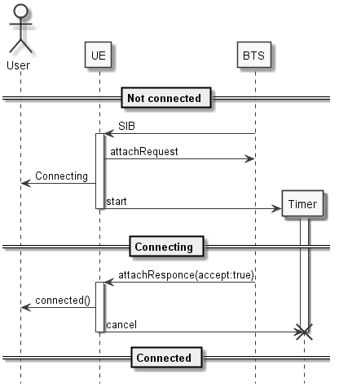

Figure 5 Attach to BTS - Success

#### Attach to BTS Sequence Diagram – Failure: BTS rejected

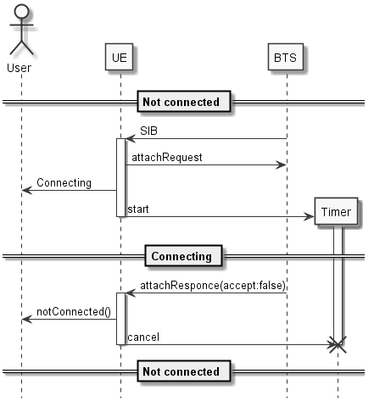

Figure 6 Attach to BTS, BTS rejected

#### Attach to BTS Sequence Diagram – Failure: timeout

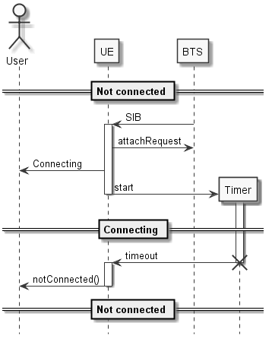

Figure 7 Attach to BTS, timeout

### Re-Attach to BTS

UE has to be able to perform subsequent attach procedure, if disconnected.  
This procedure consists of two sub-procedures:

1. Disconnecting
2. Attaching

Attaching while reattaching does not differ from initial attaching described in 4.1.1 Attach to BTS.

Disconnecting is information received from Transport object that connection to BTS was drop.

Transport object is part of UE ApplicationEnviroment (see UE basic information) – for details refer to Transport object interface definition - see UE basic information to find header file location.

#### Disconnecting – Use Case

**Preconditions:**

* UE in Connecting or Connected:

**Scenario:**

1. ApplicationEnvironment/Transport informs UE via registered callback that connection to BTS was drop

**Postconditions:**

* UE is in NotConnected state.
* UE is ready to received next Sib message to start new Attach procedure

### Receiving SMS

UE can receive SMS from any other UE connected to the same BTS.  
UE has to store these SMS to allow its User to view them.

#### Receiving SMS – Use Case Scenario

**Preconditions:**

* UE in Connected state:

**Scenario:**

1. UE receives SMS(from,text) message from BTS
2. UE stores it in its SMS DB (as SMS not yet read)
3. UE informs User that there is new SMS.

**Postconditions:**

* Received SMS(from,text) stored in SMS DB
* User is informed new SMS arrived

#### Receiving SMS Sequence Diagram

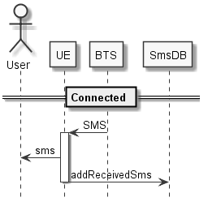

Figure 8 Receiving SMS

### Viewing SMS

User shall be able to view SMS on UE.  
UE shall maintain “read/not read” property of received SMS.

#### Viewing SMS – Use Case

**Preconditions:**

* UE is presenting main menu actions to the User

**Main success scenario:**

1. User selects on UE: view SMS action (might be implement as menu/selection item)
2. UE shows SMS List to User (might be implemented as selection items)
3. User selects one SMS
4. UE shows selected SMS to User
   1. UE for “not read” SMS changes this SMS property to “read”
5. User closes the SMS view
6. User closes the SMS List view

**Alternative success** scenario

6a. User selects another SMS to view – i.e. go to p4

**Alternative success scenario**

2a SMS List is empty – i.e. go to p6

**Postconditions:**

* All viewed SMS marked as “read” in SMS DB
* UE is presenting main menu actions to the User

#### Viewing SMS Sequence Diagram – Success

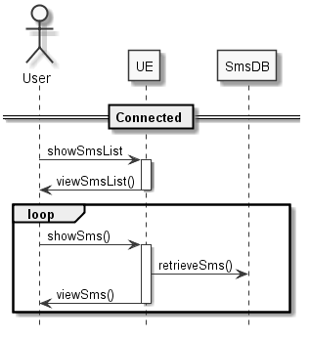

Figure 9 Viewing SMS

### Sending SMS

UE, when connected, shall be able to allow User to send SMS to other UE (via BTS).

#### Sending SMS – Use Case

**Preconditions:**

* UE in Connected state

**Success scenario:**

1. User selects on UE: send SMS action (might be implement as menu/selection item)
2. UE switches to edit SMS mode
3. User types other UE Phone Number and text of SMS
4. User clicks Accept (green “pick up handset” button)
5. UE sends to BTS SMS(from=myPhoneNumber,to=enteredPhoneNumber,text=enteredText)
6. UE stores SMS as sent SMS
7. UE switches to main menu mode

**Failure scenario**

3a. User clicks Reject (red “hang up the phone” button)

**Alternative failure scenario**

4a. User clicks Reject (red “hang up the phone” button)

**(Optional) Alternative partial-success scenario**

8a. Unknown Recipient message is received with body indicating that SMS sent in p6 was not received. SMS might be marked in SMS DB as sent but not received.

**Postconditions**

* UE in Connected state
* [success] UE sends SMS and stores it in SMS DB

#### Sending SMS Sequence Diagram – Success

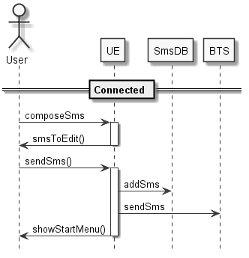

Figure 10 Sending SMS – Success

#### Sending SMS Sequence Diagram – SMS sent to unknown recipient

This sequence diagram is one of possible many solution to the case when UE application receives Unknown Recipient message in response to SMS. It means, that this specification does not force UE Application implementation to behave in this way presented here:

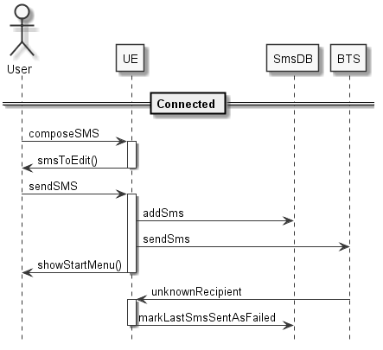

Figure 11 Sending SMS – Partial Success

#### Sending SMS Sequence Diagram – Failure (Abort)

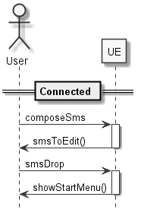

Figure 12 Sending SMS - Abort

### Receiving Call Request

UE shall present to User the incoming call Request from other UE (via BTS).

User shall see incoming phone number and two options:

1. Accept call – thus starting conversation
2. Reject call

According to the User action – proper response message shall be sent to other UE (via BTS).

UE shall guard User reaction with timeout, i.e. when User does not react in the specified time (see proper sequence diagram) then User Reject action is assumed.

This is mirror procedure to Sending Call Request.

#### Receiving Call Request – Use Case

**Preconditions:**

* UE in Connected state:

**Main success scenario:**

1. BTS sends CallRequest(from=callingPhoneNumber) message to UE
2. UE informs User about incoming call
3. User selects Accept option (green “pick up handset” button)
4. UE changes its mode to conversation mode (Talking state)
5. UE sends to BTS CallAccept(to=callingPhoneNumber)

**Main failure scenario – Reject**

3a. User selects Reject option (red “hang up the phone” button)

4a. UE returns to main menu mode

5a. UE sends to BTS CallDropped(to=callingPhoneNumber)

**Alternate failure scenario - Timeout**

3a. User does not perform any action within 30s timeout

4a. UE returns to main menu mode

5a. UE sends to BTS CallDropped(to=callingPhoneNumber)

**Alternate failure scenario – Peer UE becomes unknown after CallAccepted**

6. BTS sends UnknownRecipient(failedHeader.to=callingPhoneNumber)

7. Inform UE User that Peer User was disconnected from BTS

* UE GUI AlertMode can be used for this (for a short moment display some message)

8. UE behaves as if Peer User dropped call

* see Dropping Call Sequence Diagram – Initiated by other User

**Alternate failure scenario – Peer UE becomes unknown after CallDropped**

6a. BTS sends UnknownRecipient(failedHeader.to=callingPhoneNumber)

7a. Message is ignored.

**Postconditions**

* [success] UE is ready for talking (Talking state)
* [failure] UE returns to Connected state.

#### Receiving Call Request Sequence Diagram – Success (Accept)

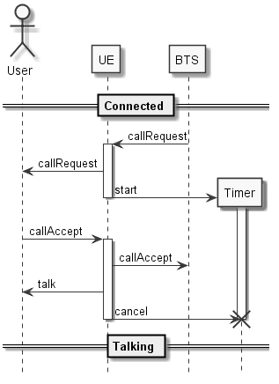

Figure 13 Received Call Request Accepted

#### Receiving Call Request Sequence Diagram – Failure (Reject)

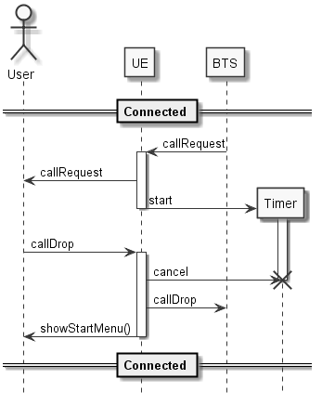

Figure 14 Received Call Request Rejected

#### Receiving Call Request Sequence Diagram – Failure (Timeout)

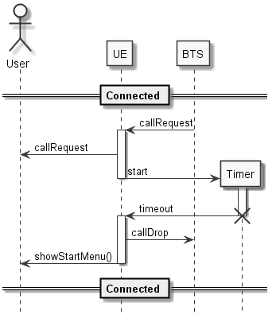

Figure 15 Received Call Request Expired

#### Receiving Call Request Sequence Diagram – Failure to Accept: Peer UE Disconnected

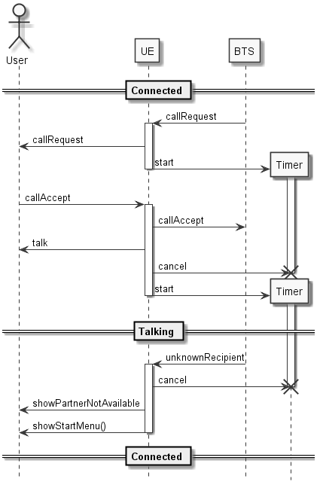

Figure 16 Received Call Request Accepted, but Peer UE already disconnected

### Sending Call Request

UE shall allow User to initiate call to other User, via BTS, then other User UE.

While waiting for other User accepting the call, User shall be able to reject own request.

After successfully connected both User can talk.

This is mirror procedure to Receiving Call Request.

Similarly to Receiving Call Request, on every message sent to Peer UE - Unknown Recipient message can be received in response.

#### Sending Call Request – Use Case

**Preconditions:**

* UE in Connected state

**Main success scenario:**

1. User selects on UE: dial action (might be implement as menu/selection item)
2. UE switches to dialling mode
3. User types other UE Phone Number
4. User clicks Accept (green “pick up handset” button)
5. UE sends to BTS CallRequest(from=myPhoneNumber,to=enteredPhoneNumber)
6. BTS responds with CallAccepted(from=enteredPhoneNumber,to= myPhoneNumber)
7. UE changes its mode to conversation mode (Talking state)

**Main failure scenario**

6a. BTS responds with CallDropped

7a. UE informs User call dropped

7b UE returns to main menu mode

**Alternative failure scenario – Peer User not connected**

6a. BTS responds with UnknownRecipient

7a. UE informs User that peer UE is not connected

7b UE returns to main menu mode

**Alternate failure scenario - Timeout**

6a. BTS does not respond within 60s timeout

7a. UE informs User call dropped

7b UE returns to main menu mode

**Alternate failure scenario - Resignation**

6a. BTS is not responding, User click Reject (red “hang up the phone” button)

7a. UE sends to BTS CallDropped

7b. UE returns to main menu mode

**Alternate failure scenario – Resignation and Peer UE was disconnected in meantime**

6a. BTS is not responding, User click Reject (red “hang up the phone” button)

7a. UE sends to BTS CallDropped

7b. BTS responds with UnknownRecipient

7c. UE returns to main menu mode

**Postconditions**

* [success] UE is ready for talking (Talking state)
* [failure] UE returns to Connected state.

#### Sending Call Request Sequence Diagram – Success

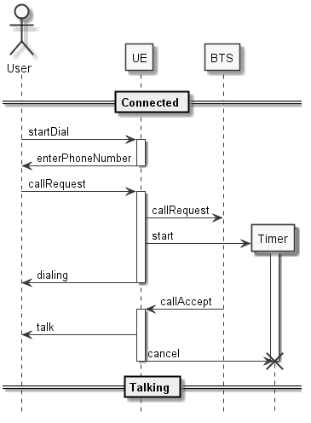

Figure 17 Call Initiated - Success

#### Sending Call Request Sequence Diagram – Failure: Peer User dropped call

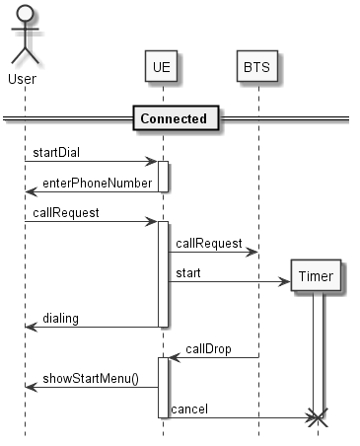

Figure 18 Call Initiated – Rejected

#### Sending Call Request Sequence Diagram – Failure: Peer User not connectedl

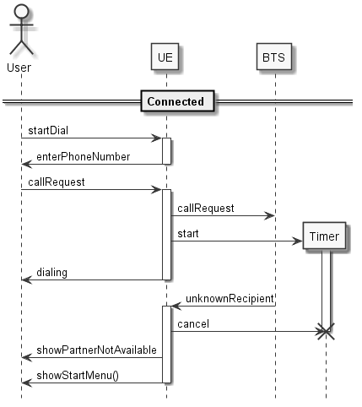

Figure 19 Call Initiated to not connected UE

#### Sending Call Request Sequence Diagram – Timeout

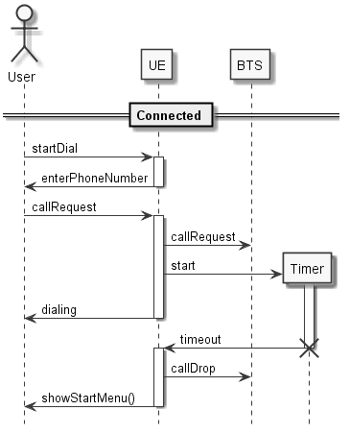

Figure 20 Call Initiated - Timeout

#### Sending Call Request Sequence Diagram – Resignation

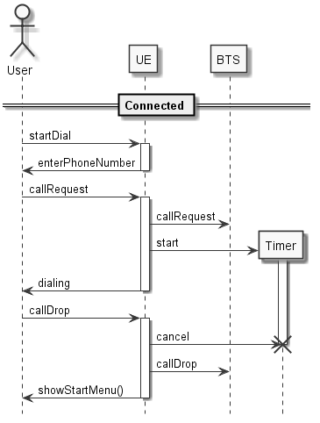

Figure 21 Call Initiated - Resignation

### Dropping Call

User, when UE is in Talking state, shall be able to drop the call.

Similarly, when UE is in Talking state, on receiving CallDropped from other User shall end the current call.

Every Unknown Recipient message that is received on CallDropped message shall be ignored.   
To keep this procedure simple – alternative scenarios where UnknownRecipient is received are not present in Sequence Diagrams.

#### Dropping Call – Use Case

**Preconditions:**

* UE in Talking state

**Main scenario:**

1. User clicks Reject (red “hang up the phone” button)
2. UE sends CallDropped(from=myPhoneNumber, to=partnerPhoneNumber) to BTS
   1. [Optional] UnknownRecipient is ignored.
3. UE shows main menu to User

**Alternative scenario:**

1a. BTS sends CallDropped(from= partnerPhoneNumber, to= myPhoneNumber) to UE

2a UE informs User that call ended

3 UE shows main menu to User

**Postconditions**

* UE is in Connected state.

#### Dropping Call Sequence Diagram – Initiated by User

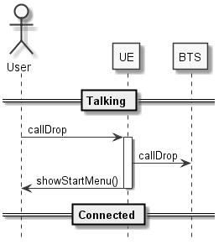

Figure 22 Call Dropped by User

#### Dropping Call Sequence Diagram – Initiated by other User

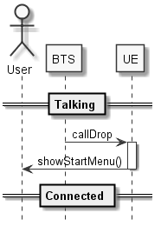

Figure 23 Call Dropped by other User

### Call (talking)

UE is in Talking state.

User shall be able to enter message to the other User and UE shall send this message to other UE via BTS.

In parallel, on receiving CallTalk message from other User, UE shall presents the message to the User.

UE shall detect inactivity from both parties of the conversation.

#### Call (talking) – Use Case

**Preconditions:**

* UE in Talking state:

**Main success scenario:**

1. User enter text message
2. UE sends CallTalk(partnerPhoneNumber, text) to BTS
3. UE presents just sent message to User as part of conversation

**Alternate success scenario**

1a. no action

2a. UE receives CallTalk(itsPhoneNumber, text) from BTS

3a. UE presents just received message to User as part of conversation

**Main failure scenario**

4a. Last performed action was sending message to the other User

5a. No activity, as described in Success Scenarios, detected for 2min

6a. UE sends CallDropped(from=myPhoneNumber, to=partnerPhoneNumber) to BTS

7a. UE shows main menu to User

**Alternate failure scenario**

4b. Last performed action was receiving message from the other User

**Alternate failure scenario – Peer UE was disconnected in meantime**

2a. UE sends CallTalk(partnerPhoneNumber, text) to BTS

3a. BTS sends UnknownRecipient(failedHeader.to=partnerPhoneNumber) to UE

4a. UE shows to User, that Peer UE is disconnected

5a. UE shows main menu to User

**Postconditions**

* [success] UE is in Talking state.
* [failure] UE is in Connected state.

#### Call (talking) Sequence Diagram – Success – Sending talk message

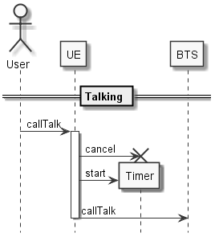

Figure 24 Call - Sending talk message

#### Call (talking) Sequence Diagram – Success – Receiving talk message

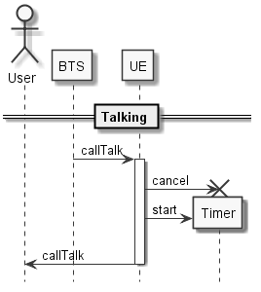

Figure 25 Call - Receiving talk message

#### Call (talking) Sequence Diagram – Failure – Timeout after sending message

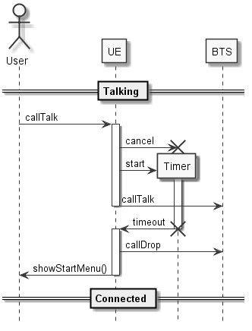

Figure 26 Call - Timeout (send)

#### Call (talking) Sequence Diagram – Failure – Timeout after receiving message

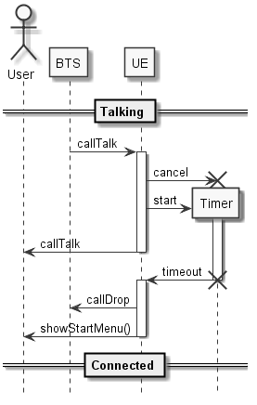

Figure 27 Call - Timeout (receive)

#### Call (talking) Sequence Diagram – Failure – Peer UE disconnected

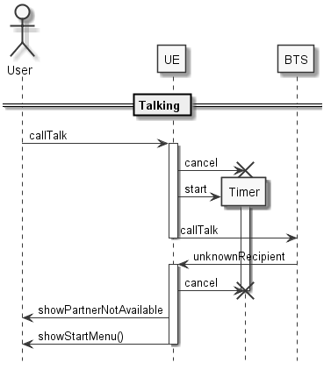

Figure 28 Call – Peer UE disconnected

## UE basic interactions

Interactions between features defined in UE basic features.

Only selected interactions are fully defined by using Use Cases or Sequence Diagrams.

Most of trivial interactions are only listed and very briefly described, but they shall be tested too.

It could be a good task for student to write missing UML diagrams…

### Interaction with Attach to BTS procedure.

The only possible interactions with Attach to BTS procedure are in Connecting state, i.e. while UE is waiting on AttachResponse.

#### User closes UE while connecting to BTS – Use Case

**Preconditions:**

* UE in Connecting state:

**Scenario:**

1. User selects “close the application” action.
2. UE stops running timer
3. UE closes

**Postconditions**

* UE closed.

#### User closes UE while connecting to BTS - Sequence Diagram

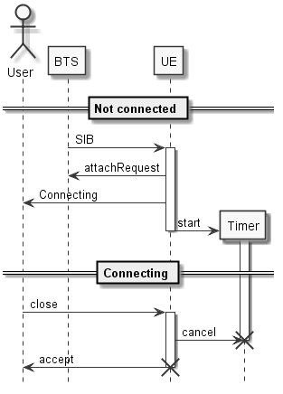

Figure 29 User closes UE while connecting to BTS

#### UE receives SIB while connecting to BTS – Use Case

**Preconditions:**

* UE in Connecting state

**Scenario:**

1. UE receives SIB from BTS
2. UE stores SIB data
   1. Note that current procedure is not restarted…

**Postconditions**

* UE in Connecting state

#### UE receives SIB while connecting to BTS Sequence Diagram

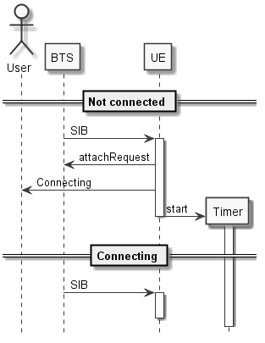

Figure 30 UE receives SIB while connecting to BTS

#### UE connection to BTS was dropped while connecting to BTS – Use Case

**Preconditions:**

* UE in Connecting state

**Scenario:**

1. UE ApplicationEnvironment informs (via callback) that connection to BTS is dropped
2. UE breaks Attach procedure (by cancelling Timer)

**Postconditions**

* UE in NotConnected state

#### UE connection to BTS was dropped while connecting to BTS – Sequence Diagram

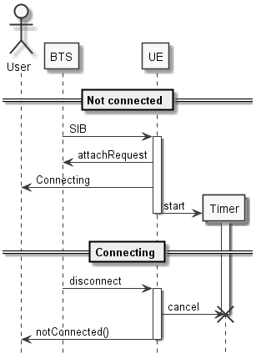

Figure 31 UE connection to BTS was dropped whilst attaching

### Interactions with Re-Attach

As described in 4.1.2 Re-Attach to BTS – this is two steps procedure.

First part - Disconnecting – has no interactions as this is stateless procedure.

Second part – Attaching – has exactly the same interactions as initial attaching – see 4.2.1 Interaction with Attach to BTS procedure.

### Interactions with Receiving SMS

There is no interactions with Receiving SMS scenario, because it is stateless procedure.

### Interactions with Viewing SMS

There are two possible states of Viewing SMS procedure:

1. Viewing list of SMS
2. Viewing one selected SMS content.

The very same interactions scenarios apply for both states.

Just to clarify: interactions in both states should be verified by tests.

#### User closes UE while viewing SMS/SMS list

UE shall close immediately, i.e. it shall not wait, until User stops viewing SMS/SMS list.

#### UE connection to BTS was dropped while viewing SMS/SMS List

UE shall go to NotConnected state immediately, i.e. it shall not wait, until User stops viewing SMS/SMS list.

#### UE receives SMS, while viewing SMS/SMS list

UE shall store received SMS, but not interrupt the current viewing SMS scenario.

Basically, in the background of Viewing SMS, the Receiving SMS procedure shall be performed.

It is **not** required, but can be implemented, that:

* The list of viewed SMS will be refreshed (by adding newly received SMS)
* The User will be informed that new SMS is received.

Of course, subsequent Viewing SMS procedure shall present all SMS, including the one discussed here.

#### UE receives Call Request, while viewing SMS/SMS list – Use Case

**Preface:**

Receiving Call Request procedure shall interrupt the Viewing SMS.

**Preconditions:**

* UE in ViewingSMS state

**Main Scenario:**

1. BTS sends CallRequest(from=callingPhoneNumber) message to UE
2. UE stops ViewingSMS procedure
3. UE informs User about incoming call
4. Plus all steps as defined in Receiving Call Request – Use Case
5. There is no return to ViewingSMS, even in case of Call Request rejection

**Alternate and Optional (not required to be implemented) Scenario:**

5a. On Receiving Call Request failure scenarios – UE returns to Viewing SMS procedure,

**Postconditions**

* [main] UE not in ViewingSMS state – see Receiving Call Request – Use Case
* [alternate-optional] In case of Rejecting Call – UE in exactly the same ViewingSMS state

### Interactions with Sending SMS

The interaction with Sending SMS are very similar to Interactions with Viewing SMS.

#### User closes UE while sending SMS

UE shall close immediately, i.e. it shall not wait until User sends (or cancel sending) SMS.

#### UE connection to BTS was dropped while sending SMS

UE shall go to NotConnected state immediately, i.e. it shall not wait until sends (or cancel sending) SMS.

#### UE receives SMS, while sending SMS

UE shall store received SMS, but not interrupt the current sending SMS scenario.

Basically, in the background of Sending SMS, the Receiving SMS procedure shall be performed.

It is **not** required, but can be implemented, that:

* The User will be informed that new SMS is received.

#### UE receives Call Request, while viewing SMS/SMS list – Use Case

**Preface:**

Receiving Call Request procedure shall interrupt the Sending SMS.

**Preconditions:**

* UE in SendingSMS state

**Main Scenario:**

1. BTS sends CallRequest(from=callingPhoneNumber) message to UE
2. UE stops SendingSMS procedure
3. UE informs User about incoming call
4. Plus all steps as defined in Receiving Call Request – Use Case
5. There is no return to SendingSMS, even in case of Call Request rejection

**Alternate and Optional (not required to be implemented) Scenario:**

5a. On Receiving Call Request failure scenarios – UE returns to Sending SMS procedure,

**Postconditions**

* [main] UE not in SendingSMS state – see Receiving Call Request – Use Case
* [alternate-optional] In case of Rejecting Call – UE in exactly the same SendingSMS state

### Interactions with Receiving Call Request

This chapter describes interaction with Receiving Call Request procedure.

So, this is the state when UE is waiting on User to accept (or reject, or timeout) the incoming call – e.g. see *Figure 13 Received Call Request Accepted*.

#### User closes UE while receiving CallRequest

UE shall close without waiting on completion of Receiving Call Request procedure.

UE shall send the corresponding *Call Dropped* message to BTS, as it is showed in *Figure 14 Received Call Request Rejected*.

#### UE connection to BTS was dropped while receiving CallRequest

UE shall go to NotConnected state immediately.

In this very interactions there is no possibility to inform peer UE (via *Call Dropped*) that Call cannot be performed.

#### UE receives SMS, while receiving CallRequest

UE shall store received SMS, but not interrupt the current receiving Call Request scenario.

Basically, in the background of Receiving Call Request, the Receiving SMS procedure shall be performed.

It is **not** required, but can be implemented, that:

* The User will be informed that new SMS is received.

#### UE receives subsequent Call Request

UE shall drop the new incoming Call Request.

UE shall respond on new Call Request with *Call Dropped*, unless it is Call Request from the same UE as the old Call Request.

### Interactions with Sending Call Request

This chapter describes interaction with Sending Call Request.

This procedure consists of two main steps:

1. User is typing phone number – so before User clicks Accept (green “pick up handset” button)
2. UE is waiting on *Call Accepted* message from BTS (actually, from other UE/User)

When this is needed – UE handles interruptions in these steps differently.

#### User closes UE while sending Call Request

UE shall close without waiting on completion of Sending Call Request procedure.

If User already clicks Accept (green “pick up handset” button) and *Call Request* message was sent, the corresponding *Call Dropped* should be sent to BTS, as it is showed in *Figure 21 Call Initiated - Resignation*.

#### UE connection to BTS was dropped while sending Call Request

UE shall go to NotConnected state immediately.

In this very interactions there is no possibility to inform peer UE (via *Call Dropped*) that Call cannot be performed.

#### UE receives SMS, while sending Call Request

UE shall store received SMS, but not interrupt the current sending Call Request scenario.

Basically, in the background of Sending Call Request, the Receiving SMS procedure shall be performed.

It is **not** required, but can be implemented, that:

* The User will be informed that new SMS is received.

#### UE receives Call Request, while sending Call Request – Use Case

**Preface:**

Receiving Call Request procedure shall interrupt the Sending Call Request.

**Preconditions:**

* UE in SendingCall state

**1st Scenario –** CallRequest **was not sent to BTS:**

1. BTS sends CallRequest(from=callingPhoneNumber) message to UE
2. UE stops SendingCallRequest procedure
3. UE informs User about incoming call
4. Plus all steps as defined in Receiving Call Request – Use Case
5. There is no return to SendingCallRequest, even in case of Call Request rejection

**2nd Scenario –** CallRequest **was sent to BTS:**

1. BTS sends CallRequest(from=callingPhoneNumber) message to UE
2. UT stops SendingCallRequest procedure
   1. UE sends CallDropped(from=itsPhoneNumber) to BTS
3. UE informs User about incoming call
4. Plus all steps as defined in Receiving Call Request – Use Case
5. There is no return to SendingCallRequest, even in case of Call Request rejection

**Postconditions**

* [main] UE not in SendingCall state – see Receiving Call Request – Use Case

### Interactions with Dropping Call

There is no interactions with Dropping Call scenario, because it is stateless procedure.

### Interactions with Call (Talking)

This chapter describes interaction with [Call (talking)](#_Call_(talking)).

#### User closes UE while having Call (Talking)

UE shall close without waiting on completion of [Call (talking)](#_Call_(talking)) procedure.

The corresponding *Call Dropped* message should be sent to BTS, as it is showed in *Figure 22 Call Dropped by User*.

#### UE connection to BTS was dropped while having Call (Talking)

UE shall go to NotConnected state immediately.

In this very interactions there is no possibility to inform peer UE (via *Call Dropped*) that Call cannot be continued.

#### UE receives SMS, while having Call (Talking)

UE shall store received SMS, but not interrupt the current sending Call(Talking) scenario.

Basically, in the background of [Call (talking)](#_Call_(talking)), the Receiving SMS procedure shall be performed.

It is **not** required, but can be implemented, that:

* The User will be informed that new SMS is received.

#### UE receives Call Request, while having Call (Talking)

UE shall drop the new incoming Call Request.

UE shall respond on new Call Request with *Call Dropped*, unless it is Call Request from the same UE as the ongoing Call (Talking).

## UE advanced features

Advanced features are discussed in details during lectures.

Examples of advanced features:

1. Sending encrypted SMS (see *Table 7 SMSSMS* message)

2. Request Call (Talking) in encrypted mode (see *Call Request* message)

# List of figures

Figure 1 Project directory structure 6

Figure 2 Possible deployment 7

Figure 3 UE directory structure 8

Figure 4 UE Application States 11

Figure 5 Attach to BTS - Success 19

Figure 6 Attach to BTS, BTS rejected 20

Figure 7 Attach to BTS, timeout 21

Figure 8 Receiving SMS 23

Figure 9 Viewing SMS 24

Figure 10 Sending SMS – Success 25

Figure 11 Sending SMS – Partial Success 26

Figure 12 Sending SMS - Abort 27

Figure 13 Received Call Request Accepted 29

Figure 14 Received Call Request Rejected 30

Figure 15 Received Call Request Expired 31

Figure 16 Received Call Request Accepted, but Peer UE already disconnected 32

Figure 17 Call Initiated - Success 35

Figure 18 Call Initiated – Rejected 36

Figure 19 Call Initiated to not connected UE 37

Figure 20 Call Initiated - Timeout 38

Figure 21 Call Initiated - Resignation 39

Figure 22 Call Dropped by User 40

Figure 23 Call Dropped by other User 41

Figure 24 Call - Sending talk message 43

Figure 25 Call - Receiving talk message 43

Figure 26 Call - Timeout (send) 44

Figure 27 Call - Timeout (receive) 45

Figure 28 Call – Peer UE disconnected 46

Figure 29 User closes UE while connecting to BTS 47

Figure 30 UE receives SIB while connecting to BTS 48

Figure 31 UE connection to BTS was dropped whilst attaching 49

# List of tables

Table 1 SIB (System Information Broadcast) message 12

Table 2 Attach Request 13

Table 3 Attach Response 13

Table 4 Message header from/to fields meaning when message is sent from UE 13

Table 6.1 Encryption for XOR encrypted communication 15

Table 6.2 Encryption for Cesar encrypted communication 15

Table 6.3 Encryption for RSA encrypted communication 15

Table 7 SMS 16

Table 8 Call Request 16

Table 9 Call Accepted 16

Table 10 Call Dropped 16

Table 11 Call Talk 17

Table 12 Uknown Recipient 17

Table 13 Unknown Sender 18

# List of acronyms

|  |  |
| --- | --- |
| LTE | Long Term Evolution (3GPP 4G technology) |
| 3GPP | 3rd Generation Partnership Project |
| BTS | Base Transceiver Station |
| UE | User Equipment |
| NE | Network Element |
| SMS | Short Message Service |
| TCP | Transmission Control Protocol |
| IP | Internet Protocol |