Contents

MS Windows – needed tools 2

GNU-Bash + Git: 2

CMake 2

QtCreator/Qt/MinGW(gcc) 2

Linux – needed tools 3

# MS Windows – needed tools

## GNU-Bash + Git:

<https://gitforwindows.org/>

## CMake

<https://cmake.org/>

“Download latest”

## QtCreator/Qt/MinGW(gcc)

<https://www.qt.io/download>

* Select Open Source / Windows
* It is good to have some account in qt
* There might be a problem with proxy/firewall - there is a -proxy option
  + We just need MinGW with gcc7 or newer
* In ManageKits – if CMake was not detected – specify it manually
* Set “Run in Terminal” for console application – like BTS
* To speed up MS Windows compilation – try to use -j option (for parallel compilation):

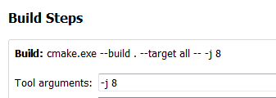

# Linux – needed tools

Just be sure you have:

* Git
* Gcc7 or newer
* Qt5.5 or newer
* CMake 3.10 or newer