Basic KF Mapping - Part One

Mapping for Killing Floor is a lot like mapping for Unreal Tournament. You're using brushes and actors to flesh out a scenario for players. In Killing Floor's case, you will need to be aware however, that your map must be planned with both human players, and AI enemies in mind, as regards pathing and various other considerations.

In this document I'm going to briefly run over how to put together a basic map for Killing Floor 2.0
I'm assuming a basic level of understanding with UED and the raw skills required to manipulate brushes or place actors.

1. Let's start a new map with the name "KF-BoxOfDoom"

Note: All Killing Floor maps MUST have the "KF" prefix in order to be recognized by the engine, and played.

2. Unfortunately, I can’t help you build the brushes. You’re going to have to do that yourself. The level pictured below is comprised of a fairly basic series of subtractive box brushes (all of which are the same height). There is a central room, and several annex rooms with corridors coming off them. Add 6 playerstarts to the central room. It must be this number, or you will get spawning issues in a server at full player capacity.

While this layout may seem random, it isn’t.

The “playable area” of our BoxofDoom, is going to be ONLY the central room. The annex corridors and rooms will be used for Zombie spawning.

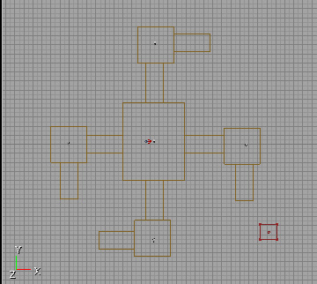

3. Assuming you’ve managed to create something remotely similar to what is pictured above, let’s go ahead and start adding some KF specific actors.

One of the new KF specific volumes you will want to become familiar with is the “ZombieVolume”. These are best placed in box-form, but obviously any size or shape is supported, and should work. There are however, a few caveats. Firstly, ZombieVolumes MUST not be viewable by players. In other words, if you place your zombie volume smack in the middle of the central chamber, right beside your spawn points, no zombies will spawn – period.

That’s where our little annex rooms come in handy. Because each annex has its own little corridor, we can use these to add the volumes. If you look at the layout of the map, at no time will the corridors leading off the annexes be visible from the main chamber. And if we plan on keeping our players confined to the central room (Hey, the name is BoxofDoom after all) then the zombies will have no problems spawning.

So having added volumes to each of the four annex corridors, here is what you should have:

Note: try to make sure that the volumes fit nicely in their allotted area. Having the edges of the volume poking through the floor or the walls is not a good idea; it can sometimes affect spawning.

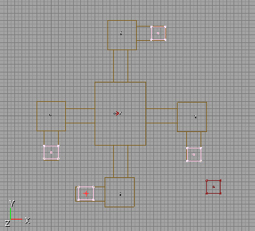

4. OK, so you’ve now got a map with spawning zombies. If you plunk down a player start in the central chamber and load her up, you should have a fight on your hands. But what if members of your team decide to wander down those annex corridors?

Well the zombies are going to have trouble spawning!

Now if you’re a somewhat experienced mapper, you have no doubt encountered “Blocking Volumes” at some point in your career. KF has its own variant of this called “KFZombieZoneVolume” which will ONLY block players. Zombies can pass through as though there was nothing there!
So if we add a few of these to the head of each corridor leading off the main room, we can restrict the players from entering the zombie spawning grounds.

Having gone ahead and done that, you should have something like this:

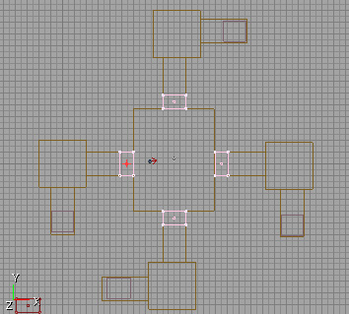

5. Well, that about does it. You’ve created the most ugly, boring and tiny Killing Floor map imaginable. BUT the principles of the most complex of the official KF maps still stick to a very similar formula! Keep a checklist in your mind, no matter what kind of map you’re creating.

a. Do I have “Zombie spawning areas” out of sight from the playable area of the map?
b. Do I have enough zombie volumes in my map? (Minimum of 3 is recommended)
c. Do I have the Spawning areas spaced out and positioned at different ends of the map?

This one’s actually VERY important. Having one end of the map full of spawning volumes and the other end with none may be nice if you’re planning on simulating a “hold out” shooting gallery style map where the zombies are advancing at you from one direction, but if you want a more dynamic setup you are going to need to plan your map so that there is room for zombie spawning areas all around the perimeter. It’s always scarier being attacked from all sides, potentially than just from a single direction.

Finally, keep in mind that this really is a bit of an art. There is no magic “Make the map fun” button. A KF map with badly positioned volumes can feel too easy, or unexciting.

Try various positions until you feel that the game play has the tension it needs.

Basic KF mapping - Part Two

So having created KF-BoxofDoom you’re feeling like it might need something more. It’s an exciting box, sure. It’s pretty marvelous in fact. But there are some touches it might need before it can be said that nobody’s box is better than yours.

For starters, it could use some ammo and weapon pickups. In Killing Floor maps, these are handled through variants of UTs XPickupBase class. Ammo is spawned through an actor named “KFRandomAmmoSpawn”. Items through “KFRandomItemSpawn”.

Creative nomenclature eh?

Here’s what each actor looks like. (Left: Item, Right: Ammo)
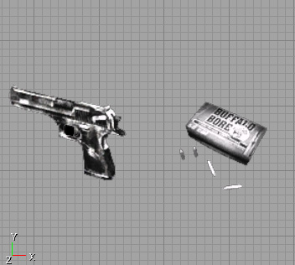

By default, each actor will spawn predetermined weaponry and ammunition. These have been selected carefully by the developers for the sake of balance.
Note: if you wish to change what is spawned, you may do so through the actor properties.

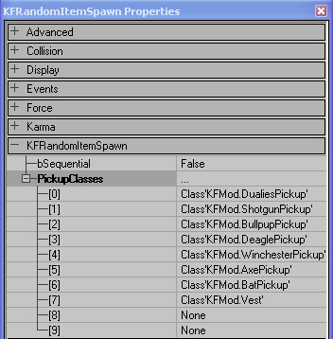

It is not recommended however (unless you’re planning a variant of KF’s gameplay), because once you change the properties of the actor in your map, if there are any patches or updates to Killing Floor which alter the class, you will need to delete and re-place the actor in your map, if you would like to play with the vanilla Killing Floor gameplay.

Each Killing Floor map has an average of 6 ItemSpawns staggered throughout the map, and about twice that number of AmmoSpawns. You don’t have to stick to these figures, and the number of Spawns you choose to add is really determined by map size anyway.
Spawns are best placed in slightly out of the way locations (ie. Finding a shotgun right in the middle of a straightaway corridor seems lame) But again, that’s your choice. Look at the official maps to study the placements we have chosen.

Once you’ve added some Ammo and Item spawns to your map, you and your team mates will have an unlimited supply of low to mid range weaponry and ammunition. (Keep in mind that there Is however a cool down between respawning of items. In Killing Floor 2.0, the higher end equipment is not found, but purchased.
Meet Katiana, “The Trader”

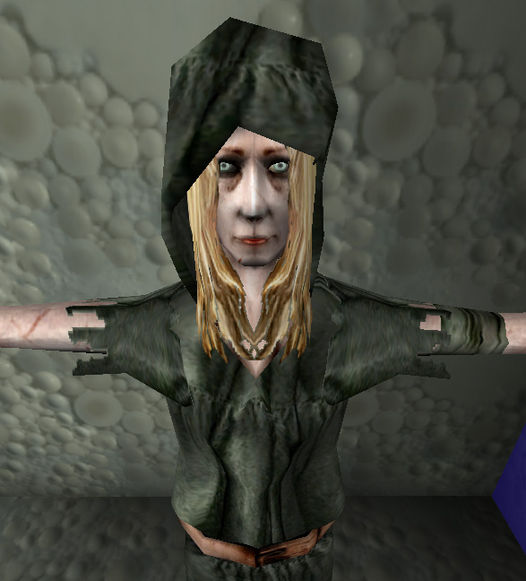

Her actor class “WeaponLocker.uc” is located in all of the official KF maps, in a secret room, in a given area of the map. It’s hard for me to tell you that you HAVE to stuff her away in a room, and follow standard KF protocols, but as with the item spawns, if you want to stay true to the gameplay which the devs have in mind, you will abide by the unwritten rules of trader placement.

To that end, we need to give her abit of space away from the fighting. She’s a safety conscious, even reclusive woman, this trader. And getting mauled by zombies or caught in a crossfire certainly isn’t in her job description.

In the below image, I have created another very basic box room leading off from the north east corner of the main chamber. It has a doorway, and the WeaponLocker actor (yes, our trader) has been placed inside.

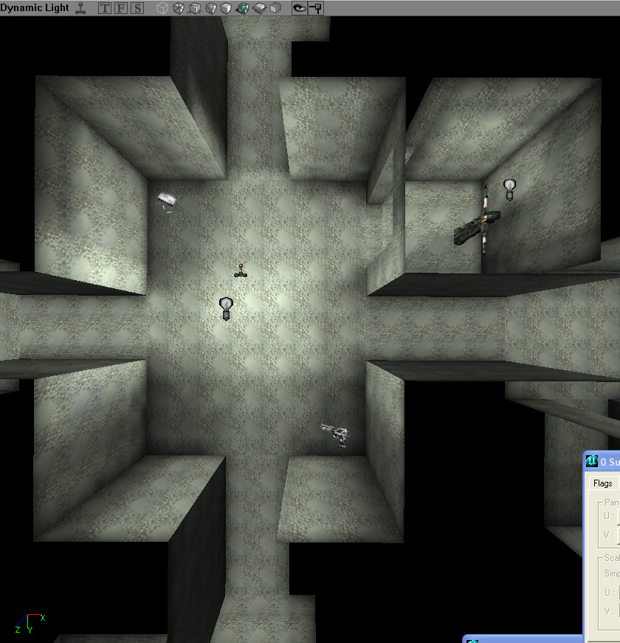

As you can see, the trader is now in her own room, and we have everything in place to start adding Trader specific actors.

In the “codex of Killing Floor trader rules” ™ Katiana will close her shop when there are zombies roaming, and only open it during the brief gaps when the countdown to the next wave is running. This is significant obviously, because it means that a visit to the traders shop is abit of a luxury. One that players caught on the other end of the map when the countdown is ticking will certainly not be able to partake in. Choose a location for the trader’s room which is out of the way, but just close enough to the action that reaching it is feasible. Clearly, in our BoxofDoom map, the trader is going to be literally next door at all times, and some of these rules don’t apply.

Let’s go ahead and add a “KFTraderDoor” mover to block up that doorway leading into the trader’s closet. The actual mover can come in ANY visual form, as long as it abides by these two simple rules

a. It should completely fill the doorway (so players can’t get at the trader when it’s closed)

b. The first mover key (0) should be the OPEN state of the door! And the second key (1) is the closed state. This is very important! (And a little confusing maybe) because it is a reversal of the typical UT door mover which is closed at frame 0. Make sure your KFTraderDoor defaults to an open state!

Ok. So you’ve added your TraderDoor right? Good. Now things get a little funky.

What if players are in the shop after closing time? They can buy all they want for as long as they want! No fair! And worse, they will be trapped, right?!

Yep, but there’s a solution. It’s ugly, but I’m going to walk you through it to ease the pain.

Let’s begin by adding a new volume to the Trader’s room. It is called a “ShopVolume” and it should be stretched to fit the area of the shop EXACTLY. It is imperative that there be as little possible space between the edges of the volume and the walls / floor / ceiling of the shop area as you can afford. If it has to go over the edges, that is fine.

Here is my result.

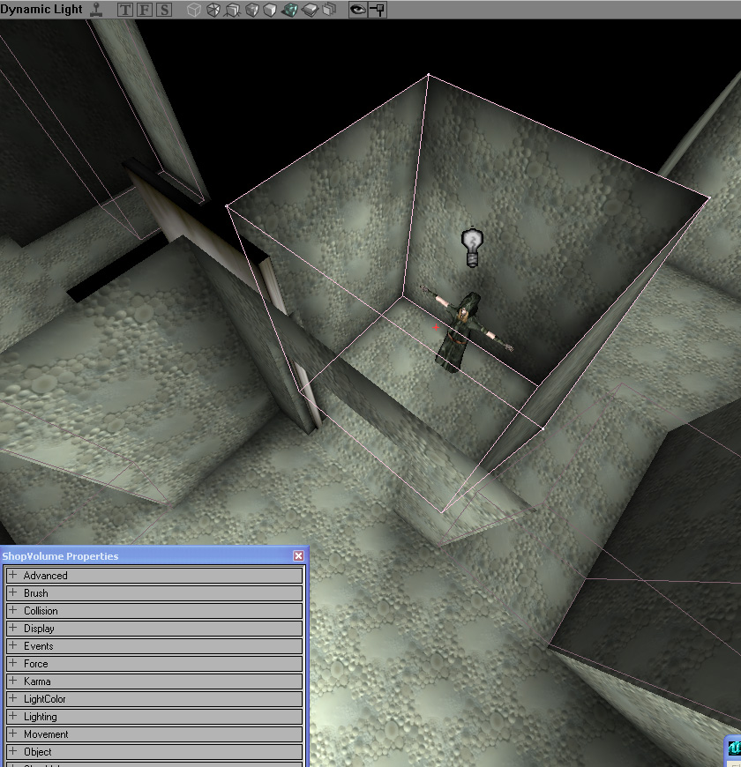
You will notice that I have the door in its open state, and the Volume enclosing the room entirely. Try to do something similar.

In the “ShopVolume” roll down of the ShopVolume you just placed, you will see a URL box. Enter anything you’d like in there, as long as you can remember it. I use “TraderLeaveSpot” as it’s pretty obvious to me what it’s referring to.

Outside the shop, in the main box room, add 6 teleporters. Just the basic UT ones, nothing fancy here. But you need to do a few things when you’ve added them.

a. Make sure that “bEnabled” is set to false on each teleporter.
b. Make sure that each teleporter’s event tag is the same. And that it matches your shopvolume’s URL

If you do these things properly, then you should be set up fine. Here is an image to illustrate the finished result.

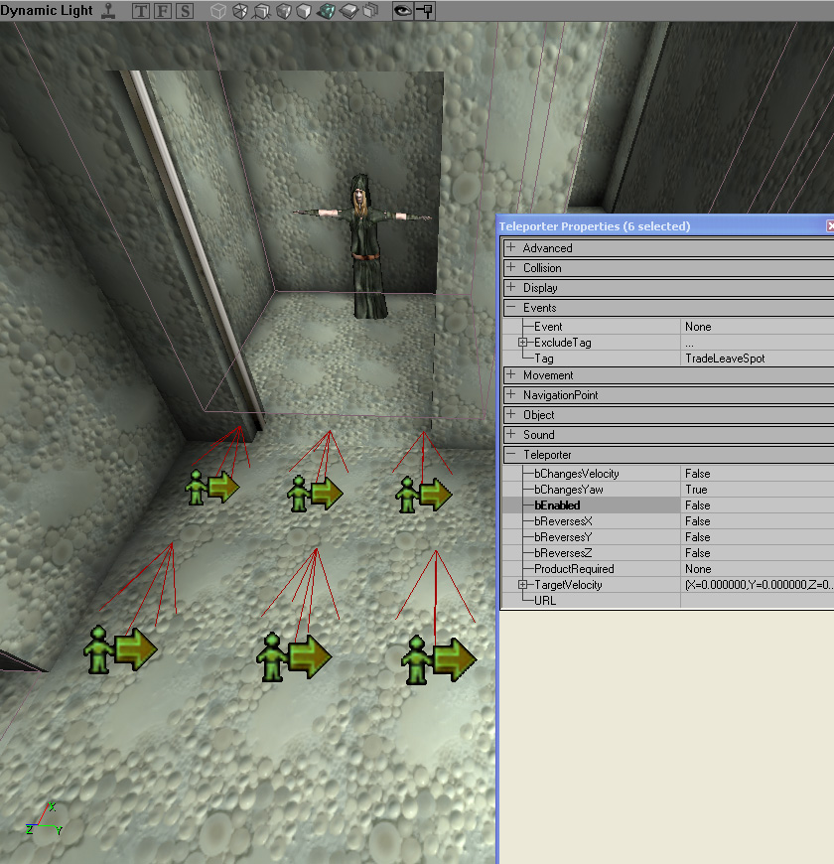
Why 6 teleporters? One for each potential player. In KF 2.0, the cap is 6 players. So you’re basically trying to avoid any teleporter overlap. In the same way as you would when you added 6 playerstarts at the start of creating this map.
You may also want to make the teleporters “face” the door, so it is clear to players where they have just been kicked out of, if they should linger in the shop after closing. Up to you though, that’s cosmetic.

Done!

If you followed the above steps correctly, you now have a fully functioning trader room that will open and close properly in response to the presence of zombies, and will kick out lingering players who decide to stick around after “closing time”.

Additional Features – Further Caveats

Killing Floor 2.0 makes use of the “KFDoorMover” actor instead of regular Movers, for its doors. You will want to use this mover type if you would like to build a door that can be welded by players and destroyed by zombies. You can change the effect that is spawned when the door dies from the default properties of the actor. Everything else is handled explicitly by the gametype, so adding these doors should be pretty self explanatory. (And unlike the trader doors the first mover frame should be the closed state of the door. Just like UT)

Recently, it has come to my attention that a bug exists with Weapons which use instant hit traces on Killing Floor maps. They sometimes will not be able to hit their targets unless fired from up close. While this bug may be fixed before 2.0’s release, my thanks go out to Doyora a KF forum goer who discovered a fix for this issue.

Fix: Make sure that your map has distance fog. The values don’t seem to matter. And if you were planning on having a map with high visibility you can simply set the DistanceFogEnd var to a high number to reduce the appearance of the fog to almost nothing. Regardless, having it in KF maps seems to negate this bug. So keep that in mind if you experience it as you map.

Dynamic Music

Killing Floor 2.0 supports a simple form of dynamic music, care of actors called “KFMusicTriggers” which will control all of the music played in a given map. A Killing Floor map should contain one of these actors. Where it is placed is irrelevant. In the properties for the musictrigger you must set two fields. Under the “musictrigger” rollout, there should be a song field. Set it to a track of your choice (note: All tracks must be in the KFmod20/Music folder and be in the .ogg format. This track will be played when there is a break in the action, between combat waves. The other track you need to set can be found in the “KFMusicTrigger” rollout of the actor, under the name “CombatSong”. Setting this to a track (preferable one which seems to accompany action) will result in a dynamic changeover in-game between your Song and CombatSong depending on whether the wave is in progress, or counting down.

Be advised: You should leave the “Song” field under the Audio rollout of your map’s levelinfo blank if you plan on making use of KF 2.0s dynamic music system.

Pathing

When you are pathnoding your map, always make sure to give the zombies as wide of a berth as you possibly can. Just because a player can barely fit through, doesn’t mean that a Zombie’s AI won’t get confused by a path route through a room the size of an outhouse. Especially consider this with the larger zombies. Where clots might be able to fit, a Fleshpound or bloat could become stuck. This all comes down to planning, and tweaking, so I can only offer a friendly warning.

